
2025 • Volume 49 • cdc.gov.au/cdi • Epub date: 10.09.2025 • doi.org/10.33321/cdi.2025.49.034

Shigellosis in South East Metropolitan Melbourne, 1 January 2022 – 31 March 2023
Emilie Guy, Lucy O Attwood, Tania Ruz, Mohana Baptista, Simon R Crouch, Rhonda Stuart
© 2025 Commonwealth of Australia as represented by the Department of Health, Disability and Ageing
ISSN: 2209-6051 Online
This journal is indexed by Index Medicus and Medline.
Creative Commons Licence
This publication is licensed under a Creative Commons Attribution-NonCommercial-NoDerivatives 4.0 International Licence (Licence). You must read and understand the Licence before using any material from this publication.
Restrictions
The Licence does not cover, and there is no permission given for, use of any of the following material found in this publication (if any):
- the Commonwealth Coat of Arms (by way of information, the terms under which the Coat of Arms may be used can be found on the Department of Prime Minister and Cabinet website;
- any logos (including the interim Australian Centre for Disease Control and the Department of Health, Disability and Ageing’s logos) and trademarks;
- any photographs and images;
- any signatures; and
- any material belonging to third parties.
Disclaimer
Opinions expressed in Communicable Diseases Intelligence are those of the authors and not necessarily those of the Australian Government, the interim Australian Centre for Disease Control or the Department of Health, Disability and Ageing. Data may be subject to revision.
Enquiries
Enquiries regarding any other use of this publication should be addressed to the CDI Editor.
About CDI
Communicable Diseases Intelligence (CDI) is a peer-reviewed scientific journal published by the interim Australian Centre for Disease Control within the Department of Health, Disability and Ageing.
The journal aims to disseminate information on the epidemiology, surveillance, prevention and control of communicable diseases of relevance to Australia and the near region.
Editor: Christina Bareja • Deputy Editor: Simon Petrie • Design and Production: Lisa Thompson
Editorial Advisory Board: David Durrheim, Mark Ferson, Clare Huppatz, John Kaldor, Martyn Kirk and Meru Sheel
Submit an Article
Guidelines for authors and details on how to submit your publication is available on our website, or by email to the
CDI Editor.
Contact us
Communicable Diseases Intelligence (CDI)
interim Australian Centre for Disease Control, Department of Health, Disability and Ageing
GPO Box 9848, CANBERRA ACT 2601
Website: cdc.gov.au/cdi
Email: cdi.editor@health.gov.au

Contents
Abstract 4
Introduction 4
Aim 4
Methods 4
Results 4
Conclusion 4
Introduction 5
Epidemiology 5
Resistance profiles 5
Local responses to reducing infections 6
Research aim 6
Method 7
Statistical analyses 7
Results 8
Case demographics 8
Risk factors 9
Laboratory confirmed cases 11
Discussion 13
Future directions 14
Conclusion 15
Acknowledgments 16
Author details 17
References 18
Appendix A 21

Abstract

Introduction
Shigella is a notifiable condition in Victoria under the Public Health and Wellbeing Act. Since 24 October 2022, the South East Public Health Unit (SEPHU) has been managing these notifications for the south east region of Melbourne.

Aim
This study aimed to determine the demographics and risk factors for acquisition of shigellosis cases in the SEPHU catchment.

Methods
A review was performed of all shigellosis notifications within the SEPHU catchment during the period 1 January 1 2022 – 31 March 2023. De-identified information was collated from the Public Health Event Surveillance System (PHESS) for analysis of demographics, risk factors and antimicrobial resistance.

Results
A total of 127 cases were notified: 51 were confirmed with culture, with the remaining 76 identified as probable cases through polymerase chain reaction testing. The greatest numbers of cases were within the 0–4 and 5–9 years of age categories (each 19/127; 15%), followed by the 30–34 years age group (18/127; 14%). The highest case numbers were recorded in the local government area (LGA) of Casey (30/127; 24%) while the highest rate across the 15-month study period, of 20.2 per 100,000, was from the Stonnington LGA. The most prominent primary risk factor was travel overseas (62/127, 49%) followed by contact between men who have sex with men (MSM) (16/127, 13%). Of confirmed cases, 61% (31/51) met the criteria for classification as critical antibiotic resistance (CAR) shigellosis.

Conclusion
This review found that the LGAs with high number and rates of cases are Casey, Greater Dandenong and Stonnington. However, the risk factors for acquisition differs in these areas, indicating a need for LGA-specific education in the diverse SEPHU catchment.
Keywords: Shigella, shigellosis, antimicrobial resistance, incidence, Victoria

Introduction
Shigella is a highly infectious gram-negative bacterium that causes the clinical syndrome of shigellosis. There are four species: S. dysenteriae, S. flexneri, S. boydii and S. sonnei, each with many serotypes.¹ Shigella is transmitted via the faecal-oral route and is spread through contaminated food and water or by close contact with an infected individual.^{2,3} This can occur due to poor hygiene, crowded living arrangements, or through sexual contact.⁴ Due to the low infectious dose of 10 to 100 organisms, Shigella is easily transmitted from person to person.⁵ The incubation period varies from one to seven days; the infectious period ends when the bacteria are no longer shed into faeces, which can be up to four weeks.^{6,7} After ingestion, Shigella invades the epithelial lining of the lower gastrointestinal tract, leading to symptoms of diarrhoea or fulminant dysentery, fever and abdominal cramps.⁸ It is generally a mild and self-limiting gastroenteritis but can be severe, requiring hospitalisation for dysentery or haemolytic uraemic syndrome.⁹

Epidemiology
Shigellosis is a disease seen globally; it causes approximately 190 million cases of diarrhoea each year.¹⁰ Risk factors for Shigella infection include direct oral-anal contact, human immunodeficiency virus (HIV) infection, poor hygiene and travel overseas.¹¹ It occurs in people of all ages, but infections amongst young children aged one to four years from low- or middle-income areas account for the majority of the disease burden.⁸ In high-income countries such as Australia, the majority of cases reported are in returning travellers from endemic countries and men who have sex with men (MSM).³ In Australia, higher rates are also seen amongst remote Aboriginal and Torres Strait Islander communities associated with crowded households and poor sewerage management.³ Out of 459 notified cases of shigellosis with risk factor data in Victoria between 2008 and 2012, the majority (249/459; 54%) were related to returned overseas travellers, with the remaining 210 cases locally acquired in Australia. Locally acquired infections were predominately in males (150/210), with the majority of these (120/150; 80%) associated with MSM contact.¹¹ Following the inclusion of culture independent diagnostic tests (CIDT) in the surveillance case definition in 2016, the notification rate increased from 2.2 per 100,000 population per year in 2011 to 12.4 per 100,000 population per year in 2019.¹¹ Reported cases of shigellosis are rising in Victoria, with 667 notifications in 2023 (of which 188 were in the catchment of the South East Public Health Unit), potentially due to increased testing, as well as to increases in overseas travel and in transmission of infections between men who have sex with men.^{12,13}

Resistance profiles
Antimicrobial therapy can be provided for shigellosis to reduce symptoms and bacterial shedding;¹⁴ however, this is reserved for severe infections, due to concerns regarding increasing antimicrobial resistance.⁴ Antibiotic therapy involves oral ciprofloxacin as first-line and azithromycin or trimethoprim-sulfamethoxazole as second-line options.^{10,15} For infections with resistance to these oral agents, third-generation cephalosporins such as ceftriaxone are prescribed.¹⁵ Dissemination of resistance is particularly facilitated by travellers and MSM contact.⁸ Between 1 January 2016 and 31 March 2018, the rates of resistance amongst cases in Victoria were found to be 17.6% (95/541) and 50.6% (274/541) to ciprofloxacin and azithromycin respectively. Azithromycin resistance across all cases was 50.6%, but in MSM associated Shigella isolates, resistance was recorded at 93% for S. sonnei and 71% for S. flexneri lineages.¹⁰ Theories for these observations include the use of azithromycin for the treatment of urethritis selecting for resistance.¹⁰ In contrast, resistance to ciprofloxacin more strongly correlates to cases in international travellers predominantly returning from southeast and central Asia.¹⁰ Data analysis for Victorian shigellosis cases revealed that those returning from India were more predominately infected with ciprofloxacin-resistant lineages than those returning from Indonesia, among whom sensitive strains predominated.¹¹ Rising resistance amongst Shigella species prompted the World Health Organization to list Shigella as a medium priority for research and development of new antibiotics in 2017.^{16,17}

Local responses to reducing infections
Prompt case notification and implementation of thorough cleaning and isolation strategies are critical to minimise spread.¹⁸ With increasing antibiotic resistance, finding an appropriate antibiotic regimen is becoming more difficult.¹⁹ The introduction of local public health units in Victoria has provided an opportunity to deliver targeted responses at a local level. The South East Public Health Unit (SEPHU), based at Monash Health, is one such unit. SEPHU covers a population of 1.5 million people in the South East Metropolitan region of Melbourne.

Research aim
There is no recent published information regarding the demographics, risk groups and antimicrobial status within the SEPHU catchment for shigellosis cases. Understanding the local epidemiology is important for SEPHU’s new role in effectively managing these cases. It is also critical for ensuring appropriate prevention measures are in place, to support both patients and healthcare providers in the region.
The aim of this research is to describe the epidemiology of Shigella cases in the SEPHU catchment between January 2022 and March 2023 in order to shape local public health action to mitigate the spread of disease.

Method
This project is a review of all shigellosis cases in the SEPHU catchment notified to the Victoria State Government Department of Health (DH) during the period 1 January 2022 to 31 March 2023. Shigella is a notifiable condition and thus the demographics, risk group and antimicrobial resistance status is recorded through the PHESS. Cases are notified to DH but immediately referred to SEPHU for public health follow-up based on Local Government Area (LGA) where they live.
This project was reviewed by the Monash Health research office (reference number RES-23-0000-245Q) and considered as exempt from Human Research Ethics Committee review, consistent with the National Health and Medical Research Council (NHMRC) Ethical Considerations in Quality Assurance and Evaluation Activities (March 2014) guideline.
Cases are defined as either confirmed or probable, both of which have been included in the analysis. A confirmed case requires either laboratory isolation of Shigella species through culture or detection of Shigella by nucleic acid testing, as well as an established epidemiological link such as contact with a confirmed case or exposure to a source. A probable case requires the detection of Shigella by polymerase chain reaction (PCR) testing alone.²⁰ Cases are identified to be high risk if they have an occupation in, or have acquired the infection in, childcare or healthcare settings or high risk residential settings such as aged care facilities, correctional facilities, disability group homes and defence force facilities.
Culture positive samples are referred to the reference laboratory, the Microbiological Diagnostic Unit, for analysis of antimicrobial susceptibilities. A critical antibiotic resistance (CAR), as defined by the CARAlert system,²¹ is assigned to an isolate that has a resistance mechanism or profile that may impact effectiveness of typical first line antibiotics. The condition of CAR shigellosis is defined as an isolate resistant to at least three of the following antibiotics: ampicillin/amoxicillin; ciprofloxacin/norfloxacin; co-trimoxazole; ceftriaxone/cefotaxime/ceftazidime; or azithromycin.
Until 24 October 2022, Shigella notifications were followed up by the Victoria State Government Department of Health. Thereafter, SEPHU took over this role, conducting case interviews that included a three-day food history if there was no MSM contact, travel or known contact risk factors identified. Data from notifying clinicians, enhanced surveillance forms (ESF) and case interviews were extracted from PHESS and collated. Identification of primary risk factors was dependent on the information sought by individual interviewers. For cases that did not have a primary risk factor listed, manual reviews of the correspondence notes related to the case were conducted (Appendix A). De-identified information regarding cases was collated from PHESS to review demographics, risk factors and antimicrobial resistance.

Statistical analyses
Descriptive statistics were presented from collated epidemiological data. Data was analysed using Microsoft Excel. Descriptive analysis was performed on the demographic variables. For visualisation of notification trends, data was presented in graphs created in Excel. The likelihood of having faecal culture performed depending on the presence of major risk factors for Shigella (travel overseas and MSM contact) was determined using a Chi square test.

Results
A total of 127 confirmed or probable cases with a case rate of 6.9 per 100,000 people were notified within the SEPHU catchment for the period 1 January 2022 – 31 March 2023.

Case demographics
Demographic characteristics are listed in Table 1. The age groups which recorded the greatest number of cases (each with 19/127; 15%) were the 0–4 and 5–9 years of age categories followed closely by the 30–34 years age category (18/127; 14%) (Figure 1). A higher proportion of cases were in males than females (Figure 1). Figure 2a shows that the highest case numbers came from the Casey LGA, while Figure 2b demonstrates that the highest case rates for the 15-month study period came from the Stonnington LGA (20.2 per 100,000 population) followed by the Greater Dandenong LGA (9.5 per 100,000 population) and Casey LGA (8.2 per 100,000 population).
Table 1: Demographic characteristics of Shigella notifications within South-East Metropolitan Melbourne from January 2022 to March 2023
Category | Characteristic | n | %
Sex | Male | 79 | 62
Sex | Female | 48 | 38
Indigenous status | Not Aboriginal or Torres Strait Islander | 94 | 74
Indigenous status | Aboriginal or Torres Strait Islander | 0 | 0
Indigenous status | Unknown | 33 | 26
Figure 1: Shigellosis cases in SEPHU catchment area from January 2022 to March 2023, distributed according to age and sex
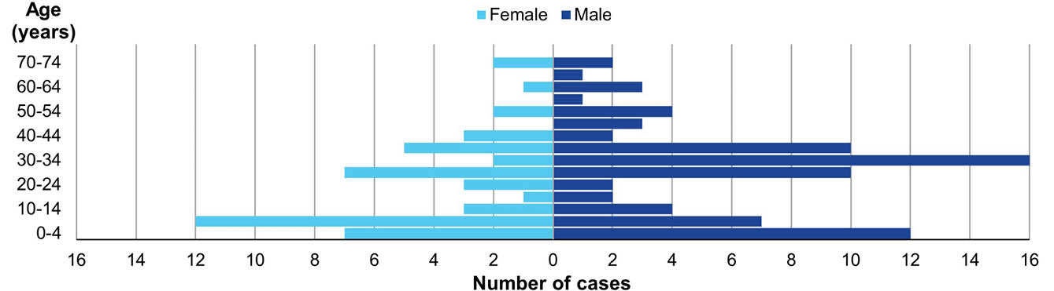
Figure 2: Shigellosis cases in SEPHU catchment area from January 2022 to March 2023, as (a) case numbers and (b) case rates, according to the local government area (LGA) where they were reported and primary risk factor
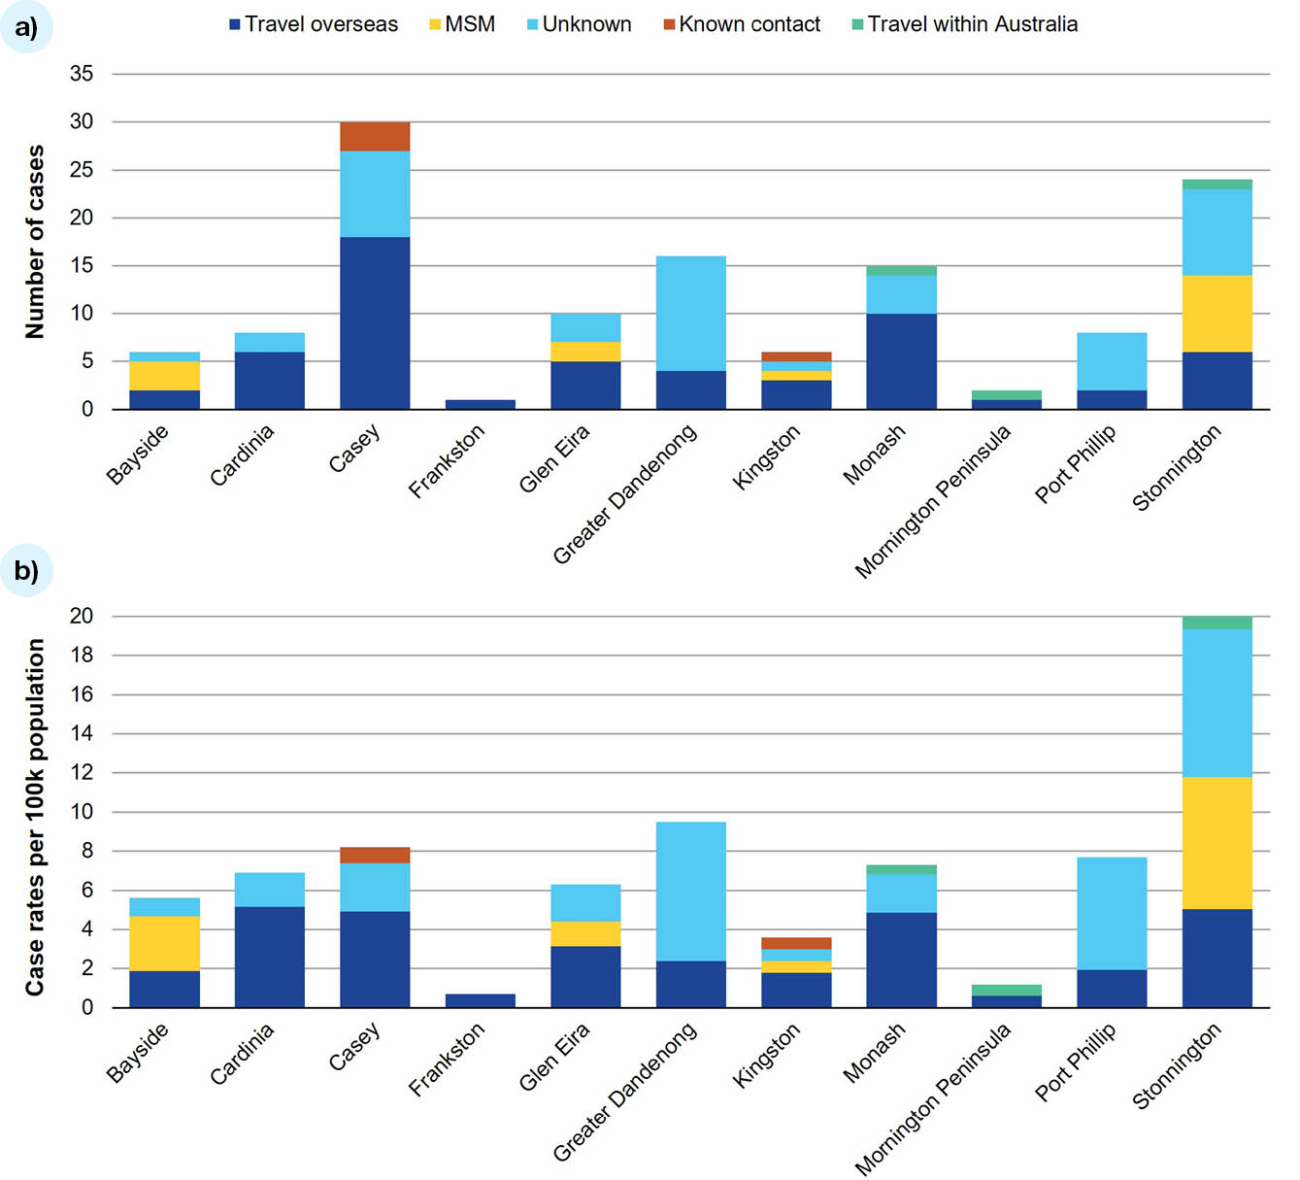

Risk factors
The most prominent primary risk factor was travel overseas (62/127; 48.9%). Thirty-two of the cases related to overseas travel (51.6%) were in females. India was the most frequent country visited for these cases. Contact between MSM was the second most common risk factor (16/127; 12.6%). Contact with a known case accounted for four cases (3%; Figure 3). Forty cases (40/127; 31.5%) did not have a primary risk factor identified. Within the LGA of Stonnington, cases were predominately associated with MSM. The Cardinia LGA, in comparison, had a greater proportion of cases for which travel overseas was the primary risk factor. The majority of Greater Dandenong’s cases were of unknown risk factor followed by overseas travel (Figure 2a). Twelve of the cases for Greater Dandenong (12/16; 75%) were recorded prior to SEPHU taking over the management of shigellosis notifications.
Figure 3: Shigellosis cases in SEPHU catchment area from January 2022 to March 2023, according to the primary risk factor reported
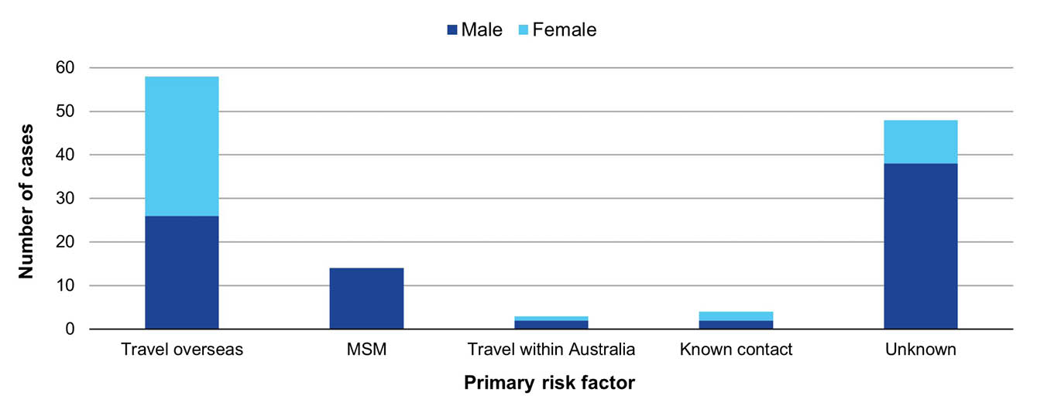
There were 59 cases reported prior to 24 October 2022, with 34 of these (58%) having no primary risk factors recorded. From 24 October 2022 and integration to SEPHU, there were 68 cases notified, of which only 14 (21%) had no listed primary risk factor (Appendix A, Table A.1). No sources were identified following completion of three-day food histories where no primary risk factor was identified.
Table 2 shows that travel overseas was the most prominent risk factor in the youngest ten-year age group of 0–9 years (23/38 cases within this age group). In comparison, within the age group of 30–39 years, after ‘unknown’, the next highest number of cases were associated with MSM (11/33).
Table 2: Shigellosis cases in SEPHU catchment area from January 2022 to March 2023, by risk factors and age group
Age group (years) | Risk factor
Age group (years) | Travel overseas | Contact with known case | Travel within Australia | MSM | Unknown | Total
0–9 | 23 | 3 | 2 | 0 | 10 | 38
10–19 | 3 | 0 | 0 | 0 | 7 | 10
20–29 | 14 | 0 | 0 | 2 | 6 | 22
30–39 | 7 | 0 | 1 | 11 | 14 | 33
40–49 | 5 | 0 | 0 | 1 | 2 | 8
50–59 | 3 | 0 | 0 | 0 | 4 | 7
60–69 | 1 | 1 | 0 | 0 | 3 | 5
70–79 | 2 | 0 | 0 | 0 | 2 | 4

Laboratory confirmed cases
There were 51 confirmed shigellosis cases. MSM cases were more likely to be confirmed with culture compared to the cases associated with travel overseas, which were predominately diagnosed by PCR (χ² = 3.841; p < 0.05) (Figure 4a). From the total cases, 29 were identified as associated with a high-risk occupation; of these, 18/29 (62%) were probable cases and 11/29 (38%) were confirmed cases. Thirty-four of the total confirmed cases (67%) were identified as Shigella sonnei (Figure 4b). The single case of S. dysenteriae was in a returned traveller from India. The majority of confirmed cases (31/51; 61%) met the criteria for classification as a critical antibiotic resistance (CAR);²¹ 18 confirmed cases did not, while two were not listed. The majority of cases identified as CAR shigellosis were in S. sonnei species (26/31; 84%) with the remaining instances identified in S. flexneri cases. As seen in Figure 4c, rates of CAR shigellosis differed depending on the associated primary risk factor. The highest proportion of CAR cases occurred amongst the MSM group, with 11 of the 12 confirmed MSM cases (92%) identified as CAR shigellosis.
Figure 4: Attributes of shigellosis cases in SEPHU catchment area, 1 January 2022 – 31 March 2023, showing (a) the number of confirmed and probable cases (N = 127) for the primary risk factors; (b) the number of confirmed cases (N = 51) by isolated Shigella species and presence/absence of CAR shigellosis; (c) categorisation of CAR shigellosis cases (N = 31) by isolated Shigella species and primary risk factor
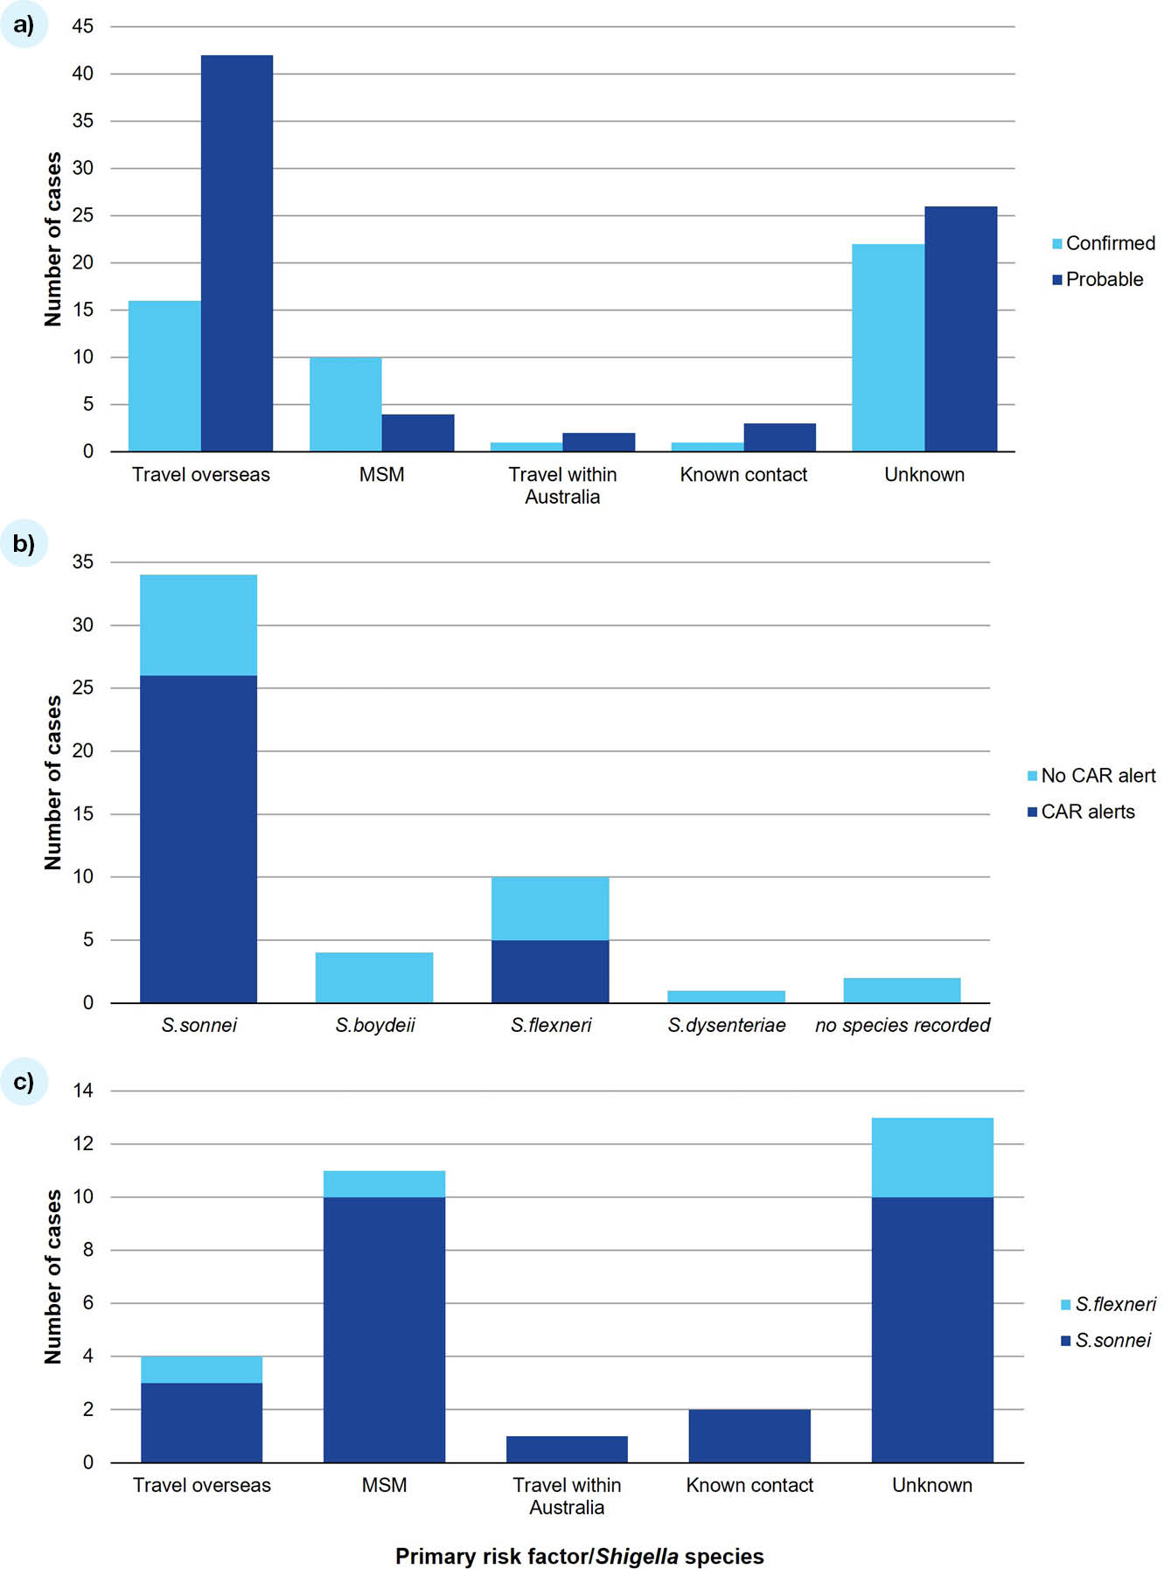

Discussion
In the SEPHU catchment, the highest number of Shigella cases occurred in the LGAs of Stonnington and Casey, with MSM contact and travel overseas documented as the main risk factors respectively. We found the highest case rates occurred in the Stonnington LGA. As an area with a vibrant LGBTIQA+ community,²² the most common risk factor recorded was MSM. Greater Dandenong had the second highest case rate, with a majority of cases of unknown risk factor, followed by Casey, which had the highest total number of cases. Within the LGA of Casey, with many families from culturally and linguistically diverse backgrounds,²³ the most significant risk factor was overseas travel.
Despite the knowledge that Shigella can be transmitted through contaminated water or food, the collection of three-day food histories conducted did not identify any common sources between these cases. Public Health England’s questionnaire incorporates a week-long food history but similarly rarely finds a food source.^{24,25} In 2015, there were two perceived foodborne outbreaks in hospital and take-away settings within the UK but no food sources were identified.²⁵ However, a United Kingdom (UK) outbreak in 2022, linked to spring onions from Egypt, shows that food histories can aid in source identification and control in rare circumstances.²⁶
The highest rates of CAR shigellosis were seen amongst MSM cases. This is consistent with research findings within and outside Victoria. An epidemiological study conducted in the UK highlighted the rapid spread of extensively drug-resistant, extended spectrum beta-lactamase producing S. sonnei amongst MSM.²⁷ Similarly, reduced susceptibility to azithromycin, trimethoprim-sulfamethoxazole and ciprofloxacin were found amongst MSM-associated S. sonnei isolates in Victoria from 2016 to 2018 and in Australia from 2019 to 2020.^{10,16} While bacterial culture is recognised as the gold standard for the detection of Shigella and analysis of antimicrobial resistance,³ laboratories more commonly perform faecal PCR rather than an initial culture. There also seem to be trends of culture requests according to primary risk factors. The MSM population had faecal culture requested for most cases, allowing for identification of resistant species requiring CAR alerts. Cases who had travelled overseas, in contrast, rarely had a culture performed. Potentially, MSM-associated cases in Stonnington are visiting high-caseload general practitioners (GPs) who are more aware of the risk of Shigella and associated antimicrobial resistance in MSM and therefore specifically request culture. The single S. dysenteriae case was associated with travel overseas to India. This emphasises the importance of ordering cultures for patients who return from overseas with diarrhoeal illnesses to prevent the spread of a potentially severe infection. Patients who return from overseas with a diarrhoeal illness should have a faecal culture ordered to ensure that both the bacterial species such as Shigella, as well as any antimicrobial resistance, can be promptly identified.
The finding that a lower proportion of cases notified from 24 October 2022, when SEPHU commenced follow-up of shigellosis cases, had an unknown primary risk factor may reflect the fact that there is now increased capacity across the Victorian public health system for case interviews and investigation as part of the new networked approach. Local public health units were established to help enhance a local response and these results support the idea that there have been small but meaningful steps in this direction. There is limited research on the benefit of determining sources of local acquisitions in order to prevent outbreaks. A case series in a Victorian child-care centre shows that outbreak control is possible without determining the source.⁹ The finding that four cases were acquired from contact with a known infected individual suggests that outbreaks within the SEPHU catchment are minimal. However, due to the high number of cases with no determined primary risk factor, we would be hesitant to definitively draw this conclusion.
Victoria’s guidelines for isolation and clearance have emphasis on high-risk settings. Case clearance in Victoria, for those in high-risk occupations, requires two negative stool samples 24 hours apart, taken not less than 48 hours after symptoms or antibiotic treatments have ceased. Following publication of a 2010 study showing that absence of Shigella in the first stool culture appears sufficient, the UK changed their guidelines to cases being cleared after only one negative stool sample 48 hours post symptoms/ treatment ceasing.^{24,28} New South Wales guidelines state that those in high-risk occupations can return to work after 48 hours of being symptom free.²⁹ Our review found that cases from high-risk occupations were not found to be associated with a higher rate of antibiotic resistance than cases overall. The percentage of high-risk confirmed cases having CAR shigellosis (45%) is slightly lower than the total percentage of CAR shigellosis in confirmed cases (61%). These considerations suggest that Victorian guidelines could be reviewed to adopt an approach requiring a single negative sample and a 48-hour symptom-free period.
This study contains inherent limitations due to its retrospective nature. We were reliant on case information recorded in PHESS, which at times may have been incomplete. Incomplete data on demographics and risk factors affected analysis of this dataset, particularly within Greater Dandenong. This makes it difficult to gain a true perspective on risk factor profile; however, risk factor analysis was able to occur in the majority of cases (62%). It should also be noted that nucleic acid testing is not 100% accurate, as other pathogens can cause false positive Shigella PCR results.³⁰ This highlights the importance of culture as an adjunct to PCR testing for more accurate diagnosis.

Future directions
SEPHU should continue to work towards completing a full risk factor profile on cases within the catchment due to the high number of unidentified primary risks. However, the benefit of a three-day food history strategy could be reviewed, as this study does not provide any evidence for its benefit. A system of being able to link food histories in order to effectively find a common source could potentially be developed, providing real utility to this activity.
We found CAR rates of 61% amongst confirmed cases. It is essential that education is provided to healthcare providers in the SEPHU catchment on antibiotic resistance and the importance of limiting the spread of Shigella. There are low numbers of faecal cultures performed for returned travellers compared to PCR alone. Engagement between SEPHU and GPs might be beneficial, particularly in the LGAs of Casey and Greater Dandenong, to determine the reason for this finding and reiterate the importance of obtaining a culture. The priority areas within the SEPHU catchment are Stonnington, Casey and Greater Dandenong as they demonstrated the highest case rates. However, the interventions required in these LGAs differ. In Stonnington, emphasis should be on education for the MSM community about the risk of Shigella spread through sexual contact and harm minimisation strategies. In Casey (and most likely also in Greater Dandenong), the focus should be on education regarding risk of Shigella exposure through overseas travel particularly regarding towards children. This could include education to GPs regarding risk factors for Shigella and other bacterial infection acquisition, travel safety education and an emphasis on the importance of stool cultures if symptoms develop after travelling to endemic areas such as India.

Conclusion
This review of shigellosis notifications between January 1 2022 and March 31 2023 revealed that the highest case rates by LGA in the SEPHU catchment are driven by quite different risk factors. Within the LGA of Stonnington, the highest known risk factor was MSM contact and for the culturally and linguistically diverse area of Casey it was overseas travel. This information can be used to drive priority areas for awareness campaigns and community engagement.
Furthermore, cases among MSM were more likely to be identified by culture with the majority of showing critical antibiotic resistance. Culture was much less commonly available in cases with overseas travel as the primary risk factor. SEPHU will work with local clinicians and laboratories to optimise reflex cultures so all CAR cases are identified and appropriately managed.

Note added in proof
Subsequent to the drafting of this article, the Therapeutic Guidelines: Antibiotic website has been updated (in March 2025) and should be considered as a current and local Australian source of guidance on antimicrobial therapy for cases of Shigella enteritis (shigellosis).

Acknowledgments
The authors wish to acknowledge the medical practitioners & pathology services who diagnosed and notified the cases to the Department of Health, Victoria. We also wish to acknowledge the contributions of the public health officers in the Communicable Disease Prevention and Control Unit at the South East Public Health Unit and at the Department of Health who undertook the case follow up for shigella, along with staff of the Communicable Disease Epidemiology and Surveillance Unit who have contributed to the management, response, collection, and curation of this dataset prior to and after integration of the condition to the state’s new network of Local Public Health Units.

Author details
Dr Emilie A Guy,¹
Dr Lucy O Attwood,^{1,2}
A/Prof. Simon R Crouch,^{1,2}
Ms Mohana Baptista,^{1,2}
Ms Tania Ruz,²
Dr Rhonda L Stuart^{1,2}
- Faculty of Medicine, Nursing and Health Science, Monash University, Victoria
- South East Public Health Unit, Monash Health, Victoria

Corresponding author
Emilie A Guy
Address: Monash University, Wellington Road, Clayton, VIC, 3800
Phone: +61 431 269 822
Email: emilieaguy@gmail.com

References
- Baker S, The HC. Recent insights into Shigella. Curr Opin Infect Dis. 2018;31(5):449–54. doi: https://doi.org/10.1097/QCO.0000000000000475.
- Mattock E, Blocker AJ. How do the virulence factors of Shigella work together to cause disease? Front Cell Infect Microbiol. 2017;7:64. doi: https://doi.org/10.3389/fcimb.2017.00064.
- Ibrahim AF, Glass K, Williamson DA, Polkinghorne BG, Ingle DJ, Wright R et al. The changing epidemiology of shigellosis in Australia, 2001-2019. PLoS Negl Trop Dis. 2023;17(3):e0010450. doi: https://doi.org/10.1371/journal.pntd.0010450.
- Boveé L, Whelan J, Sonder GJ, van Dam AP, van den Hoek A. Risk factors for secondary transmission of Shigella infection within households: implications for current prevention policy. BMC Infect Dis. 2012;12:347. doi: https://doi.org/10.1186/1471-2334-12-347.
- Victorian State Government Department of Health. Shigellosis. [Internet.] Melbourne: Victorian State Government Department of Health; 29 November 2022. [Accessed on 26 April 2023.] Available from: https://www.health.vic.gov.au/infectious-diseases/shigellosis.
- Wise J. Sixty seconds on... Shigella. BMJ. 2022;376:o253. doi: https://doi.org/10.1136/bmj.o253.
- Cheftel E, Spiegel A, Bornert G, Morell E, Michel A, Buisson Y. [Toxic food infection caused by Shigella flexneri in a military unit]. Sante. 1997;7(5):295–9.
- Kotloff KL, Riddle MS, Platts-Mills JA, Pavlinac P, Zaidi AKM. Shigellosis. Lancet. 2018;391(10122):801–12. doi: https://doi.org/10.1016/S0140-6736(17)33296-8.
- Genobile D, Gaston J, Tallis GF, Gregory JE, Griffith JM, Valcanis M et al. An outbreak of shigellosis in a child care centre. Commun Dis Intell Q Rep. 2004;28(2):225–9.
- Ingle DJ, Easton M, Valcanis M, Seemann T, Kwong JC, Stephens N et al. Co-circulation of multidrug-resistant Shigella among men who have sex with men in Australia. Clin Infect Dis. 2019;69(9):1535–44. doi: https://doi.org/10.1093/cid/ciz005.
- Lane CR, Sutton B, Valcanis M, Kirk M, Walker C, Lalor K, et al. Travel destinations and sexual behavior as indicators of antibiotic resistant Shigella strains–Victoria, Australia. Clin Infect Dis. 2016;62(6):722–9. doi: https://doi.org/10.1093/cid/civ1018.
- Australian Bureau of Statistics (ABS). Overseas Arrivals and Departures, Australia. [Internet.] Canberra: ABS; 2023. [Accessed on 15 May 2023.] Available from: https://www.abs.gov.au/statistics/industry/tourism-and-transport/overseas-arrivals-and-departures-australia/latest-release.
- Martín-Sánchez M, Case R, Fairley C, Hocking JS, Bradshaw C, Ong J et al. Trends and differences in sexual practices and sexually transmitted infections in men who have sex with men only (MSMO) and men who have sex with men and women (MSMW): a repeated cross-sectional study in Melbourne, Australia. BMJ Open. 2020;10(11):e037608. doi: https://doi.org/10.1136/bmjopen-2020-037608.
- Lolekha S, Vibulbandhitkit S, Poonyarit P. Response to antimicrobial therapy for shigellosis in Thailand. Rev Infect Dis. 1991;13(Suppl 4):S342–6. doi: https://doi.org/10.1093/clinids/13.supplement_4.s342.
- Williams PCM, Berkley JA. Guidelines for the treatment of dysentery (shigellosis): a systematic review of the evidence. Paediatr Int Child Health. 2018;38(sup1):S50–65. doi: https://doi.org/10.1080/20469047.2017.1409454.
- Ingle DJ, Andersson P, Valcanis M, Barnden J, da Silva AG, Horan KA et al. Prolonged outbreak of multidrug-resistant Shigella sonnei harboring blaCTX-M-27 in Victoria, Australia. Antimicrob Agents Chemother. 2020;64(12). doi: https://doi.org/10.1128/AAC.01518-20.
- World Health Organization (WHO). Global priority list of antibiotic-resistant bacteria to guide research, discovery and development of new antibiotics. Geneva: WHO; 27 February 2017. [Accessed on 19 April 2023.] Available from: http://www.who.int/medicines/publications/global-priority-list-antibiotic-resistant-bacteria/en/.
- Chen T, Leung RK, Zhou Z, Liu R, Zhang X, Zhang L. Investigation of key interventions for shigellosis outbreak control in China. PLoS One. 2014;9(4):e95006. doi: https://doi.org/10.1371/journal.pone.0095006.
- Ranjbar R, Farahani A. Shigella: antibiotic-resistance mechanisms and new horizons for treatment. Infect Drug Resist. 2019;12:3137–67. doi: https://doi.org/10.2147/IDR.S219755.
- Australian Government Department of Health and Aged Care, Communicable Diseases Network Australia (CDNA). Shigellosis: Australian national notifiable diseases case definition. Canberra: Australian Government Department of Health and Aged Care; 1 July 2018. Available from: https://www.health.gov.au/sites/default/files/documents/2022/06/shigellosis-surveillance-case-definition.pdf.
- Australian Commission on Quality and Safety of Healthcare (ACSQHC). National Alert System for Critical Antimicrobial Resistances (CARAlert). [Internet.] Sydney: ACSQHC; 2023. [Accessed on May 1 2023.] Available from: https://www.safetyandquality.gov.au/our-work/antimicrobial-resistance/antimicrobial-use-and-resistance-australia-surveillance-system/national-alert-system-critical-antimicrobial-resistances-caralert.
- ABS. Stonnington: 2021 Census All persons QuickStats. [Webpage.] Canberra: ABS; 2021. [Accessed on 15 May 2023.] Available from: https://abs.gov.au/census/find-census-data/quickstats/2021/LGA26350.
- ABS. Casey: 2021 Census Aboriginal and/or Torres Strait Islander people QuickStats. [Webpage.] Canberra: ABS; 2021. [Accessed on 15 May 2023.] Available from: https://abs.gov.au/census/find-census-data/quickstats/2021/IQSLGA21610.
- Public Health England (PHE). Shigellosis: public health management and questionnaire. [Webpage.] London: Government of the United Kingdom, PHE; 30 November 2017. Available from: https://www.gov.uk/government/publications/shigellosis-public-health-management-and-questionnaire.
- PHE. Shigella data 2006 to 2015: November 2016. London: Government of the United Kingdom, PHE; 30 November 2017. Available from: https://assets.publishing.service.gov.uk/media/5a816f53ed915d74e33fe317/Shigella_2016_Data.pdf.
- Jenkins C, Griffith P, Hoban A, Brown C, Garner J, Bardsley M et al. Foodborne outbreak of extended spectrum beta-lactamase producing Shigella sonnei associated with contaminated spring onions in the United Kingdom. J Food Prot. 2023;86(6):100074. doi: https://doi.org/10.1016/j.jfp.2023.100074.
- Charles H, Prochazka M, Thorley K, Crewdson A, Greig DR, Jenkins C et al. Outbreak of sexually transmitted, extensively drug-resistant Shigella sonnei in the UK, 2021–22: a descriptive epidemiological study. Lancet Infect Dis. 2022;22(10):1503–10. doi: https://doi.org/0.1016/S1473-3099(22)00370-X.
- Turabelidze G, Bowen A, Lin M, Tucker A, Butler C, Fick F. Convalescent cultures for control of shigellosis outbreaks. Pediatr Infect Dis J. 2010;29(8):728–30. doi: https://doi.org/10.1097/INF.0b013e3181e4ee6e.
- New South Wales Government Department of Health (NSW Health). Shigellosis: NSW Control Guideline for Public Health Units. Sydney: NSW Health; July 2018. Available from: https://www.health.nsw.gov.au/Infectious/controlguideline/Documents/shigellosis.pdf.
- Devanga Ragupathi NK, Muthuirulandi Sethuvel DP, Inbanathan FY, Veeraraghavan B. Accurate differentiation of Escherichia coli and Shigella serogroups: challenges and strategies. New Microbes New Infect. 2018;21:58–62. doi: https://doi.org/10.1016/j.nmni.2017.09.003.

Appendix A
Table A.1: Categorisation of cases with unknown primary risk factor
Category | Cases with no stated primary risk factorª
Category | handled by DH | handled by SEPHU
Event date range | 1 January – 23 October 2022 | 24 October 2022 – 31 March 2023
Cases with unknown risk factor / total | 34/59 | 14/68
ESF^{b} not received / incomplete | 17 | 0
No risk factors identified / determinable | 12 | 11
Other^{c} | 5 | 3
a DH: Victorian State Government Department of Health; SEPHU: South East Public Health Unit.
b ESF: enhanced surveillance form.
c Risk factors noted but not definitively identified as the primary risk factor included possible contact; cluster case; possible MSM; and travel overseas to South Asia or within two weeks prior to illness onset.

https://www.nhmrc.gov.au/about-us/resources/ethical-considerations-quality-assurance-and-evaluation-activities.
Data were extracted from the Victorian Public Health Event Surveillance System on 21 April 2023. The data reported are only of events that have been notified to the Department of Health, Victoria, and therefore do not represent a true incidence of the condition. Data are correct at the time of writing and are subject to change.

