
2025 • Volume 49 • cdc.gov.au/cdi • Epub date: 10.09.2025 • doi.org/10.33321/cdi.2025.49.023

Annual Immunisation Coverage Report 2022
Brynley Hull, Alexandra Hendry, Aditi Dey, Julia Brotherton, Kristine Macartney, Frank Beard
© 2025 Commonwealth of Australia as represented by the Department of Health, Disability and Ageing
ISSN: 2209-6051 Online
This journal is indexed by Index Medicus and Medline.
Creative Commons Licence
This publication is licensed under a Creative Commons Attribution-NonCommercial-NoDerivatives 4.0 International Licence (Licence). You must read and understand the Licence before using any material from this publication.
Restrictions
The Licence does not cover, and there is no permission given for, use of any of the following material found in this publication (if any):
- the Commonwealth Coat of Arms (by way of information, the terms under which the Coat of Arms may be used can be found on the Department of Prime Minister and Cabinet website;
- any logos (including the interim Australian Centre for Disease Control and the Department of Health, Disability and Ageing’s logos) and trademarks;
- any photographs and images;
- any signatures; and
- any material belonging to third parties.
Disclaimer
Opinions expressed in Communicable Diseases Intelligence are those of the authors and not necessarily those of the Australian Government, the interim Australian Centre for Disease Control or the Department of Health, Disability and Ageing. Data may be subject to revision.
Enquiries
Enquiries regarding any other use of this publication should be addressed to the CDI Editor.
About CDI
Communicable Diseases Intelligence (CDI) is a peer-reviewed scientific journal published by the interim Australian Centre for Disease Control within the Department of Health, Disability and Ageing.
The journal aims to disseminate information on the epidemiology, surveillance, prevention and control of communicable diseases of relevance to Australia and the near region.
Editor: Christina Bareja • Deputy Editor: Simon Petrie • Design and Production: Lisa Thompson with support from Sehaj Dhillon
Editorial Advisory Board: David Durrheim, Mark Ferson, Clare Huppatz, John Kaldor, Martyn Kirk and Meru Sheel
Submit an Article
Guidelines for authors and details on how to submit your publication is available on our website, or by email to the
CDI Editor.
Contact us
Communicable Diseases Intelligence (CDI)
interim Australian Centre for Disease Control, Department of Health, Disability and Ageing
GPO Box 9848, CANBERRA ACT 2601
Website: cdc.gov.au/cdi
Email: cdi.editor@health.gov.au

Contents
List of figures 4
List of tables 7
Vaccine abbreviations 9
Abstract 10
Children 10
Adolescents 10
Adults 11
Conclusions 11
Introduction 12
Results 13
Children 13
Adolescents 28
Adults 41
Discussion 53
Vaccination coverage in population overall 53
Vaccination coverage in Indigenous people 57
Conclusions 59
Acknowledgments 60
Author details 61
References 62
Appendix A 67
Detailed methods 72

Information correct as at 10 January 2024.

List of figures
Figure 1: Coverage of seasonal influenza vaccine in children aged 6–59 months, by jurisdiction, Australia,^{a,b,c,d} 2021 versus 2022 16
Figure 2: Coverage of seasonal influenza vaccine by age group, Australia,^{a,b,c} 2021 versus
2022 16
Figure 3: Coverage of seasonal influenza vaccine in Indigenous children aged 6–59 months, by jurisdiction, Australia,^{a,b,c,d} 2021 versus 2022 18
Figure 4: Coverage of seasonal influenza vaccine by age group for Indigenous persons, Australia,^{a,b,c} 2021 versus 2022 18
Figure 5: Coverage of meningococcal B vaccine for Indigenous children, by dose number and jurisdiction, Australia,^{a,b,c,d} 2022 20
Figure 6: Trends in on-time vaccination coverage for the second dose of DTPa-containing vaccine, by Indigenous status and quarter, Australia,^{a,b,c} 2019–2022 21
Figure 7: Trends in on-time vaccination coverage for the first dose of MMR-containing vaccine, by Indigenous status and quarter, Australia,^{a,b,c} 2019–2022 22
Figure 8: On-time vaccination coverage of first dose of MMR-containing vaccine assessed at 13 months of age by Statistical Area 3, Australia and major capital cities^{,a,b,c} 2022 23
Figure 9: Coverage of the first dose of measles-mumps-rubella (MMR)-containing vaccine at 24 months of age by Statistical Area 3, Australia and major capital cities,^{a,b} 2022 25
Figure 10: Coverage of the second dose of measles-mumps-rubella (MMR)-containing vaccine at 24 months of age by Statistical Area 3, Australia and major capital cities,^{a,b} 2022 26
Figure 11: Proportion of all vaccinations given to children aged < 10 years by provider setting and jurisdiction, Australia,^{a,b,c} 2022 27
Figure 12: Proportion of all non-COVID-19 vaccinations given to children aged < 10 years by provider setting and jurisdiction, Australia,^{a,b,c} 2022 27
Figure 13: Coverage of at least one dose of HPV vaccine for females by birth cohort/age and Indigenous status, Australia,^{a,b} 2022 31
Figure 14: Coverage of at least one dose of HPV vaccine for males by birth cohort/age and Indigenous status, Australia,^{a,b} 2022 32
Figure 15: Coverage of an adolescent dose of diphtheria-tetanus-acellular pertussis vaccine by birth cohort/age and Indigenous status, Australia,^{a,b,c} 2022 33
Figure 16: Coverage of an adolescent dose of meningococcal ACWY vaccine by birth cohort/age and Indigenous status, Australia,^{a,b} 2022 34
Figure 17: Vaccination coverage using composite measure (dose of HPV and adolescent dose of diphtheria-tetanus-pertussis vaccine) in adolescents turning 15 years, by jurisdiction, Australia,^{a,b,c,d} 2021 versus 2022 35
Figure 18: Vaccination coverage using composite measure (dose of HPV and adolescent dose of diphtheria-tetanus-pertussis vaccine) in Indigenous adolescents turning 15 years, by jurisdiction, Australia,^{a,b,c,d} 2021 versus 2022 36
Figure 19: Vaccination coverage using composite measure (dose of HPV and adolescent doses of diphtheria-tetanus-pertussis and meningococcal ACWY vaccine) in adolescents turning 18 years, by jurisdiction, Australia,^{a,b,c,d} 2021 versus 2022 37
Figure 20: Vaccination coverage using composite measure (dose of HPV and adolescent doses of diphtheria-tetanus-pertussis and meningococcal ACWY vaccine) in Indigenous adolescents turning 18 years, by jurisdiction, Australia,^{a,b,c,d} 2021 versus 2022 38
Figure 21: Proportion of all vaccinations given to adolescents aged 10–19 years by provider setting and jurisdiction, Australia,^{a,b,c} 2022 39
Figure 22: Proportion of non-COVID-19 vaccinations given to adolescents aged 10–19 years by provider setting and jurisdiction, Australia,^{a,b,c} 2022 40
Figure 23: Zoster vaccination coverage for adults turning 71 years of age in the year of interest, by jurisdiction, Australia,^{a,b,c,d,e} 2020, 2021 and 2022 41
Figure 24: Zoster vaccination coverage for Indigenous adults turning 71 years of age in the year of interest, by jurisdiction, Australia,^{a,b,c,d,e} 2020, 2021 and 2022 42
Figure 25: Zoster vaccination coverage in adults by birth cohort and age at vaccination, Australia,^{a,b} 2022 43
Figure 26: Zoster vaccination coverage in Indigenous adults by birth cohort and age at vaccination, Australia,^{a,b} 2022 43
Figure 27: Coverage of an adult dose of 13vPCV in the cohort turning 71 years of age in the year of interest, by jurisdiction, Australia,^{a,b,c,d,e} 2020, 2021 and 2022 44
Figure 28: Coverage of an adult dose of 13vPCV in the Indigenous cohort turning 71 years of age in the year of interest, by jurisdiction, Australia,^{a,b,c,d,e} 2020, 2021 and 2022 45
Figure 29: Coverage of an adult dose of 13vPCV by birth cohort and age at vaccination, Australia,^{a,b} 2022 46
Figure 30: Coverage of an adult dose of 13vPCV by Indigenous birth cohort and age at vaccination, Australia,^{a,b} 2022 46
Figure 31: Coverage of seasonal influenza vaccine by adult age group, Australia,^{a,b,c}
2019–2022 47
Figure 32: Vaccination coverage using composite measure (influenza vaccine dose in past 12 months and an adult dose of 13vPCV), adults turning 71 years of age in relevant year, by jurisdiction, Australia,^{a,b,c,d} 2022 versus 2021 48
Figure 33: Vaccination coverage using composite measure (influenza vaccine dose in past 12 months and an adult dose of 13vPCV), Indigenous adults turning 71 years of age in relevant year, by jurisdiction, Australia,^{a,b,c,d} 2022 versus 2021 49
Figure 34: Proportion of vaccinations (overall versus non-COVID-19) given to adults by provider setting and age group, Australia,^{a,b} 2022 51
Figure A.1: Trends in fully vaccinated coverage by quarter, Australia,^{a,b,c} 2013–2022 78
Figure A.2: Trends in vaccination coverage at 12 months of age, by vaccine/antigen and quarter, Australia,^{a,b,c,d} 2013–2022 79
Figure A.3: Trends in vaccination coverage at 24 months of age by vaccine/antigen and quarter, Australia,^{a,b,c,d} 2013–2022 80
Figure A.4: Trends in vaccination coverage at 60 months of age by vaccine/antigen and quarter, Australia,^{a,b,c,d} 2013–2022 81
Figure A.5: Trends in fully vaccinated coverage at 12 months of age by Indigenous status and quarter, Australia,^{a,b,c,d} 2013–2022 81
Figure A.6: Trends in fully vaccinated coverage at 24 months of age by Indigenous status and quarter, Australia,^{a,b,c,d} 2013–2022 82
Figure A.7: Trends in fully vaccinated coverage at 60 months of age by Indigenous status and quarter, Australia,^{a,b} 2013–2022 82
Figure A.8: Trends in coverage for hepatitis A vaccine by 30 months of age for Indigenous children by jurisdiction, Australia,^{a,b,c,d} 2013–2022 83
Figure A.9: Trends in coverage for pneumococcal vaccine for Indigenous children by jurisdiction, Australia,^{a,b,c,d,e} 2013–2022 83
Figure A.10: Coverage of COVID-19 vaccines (doses 1–4) in all people by age group, Australia,^{a,b,c} 2022 84
Figure A.11: Coverage of COVID-19 vaccines (doses 1–4) in people aged 16 years and over by Indigenous status, Australia,^{a,b} 2022 84

List of tables
Table 1: Vaccination coverage in children by age assessment milestone, vaccine/antigen and Indigenous status, Australia, 2021 versus 2022ª 14
Table 2: Coverage of at least one dose of HPV vaccine, received before their fifteenth birthday, in adolescents turning 15 years of age in the relevant year, by gender, Indigenous status and jurisdiction, Australia,^{a,b,c,d} 2021 and 2022 29
Table 3: Coverage of at least one dose of HPV vaccine, received before 15th birthday, in adolescents turning 15 years of age in the relevant year, by gender, Indigenous status and socioeconomic status, Australia,^{a,b,c,d} 2021 and 2022 30
Table 4: Coverage of at least one dose of HPV vaccine, received before 15th birthday, in adolescents turning 15 years of age in relevant year, by gender, Indigenous status and remoteness of area of residence, Australia,^{a,b,c,e} 2021 and 2022 30
Table 5: Concomitant vaccination in adults turning 71 years of age, Australia,^{a,b,c} 2022 50
Table A.1.1: Australian NIP Schedule in 2022, for children (≤ 9 years of age)ª 67
Table A.1.2: Australian National Immunisation Program (NIP) schedule in 2022, for adolescents (9 – ≤ 20 years of age)ª 68
Table A.1.3: Australian National Immunisation Program (NIP) schedule in 2022, for adults (≥ 20 years of age)ª 69
Table A.2: Vaccinations required to be deemed fully vaccinated by each assessment milestone,ª 2022 74
Table A.3: Fully vaccinated coverage assessed at standard age milestones (12, 24 and 60 months) and earlier (9, 15, 21, 51 months) milestones, all children, by PHN and jurisdiction, Australia,ª 2022 85
Table A.4: Fully vaccinated coverage assessed at standard age milestones (12, 24 and 60 months) and earlier (9, 15, 21, 51 months) milestones, Indigenous children, by PHN and jurisdiction, Australia,ª 2022 87
Table A.5: Coverage of at least one dose of HPV vaccine in females by birth cohort/age, Indigenous status and jurisdiction, Australia,^{a,b,c,d,e} 2022 89
Table A.6: Coverage of at least one dose of HPV vaccine in males by birth cohort/age, Indigenous status and jurisdiction, Australia,^{a,b,c,d,e} 2022 90
Table A.7: Coverage of a dose of diphtheria-tetanus-acellular pertussis vaccine in adolescents by age, Indigenous status and jurisdiction, Australia,^{a,b,c,d} 2021 and 2022 91
Table A.8: Coverage of a dose of meningococcal ACWY vaccine in adolescents by age, Indigenous status and jurisdiction, Australia,^{a,b,c,d} 2021 and 2022 92
Table A.9.1: Recorded coverage of seasonal influenza vaccine by age group, jurisdiction and Indigenous status, Australia,^{a,b,c,d} 2021 93
Table A.9.2: Recorded coverage of seasonal influenza vaccine by age group, jurisdiction and Indigenous status, Australia,^{a,b,c,d} 2022 94
Table A.10: Coverage of COVID-19 vaccines (doses 1–4) in all people by age group and jurisdiction, Australia,^{a,b,c,d} 2022 95
Table A.11: Coverage of COVID-19 vaccines (doses 1–3) in people aged 16 years and over by jurisdiction and Indigenous status, Australia,^{a,b,c,d} 2022 96

Vaccine abbreviations
13vPCV 13-valent pneumococcal conjugate vaccine
DTPa diphtheria-tetanus-acellular pertussis (children aged under 10 years formulation)
dTpa diphtheria-tetanus-acellular pertussis (individuals aged 10 years and over formulation)
23vPPV 23-valent pneumococcal polysaccharide vaccine
Flu influenza
Hep A hepatitis A
Hep B hepatitis B
Hib Haemophilus influenzae type b
HPV human papillomavirus
IPV inactivated polio vaccine
MenACWY meningococcal ACWY
MenC meningococcal C
MMR measles-mumps-rubella
MMRV measles-mumps-rubella-varicella

Abstract
We analysed Australian Immunisation Register (AIR) data, predominantly for National Immunisation Program funded vaccines, as at 2 April 2023 for children, adolescents and adults, focusing on the calendar year 2022 and on trends from previous years. This report aims to provide comprehensive analysis and interpretation of vaccination coverage data to inform immunisation policy and programs.

Children
Fully vaccinated coverage in Australian children in 2022 was 0.6–1.1 percentage points lower than in 2021 at the 12-month (93.3%), 24-month (91.0%) and 60-month (93.4%) age assessment milestones. This follows the 0.6–0.8 percentage point decrease at the 12- and 60-month milestones between the 2020 and 2021 reports, which came after eight years of generally increasing coverage. Due to the lag time involved in assessment, fully vaccinated coverage figures for 2021 and 2022 predominantly reflect vaccinations due in 2020 and 2021, respectively, and therefore reflect impacts of the first two years of the coronavirus disease 2019 (COVID-19) pandemic. Fully vaccinated coverage in Aboriginal and Torres Strait Islander (hereafter, respectfully, Indigenous) children was 1.2–2.2 percentage points lower in 2022 than in 2021 at the 12-month (90.0%), 24-month (87.9%) and 60-month (95.1%) milestones, indicating differential impacts of the pandemic. However, at the 60-month milestone, coverage in Indigenous children was 1.7 percentage points higher than in children overall. There were also clear pandemic impacts on on-time (within 30 days of recommended age) vaccination. On-time coverage of both the second dose of diphtheria-tetanus-pertussis and the first dose of measles-mumps-rubella-containing vaccines decreased progressively from mid-2020 onwards (6 and 12 percentage point falls, respectively) before recovering partially in the second half of 2022, with decreases 1.5–2.3 percentage points greater in Indigenous than non-Indigenous children, from an already close to 10 percentage points lower pre-pandemic baseline.

Adolescents
Of adolescents turning 15 years in 2022, a total of 85.3% of girls and 83.1% of boys (83.0% and 78.1% of Indigenous girls and boys) had received at least one dose of human papillomavirus (HPV) vaccine by their fifteenth birthday, 0.9–1.3 percentage points lower than in 2021 (2.5–3.1 percentage points for Indigenous adolescents), also reflecting pandemic impacts. It will be important to monitor coverage with the single-dose HPV vaccine schedule – which was implemented from February 2023 – to ensure that it is sustained (ideally, increasing) and equitable, given that coverage in 2022 was 5–6 percentage points lower in adolescents in socioeconomically disadvantaged and remote areas. By 31 December 2022, coverage for an adolescent dose of diphtheria-tetanus-acellular pertussis vaccine in adolescents turning 15 years in 2022 was 86.9% (82.6% for Indigenous adolescents) and coverage for an adolescent dose of meningococcal ACWY vaccine in those turning 17 years was 75.9% (65.6% for Indigenous adolescents). Ongoing adolescent coverage gaps warrant tailored strategies to achieve higher vaccine uptake.

Adults
Zoster vaccination coverage in 2022 was 41.3% in adults turning 71 years (37.7% in Indigenous adults), 2.6 (3.6) percentage points higher than in 2021, and was highest in adults turning 75 years (54.6% and 54.0%), reflecting a combination of vaccination at 70 years and catch-up at older ages. Coverage of 13-valent pneumococcal conjugate vaccine (13vPCV) was 33.8% in adults turning 70 years in 2022 (37.7% in Indigenous adults), 9.9 (12.6) percentage points higher than in 2021. These increases may be partly due to more complete reporting following the introduction of mandatory reporting to the AIR in mid-2021. Influenza vaccination coverage in adults in 2022 increased with increasing age, reaching 73.0% in the ≥ 75 years age group. Coverage was higher in 2022 than in 2021 across all adult age groups, with the proportionate increase since 2019 four- to five-fold higher in those aged < 65 years than in those aged ≥ 65 years. This likely reflects increased completeness due to mandatory reporting, with coverage previously substantially underestimated in younger adults.

Conclusions
Vaccination coverage in children and adolescents decreased modestly in 2022, reflecting impacts of the COVID-19 pandemic, but remained relatively high in global terms. The decrease in coverage was greater in Indigenous children and adolescents, with timeliness of vaccination an ongoing issue exacerbated by the pandemic. While adult coverage increased in 2022 – likely, in part, due to the introduction of mandatory reporting to AIR resulting in more accurate estimates – it remains suboptimal. Limited evidence suggests the lower coverage in children and adolescents is due to a combination of acceptance and access factors. Particularly given the evidence that these modest declines in coverage have continued into the first half of 2023, further exploration is needed to better understand these factors and to inform approaches to effectively address barriers and increase vaccine uptake.

Introduction
This is the sixteenth annual Australian immunisation coverage report, and these reports now cover the years 2007–2022.^{1–15} This 2022 report is the third in the series to report ‘whole-of-life’ coverage data – that is, vaccinations for children, adolescents and adults – from the Australian Immunisation Register (AIR), following the expansion of the AIR in 2016. This report complements other vaccination coverage data published by the Australian Government Department of Health, Disability and Ageing¹⁶ providing a comprehensive analysis of trends and interpretation of their relationship to factors including policy and program changes. It includes detailed analyses of coverage data for the calendar year 2022, with a particular focus on changes from 2021. This report also shows trend data from 2013 onwards.
This report uses the longstanding international practice of reporting at key milestone ages to measure coverage – including against national targets, where applicable – and to track trends over time. National vaccination coverage and timeliness for 2022 were measured using AIR data as at 2 April 2023. Childhood cohort vaccination status was assessed for ‘fully vaccinated’ coverage (as defined by the Australian Government Department of Health, Disability and Ageing, including certain specific vaccine or antigen [component of vaccine] doses which should have been received by the relevant age milestone) and for individual vaccines at the standard milestones – 12 months of age (for vaccines due at 6 months), 24 months of age (for vaccines due at 6, 12 and 18 months) and 60 months of age (for vaccines due at 48 months), including by Aboriginal and Torres Strait Islander (hereafter referred to, respectfully, as Indigenous) status and at small area levels (Primary Health Network [PHN] and Australian Bureau of Statistics Statistical Area 3 [SA3]). Coverage for vaccines included in the National Immunisation Program (NIP) for Indigenous children only was also assessed for relevant jurisdictions using appropriate milestones and cohorts. Timeliness of childhood vaccination was assessed by calculating on-time vaccination (within 30 days of recommended age) for selected vaccine doses, by Indigenous status, as well as by calculating fully vaccinated coverage at age milestones earlier than the standard ones (i.e. 9, 15, 21 and 51 months) by PHN. Coverage for vaccines included in the NIP for adolescents and adults was assessed using appropriate milestones and cohorts. We assessed HPV, dTpa and meningococcal ACWY vaccination coverage for adolescents by jurisdiction, Indigenous status, age and gender. We assessed zoster vaccination coverage – including for the new inactivated recombinant vaccine Shingrix, which became available through private prescription in June 2021 – for adults by jurisdiction and Indigenous status, and with expanded assessment by age group compared to previous reports, as well as 13-valent pneumococcal conjugate vaccine (13vPCV) coverage for adults by Indigenous status and age. Influenza vaccination coverage for 2022 compared to 2021 was assessed across all ages by Indigenous status. We also calculated composite measures of vaccination coverage for vaccines routinely scheduled in the relevant age group (adolescents or adults).¹⁷ A more detailed description of the methods used in this report is provided in the Appendix.
The NIP schedule in 2022 is summarised in Tables A.1.1 (children), A.1.2 (adolescents) and A.1.3 (adults) in the Appendix. Important recent changes to vaccination policy, incentives and fully vaccinated coverage algorithms are shown in Box A.1 in the Appendix.

Results

Children

Coverage at 12, 24 and 60 months of age

Fully vaccinated
Fully vaccinated coverage decreased between 2021 and 2022 at all three age milestones: 12 months (from 94.2% to 93.3%); 24 months (from 92.1% to 91.0%); and 60 months (from 94.0% to 93.4%; see Table 1.) Trends in fully vaccinated coverage by quarter from 2013 to 2022 are shown in Figure A.1 in the Appendix. Fully vaccinated coverage for 2022 at the three age milestones is also provided by PHN in Table A.3 in the Appendix. It should be noted that coverage estimates in this report may differ slightly from estimates published elsewhere that are calculated using rolling annualised quarterly coverage data.

Coverage by individual vaccines/antigens
Coverage for all individual vaccines/antigens at 12 months of age decreased between 2021 and 2022, by 0.4–1.2 percentage points (Table 1). Coverage for vaccines/antigens included in the fully vaccinated algorithm (see Table A.2 in the Appendix for definition) was 93.8–95.5% in 2022. Coverage for the second dose of rotavirus vaccine, which is not included in the fully vaccinated algorithm due to upper age limits, decreased by 1.2 percentage points, from 91.7% to 90.5%. Trends in individual vaccine/antigen coverage at 12 months of age by quarter from 2013 to 2022 are shown in Figure A.2 in the Appendix.
Coverage for all individual vaccines/antigens included in the fully vaccinated algorithm at 24 months of age (see Table A.2 in the Appendix for definition) decreased between 2021 and 2022 by 0.4–0.9 of a percentage point to be 92.3–96.1% in 2022 (Table 1). Trends in individual vaccine/antigen coverage at 24 months of age by quarter from 2013 to 2022 are shown in Figure A.3 in the Appendix.
Coverage for antigens included in the fully vaccinated algorithm at 60 months of age (see Table A.2 in the Appendix for definition) decreased between 2021 and 2022, from 94.2% to 93.6% for the fourth (or fifth) dose of DTPa and from 94.3% to 93.8% for the fourth dose of polio vaccine (Table 1). Trends in individual vaccine/antigen coverage at 60 months of age by quarter from 2013 to 2022 are shown in Figure A.4 in the Appendix.
Table 1: Vaccination coverage in children by age assessment milestone, vaccine/antigen and Indigenous status, Australia, 2021 versus 2022ª
Vaccine/antigen | Milestone age | Indigenous children (%) |  | All children (%)
Vaccine/antigen | Milestone age | 2021 | 2022 | 2021 | 2022
Fully vaccinated^{b} | 12 months^{c} | 91.6 | 90.0 | 94.2 | 93.3
Fully vaccinated^{b} | 24 months^{d} | 90.1 | 87.9 | 92.1 | 91.0
Fully vaccinated^{b} | 60 months^{e} | 96.3 | 95.1 | 94.0 | 93.4
Diphtheria-tetanus-acellular pertussis | 12 months^{c} (dose 3) | 91.8 | 90.2 | 94.7 | 93.9
Diphtheria-tetanus-acellular pertussis | 24 months^{d} (dose 4) | 91.3 | 89.1 | 93.2 | 92.3
Diphtheria-tetanus-acellular pertussis | 60 months^{e} (dose 4 or 5) | 96.5 | 95.4 | 94.2 | 93.6
Polio | 12 months^{c} (dose 3) | 91.8 | 90.2 | 94.7 | 93.9
Polio | 24 months^{d} (dose 3) | 96.9 | 96.1 | 96.5 | 96.1
Polio | 60 months^{e} (dose 4) | 96.4 | 95.2 | 94.3 | 93.8
Haemophilus influenzae type b | 12 months^{c} (dose 3) | 91.8 | 90.2 | 94.6 | 93.9
Haemophilus influenzae type b | 24 months^{d} (dose 4) | 93.3 | 91.5 | 93.9 | 93.2
Haemophilus influenzae type b | 60 months^{e} (dose 4) | 98.6 | 98.2 | 96.4 | 95.8
Hepatitis B | 12 months^{c} (dose 3) | 91.8 | 90.2 | 94.6 | 93.8
Hepatitis B | 24 months^{d} (dose 3) | 96.9 | 96.1 | 96.3 | 95.9
Hepatitis B | 60 months^{e} (dose 3) | 98.7 | 98.5 | 96.6 | 96.5
Measles-mumps-rubella | 12 months^{f} | N/A | N/A | N/A | N/A
Measles-mumps-rubella | 24 months^{d} (dose 1) | 96.3 | 95.3 | 95.5 | 95.1
Measles-mumps-rubella | 24 months^{d} (dose 2) | 92.4 | 90.2 | 93.6 | 92.7
Measles-mumps-rubella | 60 months^{e} (dose 2) | 98.6 | 98.3 | 96.6 | 96.3
Varicella | 12 months^{f} | N/A | N/A | N/A | N/A
Varicella | 24 months^{d} (dose 1) | 92.2 | 90.0 | 93.6 | 92.7
Varicella | 60 months^{e} (dose 1) | 98.6 | 98.3 | 96.6 | 96.3
Meningococcal C-containing vaccine | 12 months^{f} | N/A | N/A | N/A | N/A
Meningococcal C-containing vaccine | 24 months^{d} (dose 1) | 96.6 | 95.7 | 95.4 | 95.0
Meningococcal C-containing vaccine | 60 months^{e} (dose 1) | N/A | N/A | N/A | N/A
Meningococcal ACWY vaccine | 24 months^{d} (dose 1) | 96.6 | 95.7 | 95.1 | 94.7
13-valent pneumococcal conjugate vaccine | 12 months^{c} (dose 2 or 3) | 96.1 | 95.3 | 95.9 | 95.5
13-valent pneumococcal conjugate vaccine | 24 months^{d} (dose 3) | 96.3 | 95.4 | 95.4 | 94.8
13-valent pneumococcal conjugate vaccine | 60 months^{e} (dose 3) | 97.8 | 97.4 | 95.4 | 95.4
Rotavirus vaccine | 12 months^{c} (dose 2) | 86.4 | 83.7 | 91.7 | 90.5
Rotavirus vaccine | 24 months^{f} | N/A | N/A | N/A | N/A
Rotavirus vaccine | 60 months^{f} | N/A | N/A | N/A | N/A
a Source: Australian Immunisation Register data as at 3 April 2022 (for 2021 coverage) and 2 April 2023 (for 2022 coverage).
b Refer to the Appendix for details of ‘fully vaccinated’ assessment algorithms. Coverage estimates in this table are calculated using 12-month-wide cohorts and may differ slightly from estimates published elsewhere using rolling annualised quarterly coverage data.
c Cohort born 1 January 2020–31 December 2020 (2021 estimate – i.e., vaccines due from mid-2020 to mid-2021) and 1 January 2021–31 December 2021 (2022 estimate – i.e., vaccines due from mid-2021 to mid-2022).
d Cohort born 1 January 2019–31 December 2019 (2021 estimate – i.e., vaccines due from mid-2019 [6-month doses] to mid-2021 [18-month doses]) and 1 January 2020–31 December 2020 (2022 estimate – i.e., vaccines due from mid-2020
[6-month doses] to mid-2022 [18-month doses]).
e Cohort born 1 January 2016–31 December 2016 (2021 estimate – i.e., vaccines due in 2020) and 1 January 2017–31 December 2017 (2022 estimate – i.e., vaccines due in 2021).
f N/A: not applicable; vaccine either not given prior to this milestone or contraindicated after previous milestone.

Influenza vaccination coverage
Influenza vaccination coverage in children aged 6–59 months increased from 26.5% in 2021 to 34.1% in 2022 (Figure 1); in children aged 5–9 years, it increased from 15.6% to 24.1% (Figure 2). Coverage for children aged 6–59 months increased in all jurisdictions, with the largest increase seen in New South Wales (from 23.3% in 2021 to 33.1% in 2022). There was substantial variation in recorded coverage for children aged 6–59 months by jurisdiction in 2022, ranging from 27.4% in Queensland to 56.4% in the Australian Capital Territory (Figure 1).
Figure 1: Coverage of seasonal influenza vaccine in children aged 6–59 months, by jurisdiction, Australia,^{a,b,c,d} 2021 versus 2022
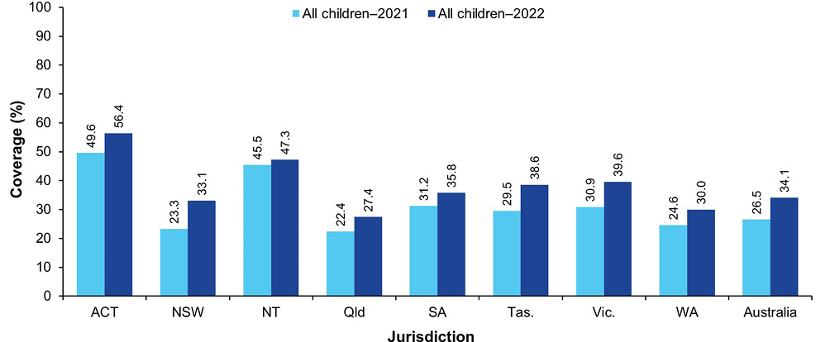
a Source: Australian Immunisation Register data as at 3 April 2022 (for 2021 data) and as at 2 April 2023 (for 2022 data).
b Receipt of at least one dose of any influenza vaccine in the calendar year of interest.
c Influenza vaccine received at age 6–59 months.
d ACT: Australian Capital Territory; NSW: New South Wales; NT: Northern Territory; Qld: Queensland; SA: South Australia; Tas.: Tasmania; Vic.: Victoria; WA: Western Australia.
Figure 2: Coverage of seasonal influenza vaccine by age group, Australia,^{a,b,c} 2021 versus 2022
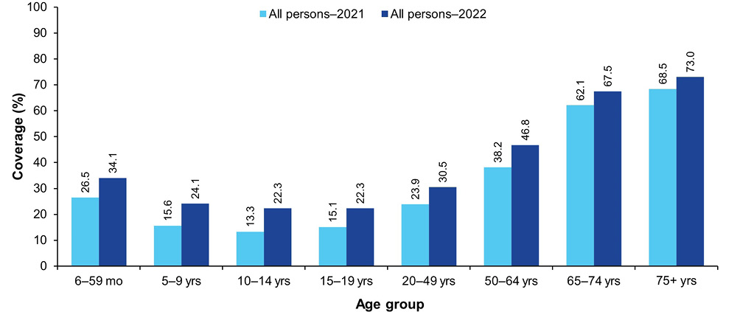
a Source: Australian Immunisation Register data as at 3 April 2022 (for 2021 data) and as at 2 April 2023 (for 2022 data).
b Receipt of at least one dose of any influenza vaccine in the calendar year of interest.
c People categorised into age groups based on age at vaccination.

Coverage by Indigenous status

Fully vaccinated at 12, 24 and 60 months of age
Between 2021 and 2022, fully vaccinated coverage for Indigenous children decreased at all three age milestones: 12 months (from 91.6% to 90.0%), 24 months (from 90.1% to 87.9%) and 60 months (96.3% to 95.1%; see Table 1).
The disparity in fully vaccinated coverage between Indigenous and children overall increased at 12 months of age from 2.6 percentage points in 2021 to 3.3 percentage points in 2022, and at 24 months from 2.0 percentage points in 2021 to 3.1 percentage points in 2022 (Table 1). However, fully vaccinated coverage at 60 months of age in 2021 remained higher in Indigenous than in children overall, by 1.7 percentage points.
Trends in fully vaccinated coverage by Indigenous status, by quarter from 2013 to 2022, are shown in Figure A.5, Figure A.6 and Figure A.7 in the Appendix.

Coverage by individual vaccines/antigens at 12, 24 and 60 months of age
Coverage at 12 months of age in Indigenous children decreased for all individual vaccines/antigens between 2021 and 2022, by 0.8–2.7 percentage points (Table 1).
Between 2021 and 2022, coverage at 24 months of age in Indigenous children decreased for individual vaccines/antigens, by 0.4–0.9 percentage points, except for 13vPCV, for which coverage remained the same. Coverage in Indigenous children in 2022 was higher than in children overall for the third dose of hepatitis B, the first dose of measles-mumps-rubella (MMR), meningococcal C-containing vaccine and the third dose of 13vPCV, but lower for the fourth dose of DTPa and Hib, the second dose of MMR, and the dose of varicella (Table 1).
Coverage at 60 months of age in Indigenous children in 2022 remained very high (over 95%) for all vaccines/antigens, and higher than in children overall (Table 1). However, coverage decreased marginally for all individual vaccines/antigens from 2021 to 2022.

Influenza vaccination coverage
Influenza vaccination coverage in Indigenous children increased from 22.5% in 2021 to 24.6% in 2022 in those aged 6–59 months (Figure 3) and from 15.5% to 18.1% in those aged 5–9 years (Figure 4). Coverage in Indigenous children aged 6–59 months increased in all jurisdictions, with the largest increases seen in Victoria (from 23.1% in 2021 to 27.1% in 2022) and Western Australia (from 18.9% to 22.5%). There was substantial variation in coverage for Indigenous children aged 6–59 months by jurisdiction in 2022, ranging from 19.6% in Queensland to 54.6% in the Northern Territory (Figure 3).
Figure 3: Coverage of seasonal influenza vaccine in Indigenous children aged 6–59 months, by jurisdiction, Australia,^{a,b,c,d} 2021 versus 2022
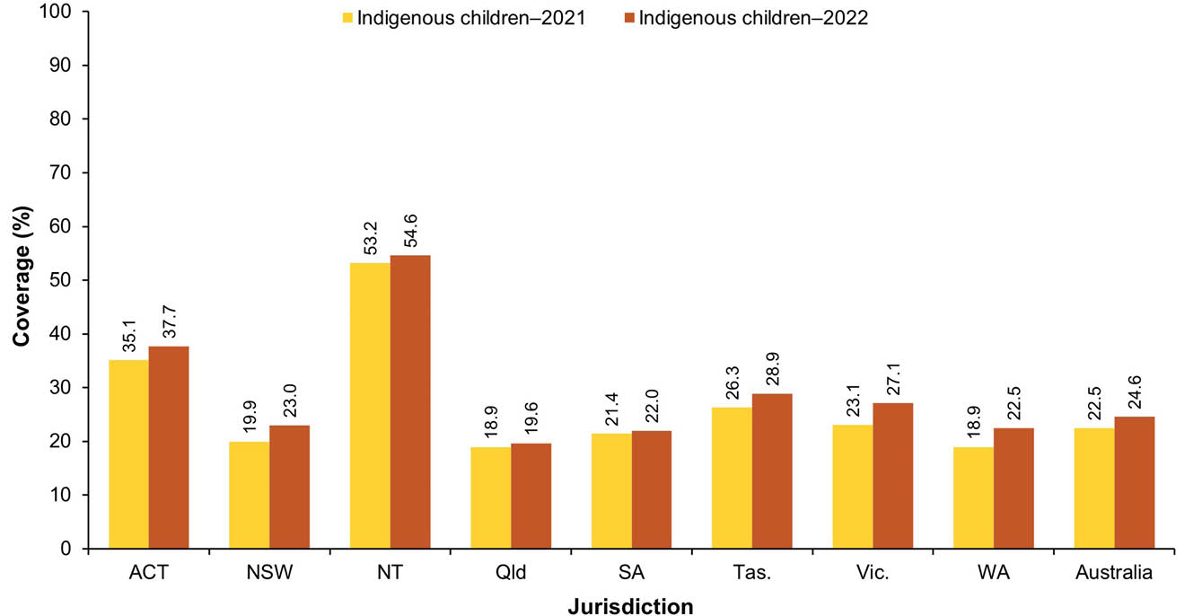
a Source: Australian Immunisation Register data as at 3 April 2022 (for 2021 data) and as at 2 April 2023 (for 2022 data).
b Receipt of at least one dose of any influenza vaccine in the calendar year of interest.
c Influenza vaccine received at age 6–59 months.
d ACT: Australian Capital Territory; NSW: New South Wales; NT: Northern Territory; Qld: Queensland; SA: South Australia; Tas.: Tasmania; Vic.: Victoria; WA: Western Australia.
Figure 4: Coverage of seasonal influenza vaccine by age group for Indigenous persons, Australia,^{a,b,c} 2021 versus 2022
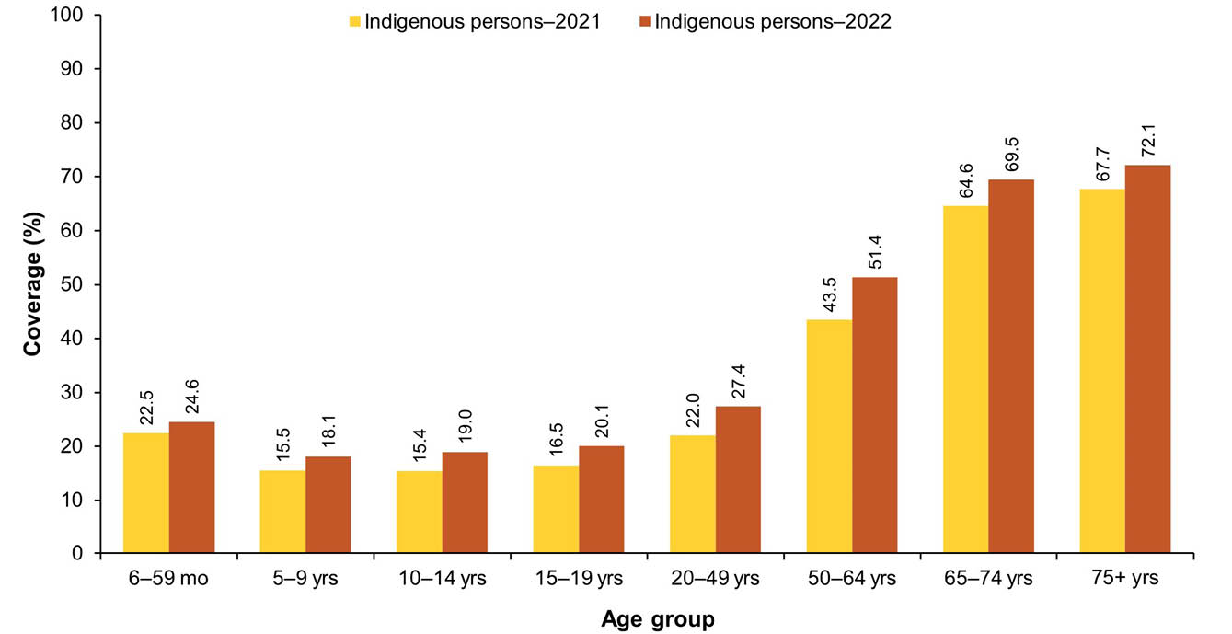
a Source: Australian Immunisation Register data as at 3 April 2022 (for 2021 data) and as at 2 April 2023 (for 2022 data).
b Receipt of at least one dose of any influenza vaccine in the calendar year of interest.
c People categorised into age groups based on age at vaccination.

Hepatitis A vaccination coverage for Indigenous children
Coverage for the first dose of hepatitis A vaccine by 30 months of age for the four jurisdictions (combined) where it is funded under the NIP (the Northern Territory, Queensland, South Australia and Western Australia) was 80.2% in 2022, with coverage for the second dose under the new schedule (due at 4 years of age) not yet able to be assessed. Longer-term trends in hepatitis A vaccination coverage (see Figure A.8 in the Appendix) show the highest coverage levels are consistently achieved in the Northern Territory (86.6% for dose 1 in the September 2022 quarter).

Pneumococcal vaccination coverage for Indigenous children
Coverage for the additional fourth dose of 13vPCV by 30 months of age, for the four jurisdictions (combined) where it is funded for Indigenous children (the Northern Territory, Queensland, South Australia and Western Australia), decreased from 87.1% in 2021 to 79.9% in 2022. Longer-term trends in 13vPCV fourth-dose coverage (see Figure A.9 in the Appendix) show the highest coverage levels are consistently achieved in the Northern Territory (92.7% in the March 2022 quarter).

Meningococcal B vaccination coverage for Indigenous children
Meningococcal B vaccination coverage for the first year-wide cohort of Indigenous children eligible to receive doses at 2, 4 and 12 months of age by 31 December 2022 is shown in Figure 5. Nationally, 80.4% had received their first dose of meningococcal B vaccine, 78.6% their second dose and 69.8% their third dose. Coverage was highest in South Australia and the Northern Territory and lowest in Victoria and Tasmania (Figure 5).
Figure 5: Coverage of meningococcal B vaccine for Indigenous children, by dose number and jurisdiction, Australia,^{a,b,c,d} 2022
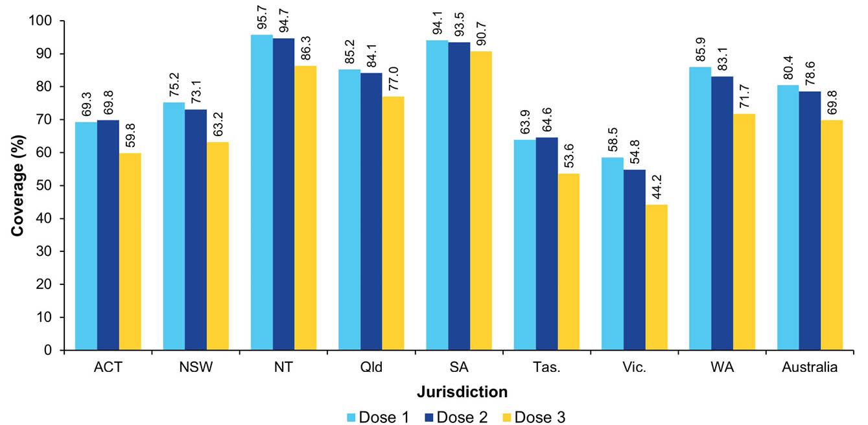
a Source: Australian Immunisation Register data as at 2 April 2023.
b Coverage assessed for cohort of Indigenous children born 1 July 2020 – 30 June 2021. First year-wide eligible cohort to receive 2-month, 4-month and 12-month doses following NIP implementation of MenB vaccination in July 2020. Only two doses of meningococcal B vaccine are required if the first dose is administered after 12 months of age. Dose 3 is not required if MenB vaccination commenced after 12 months of age.
c Note: coverage may be underestimated, particularly for dose 1, due to under-reporting to the AIR (e.g. of doses given prior to child being registered on Medicare).
d ACT: Australian Capital Territory; NSW: New South Wales; NT: Northern Territory; Qld: Queensland; SA: South Australia; Tas.: Tasmania; Vic.: Victoria; WA: Western Australia.

On-time vaccination coverage
The proportion of non-Indigenous children vaccinated on time (i.e. within 30 days of the recommended age) with the second dose of DTPa-containing vaccine was stable during 2019, at around 89%; it then decreased progressively, from 90.1% in the second quarter of 2020 to 83.7% in the third quarter of 2022, before increasing to 84.4% in the fourth quarter of 2022 (Figure 6). On-time vaccination coverage for Indigenous children followed a similar pattern but was 8–9 percentage points lower than for non-Indigenous children in 2019, with the disparity increasing to 11–12 percentage points from the fourth quarter of 2020 onwards (Figure 6).
Similarly, the proportion of non-Indigenous children vaccinated on time with the first dose of MMR-containing vaccine was stable during 2019, peaking at 77.3% in the first quarter of 2020; it then decreased to 65.6% in the second quarter of 2022, before increasing to 67.3% in the fourth quarter of 2022 (Figure 7). On-time MMR vaccination coverage for Indigenous children followed a similar pattern but was 8–11 percentage points lower than for non-Indigenous children in 2019, with the disparity generally greater from the second half of 2020 onwards (Figure 7).
Figure 6: Trends in on-time vaccination coverage for the second dose of DTPa-containing vaccine, by Indigenous status and quarter, Australia,^{a,b,c} 2019–2022
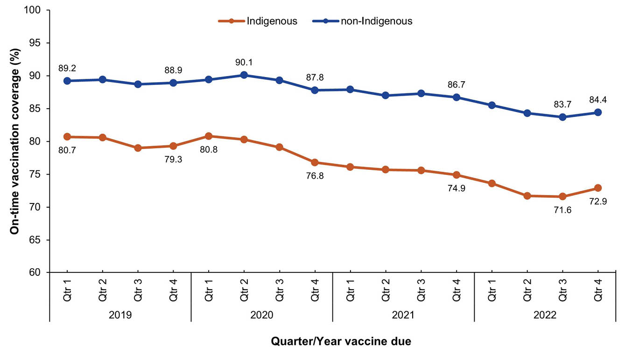
a Source: Australian Immunisation Register data as at 2 April 2023.
b On-time vaccination coverage calculated using 3-month-wide birth cohorts due to have received the second dose of DTPa-containing vaccine in the relevant quarter/year. To be considered on-time, a child must have received the second dose of DTPa-containing vaccine by 5 months of age.
c Quarter vaccine dose due used to define birth cohorts (e.g. if second dose of DTPa-containing vaccine was due in 2022: children born 1 September 2021 – 30 November 2021 were due in Quarter 1, children born 1 December 2021 – 28 February 2022 were due in Quarter 2, children born 1 March 2022 – 31 May 2022 were due in Quarter 3 and children born 1 June 2022 – 31 August 2022 were due in Quarter 4).
Figure 7: Trends in on-time vaccination coverage for the first dose of MMR-containing vaccine, by Indigenous status and quarter, Australia,^{a,b,c} 2019–2022
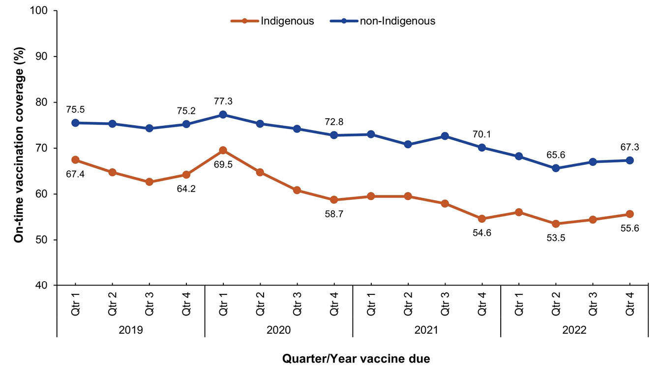
a Source: Australian Immunisation Register data as at 2 April 2023.
b On-time vaccination coverage calculated using 3-month-wide birth cohorts due to have received the first dose of MMR-containing vaccine in the relevant quarter/year. To be considered on-time, a child must have received the second dose of MMR-containing vaccine by 13 months of age.
c Quarter vaccine dose due used to define birth cohorts (e.g. if first dose of MMR-containing vaccine was due in 2022: children born 1 January 2021 – 31 March 2021 were due in Quarter 1, children born 1 April 2021 – 30 June 2021 were due in Quarter 2, children born 1 July 2021 – 30 September 2021 were due in Quarter 3 and children born 1 October 2021 – 31 December 2021 were due in Quarter 4).
On-time vaccination coverage for the first dose of MMR-containing vaccine, assessed at 13 months of age, in 2022 varied across Australia (Figure 8). Coverage in many remote areas of Western, Central and Far North Australia was substantially below that in Southeast Australia, with 36.1% on-time vaccination in Barkly, 43.1% in East Pilbara and 53.5% in Alice Springs.
Fully vaccinated coverage assessed at the standard (12, 24 and 60 months) and earlier (9, 15, 21 and 51 months) age milestones in 2022, by PHN, are provided in Table A.3 in the Appendix.
Figure 8: On-time vaccination coverage of first dose of MMR-containing vaccine assessed at 13 months of age by Statistical Area 3, Australia and major capital cities^{,a,b,c} 2022
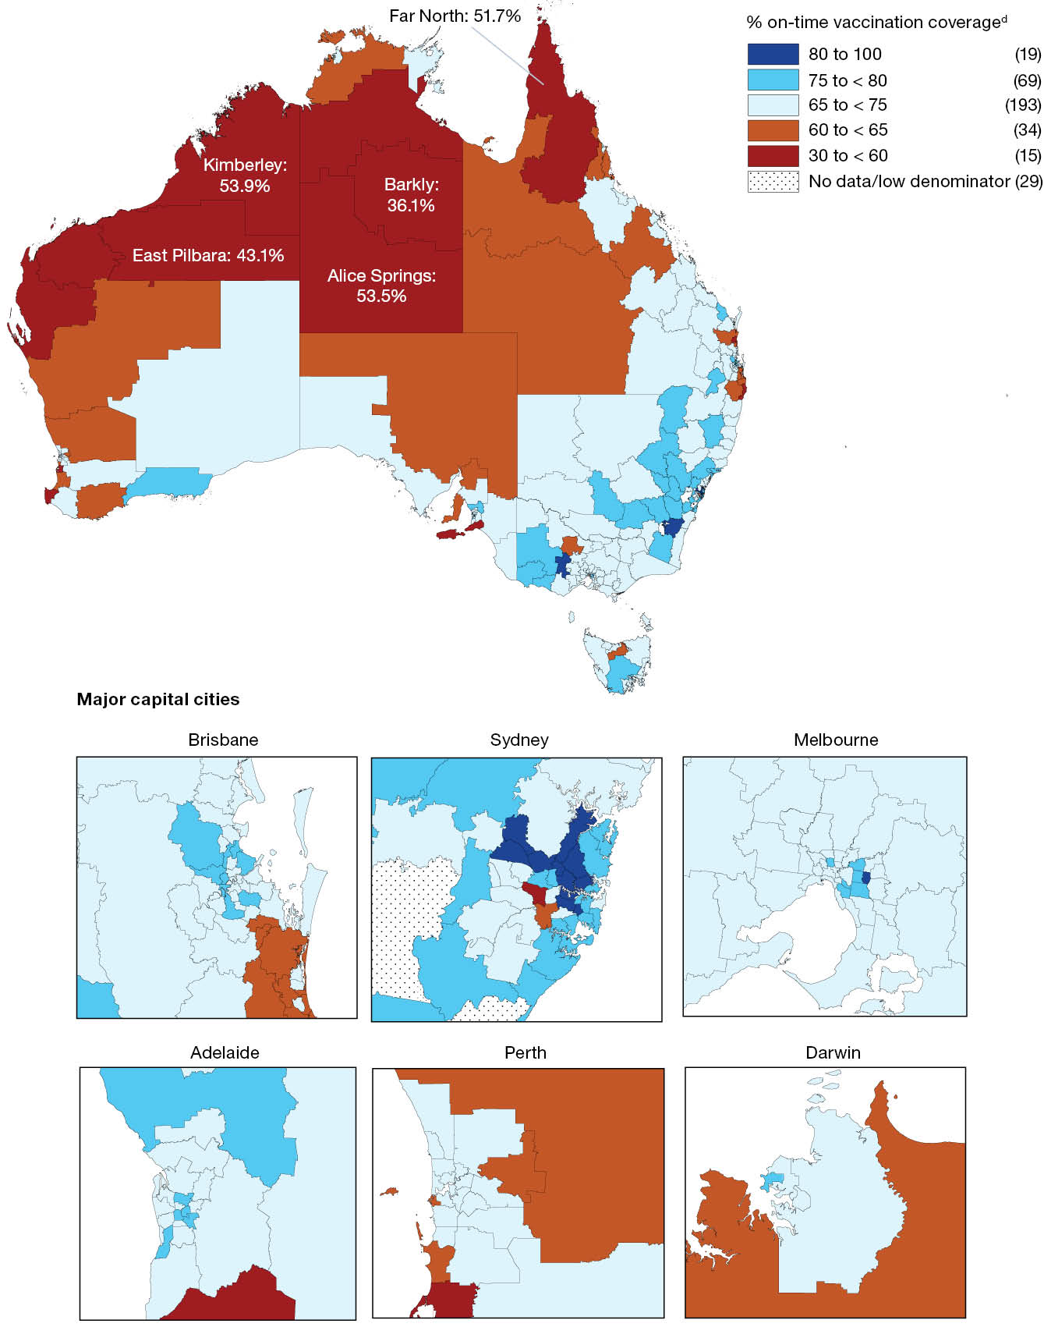
a Source: Australian Immunisation Register data as at 2 April 2023.
b Receipt of a scheduled vaccine dose within 30 days of the recommended age (i.e. by 13 months of age as first dose of MMR vaccine due at 12 months of age).
c Cohort born 1 January 2020 – 31 December 2020 (i.e. due for first dose of MMR in 2021).
d Number in parentheses: number of Statistical Area 3s in each on-time category.

Small area coverage analysis
Childhood vaccination coverage in 2022 varied across Australia. Coverage in some areas – especially the north coast region of New South Wales and the Gold Coast and Sunshine Coast regions of Queensland – was substantially below the national average (Figure 9 and Figure 10). Coverage of 95% or higher at 24 months of age was achieved for 58.5% of SA3 areas (193/330) for the first dose of MMR-containing vaccine (Figure 9) and for 13.6% of SA3 areas (45/330) for the second dose of MMR-containing vaccine (Figure 10).

Provider setting
In 2022, the large majority (73.2%) of vaccinations given to children aged < 10 years in Australia were administered in general practice settings, with the Northern Territory the only jurisdiction in which a minority (16.6%) of vaccinations in young children were given in general practice (Figure 11). Overall, 15.0% of vaccinations were given in local council clinic settings (with the proportion highest in Tasmania, at 27.9%); 4.6% were given in community health service settings (highest in the Northern Territory, at 41.4%); 0.9% were given in Indigenous health service settings (highest in the Northern Territory, at 24.7%); and 2.2% were given in hospitals. The distribution by provider type for non-COVID-19 vaccinations was generally similar but with a smaller proportion being given in local council settings (Figure 12).

COVID-19 vaccination coverage
By 4 January 2023, data published by the Department of Health, Disability and Ageing showed 49.7% of Australian children aged 5–11 years had received a first dose of a COVID-19 vaccine and 39.6% had received a second dose (Figure A.10 in the Appendix). Coverage in children aged 5–11 years ranged from 40.7% in Queensland to 74.7% in the Australian Capital Territory for the first dose, and from 31.3% in Queensland to 66.4% in the Australian Capital Territory for the second dose (Table A.10 in the Appendix).
Figure 9: Coverage of the first dose of measles-mumps-rubella (MMR)-containing vaccine at 24 months of age by Statistical Area 3, Australia and major capital cities,^{a,b} 2022
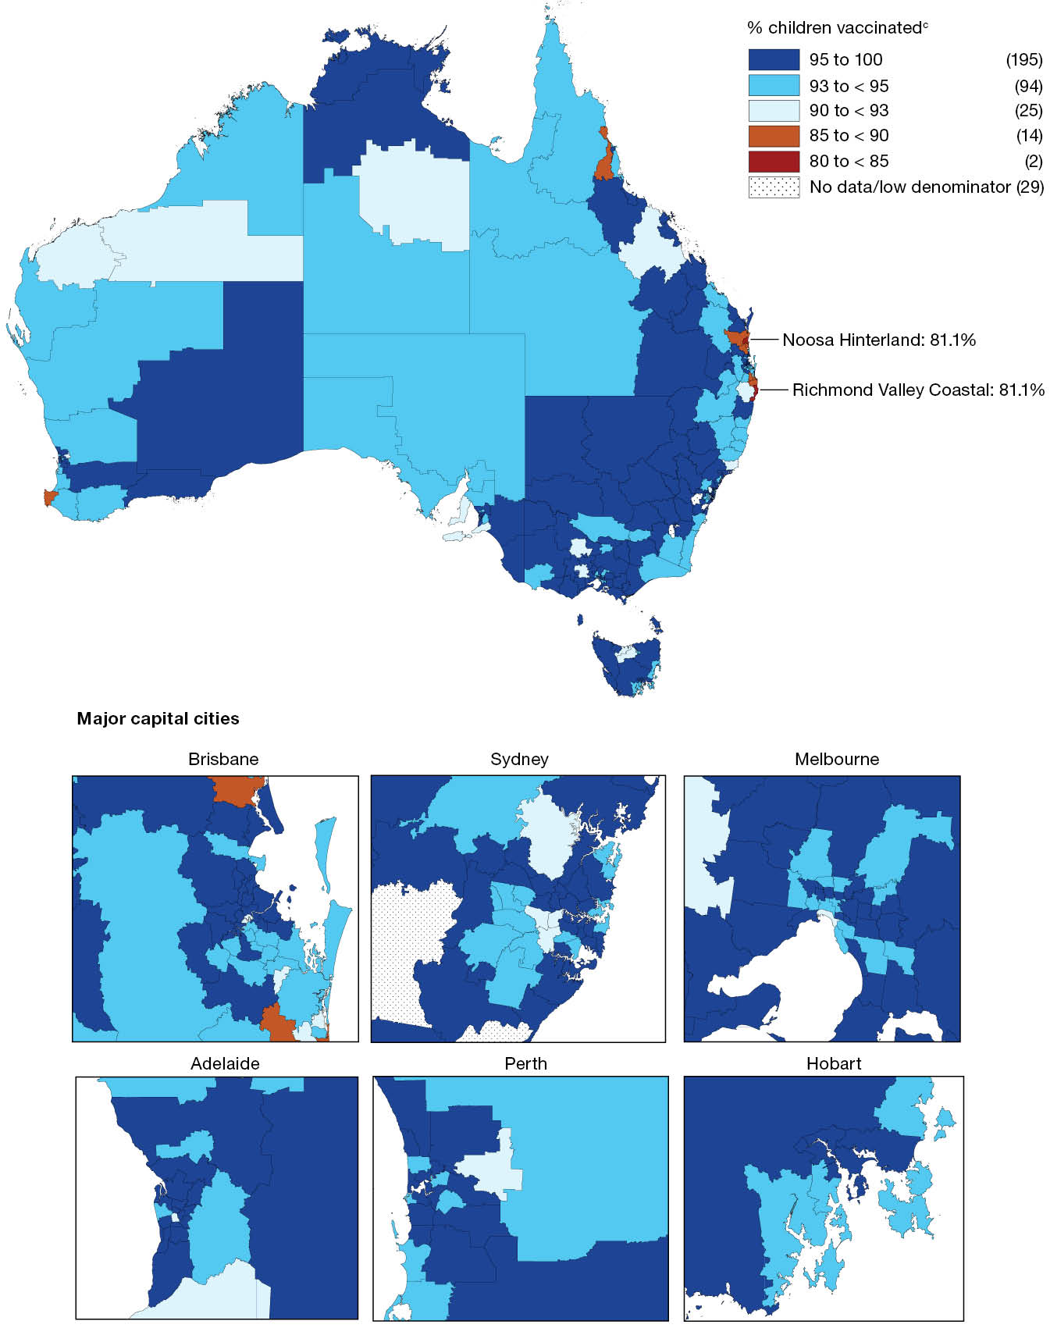
a Source: Australian Immunisation Register data as at 2 April 2023.
b Cohort born 1 January 2020 – 31 December 2020 (i.e. due for first dose of MMR in 2021).
c Number in parentheses: number of Statistical Area 3s in each coverage category.
Figure 10: Coverage of the second dose of measles-mumps-rubella (MMR)-containing vaccine at 24 months of age by Statistical Area 3, Australia and major capital cities,^{a,b} 2022
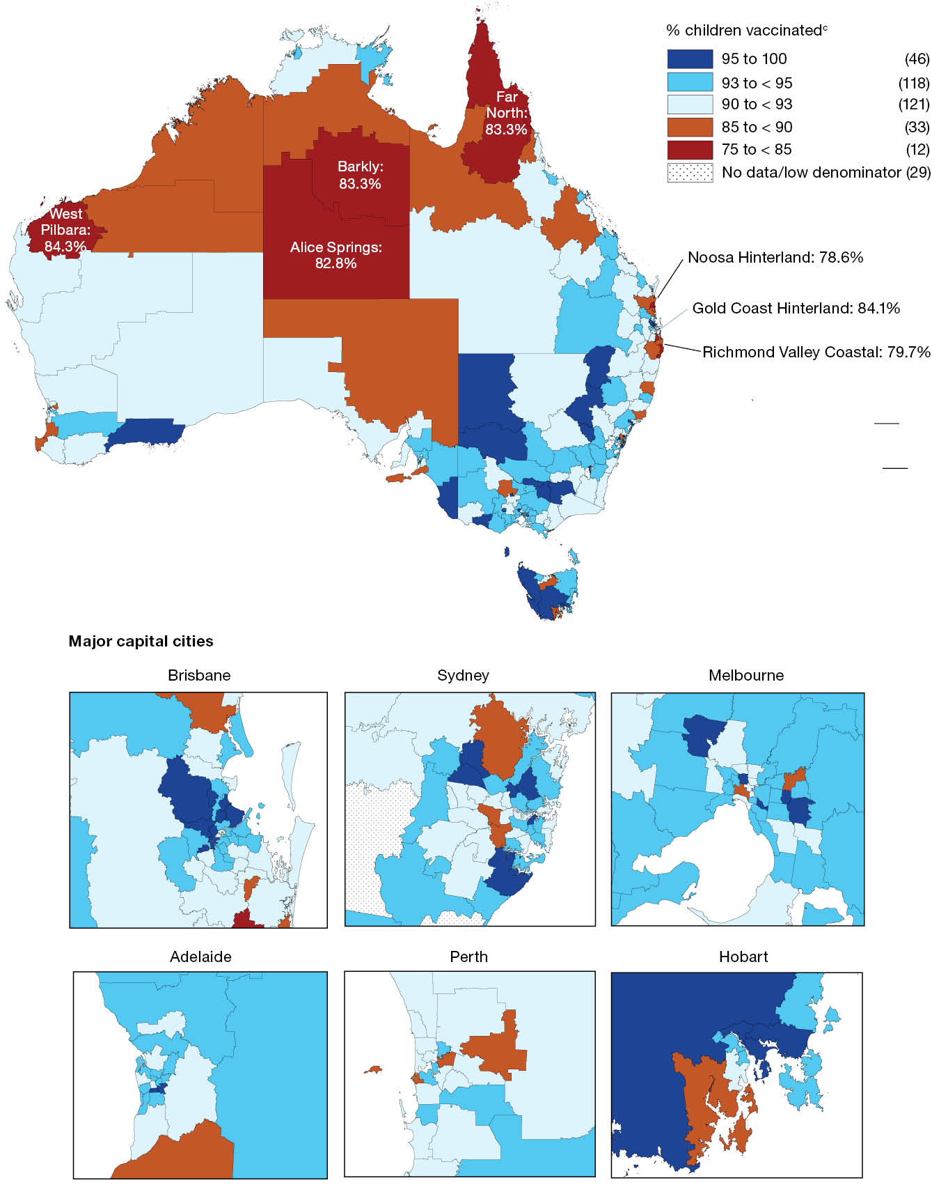
a Source: Australian Immunisation Register data as at 2 April 2023.
b Cohort born 1 January 2020 – 31 December 2020 (i.e. due for their second dose of MMR during 2021 and 2022).
c Number in parentheses: number of Statistical Area 3s in each coverage category.
Figure 11: Proportion of all vaccinations given to children aged < 10 years by provider setting and jurisdiction, Australia,^{a,b,c} 2022
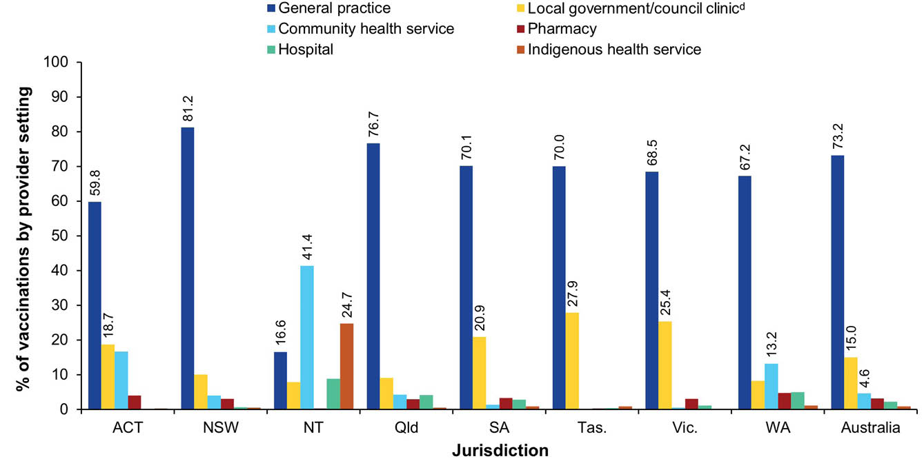
a Source: Australian Immunisation Register data as at 2 April 2023.
b Note: includes all vaccine types able to be reported to the AIR (i.e. both NIP and non-NIP vaccines).
c ACT: Australian Capital Territory; NSW: New South Wales; NT: Northern Territory; Qld: Queensland; SA: South Australia; Tas.: Tasmania; Vic.: Victoria; WA: Western Australia.
d Includes public health units and jurisdictional health departments.
Figure 12: Proportion of all non-COVID-19 vaccinations given to children aged < 10 years by provider setting and jurisdiction, Australia,^{a,b,c} 2022
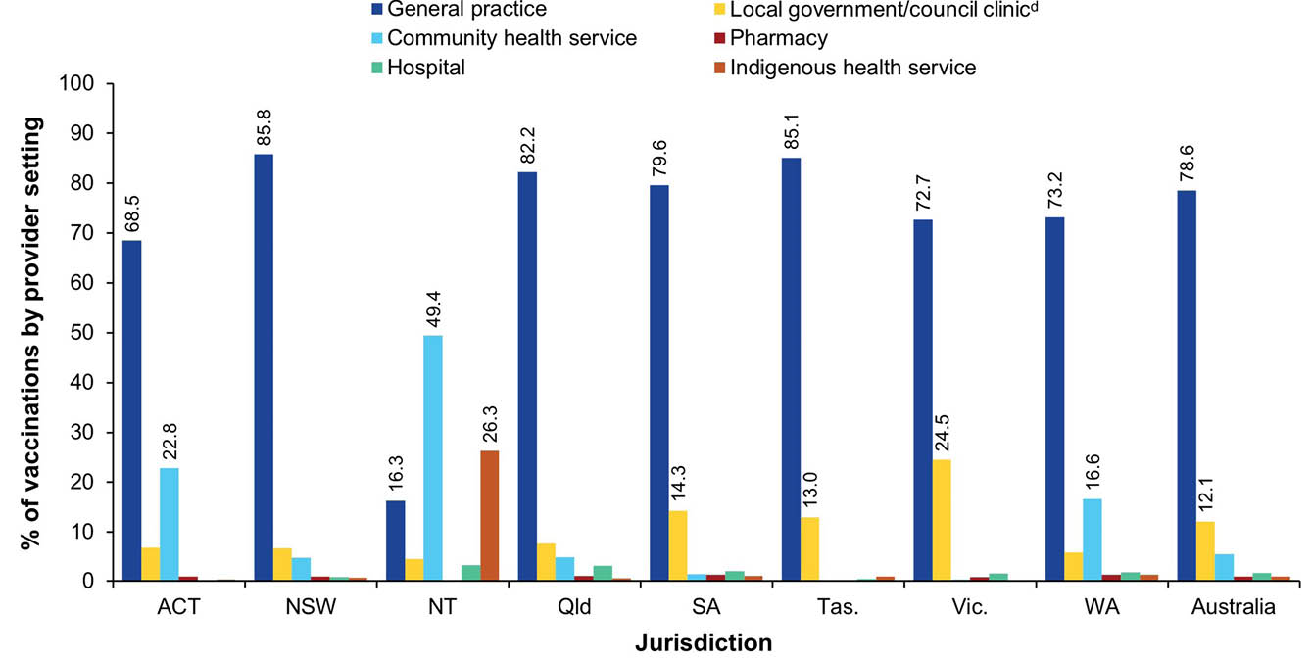
a Source: Australian Immunisation Register data as at 2 April 2023.
b Note: Includes all vaccine types able to be reported to the AIR (i.e. both NIP and non-NIP vaccines), except COVID-19 vaccines.
c ACT: Australian Capital Territory; NSW: New South Wales; NT: Northern Territory; Qld: Queensland; SA: South Australia; Tas.: Tasmania; Vic.: Victoria; WA: Western Australia.
d Includes public health units and jurisdictional health departments.

Adolescents

Human papillomavirus (HPV) vaccination coverage – cohorts turning 15 years
Among adolescents turning 15 years in 2022, a total of 85.3% of girls had received at least one dose of HPV vaccine before their fifteenth birthday, down from 86.2% in 2021, and 83.1% of boys had received at least one dose, down from 84.4% in 2021 (Table 2). Coverage for girls and boys ranged from 81.6% and 78.3%, respectively, in the Northern Territory to 89.8% and 87.5%, respectively, in the Australian Capital Territory (Table 2).
Among Indigenous adolescents turning 15 years in 2022, a total of 83.0% of girls had received at least one dose of HPV vaccine before their fifteenth birthday, down from 86.1% in 2021, and 78.1% of boys had received at least one dose, down from 80.6% in 2021 (Table 2). Coverage for girls and boys ranged from 74.6% and 65.6%, respectively, in South Australia to 88.5% and 82.7%, respectively in the Australian Capital Territory (Table 2).
In girls, coverage of at least one dose of HPV vaccine by the fifteenth birthday in 2022 was 5.0 percentage points higher overall (and 10.3 percentage points higher in Indigenous girls) in those living in the most socioeconomically advantaged (fifth quintile) areas than in those living in the least advantaged (first quintile) areas (overall: 87.7% versus 82.7%; Indigenous: 89.3% versus 79.0%; see Table 3).
In boys, coverage of at least one dose of HPV vaccine by the fifteenth birthday in 2022 was 6.6 percentage points higher overall (and 7.9 percentage points higher in Indigenous boys) in those living in the most socioeconomically advantaged areas than in those living the least advantaged areas (overall: 86.0% versus 79.4%; Indigenous: 82.8% versus 74.9%; see Table 3).
Adolescents turning 15 years in 2022 who resided in remote and very remote areas had lower coverage of at least one dose of HPV vaccine received before their fifteenth birthday, with the disparity, compared to major cities, greater for girls than for boys (3.2 and 6.2 percentage points lower for girls overall and Indigenous girls, respectively, compared to 2.8 and 3.3 percentage points lower for boys overall and Indigenous boys, respectively; see Table 4).
Table 2: Coverage of at least one dose of HPV vaccine, received before their fifteenth birthday, in adolescents turning 15 years of age in the relevant year, by gender, Indigenous status and jurisdiction, Australia,^{a,b,c,d} 2021 and 2022
Jurisdiction^{d} | Indigenous status | Girls |  | Boys
Jurisdiction^{d} | Indigenous status | 2021 | 2022 | 2021 | 2022
ACT | All | 90.4 | 89.8 | 89.4 | 87.5
ACT | Indigenous | 89.7 | 88.5 | 82.7 | 82.7
NSW | All | 87.8 | 86.7 | 85.3 | 84.2
NSW | Indigenous | 90.8 | 88.1 | 86.7 | 81.7
NT | All | 86.4 | 81.6 | 80.8 | 78.3
NT | Indigenous | 87.3 | 78.4 | 79.5 | 75.2
Qld | All | 83.0 | 82.4 | 81.5 | 80.5
Qld | Indigenous | 83.7 | 80.3 | 76.8 | 76.4
SA | All | 86.2 | 85.1 | 84.3 | 83.3
SA | Indigenous | 74.7 | 74.6 | 72.0 | 65.6
Tas. | All | 88.1 | 84.0 | 83.6 | 80.3
Tas. | Indigenous | 88.8 | 84.6 | 82.5 | 79.5
Vic. | All | 87.6 | 86.8 | 85.9 | 84.2
Vic. | Indigenous | 87.1 | 82.5 | 79.6 | 78.8
WA | All | 84.3 | 84.5 | 84.2 | 83.1
WA | Indigenous | 81.0 | 81.4 | 77.6 | 78.6
Australia | All | 86.2 | 85.3 | 84.4 | 83.1
Australia | Indigenous | 86.1 | 83.0 | 80.6 | 78.1
a Source: Australian Immunisation Register data as at 3 April 2022 (for 2021 data) and as at 2 April 2023 (for 2022 data).
b Coverage calculated using the number of Medicare-registered adolescents in each year-wide birth cohort with an AIR record of having received at least one dose of HPV vaccine after their 9th birthday (since HPV is registered to be given from 9 years of age) but before their 15th birthday as the numerator and the total number of Medicare-registered adolescents in the relevant birth cohort as the denominator, expressed as a percentage.
c Cohort born 1 January–31 December 2006 for 2021 coverage estimates (i.e. vaccines due from early 2018 to late 2019) and cohort born 1 January–31 December 2007 for 2022 coverage estimates (i.e. vaccines due from early 2019 to late 2020).
d ACT: Australian Capital Territory; NSW: New South Wales; NT: Northern Territory; Qld: Queensland; SA: South Australia; Tas.: Tasmania; Vic.: Victoria; WA: Western Australia.
Table 3: Coverage of at least one dose of HPV vaccine, received before 15th birthday, in adolescents turning 15 years of age in the relevant year, by gender, Indigenous status and socioeconomic status, Australia,^{a,b,c,d} 2021 and 2022
SEIFA quintile^{d} | All girls |  | Indigenous girls |  | All boys |  | Indigenous boys
SEIFA quintile^{d} | 2021 | 2022 | 2021 | 2022 | 2021 | 2022 | 2021 | 2022
First (least advantaged) | 84.8 | 82.7 | 83.8 | 79.0 | 81.8 | 79.4 | 78.1 | 74.9
Second | 86.3 | 85.0 | 88.4 | 84.6 | 83.8 | 82.6 | 80.2 | 78.7
Third | 86.0 | 85.2 | 87.5 | 83.6 | 84.3 | 82.9 | 81.4 | 79.9
Fourth | 86.4 | 85.4 | 87.5 | 85.5 | 85.1 | 83.7 | 83.4 | 81.3
Fifth (most advantaged) | 87.1 | 87.7 | 86.3 | 89.3 | 86.1 | 86.0 | 85.5 | 82.8
Table 4: Coverage of at least one dose of HPV vaccine, received before 15th birthday, in adolescents turning 15 years of age in relevant year, by gender, Indigenous status and remoteness of area of residence, Australia,^{a,b,c,e} 2021 and 2022
Remoteness category^{e} | All girls |  | Indigenous girls |  | All boys |  | Indigenous boys
Remoteness category^{e} | 2021 | 2022 | 2021 | 2022 | 2021 | 2022 | 2021 | 2022
Major cities | 86.0 | 85.4 | 86.9 | 84.9 | 84.3 | 83.1 | 82.4 | 80.1
Inner and outer regional | 87.0 | 85.4 | 86.4 | 82.8 | 84.9 | 83.4 | 79.9 | 76.9
Remote and very remote | 85.4 | 82.2 | 84.4 | 78.7 | 82.2 | 80.3 | 78.2 | 76.8
a Source: Australian Immunisation Register data as at 3 April 2022 (for 2021 data) and as at 2 April 2023 (for 2022 data).
b Coverage calculated using the number of Medicare-registered adolescents in each year-wide birth cohort with an AIR record of having received at least one dose of HPV vaccine after their 9th birthday (since HPV is registered to be given from 9 years of age) but before their 15th birthday as the numerator and the total number of Medicare-registered adolescents in the relevant birth cohort as the denominator, expressed as a percentage.
c Cohort born 1 January–31 December 2006 for 2021 coverage estimates (i.e. vaccines due from early 2018 to late 2019) and cohort born 1 January–31 December 2007 for 2022 coverage estimates (i.e. vaccines due from early 2019 to late 2020).
d Socio-Economic Indexes for Areas Index of Economic Resources.
e Accessibility/Remoteness Index of Australia (ARIA++).

Human papillomavirus vaccination coverage – cohorts turning
13–26 years
Assessing a broader range of year-wide birth cohorts, and including vaccine doses received by the end of 2022 (i.e. rather than before the relevant birthday), 74.1% of adolescent girls turning 13 years of age in 2022 had received at least one dose of HPV vaccine by 31 December 2022, while 83.3% of those turning 14 years and 85.7% of those turning 15 years had received at least one dose; there were less marked differences in older cohorts up to the age of 21 years (Figure 13). Coverage then decreased with increasing age, down to 69.6% for those turning 26 years. Coverage in Indigenous females was 9.4 percentage points lower than overall coverage in those turning 13 years of age in 2022, but this disparity decreased with increasing age, with coverage higher in Indigenous females than overall in most cohorts turning 16–26 years of age (Figure 13).
Figure 13: Coverage of at least one dose of HPV vaccine for females by birth cohort/age and Indigenous status, Australia,^{a,b} 2022
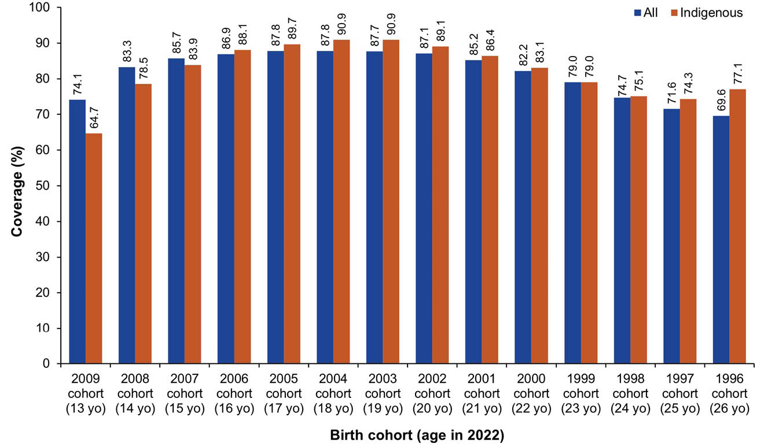
a Source: Australian Immunisation Register data as at 2 April 2023.
b Coverage calculated using the number of Medicare-registered individuals in each year-wide cohort with an AIR record of having received at least one dose of HPV vaccine after their 9th birthday (since HPV is registered to be given from 9 years of age) and given by 31 December 2022 as the numerator and the total number of Medicare-registered individuals in the relevant cohort as the denominator, expressed as a percentage.
Figure 14 shows a similar pattern for males, with 69.9% of adolescent boys turning 13 years of age in 2022 having received at least one dose of HPV vaccine by 31 December 2022; 80.7% of those turning 14 years and 83.5% of those turning 15 years had received at least one dose, with less marked increases in older cohorts up to the age of 18 years (Figure 14). Coverage then decreased with increasing age, down to 0.8% for those turning 26 years, noting that HPV vaccination was only funded for males from 2013 (i.e. from the 1998 cohort onwards). Coverage in Indigenous males was 13.5 percentage points lower than overall coverage in those turning 13 years of age in 2022, but the disparity decreased with increasing age in cohorts turning up to 17 years of age, with coverage higher in Indigenous males than overall in those turning 18 and 19 years of age but lower in those turning 20–21 years (Figure 14).
Figure 14: Coverage of at least one dose of HPV vaccine for males by birth cohort/age and Indigenous status, Australia,^{a,b} 2022
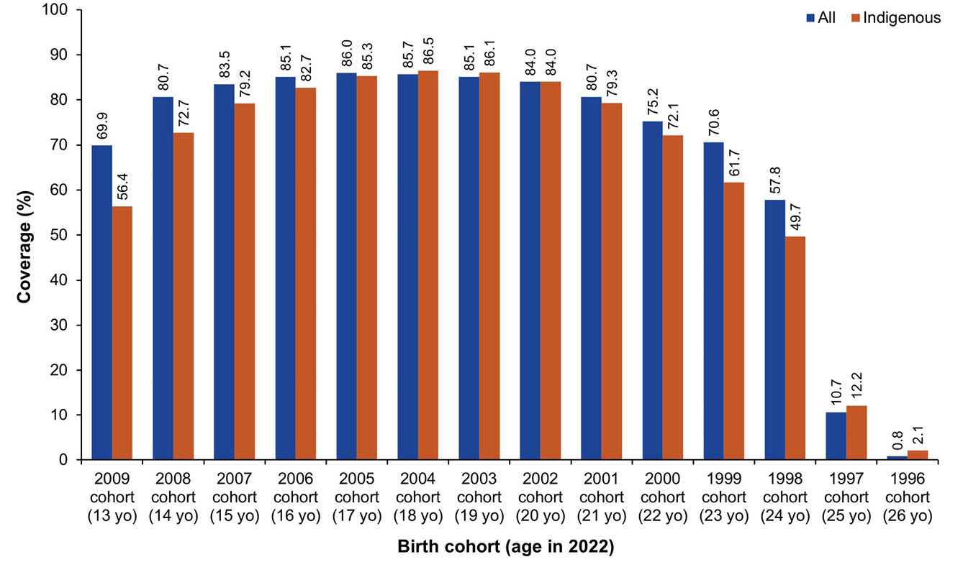
a Source: Australian Immunisation Register data as at 2 April 2023.
b Coverage calculated using the number of Medicare-registered individuals in each year-wide cohort with an AIR record of having received at least one dose of HPV vaccine after their 9th birthday (since HPV is registered to be given from 9 years of age) and given by 31 December 2022 as the numerator and the total number of Medicare-registered individuals in the relevant cohort as the denominator, expressed as a percentage.

Adolescent diphtheria-tetanus-acellular pertussis vaccination coverage – cohorts turning 13–19 years
Assessing a broad range of year-wide birth cohorts, 73.0% of adolescents turning 13 years of age in 2022 had received a dose of diphtheria-tetanus-pertussis vaccine as an adolescent by 31 December 2022; 83.8% of those turning 14 years and 86.9% of those turning 15 years had received a dose, with less marked differences in older cohorts (Figure 15). Coverage in Indigenous adolescents was 12.0 percentage points lower than overall coverage in those turning 13 years of age in 2022, but the disparity decreased with increasing age, reaching less than a percentage point in Indigenous adolescents turning 18 and 19 years of age (Figure 15).
Figure 15: Coverage of an adolescent dose of diphtheria-tetanus-acellular pertussis vaccine by birth cohort/age and Indigenous status, Australia,^{a,b,c} 2022
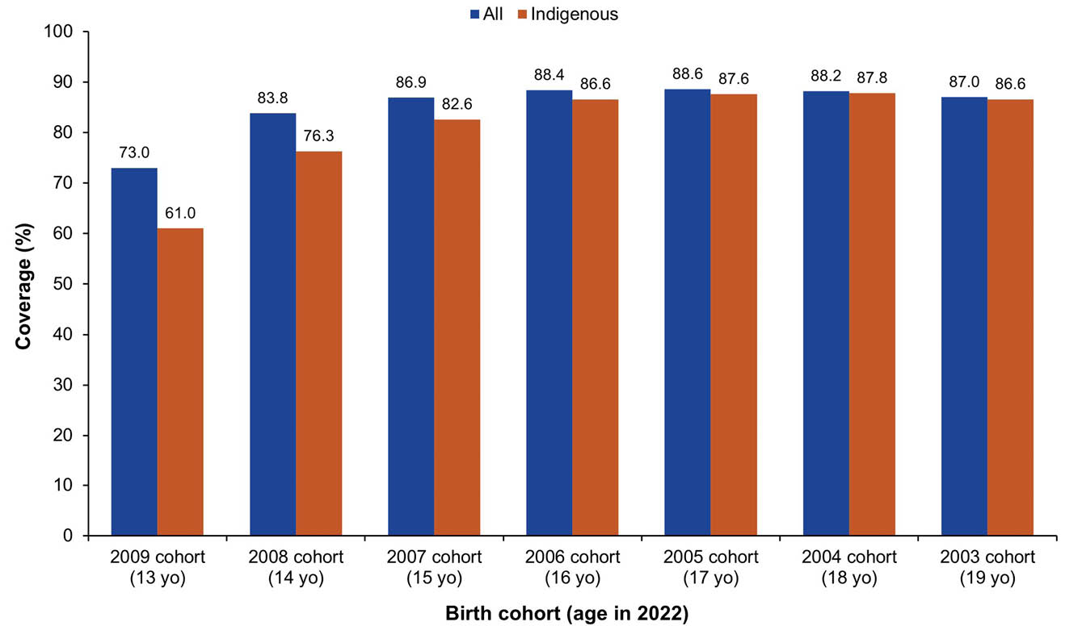
a Source: Australian Immunisation Register data as at 2 April 2023.
b Coverage calculated using the number of Medicare-registered adolescents in each year-wide cohort with an AIR record of having received an adolescent (i.e. ≥ 10 years of age) dose of a diphtheria-tetanus-pertussis vaccine (recorded as either dTpa or DTPa) by 31 December 2022 as the numerator and the total number of Medicare-registered adolescents in the relevant cohort as the denominator, expressed as a percentage.
c dTpa: diphtheria–tetanus–pertussis (acellular) [formulation for individuals aged ≥ 10 years]; DTPa: diphtheria–tetanus–pertussis (acellular) [paediatric formulation].

Meningococcal ACWY vaccination coverage – cohorts turning
15–19 years
Figure 16 shows that 75.9% of adolescents turning 17 years in 2022 had received a dose of meningococcal ACWY vaccine as an adolescent by 31 December 2022; 79.1% of those turning 18 years and 78.8% of those turning 19 years had received a dose. Coverage in Indigenous adolescents was several percentage points higher than overall in those turning 15 years, but lower in older age cohorts, ranging from 12.5 percentage points lower at 16 years to 6.4 percentage points lower at 19 years (Figure 16).
Figure 16: Coverage of an adolescent dose of meningococcal ACWY vaccine by birth cohort/age and Indigenous status, Australia,^{a,b} 2022
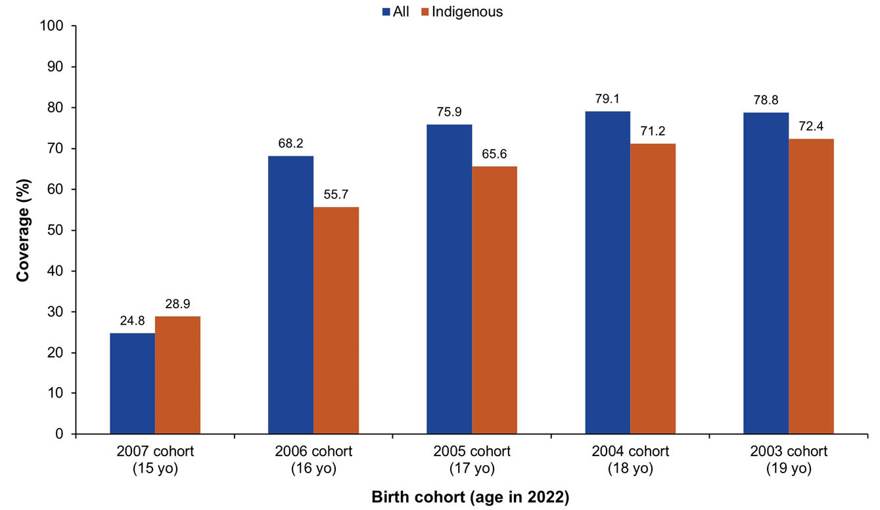
a Source: Australian Immunisation Register data as at 2 April 2023.
b Coverage calculated using the number of Medicare-registered adolescents in each year-wide cohort with an AIR record of having received an adolescent (i.e. ≥ 10 years of age) dose of a meningococcal ACWY vaccine given by 31 December 2022 as the numerator and the total number of Medicare-registered adolescents in the relevant cohort as the denominator, expressed as a percentage.

Adolescent composite measures of vaccination coverage

HPV + diphtheria-tetanus-pertussis
Using a composite measure (viz., receipt of both an HPV vaccine dose and an adolescent dose of diphtheria-tetanus-pertussis vaccine by 31 December 2022), coverage was 83.7% for adolescents turning 15 years of age in 2022, down from 84.5% in 2021 (Figure 17). Coverage in 2022 varied by jurisdiction and was highest in the Australian Capital Territory, at 85.8%, and lowest in the Northern Territory, at 78% (Figure 17). Coverage using this composite measure was 80.1% in Indigenous adolescents turning 15 years in 2022, down from 82.3% in 2021, and ranged from 84.6% in New South Wales to 69.9% in South Australia (Figure 18).
Figure 17: Vaccination coverage using composite measure (dose of HPV and adolescent dose of diphtheria-tetanus-pertussis vaccine) in adolescents turning 15 years, by jurisdiction, Australia,^{a,b,c,d} 2021 versus 2022
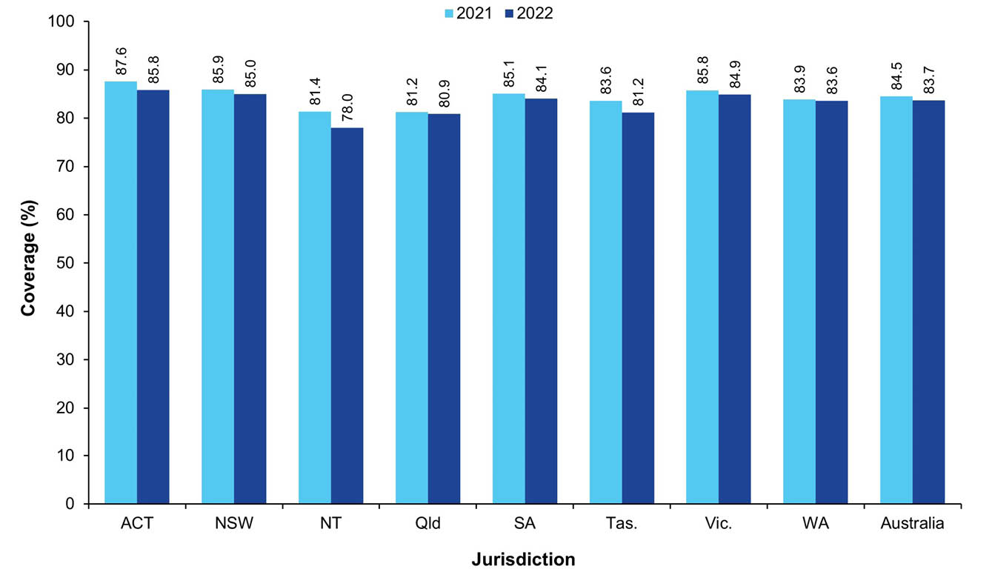
a Source: Australian Immunisation Register data as at 3 April 2022 for 2021 coverage and as at 2 April 2023 for 2022 coverage.
b Coverage calculated using the number of Medicare-registered adolescents in each year-wide cohort with an AIR record of having received at least one dose of HPV vaccine ≥ 9 years of age and an adolescent (i.e. ≥ 10 years of age) dose of diphtheria-tetanus-pertussis vaccine (recorded as either dTpa or DTPa) by 31 December of the relevant year as the numerator and the total number of Medicare-registered adolescents in the relevant cohort as the denominator, expressed as a percentage.
c Cohorts: 1 January – 31 December 2006 for 2021 coverage; 1 January – 31 December 2007 for 2022 coverage.
d ACT: Australian Capital Territory; NSW: New South Wales; NT: Northern Territory; Qld: Queensland; SA: South Australia; Tas.: Tasmania; Vic.: Victoria; WA: Western Australia.
Figure 18: Vaccination coverage using composite measure (dose of HPV and adolescent dose of diphtheria-tetanus-pertussis vaccine) in Indigenous adolescents turning 15 years, by jurisdiction, Australia,^{a,b,c,d} 2021 versus 2022
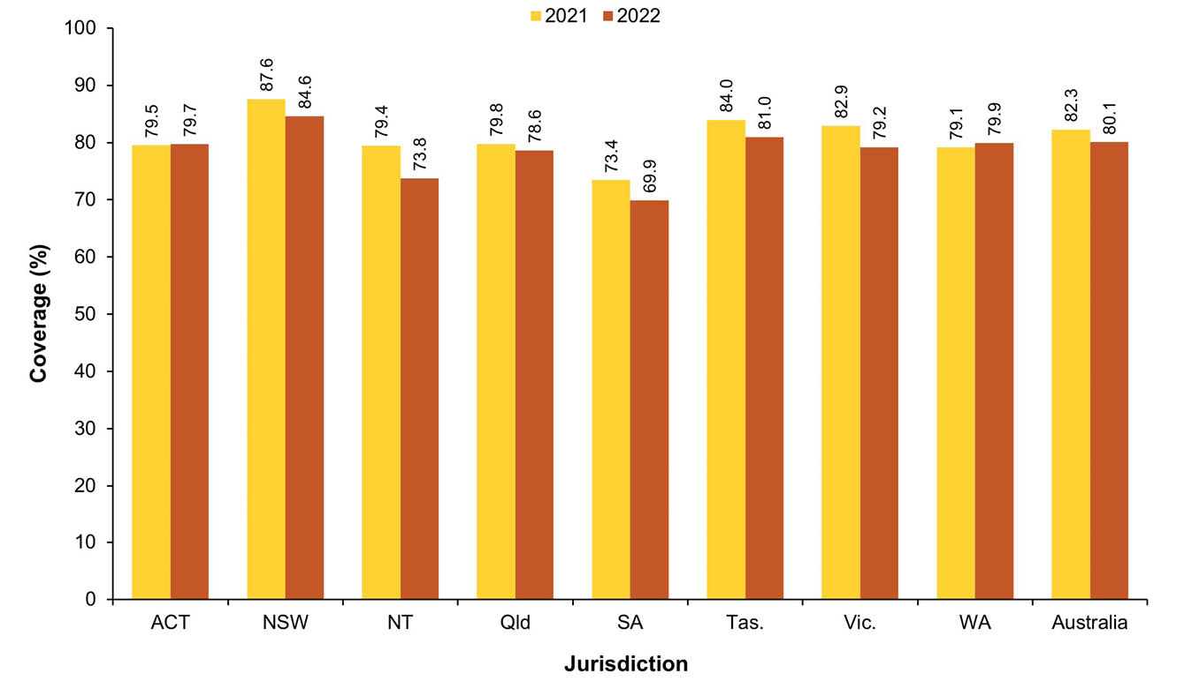
a Source: Australian Immunisation Register data as at 3 April 2022 for 2021 coverage and as at 2 April 2023 for 2022 coverage.
b Coverage calculated using the number of Medicare-registered Indigenous adolescents in each year-wide cohort with an AIR record of having received at least one dose of HPV vaccine ≥ 9 years of age and an adolescent (i.e. ≥ 10 years of age) dose of diphtheria-tetanus-pertussis vaccine (recorded as either dTpa or DTPa) by 31 December of the relevant year as the numerator and the total number of Medicare-registered Indigenous adolescents in the relevant cohort as the denominator, expressed as a percentage.
c Cohorts: 1 January – 31 December 2006 for 2021 coverage; 1 January – 31 December 2007 for 2022 coverage.
d ACT: Australian Capital Territory; NSW: New South Wales; NT: Northern Territory; Qld: Queensland; SA: South Australia; Tas.: Tasmania; Vic.: Victoria; WA: Western Australia.

HPV + diphtheria-tetanus-pertussis + meningococcal ACWY vaccine
Using another composite measure (viz., receipt of an HPV vaccine dose and adolescent doses of both diphtheria-tetanus-pertussis and meningococcal ACWY vaccine by 31 December 2022), coverage was 73.4% for adolescents turning 18 years of age in 2022, up from 71.7% in 2021 (Figure 19). Coverage in 2022 varied by jurisdiction and was highest in the Australian Capital Territory, at 78.3%, and lowest in Queensland, at 70.0% (Figure 19). Coverage using this composite measure was 65.4% for Indigenous adolescents turning 18 years in 2022, up from 65.0% in 2021, and ranged from 78.1% in the Northern Territory to 57.7% in South Australia (Figure 20).
Figure 19: Vaccination coverage using composite measure (dose of HPV and adolescent doses of diphtheria-tetanus-pertussis and meningococcal ACWY vaccine) in adolescents turning 18 years, by jurisdiction, Australia,^{a,b,c,d} 2021 versus 2022
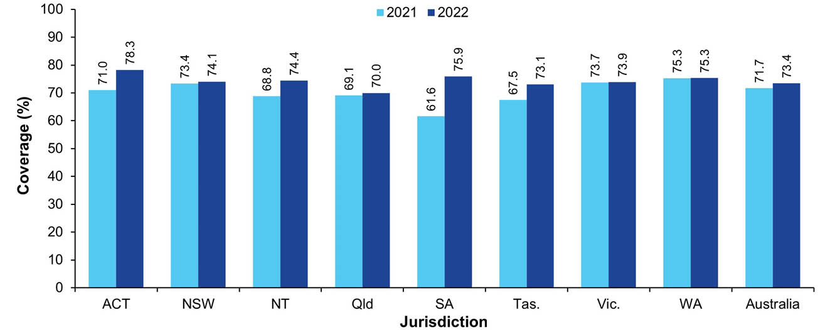
a Source: Australian Immunisation Register data as at 3 April 2022 for 2021 coverage and as at 2 April 2023 for 2022 coverage.
b Coverage calculated using the number of Medicare-registered adolescents in each year-wide cohort with an AIR record of having received at least one dose of HPV vaccine (≥ 9 years of age) and an adolescent (i.e. ≥ 10 years of age) dose of both diphtheria-tetanus-pertussis vaccine (recorded as either dTpa or DTPa) and meningococcal ACWY vaccine by 31 December of the relevant year as the numerator and the total number of Medicare-registered adolescents in the relevant cohort as the denominator, expressed as a percentage.
c Cohorts: 1 January – 31 December 2003 for 2021 coverage; 1 January – 31 December 2004 for 2022 coverage.
d ACT: Australian Capital Territory; NSW: New South Wales; NT: Northern Territory; Qld: Queensland; SA: South Australia; Tas.: Tasmania; Vic.: Victoria; WA: Western Australia.
Figure 20: Vaccination coverage using composite measure (dose of HPV and adolescent doses of diphtheria-tetanus-pertussis and meningococcal ACWY vaccine) in Indigenous adolescents turning 18 years, by jurisdiction, Australia,^{a,b,c,d} 2021 versus 2022
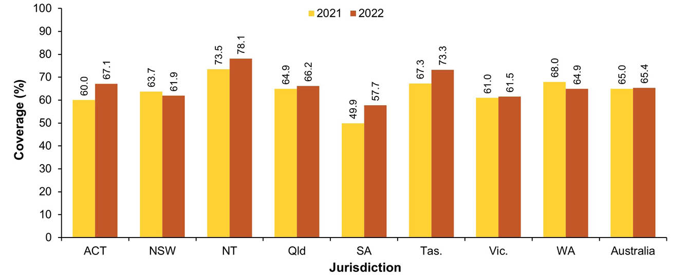
a Source: Australian Immunisation Register data as at 3 April 2022 for 2021 coverage and as at 2 April 2023 for 2022 coverage.
b Coverage calculated using the number of Medicare-registered Indigenous adolescents in each year-wide cohort with an AIR record of having received at least one dose of HPV vaccine (≥ 9 years of age) and an adolescent (i.e. ≥ 10 years of age) dose of both diphtheria-tetanus-pertussis vaccine (recorded as either dTpa or DTPa) and meningococcal ACWY vaccine by 31 December of the relevant year as the numerator and the total number of Medicare-registered Indigenous adolescents in the relevant cohort as the denominator, expressed as a percentage.
c Cohorts: 1 January – 31 December 2003 for 2021 coverage; 1 January – 31 December 2004 for 2022 coverage.
d ACT: Australian Capital Territory; NSW: New South Wales; NT: Northern Territory; Qld: Queensland; SA: South Australia; Tas.: Tasmania; Vic.: Victoria; WA: Western Australia.

Influenza vaccination coverage
Influenza vaccination coverage in adolescents aged 10–14 years and 15–19 years increased by 9 and 7.2 percentage points, respectively, between 2021 and 2022, to 22.3% in both age groups (Figure 2), with increases seen in all jurisdictions (Tables A.9.1 [2021] and A.9.2 [2022] in the Appendix). In 2022, coverage for adolescents aged 10–14 years ranged from 19.3% in Queensland and Western Australia to 26.1% in the Australian Capital Territory (Table A.9.2 in the Appendix).
Influenza vaccination coverage in Indigenous adolescents aged both 10–14 years and 15–19 years increased by 3.6 percentage points between 2021 and 2022, to 19.0% and 20.1%, respectively (Figure 4), with increases seen in all jurisdictions (Tables A.9.1 and A.9.2 in the Appendix). Coverage for Indigenous adolescents aged 10–14 years in 2022 ranged from 16.2% in Queensland to 30.5% in the Northern Territory; for those aged 15–19 years, it ranged from 17.5% in Queensland to 34.4% in the Northern Territory (Table A.9.2 in the Appendix).

Provider setting
In 2022, vaccinations given to adolescents aged 10–19 years in Australia were most commonly administered in general practice settings (39.9%), followed by local government and council clinics (31.2%) and pharmacies (15.7%; see Figure 21). The proportion of vaccinations administered in pharmacies increased from 0.9% in 2019 (data not shown). The proportion administered in different provider settings varied by jurisdiction: for local government/council clinics, this figure ranged from 55.0% in Tasmania to 13.7% in Western Australia; for pharmacies, it ranged from 51.8% in Queensland to 3.0% in the Northern Territory (Figure 21). The distribution by provider setting for non-COVID-19 vaccinations was generally similar, but with a larger proportion given in local council settings and a smaller proportion given in general practice settings (Figure 22).

COVID-19 vaccination coverage
By 4 January 2023, data published by the Department of Health, Disability and Ageing showed that 79.5% of Australian adolescents aged 12–15 years had received a first dose of a COVID-19 vaccine and 74.5% had received a second dose (Figure A.10 in the Appendix). Coverage in adolescents aged 12–15 years ranged from 71.0% in Queensland to 95.8% in the Australian Capital Territory for the first dose, and from 65.6% in Queensland to 92.9% in the Australian Capital Territory for the second dose (Table A.10 in the Appendix).
Figure 21: Proportion of all vaccinations given to adolescents aged 10–19 years by provider setting and jurisdiction, Australia,^{a,b,c} 2022
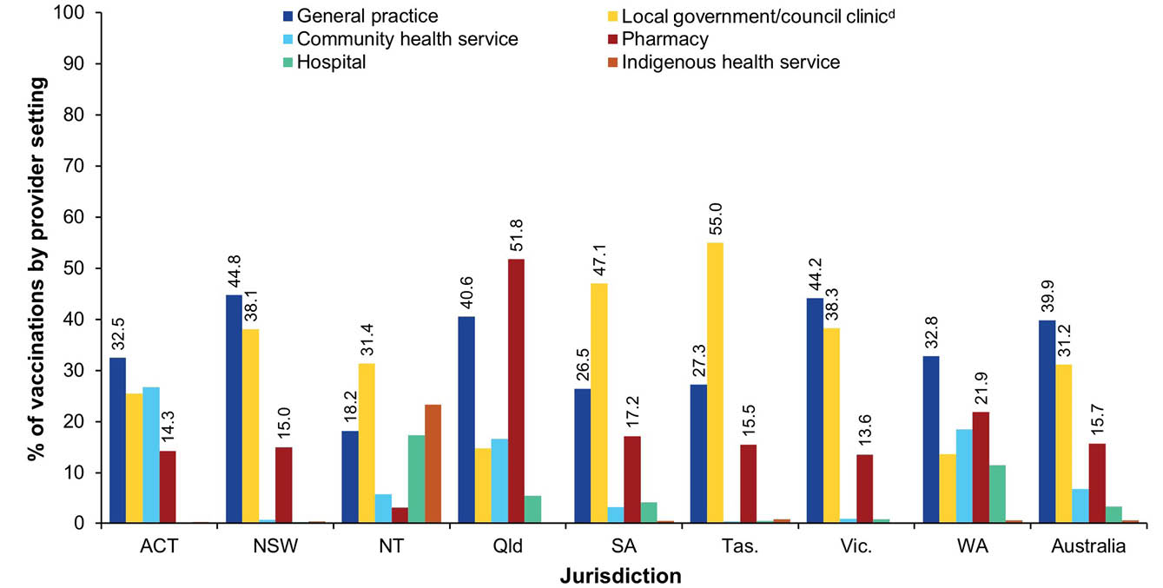
a Source: Australian Immunisation Register data as at 2 April 2023.
b Note: Includes all vaccine types able to be reported to the AIR (i.e. both NIP and non-NIP vaccines).
c ACT: Australian Capital Territory; NSW: New South Wales; NT: Northern Territory; Qld: Queensland; SA: South Australia; Tas.: Tasmania; Vic.: Victoria; WA: Western Australia.
d Includes vaccines given as part of school-based programs, in public health units and by jurisdictional health departments.
Figure 22: Proportion of non-COVID-19 vaccinations given to adolescents aged 10–19 years by provider setting and jurisdiction, Australia,^{a,b,c} 2022
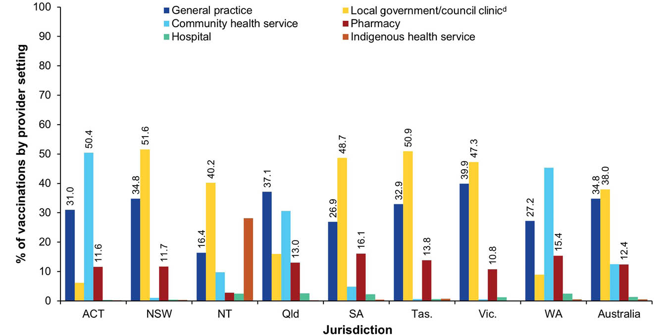
a Source: Australian Immunisation Register data as at 2 April 2023.
b Note: Includes all vaccine types able to be reported to the AIR (i.e. both NIP and non-NIP vaccines), except COVID-19 vaccines.
c ACT: Australian Capital Territory; NSW: New South Wales; NT: Northern Territory; Qld: Queensland; SA: South Australia; Tas.: Tasmania; Vic.: Victoria; WA: Western Australia.
d Includes vaccines given as part of school-based programs, in public health units and by jurisdictional health departments.

Adults

Zoster vaccination coverage
Zoster vaccination coverage (i.e. receipt of one dose of Zostavax or two doses of Shingrix) for Australian adults turning 71 years of age in 2022 was 41.3% in 2022, up from 38.7% in 2021, with coverage in 2022 ranging from 21.6% in the Northern Territory to 52.6% in Queensland (Figure 23). Coverage in Indigenous adults turning 71 years was 36.5% in 2022, up from 32.9% in 2021 (Figure 24), with coverage in 2022 ranging from 15.9% in the Northern Territory to 50.0% in the Australian Capital Territory.
The majority of adults turning 70–76 years in 2022 who had received zoster vaccine by 31 December 2022 were vaccinated at the 70-year schedule point, although with a substantial proportion vaccinated through the catch-up program, whereas adults turning 77–79 years were predominantly vaccinated through the catch-up program (Figure 25). Coverage was highest for adults turning 75 years (54.6% overall). Coverage patterns for Indigenous adults were similar (Figure 26).
Figure 23: Zoster vaccination coverage for adults turning 71 years of age in the year of interest, by jurisdiction, Australia,^{a,b,c,d,e} 2020, 2021 and 2022
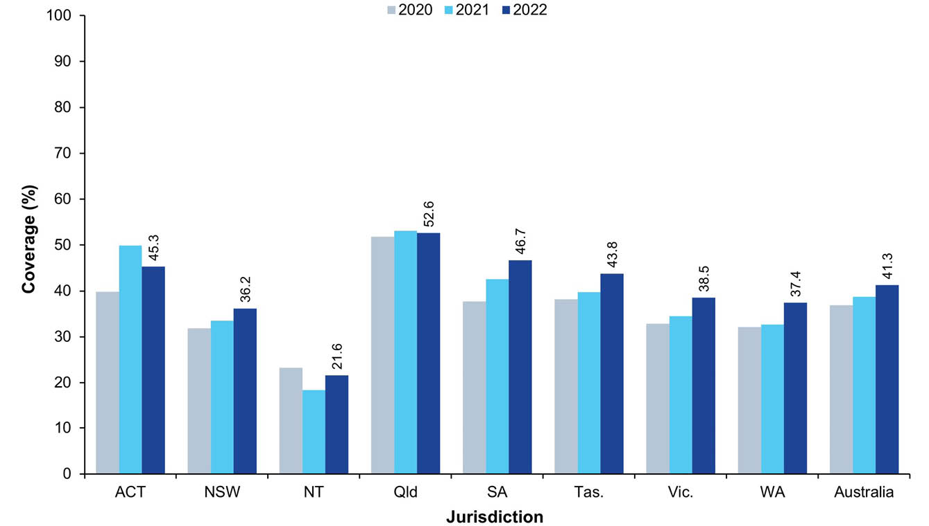
a Source: Australian Immunisation Register data as at 3 April 2022 (for 2020 and 2021 coverage) and as at 2 April 2023 (for 2022 coverage).
b Coverage calculated using the number of Medicare-registered adults in each year-wide cohort with an AIR record of having received one dose of Zostavax or two doses of Shingrix by 31 December of the relevant year as the numerator and the total number of Medicare-registered adults in the relevant cohort as the denominator, expressed as a percentage.
c Note: The 2020 and 2021 data points differ to what was presented in the 2021 report due to vaccinations given after 71 years of age now being included in the coverage calculations.
d Cohorts born 1 January – 31 December 1949 for 2020 coverage; 1 January – 31 December 1950 for 2021 coverage; 1 January – 31 December 1951 for 2022 coverage.
e ACT: Australian Capital Territory; NSW: New South Wales; NT: Northern Territory; Qld: Queensland; SA: South Australia; Tas.: Tasmania; Vic.: Victoria; WA: Western Australia.
Figure 24: Zoster vaccination coverage for Indigenous adults turning 71 years of age in the year of interest, by jurisdiction, Australia,^{a,b,c,d,e} 2020, 2021 and 2022
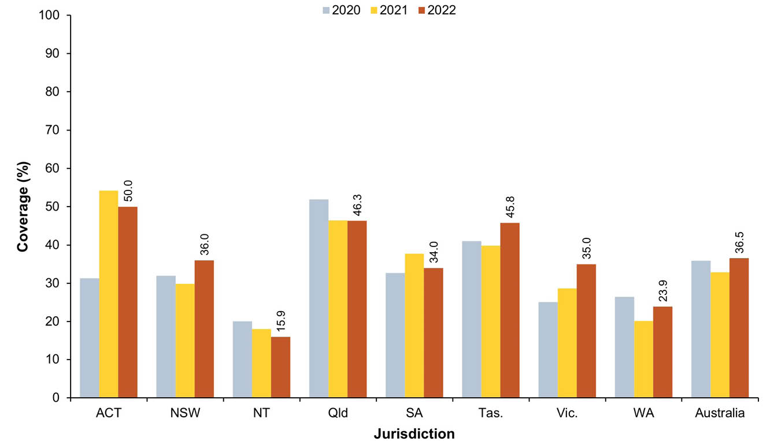
a Source: Australian Immunisation Register data as at 3 April 2022 (for 2020 and 2021 coverage) and as at 2 April 2023 (for 2022 coverage).
b Coverage calculated using the number of Medicare-registered Indigenous adults in each year-wide cohort with an AIR record of having received one dose of Zostavax or two doses of Shingrix by 31 December of the relevant year as the numerator and the total number of Medicare-registered Indigenous adults in the relevant cohort as the denominator, expressed as a percentage.
c Note: The 2020 and 2021 data points differ to what was presented in the 2021 report due to vaccinations given after 71 years of age now being included in the coverage calculations.
d Cohorts born 1 January – 31 December 1949 for 2020 coverage; 1 January – 31 December 1950 for 2021 coverage; 1 January – 31 December 1951 for 2022 coverage.
e ACT: Australian Capital Territory; NSW: New South Wales; NT: Northern Territory; Qld: Queensland; SA: South Australia; Tas.: Tasmania; Vic.: Victoria; WA: Western Australia.
Figure 25: Zoster vaccination coverage in adults by birth cohort and age at vaccination, Australia,^{a,b} 2022
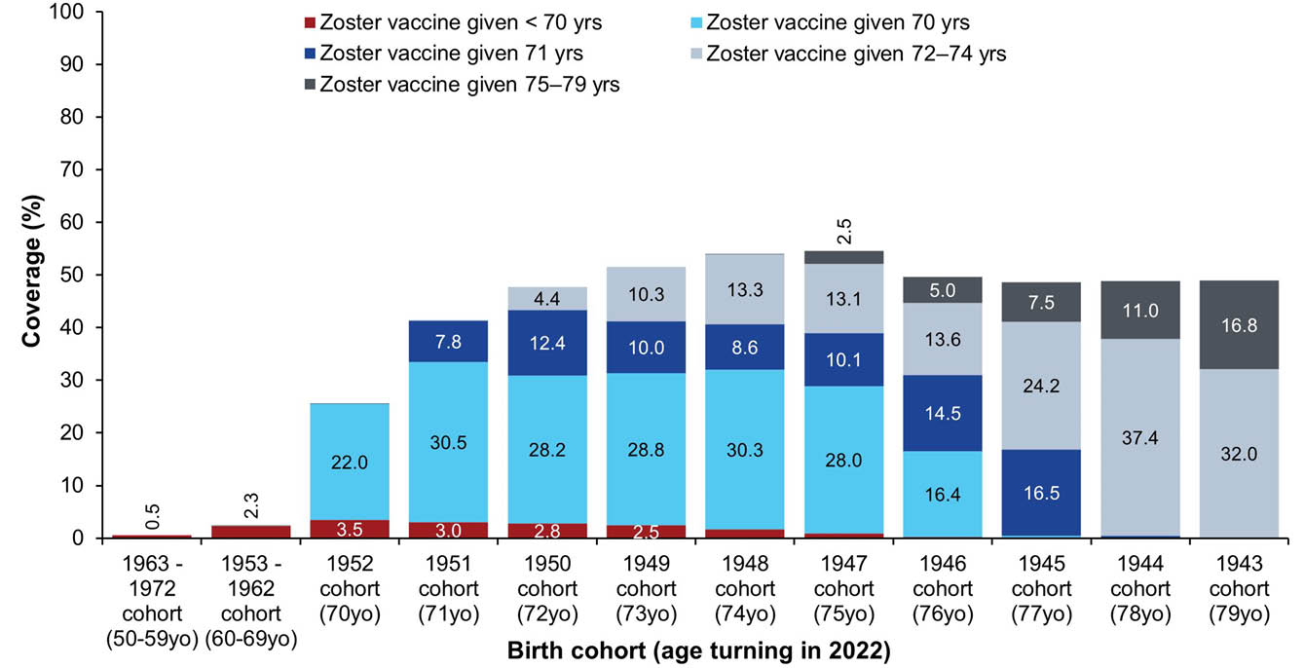
a Source: Australian Immunisation Register data as at 2 April 2023.
b Coverage calculated using the number of Medicare-registered adults in each cohort with an AIR record of having received either one dose of Zostavax vaccine or two doses of Shingrix vaccine as the numerator and the total number of Medicare-registered adults in the relevant cohort as the denominator, expressed as a percentage. Vaccinations given up to 31 December 2022 are included in the numerator.
Figure 26: Zoster vaccination coverage in Indigenous adults by birth cohort and age at vaccination, Australia,^{a,b} 2022
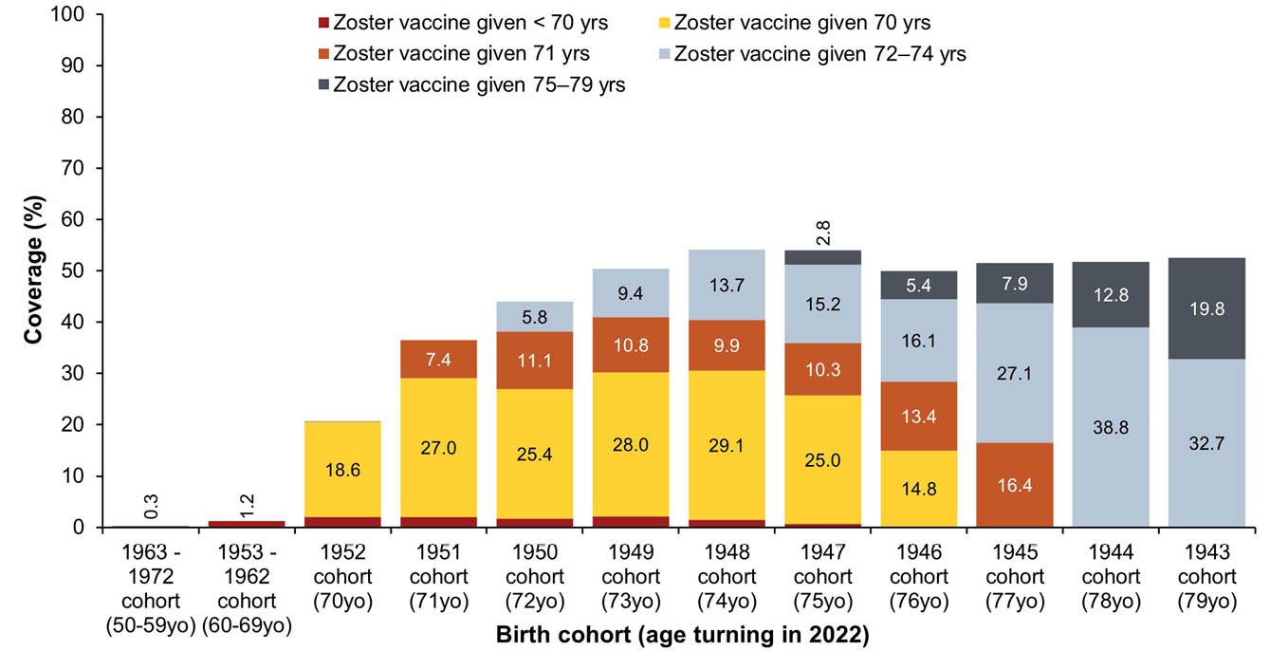
a Source: Australian Immunisation Register data as at 2 April 2023.
b Coverage calculated using the number of Medicare-registered Indigenous adults in each cohort with an AIR record of having received either one dose of Zostavax vaccine or two doses of Shingrix vaccine as the numerator and the total number of Medicare-registered Indigenous adults in the relevant cohort as the denominator, expressed as a percentage. Vaccinations given up to 31 December 2022 are included in the numerator.

Pneumococcal vaccination coverage
Coverage of an adult dose of 13vPCV in the overall cohort turning 71 years in 2022 was 33.8% overall, up from 23.9% in 2021 (Figure 27), and 37.7% for the Indigenous ohort, up from 25.1% in 2021 (Figure 28).
Figure 27: Coverage of an adult dose of 13vPCV in the cohort turning 71 years of age in the year of interest, by jurisdiction, Australia,^{a,b,c,d,e} 2020, 2021 and 2022
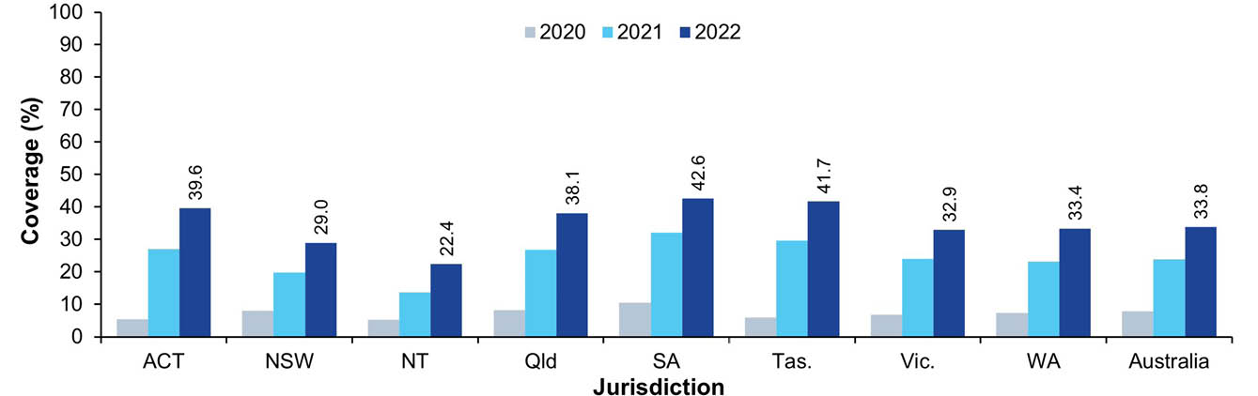
a Source: Australian Immunisation Register data as at 3 April 2022 (for 2020 and 2021 coverage) and as at 2 April 2023 (for 2022 coverage).
b Coverage calculated using the number of Medicare-registered adults in each year-wide cohort with an AIR record of having received an adult dose of 13vPCV by 31 December of the relevant year as the numerator and the total number of Medicare-registered adults in the relevant cohort as the denominator, expressed as a percentage.
c Note: The 2020 and 2021 data points differ to what was presented in the 2021 report due to vaccinations given after 71 years of age now being included in the coverage calculations.
d Cohorts born 1 January – 31 December 1949 for 2020 coverage; 1 January – 31 December 1950 for 2021 coverage; 1 January – 31 December 1951 for 2022 coverage.
e ACT: Australian Capital Territory; NSW: New South Wales; NT: Northern Territory; Qld: Queensland; SA: South Australia; Tas.: Tasmania; Vic.: Victoria; WA: Western Australia.
Figure 28: Coverage of an adult dose of 13vPCV in the Indigenous cohort turning 71 years of age in the year of interest, by jurisdiction, Australia,^{a,b,c,d,e} 2020, 2021 and 2022
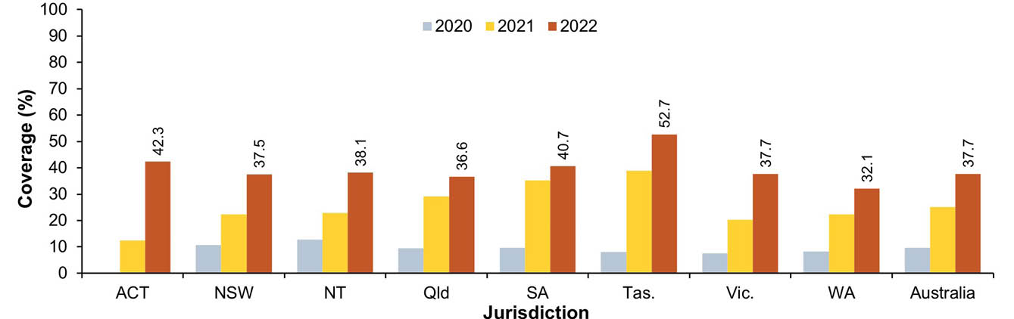
a Source: Australian Immunisation Register data as at 3 April 2022 (for 2020 and 2021 coverage) and as at 2 April 2023 (for 2022 coverage).
b Coverage calculated using the number of Medicare-registered Indigenous adults in each year-wide cohort with an AIR record of having received an adult dose of 13vPCV by 31 December of the relevant year as the numerator and the total number of Medicare-registered Indigenous adults in the relevant cohort as the denominator, expressed as a percentage.
c Note: The 2020 and 2021 data points differ to what was presented in the 2021 report due to vaccinations given after 71 years of age now being included in the coverage calculations.
d Cohorts born 1 January – 31 December 1949 for 2020 coverage; 1 January – 31 December 1950 for 2021 coverage; 1 January – 31 December 1951 for 2022 coverage.
e ACT: Australian Capital Territory; NSW: New South Wales; NT: Northern Territory; Qld: Queensland; SA: South Australia; Tas.: Tasmania; Vic.: Victoria; WA: Western Australia.
The majority of adults turning 70 and 71 years of age in 2022 who had received an adult dose of 13vPCV by 31 December 2022 were vaccinated at 70 years, whereas adults turning 73 years and above were predominantly vaccinated at older ages (Figure 29). Coverage was highest for adults turning 72 years (34.1% overall). Coverage patterns for Indigenous adults were similar (Figure 30).
Figure 29: Coverage of an adult dose of 13vPCV by birth cohort and age at vaccination, Australia,^{a,b} 2022
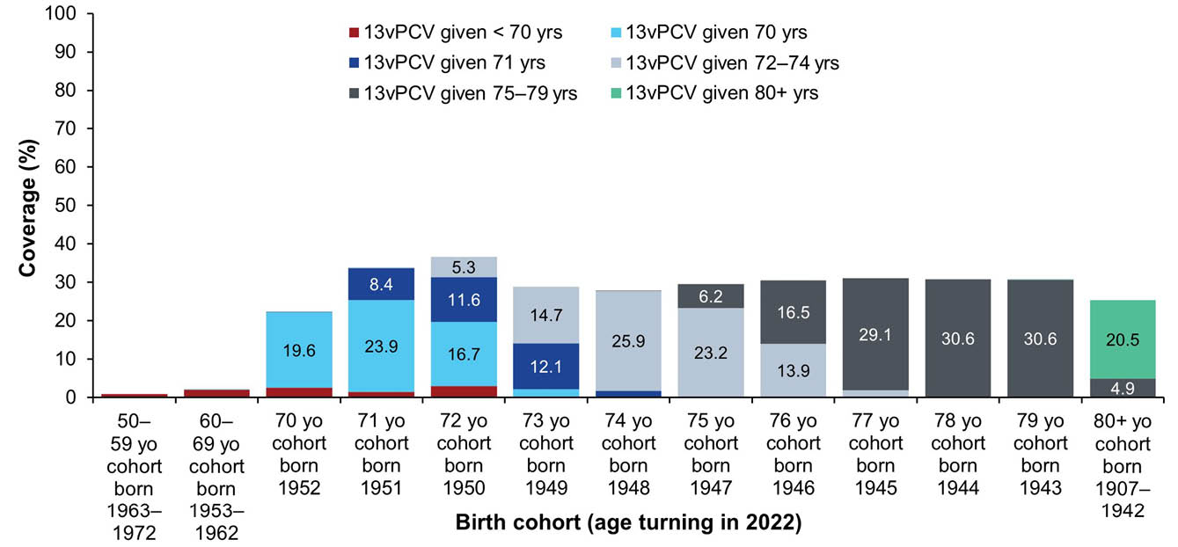
a Source: Australian Immunisation Register data as at 2 April 2023.
b Coverage calculated using the number of Medicare-registered adults in each cohort with an AIR record of having received an adult dose of 13vPCV as the numerator and the total number of Medicare-registered adults in the relevant cohort as the denominator, expressed as a percentage. Vaccinations given up to 31 December 2022 are included in the numerator.
Figure 30: Coverage of an adult dose of 13vPCV by Indigenous birth cohort and age at vaccination, Australia,^{a,b} 2022
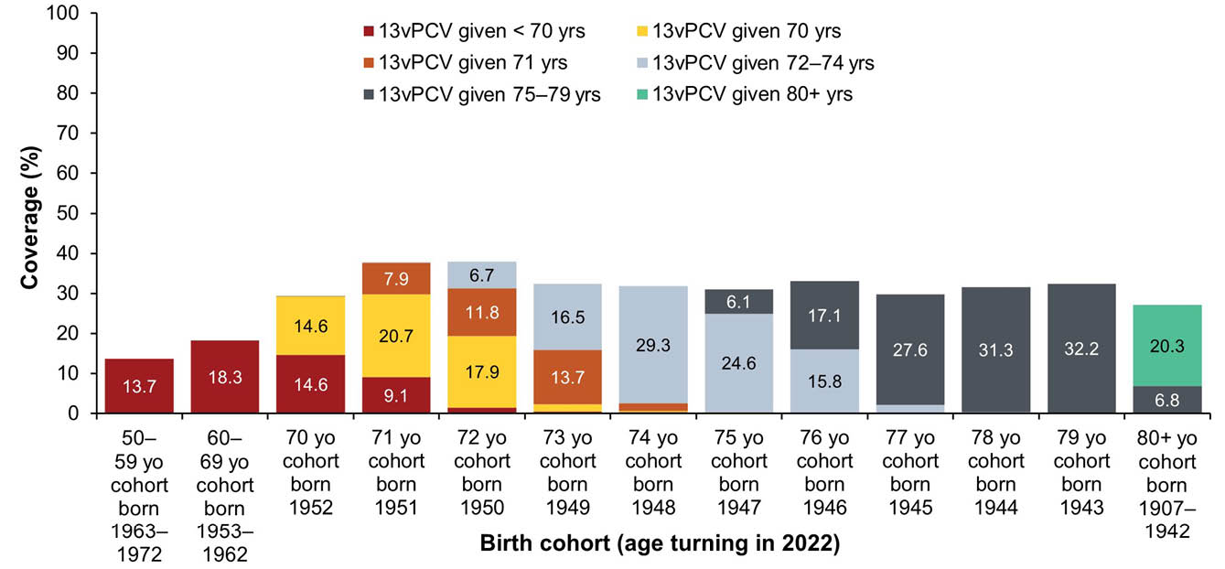
a Source: Australian Immunisation Register data as at 2 April 2023.
b Coverage calculated using the number of Medicare-registered Indigenous adults in each cohort with an AIR record of having received an adult dose of 13vPCV as the numerator and the total number of Medicare-registered Indigenous adults in the relevant cohort as the denominator, expressed as a percentage. Vaccinations given up to 31 December 2022 are included in the numerator.

Influenza vaccination coverage
Influenza vaccination coverage in adults in 2022 increased with increasing age: coverage was 30.5% in the 20–49 years age group, 46.8% in the 50–64 years age group, 67.5% in the 65–74 years age group and 73.0% in the ≥ 75 years age group, with coverage up by between 4.5 and 8.6 percentage points compared to 2021 (Figure 2). Coverage by jurisdiction is shown in Tables A.9.1 and A.9.2 in the Appendix.
Similarly, influenza vaccination coverage in Indigenous adults in 2022 increased with increasing age: coverage was 27.4% in the 20–49 years age group, 51.4% in the 50–64 years age group, 69.5% in the 65–74 years and 72.1% in the ≥ 75 years age group, with coverage up by between 4.4 and 7.9 percentage points compared to 2021 (Figure 4). Coverage by jurisdiction is shown in Tables A.9.1 and A.9.2 in the Appendix.
Influenza coverage estimates increased between 2019 and 2022 for all adult age groups, with the highest percentage increases in those aged 20–49 years (a 100.7% increase, from 15.2% in 2019 to 30.5% in 2022) and 50–64 years (an increase of 88.7%, from 24.8% to 46.8%), compared to increases of 23.4% in those aged 65–74 years (from 54.7% to 67.5%) and of 18.7% in those aged ≥ 75 years (from 61.5% to 73.0%; see Figure 31).
Figure 31: Coverage of seasonal influenza vaccine by adult age group, Australia,^{a,b,c} 2019–2022
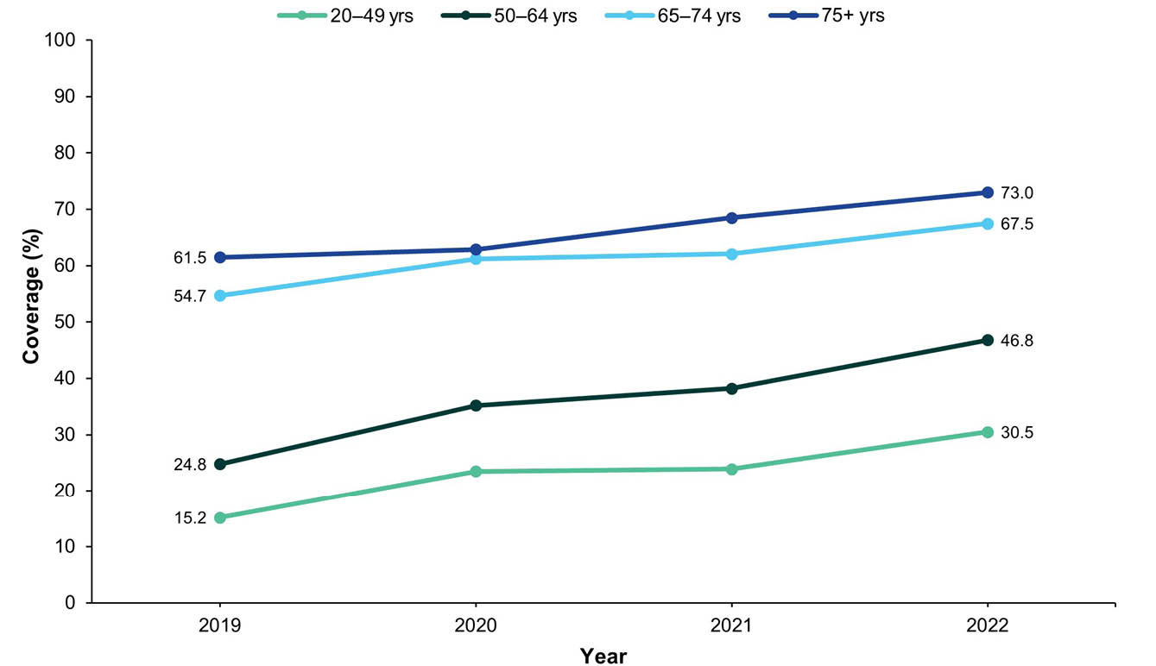
a Source: Australian Immunisation Register data as at 31 March 2020 (for 2019 data), 31 March 2021 (for 2020 data), 3 April 2022 (for 2021 data) and as at 2 April 2023 (for 2022 data).
b Receipt of at least one dose of any influenza vaccine in the calendar year of interest.
c People categorised into age groups based on age at vaccination.

Adult composite measure of vaccination coverage
Using a composite measure (viz., a dose of influenza vaccine in the past 12 months and an adult dose of 13vPCV), coverage was 31.3% overall in adults turning 71 years in 2022; this was 9.8 percentage points higher than the corresponding figure for 2021 (Figure 32). Coverage in Indigenous adults turning 71 years in 2022 was 33.6%; this was 12.3 percentage points higher than in 2021 (Figure 33). Coverage for the composite measure varied by jurisdiction, with overall coverage in 2022 highest in South Australia (40.2%) and lowest in the Northern Territory (20.5%; see Figure 32); coverage for Indigenous adults was highest in Tasmania (49.6%) and lowest in Western Australia (26.4%; see Figure 33).
Figure 32: Vaccination coverage using composite measure (influenza vaccine dose in past 12 months and an adult dose of 13vPCV), adults turning 71 years of age in relevant year, by jurisdiction, Australia,^{a,b,c,d} 2022 versus 2021
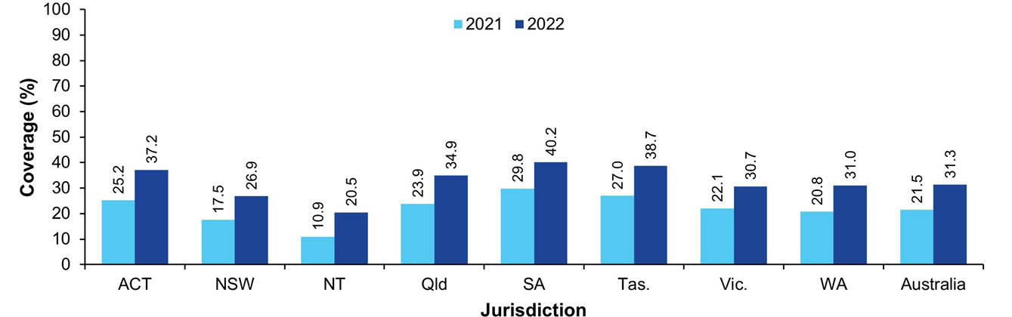
a Source: Australian Immunisation Register data as at 3 April 2022 (for 2021 coverage) and as at 2 April 2023 (for 2022 coverage).
b Coverage calculated using the number of Medicare-registered adults in each cohort with an AIR record of a dose of influenza vaccine in the past 12 months and an adult dose of 13vPCV by the end of the relevant year as the numerator and the total number of Medicare-registered adults in the relevant cohort as the denominator, expressed as a percentage.
c Cohorts born 1 January–31 December 1950 for 2021 coverage; 1 January–31 December 1951 for 2022 coverage.
d ACT: Australian Capital Territory; NSW: New South Wales; NT: Northern Territory; Qld: Queensland; SA: South Australia; Tas.: Tasmania; Vic.: Victoria; WA: Western Australia.
Figure 33: Vaccination coverage using composite measure (influenza vaccine dose in past 12 months and an adult dose of 13vPCV), Indigenous adults turning 71 years of age in relevant year, by jurisdiction, Australia,^{a,b,c,d} 2022 versus 2021
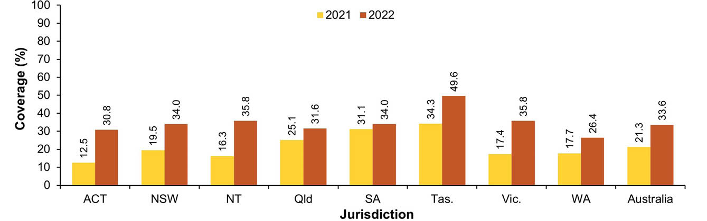
a Source: Australian Immunisation Register data as at 3 April 2022 (for 2021 coverage) and as at 2 April 2023 (for 2022 coverage).
b Coverage calculated using the number of Medicare-registered Indigenous adults in each cohort with an AIR record of a dose of influenza vaccine in the past 12 months and an adult dose of 13vPCV by the end of the relevant year as the numerator and the total number of Medicare-registered Indigenous adults in the relevant cohort as the denominator, expressed as a percentage.
c Cohorts born 1 January–31 December 1950 for 2021 coverage; 1 January–31 December 1951 for 2022 coverage.
d ACT: Australian Capital Territory; NSW: New South Wales; NT: Northern Territory; Qld: Queensland; SA: South Australia; Tas.: Tasmania; Vic.: Victoria; WA: Western Australia.

Concomitant adult vaccination
Table 5 shows the percentage of adults turning 71 years of age in 2022 with a record on the AIR of having received two or three of the adult vaccines recommended at 70 years of age (zoster, 13vPCV and influenza), and of these, the percentage who received two or more of the vaccines on the same date. Nationally, 24.2% of adults turning 71 years in 2022 had a record of all three vaccines administered at 70 years of age in either 2021 or 2022. Of these, only 3.0% had received all three vaccines on the same date, while 42.5% had received zoster vaccine and 13vPCV on the same date and 16.2% had received 13vPCV and influenza vaccine on the same date (Table 5). The most common permutation of two adult vaccines given at the same time and one vaccine not given at all was for adults receiving a dose of zoster vaccine and a dose of 13vPCV on the same date (57.7%; see Table 5).
Table 5: Concomitant vaccination in adults turning 71 years of age, Australia,^{a,b,c} 2022
Category^{d} | Number of adults | % of category
Receipt of zoster, 13vPCV and influenza | 61,033 | –
All three vaccines given concomitantly | 1,850 | 3.0
Concomitant zoster and 13vPCV, influenza given on different date | 25,925 | 42.5
Concomitant 13vPCV and influenza, zoster given on different date | 9,869 | 16.2
Concomitant zoster and influenza, 13vPCV given on different date | 4,095 | 6.7
Receipt of zoster and influenza but not 13vPCV | 33,147 | –
Concomitant zoster and influenza | 2,988 | 9.0
Receipt of 13vPCV and influenza but not zoster | 19,302 | –
Concomitant 13vPCV and influenza | 6,247 | 32.4
Receipt of zoster and 13vPCV but not influenza | 2,159 | –
Concomitant zoster and 13vPCV | 1,245 | 57.7
a Source: Australian Immunisation Register data as at 2 April 2023.
b Only includes zoster, 13vPCV or influenza vaccines received at 70 years of age during 2021 and 2022.
c Cohort born 1 January 1951 – 31 December 1951 (i.e. turning 71 years during 2022).
d Based on whether two or three vaccines were received at 70 years of age in either 2021 or 2022 and whether any concomitant vaccination occurred.

Provider setting
In 2022, vaccinations given to adults in Australia were most commonly administered in general practice settings (43.6% for adults aged 20–64 years and 71.0% for those aged ≥ 65 years), followed by pharmacies (29.7% and 18.2%, respectively) and local government and council clinics (16.9% and 6.8%, respectively; see Figure 34). The distribution by provider setting for non-COVID-19 adult vaccinations was generally similar, but with a larger proportion given in general practice settings, particularly for adults aged ≥ 65 years (86.4%; see Figure 34).
Figure 34: Proportion of vaccinations (overall versus non-COVID-19) given to adults by provider setting and age group, Australia,^{a,b} 2022
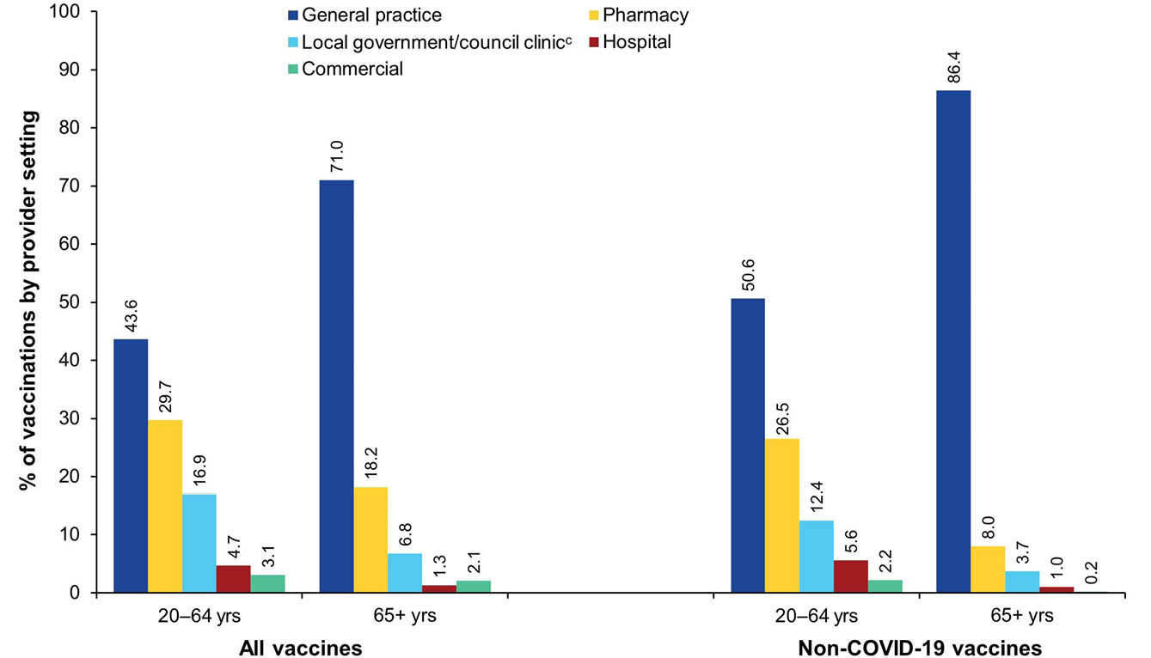
a Source: Australian Immunisation Register data as at 2 April 2023.
b Note: 'All vaccines' includes all vaccine types able to be reported to the AIR (i.e. both NIP and non-NIP vaccines); 'non-COVID-19 vaccines' includes all vaccine types able to be reported to the AIR (i.e. both NIP and non-NIP vaccines), except COVID-19 vaccines.
c Includes public health units and jurisdictional health departments.

COVID-19 vaccination coverage
Adult coverage of all COVID-19 vaccine doses increased with increasing age (Figure A.10 in the Appendix). Data published by the Australian Government Department of Health, Disability and Ageing showed that by 4 January 2023, coverage ranged from 94.8% for the first dose, 92.7% for the second dose and 47.7% for the third dose in those aged 16–29 years to above 99% for first and second doses, and 92.7% for third doses in those aged 65 years and over. Fourth dose coverage was 19.7% in adults aged 30–64 years, but 70.5% in those aged 65 years and over. Coverage of each dose by jurisdiction and age group is shown in Table A.10 in the Appendix.
By 4 January 2023, data published by the Department of Health, Disability and Ageing showed that 97.4% of Australians aged 16 years and over had received a first dose of a COVID-19 vaccine and 96.0% had received a second dose, whilst receipt of a third dose was lower, at 69.5% (Figure A.11 in the Appendix). Coverage in people aged 16 years and over for the first dose ranged from 88.5% in the Northern Territory to 98.0% in Victoria; for the second dose, it ranged from 86.6% in the Northern Territory to 96.8% in Victoria; and for the third dose, it ranged from 60.0% in Queensland to 77.2% in the Australian Capital Territory (Table A.11 in the Appendix). Coverage of a fourth dose of a COVID-19 vaccine in Australians aged 30 years and over was 33.4% (Figure A.11 in the Appendix).
Data published by the Department of Health, Disability and Ageing showed that COVID-19 vaccination coverage was lower in Indigenous people aged 16 years and over for the first, second and third doses, at 85.5%, 82.3% and 56.6%, respectively (Figure A.11 in the Appendix). Coverage of doses 1–3 in those aged 16 and over is shown by Indigenous status and jurisdiction in Table A.11 in the Appendix. Nationally, coverage of a fourth dose of a COVID-19 vaccine in Indigenous people aged 30 years and over was 35.1%, 1.7 percentage points higher than overall (Figure A.11 in the Appendix).

Discussion
This report documents relatively high vaccination coverage in Australia, by global standards, in line with NIP and World Health Organization (WHO) Immunization Agenda 2030 (IA2030)¹⁸ aims to reduce vaccine preventable disease burden across the life course. Opportunities for further improvement, in the context of ongoing COVID-19 pandemic impacts, are discussed below.

Vaccination coverage in population overall

Children
Fully vaccinated coverage in Australian children in this 2022 report was 0.6–1.1 of a percentage point lower than in our 2021 report at the 12-month (93.3%, down from 94.2%), 24-month (91.0%, down from 92.1%) and 60-month (93.4%, down from 94.0%) age assessment milestones.¹⁵ This follows the 0.6–0.8 of a percentage point decrease at the 12- and 60-month milestones between the 2020 and 2021 reports,¹⁵ which came after approximately eight years of generally increasing coverage.⁸⁻¹⁴ Due to the lag time involved in fully vaccinated coverage assessment, fully vaccinated coverage figures in the 2021 and 2022 reports predominantly represent vaccinations due in 2020 and 2021, respectively, and hence reflect impacts of the first two years of the COVID-19 pandemic. Decreases of similar magnitude have been seen in comparable developed countries, such as the United Kingdom (UK) and the United States of America (USA).^{19,20}
We also found clear impacts of the pandemic on on-time vaccination (i.e., within 30 days of recommended age) in young children, with on-time coverage of both the second dose of DTPa and the first dose of MMR-containing vaccines decreasing progressively from mid-2020 onwards, before recovering partially in the second half of 2022.
Pandemic impacts on coverage have also been greater in some parts of Australia than others, particularly in remote areas with a high proportion of Indigenous people, such as the West Pilbara SA3 area in Western Australia and the Barkly and Alice Springs SA3 areas in the Northern Territory. In these areas, coverage for the second dose of MMR at 24 months of age decreased from above 90% in the 2020 report¹⁴ to below 85% in this report. As noted earlier, true coverage in children is likely somewhat higher than presented here, given previously documented under-reporting to the AIR.^{21,22}
Fully vaccinated coverage in 2022 was around two percentage points lower at the 24-month milestone than at 12 and 60 months of age, likely due to the greater number of antigens required in order to be classified as fully vaccinated at 24 months. In contrast, only one vaccine (DTPa-polio, scheduled at 48 months) is included in the current fully vaccinated assessment at 60 months. Expansion of the 60-month assessment algorithm to include a more comprehensive range of the vaccines/antigens that should have been received by that age has been recommended to better monitor uptake under the NIP.²³
Coverage was lower in 2022 than in 2021 for almost all individual vaccines/antigens included in the fully vaccinated assessment algorithms. The largest decrease was for rotavirus at 12 months of age (1.2 percentage points); all other decreases were of less than one percentage point. In the context of Australia’s 95% coverage targets (which are particularly critical to measles control), coverage at 24 months of age in 2022 was 95.1% for the first dose of measles-containing vaccine and, while coverage was lower for the second dose of MMR at 24 months (92.7%), it was 96.3% at 60 months of age.

Adolescents
In 2022, a total of 85.3% of Australian girls had received at least one dose of HPV vaccine by 15 years of age, down from 86.2% in 2021; similarly, 83.1% of boys had received at least one dose, down from 84.4%. These figures compare well with coverage in 2022 in similar developed countries that used the same WHO-recommended assessment methodology: 84% and 78% in girls and boys, respectively, in the UK; 82% and 76% in the USA; 75% and 74% in New Zealand; and 86% and 81% in Canada.²⁴ The decreases seen in Australia in this report are likely due to pandemic impacts, since the 2022 coverage figures reflect vaccinations due in school-based programs both prior to and during the COVID-19 pandemic, while 2021 coverage reflects vaccinations predominantly due before the pandemic. Pandemic disruption to school-based immunisation programs in 2020 and 2021 – due to lengthy school closures in some jurisdictions – has been well documented, with decreases of 12 and 15 percentage points, respectively, in the proportion of adolescents completing the two-dose HPV vaccination schedule within the 2020 and 2021 calendar years.^{14,15,25}
Assessment of coverage of at least one dose of HPV vaccine by broader year-wide birth cohorts showed that by 31 December 2022, coverage in Australia had peaked in adolescents turning 17 years in 2022, at 87.8%% in girls and 86.0% in boys, and that it then decreased in older cohorts. Coverage was below 80% in females turning 23–26 years and males turning 22–26 years in 2022, with coverage in males turning 25 and 26 below 15%, reflecting the later commencement of the male program. With HPV vaccine now funded under the NIP up to 26 years of age, these data show substantial scope for catch-up vaccination.
In this report we present coverage of at least one dose of HPV vaccine, as Australia switched to a single-dose schedule in 2023. A single-dose schedule is logistically simpler and less costly than a two- or three-dose schedule, but it will be essential to monitor to ensure that coverage is maintained and increases over time. It will be particularly important to ensure equitable coverage across disadvantaged groups, given our finding that coverage of at least one dose of HPV vaccine in 2022 was 5–6 percentage points lower in adolescents residing in socio-economically disadvantaged and remote areas. Australia’s national strategy for the elimination of cervical cancer calls for a focus on equity in elimination and has an HPV vaccination target of 90% for both females and males, building on WHO’s global target of 90% coverage for all girls by age 15 by 2030 in the context of our both-sex vaccination program.²⁶
Coverage of an adolescent dose of diphtheria-tetanus-pertussis vaccine in adolescents turning 15 years in 2022 was 86.9%, lower by 0.4 of a percentage point than in 2021, and coverage of an adolescent dose of meningococcal ACWY vaccine in adolescents turning 17 years in 2022 was 75.9%, lower by 0.2 of a percentage point than in 2021. These slight decreases are also likely due to pandemic impacts.
For the first time in this series of annual reports, we also calculated adolescent coverage using composite measures, as previously recommended,¹⁷ to assess overall uptake in the adolescent immunisation program. We estimate that coverage for adolescents turning 15 years of age in 2022 was 83.7% for a composite measure comprising at least one dose of HPV vaccine and an adolescent dose of diphtheria-tetanus-pertussis vaccine, and that coverage for adolescents turning 18 years of age in 2022 was 73.4% for a composite measure comprising at least one dose of HPV vaccine, an adolescent dose of diphtheria-tetanus-pertussis vaccine and an adolescent dose of meningococcal ACWY. These figures show relatively high overall adolescent coverage through the NIP; however, strategies are required to further improve uptake, particularly of meningococcal ACWY vaccine.
We also calculated, for the first time in this series of reports, the proportion of adolescent vaccinations administered in different settings. In 2022, adolescent vaccinations were most commonly administered in general practice settings (39.9%), followed by local government/council clinics (31.2%). The proportion administered in pharmacies has increased markedly, from 0.9% in 2019 to 15.7% in 2022 (51.8% in Queensland).

Adults
Zoster vaccination coverage in adults turning 71 years of age was 41.3% in 2022; this was 2.6 percentage points higher than in 2021.¹⁵ Coverage in 2022 was highest in adults turning 75 years (54.6%), reflecting a combination of vaccinations given at 70 years and from 71 years onwards via the catch-up vaccination program. True zoster vaccination coverage is likely higher, particularly in older cohorts, given previously documented under-reporting to the AIR;^{27–29} however, it is still suboptimal. It will be important to continue to monitor zoster vaccination coverage in the wake of the implementation, from 1 November 2023, of a two-dose Shingrix vaccination program funded under the NIP for all adults aged 65 years and over, replacing the single-dose Zostavax vaccination program.³⁰
Coverage of 13vPCV – which was introduced onto the NIP for all adults aged 70 years and over in July 2020 – was 33.8% in adults turning 70 years of age in 2022; this was 9.9 percentage points higher than in 2021. The increases in both 13vPCV and zoster coverage are likely due, in part, to greater completeness of reporting following the introduction of mandatory reporting of all NIP vaccines to the AIR in July 2021.²⁹
Influenza vaccination coverage in adults in 2022 was progressively higher with increasing age, reaching 67.5% in the 65–74 year age group and 73.0% in the 75 years and over age group. Coverage was higher in 2022 than 2021 across all adult age groups, with the proportionate increase four- to five-fold higher in adults aged less than 65 years than in older adults. This likely reflects, in large part, increased completeness due to mandatory reporting, along with the introduction of new categories of immunisation providers able to report to the AIR, such as commercial providers who have been able to report vaccinations to the AIR since 2018 and required to report since 2021. Influenza vaccination coverage has previously been thought to be substantially under-estimated, particularly in younger adults, due to under-reporting of vaccinations administered in workplaces and other non-GP (general practice) settings.^{31,32} More comprehensive evaluation of the completeness of ongoing reporting to the AIR would be of benefit to inform strategies to optimise the utility of AIR data to immunisation policy and programs.
For the first time in this series of reports, we assessed the level of concomitant vaccination in adults for the three vaccines recommended at 70 years under the NIP (zoster, 13vPCV and influenza). We found that among adults turning 71 years of age in 2022, only 3.0% of those who had records of all three vaccines in the AIR had received them all on the same date, although two-fifths had received zoster vaccine and 13vPCV together and one in eight had received 13vPCV and influenza vaccine together. Similarly, of those who had records of only two of the three vaccines, three-fifths of those who had received zoster vaccine and 13vPCV had them together and one-third of those who had received 13vPCV and influenza vaccine had them together. These patterns likely reflect that adults without other specific risk factors become eligible for both 13vPCV and zoster vaccine when they turn 70, and so are more likely to receive these vaccines together, whereas influenza vaccine is mostly given in a relatively short period, from around April to May. These data also suggest that there may be scope to increase adult coverage by promoting concomitant vaccination.
Also for the first time in this series of reports, we calculated the proportion of adult vaccinations administered in different settings. In 2022, adult vaccinations were most commonly given in GP settings, followed by pharmacies. In adults aged 65 years, close to three-quarters of vaccinations overall and nine out of ten non-COVID-19 vaccinations were given in general practice, while in adults aged 20–64 years close to one-third of vaccinations overall were given in pharmacies.

Vaccination coverage in Indigenous people

Children
Fully vaccinated coverage for Indigenous children decreased between 2021 and 2022 at all three standard age milestones: 12 months (from 91.6% to 90.0%), 24 months (from 90.1% to 87.9%) and 60 months (from 96.3% to 95.1%). These decreases were all larger than the corresponding decreases in children overall, indicating differential impacts of the COVID-19 pandemic and increasing the difference in coverage at 12 and 24 months of age; however, coverage at the 60-month milestone remained higher in Indigenous children than in children overall in 2022. This lower coverage at the 12- and 24-month milestones highlights longstanding timeliness issues among Indigenous children,^{1,9} with some exacerbation due to the pandemic apparent, particularly in remote areas. We also showed a several-percentage-point greater pandemic impact on on-time vaccination coverage for the second dose of DTPa and first dose of MMR-containing vaccines in Indigenous children, among whom coverage was already close to ten percentage points lower than in non-Indigenous children prior to the pandemic. Timeliness of vaccination in Indigenous children is particularly an issue in relation to vaccines/antigens due 6 months before the standard assessment milestones, whereas coverage of individual vaccines/antigens due at 6 or 12 months of age with no further doses required at 18 months (meningococcal ACWY, polio and hepatitis B vaccines) was 95.7% or greater in Indigenous children at 24 months in 2022. Similarly, although coverage in 2022 for the second dose of MMR and varicella (usually given as measles-mumps-rubella-varicella [MMRV] vaccine at 18 months) in Indigenous children was 90.2% at 24 months, it was over eight percentage points higher (98.3%) at 60 months. Likely related to these issues, in remote areas with a high proportion of Indigenous people, less pandemic-related impact was observed on coverage at 24 months for meningococcal ACWY vaccine (due at 12 months) than for the fourth dose of DTPa and second dose of MMR (both due at 18 months).
Coverage of meningococcal B vaccine – which was introduced onto the NIP for all Indigenous children in July 2020 – increased in 2022, with coverage of the first dose 80.4%, the second dose 78.6% and the third dose 69.8%. It should be noted that the third-dose coverage figures likely understate the true rates of course completion, given that only two doses are required if the first dose is administered after 12 months of age.
Influenza vaccination coverage in Indigenous children was also higher in 2022 than in 2021, but was still suboptimal; among those aged 6–59 months (an age group at particularly high risk of severe influenza), only one quarter were vaccinated. Strategies to improve influenza vaccine uptake in this age group are needed, particularly since the increase in coverage seen in 2022 was not sustained in 2023.³³
Coverage for hepatitis A vaccine and the fourth dose of 13vPCV – which are funded under the NIP for Indigenous children in four jurisdictions only (South Australia, Northern Territory, Queensland and Western Australia) – remained suboptimal in 2022. One-fifth of young children had not received the first dose of hepatitis A and one-fifth had not received the fourth dose of 13vPCV; slight decreases in coverage were likely due to pandemic impacts.

Adolescents
Coverage of at least one dose of HPV vaccine for Indigenous girls and boys by 15 years of age was 2.5–3.1 percentage points lower in 2022 than in 2021. These decreases were larger than the decreases in adolescents overall, leading to coverage in 2022 being 2.3 percentage points lower for Indigenous girls and 5.0 percentage points for Indigenous boys. Further efforts to address these disparities are required, given the much higher rates of cervical cancer in Indigenous women.³⁴ While a single dose of HPV vaccine is highly effective in preventing infection and subsequent disease,^{35–37} it is important to ensure that the switch to a single-dose schedule does not exacerbate existing equity issues.
Coverage of at least one dose of HPV vaccine received by the end of 2022 was 9.4 percentage points lower in Indigenous girls turning 13 years of age in 2022 than overall coverage, and 13.5 percentage points lower in Indigenous boys turning 13 years. The disparity decreased with increasing age, with coverage higher than overall in both Indigenous girls and boys turning 19 years of age in 2022. However, more than two-fifths of Indigenous women and men turning 23–26 years in 2022 had not been vaccinated, indicating substantial scope for catch-up vaccination.
More than four-fifths of Indigenous adolescents turning 15–19 years in 2022 had received an adolescent dose of diphtheria-tetanus-pertussis vaccine, close to overall coverage. However, three in ten or more had not received an adolescent dose of meningococcal ACWY; this was 6–13 percentage points below overall coverage. This disparity is likely the main factor behind the 4–8 percentage point lower coverage for Indigenous adolescents than overall using our two composite measures. Strategies are required to improve meningococcal ACWY coverage in Indigenous adolescents, given the elevated risk of meningococcal disease in this age group and the occurrence of serogroup W outbreaks in Indigenous communities in recent years.³⁸

Adults
Zoster vaccination coverage in Indigenous adults turning 70 years in 2022 was 36.5%; this was 3.6 percentage points higher than in 2021, with coverage highest for those turning 74 years (54.1%). Coverage of an adult dose of 13vPCV in Indigenous adults turning 70 years in 2022 reached 37.7%, a 12.6 percentage point increase from 2021, with coverage highest for those turning 72 years (38.0%). Only 13.7% of Indigenous adults aged 50–59 years, and 18.3% of those aged 60–69 years, were recorded as having received an adult dose of 13vPCV, despite the vaccine being funded under the NIP for all Indigenous adults in this age group since July 2020. The funding of Shingrix on the NIP for Indigenous adults aged 50 years and older, from 1 November 2023,³⁰ should provide opportunities to increase coverage of both 13vPCV and zoster vaccine in younger Indigenous adults, including through promotion of concomitant vaccination.
Influenza vaccination coverage, while relatively high in older Indigenous adults – at 69.5% for those aged 65–74 years and 72.1% for those aged 75 years and over – was considerably lower in younger Indigenous adults, at 51.4% for those aged 50–64 years and 27.4% for those aged 20–49 years. Further efforts to increase uptake are needed, given that annual influenza vaccination is funded on the NIP for all Indigenous adults, due to their increased risk of severe disease.

Conclusions
Vaccination coverage in Australia is relatively high by global standards, in line with NIP and IA2030 aims to reduce vaccine preventable disease burden across the life course. In 2022, vaccination coverage in children in Australia at the three standard age milestones decreased by around one percentage point overall from 2021, reflecting impacts of the COVID-19 pandemic. These impacts have been greater in some areas and populations than in others. Coverage in Indigenous children in 2022 decreased by slightly more (1–2 percentage points) than in 2021, and although also relatively high overall, timeliness of vaccination remains a persistent issue and has been exacerbated by the pandemic, particularly in remote areas.
Adolescent coverage of at least one dose of HPV vaccine by age 15 years in Australia also decreased by around one percentage point overall in 2022, reflecting pandemic impacts. However, coverage in Indigenous adolescents decreased by close to three percentage points, underlining the importance of ensuring that the new single-dose HPV vaccine schedule does not exacerbate equity gaps. While adult coverage increased across the board in 2022 for 13vPCV, zoster and influenza vaccines, these increases are likely due in part to the introduction of mandatory reporting to the AIR in 2021; adult coverage for these vaccines remains suboptimal.
Limited evidence from Australian studies and data to date suggest that factors contributing to the lower coverage in children and adolescents seen since the pandemic include a combination of acceptance issues (concerns regarding increased number of vaccines; ‘vaccine fatigue’; increased polarisation related to the intense attention given to COVID-19 vaccination and associated mandates) and access issues (direct pandemic-related impacts on immunisation programs; indirect impacts on health services, such as difficulty obtaining GP appointments and reduced bulk-billing).^{25,39–42} Given the evidence that these modest declines in coverage have continued into the first half of 2023,¹⁶ monitoring of vaccination coverage and further exploration of the reasons underpinning these decreases are needed to inform approaches to effectively address barriers and increase uptake.

Acknowledgments
This study was undertaken under the funding agreement between the National Centre for Immunisation Research and Surveillance and the Australian Government Department of Health, Disability and Ageing. The authors wish to acknowledge useful feedback from state and territory immunisation program coordinators about the study design and the draft report.

Author details
Brynley Hull
Alexandra Hendry
Aditi Dey
Julia Brotherton
Kristine Macartney
Frank Beard

Corresponding author
Brynley Hull
National Centre for Immunisation Research and Surveillance
The Children’s Hospital at Westmead and The University of Sydney
Locked Bag 4001
Westmead NSW 2145
Telephone: +61 2 9845 1435
Email: brynley.hull@health.nsw.gov.au

References
- Hull B, Deeks S, Menzies R, McIntyre P. Immunisation coverage annual report, 2007. Commun Dis Intell Q Rep. 2009;33(2):170–87.
- Hull BP, Mahajan D, Dey A, Menzies RI, McIntyre PB. Immunisation coverage annual report, 2008. Commun Dis Intell Q Rep. 2010 Sep;34(3):241–58.
- Hull B, Dey A, Mahajan D, Menzies RI, McIntyre PB. Immunisation coverage annual report, 2009. Commun Dis Intell Q Rep. 2011;35(2):132–48.
- Hull B, Dey A, Menzies R, McIntyre P. Annual immunisation coverage report, 2010. Commun Dis Intell Q Rep. 2013;37(1):E21–39.
- Hull BP, Dey A, Menzies RI, Brotherton JM, McIntyre PB. Immunisation coverage annual report, 2011. Commun Dis Intell Q Rep. 2013;37(4):E291–312.
- Hull BP, Dey A, Menzies RI, Brotherton JM, McIntyre PB. Immunisation coverage, 2012. Commun Dis Intell Q Rep. 2014;38(3):E208–31.
- Hull BP, Dey A, Beard FH, Menzies RI, Brotherton JM, McIntyre PB. Immunisation coverage annual report, 2013. Commun Dis Intell Q Rep. 2016;40(1):E146–69.
- Hull BP, Hendry AJ, Dey A, Beard F, Brotherton J, McIntyre P. Immunisation coverage annual report, 2014. Commun Dis Intell Q Rep. 2017;41(1):E68–90.
- Hull B, Hendry A, Dey A, Beard F, Brotherton J, McIntyre P. Immunisation coverage annual report, 2015. Commun Dis Intell (2018). 2019;43. doi: https://doi.org/10.33321/cdi.2019.43.11.
- Hull B, Hendry A, Dey A, Beard F, Brotherton J, McIntyre P. Annual immunisation coverage report, 2016. Commun Dis Intell (2018). 2019;43. doi: https://doi.org/10.33321/cdi.2019.43.44.
- Hull B, Hendry A, Dey A, Brotherton J, Macartney K, McIntyre P. Annual immunisation coverage report 2017. Commun Dis Intell (2018). 2019;43. doi: https://doi.org/10.33321/cdi.2019.43.47.
- Hull B, Hendry A, Dey A, McIntyre P, Macartney K, Beard F. Annual Immunisation Coverage Report 2018. Commun Dis Intell (2018). 2021;45. doi: https://doi.org/10.33321/cdi.2020.45.17.
- Hull B, Hendry A, Dey A, Macartney K, Beard F. Immunisation Coverage Annual Report 2019. Commun Dis Intell (2018). 2021;45. doi: https://doi.org/10.33321/cdi.2020.45.18.
- Hull B, Hendry A, Dey A, Brotherton J, Macartney K, Beard F. Annual immunisation coverage report 2020. Commun Dis Intell (2018). 2022;46. doi: https://doi.org/10.33321/cdi.2022.46.60.
- Hull B, Hendry A, Dey A, Brotherton J, Macartney K, Beard F. Annual immunisation coverage report 2021. Commun Dis Intell (2018). 2023;47. doi: https://doi.org/10.33321/cdi.2023.47.47.
- Australian Government Department of Health and Aged Care. Childhood immunisation coverage. [Webpage.] Canberra: Australian Government Department of Health and Aged Care; 2023. [Accessed on 19 September 2023.] Available from: https://www.health.gov.au/topics/immunisation/immunisation-data/childhood-immunisation-coverage.
- National Centre For Immunisation Research and Surveillance (NCIRS). Optimising adolescent and adult coverage rate methodologies. Sydney: Sydney Children’s Hospitals Network, NCIRS; 22 June 2023. [Accessed on 13 September 2023.] Available from: https://ncirs.org.au/optimising-adolescent-and-adult-coverage-rate-methodologies.
- World Health Organization (WHO). Immunization Agenda 2030: a global strategy to leave no one behind. Geneva: WHO; 1 April 2020. [Accessed on 19 September 2023.] Available from: https://www.who.int/teams/immunization-vaccines-and-biologicals/strategies/ia2030.
- NHS Digital. Childhood vaccination coverage statistics – England, 2021–22. London: Government of the United Kingdom, National Health Service, NHS Digital; 29 September 2022. [Accessed on 13 September 2023.] Available from: https://digital.nhs.uk/data-and-information/publications/statistical/nhs-immunisation-statistics/2021-22.
- Seither R, Calhoun K, Yusuf OB, Dramann D, Mugerwa-Kasujja A, Knighton CL et al. Vaccination coverage with selected vaccines and exemption rates among children in kindergarten – United States, 2021–22 school year. MMWR Morb Mortal Wkly Rep. 2023;72(2):26–32. doi: https://doi.org/10.15585/mmwr.mm7202a2.
- Dalton L, Meder K, Beard F, Dey A, Hull B, McIntyre P et al. Australian Immunisation Register Data Transfer Study - Stage 2 Final Report. Sydney: National Centre for Immunisation Research and Surveillance; August 2018. [Accessed on 9 September 2023.] Available from: https://ncirs.org.au/sites/default/files/2018-12/2018%20AIR%20data%20tranfer%20report_FINAL_0.pdf.
- Law C, McGuire R, Ferson MJ, Reid S, Gately C, Stephenson J et al. Children overdue for immunisation: a question of coverage or reporting? An audit of the Australian Immunisation Register. Aust N Z J Public Health. 2019;43(3):214–20.
- NCIRS. Research report: Optimising childhood coverage rate assessment and reporting methodologies. Final report. Sydney: Sydney Children’s Hospitals Network, NCIRS; 30 May 2022. [Accessed on 16 August 2023.] Available from: https://ncirs.org.au/optimising-childhood-coverage-rate-assessment-and-reporting-methodologies.
- WHO. Human Papillomavirus (HPV) vaccination coverage. [Webpage.] Geneva: WHO; 2022. [Accessed on 13 September 2023.] Available from: https://immunizationdata.who.int/pages/coverage/hpv.html.
- NCIRS. Impact of COVID-19 on school-based vaccination programs – Module 1, 2 & 3: Final report. Sydney: Sydney Children’s Hospitals Network, NCIRS; 1 March 2023. [Accessed on 13 September 2023.] Available from: https://www.ncirs.org.au/impact-covid-19-school-based-vaccination-programs.
- Australian Centre for the Prevention of Cervical Cancer (ACPCC). National Strategy for the Elimination of Cervical Cancer in Australia: a pathway to achieve equitable elimination of cervical cancer as a public health problem by 2035. Melbourne: ACPCC; December 2022. [Accessed on 7 November 2023.] Available from: https://acpcc.org.au/wp-content/uploads/2023/02/Draft-Strategy-PDF-including-appendices.pdf.
- Lin J, Wood JG, Bernardo C, Stocks NP, Liu B. Herpes zoster vaccine coverage in Australia before and after introduction of a national vaccination program. Vaccine. 2020;38(20):3646–52. doi: https://doi.org/10.1016/j.vaccine.2020.03.036.
- Rashid H, Dey A, Manocha R, Tashani M, Macartney K, Beard F. Australia's national zoster vaccination program: knowledge, attitudes and behaviour of general practitioners. Commun Dis Intell (2018). 2020;44. doi: https://doi.org/10.33321/cdi.2020.44.59.
- Australian Government Department of Health, The Hon Greg Hunt MP. Building a stronger Australian Immunisation Register. [Internet.] Canberra: Australian Government Department of Health, Ministers; 4 February 2021. [Accessed on 9 September 2021.] Available from: https://www.health.gov.au/ministers/the-hon-greg-hunt-mp/media/building-a-stronger-australian-immunisation-register.
- Australian Government Department of Health and Aged Care. National Immunisation Program – changes to shingles vaccination from 1 November 2023. [Webpage.] Canberra: Australian Government Department of Health and Aged Care; 8 October 2023. [Accessed on 7 November 2023.] Available from: https://www.health.gov.au/news/national-immunisation-program-changes-to-shingles-vaccination-from-1-november-2023.
- Beard F, Hendry A, Macartney K. Influenza vaccination uptake in Australia in 2020: impact of the COVID-19 pandemic? Commun Dis Intell (2018). 2021;45. doi: https://doi.org/10.33321/cdi.2021.45.10.
- Hull B, Hendry A, Dey A, Macartney K, McIntyre P, Beard F. Exploratory analysis of the first 2 years of adult vaccination data recorded on AIR. Sydney: National Centre for Immunisation Research and Surveillance; November 2019. [Accessed on 24 June 2020.] Available from: http://ncirs.org.au/sites/default/files/2019-12/Analysis%20of%20adult%20vaccination%20data%20on%20AIR_Nov%202019.pdf.
- NCIRS. Influenza vaccination coverage data. [Webpage.] Sydney: Sydney Children’s Hospitals Network, NCIRS; 2023. [Accessed on 19 September 2023.] Available from: https://ncirs.org.au/influenza-vaccination-coverage-data.
- Australian Institute of Health and Welfare (AIHW). National Cervical Screening Program monitoring report 2020. Canberra: AIHW; 1 December 2020. [Accessed on 9 September 2021.] Available from: https://www.aihw.gov.au/reports/cancer-screening/national-cervical-screening-monitoring-report-2020/contents/summary.
- Brotherton JM, Budd A, Rompotis C, Bartlett N, Malloy MJ, Andersen RL et al. Is one dose of human papillomavirus vaccine as effective as three?: A national cohort analysis. Papillomavirus Res. 2019;8:100177. doi: https://doi.org/10.1016/j.pvr.2019.100177.
- Brotherton JML, Sundström K. More evidence suggesting that 1-dose human papillomavirus vaccination may be effective. Cancer. 2020;126(8):1602–4. doi: https://doi.org/10.1002/cncr.32696.
- Whitworth HS, Gallagher KE, Howard N, Mounier-Jack S, Mbwanji G, Kreimer AR et al. Efficacy and immunogenicity of a single dose of human papillomavirus vaccine compared to no vaccination or standard three and two-dose vaccination regimens: a systematic review of evidence from clinical trials. Vaccine. 2020;38(6):1302–14. doi: https://doi.org/10.1016/j.vaccine.2019.12.017.
- Jackson J, Sonneveld N, Rashid H, Karpish L, Wallace S, Whop L et al. Vaccine preventable diseases and vaccination coverage in Aboriginal and Torres Strait Islander people, Australia, 2016–2019. Commun Dis Intell (2018). 2023;47. doi: https://doi.org/10.33321/cdi.2023.47.32.
- Bolsewicz KT, Steffens MS, King C, Abdi I, Bullivant B, Beard F. A qualitative study on COVID-19 pandemic impacts on parental attitudes and intentions for routine adolescent vaccinations: the role of trust. Vaccine. 2023;41(28):4138–43. doi: https://doi.org/10.1016/j.vaccine.2023.05.037.
- Wolstenholme A, Smith C. Community attitude research on childhood immunisation 2022: research report. Canberra: Australian Government Department of Health and Aged Care; April 2022. [Accessed on 14 September 2023.] Available from: https://www.health.gov.au/sites/default/files/documents/2022/09/community-attitude-research-on-childhood-vaccination-2022-research-report.pdf.
- Australian Government Department of Health and Aged Care. Total Medicare statistics, 2022–23 Jul–Jun YTD. Canberra: Australian Government Department of Health and Aged Care; August 2023. [Accessed on 14 September 2023.] Available from: https://www.health.gov.au/sites/default/files/2023-08/medicare-statistics-year-to-date-dashboard-july-to-june-2022-23.pdf.
- Kaufman J, Attwell K. Maintaining routine vaccination during the COVID-19 pandemic. Med J Aust. 2021;214(2):93e1. doi: https://doi.org/10.5694/mja2.50919.
- Gidding HF, Quinn HE, Hueston L, Dwyer DE, McIntyre PB. Declining measles antibodies in the era of elimination: Australia's experience. Vaccine. 2018;36(4):507–13. doi: https://doi.org/10.1016/j.vaccine.2017.12.002.
- Hull BP, McIntyre PB, Heath TC, Sayer GP. Measuring immunisation coverage in Australia: a review of the Australian Childhood Immunisation Register. Aust Fam Physician. 1999;28(1):55–60.
- Australian Digital Health Agency (ADHA). Australian Immunisation Register. [Website.] Canberra: Australian Government, ADHA; 2019. [Accessed on 27 August 2019.] Available from: https://developer.digitalhealth.gov.au/products/australian-immunisation-register.
- Hull BP, Deeks SL, McIntyre PB. The Australian Childhood Immunisation Register – a model for universal immunisation registers? Vaccine. 2009;27(37):5054–60. doi: https://doi.org/10.1016/j.vaccine.2009.06.056.
- O'Brien ED, Sam GA, Mead C. Methodology for measuring Australia's childhood immunisation coverage. Commun Dis Intell. 1998;22(3):36–7.
- Australian Government Department of Health and Aged Care. COVID-19 vaccine roll-out – 05 January 2023. Canberra: Australian Government Department of Health and Aged Care; 6 January 2023. [Accessed on 14 September 2023.] Available from: https://www.health.gov.au/sites/default/files/2023-01/covid-19-vaccine-rollout-update-06-january-2023.pdf.
- Hugo Centre for Migration and Population Research. Accessibility/Remoteness Index of Australia - ARIA++(2011). [Internet.] Adelaide: University of Adelaide, Hugo Centre for Migration and Population Research, 2011. [Accessed on 17 November 2017.] Available from: https://www.adelaide.edu.au/hugo-centre/spatial_data/.
- Australian Bureau of Statistics. Socio-Economic Indexes for Areas. [Internet.] Canberra: Australian Bureau of Statistics; 2013. [Accessed on 26 August 2023.] Available from: http://www.abs.gov.au/websitedbs/censushome.nsf/home/seifa.
- Australian Bureau of Statistics. Australian Statistical Geography Standard (ASGS). Canberra: Australian Bureau of Statistics; 2011. [Accessed on 17 November 2022.] Available from: http://www.abs.gov.au/websitedbs/d3310114.nsf/home/australian+statistical+geography+standard+%28asgs%29.
- MapInfo. MapInfo Pro version 15.0. [Software.] Pitney Bowes Software, Stamford, Connecticut, USA; 2015.
- Australian Bureau of Statistics. Correspondences: Australian Statistical Geography Standard (ASGS) Edition 3. [Webpage.] Canberra: Australian Bureau of Statistics; 20 July 2021. [Accessed on 16 August 2023.] Available from: https://www.abs.gov.au/statistics/standards/australian-statistical-geography-standard-asgs-edition-3/jul2021-jun2026/access-and-downloads/correspondences.

Appendix A
Table A.1.1: Australian NIP Schedule in 2022, for children (≤ 9 years of age)ª
Age | Vaccineª
Age | Hep B | DTPa/ dTpa | Hib | Polio | MMR | MMRV | Men ACWY | Hep A | 13vPCV/ 23vPPV | Rotavirus | Flu | Other
Birth | Scheduled
2 months | Scheduled | DTPa | Scheduled | Scheduled |  |  |  |  | 13vPCV | Scheduled |  | MenB^{b}
4 months | Scheduled | DTPa | Scheduled | Scheduled |  |  |  |  | 13vPCV | Scheduled |  | MenB^{b}
6 months | Scheduled | DTPa | Scheduled | Scheduled |  |  |  |  | 13vPCV^{c} |  |  | MenB^{b}
12 months |  |  |  |  | Scheduled |  | Scheduled |  | 13vPCV |  |  | MenB^{b}
18 months |  | DTPa | Scheduled |  |  | Scheduled |  | Scheduled^{d}
24 months
48 months |  | DTPa |  | Scheduled |  |  |  | Scheduled^{d} | 23vPPVe
6 months – 9 years |  |  |  |  |  |  |  |  |  |  | Scheduled^{f}
a Hep B: hepatitis B; DTPa: diphtheria-tetanus-pertussis (acellular) – paediatric formulation; dTpa: diphtheria-tetanus-pertussis (acellular) – adolescent/adult formulation; Hib: Haemophilus influenzae type b; IPV: inactivated polio vaccine; MMR: measles-mumps-rubella; MMRV: measles-mumps-rubella-varicella; Men ACWY: meningococcal ACWY conjugate vaccine; Hep A: hepatitis A; 13vPCV: 13-valent pneumococcal conjugate vaccine; 23vPPV: 23-valent pneumococcal polysaccharide vaccine; Flu: influenza; MenB: meningococcal B vaccine; HPV: human papilloma virus; HZ: herpes zoster.
b Indigenous children only (since July 2020) receive a dose of meningococcal B vaccine at 2, 4 and 12 months of age, with an additional dose at 6 months of age for those with specific medical risk conditions.
c Indigenous children living in the Northern Territory, Western Australia, Queensland and South Australia, and children with specified underlying medical conditions that predispose them to invasive pneumococcal disease.
d Indigenous children: doses at 18 months and 4 years of age in the Northern Territory, Western Australia, Queensland and South Australia.
e Medically at-risk children and Indigenous children living in the Northern Territory, South Australia, Queensland and Western Australia.
f Annual vaccination: all Indigenous persons aged over 6 months; non-Indigenous adults aged ≥ 65 years.
Table A.1.2: Australian National Immunisation Program (NIP) schedule in 2022, for adolescents (9 – ≤ 20 years of age)ª
Age | Vaccineª
Age | Hep B | DTPa/ dTpa | Hib | Polio | MMR | MMRV | Men ACWY | Hep A | 13vPCV/ 23vPPV | Rotavirus | Flu | Other
9–14 years |  |  |  |  |  |  |  |  | 23vPPV^{b}
12–15 years |  | dTpa |  |  |  |  |  |  |  |  |  | HPV
14–19 years |  |  |  |  |  |  | Scheduled
10–19 years |  |  |  |  |  |  |  |  |  |  | Scheduled^{c}
a Hep B: hepatitis B; DTPa: diphtheria-tetanus-pertussis (acellular) – paediatric formulation; dTpa: diphtheria-tetanus-pertussis (acellular) – adolescent/adult formulation; Hib: Haemophilus influenzae type b; IPV: inactivated polio vaccine; MMR: measles-mumps-rubella; MMRV: measles-mumps-rubella-varicella; Men ACWY: meningococcal ACWY conjugate vaccine; Hep A: hepatitis A; 13vPCV: 13-valent pneumococcal conjugate vaccine; 23vPPV: 23-valent pneumococcal polysaccharide vaccine; Flu: influenza; MenB: meningococcal B vaccine; HPV: human papilloma virus; HZ: herpes zoster.
b Indigenous adolescents living in the Northern Territory, Western Australia, Queensland and South Australia, and those with specified underlying medical conditions that predispose them to invasive pneumococcal disease.
c Annual vaccination: all Indigenous persons aged over 6 months; non-Indigenous adults aged ≥ 65 years.
Table A.1.3: Australian National Immunisation Program (NIP) schedule in 2022, for adults (≥ 20 years of age)ª
Age | Vaccineª
Age | Hep B | DTPa/ dTpa | Hib | Polio | MMR | MMRV | Men ACWY | Hep A | 13vPCV/ 23vPPV | Rotavirus | Flu | Other
20–49 years |  |  |  |  |  |  |  |  |  |  | Scheduled^{b}
≥ 50 years |  |  |  |  |  |  |  |  |  |  | Scheduled^{b} | 13vPCV, 23vPPV^{c}
≥ 65 years |  |  |  |  |  |  |  |  |  |  | Scheduled^{b}
Pregnant women (any age) |  | dTpa^{d} |  |  |  |  |  |  |  |  | Scheduled^{e}
70 years |  |  |  |  |  |  |  |  |  |  |  | HZ,^{f} 13vPCV^{g}
a Hep B: hepatitis B; DTPa: diphtheria-tetanus-pertussis (acellular) – paediatric formulation; dTpa: diphtheria-tetanus-pertussis (acellular) – adolescent/adult formulation; Hib: Haemophilus influenzae type b; IPV: inactivated polio vaccine; MMR: measles-mumps-rubella; MMRV: measles-mumps-rubella-varicella; Men ACWY: meningococcal ACWY conjugate vaccine; Hep A: hepatitis A; 13vPCV: 13-valent pneumococcal conjugate vaccine; 23vPPV: 23-valent pneumococcal polysaccharide vaccine; Flu: influenza; MenB: meningococcal B vaccine; HPV: human papilloma virus; HZ: herpes zoster.
b Annual vaccination: all Indigenous persons aged over 6 months; non-Indigenous adults aged ≥ 65 years.
c Indigenous adults aged ≥ 50 years and all adults aged ≥ 65 years. 13vPCV vaccine replaced 23vPPV vaccine in mid-2020.
d During the third trimester of pregnancy.
e At any stage of pregnancy.
f A single dose of HZ vaccine is funded for adults aged 70 years (with catch up for 71–79 year olds to 2021) who have not previously received a dose of HZ vaccine.
g A 13vPCV vaccine for non-Indigenous elderly adults from mid-2020.

Box A.1: Significant changes in immunisation policy, immunisation incentives and coverage calculation algorithms, Australia, 2018–2022^{a,b}
October 2021
- The Australian Technical Advisory Group on Immunisation recommends first inactivated recombinant zoster vaccine (Shingrix) over first live zoster vaccine (Zostavax) in individuals aged ≥ 50 years for prevention of herpes zoster and its complications because of Shingrix’s higher efficacy.
May 2021
- First recombinant quadrivalent influenza vaccine registered for use in people aged ≥ 18 years.
July 2020
- Funded schedule expanded for Indigenous children living in the NT, SA, Qld and WA from 13vPCV at 2, 4, 6 and 12 months (3+1) to include an additional dose of 23-valent pneumococcal polysaccharide vaccine (23vPPV) at 4 years of age and a second dose 5–10 years later;
- A single dose of 13vPCV is recommended and funded for Indigenous adults at 50 years of age, followed by a dose of 23vPPV 12 months later and a second dose of 23vPPV 5–10 years after that;
- A single dose of 13vPCV is recommended and funded for non-Indigenous adults at 70 years of age, replacing the previously funded dose of 23vPPV at 65 years of age;
- Meningococcal B vaccine funded for all Indigenous children aged < 12 months and individuals of any age with specified high-risk medical conditions. Catch-up available for all Indigenous children aged < 2 years (up to 23 months) for three years (until 30 June 2023); and
- Scheduled ages for funded hepatitis A vaccination (2 doses) for Indigenous children in the NT, Qld, SA and WA changed to 18 months and 4 years.
March 2020
- All children aged 6–59 months funded for influenza vaccine under NIP; and
- First enhanced quadrivalent influenza vaccine (adjuvanted) funded nationally for adults aged 65 years and over.
April 2029
- Meningococcal ACWY conjugate vaccine funded under NIP for adolescents aged 14–16 years, delivered through school-based vaccination programs, and for adolescents aged 15–19 years, delivered through primary care providers as part of an ongoing catch-up program.
March 2019
- Annual seasonal influenza vaccination funded by the NT for all children aged 6–59 months.

February 2019
- Indigenous children and adolescents aged 5–14 years funded for influenza vaccine under NIP (all Indigenous people aged 6 months and older now eligible for a funded annual influenza vaccine).
July 2018
- Schedule for routine childhood vaccination with 13vPCV changed from 2, 4 and 6 months of age to 2, 4 and 12 months of age. Vaccination coverage assessment algorithm for fully vaccinated at the 12-month milestone amended to require either 2 or 3 doses of 13vPCV. Vaccination coverage assessment algorithm for fully vaccinated at the 24-month milestone amended to require 3 doses of 13vPCV; and
- Meningococcal ACWY conjugate vaccine funded for all children at 12 months of age, replacing combined Hib and MenC-containing, with the Hib dose moved to 18 months and given as monovalent Hib vaccine.
May 2018
- Annual seasonal influenza vaccination program funded for all children aged 6–59 months in ACT, NSW, Qld, SA, Tas. and Vic. (in place in WA since 2008).
April 2018
- Enhanced trivalent influenza vaccines (high-dose and adjuvanted) funded nationally for all adults aged 65 years and over.
February 2018
- A two-dose schedule of 9vHPV vaccine recommended and funded under NIP for female and male adolescents aged 12–14 years, delivered through a school-based program (changed from a three-dose schedule of 4vHPV vaccine in place since 2007 for females and 2013 for males).
a Reference 43.
b ACT: Australian Capital Territory; NSW: New South Wales; NT: Northern Territory; Qld: Queensland; SA: South Australia; Tas.: Tasmania; Vic.: Victoria; WA: Western Australia.

Detailed methods

The Australian Immunisation Register
The Australian Childhood Immunisation Register (ACIR) was established on 1 January 1996 by transferring demographic data from Medicare on all enrolled children aged < 7 years.⁴⁴ On 30 September 2016, the ACIR expanded to become the Australian Immunisation Register (AIR), which collects data on all vaccinations given from birth to death.⁴⁵ All people registered with Medicare are automatically added to the AIR and assigned a unique Personal Identification Number (PIN) that then travels with that person for life, across all relevant Medicare card numbers (e.g. where there are multiple cards due to family circumstances or maturity). Participation in the AIR is ‘opt-out’, and so the AIR constitutes a nearly complete population register for Australian residents.⁴⁴ Individuals who are not Medicare-registered but for whom a vaccination encounter is reported to the AIR are assigned a Supplementary Identification Number (SIN),⁴⁶ with subsequent assignment of a PIN where the individual is identified to be Medicare-registered. Since 2001, vaccinations given overseas can be recorded if an Australia-based provider endorses their validity. Data are transferred to the AIR when a recognised Australia-based immunisation provider supplies details of an eligible vaccination. This occurs predominantly via medical practice management software or direct data entry on the AIR website. A person remains active on the AIR until Medicare is notified that they have either died or permanently left Australia, after which an ‘end date’ is applied to their AIR record. All vaccination encounter records for a person remain on the register indefinitely. Mandatory reporting to the AIR was introduced in 2021 for all vaccines given to people of any age under the NIP, as well as for influenza and COVID-19 vaccines.

Data source
The AIR contains limited information for each individual (PIN/SIN status, date of birth, gender, Indigenous status, postcode) and regarding vaccinations received (brand/type, dose number, date, immunisation provider). Individuals with a SIN (i.e. not Medicare-registered) are excluded from all coverage analyses in this report, along with those records with an ‘end date’. Prior to analysis, NCIRS removes duplicate AIR records (i.e. where the PIN is identical), retaining only the most up-to-date record based on Medicare registration date, as well as duplicate vaccination records (i.e. where the PIN, vaccine type, vaccine dose and encounter date are identical). To allow for data entry errors, NCIRS uses statistical programs that look for vaccine dose numbers greater than the nominal last dose (e.g. for second MMR dose coverage, the programs look for doses 2, 3 or 4 of MMR).

Indigenous status
Indigenous status on the AIR is recorded as ‘Indigenous’, ‘non-Indigenous’ or ‘unknown’. For this report, individuals whose Indigenous status was not specified (0.7% of persons on the AIR) were classified as non-Indigenous for the purposes of analysis. While Indigenous status is available in AIR, other parameters such as country of birth, ethnicity and medical conditions (including pregnancy) are not.

Provider setting
The proportion of vaccinations in 2022 in the AIR was calculated by provider setting and by jurisdiction, for children aged 0–9 years, adolescents aged 10–19 years, adults aged 20–64 years and adults aged ≥ 65 years. Analysis of provider setting assessed all vaccines and non-COVID-19 vaccines separately.

Vaccination coverage – children
This report uses AIR data as at 2 April 2023. The cohort method has been used for calculating coverage at the population level (national and state/territory) since the inception of the ACIR.⁴⁷ Vaccine/antigen doses included in the algorithms to assess whether a child is fully vaccinated are set by the Australian Government Department of Health, Disability and Ageing (‘the Department’). The standard methodology used by Services Australia/the Department and NCIRS assesses coverage at 6–12 months after vaccines are due, to allow time for delayed vaccination. Cohort vaccination status is assessed at 12 months of age (for vaccines due at 6 months), 24 months of age (for vaccines due at 6, 12 and 18 months) and 60 months of age (for vaccines due at 48 months). Only vaccines given on or before a child’s first, second or fifth birthday, respectively, are included in coverage calculations.⁴⁷ If a child’s records indicate receipt of the last dose of a vaccine that required more than one dose to complete the series, it is assumed that earlier vaccines in the sequence were given.
For most analyses in this report, 12-month-wide cohorts were used: specifically, children born between 1 January 2021 and 31 December 2021 for the 12-month milestone, between 1 January 2020 and 31 December 2020 for the 24-month milestone, and between 1 January 2017 and 31 December 2017 for the 60-month milestone. However, to assess fully vaccinated trends over time, we used three-month-wide birth cohorts, with children aged 12–14 months for the 12-month assessment age, children aged 24–26 months for the 24-month assessment age and children aged 60–62 months for the 60-month assessment age.
The proportion of children fully vaccinated was calculated using the number of Medicare-registered children completely vaccinated with the vaccines of interest by the designated age as the numerator and the total number of Medicare-registered children in the relevant age cohort as the denominator. Definitions of fully vaccinated coverage are provided in Table A.2 in this Appendix; definitions for the 12-, 24- and 60-month milestones have been developed by the Department for the purpose of standardised reporting. However, vaccination coverage estimates in this report may differ slightly from estimates published elsewhere that are calculated using rolling annualised quarterly coverage data.
Vaccination coverage was also calculated for individual NIP vaccines/antigens, including those given in early childhood but not routinely reported on and not part of fully vaccinated calculations at 12, 24 and 60 months of age. This additional coverage assessment included the second dose of rotavirus vaccine by 12 months of age, the first dose of hepatitis A vaccine in Indigenous children by 30 months of age and the fourth dose of 13vPCV in Indigenous children by 30 months of age. Coverage was also calculated for doses 1–3 of meningococcal B vaccine in Indigenous children for the first Indigenous cohort eligible for meningococcal B vaccination under the NIP, following the implementation, on 1 July 2020, of a three-dose schedule at 2, 4 and 12 months of age. The proportion of children vaccinated with the relevant vaccine/antigen and dose was calculated using the number of Medicare-registered children vaccinated with the relevant vaccine/dose by the designated age as the numerator and the total number of Medicare-registered children in the relevant age cohort as the denominator.
Influenza vaccination coverage for children aged 6–59 months and 5–9 years was calculated using the number of children in the relevant age group with at least one dose of influenza vaccine recorded on the AIR in the calendar year of interest (i.e. 2021 or 2022) as the numerator and the total number of children registered on the AIR in each relevant age group as the denominator. Vaccination numerators were based on age at vaccination, and age group denominators were based on age at 30 June in the year of interest. Analyses were undertaken by age group, Indigenous status, jurisdiction and year.
COVID-19 vaccination coverage estimates for children aged 5–11 years by jurisdiction were obtained from available data published by the Department.⁴⁸ These estimates used the number of first and second doses of a COVID-19 vaccine recorded on the AIR for children aged 5–11 years as at 4 January 2023 as the numerator and Australian Bureau of Statistics Estimated Resident Population for the 5–11 year age group as at 30 June 2021 as the denominator.
Table A.2: Vaccinations required to be deemed fully vaccinated by each assessment milestone,ª 2022
Milestone | Vaccinations
9 months/12 months  Cohort born  1 January 2021 – 31 December 2021 | Dose 3 DTPa (due at 6 months)
 | Dose 3 polio (due at 6 months)
 | Dose 3 HepB (due at 6 months)
 | Dose 3 Hib (due at 6 months)
 | Dose 2 or 3 13vPCV (due at 4 or 6 months)
15 months  Cohort born  1 January 2020 – 31 December 2020 | Dose 3 DTPa (due at 6 months)
15 months  Cohort born  1 January 2020 – 31 December 2020 | Dose 3 polio (due at 6 months)
15 months  Cohort born  1 January 2020 – 31 December 2020 | Dose 3 HepB (due at 6 months)
15 months  Cohort born  1 January 2020 – 31 December 2020 | Dose 3 13vPCV (due at 6 or 12 months)
15 months  Cohort born  1 January 2020 – 31 December 2020 | Dose 1 meningococcal C-containing vaccine (due at 12 months)
15 months  Cohort born  1 January 2020 – 31 December 2020 | Dose 1 MMR (due at 12 months)
21 months/24 months  Cohort born  1 January 2020 – 31 December 2020 | Dose 4 DTPa (due at 18 months)
 | Dose 3 polio (due at 6 months)
 | Dose 3 HepB (due at 6 months)
 | Dose 4 Hib (due at 18 months)
 | Dose 1 meningococcal C-containing vaccine (due at 12 months)
 | Dose 1 varicella (due at 18 months)
 | Dose 2 MMR (due at 18 months)
 | Dose 3 13vPCV (due at 6 or 12 months)
51 months/60 months  Cohort born  1 January 2017 – 31 December 2017 | Dose 4 or 5 DTPa (due at 48 months)
 | Dose 4 polio (due at 48 months)
a DTPa: diphtheria–tetanus–pertussis (acellular) – paediatric formulation; Hep B: hepatitis B; Hib: Haemophilus influenzae type b; 13vPCV: 13-valent pneumococcal conjugate vaccine; MMR: measles-mumps-rubella.

On-time vaccination coverage
On-time vaccination was defined as receipt of the scheduled vaccine dose within 30 days of the recommended age. Specifically, a child who received the second dose of DTPa-containing vaccine (due at 4 months of age under the NIP) before they were more than 5 months of age was classified as on-time for that dose, and a child who received the first dose of MMR-containing vaccine (due at 12 months of age under the NIP) before they were more than 13 months of age was classified as on-time for that dose. On-time vaccination was measured in three-month-wide birth cohorts, defined by the quarter and year in which the children in each cohort were due to receive the vaccine dose being assessed. The proportion of each cohort vaccinated on time was calculated using the number of Medicare-registered children vaccinated within 30 days of the recommended age of the vaccine of interest as the numerator and the total number of Medicare-registered children in the relevant cohort as the denominator. This is a more timely way to assess on-time vaccination (as children due for the relevant vaccines in 2022 were included in the analysis) and differs from how timeliness of vaccination has been calculated in previous reports, where the denominator was the number of Medicare-registered children in the relevant cohort who had ever received the vaccine of interest and required assessment of timeliness at up to 3 years after doses were due, to allow time for very late vaccinations to be included in the analysis.
To capture other aspects of timeliness, fully vaccinated coverage was also assessed at 3 months after last vaccine dose due – that is, earlier than the standard assessment milestones – by Indigenous status, PHN and jurisdiction. The definitions of fully vaccinated coverage used are provided in Table A.2 in this Appendix.

Remoteness status
The areas of residence of children were defined as ‘Major cities’, ‘Inner regional’, ‘Outer regional’, ‘Remote’ and ‘Very remote’ using the Accessibility/Remoteness Index of Australia (ARIA++).⁴⁹ ARIA++ is a continuous varying index with values ranging from 0 (high accessibility) to 15 (high remoteness), and is based on road distance measurements from over 12,000 populated localities to the nearest service centres in five categories based on population size. For analysis in this report, we combined the two ‘Regional’ categories (‘Inner regional’ and ‘Outer regional’) into one category and the two ‘Remote’ categories (‘Remote’ and ‘Very remote’) into one category. ARIA++ Accessibility/Remoteness categories were assigned to each child using their current recorded postcode on the AIR.

Socio-economic status
Vaccination coverage and timeliness were assessed by socio-economic status using the Australian Bureau of Statistics Socio-Economic Indexes for Areas (SEIFA) Index of Economic Resources.⁵⁰ The SEIFA index category was assigned for each individual using their recorded postcode of residence on the AIR. For this analysis, we compared vaccination coverage for children living in postcodes classified as being in the top quintile of all postcodes with regard to economic resources with vaccination coverage for children living in postcodes classified as being in the bottom quintile of postcodes with regard to economic resources.

Small area analysis

SA3
Analysis of coverage was undertaken at the small area level using the Australian Bureau of Statistics-defined SA3,⁵¹ which was chosen because each SA3 is small enough to show differences within jurisdictions but not so small as to render maps unreadable. For reasons of both confidentiality and precision of coverage estimates, SA3s with denominators of less than 26 children were not included in any small area coverage analysis. Maps were created using version 15 of the MapInfo mapping software⁵² and the Australian Bureau of Statistics Census Boundary Information. As postcode is the only geographical data field available on the AIR, the Australian Bureau of Statistics Postal Area to SA3 Concordance 2021 was used to match AIR postcodes to SA3s.⁵³

PHN
Analysis of coverage was also undertaken at the PHN level. PHNs are organisations that work to improve coordination of healthcare in their area. There are 31 PHNs in Australia.

Vaccination coverage – adolescents
The WHO recommends assessing HPV vaccination coverage by 15 years of age for the purpose of comparison internationally and over time. As HPV vaccination in Australia is delivered routinely in early high school, usually around the age of 12–13 years, all adolescents should have had the opportunity to have received at least one dose of HPV vaccination by age 15 years. Similar to childhood vaccination coverage, HPV vaccination coverage by 15 years of age was calculated using the cohort method. In the cohorts of Medicare-registered adolescents turning 15 years of age during 2022 or 2021 (i.e. cohorts born in 2007 or 2006, respectively), the proportion who had received at least one dose of HPV vaccine after their 9th birthday (as HPV vaccine is registered from 9 years of age) but before their 15th birthday was calculated. Analysis of HPV vaccination coverage by 15 years of age was undertaken by year, gender, Indigenous status, jurisdiction, socio-economic status and remoteness category of area of residence.
Vaccination coverage of individual adolescent vaccines – namely, at least one dose of HPV vaccine given ≥ 9 years of age, a dose of diphtheria-tetanus-acellular pertussis vaccine (recorded on AIR as either dTpa or DTPa) given ≥ 10 years of age, and a dose of meningococcal ACWY vaccine given ≥ 10 years of age – were also calculated using single year-wide birth cohorts of Medicare-registered individuals, with reference to the age the cohorts were turning in 2022. Coverage was assessed in cohorts turning 13–26 years of age (for HPV vaccine), 13–19 years of age (for adolescent dose of diphtheria-tetanus-acellular pertussis vaccine) and 15–19 years of age (for adolescent dose of meningococcal ACWY vaccine). Analysis was undertaken by gender (HPV vaccine only), birth cohort/age, Indigenous status and jurisdiction.
Two adolescent composite measures of vaccination coverage were assessed. One composite measure – receipt of both an HPV vaccine dose and an adolescent dose of diphtheria-tetanus-acellular pertussis vaccine by 31 December of the relevant year – was assessed in the cohort of Medicare-registered adolescents turning 15 years of age in 2022 or 2021. Another composite measure – receipt of an HPV vaccine dose and adolescent doses of diphtheria-tetanus-acellular pertussis and meningococcal ACWY vaccine by 31 December of the relevant year – was assessed in the cohort of Medicare-registered adolescents turning 18 years of age in 2022 or 2021. Analysis of both adolescent composite measures was undertaken by Indigenous status and jurisdiction.
Influenza vaccination coverage for adolescents aged 10–14 years and 15–19 years was calculated using the number of Medicare-registered adolescents in the relevant age group with at least one dose of influenza vaccine recorded on the AIR in the calendar year of interest (i.e. 2022 or 2021) as the numerator and the total number of adolescents registered on the AIR in each relevant age group as the denominator. Vaccination numerators were based on age at vaccination, and age group denominators were based on age at 30 June in the year of interest. Analysis was undertaken by age group, Indigenous status, jurisdiction and year.
COVID-19 vaccination coverage estimates for adolescents aged 12–15 years by jurisdiction were obtained from available data published by the Department.⁴⁸ These estimates used the number of first and second doses of a COVID-19 vaccine recorded on the AIR for adolescents aged 12–15 years as at 4 January 2023 as the numerator and Australian Bureau of Statistics Estimated Resident Population for the 12–15 year age group as at 30 June 2021 as the denominator.

Vaccination coverage – adults
Adult zoster vaccination coverage was calculated using the cohort method for Medicare-registered adults turning 71 years of age during 2022, 2021 or 2020 (i.e. cohorts born in 1951, 1950 or 1949, respectively) and for cohorts of adults eligible for catch-up vaccination (i.e. those turning 72–80 years of age in 2022). The proportion of these cohorts that had received either one dose of Zostavax vaccine or two doses of Shingrix vaccine by 31 December of the relevant year was calculated. Analysis was undertaken by Indigenous status, cohort/single year of age, age at vaccination and jurisdiction.
Adult 13vPCV vaccination coverage was calculated using the cohort method for Medicare-registered adults turning 71 years of age during 2022, 2021 or 2020 (i.e. cohorts born in 1951, 1950 or 1949, respectively) and for cohorts of adults turning ≥ 72 years of age in 2022. The proportion of these cohorts that had received an adult dose of 13vPCV by 31 December of the relevant year was calculated. Analysis for each year was undertaken by Indigenous status, cohort/single year of age, age at vaccination and jurisdiction.
Influenza vaccination coverage for adults aged 20–49 years, 50–64 years, 65–74 years and ≥ 75 years was calculated using the number of Medicare-registered adults in the relevant age group with at least one dose of influenza vaccine recorded on the AIR in the calendar year of interest (i.e. 2022 or 2021) as the numerator and the total number of adults registered on the AIR in each relevant age group as the denominator. Vaccination numerators were based on age at vaccination and age group denominators based on age at 30 June in the year of interest). Analysis was undertaken by age group, Indigenous status, jurisdiction and year.
COVID-19 vaccination coverage estimates for individuals aged ≥ 16 years, ≥ 30 years and ≥ 65 years by jurisdiction were obtained from available data published by the Department.⁴⁸ Using these publicly available data, coverage for individuals aged 16–29 years and 30–64 years were also calculated. Coverage of doses 1–4 of a COVID-19 vaccine was calculated using the number of individuals in each age group with the relevant dose recorded on the AIR as at 4 January 2023 as the numerator and Australian Bureau of Statistics Estimated Resident Population for the relevant age group as at 30 June 2021 as the denominator.
COVID-19 vaccination coverage estimates for Indigenous people aged 16 years and over were also obtained from available data.⁴⁸ Coverage of doses 1–3 of a COVID-19 vaccine was calculated using the number of Indigenous people aged ≥ 16 years with the relevant dose recorded on the AIR as at 4 January 2023 as the numerator and the total number of Indigenous people aged 16 years and over registered on the AIR as at 4 January 2023 as the denominator. Dose 4 coverage data for people (overall and Indigenous) aged ≥ 30 years were also obtained from available data.⁴⁸
An adult composite measure of vaccination coverage – receipt of a dose of influenza vaccine in the past 12 months and a dose of 13vPCV by 31 December of the relevant year – was assessed in the cohort of Medicare-registered adults turning 71 years of age in 2022 or 2021 by Indigenous status and jurisdiction.
Concomitant adult vaccination was also examined in this report. The number of Medicare-registered adults turning 71 years of age in 2022 who had a record on the AIR of having received two or three of the three adult vaccines funded under the NIP at this age (zoster vaccine, 13vPCV and influenza vaccine) at 70 years of age during 2021 and 2022 was calculated. The proportion that had received two or three vaccines concomitantly (i.e. on the same date) was calculated.
Figure A.1: Trends in fully vaccinated coverage by quarter, Australia,^{a,b,c} 2013–2022
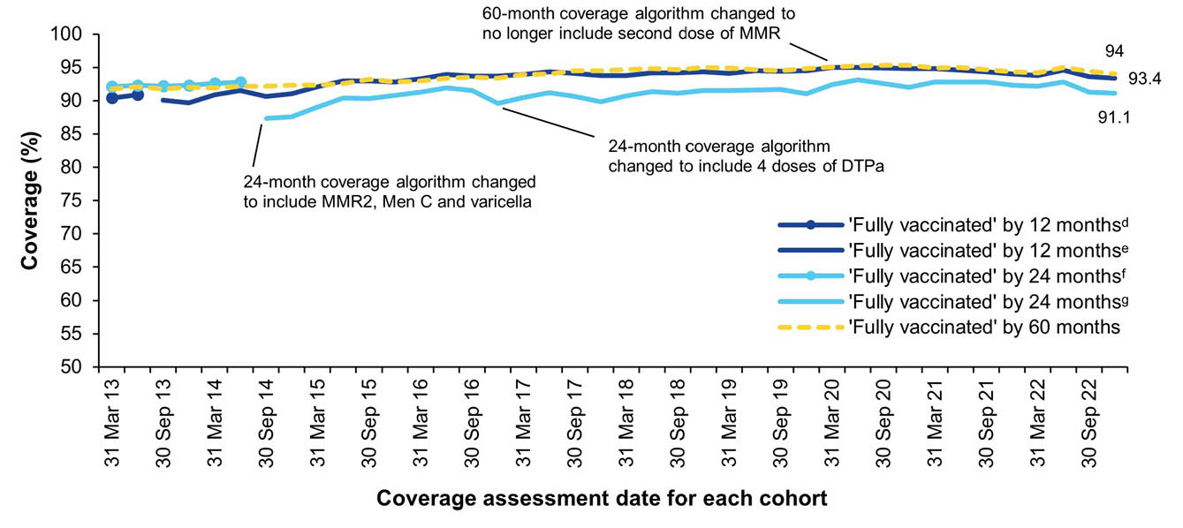
a Source: Australian Immunisation Register.
b By three-month birth cohorts born between 1 January 2012 and 31 December 2021. Coverage assessment date was 12, 24 or 60 months after the last birthdate of each cohort. Vaccination coverage estimates are calculated by quarter and may differ slightly from estimates published elsewhere using rolling annualised data.
c MMR2: second dose of MMR vaccine; MenC: Meningococcal C-containing; DTPa: Diphtheria-tetanus-acellular pertussis.
d Coverage algorithm before 1 July 2013.
e Coverage algorithm from 1 July 2013.
f Coverage algorithm before 1 July 2014.
g Coverage algorithm from 1 July 2014.
Figure A.2: Trends in vaccination coverage at 12 months of age, by vaccine/antigen and quarter, Australia,^{a,b,c,d} 2013–2022
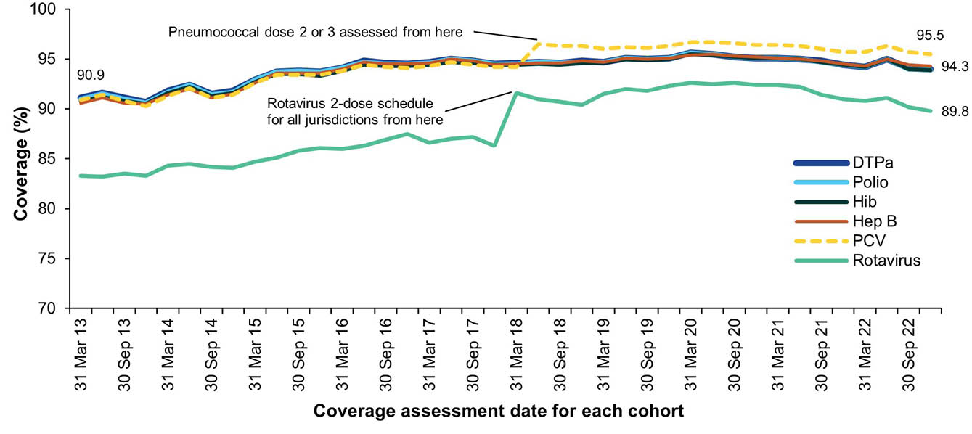
a Source: Australian Immunisation Register.
b Note: By three-month birth cohorts born between 1 January 2012 and 31 December 2021. Coverage assessment date was 12 months after the last birth date of each cohort. Vaccination coverage estimates are calculated by quarter and may differ slightly from estimates published elsewhere using rolling annualised data.
c Third dose of DTPa vaccine, polio vaccine and 13vPCV, second or third dose of Hib and rotavirus vaccines, and third dose of hepatitis B vaccine.
d DTPa: diphtheria-tetanus-acellular pertussis; Hib: Haemophilus influenzae type b; Hep B: hepatitis B; 13vPCV: pneumococcal conjugate vaccine.
Figure A.3: Trends in vaccination coverage at 24 months of age by vaccine/antigen and quarter, Australia,^{a,b,c,d} 2013–2022
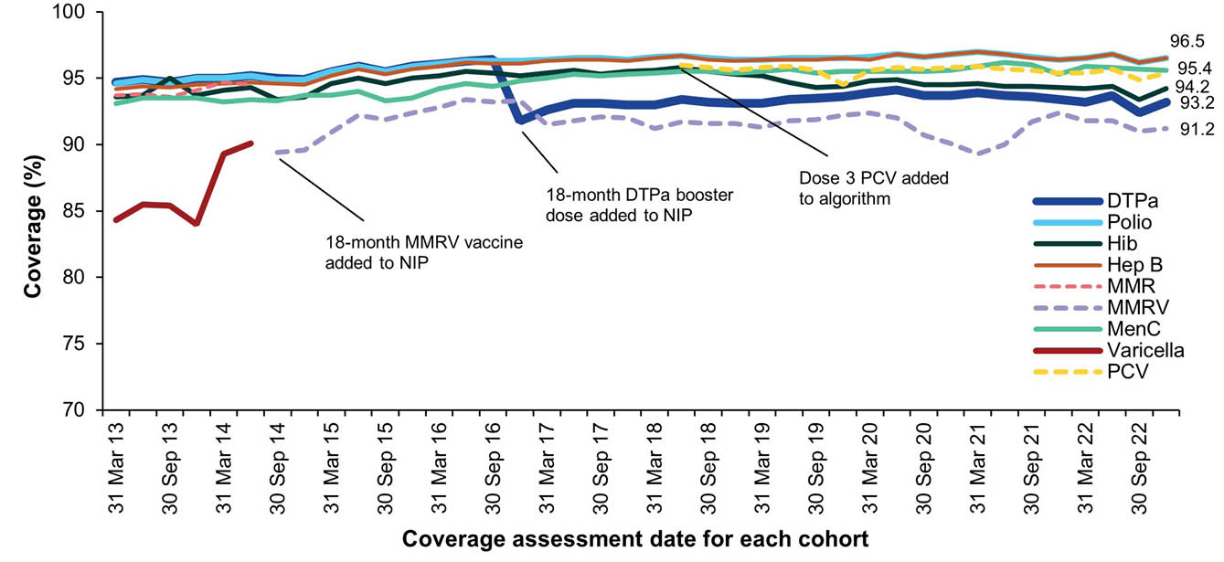
a Source: Australian Immunisation Register.
b Note: By three-month birth cohorts born between 1 January 2011 and 31 December 2020. Coverage assessment date was 24 months after the last birth date of each cohort. Vaccination coverage estimates are calculated by quarter and may differ slightly from estimates published elsewhere using rolling annualised data.
c Fourth dose of DTPa, third dose of polio, third or fourth dose of Hib, third dose of hepatitis B, second dose of MMR, dose 2 of MMRV, first dose of MenC, one dose of varicella, and third or fourth dose of 13vPCV.
d DTPa: diphtheria-tetanus-acellular pertussis; Hib: Haemophilus influenzae type b; Hep B: hepatitis B; MMR: measles-mumps-rubella; MenC: meningococcal C-containing; MMRV: measles-mumps-rubella-varicella; 13vPCV: pneumococcal conjugate vaccine.
Figure A.4: Trends in vaccination coverage at 60 months of age by vaccine/antigen and quarter, Australia,^{a,b,c,d} 2013–2022
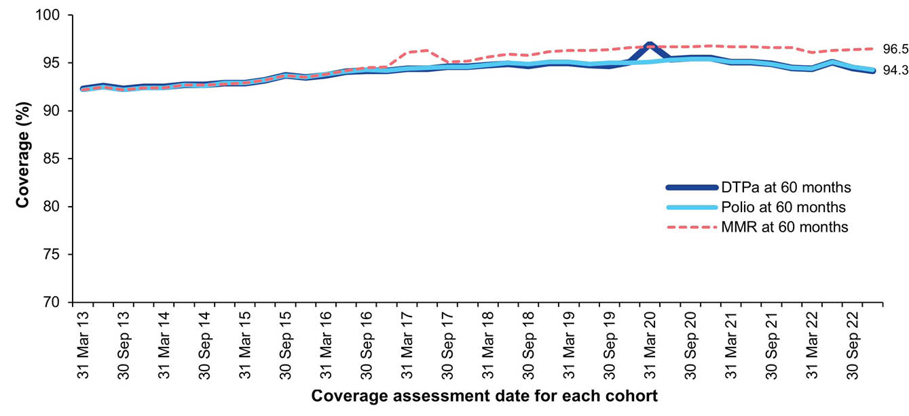
a Source: Australian Immunisation Register.
b Note: By three-month birth cohorts born between 1 January 2008 and 31 December 2017. Coverage assessment date was 60 months after the last birth date of each cohort. Vaccination coverage estimates are calculated by quarter and may differ slightly from estimates published elsewhere using rolling annualised data.
c Fourth or fifth dose of DTPa and fourth dose of polio, second dose of MMR (until June 2017).
d DTPa: Diphtheria-tetanus-acellular pertussis; MMR: Measles-mumps-rubella.
Figure A.5: Trends in fully vaccinated coverage at 12 months of age by Indigenous status and quarter, Australia,^{a,b,c,d} 2013–2022
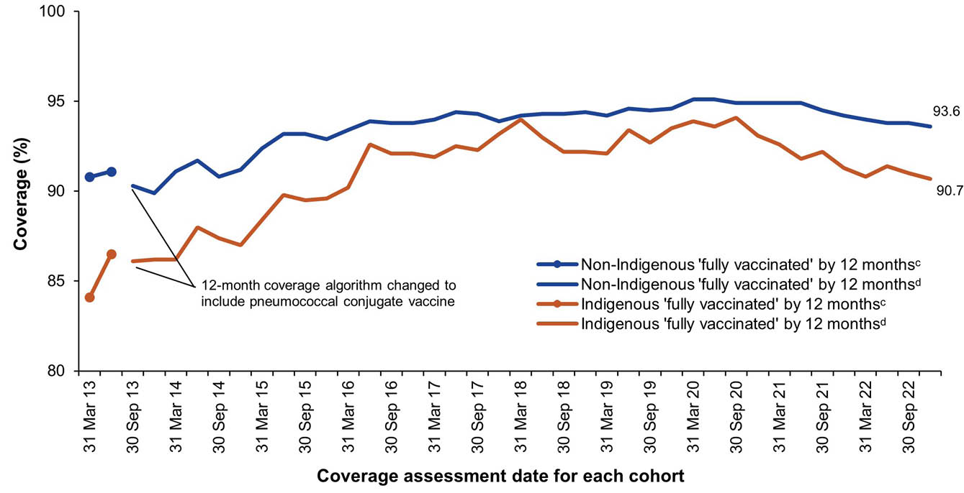
a Source: Australian Immunisation Register.
b Note: Vaccination coverage estimates are calculated using three-month-wide birth cohorts by quarter and may differ slightly from estimates published elsewhere using rolling annualised data.
c Coverage algorithm before 1 July 2013.
d Coverage algorithm from 1 July 2013.
Figure A.6: Trends in fully vaccinated coverage at 24 months of age by Indigenous status and quarter, Australia,^{a,b,c,d} 2013–2022
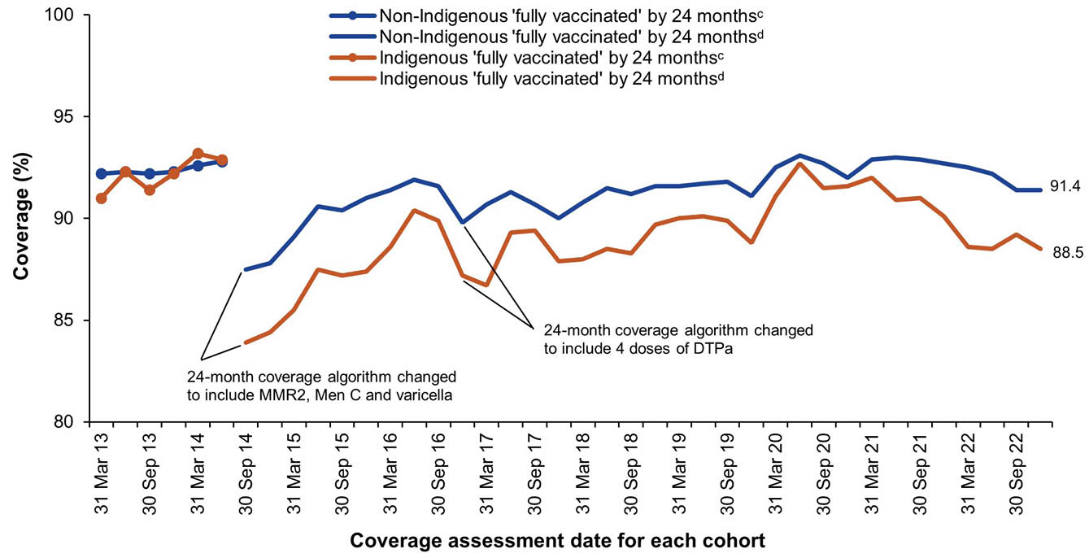
a Source: Australian Immunisation Register.
b Note: Vaccination coverage estimates are calculated using three-month-wide birth cohorts by quarter and may differ slightly from estimates published elsewhere using rolling annualised data.
c Coverage algorithm before 1 July 2014.
d Coverage algorithm from 1 July 2014.
Figure A.7: Trends in fully vaccinated coverage at 60 months of age by Indigenous status and quarter, Australia,^{a,b} 2013–2022
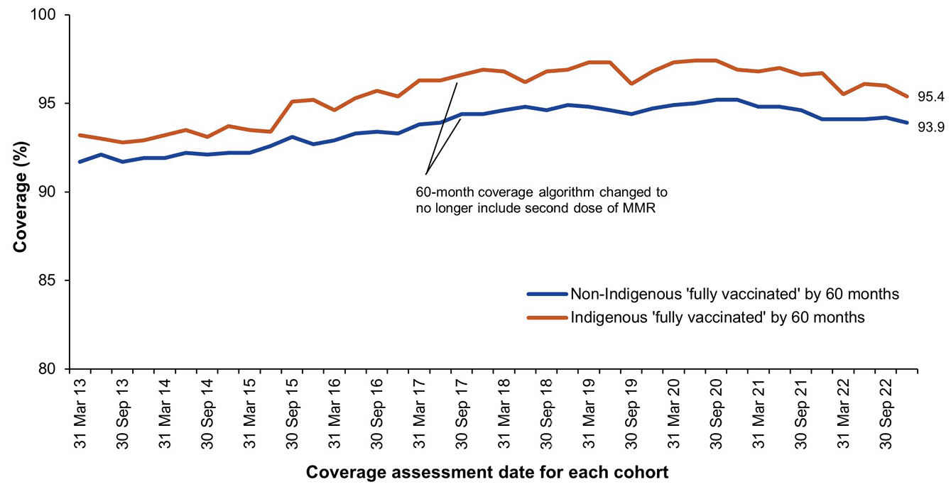
a Source: Australian Immunisation Register.
b Note: Vaccination coverage estimates are calculated using three-month-wide birth cohorts by quarter and may differ slightly from estimates published elsewhere using rolling annualised data.
Figure A.8: Trends in coverage for hepatitis A vaccine by 30 months of age for Indigenous children by jurisdiction, Australia,^{a,b,c,d} 2013–2022
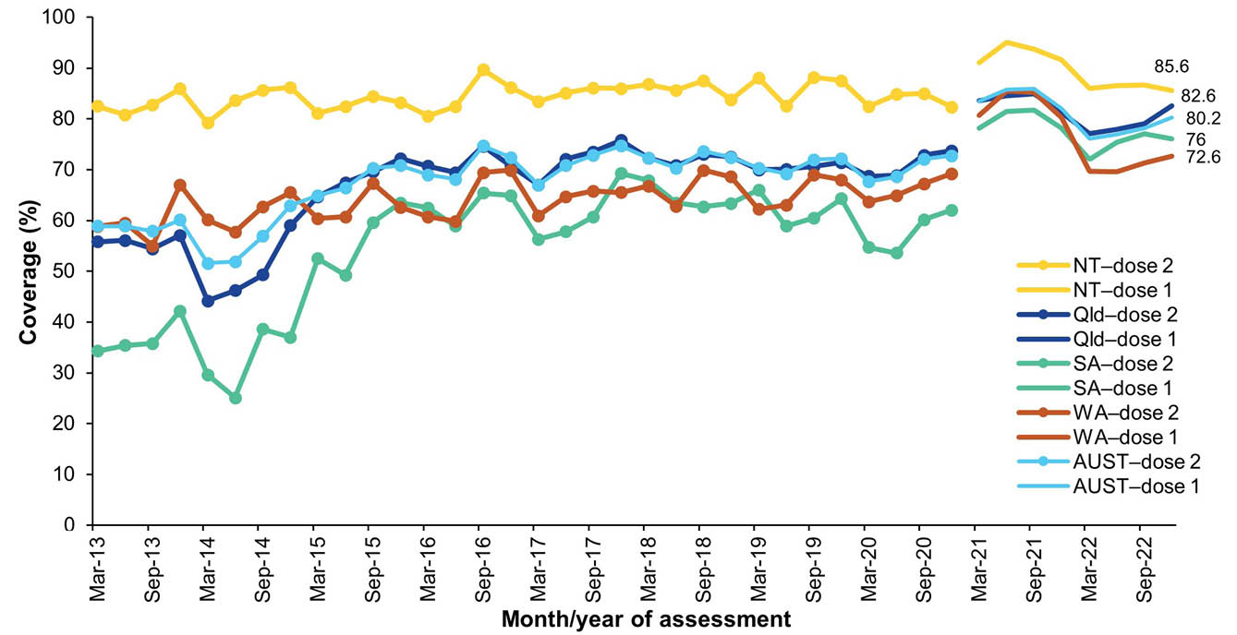
a Source: Australian Immunisation Register.
b Note: Vaccination coverage estimates are calculated using three-month-wide birth cohorts by quarter.
c 18-month dose assessed: Scheduled ages for hepatitis A vaccination changed from 12 to 18 months (dose 1) and from 18 months to 4 years (dose 2) from July 2020.
d Northern Territory (NT), Queensland (Qld), South Australia (SA) and Western Australia (WA) only; AUST: Australia.
Figure A.9: Trends in coverage for pneumococcal vaccine for Indigenous children by jurisdiction, Australia,^{a,b,c,d,e} 2013–2022
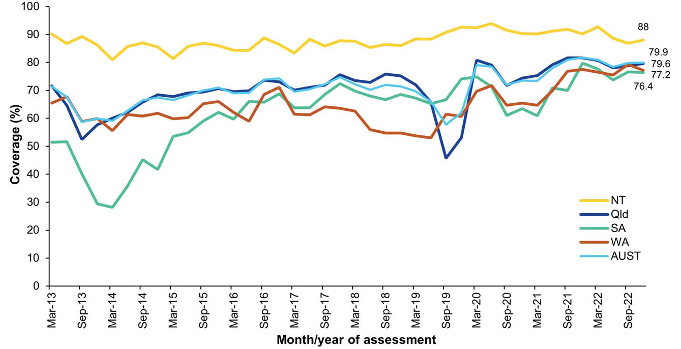
a Source: Australian Immunisation Register.
b Note: Vaccination coverage estimates are calculated using three-month-wide birth cohorts by quarter.
c 13vPCV: 13-valent pneumococcal conjugate vaccine.
d Northern Territory (NT), Queensland (Qld), South Australia (SA) and Western Australia (WA) only; AUST: Australia.
e 12-month booster dose (fourth dose) assessed at 30 months of age in all four jurisdictions.
Figure A.10: Coverage of COVID-19 vaccines (doses 1–4) in all people by age group, Australia,^{a,b,c} 2022
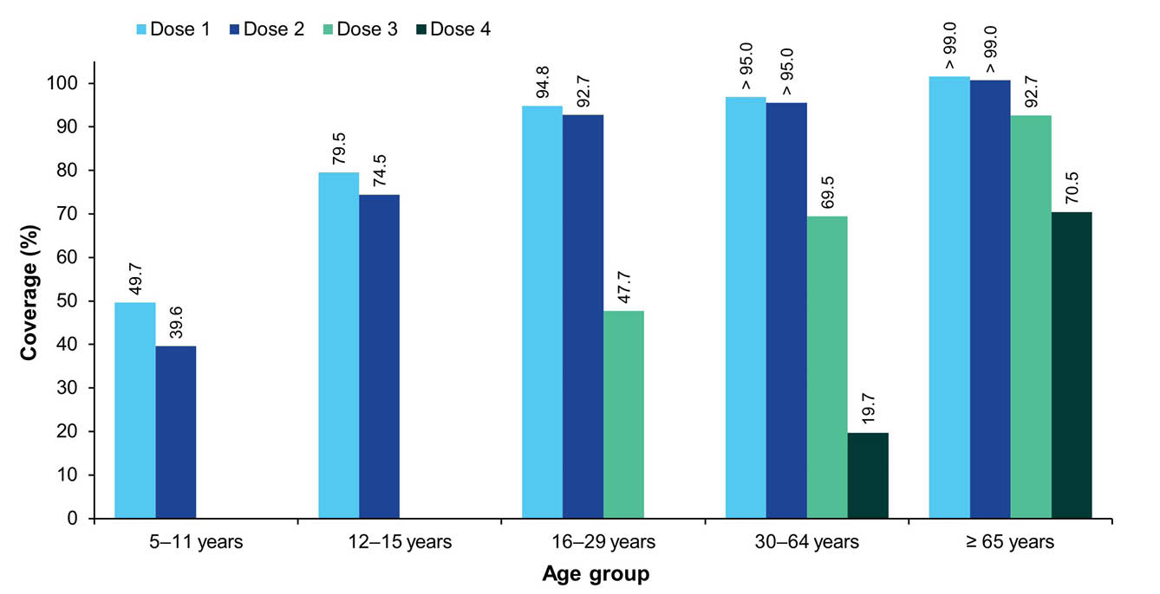
a Source: Adapted from Australian Department of Health, Disability and Ageing data as at 4 January 2023.
b Coverage for doses 3 and 4 only shown for people aged 16 years and over, as these doses were not routinely offered to children and adolescents aged 5–15 years.
c Note: Coverage for doses 3 and 4 may be underestimated, given that not all people aged 16 years and over in the population were eligible to receive a third or fourth dose (based on completion of previous doses, age and the time period elapsed since last dose).
Figure A.11: Coverage of COVID-19 vaccines (doses 1–4) in people aged 16 years and over by Indigenous status, Australia,^{a,b} 2022
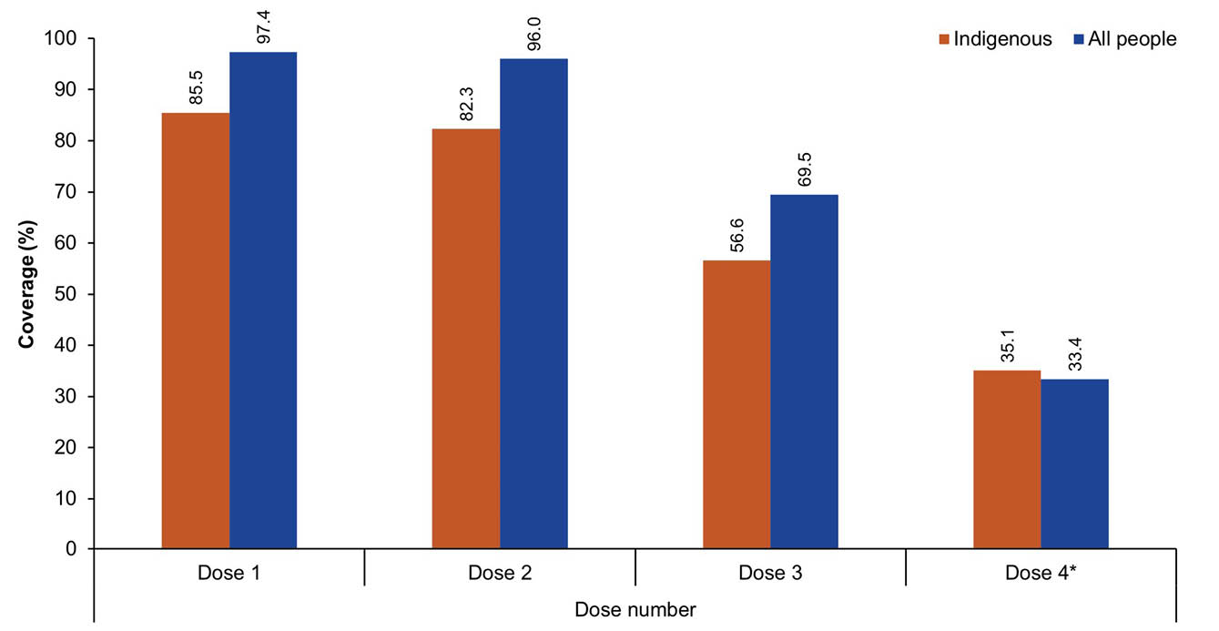
a Source: Adapted from Australian Department of Health, Disability and Ageing data as at 4 January 2023.
b Coverage for dose 4 is for people aged 30 years and over.
Table A.3: Fully vaccinated coverage assessed at standard age milestones (12, 24 and 60 months) and earlier (9, 15, 21, 51 months) milestones, all children, by PHN and jurisdiction, Australia,ª 2022
Jurisdiction and PHN | Age milestone
Jurisdiction and PHN | 9 mo^{b} | 12 mo^{b} | 15 mo^{c} | 21 mo^{c} | 24 mo^{c} | 51 mo^{d} | 60 mo^{d}
Australian Capital Territory | 94.8 | 96.5 | 93.5 | 91.9 | 94.0 | 91.2 | 95.0
Australian Capital Territory | 94.8 | 96.5 | 93.5 | 91.9 | 94.0 | 91.2 | 95.0
New South Wales | 90.2 | 93.5 | 90.0 | 87.2 | 91.0 | 86.6 | 93.4
Central and Eastern Sydney | 91.1 | 93.9 | 90.0 | 87.2 | 90.8 | 84.1 | 91.1
Hunter New England and Central Coast | 91.7 | 94.9 | 91.8 | 89.3 | 92.8 | 88.5 | 95.0
Murrumbidgee | 91.8 | 94.3 | 92.3 | 88.8 | 92.3 | 90.6 | 95.3
Nepean Blue Mountains | 90.1 | 93.5 | 91.5 | 88.0 | 91.8 | 88.4 | 95.4
North Coast | 84.0 | 88.1 | 84.9 | 82.2 | 86.1 | 82.1 | 89.1
Northern Sydney | 92.7 | 94.8 | 91.1 | 88.6 | 91.5 | 86.1 | 92.2
South Eastern NSW | 91.7 | 94.3 | 92.1 | 89.1 | 92.8 | 89.2 | 95.2
South Western Sydney | 87.9 | 92.2 | 88.3 | 85.6 | 90.1 | 86.6 | 94.1
Western NSW | 91.9 | 95.3 | 92.1 | 89.4 | 93.8 | 88.7 | 95.9
Western Sydney | 89.2 | 92.9 | 88.4 | 85.9 | 89.8 | 86.4 | 93.8
Victoria | 89.7 | 93.7 | 90.0 | 88.0 | 91.7 | 87.9 | 94.2
Eastern Melbourne | 90.7 | 94.3 | 90.6 | 89.0 | 92.2 | 88.3 | 94.2
Gippsland | 88.9 | 92.9 | 90.5 | 86.9 | 91.7 | 90.1 | 95.8
Murray | 89.8 | 94.1 | 90.9 | 89.4 | 93.0 | 89.1 | 95.8
North Western Melbourne | 88.8 | 93.1 | 88.7 | 86.8 | 90.6 | 87.1 | 93.7
South Eastern Melbourne | 89.4 | 93.5 | 89.8 | 87.5 | 91.4 | 87.4 | 93.7
Western Victoria | 91.0 | 94.5 | 92.5 | 90.8 | 93.8 | 89.0 | 95.4
Queensland | 88.5 | 92.5 | 89.0 | 85.8 | 90.5 | 85.3 | 92.5
Brisbane North | 91.0 | 94.4 | 91.4 | 88.7 | 92.8 | 87.2 | 93.6
Brisbane South | 89.4 | 93.2 | 89.5 | 86.5 | 90.9 | 85.1 | 92.1
Central Queensland, Wide Bay, Sunshine Coast | 86.6 | 90.6 | 87.6 | 84.1 | 89.0 | 83.6 | 91.1
Darling Downs and West Moreton | 89.4 | 93.2 | 90.2 | 87.2 | 91.5 | 87.6 | 94.1
Gold Coast | 85.5 | 90.0 | 85.4 | 82.2 | 87.5 | 83.1 | 90.4
Northern Queensland | 87.5 | 92.5 | 88.6 | 84.8 | 90.5 | 85.1 | 93.6
Western Queensland | 84.4 | 90.7 | 86.3 | 77.8 | 87.2 | 80.0 | 92.1
South Australia | 90.6 | 94.1 | 90.3 | 88.0 | 91.4 | 88.5 | 94.8
Adelaide | 90.9 | 94.4 | 90.6 | 88.4 | 91.7 | 88.6 | 94.7
Country SA | 88.8 | 92.8 | 88.7 | 85.4 | 90.0 | 87.6 | 94.8
Western Australia | 88.3 | 92.9 | 88.3 | 84.5 | 89.8 | 84.0 | 92.3
Country WA | 84.5 | 90.8 | 85.4 | 80.0 | 87.0 | 81.3 | 91.5
Perth North | 89.5 | 93.6 | 89.3 | 85.9 | 90.8 | 84.8 | 92.6
Perth South | 89.1 | 93.3 | 88.9 | 85.6 | 90.3 | 84.5 | 92.4
Tasmania | 91.2 | 94.5 | 90.6 | 87.9 | 91.5 | 87.5 | 93.7
Tasmania | 91.2 | 94.5 | 90.6 | 87.9 | 91.5 | 87.5 | 93.7
Northern Territory | 84.9 | 90.6 | 86.7 | 79.7 | 87.9 | 81.0 | 92.6
Northern Territory | 84.9 | 90.6 | 86.7 | 79.7 | 87.9 | 81.0 | 92.6
Australia | 89.6 | 93.3 | 89.7 | 86.9 | 91.0 | 86.5 | 93.4
a Coverage algorithm used for 9-, 21- and 51-month milestones same as for 12-,24- and 60-month milestones, respectively; algorithm used for 15 months same as for 24 months but excludes doses due at 18 months. For further detail on algorithms, refer to Table A.2.
b Cohort born 1 January 2021 – 31 December 2021.
c Cohort born 1 January 2020 – 31 December 2020.
d Cohort born 1 January 2017 – 31 December 2017.
Table A.4: Fully vaccinated coverage assessed at standard age milestones (12, 24 and 60 months) and earlier (9, 15, 21, 51 months) milestones, Indigenous children, by PHN and jurisdiction, Australia,ª 2022
Jurisdiction and PHN | Age milestone
Jurisdiction and PHN | 9 mo^{b} | 12 mo^{b} | 15 mo^{c} | 21 mo^{c} | 24 mo^{c} | 51 mo^{d} | 60 mo^{d}
Australian Capital Territory | 87.3 | 92.1 | 83.5 | 82.9 | 87.7 | 86.2 | 94.2
Australian Capital Territory | 87.3 | 92.1 | 83.5 | 82.9 | 87.7 | 86.2 | 94.2
New South Wales | 86.5 | 92.8 | 88.5 | 84.6 | 90.8 | 86.7 | 96.1
Central and Eastern Sydney | 84.9 | 92.1 | 83.1 | 79.6 | 86.6 | 82.2 | 95.6
Hunter New England and Central Coast | 87.8 | 94.2 | 89.3 | 85.3 | 91.1 | 87.9 | 96.5
Murrumbidgee | 89.0 | 93.2 | 89.4 | 84.2 | 92.1 | 90.5 | 98.0
Nepean Blue Mountains | 88.8 | 92.2 | 91.3 | 88.3 | 93.0 | 88.1 | 96.6
North Coast | 82.6 | 90.0 | 87.2 | 83.6 | 89.0 | 83.6 | 94.2
Northern Sydney | 86.7 | 90.3 | 91.5 | 88.1 | 91.5 | 87.1 | 95.7
South Eastern NSW | 87.5 | 93.4 | 88.2 | 83.9 | 89.9 | 87.3 | 97.0
South Western Sydney | 84.5 | 92.5 | 88.6 | 84.2 | 90.9 | 83.4 | 94.6
Western NSW | 85.4 | 92.8 | 87.6 | 83.8 | 91.6 | 86.5 | 96.2
Western Sydney | 85.8 | 91.5 | 89.0 | 84.7 | 90.9 | 86.3 | 95.3
Victoria | 84.7 | 91.5 | 86.3 | 82.4 | 89.1 | 86.0 | 94.8
Eastern Melbourne | 85.3 | 88.7 | 88.2 | 84.2 | 91.6 | 89.5 | 96.8
Gippsland | 81.8 | 90.2 | 81.9 | 69.9 | 83.7 | 84.3 | 95.0
Murray | 84.7 | 92.6 | 84.0 | 84.3 | 89.1 | 84.7 | 94.1
North Western Melbourne | 84.6 | 90.4 | 86.6 | 83.1 | 87.3 | 85.0 | 94.4
South Eastern Melbourne | 84.7 | 93.2 | 88.2 | 82.0 | 89.4 | 89.0 | 96.1
Western Victoria | 86.2 | 92.7 | 88.7 | 86.9 | 92.6 | 86.4 | 94.6
Queensland | 79.7 | 89.1 | 85.9 | 79.6 | 88.4 | 82.5 | 95.1
Brisbane North | 82.7 | 91.0 | 86.8 | 83.4 | 90.3 | 83.3 | 95.7
Brisbane South | 78.2 | 88.5 | 87.6 | 81.2 | 88.6 | 83.8 | 95.5
Central Queensland, Wide Bay, Sunshine Coast | 82.1 | 89.0 | 87.1 | 82.9 | 89.4 | 82.5 | 94.8
Darling Downs and West Moreton | 84.4 | 91.6 | 88.3 | 82.6 | 90.3 | 86.4 | 94.9
Gold Coast | 83.0 | 91.2 | 85.7 | 82.7 | 90.7 | 87.2 | 95.7
Northern Queensland | 76.6 | 87.9 | 84.1 | 76.3 | 87.2 | 81.5 | 95.2
Western Queensland | 72.0 | 84.4 | 80.8 | 68.0 | 82.1 | 72.8 | 93.5
South Australia | 81.4 | 90.5 | 84.9 | 80.3 | 88.9 | 80.3 | 95.0
Adelaide | 82.8 | 91.4 | 86.7 | 81.2 | 89.9 | 80.3 | 94.8
Country SA | 74.4 | 87.0 | 79.5 | 72.2 | 83.2 | 77.0 | 94.3
Western Australia | 71.3 | 84.6 | 77.1 | 68.2 | 80.0 | 77.0 | 93.3
Country WA | 68.6 | 83.2 | 75.6 | 65.4 | 78.6 | 74.2 | 92.4
Perth North | 72.0 | 85.2 | 76.4 | 69.0 | 80.2 | 79.0 | 94.1
Perth South | 74.9 | 86.4 | 80.4 | 73.2 | 82.8 | 79.6 | 93.8
Tasmania | 88.3 | 94.6 | 91.8 | 87.9 | 93.6 | 89.8 | 97.1
Tasmania | 88.3 | 94.6 | 91.8 | 87.9 | 93.6 | 89.8 | 97.1
Northern Territory | 73.4 | 84.5 | 79.7 | 67.9 | 81.5 | 76.3 | 93.8
Northern Territory | 73.4 | 84.5 | 79.7 | 67.9 | 81.5 | 76.3 | 93.8
Australia | 81.5 | 90.0 | 85.4 | 79.5 | 87.9 | 83.1 | 95.1
a Coverage algorithm used for 9-, 21- and 51-month milestones same as for 12-,24- and 60-month milestones, respectively; algorithm used for 15 months same as for 24 months but excludes doses due at 18 months. For further detail on algorithms, refer to Table A.2.
b Cohort born 1 January 2021 – 31 December 2021.
c Cohort born 1 January 2020 – 31 December 2020.
d Cohort born 1 January 2017 – 31 December 2017.
Table A.5: Coverage of at least one dose of HPV vaccine in females by birth cohort/age, Indigenous status and jurisdiction, Australia,^{a,b,c,d,e} 2022
Cohort^{d} | Indigenous status
Cohort^{d} | All |  |  |  |  |  |  |  | Indigenous
Cohort^{d} | ACT | NSW | NT | Qld | SA | Tas. | Vic. | WA | ACT | NSW | NT | Qld | SA | Tas. | Vic. | WA
2009 cohort (13 yo) | 84.2 | 78.9 | 63.3 | 74.8 | 26.8 | 72.3 | 78.5 | 77.2 | 79.7 | 74.0 | 50.5 | 64.5 | 23.2 | 68.6 | 69.2 | 63.6
2008 cohort (14 yo) | 89.4 | 85.4 | 75.5 | 80.8 | 81.2 | 82.5 | 84.4 | 81.5 | 90.5 | 85.5 | 67.6 | 77.3 | 61.0 | 80.0 | 78.6 | 75.3
2007 cohort (15 yo) | 90.3 | 87.0 | 82.7 | 82.8 | 85.6 | 84.6 | 87.2 | 84.8 | 90.4 | 88.6 | 80.4 | 81.3 | 76.8 | 85.3 | 83.0 | 82.5
2006 cohort (16 yo) | 91.1 | 88.3 | 87.9 | 83.9 | 87.0 | 88.8 | 88.3 | 85.0 | 89.4 | 91.6 | 90.1 | 86.0 | 78.7 | 89.6 | 88.3 | 84.8
2005 cohort (17 yo) | 91.4 | 88.6 | 90.0 | 85.1 | 88.2 | 89.9 | 89.3 | 86.2 | 89.4 | 92.7 | 92.9 | 88.4 | 82.5 | 89.4 | 87.9 | 86.2
2004 cohort (18 yo) | 90.3 | 88.6 | 91.7 | 85.4 | 88.5 | 89.9 | 89.4 | 85.8 | 89.3 | 92.8 | 95.4 | 89.7 | 81.6 | 90.6 | 91.9 | 88.5
2003 cohort (19 yo) | 89.7 | 88.4 | 90.6 | 85.0 | 88.8 | 89.7 | 89.0 | 86.5 | 89.2 | 92.3 | 94.4 | 88.7 | 91.1 | 92.0 | 90.8 | 89.8
2002 cohort (20 yo) | 88.6 | 87.2 | 91.3 | 85.2 | 88.2 | 88.9 | 88.4 | 86.1 | 87.0 | 89.6 | 95.4 | 88.7 | 86.1 | 86.8 | 86.7 | 86.9
2001 cohort (21 yo) | 87.7 | 84.9 | 90.0 | 83.8 | 87.6 | 87.3 | 85.8 | 84.8 | 92.2 | 85.6 | 93.5 | 85.5 | 79.1 | 87.1 | 86.7 | 85.9
2000 cohort (22 yo) | 84.3 | 82.1 | 86.5 | 81.3 | 84.0 | 83.1 | 82.7 | 80.8 | 85.7 | 85.0 | 93.2 | 81.0 | 74.0 | 80.4 | 80.7 | 80.7
1999 cohort (23 yo) | 82.1 | 77.9 | 82.9 | 77.9 | 83.0 | 78.5 | 79.9 | 78.9 | 82.7 | 78.4 | 87.1 | 76.5 | 80.3 | 78.3 | 79.9 | 78.3
1998 cohort (24 yo) | 77.8 | 71.4 | 78.5 | 74.6 | 79.5 | 74.4 | 76.7 | 75.9 | 81.9 | 72.6 | 87.0 | 71.5 | 71.6 | 75.3 | 76.1 | 81.1
1997 cohort (25 yo) | 73.9 | 69.9 | 75.6 | 71.5 | 74.4 | 70.5 | 72.4 | 72.1 | 78.6 | 73.0 | 87.0 | 70.7 | 69.7 | 75.2 | 76.8 | 75.7
1996 cohort (26 yo) | 69.7 | 69.0 | 72.5 | 71.7 | 72.3 | 72.8 | 69.7 | 64.7 | 80.0 | 77.0 | 87.8 | 76.5 | 72.0 | 76.8 | 73.5 | 75.1
a Source: Australian Immunisation Register data as at 2 April 2023.
b Coverage calculated using the number of Medicare-registered females in each year-wide cohort with an AIR record of having received at least one dose of HPV vaccine by 31 December 2022 as the numerator and the total number of Medicare-registered females in the relevant age cohort as the denominator, expressed as a percentage.
c Note: Coverage data for the cohort of 15-year-olds presented in this table include doses given before and after their fifteenth birthday. Data may therefore differ slightly from data presented in Table 2, where coverage only includes doses given before the fifteenth birthday (in line with WHO recommendations for international reporting).
d Birth/age cohort based on age turning in 2022.
e ACT: Australian Capital Territory; NSW: New South Wales; NT: Northern Territory; Qld: Queensland; SA: South Australia; Tas.: Tasmania; Vic.: Victoria; WA: Western Australia.
Table A.6: Coverage of at least one dose of HPV vaccine in males by birth cohort/age, Indigenous status and jurisdiction, Australia,^{a,b,c,d,e} 2022
Cohort^{d} | Indigenous status
Cohort^{d} | All |  |  |  |  |  |  |  | Indigenous
Cohort^{d} | ACT | NSW | NT | Qld | SA | Tas. | Vic. | WA | ACT | NSW | NT | Qld | SA | Tas. | Vic. | WA
2009 cohort (13 yo) | 83.1 | 73.3 | 56.2 | 71.3 | 23.5 | 67.9 | 73.9 | 75.6 | 76.7 | 61.7 | 41.8 | 57.8 | 19.4 | 62.8 | 61.6 | 59.4
2008 cohort (14 yo) | 87.5 | 81.8 | 70.0 | 78.0 | 77.8 | 78.9 | 82.4 | 81.0 | 76.6 | 78.4 | 61.1 | 72.0 | 53.1 | 79.7 | 74.4 | 71.6
2007 cohort (15 yo) | 87.8 | 84.6 | 79.2 | 80.9 | 83.8 | 80.9 | 84.7 | 83.5 | 82.7 | 82.8 | 76.7 | 77.8 | 66.0 | 80.5 | 79.8 | 79.6
2006 cohort (16 yo) | 89.8 | 85.8 | 82.1 | 82.3 | 85.3 | 84.5 | 86.7 | 84.7 | 83.7 | 87.1 | 82.0 | 80.3 | 75.4 | 83.0 | 82.3 | 80.4
2005 cohort (17 yo) | 88.7 | 86.8 | 86.8 | 83.5 | 86.8 | 87.2 | 87.2 | 85.3 | 81.2 | 88.2 | 86.6 | 84.5 | 77.4 | 86.6 | 84.0 | 82.1
2004 cohort (18 yo) | 89.4 | 86.0 | 88.9 | 83.0 | 86.1 | 88.6 | 87.3 | 85.1 | 89.7 | 86.1 | 92.6 | 86.4 | 78.7 | 88.3 | 88.7 | 83.6
2003 cohort (19 yo) | 88.3 | 85.4 | 87.7 | 82.0 | 86.6 | 87.7 | 86.8 | 84.3 | 87.7 | 87.8 | 91.3 | 83.8 | 80.5 | 84.2 | 85.7 | 84.7
2002 cohort (20 yo) | 87.5 | 83.9 | 88.6 | 81.3 | 85.7 | 85.9 | 85.8 | 83.6 | 80.3 | 83.5 | 91.9 | 82.1 | 79.7 | 83.6 | 85.6 | 84.5
2001 cohort (21 yo) | 81.8 | 79.2 | 86.0 | 79.4 | 84.1 | 80.6 | 81.8 | 81.9 | 82.6 | 76.9 | 91.0 | 77.2 | 76.9 | 78.6 | 80.5 | 78.8
2000 cohort (22 yo) | 78.2 | 73.0 | 81.2 | 75.0 | 79.4 | 75.8 | 77.3 | 73.8 | 66.2 | 68.5 | 85.9 | 73.0 | 70.0 | 74.2 | 70.3 | 67.9
1999 cohort (23 yo) | 76.0 | 69.0 | 73.3 | 69.1 | 75.7 | 72.8 | 73.8 | 66.0 | 61.3 | 60.4 | 74.6 | 61.4 | 58.3 | 65.6 | 64.4 | 53.8
1998 cohort (24 yo) | 59.9 | 49.4 | 57.0 | 64.2 | 53.2 | 64.8 | 60.9 | 63.2 | 45.8 | 46.4 | 57.6 | 52.4 | 46.1 | 56.6 | 53.3 | 44.1
1997 cohort (25 yo) | 8.5 | 4.3 | 16.8 | 14.2 | 9.8 | 7.6 | 7.6 | 30.5 | 8.6 | 6.9 | 16.2 | 15.0 | 7.9 | 7.9 | 8.7 | 20.3
1996 cohort (26 yo) | 1.3 | 0.7 | 1.6 | 0.8 | 0.5 | 1.2 | 1.0 | 0.7 | 3.9 | 3.5 | 2.2 | 0.6 | 1.4 | 2.1 | 1.2 | 2.2
a Source: Australian Immunisation Register data as at 2 April 2023.
b Coverage calculated using the number of Medicare-registered males in each year-wide cohort with an AIR record of having received at least one dose of HPV vaccine by 31 December 2022 as the numerator and the total number of Medicare-registered males in the relevant age cohort as the denominator, expressed as a percentage.
c Note: Coverage data for the cohort of 15-year-olds presented in this table include doses given before and after their fifteenth birthday. Data may therefore differ slightly from data presented in Table 2, where coverage only includes doses given before the fifteenth birthday (in line with WHO recommendations for international reporting).
d Birth/age cohort based on age turning in 2022.
e ACT: Australian Capital Territory; NSW: New South Wales; NT: Northern Territory; Qld: Queensland; SA: South Australia; Tas.: Tasmania; Vic.: Victoria; WA: Western Australia.
Table A.7: Coverage of a dose of diphtheria-tetanus-acellular pertussis vaccine in adolescents by age, Indigenous status and jurisdiction, Australia,^{a,b,c,d} 2021 and 2022
Age | Year | Indigenous status
Age | Year | All |  |  |  |  |  |  |  | Indigenous
Age | Year | ACT | NSW | NT | Qld | SA | Tas. | Vic. | WA | ACT | NSW | NT | Qld | SA | Tas. | Vic. | WA
13 years | 2021 | 28.4 | 80.6 | 68.9 | 79.5 | 29.5 | 73.4 | 81.4 | 82.2 | 29.1 | 77.2 | 56.6 | 72.2 | 22.7 | 70.7 | 68.6 | 69.8
13 years | 2022 | 76.7 | 76.5 | 61.0 | 74.6 | 27.3 | 69.9 | 77.3 | 78.7 | 62.1 | 68.0 | 47.3 | 62.2 | 23.0 | 64.8 | 65.0 | 62.2
14 years | 2021 | 86.4 | 86.6 | 78.3 | 83.3 | 85.7 | 79.2 | 86.2 | 86.4 | 73.6 | 83.0 | 63.7 | 75.9 | 58.4 | 77.8 | 76.0 | 74.4
14 years | 2022 | 84.2 | 85.4 | 73.0 | 81.4 | 82.3 | 80.6 | 85.0 | 84.2 | 80.0 | 83.9 | 72.3 | 78.1 | 67.5 | 80.8 | 78.3 | 80.5
15 years | 2021 | 89.9 | 89.0 | 84.3 | 85.3 | 89.1 | 87.2 | 88.8 | 88.2 | 82.5 | 90.1 | 82.5 | 82.7 | 78.3 | 89.1 | 85.6 | 82.6
15 years | 2022 | 88.5 | 87.8 | 81.0 | 84.5 | 87.5 | 84.5 | 87.7 | 87.4 | 82.7 | 86.6 | 76.8 | 81.3 | 73.3 | 84.9 | 81.6 | 82.5
16 years | 2021 | 88.3 | 88.7 | 87.2 | 85.6 | 89.8 | 85.3 | 88.4 | 88.6 | 75.2 | 89.3 | 85.6 | 85.4 | 81.3 | 84.1 | 85.3 | 83.8
16 years | 2022 | 90.3 | 89.3 | 85.2 | 85.8 | 89.4 | 87.8 | 89.3 | 88.4 | 82.9 | 90.5 | 84.8 | 84.6 | 80.2 | 89.7 | 87.0 | 84.5
17 years | 2021 | 86.5 | 88.4 | 86.3 | 85.7 | 88.9 | 81.3 | 88.7 | 88.6 | 83.5 | 87.1 | 86.3 | 88.2 | 78.3 | 81.3 | 86.7 | 85.5
17 years | 2022 | 89.1 | 89.3 | 88.3 | 86.4 | 90.1 | 86.8 | 89.4 | 88.9 | 77.8 | 90.2 | 87.4 | 86.6 | 83.4 | 86.6 | 87.3 | 85.8
18 years | 2021 | 80.8 | 88.1 | 85.5 | 84.5 | 88.0 | 79.5 | 87.2 | 88.3 | 77.4 | 88.5 | 85.9 | 84.7 | 79.4 | 79.0 | 85.5 | 85.8
18 years | 2022 | 87.7 | 88.8 | 87.2 | 86.3 | 89.4 | 83.5 | 89.1 | 88.7 | 84.6 | 88.1 | 88.3 | 89.3 | 81.5 | 83.7 | 87.9 | 86.4
19 years | 2021 | 81.2 | 85.9 | 86.2 | 84.2 | 84.4 | 67.6 | 82.7 | 86.9 | 73.2 | 84.8 | 87.7 | 84.2 | 74.7 | 68.7 | 78.5 | 81.5
19 years | 2022 | 82.2 | 88.3 | 85.9 | 84.9 | 88.3 | 80.9 | 87.4 | 88.2 | 78.9 | 89.3 | 86.8 | 86.0 | 81.2 | 79.0 | 86.5 | 85.6
a Source: Australian Immunisation Register data as at 3 April 2022 (for 2021 data points) and as at 2 April 2023 (for 2022 data points).
b Coverage calculated using the number of Medicare-registered individuals in each year-wide cohort with an AIR record of having received an adolescent (i.e. ≥ 10 years of age) dose of diphtheria-tetanus-acellular pertussis vaccine (recorded as either dTpa or DTPa) by 31 December of the relevant year as the numerator and the total number of Medicare-registered adolescents in the relevant age cohort as the denominator, expressed as a percentage.
c Birth/age cohort based on age turning in the relevant year.
d ACT: Australian Capital Territory; NSW: New South Wales; NT: Northern Territory; Qld: Queensland; SA: South Australia; Tas.: Tasmania; Vic.: Victoria; WA: Western Australia.
Table A.8: Coverage of a dose of meningococcal ACWY vaccine in adolescents by age, Indigenous status and jurisdiction, Australia,^{a,b,c,d} 2021 and 2022
Age | Year | Indigenous status
Age | Year | All |  |  |  |  |  |  |  | Indigenous
Age | Year | ACT | NSW | NT | Qld | SA | Tas. | Vic. | WA | ACT | NSW | NT | Qld | SA | Tas. | Vic. | WA
15 years | 2021 | 23.8 | 17.7 | 76.3 | 32.6 | 26.8 | 71.5 | 15.3 | 38.6 | 15.7 | 13.4 | 82.8 | 35.7 | 29.2 | 77.7 | 12.6 | 38.1
15 years | 2022 | 23.1 | 20.1 | 71.4 | 29.6 | 24.8 | 71.8 | 15.4 | 36.0 | 15.8 | 11.4 | 75.5 | 32.6 | 25.5 | 72.4 | 10.4 | 33.6
16 years | 2021 | 81.6 | 64.8 | 79.3 | 70.5 | 79.4 | 81.1 | 70.2 | 75.8 | 60.0 | 51.0 | 84.3 | 63.6 | 57.4 | 81.8 | 51.5 | 57.7
16 years | 2022 | 78.8 | 65.3 | 78.9 | 65.6 | 74.4 | 82.8 | 68.9 | 71.1 | 57.6 | 46.3 | 84.6 | 56.1 | 55.9 | 83.8 | 46.8 | 55.6
17 years | 2021 | 85.4 | 77.8 | 80.4 | 75.4 | 81.3 | 84.2 | 77.2 | 80.3 | 69.0 | 65.0 | 84.7 | 69.4 | 64.5 | 87.2 | 62.5 | 67.8
17 years | 2022 | 84.3 | 74.1 | 80.8 | 73.6 | 81.6 | 83.8 | 76.5 | 77.8 | 63.0 | 59.3 | 86.1 | 67.5 | 61.9 | 83.9 | 58.4 | 61.8
18 years | 2021 | 83.9 | 79.2 | 76.7 | 77.2 | 67.4 | 82.1 | 80.6 | 81.7 | 72.3 | 69.1 | 81.8 | 72.5 | 58.2 | 82.6 | 67.3 | 73.9
18 years | 2022 | 86.5 | 79.1 | 81.0 | 76.5 | 82.1 | 85.6 | 78.7 | 80.9 | 73.4 | 66.7 | 85.9 | 71.6 | 67.5 | 87.5 | 65.6 | 69.9
19 years | 2021 | 82.9 | 75.2 | 74.7 | 73.4 | 31.9 | 85.6 | 79.2 | 78.2 | 66.7 | 62.3 | 79.6 | 70.8 | 36.6 | 84.5 | 65.2 | 69.7
19 years | 2022 | 84.4 | 79.3 | 77.2 | 77.3 | 68.1 | 82.4 | 80.8 | 81.5 | 71.4 | 69.2 | 81.8 | 73.3 | 59.5 | 82.6 | 67.7 | 74.4
a Source: Australian Immunisation Register data as at 3 April 2022 (for 2021 data points) and as at 2 April 2023 (for 2022 data points).
b Coverage calculated using the number of Medicare-registered individuals in each year-wide cohort with an AIR record of having received an adolescent (i.e. ≥ 10 years of age) dose of meningococcal ACWY vaccine by 31 December of the relevant year as the numerator and the total number of Medicare-registered adolescents in the relevant age cohort as the denominator, expressed as a percentage.
c Birth/age cohort based on age turning in the relevant year.
d ACT: Australian Capital Territory; NSW: New South Wales; NT: Northern Territory; Qld: Queensland; SA: South Australia; Tas.: Tasmania; Vic.: Victoria; WA: Western Australia.
Table A.9.1: Recorded coverage of seasonal influenza vaccine by age group, jurisdiction and Indigenous status, Australia,^{a,b,c,d} 2021
Age group | Jurisdiction^{d}
Age group | ACT |  | NSW |  | NT |  | Qld |  | SA |  | Tas. |  | Vic. |  | WA
Age group | All | Indigenous | All | Indigenous | All | Indigenous | All | Indigenous | All | Indigenous | All | Indigenous | All | Indigenous | All | Indigenous
6–59 mo | 49.6 | 35.1 | 23.3 | 19.9 | 45.5 | 53.2 | 22.4 | 18.9 | 31.2 | 21.4 | 29.5 | 26.3 | 30.9 | 23.1 | 24.6 | 18.9
5–9 yrs | 23.7 | 20.1 | 14.4 | 15.6 | 15.3 | 26.3 | 13.3 | 13.1 | 19.2 | 17.3 | 14.8 | 18.1 | 17.4 | 14.0 | 16.2 | 13.4
10–14 yrs | 17.3 | 16.6 | 11.8 | 15.1 | 15.2 | 25.1 | 12.1 | 13.6 | 17.6 | 16.9 | 13.6 | 17.2 | 14.5 | 15.4 | 13.9 | 12.8
15–19 yrs | 18.0 | 17.7 | 13.2 | 15.5 | 17.1 | 24.5 | 14.9 | 15.6 | 20.0 | 19.1 | 15.6 | 19.1 | 15.9 | 14.5 | 15.3 | 14.0
20–49 yrs | 33.6 | 28.9 | 21.8 | 21.2 | 23.7 | 31.5 | 23.0 | 19.9 | 32.5 | 24.3 | 27.5 | 28.0 | 24.7 | 21.0 | 22.3 | 18.1
50–64 yrs | 45.6 | 46.7 | 35.6 | 44.9 | 28.4 | 45.8 | 38.6 | 42.0 | 48.2 | 48.6 | 44.8 | 55.1 | 38.6 | 42.6 | 35.9 | 36.2
65–74 yrs | 66.6 | 70.3 | 58.8 | 67.1 | 38.6 | 55.2 | 63.1 | 64.5 | 70.9 | 67.1 | 68.0 | 75.0 | 63.3 | 67.6 | 61.0 | 57.0
75+ yrs | 72.0 | 74.3 | 64.7 | 72.3 | 35.3 | 46.0 | 69.9 | 67.6 | 76.1 | 74.0 | 74.8 | 84.3 | 69.1 | 72.8 | 70.2 | 57.1
Total (≥ 6 mo) | 39.2 | 30.2 | 30.0 | 24.9 | 25.9 | 34.3 | 31.2 | 22.6 | 41.2 | 27.2 | 37.9 | 31.3 | 33.0 | 25.4 | 30.4 | 20.6
a Source: Australian Immunisation Register data as at 3 April 2022.
b Receipt of at least one dose of any influenza vaccine in the calendar year of interest.
c People categorised into age groups based on age at vaccination.
d ACT: Australian Capital Territory; NSW: New South Wales; NT: Northern Territory; Qld: Queensland; SA: South Australia; Tas.: Tasmania; Vic.: Victoria; WA: Western Australia.
Table A.9.2: Recorded coverage of seasonal influenza vaccine by age group, jurisdiction and Indigenous status, Australia,^{a,b,c,d} 2022
Age group | Jurisdiction^{d}
Age group | ACT |  | NSW |  | NT |  | Qld |  | SA |  | Tas. |  | Vic. |  | WA
Age group | All | Indigenous | All | Indigenous | All | Indigenous | All | Indigenous | All | Indigenous | All | Indigenous | All | Indigenous | All | Indigenous
6–59 mo | 56.4 | 37.7 | 33.1 | 23.0 | 47.3 | 54.6 | 27.4 | 19.6 | 35.8 | 22.0 | 38.6 | 28.9 | 39.6 | 27.1 | 30.0 | 22.5
5–9 yrs | 31.1 | 22.2 | 24.5 | 17.6 | 20.2 | 32.7 | 19.9 | 14.6 | 25.6 | 17.4 | 25.3 | 20.5 | 28.0 | 18.5 | 20.7 | 18.3
10–14 yrs | 26.1 | 21.7 | 21.9 | 18.4 | 19.5 | 30.5 | 19.3 | 16.2 | 25.8 | 19.4 | 25.1 | 21.5 | 25.7 | 20.1 | 19.3 | 17.6
15–19 yrs | 25.2 | 20.6 | 21.3 | 17.8 | 22.7 | 34.4 | 20.2 | 17.5 | 26.7 | 21.1 | 24.8 | 22.6 | 25.0 | 21.0 | 20.2 | 19.3
20–49 yrs | 38.8 | 31.1 | 29.2 | 24.1 | 29.7 | 45.2 | 27.0 | 23.2 | 36.9 | 29.7 | 34.6 | 30.5 | 33.7 | 27.2 | 27.5 | 27.3
50–64 yrs | 52.9 | 54.3 | 44.6 | 50.4 | 34.6 | 58.8 | 44.9 | 47.7 | 54.7 | 55.3 | 55.3 | 62.4 | 48.8 | 51.8 | 45.4 | 50.8
65–74 yrs | 70.7 | 73.1 | 65.0 | 71.6 | 44.4 | 62.9 | 66.7 | 67.1 | 75.0 | 71.8 | 74.8 | 81.3 | 69.3 | 72.6 | 66.9 | 66.2
75+ yrs | 74.6 | 77.2 | 70.6 | 77.2 | 41.3 | 52.1 | 73.0 | 70.7 | 78.7 | 74.7 | 78.8 | 83.8 | 73.8 | 77.1 | 75.0 | 63.4
Total (≥ 6 mo) | 45.2 | 33.8 | 38.1 | 28.4 | 31.5 | 44.9 | 36.2 | 25.7 | 46.5 | 31.2 | 46.1 | 35.3 | 42.0 | 31.7 | 36.6 | 28.6
a Source: Australian Immunisation Register data as at 3 April 2023.
b Receipt of at least one dose of any influenza vaccine in the calendar year of interest.
c People categorised into age groups based on age at vaccination.
d ACT: Australian Capital Territory; NSW: New South Wales; NT: Northern Territory; Qld: Queensland; SA: South Australia; Tas.: Tasmania; Vic.: Victoria; WA: Western Australia.
Table A.10: Coverage of COVID-19 vaccines (doses 1–4) in all people by age group and jurisdiction, Australia,^{a,b,c,d} 2022
Age group | Dose | ACT | NSW | NT | Qld | SA | Tas. | Vic. | WA
5–11 years | Dose 1 | 74.7 | 47.5 | 47.1 | 40.7 | 52.7 | 58.5 | 53.9 | 52.0
5–11 years | Dose 2 | 66.4 | 39.1 | 33.8 | 31.3 | 42.4 | 48.8 | 42.9 | 40.0
12–15 years | Dose 1 | 95.8 | 78.2 | 77.3 | 71.0 | 77.6 | 80.4 | 84.6 | 79.9
12–15 years | Dose 2 | 92.9 | 74.1 | 69.1 | 65.6 | 72.6 | 75.6 | 80.0 | 73.2
16–29 years | Dose 1 | 83.1 | 93.8 | 84.7 | 90.0 | 90.1 | 94.4 | 94.6 | 95.6
16–29 years | Dose 2 | 81.4 | 92.0 | 81.5 | 87.8 | 86.9 | 91.4 | 93.0 | 93.6
16–29 years | Dose 3 | 52.7 | 44.8 | 54.0 | 34.6 | 47.5 | 45.5 | 52.1 | 63.6
30–64 years | Dose 1 | >99.0 | 96.7 | 89.1 | 92.5 | 92.4 | 94.0 | 98.0 | 95.3
30–64 years | Dose 2 | >99.0 | 95.5 | 87.5 | 91.2 | 90.8 | 92.4 | 96.9 | 94.2
30–64 years | Dose 3 | 81.9 | 67.2 | 72.5 | 59.2 | 68.8 | 68.7 | 72.8 | 80.2
30–64 years | Dose 4 | 31.9 | 20.0 | 13.9 | 17.6 | 20.3 | 22.4 | 19.9 | 19.1
≥ 65 years | Dose 1 | >99.0 | >99.0 | 94.7 | 98.5 | >99.0 | 98.8 | >99.0 | >99.0
≥ 65 years | Dose 2 | >99.0 | >99.0 | 93.5 | 97.8 | 98.4 | 98.2 | >99.0 | >99.0
≥ 65 years | Dose 3 | >99.0 | 91.9 | 85.2 | 89.9 | 92.4 | 92.7 | 92.3 | 94.1
≥ 65 years | Dose 4 | 84.1 | 69.4 | 55.1 | 69.9 | 72.8 | 74.6 | 68.5 | 71.2
a Source: Adapted from Australian Department of Health, Disability and Ageing data as at 4 January 2023.
b Coverage for doses 3 and 4 only shown for people aged 16 years and over, as these doses were not routinely offered to children and adolescents aged 5–15 years
c Note: Coverage for doses 3 and 4 may be underestimated, as not all people aged 16 years and over in the population were eligible to receive a third or fourth dose (based on completion of previous doses, age and time period elapsed since last dose).
d ACT: Australian Capital Territory; NSW: New South Wales; NT: Northern Territory; Qld: Queensland; SA: South Australia; Tas.: Tasmania; Vic.: Victoria; WA: Western Australia.
Table A.11: Coverage of COVID-19 vaccines (doses 1–3) in people aged 16 years and over by jurisdiction and Indigenous status, Australia,^{a,b,c,d} 2022
Indigenous status | Dose | ACT | NSW | NT | Qld | SA | Tas. | Vic. | WA
Indigenous people | Dose 1 | 92.2 | 87.9 | 90.2 | 82.4 | 81.3 | 89.3 | 90.9 | 87.6
Indigenous people | Dose 2 | 90.0 | 86.1 | 86.3 | 78.9 | 76.2 | 86.9 | 89 | 82.3
Indigenous people | Dose 3 | 65.6 | 53.2 | 70.4 | 49.2 | 61.2 | 60.2 | 62.5 | 66.5
All people | Dose 1 | 96.9 | 97.1 | 88.5 | 93.2 | 93.5 | 95.3 | 98.0 | 96.2
All people | Dose 2 | 95.5 | 95.8 | 86.6 | 91.8 | 91.8 | 93.6 | 96.8 | 95.0
All people | Dose 3 | 77.2 | 67.5 | 68.9 | 60.0 | 69.9 | 69.9 | 72.1 | 79.3
a Source: Adapted from Australian Department of Health, Disability and Ageing data as at 4 January 2023.
b Dose 3 coverage may be underestimated, as not all people in the population were eligible to receive a third dose (based on completion of previous doses, age, and time period elapsed since last dose).
c Note: Dose 4 coverage not shown, as data for people aged 16 years and over was not available at the jurisdictional level by Indigenous status.
d ACT: Australian Capital Territory; NSW: New South Wales; NT: Northern Territory; Qld: Queensland; SA: South Australia; Tas.: Tasmania; Vic.: Victoria; WA: Western Australia.

