
2025 • Volume 49 • cdc.gov.au/cdi • Epub date: 30.07.2025 • doi.org/10.33321/cdi.2025.49.035

Enhancing notification-driven linkage to care for people living with hepatitis C in Queensland: system constraints and solutions
Amanda E Armstrong, Stephen B Lambert, Theophilus I Emeto, Janet L Farmer, Catherine A Quagliotto
© 2025 Commonwealth of Australia as represented by the Department of Health, Disability and Ageing
ISSN: 2209-6051 Online
This journal is indexed by Index Medicus and Medline.
Creative Commons Licence
This publication is licensed under a Creative Commons Attribution-NonCommercial-NoDerivatives 4.0 International Licence (Licence). You must read and understand the Licence before using any material from this publication.
Restrictions
The Licence does not cover, and there is no permission given for, use of any of the following material found in this publication (if any):
- the Commonwealth Coat of Arms (by way of information, the terms under which the Coat of Arms may be used can be found on the Department of Prime Minister and Cabinet website;
- any logos (including the interim Australian Centre for Disease Control and the Department of Health, Disability and Ageing’s logos) and trademarks;
- any photographs and images;
- any signatures; and
- any material belonging to third parties.
Disclaimer
Opinions expressed in Communicable Diseases Intelligence are those of the authors and not necessarily those of the Australian Government, the interim Australian Centre for Disease Control or the Department of Health, Disability and Ageing. Data may be subject to revision.
Enquiries
Enquiries regarding any other use of this publication should be addressed to the CDI Editor.
About CDI
Communicable Diseases Intelligence (CDI) is a peer-reviewed scientific journal published by the interim Australian Centre for Disease Control within the Department of Health, Disability and Ageing.
The journal aims to disseminate information on the epidemiology, surveillance, prevention and control of communicable diseases of relevance to Australia and the near region.
Editor: Christina Bareja • Deputy Editor: Simon Petrie • Design and Production: Lisa Thompson
Editorial Advisory Board: David Durrheim, Mark Ferson, Clare Huppatz, John Kaldor, Martyn Kirk and Meru Sheel
Submit an Article
Guidelines for authors and details on how to submit your publication is available on our website, or by email to the
CDI Editor.
Contact us
Communicable Diseases Intelligence (CDI)
interim Australian Centre for Disease Control, Department of Health, Disability and Ageing
GPO Box 9848, CANBERRA ACT 2601
Website: cdc.gov.au/cdi
Email: cdi.editor@health.gov.au

Contents
Abstract 4
Introduction 4
Methods 4
Results 4
Conclusion 4
Introduction 5
Methods 7
System mapping and gap identification 7
Descriptive data analysis of enhanced surveillance HCV notification data 7
Statistical analysis 8
Ethical considerations 8
Results 9
System mapping and gap identification 9
Descriptive data analysis to inform system improvement 11
Discussion 15
Development of a centralised coordinated state-wide public health response 15
Creating a clearance cascade 15
Improving data completeness 16
Conclusion 17
Acknowledgments 17
Author details 18
References 19

Abstract

Introduction
Achieving the World Health Organization’s 2030 hepatitis C virus (HCV) elimination goals necessitates robust and outcome-focussed surveillance. In Australia, HCV is a nationally notifiable condition, with state and territory health authorities leading surveillance and public health response. This study aimed to examine Queensland’s HCV surveillance system and to identify barriers to, and solutions for, implementing notification-driven linkage to care.

Methods
This study was conducted in two parts. System mapping and gap identification were conducted through consultation with key stakeholders operationally involved in HCV surveillance. Secondly, a proof-of-concept descriptive analysis of two months of notification data (January to February 2023), coinciding with a period of enhanced surveillance work, was conducted to scope the magnitude of follow-up and to provide insights into groups needing targeted support. Cases were grouped into indeterminate, active and cleared categories.

Results
System mapping and gap analysis identified significant constraints, including the absence of automated data processes and key data elements. These factors impeded the implementation of surveillance case definitions and hindered the identification of priority groups for linkage to care.
Of 2,257 cases, 1,218 (54.0%) were individuals who had cleared HCV infection. There were 305 cases with incomplete diagnostic testing; 92/305 (30.2%) were Aboriginal and/or Torres Strait Islander people. Incomplete diagnostic testing was significantly more likely to occur for cases tested in the community compared to those tested in a correctional setting (p < 0.001). Of 734 active cases, 83.1% were male, 53.3% were tested in corrections, and 36.0% were Aboriginal and/or Torres Strait Islander people.

Conclusion
To strengthen Queensland’s HCV surveillance and enable effective linkage to care, several recommendations are proposed. These include amending public health regulations to require negative HCV RNA testing notification; establishing systematic real-time or close to real-time linkage of related datasets, including treatment data; automating the reporting of Point of Care Testing results; implementing a HCV clearance cascade; and adopting a centralised state-wide public health model. Addressing these barriers will be essential to achieving optimal HCV surveillance and care in Queensland.
Keywords: hepatitis C; HCV; RNA testing; notifications; linkage-to-care; surveillance; system map

Introduction
Hepatitis C virus (HCV) is a major public health threat. As a bloodborne infection affecting the liver, HCV has acute and chronic impacts and can lead to long-term complications such as cirrhosis, liver failure, and liver cancer. Curative treatments, impacting both prevalence and the progression of complications, are widely available.¹ HCV disproportionately affects groups that have historically been marginalised including people who inject drugs, those incarcerated or with a history of incarceration, and Aboriginal and Torres Strait Islander people.²
Australia has committed to achieving the 2030 viral hepatitis elimination targets established by the World Health Organization (WHO) in 2016.³ Initial progress was made by providing unrestricted and affordable access to direct-acting antiviral (DAA) treatments through the Pharmaceutical Benefits Scheme (PBS) in that same year.² Unlike previous interferon-based therapies, DAA regimens are short-duration, well tolerated, and have significantly improved cure rates.^{2,4} Despite this, declines in testing, diagnosis and treatment rates necessitate renewed efforts to meet elimination targets.^{2,5}
Robust surveillance is critical for the evaluation of elimination strategies. HCV is a notifiable condition in Australia, with cases reportable under legislation. In Queensland, data is housed in the Notifiable Conditions System (NoCS) and shared with the National Notifiable Disease Surveillance System (NNDSS). Cases are classified using the National Communicable Diseases Network Australia (CDNA) case definitions as newly acquired or unspecified based on recent testing history. A data-matching surveillance strategy used in Queensland⁶ further enables unspecified cases to be appropriately reclassified as newly acquired cases, potentially accounting for the higher rates reported to NNDSS when compared to other Australian jurisdictions.⁷
Diagnosis involves serological testing for HCV antibodies and nucleic acid testing (NAT) to detect viraemia. Individuals whose infections clear spontaneously (an estimated 25% of infections, usually in the first six months)⁸ or through treatment will continue to have persistent positive antibody status despite viral clearance.⁹ Diagnosis of viraemia is generally made using laboratory-based NAT for detection of HCV ribonucleic acid (RNA), with alternatives including HCV core antigen testing and point-of-care-testing (POCT) NAT.⁹ Diagnosis of viraemia is necessary to identify those in need of treatment versus those with cleared infection or a possible false positive antibody result.
CDNA case definitions relying on a positive antibody response cannot differentiate between active infection and cleared cases, complicating accurate reporting of incidence and prevalence. National progress reports use modelling based on available data sources to provide comprehensive estimates of progress towards elimination.² These reports are unable to provide the granularity needed to identify local gaps in prevention, diagnosis, and treatment, as well as to inform and prioritise interventions and monitor local progress towards elimination.
HCV reinfections can occur and understanding the trends and characteristics of individuals experiencing HCV reinfection is needed to guide prevention efforts and to ensure appropriate care. In January 2023, CDNA revised its case definitions to allow for the counting of reinfections,^{10,11} but implementation has been inconsistent due to the extensive manual work required.
Additionally, notification data can facilitate linkage to care, a strategy known as Data-to-Care (D2C) in the United States of America, which is a well-established and effective public health strategy used for people living with HIV.^{12–15} The acceptability of this approach and application methods have been explored in Australia for HCV.^{16–20}
The West Moreton Public Health Unit (WMPHU), one of 13 local Public Health Units (PHU) covering Queensland, collaborated with the Communicable Disease Branch (CDB) of Queensland Health to pilot a process for clinically classifying HCV cases in Queensland based on HCV testing reported to NoCS collected in January and February 2023. This initiative included the implementation of the revised CDNA case definitions for the specified period.
Building on this previous pilot and dataset, this study aimed to document the barriers to implementing these definitions and identifying populations that may benefit from targeted support; specifically, individuals with incomplete diagnostic testing and those with active HCV infections. The findings aim to enhance outcome-focused surveillance and notification-driven linkage to care across Queensland.

Methods

System mapping and gap identification
A system mapping approach was employed to identify potential gaps in the Queensland HCV surveillance system with input from key personnel from the Queensland Public Health Intelligence Branch (PHIB) and the WMPHU. Informants included epidemiologists, data officers, public health physicians, and nurses. Mapping focussed on identifying operational processes, information flows, and limitations of the current system. A detailed system map was created and subsequently reviewed by informants to ensure accuracy and completeness.

Descriptive data analysis of enhanced surveillance HCV notification data
De-identified Queensland-wide HCV notification data, for confirmed cases tested between 1 January and 28 February 2023, were extracted from the NoCS database. The dataset included demographic information (age, sex, Indigenous status), laboratory test details (type, result, provider), geographic location, notification history and clinical status (indeterminate, active, cleared).
Table 1: Clinical status laboratory criteria
Clinical status | Antibody result | RNA result
Active | Reactive/not tested | Detected
Cleared | Reactive | Not detected
Indeterminateª | Reactive | Not tested/not identified
a Indeterminate clinical status differs from an indeterminate or inconclusive laboratory reported antibody test which refers to discordant results between initial and confirmatory immunoassays which may represent a false positive or early seroconversion.²¹
Clinical status (Table 1) was a recorded field in the data extracted. Where this field was incomplete, the notification was excluded from analysis. For cases where RNA testing was conducted outside the study period, data were included if testing was done within three months of the screening antibody test and ordered by the same clinician. This approach minimised the potential for artificially inflating the number of indeterminate cases.
NoCS captures address at notification; a field that is not updated with subsequent testing. Case movement was therefore assessed using the testing clinician’s address as a proxy for the case address.

Statistical analysis
Descriptive analyses were conducted using Microsoft Excel to summarise the notification data. Counts, rates and proportions were calculated for relevant variables. Association between relevant variables were determined using the χ² test for proportions. A 5% level of significance was adopted.

Ethical considerations
This study was reviewed and approved as exempt research by the West Moreton Hospital and Health Service Human Research Ethics Committee. The study was granted exemption under 5.1.17 of the National Statement on Ethical Conduct in Human Research. HREC reference number: EX/2024/QWMS/105695.

Results

System mapping and gap identification
The HCV surveillance system process map and gap identification are shown in Figure 1. The mapping process identified several gaps: the absence of automated processes; missing key data essential for implementing the CDNA case definitions and classifying cases clinically; and an inability to efficiently identify priority groups.

Absence of automated processes
The automated data matching process used to identify new notifications meeting the criteria for ‘newly acquired HCV’ cases is an efficient method for identifying this particular group. However, the implementation of the full CDNA case definitions (including counting of reinfections) and the clinical classification of cases relies on time-consuming manual processes. These include identifying, preparing and inputting negative HCV RNA test results, PoCT and treatment data into NoCS. The identification of potential reinfections is also exclusively manual, requiring the review of each case with new testing.

Missing key data required to implement the CDNA case definitions and classify cases clinically
The information necessary for clinically classifying cases as active, indeterminate and cleared, and for identifying reinfections, must be individually sought and entered/uploaded. This manual searching process increases the risk of missing relevant data and transcription errors. Moreover, without a specific prompt (such as a positive antibody result reported to NoCS) there is no mechanism to signal that new data exists and can be retrieved. Additionally, some data sources, including PoCT databases held in individual health services, are currently inaccessible for surveillance. This issue extends to most treatment records and other clinical records maintained in primary care settings and hospitals, with inaccessible or non-existent electronic medical records.

Inability to efficiently identify priority groups
Priority groups for follow-up include active untreated cases and indeterminate cases who have not completed confirmatory testing. These groups cannot be effectively identified due to missing data within NoCS and the lack of inbuilt algorithms to identify and extract data about these groups.

Figure 1: HCV surveillance system process map and gap identification
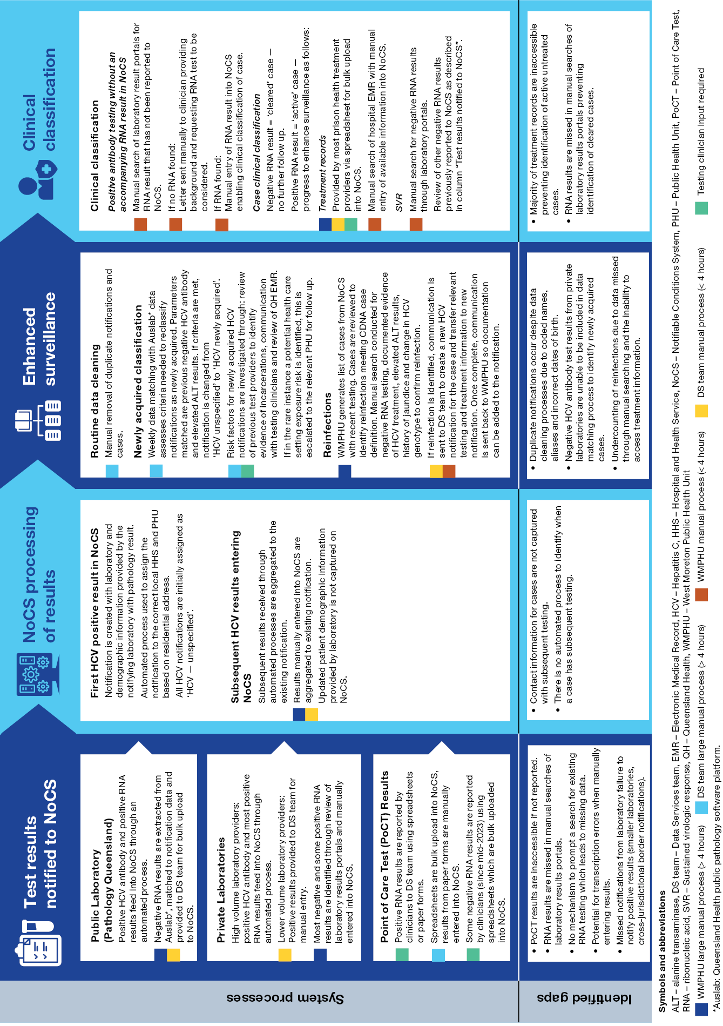

Descriptive data analysis to inform system improvement
A total of 2,257 of the 2,271 HCV cases (99.4%) were included for analysis. The remaining 14 cases (0.6%) did not have clinical status recorded in the extracted data. Of the included cases, 305 (13.5%) were indeterminate, 734 (32.5%) were active and 1,218 (54%) were cleared. Most active HCV cases were tested while in a correctional centre (391/734; 53.3%), followed by hospitals (122/734; 16.6%), and general practice settings (117/734; 15.9%). The three main testing providers for indeterminate cases were general practitioners (138/305; 45.2%), hospitals (67/305; 22.0%) and Aboriginal Medical Services (31/305; 10.2%). A more detailed breakdown of testing providers by clinical classification is provided in Table 2.
Most cases (1,857/2,257; 82.3%) had previous positive HCV testing recorded in NoCS, indicating they were not newly diagnosed. A total of 113 cases could be identified as reinfections according to the CDNA case definitions. Applying this reinfection rate over a 12-month period, an estimated 678 reinfections could be expected annually.
For cases with previous testing on NoCS, 46.3% (860/1,857) had testing ordered by a clinician located in a different PHU jurisdiction to the PHU assigned to the case at time of notification. Among cases with testing conducted in the community, 22.3% (302/1,356) had previously undergone HCV testing in a correctional setting, while 52.6% (471/895) of cases with testing conducted in a correctional setting had prior testing in a community setting. Combined, this equates to 53% of cases (1,197/ 2,257) either currently or previously having testing in a correctional setting.
Most cases were male (1,710/2,257, 75.8%). The median ages for indeterminate, active, and cleared cases were 44 years (interquartile range (IQR): 36–54 years), 35 years (IQR: 28–46 years), and 41 years (IQR: 31–52 years) respectively. Table 3 provides further demographic characteristics by clinical classifications.
Table 2: Clinical case status by testing provider type
Testing provider | Indeterminate cases |  |  | Active cases |  |  | Cleared cases |  |  | Total cases
Testing provider | Count  (n) | % of indeterminate cases | % of cases tested by provider type | Count  (n) | % of active cases | % of cases tested by provider type | Count  (n) | % of cleared cases | % of cases tested by provider type | Count  (n) | % of total cases
Aboriginal Medical Service | 31 | 10.2% | 36.9% | 11 | 1.5% | 13.1% | 42 | 3.4% | 50.0% | 84 | 3.7%
Corrections | 18 | 5.9% | 2.1% | 391 | 53.3% | 44.6% | 468 | 38.4% | 53.4% | 877 | 38.9%
General Practitioner | 138 | 45.2% | 26.6% | 117 | 15.9% | 22.6% | 263 | 21.6% | 50.8% | 518 | 23.0%
Hospital | 67 | 22.0% | 14.6% | 122 | 16.6% | 26.6% | 270 | 22.2% | 58.8% | 459 | 20.3%
Mental health/Alcohol and Other Drugs service | 13 | 4.3% | 11.6% | 32 | 4.4% | 28.6% | 67 | 5.5% | 59.8% | 112 | 5.0%
Sexual Health Service | 11 | 3.6% | 16.2% | 19 | 2.6% | 27.9% | 38 | 3.1% | 55.9% | 68 | 3.0%
Specialist (viral hepatitis-related)ª | 3 | 1.0% | 8.1% | 14 | 1.9% | 37.8% | 20 | 1.6% | 54.1% | 37 | 1.6%
Other/unknown | 24 | 7.9% | 23.5% | 28 | 3.8% | 27.5% | 50 | 4.1% | 49.0% | 102 | 4.5%
Total | 305 | 100.0% | 13.5% | 734 | 100.0% | 32.5% | 1,218 | 100.0% | 54.0% | 2,257 | 100.0%
a Hepatology/gastroenterology/infectious diseases.
Table 3: Characteristics of cases by clinical case classification
Category | Characteristic | Indeterminate cases  N = 305 |  | Active cases  N = 734 |  | Cleared cases  N = 1,218
Category | Characteristic | Count  (n) | % of indeterminate infections | Count  (n) | % of  active infections | Count  (n) | % of  cleared infections
Age group at time of test | < 20 years | 2 | 0.7% | 13 | 1.8% | 15 | 1.2%
Age group at time of test | 20–29 years | 30 | 9.8% | 219 | 29.8% | 237 | 19.5%
Age group at time of test | 30–39 years | 82 | 26.9% | 220 | 30.0% | 314 | 25.8%
Age group at time of test | 40–49 years | 89 | 29.2% | 140 | 19.1% | 304 | 25.0%
Age group at time of test | 50–59 years | 47 | 15.4% | 79 | 10.8% | 186 | 15.3%
Age group at time of test | 60–69 years | 49 | 16.1% | 55 | 7.5% | 136 | 11.2%
Age group at time of test | ≥ 70 years | 6 | 2.0% | 8 | 1.1% | 26 | 2.1%
Sex | Male | 200 | 65.6% | 610 | 83.1% | 900 | 73.9%
Sex | Female | 105 | 34.4% | 124 | 16.9% | 318 | 26.1%
Indigenous status | Aboriginal and/or Torres Strait Islander person | 92 | 30.2% | 264 | 36.0% | 415 | 34.1%
Indigenous status | Neither Aboriginal or Torres Strait Islander person | 211 | 69.2% | 468 | 63.8% | 798 | 65.5%
Indigenous status | Indigenous status unknown | 2 | 0.7% | 2 | 0.3% | 5 | 0.4%
Location at time of test | Community | 283 | 92.8% | 333 | 45.4% | 740 | 60.8%
Location at time of test | Correctional facility | 20 | 6.6% | 399 | 54.4% | 476 | 39.1%
Location at time of test | Unknown | 2 | 0.7% | 2 | 0.3% | 2 | 0.2%

Indeterminate case status was significantly more likely to occur in cases with community testing compared to those tested in a correctional setting (χ²(1) = 160.74; p < 0.001). Proportionately more Aboriginal and/or Torres Strait Islander people had an indeterminate case status than non-Indigenous people in the community (χ²(1) = 5.64; p = 0.018) but not in correctional settings (χ²(1) = 0.14; p = 0.710).
A significantly higher proportion of Aboriginal and/or Torres Strait Islander males with active case status were tested in correctional settings compared to community settings when compared to their non-Indigenous counterparts (χ²(1) = 43.51; p < 0.001). This proportional difference for test location by Indigenous status was not observed for females with an active cases status (χ²(1) = 2.37; p = 0.124). A higher proportion of Aboriginal and/or Torres Strait Islander males with an indeterminate case status were tested in corrections versus community settings compared to their non-Indigenous counterparts (χ²(1) = 6.50; p = 0.011). No significant proportional difference in test locations was demonstrated for females with indeterminate testing by Indigenous status (χ²(1) = 0.28; p = 0.598); see Figure 2.
Figure 2: Number of active and indeterminate cases by sex, Indigenous status and test location, among cases in these categories with known sex, Indigenous status and location at time of test (n = 1,031)
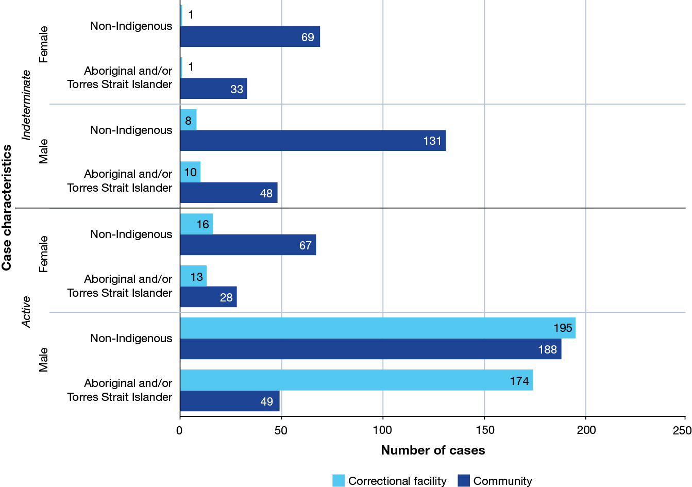

Discussion
The Sixth National Hepatitis C Strategy 2023–2030 outlines the need for improved data and surveillance to support elimination efforts.²² This study identified significant constraints within Queensland's HCV surveillance system that hinder the provision of outcome-focused information. These constraints include the absence of a centralised, coordinated public health response, incomplete data, and inefficient manual processes.

Development of a centralised coordinated state-wide public health response
Currently, public health follow-up of notifiable conditions is usually conducted by local public health units (PHUs). While this approach is effective for most conditions, a centralised, coordinated statewide response would be beneficial for HCV, given the high mobility of affected individuals and other social considerations. The inability to capture current addresses with new testing hampers the allocation of cases (and their follow-up) to appropriate PHUs, an issue that has been highlighted in a previous Queensland project.¹⁹ This is particularly problematic given the rates of movement demonstrated in this study, both geographically and between community and correctional facilities.

Creating a clearance cascade
Most Australian projects utilising HCV notification data have focused on the follow-up of newly diagnosed cases. However, as we approach elimination goals, it is crucial to also prioritise individuals with long-standing untreated infections and those who have been reinfected. A clearance cascade can categorise individuals based on their testing history and clinical status, providing valuable insights into gaps in care and informing and monitoring interventions and overarching strategies.^{23–26} While there are variations in the specific steps used in published clearance cascades, most include screening, viral testing, initial infection status, cured/cleared status, and persistent infections/reinfections.^{23–25,27–32}
The clinical classifications used in this study align with the clearance cascade and demonstrate the benefits of characterising priority groups to inform interventions. Indeterminate cases primarily received testing in community settings and these sites could be targeted for clinician education and system improvements to increase reflex RNA testing immediately following a positive antibody result.
Active cases were more likely to be male and tested in correctional settings, highlighting the need for targeted interventions in these facilities including comprehensive blood-borne virus prevention measures. Despite lower rates of infection, previous Australian studies have identified women as a group needing targeted support due to lower treatment uptake.^{30,32,33} This study suggests that females with active HCV were more likely to receive testing in community settings, underscoring the need for different strategies to enhance outcomes for this subgroup.
Consistent with other population studies in Australia, Aboriginal and/or Torres Strait Islander people were disproportionately represented in both indeterminate and active case categories compared with non-Indigenous people. Our study found higher rates of active infection among Aboriginal and Torres Strait Islander people living in Queensland than has been reported in studies conducted in New South Wales and Victoria.^{16,30,32} The significantly higher proportion of active HCV cases among Aboriginal and Torres Strait Islander males tested in corrections settings highlights the need for increased investment in culturally appropriate strategies co-led by Aboriginal and Torres Strait Islander people to address this disparity.³⁴
As the proportion of cleared cases increases, it becomes essential to identify and exclude them from ongoing follow-up, allowing for more efficient use of limited resources. Due to the high volume of incoming testing (over 2,200 tests in this two-month period), an analytical tool such as Power BI would enable this process by automatically placing cases within the clearance cascade.

Improving data completeness
Missing data, including RNA results, significantly impacts the ability to create a clearance cascade and accurately classify case status. Manual identification and entry of missing data is time-consuming and unsustainable.¹⁹ Increasingly, RNA testing is occurring through PoCT with data stored in individual healthcare settings necessitating manual clinician notification. Automating this process would improve data completeness and would reduce the potential for transcription errors.
The inability to distinguish between active and cleared cases is a common limitation of HCV surveillance projects and reports. The notification of negative RNA results is a critical step in improving HCV surveillance and linkage to care and is a frequent recommendation in Australian^{16–18} and overseas literature.^{24,27–29} By requiring laboratories to report negative results, both prospectively and historically, manual search processes can be reduced, data completeness can be improved, CDNA case definitions can be effectively implemented, and timely public health follow-up can occur. Additionally, establishing routine reflex RNA testing would enhance these outcomes and remove the risk of incomplete diagnostic testing.¹⁶
Data completeness limited the extent of some of our analyses. Data linkage, particularly with PBS treatment data, has the potential to enhance data quality and enable better characterisation of groups within the cascade of care. However, challenges such as data access delays and inconsistent recording of key information can hinder its implementation. Parameters that have been successfully linked in other studies include treatment rates, residential location (metro/regional/rural), coinfections and information that would exclude a case from follow-up, such as death and relocation interstate.^{17,28–30}
Obtaining data through means other than data linkage has been attempted by contacting clinicians. This process was found to be time-consuming and did not produce a complete data set as key information such as ethnicity was not consistently recorded by clinicians.^{17,18} Projects that have pursued data linkage have reported extensive delays in receiving approvals for and access to linked data.^{28,30} If pursued, data linkage arrangements would need to be timely and ongoing to accurately reflect the gaps in prevention, testing and treatment in real time.²⁴
Limitations of this study include a short study period with the potential for extrapolation errors due to seasonal testing trends. This prevented further breakdown of the data, including characterisation of new versus historic notifications. The use of the testing provider address as a proxy for the case address may introduce inaccuracies in assessing geographical movement. Due to the system constraints identified in this study, the true number of indeterminate cases may be lower than reported due to unidentified RNA results. Actioning the recommendations outlined above will enhance data completeness, will improve system and process efficiency, and will eliminate these limitations making it possible to conduct more robust evaluations over a longer study period.

Conclusion
Significant system constraints impede the implementation of outcomes-focused HCV surveillance and notification-driven linkage to care in Queensland. Addressing these challenges requires a multifaceted approach including: a centralised, co-ordinated public health model; linkage of relevant data sources to NoCS including PBS treatment data; amending public health regulations to require the notification of negative HCV RNA results; automating processes for PoCT data reporting; and the implementation of an analytical data tool to create a HCV clearance cascade. Clinical categorisation of notifications provides insight into progress towards elimination targets and gaps in prevention and service delivery and enables the monitoring of interventions and overarching strategies.
As we progress towards elimination goals, surveillance needs to become more individually focused to ensure prevention, testing and treatment are delivered effectively and equitably. System improvements to move from manual processes will require resources, time and effort but will allow more focused and appropriate public health follow-up to increase linkage to care and treatment and bring multifaceted benefits. By addressing the identified barriers, Queensland can enhance its ability to effectively monitor HCV transmission, to identify individuals in need of care, and ultimately to achieve the goal of hepatitis C elimination.

Acknowledgments
We thank members of the WMPHU and PHIB who contributed to this study and those who have and who continue to support and improve the QLD HCV surveillance system. Special mention to Craig Davis, Advanced Epidemiologist, and Kim Graves, Data Officer, for their work on the essential dataset that made this study possible.

Author details
Ms Amanda Armstrong,^{1,2}
Dr Stephen B. Lambert,^{3,4}
Assoc. Prof. Theophilus I. Emeto,²
Ms Janet Farmer,¹
Dr Catherine Quagliotto¹
- West Moreton Public Health Unit, West Moreton Health, Wacol QLD 4076, Australia.
- Public Health and Tropical Medicine, James Cook University, Townsville, QLD 4811, Australia
- Communicable Diseases Branch, Queensland Public Health and Scientific Services, Brisbane QLD 4000, Australia
- National Centre for Immunisation Research and Surveillance, Sydney Children’s Hospital Network, Westmead NSW 2145, Australia

Corresponding author
Amanda Armstrong
Address: Locked Bag 500, Archerfield Qld 4108
Phone: +61 7 3271 8744
Email: Amanda.Armstrong@health.qld.gov.au

References
- Ogawa E, Chien N, Kam L, Yeo YH, Ji F, Huang DQ et al. Association of direct-acting antiviral therapy with liver and nonliver complications and long-term mortality in patients with chronic hepatitis C. JAMA Intern Med. 2023;183(2):97–105. doi: https://doi.org/10.1001/jamainternmed.2022.5699.
- Burnet Institute, Kirby Institute. Australia’s progress towards hepatitis C elimination: Annual report 2023. Melbourne: Burnet Institute; 7 December 2023. [Accessed on 22 January 2024.] Available from: https://www.burnet.edu.au/media/tahd41iz/australias-progress-towards-hepatitis-c-elimination-annual-report-2023.pdf.
- World Health Organization (WHO). Global health sector strategies on, respectively, HIV, viral hepatitis and sexually transmitted infections for the period 2022–2030. Geneva: WHO; 18 July 2022. [Accessed on 22 January 2024.] Available from: https://www.who.int/publications/i/item/9789240053779.
- Traeger MW, Pedrana AE, van Santen DK, Doyle JS, Howell J, Thompson AJ et al. The impact of universal access to direct-acting antiviral therapy on the hepatitis C cascade of care among individuals attending primary and community health services. PLoS One. 2020;15(6):e0235445. doi: https://doi.org/10.137/journal.pone.0235445.
- Scott N, Sacks-Davis R, Wade AJ, Stoove M, Pedrana A, Doyle JS et al. Australia needs to increase testing to achieve hepatitis C elimination. Med J Aust. 2020;212(8):365–70. doi: https://doi.org/10.5694/mja2.50544.
- Malo JA. Communicable disease applied epidemiology in Queensland. [MPhil thesis, available online.] Canberra: Australian National University; 9 November 2017. doi: https://doi.org/10.25911/5d690a5babe27.
- Australian Government Department of Health and Aged Care. National Communicable Disease Surveillance Dashboard. [Online resource.] Canberra: Australian Government Department of Health and Aged Care; 2024. [Accessed on 1 October 2024.] Available from: https://nindss.health.gov.au/pbi-dashboard.
- Grebely J, Page K, Sacks-Davis R, van der Loeff MS, Rice TM, Bruneau J et al. The effects of female sex, viral genotype, and IL28B genotype on spontaneous clearance of acute hepatitis C virus infection. Hepatology. 2014;59(1):109–20. doi: https://doi.org/10.1002/hep.26639.
- WHO. Updated recommendations on treatment of adolescents and children with chronic HCV infection, and HCV simplified service delivery and diagnostics. Geneva: WHO; 17 October 2022. [Accessed on 22 December 2024.] Available from: https://www.who.int/publications/i/item/9789240052734.
- Australian Government Department of Health and Aged Care, Communicable Diseases Network Australia (CDNA). Hepatitis C (newly acquired) - surveillance case definition. [Internet.] Canberra: Australian Government Department of Health and Aged Care; 3 January 2023. [Accessed on 1 September 2024.] Available from: https://www.health.gov.au/resources/publications/hepatitis-c-newly-acquired-surveillance-case-definition.
- Australian Government Department of Health and Aged Care, CDNA. Hepatitis C (unspecified) - surveillance case definition. [Internet.] Canberra: Australian Government Department of Health and Aged Care; 3 January 2023. [Accessed on 1 September 2024]. Available from: https://www.health.gov.au/resources/publications/hepatitis-c-unspecified-surveillance-case-definition.
- Kunzweiler C, Kishore N, John B, Roosevelt K, Lewis S, Klevens RM et al. Using HIV surveillance and clinic data to optimize data to care efforts in community health centers in Massachusetts: The Massachusetts Partnerships for Care Project. J Acquir Immune Defic Syndr. 2019;82(Suppl 1):S33–41. doi: https://doi.org/10.1097/qai.0000000000002019.
- Beltrami J, Dubose O, Carson R, Cleveland JC. Using HIV surveillance data to link people to HIV medical care, 5 US states, 2012–2015. Public Health Rep. 2018;133(4):385–91. doi: https://doi.org/10.1177/0033354918772057.
- Anderson S, Henley C, Lass K, Burgess S, Jenner E. Improving engagement in HIV care using a Data-to-Care and patient navigation system in Louisiana, United States. J Assoc Nurses AIDS Care. 2020;31(5):553–65. doi: https://doi.org/10.1097/JNC.0000000000000150.
- Sachdev DD, Mara E, Hughes AJ, Antunez E, Kohn R, Cohen S et al. "Is a bird in the hand worth 5 in the bush?": a comparison of 3 data-to-care referral strategies on HIV care continuum outcomes in San Francisco. Open Forum Infect Dis. 2020;7(9):ofaa369. doi: https://doi.org/10.1093/ofid/ofaa369.
- Abbott M, Maclachlan JH, Romero N, Matthews N, Higgins N, Lee A et al. A pilot project harnessing surveillance systems to support clinicians providing clinical care for people diagnosed with hepatitis C in Victoria, Australia, September 2021 to 31 March 2022. Euro Surveill. 2024;29(29):2400028.
doi: https://doi.org/10.2807/1560-7917.ES.2024.29.29.2400028.
- WHO Collaborating Centre for Viral Hepatitis, Victorian Infectious Diseases Reference Laboratory (VIDRL). CHECCS pilot program: evaluation report November 2022. Melbourne: the Peter Doherty Institute for Infection and Immunity; November 2022. Available from: https://www.doherty.edu.au/uploads/content_doc/CHECCS_Evaluation_Report_Final_webNov2022.pdf.
- Carpenter M, Selvey LA, Lambert SB, Kemp R. Using notifications data to increase hepatitis C testing and treatment rates in Queensland. Commun Dis Intell (2018). 2023;47. doi: https://doi.org/10.33321/cdi.2023.47.62.
- Fernando TM, Lambert SB, Kemp R, Selvey LA. Enhanced surveillance of notifications of hepatitis C to Queensland Health up to 19 years previously. Commun Dis Intell (2018). 2023;47. doi: https://doi.org/10.33321/cdi.2023.47.63.
- Walker S, Wallace J, Latham N, Saich F, Pedrana A, Hellard M et al. “It's time!”: a qualitative exploration of the acceptability of hepatitis C notification systems to help eliminate hepatitis C. Int J Drug Policy. 2021;97:103280. doi: https://doi.org/10.1016/j.drugpo.2021.103280.
- The Royal College of Pathologists of Australasia (RCPA). Hepatitis C. [Internet.] Sydney: RCPA; 2 January 2024. [Accessed on 23 December 2024.] Available from: https://www.rcpa.edu.au/Manuals/RCPA-Manual/Pathology-Tests/H/Hepatitis-C.
- Australian Government Department of Health and Aged Care. 6th National Hepatitis C Strategy 2023–2030 (for consultation). Canberra: Department of Health and Aged Care; 2023. [Accessed on 30 September 2024.] Available from: https://www.health.gov.au/sites/default/files/2023-05/draft-sixth-national-hepatitis-c-strategy-2023-2030-for-public-consultation.pdf.
- O'Neil CR, Buss E, Plitt S, Osman M, Coffin CS, Charlton CL et al. Achievement of hepatitis C cascade of care milestones: a population-level analysis in Alberta, Canada. Can J Public Health. 2019;110(6):714–21. doi: https://doi.org/10.17269/s41997-019-00234-z.
- Wegener M, Brooks R, Speers S, Nichols L, Villanueva M. Implementing a surveillance-based approach to create a statewide viral clearance cascade for hepatitis C among people with HIV and HCV coinfection in Connecticut. Public Health Rep. 2024;139(2):208–17. doi: https://doi.org/10.1177/00333549231172173.
- Tsang CA, Tonzel J, Symum H, Kaufman HW, Meyer WA, Osinubi A et al. State-specific hepatitis C virus clearance cascades — United States, 2013–2022. MMWR Morb Mortal Wkly Rep. 2024;73(21):495–500. doi: https://doi.org/10.15585/mmwr.mm7321a4.
- Baer A, Fagalde MS, Drake CD, Sohlberg EH, Barash E, Glick S et al. Design of an enhanced public health surveillance system for hepatitis C virus elimination in King County, Washington. Public Health Rep. 2020;135(1):33–9. doi: https://doi.org/10.1177/0033354919889981.
- Brooks R, Wegener M, Speers S, Nichols L, Sideleau R, Valeriano T et al. Creating a longitudinal HCV care cascade for persons with HIV/HCV coinfection in selected HIV clinics using data to care methods. Health Promot Pract. 2023;24(5):1039–49. doi: https://doi.org/10.1177/15248399231169792.
- Ceccarelli L, Moretti G, Mazzilli S, Petri D, Corazza I, Rizzo C et al. Evaluating hepatitis C cascade of care surveillance system in Tuscany, Italy, through a population retrospective data-linkage study, 2015–2021. BMC Infect Dis. 2024;24(1):362. doi: https://doi.org/10.1186/s12879-024-09241-z.
- Montgomery MP, Sizemore L, Wingate H, Thompson WW, Teshale E, Osinubi A et al. Development of a standardized, laboratory result-based hepatitis C virus clearance cascade for public health jurisdictions. Public Health Rep. 2024;139(2):149–53. doi: https://doi.org/10.1177/00333549231170044.
- Snow K, Maclachlan JH, Rowe S, Higgins N, Cowie BC. The cascade of care for hepatitis C in Victoria, Australia: a data linkage cohort study. Intern Med J. 2024;54(7):1146–54. doi: https://doi.org/10.1111/imj.16361.
- Wester C, Osinubi A, Kaufman HW, Symum H, Meyer WA, Huang X et al. Hepatitis C virus clearance cascade – United States, 2013-2022. MMWR Morb Mortal Wkly Rep. 2023;72(26):716–20. doi: https://doi.org/10.15585/mmwr.mm7226a3.
- Yousafzai MT, Alavi M, Valerio H, Hajarizadeh B, Grebely J, Dore GJ. Hepatitis C care cascade before and during the direct-acting antiviral eras in New South Wales, Australia: a population-based linkage study. J Viral Hepat. 2023;30(3):250–61. doi: https://doi.org/10.1111/jvh.13791.
- Valerio H, Alavi M, Marshall AD, Hajarizadeh B, Amin J, Law M et al. Factors associated with hepatitis C treatment uptake among females of childbearing age in New South Wales, Australia: a population-based study. Drug Alcohol Rev. 2023;43(5):1080–92. doi: https://doi.org/10.1111/dar.13688.
- Howell J, Combo T, Binks P, Bragg K, Bukulatjpi S, Campbell K et al. Overcoming disparities in hepatocellular carcinoma outcomes in First Nations Australians: a strategic plan for action. Med J Aust. 2024;221(5):230–5. doi: https://doi.org/10.5694/mja2.52395.

