
2025 • Volume 49 • cdc.gov.au/cdi • Epub date: 30.07.2025 • doi.org/10.33321/cdi.2025.49.022

Monitoring the incidence and causes of disease potentially transmitted by food in Australia: Annual report of the OzFoodNet network, 2019
The OzFoodNet Working Group
© 2025 Commonwealth of Australia as represented by the Department of Health, Disability and Ageing
ISSN: 2209-6051 Online
This journal is indexed by Index Medicus and Medline.
Creative Commons Licence
This publication is licensed under a Creative Commons Attribution-NonCommercial-NoDerivatives 4.0 International Licence (Licence). You must read and understand the Licence before using any material from this publication.
Restrictions
The Licence does not cover, and there is no permission given for, use of any of the following material found in this publication (if any):
- the Commonwealth Coat of Arms (by way of information, the terms under which the Coat of Arms may be used can be found on the Department of Prime Minister and Cabinet website;
- any logos (including the interim Australian Centre for Disease Control and the Department of Health, Disability and Ageing’s logos) and trademarks;
- any photographs and images;
- any signatures; and
- any material belonging to third parties.
Disclaimer
Opinions expressed in Communicable Diseases Intelligence are those of the authors and not necessarily those of the Australian Government, the interim Australian Centre for Disease Control or the Department of Health, Disability and Ageing. Data may be subject to revision.
Enquiries
Enquiries regarding any other use of this publication should be addressed to the CDI Editor.
About CDI
Communicable Diseases Intelligence (CDI) is a peer-reviewed scientific journal published by the interim Australian Centre for Disease Control within the Department of Health, Disability and Ageing.
The journal aims to disseminate information on the epidemiology, surveillance, prevention and control of communicable diseases of relevance to Australia and the near region.
Editor: Christina Bareja • Deputy Editor: Simon Petrie • Design and Production: Lisa Thompson with support from Sehaj Dhillon
Editorial Advisory Board: David Durrheim, Mark Ferson, Clare Huppatz, John Kaldor, Martyn Kirk and Meru Sheel
Submit an Article
Guidelines for authors and details on how to submit your publication is available on our website, or by email to the
CDI Editor.
Contact us
Communicable Diseases Intelligence (CDI)
interim Australian Centre for Disease Control, Department of Health, Disability and Ageing
GPO Box 9848, CANBERRA ACT 2601
Website: cdc.gov.au/cdi
Email: cdi.editor@health.gov.au

Contents
Abstract 8
Introduction 9
Methods 10
Population under surveillance 10
Data sources 10
Data analysis 12
Results 13
Notified infections 13
Botulism 14
Campylobacteriosis 16
Cholera 19
Enteric fever 21
Hepatitis A 26
Hepatitis E 31
Listeriosis 34
Salmonellosis 39
Shigellosis 45
Shiga toxin-producing Escherichia coli infection and haemolytic uraemic syndrome 51
Outbreaks of gastrointestinal disease including foodborne disease outbreaks 56
Foodborne and probable foodborne outbreaks 56
Animal-to-person and probable animal-to-person outbreaks 67
Waterborne and probable waterborne outbreaks 67
Environmental and probable environmental outbreaks 67
Author details 68
Acknowledgments 69
References 70
Appendix A 75
Appendix B 76
Appendix C 89

List of figures
Figure 1: Botulism notifications in Australia by jurisdiction of residence, 1992–2019 15
Figure 2: Campylobacteriosis notificationsª and rate per 100,000 population^{b} in Australia by jurisdiction of residence, 1991–2019 17
Figure 3: Campylobacteriosis notification rate per 100,000 population in Australia by age group and sex,ª 2019 18
Figure 4: Cholera notifications in Australia by jurisdiction of residence, 1991–2019 20
Figure 5: Typhoid fever and paratyphoid fever notifications and enteric fever notification rate per 100,000 population in Australia, 1991–2019 22
Figure 6: Typhoid fever notifications and rate per 100,000 population in Australia by jurisdiction of residence, 1991–2019 23
Figure 7: Paratyphoid fever notifications and rate per 100,000 population in Australia by jurisdiction of residence, 1991–2019 23
Figure 8: HAV notifications and rate per 100,000 population in Australia by jurisdiction of residence, 1991–2019 27
Figure 9: HAV notifications in Australia by place of acquisition, 2014–2019 28
Figure 10: HEV notifications and rate per 100,000 population in Australia by jurisdiction of residence, 2001–2019 31
Figure 11: HEV notifications in Australia by place of acquisition, 2004–2019 32
Figure 12: Listeriosis notifications and rate per 100,000 population in Australia by jurisdiction of residence, 1994–2019 35
Figure 13: Salmonellosis notifications and rate per 100,000 population in Australia by jurisdiction of residence, 1991–2019 40
Figure 14: Salmonellosis notification rate per 100,000 population in Australia by age group and sex,ª 2019 42
Figure 15: Salmonellosis notifications in Australia by month, and five year historical mean,
2019 42
Figure 16: Shigellosis notifications and rate per 100,000 population in Australia by jurisdiction of residence,ª 2001–2019 46
Figure 17: Shigellosis notifications and rates per 100,000 population in Australia by Indigenous status, 2014–2019ª 48
Figure 18: Shigella flexneri serotype 2b notifications in Aboriginal and/or Torres Strait Islander people in Australia, by age group and sex, 2019 49
Figure 19: Shigellosis notifications (confirmed and probable) in Australia by place of acquisition and sex, 2019ª 50
Figure 20: STEC notifications and rate per 100,000 population in Australia by jurisdiction of residence,ª 2001–2019 53
Figure 21: HUS notifications and rate per 100,000 population in Australia by jurisdiction of residence, 1999–2019 53
Figure 22: STEC cases in Australia by age group and sex, 2019ª 54
Figure 23: Foodborne outbreaks in Australia by year and quarter,ª 2014–2019 57
Figure 24: Number of ill people in foodborne outbreaks in Australia by year and quarter,ª
2014–2019 58
Figure 25: Egg outbreaks by month and jurisdiction in Australia,^{a,b} 2019 61

List of tables
Table 1: Enteric disease notifications in Australia, 2019 13
Table 2: Summary of campylobacteriosis notifications in Australia, 2019 17
Table 3: Demographics of cases with the highest campylobacteriosis notification rates in Australia, 2019 17
Table 4: Summary of enteric fever notifications in Australia, 2019 24
Table 5: Top countries of acquisition for overseas acquired enteric fever cases notified in Australia, 2019 25
Table 6: Summary of HAV notifications in Australia, 2019 28
Table 7: Top four countries of acquisition for overseas acquired HAV cases in Australia, 2019
(n = 152) 29
Table 8: Summary of HEV notifications in Australia, 2019 32
Table 9: Top two countries of acquisition for overseas-acquired HEV cases in Australia, 2019
(n = 37) 33
Table 10: Summary of listeriosis notifications in Australia, 2019 35
Table 11: Listeriosis cases in Australia by multi-locus sequence typing (MLST), 2019^{a,b} 36
Table 12: Non-perinatal listeriosis cases by clinical presentation in Australia, 2019ª (n = 40) 38
Table 13: Immunocompromising conditions for non-perinatal listeriosis cases in Australia, 2019ª (n = 40) 38
Table 14: Summary of salmonellosis notifications in Australia, 2019 41
Table 15: Groups with the highest salmonellosis notification rate in Australia, 2019 41
Table 16: Top five Salmonella serotypes notified in Australia, 2019 43
Table 17: Salmonella Typhimurium (STm) notifications by jurisdiction and most common
multiple-locus variable number tandem repeat analysis (MLVA) typeª in Australia, 2019
(n = 4,891) 44
Table 18: Summary of shigellosis notifications in Australia, 2019 46
Table 19: Shigellosis notifications in Aboriginal and/or Torres Strait Islander people in Australia by jurisdiction of residence,ª 2019 48
Table 20: Summary of STEC and HUS notifications in Australia, 2019 54
Table 21: Gastrointestinal disease outbreaks and ill people by transmission mode in Australia, 2019 56
Table 22: Foodborne outbreaks and affected people in Australia by jurisdiction, 2019 57
Table 23: Foodborne outbreaks, ill people and hospitalisations in Australia by aetiology,
2019 59
Table 24: Foodborne outbreaks and ill people in Australia by food commodity, 2019 60
Table 25: Foodborne outbreaks in Australia by aetiology and food commodity, 2019 60
Table 26: Foodborne outbreaks in Australia by setting prepared, 2019 62
Table 27: Evidence to support foodborne transmission for outbreaks in Australia, 2019 63
Revised OzFoodNet definitions for modes of outbreak transmission implemented in 2016 75
Foodborne and probable foodborne outbreak summary for OzFoodNet sites, Australia, 2019 76
Point source foodborne and probable foodborne outbreaks within multi-jurisdictional outbreaks and large community outbreaks, summary for OzFoodNet sites, Australia, 2019 89

Abstract
In 2019, state and territory health departments in Australia received 55,622 notifications of enteric diseases potentially related to food. Consistent with previous years, the majority of all notified infections were either campylobacteriosis (n = 36,451; 66%) or salmonellosis (n = 14,676; 26%). A total of 133 gastrointestinal outbreaks, including 121 foodborne outbreaks, were reported in 2019. The remaining 12 outbreaks were due to environmental or probable environmental transmission (six outbreaks); animal-to-person or probable animal-to-person transmission (four outbreaks); and waterborne or probable waterborne transmission (two outbreaks). Foodborne outbreaks affected 2,428 people, resulting in at least 402 hospital admissions and four deaths. Eggs continue to be a source of Salmonella Typhimurium infection across the country, with 26 reported egg-related outbreaks affecting at least 936 people.

Introduction
The burden of foodborne disease in Australia is significant, with an estimated 4.1 million people infected in Australia each year, costing an estimated $2.44 billion per year.¹
The OzFoodNet network was established in 2000 by the Australian Government Department of Health, Disability and Ageing to apply concentrated effort at a national level to investigate and understand foodborne disease; to describe more effectively its epidemiology; and to identify ways to minimise foodborne illness in Australia. The OzFoodNet network includes foodborne disease epidemiologists from each state and territory health department, and collaborators from the Australian Government Department of Agriculture, Fisheries and Forestry (Agriculture), Food Standards Australia New Zealand (FSANZ), and the Public Health Laboratory Network (PHLN). OzFoodNet is represented on the Communicable Diseases Network Australia (CDNA), which is Australia’s peak body for communicable disease control.
The primary data sources used by OzFoodNet epidemiologists to understand the extent of foodborne disease in Australia include notifiable enteric disease data and reports of gastrointestinal disease outbreaks. This report provides an overview of the national enteric disease surveillance data from 1 January 2019 to 31 December 2019 and the findings from the investigations into gastrointestinal illness outbreaks caused by foodborne, animal-to-person, environmental or waterborne disease that were initiated in Australia between 1 January 2019 and 31 December 2019.

Methods

Population under surveillance
In 2019, the OzFoodNet network covered all Australian states and territories, with an estimated population of 25,340,217 persons as at 30 June 2019.²

Data sources

Notified infections
All Australian states and territories have public health legislation requiring doctors and pathology laboratories to notify cases of infectious diseases that are important to public health. State and territory health departments record details of notified cases on surveillance databases. Under the auspices of the National Health Security Act 2007, surveillance data is aggregated into a national database known as the National Notifiable Diseases Surveillance System (NNDSS). Notifiable enteric diseases include botulism, campylobacteriosis, cholera, haemolytic uraemic syndrome (HUS), hepatitis A, hepatitis E, listeriosis, paratyphoid fever, salmonellosis, Shiga toxin-producing Escherichia coli (STEC) infection, shigellosis and typhoid fever.
Data for this report were extracted from NNDSS in July 2022 and analysed by calendar year using the date of diagnosis. Date of diagnosis was derived for each case from the earliest date supplied by the jurisdiction, which could be the date of onset of the case’s illness, the date a specimen was collected, or the date on which a health department received the notification. Notifications for 2019 include those with a diagnosis date from 1 January 2019 to 31 December 2019. Estimated resident populations for each state or territory as at 30 June 2019 were used to calculate rates of notified infections.² Due to the dynamic nature of NNDSS data, the data presented in this report are subject to change over time.

Change in laboratory methods
Changes in diagnostic laboratory testing procedures, including the increasing uptake of culture independent diagnostic testing (CIDT) using polymerase chain reaction (PCR) and introduction of multiplex PCR (which can detect multiple enteric pathogens on one test) are suspected to have resulted in an increase in notifications for a number of bacterial enteric diseases including campylobacteriosis, salmonellosis, shigellosis and STEC since 2014 (see the OzFoodNet 2016 annual report for more information).³ CIDT has been introduced at varying times depending on the individual laboratory. The extent to which this has increased notifications of each of these conditions remains unclear.

Enhanced national surveillance for listeriosis
In 2010 OzFoodNet commenced enhanced surveillance data collection on all notified cases of listeriosis in Australia, using a centralised database known as the National Enhanced Listeriosis Surveillance System (NELSS). The primary aim of NELSS is to detect clusters of infection to enable a timely public health investigation and response. In accordance with the Listeriosis National Guideline for Public Health Units, jurisdictional public health staff conduct case interviews at the time of diagnosis using a standardised questionnaire. Interview data (including food histories), along with information regarding the characterisation of Listeria monocytogenes isolates by molecular subtyping methods, are entered into NELSS by OzFoodNet epidemiologists using an open-source secure web-based reporting system known as NetEpi. Commencing in 2016, whole genome sequencing with fortnightly phylogenetic analysis was conducted for all human L. monocytogenes isolates to identify potential clusters for investigation (data not included).

Enhanced national surveillance for hepatitis A
In July 2017, CDNA endorsed the commencement of hepatitis A enhanced surveillance data collection, which involved sequencing strains from all notified cases of hepatitis A nationally (see the 2017 OzFoodNet annual report for more information).⁴ Enhanced surveillance commenced on 1 July 2017, with the objectives:
- to better understand hepatitis A molecular epidemiology in Australia through the conduct of national enhanced surveillance through genotyping and sequencing RNA from each case and recording specific risk factor information in a centralised database;
- to understand the risk factors and molecular epidemiology of hepatitis A in Australia; and
- to detect clusters of locally acquired hepatitis A to enable rapid public health action.
Enhanced surveillance of hepatitis A does not impact on jurisdictional public health surveillance practices: all confirmed cases of hepatitis A are followed up as per current jurisdictional surveillance practice and the nationally agreed questionnaire, developed by OzFoodNet and the Hepatitis A Series of National Guidelines Working Group, is used when interviewing cases. De-identified case information is entered onto a secure SharePoint database as cases are notified to jurisdictions, and selected epidemiological and laboratory typing fields are completed by jurisdictional and laboratory staff. This information is interrogated as necessary.

Outbreaks of gastrointestinal disease including foodborne disease outbreaks
Gastrointestinal disease outbreaks may be notified to jurisdictional health departments from a range of sources including doctors, local councils, and members of the public, or identified by OzFoodNet epidemiologists through review of notifiable disease data.
In 2016, OzFoodNet epidemiologists revised the terminology regarding the various modes of transmission of gastrointestinal disease outbreaks. Suspected foodborne, animal-to-person, and waterborne outbreak categories were redefined as probable outbreaks to more accurately reflect the level of evidence available to implicate a mode of transmission. For data analysis and reporting pre and post 2016, suspected and probable categories can be treated as equivalent. In addition, an environmental outbreak category was introduced, to differentiate waterborne outbreaks associated with drinking water from incidental exposure to contaminated water sources in the environment. Waterborne outbreaks from 2014 to 2015 have been redefined using the 2016 case definitions to enable accurate historical comparisons in this report. Refer to Appendix A for the definitions applied to reported gastrointestinal disease outbreaks from 2016 onwards.
Commencing in the 2013–2015 annual report,⁵ person-to-person outbreaks and outbreaks of unknown transmission mode have been excluded from the OzFoodNet annual reports. These modes of transmission have historically accounted for the majority of outbreaks each year. This is a change in practice from previous annual reports and therefore the total number of outbreaks in this report cannot be directly compared with annual reports prior to 2013.
From 2018 onwards, point source outbreaks occurring within multi-jurisdictional outbreak investigations and large community outbreaks have been reported by OzFoodNet and included in annual reports, to improve understanding of the burden and variety of causes of point source outbreaks investigated by OzFoodNet that are connected to larger outbreaks.

Surveillance and outbreak data limitations
Enteric disease surveillance data reported to health departments represent only a proportion of disease in the community as these data rely on people seeking medical attention and undergoing appropriate laboratory testing to confirm a diagnosis. Research in Australia has estimated that only one in five people experiencing gastroenteritis seek medical attention, and are therefore notified.⁶ Studies have shown that for every salmonellosis case notified to a health department in Australia there are an estimated seven salmonellosis infections in the community; for every notified STEC case there are an estimated eight STEC infections; and for every notified campylobacteriosis case there are an estimated ten campylobacteriosis infections in the community.⁷
The outbreak data within this report have limitations, including the potential for variation in the categorisation of features of outbreaks, depending on differing circumstances and investigator interpretation. Outbreaks are investigated by jurisdictional health departments, where resources and follow-up practices may vary from jurisdiction to jurisdiction. In addition, outbreaks of gastroenteritis are often not reported to health authorities, resulting in under-representation of the true burden of enteric disease outbreaks within Australia. Changes in the number of outbreaks over time should be interpreted with caution. The numbers of cases and outbreaks may differ from summaries previously published, as these may take time to finalise. Outbreaks presented in this report are included based on the investigation commencing in 2019.

Data analysis
All analyses were conducted using Microsoft Excel.

Results

Notified infections
In total, 55,622 enteric diseases notifications were reported in 2019 (Table 1).
Table 1: Enteric disease notifications in Australia, 2019
Disease | Number of notifications 2019 | Proportion of all enteric notifications 2019 | Mean notifications 2014–2018 | % change | 2019 rate per 100,000 population
Campylobacteriosis | 36,451 | 66% | 25,698 | 42% | 144
Salmonellosis | 14,676 | 26% | 16,322 | -10% | 58
Shigellosis | 3,152 | 6% | 1,548 | 104% | 12
Shiga toxin-producing Escherichia coli (STEC) infection | 655 | 1% | 330 | 98% | 2.6
Hepatitis A | 242 | < 1% | 241 | 2% | 1.0
Typhoid fever | 202 | < 1% | 131 | 54% | 0.8
Paratyphoid fever | 116 | < 1% | 75 | 55% | 0.5
Hepatitis E | 54 | < 1% | 46 | 20% | 0.2
Listeriosis | 51 | < 1% | 76 | -31% | 0.2
Haemolytic uraemic syndrome (HUS) | 19 | < 1% | 16 | 16% | 0.1
Botulism | 2 | < 1% | 1 | 67% | < 0.01
Cholera | 2 | < 1% | 1 | 43% | < 0.01
Total | 55,622 | 100% | 44,485 | 25% | –
Data from the NNDSS, including number of notifications and rate by month, jurisdiction, age group and sex, can be accessed on the National Notifiable Diseases Surveillance System (NNDSS) data visualisation tool. A summary of each notifiable enteric condition is provided in this report.

Botulism
Botulism is a rare but serious illness that results in paralysis caused by nerve toxins made by Clostridium botulinum bacteria. Botulism can result from eating food containing pre-formed botulinum toxin (foodborne botulism); from ingesting food, dust or soil that contains the bacteria that produce the toxin (intestinal botulism); or from contamination of a wound with the bacteria (wound botulism). Intestinal botulism usually only affects children under 12 months of age and is more commonly known as infant botulism. This is the most common form of botulism in Australia. Foodborne botulism may be found in improperly processed, canned, low acid or alkaline foods where anaerobic conditions have occurred at some stage.
Surveillance data includes confirmed cases only. A confirmed case requires laboratory definitive and clinical evidence of infection. All notified cases are followed up by jurisdictional public health staff.

Overall trend
Notifications of botulism are extremely rare in Australia, with a total of 28 cases recorded in Australia since collation of national notification data began in 1992 (Figure 1).

Previous cases in Australia
- Three foodborne botulism cases have been reported to date, including a single case in New South Wales in 1999 where the food source was not identified; a case in Victoria in 2007 associated with consumption of a commercially manufactured convenience food; and a second case in Victoria in 2015 where the suspected source was home cured ham.
- One case of intestinal botulism was reported in a child in 2006.
- The remaining cases have been infant botulism.

Epidemiology of botulism in Australia, 2019
New South Wales and South Australia each reported a single case of infant botulism in 2019, both of which were in children less than one year of age. No high-risk foods were identified. The five-year average of botulism notifications was one case per year between 2014 and 2018.
Figure 1: Botulism notifications in Australia by jurisdiction of residence, 1992–2019
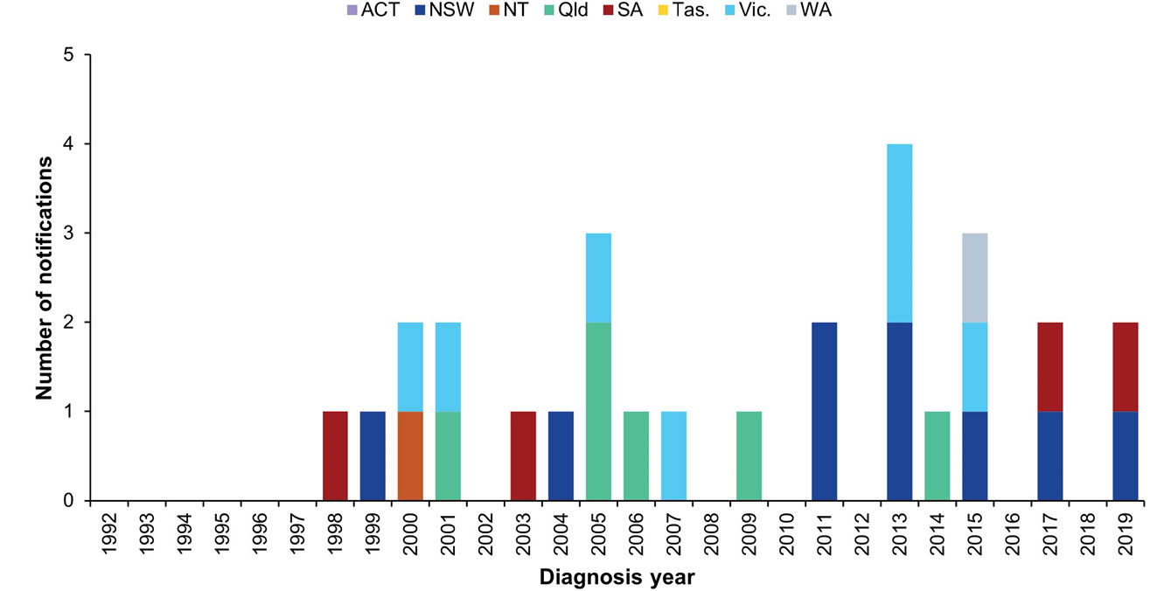

Campylobacteriosis
Campylobacteriosis is a gastrointestinal disease caused by the Campylobacter bacterium. It is a common cause of bacterial gastroenteritis globally, with infection rates in Australia among the highest in the industrialised world.⁸ In Australia, it is commonly associated with the consumption of undercooked poultry.⁹ Campylobacteriosis may also be acquired through consumption of cross-contaminated foods, animal-to-person transmission, consumption of unpasteurised milk, and contaminated water.
Surveillance data includes confirmed cases only from all jurisdictions, noting that New South Wales commenced receiving notifications in April 2017. A confirmed case requires laboratory definitive evidence of infection. Due to the volume of notifications, individual case follow-up is not undertaken routinely in all jurisdictions. Public health follow-up is usually limited to outbreaks and clusters of notified cases.

Overall trend
- The incidence of campylobacteriosis in Australia increased steadily since 1991, when notification began, to 2011 (Figure 2). A decreasing trend was observed in 2012 and 2013. This may be related to work undertaken with poultry processors to identify and control contamination on-farm and within processing operations in several jurisdictions.^{10,11}
- From 2014, there has been a marked increase in cases occurring throughout Australia, which is at least in part due to the increase in PCR testing as a method of laboratory diagnosis. From 2017 onwards, the increase in the number of notifications nationally is also attributable in part to the addition of notifications from New South Wales from April 2017.
- A slight increase in the national notification rate was observed in 2019 (144 cases per 100,000 population) compared with 2018 (133 cases per 100,000 population), due to small increases in notifications observed in all jurisdictions.

Previous outbreaks in Australia
Foodborne outbreaks have been reported each year in Australia, commonly associated with consumption of poultry, particularly chicken liver pâté. However, outbreaks account for a small number of cases compared with the overall number of cases reported annually.
Figure 2: Campylobacteriosis notificationsª and rate per 100,000 population^{b} in Australia by jurisdiction of residence, 1991–2019
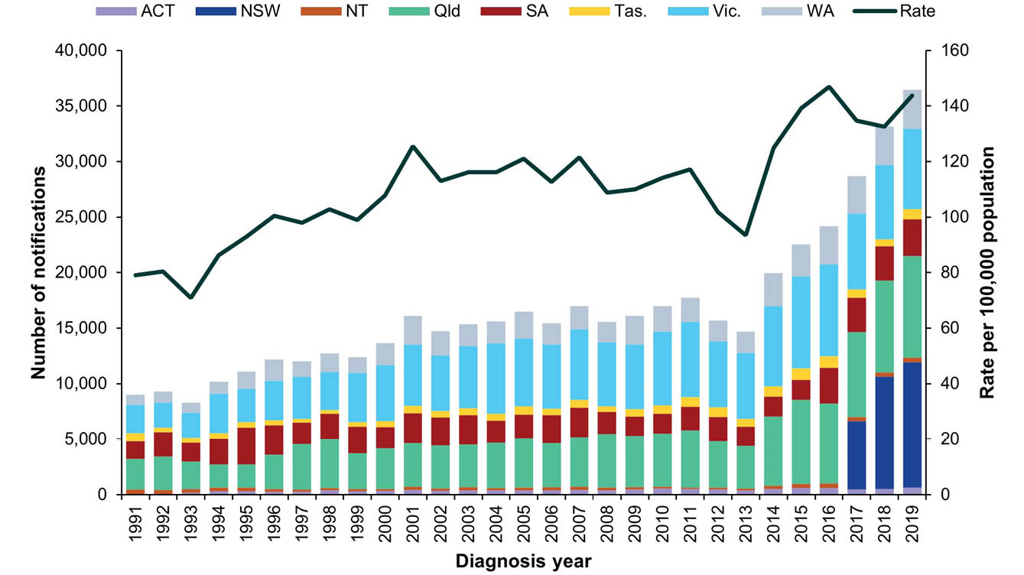
a Campylobacteriosis became notifiable in New South Wales in April 2017.
b Notifications in New South Wales have been excluded from the rate calculation prior to 2018 to avoid comparisons of incomplete data. The rate for Australia before 2018 has been calculated using the Australian Bureau of Statistics estimated resident population data for Australia minus New South Wales.
Table 2: Summary of campylobacteriosis notifications in Australia, 2019
Category | Value
Number of notifications | 36,451
Rate per 100,000 population | 144 cases
Jurisdiction with the highest number of notifications | New South Wales (n = 11,312; 39%)
Foodborne outbreaks | One
Foods implicated in outbreaksª | Chicken liver pâté (n = 1)
a Refer to Foodborne and probable foodborne outbreaks section.
Table 3: Demographics of cases with the highest campylobacteriosis notification rates in Australia, 2019
Category | Group  most affected | Rate per 100,000 population | Number  (% of all cases)
Age group (years) | 0–4 | 217 | 3,395 (9%)
Sex | Males | 160 | 20,127 (55%)
Jurisdiction | South Australia | 188 | 3,286 (9%)

Epidemiology of campylobacteriosis in Australia, 2019
- Campylobacteriosis was the most commonly notified enteric pathogen in 2019 (Table 1).
- The highest rates of infection occurred in children aged 0–4 years (217 per 100,000 population) followed by older adults aged 80–84 years (189 per 100,000 population).
- A higher incidence was observed amongst males in every age group when compared with females (Figure 3). While consistent with previous years, the reason for this remains unclear.
- Notifications were more common in spring and summer months, highest in October (n = 3,744; 10%) and January (n = 3,668; 10%).
Figure 3: Campylobacteriosis notification rate per 100,000 population in Australia by age group and sex,ª 2019
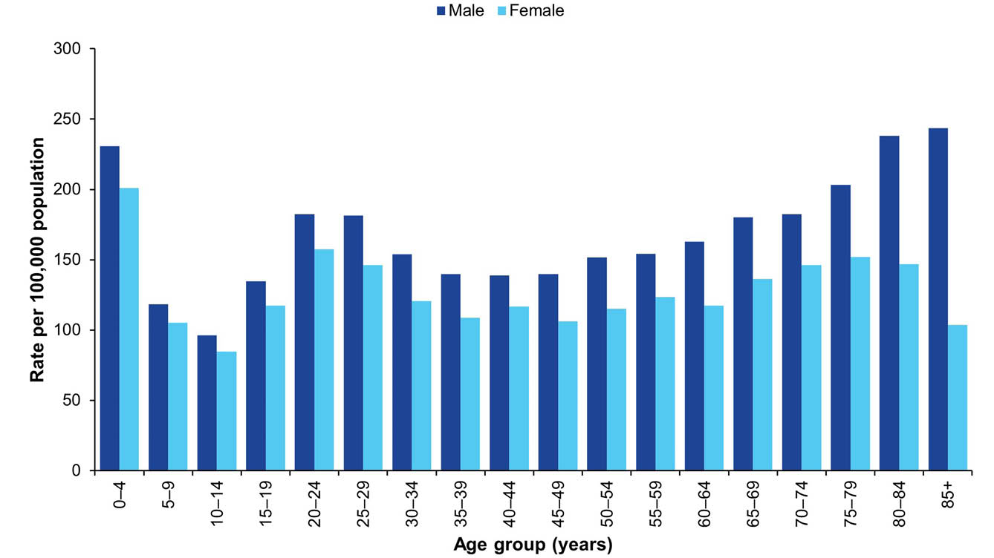
a Excluding cases with sex not defined (n = 79).

Cholera
Cholera is an infection of the digestive tract caused by certain toxin-producing strains of the bacterium Vibrio cholerae. It is mainly seen in people who have travelled overseas, including to parts of Africa, Asia, South America, the Middle East and the Pacific islands. Vibrio cholerae is found in the faeces of infected people, and is usually acquired by drinking contaminated water, eating food washed with contaminated water or prepared with contaminated hands, or eating fish or shellfish harvested from contaminated water. Person-to-person spread of cholera is less common. Symptoms typically start between two hours and five days after ingesting the bacteria. Symptoms can include characteristic ‘rice water’ faeces (profuse, watery diarrhoea); nausea and vomiting; and signs of dehydration, such as weakness, lethargy and muscle cramps. Infection without symptoms or with only mild symptoms may occur, particularly in children.
Surveillance data includes confirmed cases only. A confirmed case requires laboratory definitive evidence of isolation of toxigenic Vibrio cholerae O1 or O139. All notified cases are followed up by jurisdictional public health staff.

Overall trend
All cases of cholera reported since 1991 (the commencement of the NNDSS) were acquired outside Australia, with the exception of:
- one laboratory acquired case in 1996;¹²
- three cases in 2006 linked to imported whitebait;¹³ and
- one laboratory acquired case in 2013.¹⁴

Epidemiology of cholera in Australia, 2019
Two cases of cholera were notified in 2019 (Figure 4). Both cases were associated with overseas travel. One case travelled to India and the other case travelled to Thailand.
Figure 4: Cholera notifications in Australia by jurisdiction of residence, 1991–2019
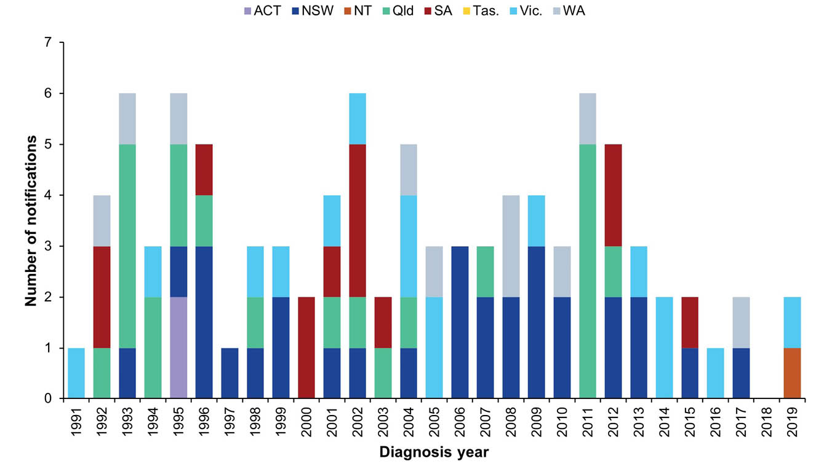

Enteric fever
Typhoid and paratyphoid fever are grouped together as enteric fever as both diseases cause a similar illness, though paratyphoid fever is less common and often less severe. Typhoid fever is caused by the bacterium Salmonella enterica subsp. enterica ser. Typhi (S. Typhi), while paratyphoid fever is caused by Salmonella enterica subsp. enterica ser. Paratyphi (S. Paratyphi) not including S. Paratyphi B biovar Java. These infections are different to the gastroenteritis infection caused by other Salmonella enterica subsp. enterica serovars Enteric fever is rarely acquired in Australia, with almost all notified infections acquired in resource-poor countries with poor sanitation, hand hygiene and food handling standards, and untreated drinking water. People who travel to countries where enteric fever is endemic, to visit friends or family, have been recognised as a risk group for infection in Australia.¹⁵ Consumption of ready-to-eat foods, especially raw fruits, vegetables, and shellfish, as well as drinking potentially contaminated water in countries where typhoid and paratyphoid are endemic, puts travellers at the greatest risk of infection.
Surveillance data includes confirmed cases only. A confirmed case requires laboratory definitive evidence of typhoid or paratyphoid infection., All notified cases are followed up by jurisdictional public health staff.

Overall trend
- Given that infections are almost always acquired outside Australia, notification rates are influenced by the incidence of disease in endemic countries and the number of people who travel to these destinations.
- The incidence of enteric fever in Australia has increased since notification began in 1991 (Figure 5).
- The rate of typhoid fever notifications has increased steadily in recent years, with the number of notifications in 2019 (n = 202) almost twice the number reported in 2016 (n = 104) (Figure 6).
- The incidence of paratyphoid fever increased notably in 2019, compared to previous years where the rate had remained relatively steady (Figure 7).
- With the exception of 2004, the annual count and rate of typhoid infections has exceeded that of paratyphoid (Figure 5).

Previous outbreaks in Australia
- The last major locally acquired typhoid outbreak occurred in Victoria in 1977 (n = 37 cases associated with a food handler who was a chronic carrier).¹⁶
- No enteric fever foodborne outbreaks have been recorded in Australia since OzFoodNet was established in 2000.
- Outbreaks resulting from transmission within households have been reported in Australia, and secondary transmission from a chronic carrier within a household setting is not uncommon. However, the exact mode or transmission from the chronic carrier is rarely able to be determined.¹⁷
Figure 5: Typhoid fever and paratyphoid fever notifications and enteric fever notification rate per 100,000 population in Australia, 1991–2019
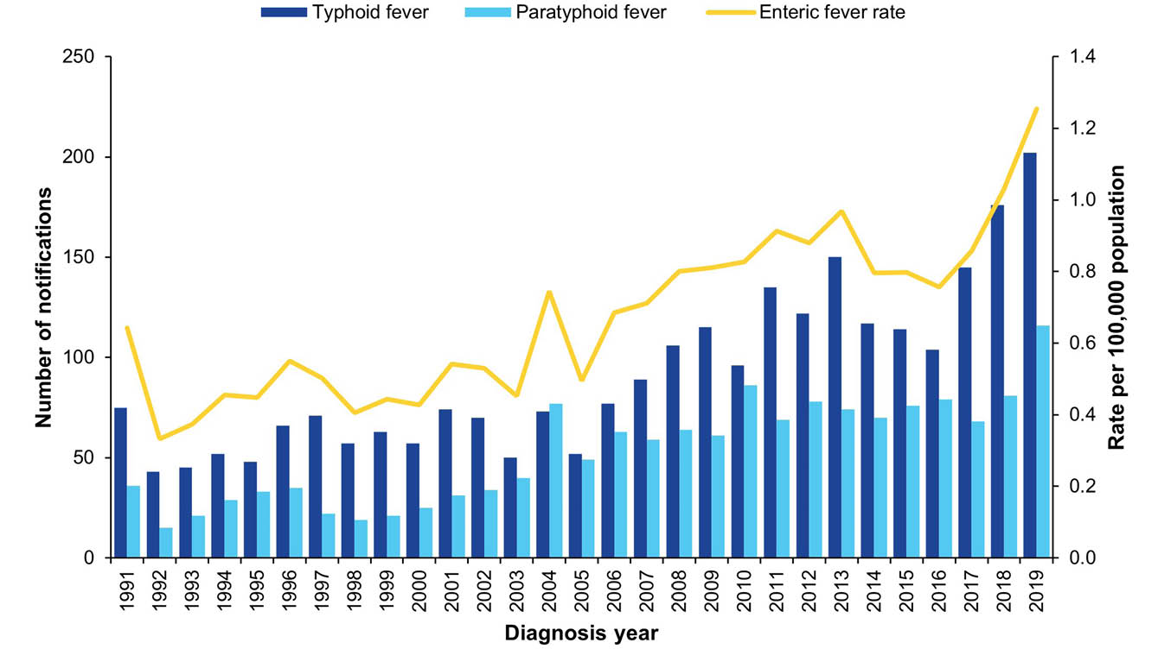
Figure 6: Typhoid fever notifications and rate per 100,000 population in Australia by jurisdiction of residence, 1991–2019
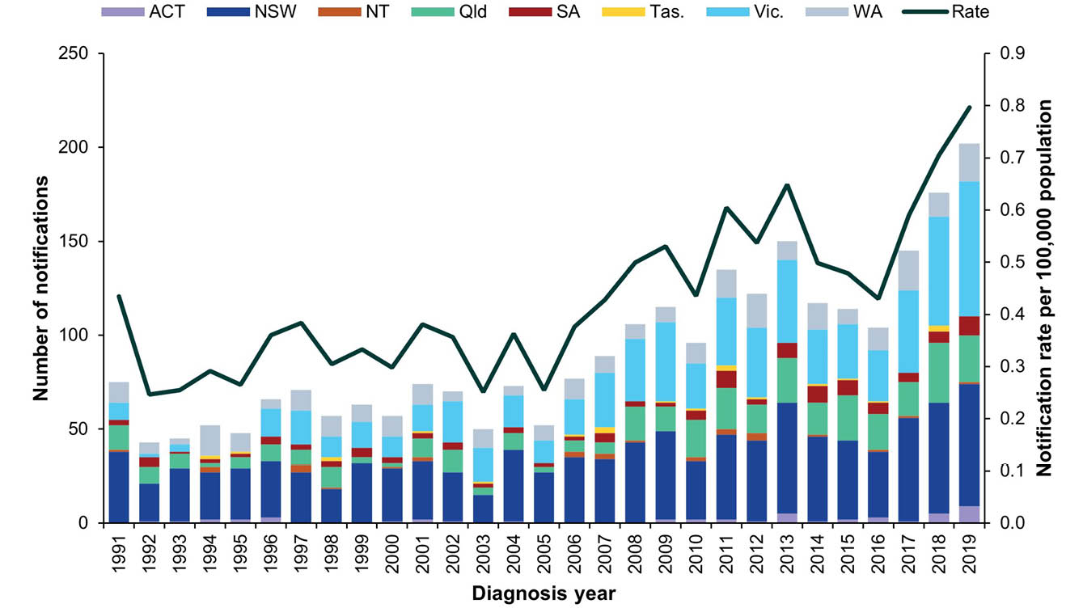
Figure 7: Paratyphoid fever notifications and rate per 100,000 population in Australia by jurisdiction of residence, 1991–2019
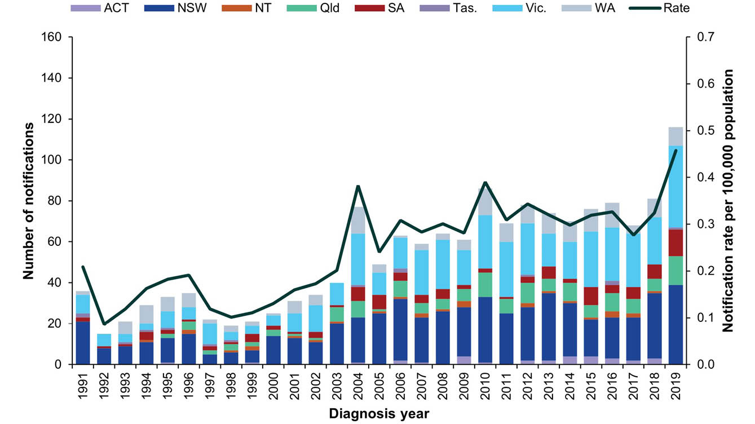
Table 4: Summary of enteric fever notifications in Australia, 2019
Category | Typhoid fever | Paratyphoid fever
Number of notifications | 202 | 116
Rate per 100,000 population | 0.8 cases | 0.5 cases
Jurisdiction with highest number of notifications | Victoria (n = 72; 36%) | Victoria (n = 40; 34%)
Hospitalisations (% of all cases) | 152 (75%) | 82 (71%)
Cases in Aboriginal and/or Torres Strait Islandersª | 0 | 0
Foodborne outbreaks | 0 | 0
a Indigenous status was not known for ten typhoid and five paratyphoid cases.

Epidemiology of enteric fever in Australia, 2019
Just over half of the typhoid cases notified in 2019 were in males (n = 106; 52%), and the proportion of males was also slightly greater for paratyphoid cases (n = 66; 57%). The median age at onset was 24 years for typhoid cases (range 0–66 years) and 27 years for paratyphoid cases (range 1–72 years). Consistent with previous years, the majority of paratyphoid cases were Paratyphoid A (n = 110; 95%) with the remaining cases Paratyphoid B (n = 6; 5%).

Country of acquisition
- As seen in previous years, most enteric fever cases in 2019 were acquired outside of Australia, with 95% of typhoid cases (n = 192/202) and 95% of paratyphoid cases (n = 110/116) reporting overseas travel during their incubation period.
- India was the most commonly reported country of acquisition for both typhoid and paratyphoid fever cases (Table 5).
- In 2019, typhoid cases without a history of overseas travel in their incubation period were reported by New South Wales (n = 4), Queensland (n = 3) and Victoria (n=3). Five cases were identified as contacts of known cases (New South Wales = 1, Queensland = 2, Victoria = 2), and one additional case was a contact of an overseas traveller (Queensland = 1). Two cases were identified in laboratory workers who were thought to have handled isolates of confirmed cases (New South Wales = 1, Victoria = 1). The risk factors for two cases acquired in Australia were unknown (New South Wales = 2).
- In 2019, paratyphoid cases without a history of overseas travel in their incubation period were reported by New South Wales (n = 1), South Australia (n = 3) and Victoria (n = 2). Two cases were identified as contacts of known cases (Victoria = 2). The risk factors for the remaining four cases acquired in Australia were unknown (New South Wales = 1, South Australia = 3).
Table 5: Top countries of acquisition for overseas acquired enteric fever cases notified in Australia, 2019
Disease | Country of acquisition | Number of notifications,  2019 | Proportion of overseas-acquired cases, 2019ª | Mean  2014–2018
Typhoid fever | India | 140 | 75% | 70
Typhoid fever | Pakistan | 22 | 12% | 11
Typhoid fever | Bangladesh | 5 | 3% | 11
Paratyphoid fever | India | 78 | 71% | 30
Paratyphoid fever | Cambodia | 8 | 7% | 6
Paratyphoid fever | Bangladesh | 4 | 4% | 5
Paratyphoid fever | Indonesia | 4 | 4% | 9
Paratyphoid fever | Pakistan | 4 | 4% | 4
a Excluding typhoid cases (n = 5) acquired overseas but with an unknown country of acquisition.

Hepatitis A
Hepatitis A is an infection of the liver caused by the hepatitis A virus (HAV) that is almost always transmitted by the faecal-oral route.
During the 1990s in Australia, groups most at risk of HAV infection were overseas travellers, childcare centre attendees, Aboriginal and/or Torres Strait Islander communities, men who have sex with men (MSM) and people who use or inject illicit drugs. Since the introduction of a vaccine into Australia in the mid-1990s and the subsequent implementation of vaccination programs and vaccine recommendations for at-risk groups, the majority of HAV infections diagnosed in Australia have been acquired while travelling overseas.¹⁸ Foodborne transmission occurs rarely, although in 2009, 2015, 2017 and 2018 there were significant multi-jurisdictional foodborne outbreaks associated with the consumption of imported food (see Previous outbreaks in Australia section below).
Surveillance data includes confirmed and probable cases. A confirmed case requires laboratory definitive evidence of hepatitis A infection and a probable case requires clinical and epidemiological evidence of infection. On 1 January 2013, the hepatitis A case definition was amended to include a requirement for confirmed cases to have clinical evidence if laboratory evidence was only suggestive of HAV infection (HAV immunoglobulin M [IgM] positive) and there was no epidemiological evidence. This has enabled jurisdictions to reject cases that are likely to have a false positive HAV IgM.
All notified cases are followed up by jurisdictional public health staff. In July 2017, enhanced national surveillance for hepatitis A commenced. This involves genomic sequencing of virus from all HAV cases in Australia and collecting information on risk factors.

Overall trend
- The incidence of HAV has markedly declined in Australia since notification began (Figure 8).
- The number of notifications in 2019 (n = 246) was similar to the five year historical mean (n = 241), but 43% lower than in 2018 (n = 434) which was directly related to outbreaks occurring within Australia during 2018 (further described below).

Previous outbreaks in Australia
Significant foodborne outbreaks previously reported in Australia have been associated with consumption of:
- oysters (n = 547 cases) predominantly in New South Wales in 1997;^{19,20}
- imported semi-dried tomatoes (n = 291 cases) in multiple jurisdictions in 2009;^{21,22}
- imported frozen berries (n = 35 cases) in multiple jurisdictions in 2015;⁵
- imported frozen mixed berries (n = 11 cases) in multiple jurisdictions in 2017;⁴ and
- imported frozen pomegranate arils (n = 31 cases) in multiple jurisdictions in 2018.^{23,24}
In addition to foodborne outbreaks, non-foodborne HAV outbreaks have also been reported in Australia amongst MSM; people who use or inject illicit drugs; people experiencing homelessness; child care centre attendees; and family groups, often where the index case has acquired their infection overseas. In 2017 a national investigation was initiated, following an increase in HAV cases with no history of overseas travel. The outbreak included cases from most jurisdictions, but mostly affected Victoria and New South Wales. Almost all cases were male and the majority identified as MSM. The outbreak peaked in 2018 but continued through 2019 and into 2020.
Figure 8: HAV notifications and rate per 100,000 population in Australia by jurisdiction of residence, 1991–2019
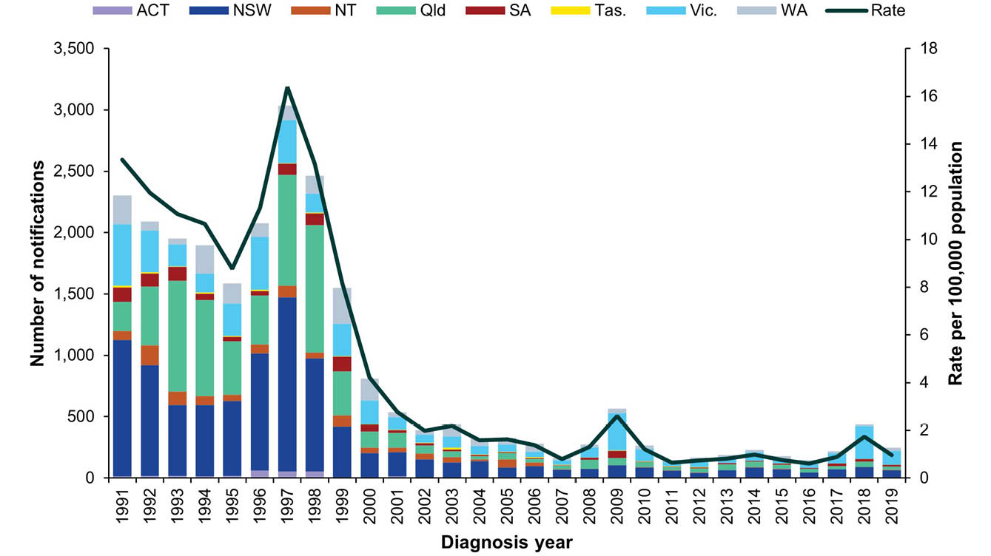

Epidemiology of HAV in Australia, 2019
Table 6: Summary of HAV notifications in Australia, 2019
Category | Value
Number of notifications | 242
Rate per 100,000 population | 1.0 case
Jurisdiction with the highest number of notifications | Victoria (n = 109; 45%)
Hospitalisations (% of all cases) | 142 (59%)
Cases in Aboriginal and/or Torres Strait Islandersª | 1 (< 1%)
Foodborne outbreaks | 1 (n = 4 cases)
Implicated foods and settings | Imported food product in the community
a Indigenous status was not known for 18 cases (7%).

Country of acquisition
The number of overseas-acquired HAV infections in 2019 remained similar to the previous year. The annual count of Australian-acquired cases in 2019 (n = 90) decreased following successful public health interventions curtailing the local MSM outbreak but remained higher than case numbers pre-2017 (Figure 8). Most cases (n = 152/242; 63%) were acquired overseas.
Figure 9: HAV notifications in Australia by place of acquisition, 2014–2019
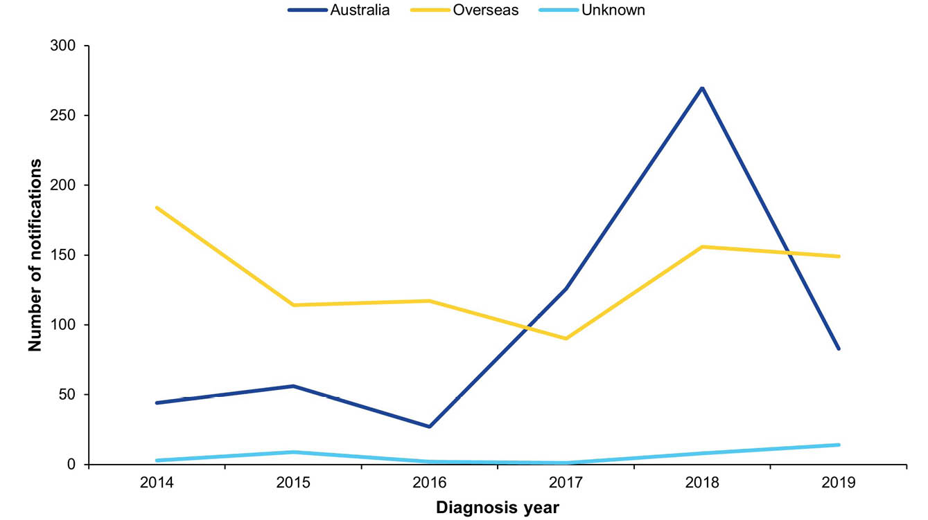

HAV cases acquired in Australia (n = 90)
- Cases acquired in Australia were most common in males (n = 57; 63%).
- Among males, cases had a median age of 35 years (range 1–71 years) and were most common among those aged 25–29 years (n = 11; 19%) and 40–44 years (n = 9; 16%). Among females, cases were most common among those aged 5–9 years (n = 5; 15%), with a median age of 31 years (range 5–72 years).
- Cases were reported in residents of Victoria (n = 58), New South Wales (n = 15), Western Australia (n = 7), the Australian Capital Territory (n = 3), Queensland (n = 3), South Australia (n = 2), the Northern Territory (n = 1) and Tasmania (n = 1).
- One case was reported in a person who identified as Aboriginal and/or Torres Strait Islander.

HAV cases acquired overseas (n = 152)
- Over half of the overseas-acquired cases were males (n = 90; 59%).
- The most frequently reported age groups affected were 20–29 years (n = 49; 32%).
- HAV infection was most commonly acquired in India, accounting for over a third of all overseas acquired cases (Table 7).
Table 7: Top four countries of acquisition for overseas acquired HAV cases in Australia, 2019 (n = 152)
Country of acquisition | Number of notifications, 2019 | Proportion of overseas acquired cases, 2019ª | Mean  2014–2018
India | 53 | 35% | 24
Pakistan | 27 | 18% | 12
Fiji | 9 | 6% | 10
Indonesia | 9 | 6% | 4
a Excluding cases known to be overseas acquired without a single identified country of acquisition (n = 1).

Outbreak amongst men who have sex with men
A national investigation initiated in 2017, following an increase in HAV cases with no history of overseas travel,⁴ continued through 2018 and into 2019. Cases who had spent some of their acquisition period (15 to 50 days prior to onset of illness) in Australia and who were identified as having one of three strains related to the large, multi-country outbreak in Europe (UK VRD 521 2016 (UK strain), RIVM-HAV16-090 (Ber/NL strain) and V16-25801 (Ber/Muc/Fra strain)) were included in the investigation.^{25–27}
There were 98 cases linked to the outbreak in 2017 and 214 cases in 2018, with cases occurring predominantly in males who identified as MSM. In 2019, the number of outbreak cases decreased to 51 across Australia. Cases were reported in Victoria (n = 49), Queensland (n = 1) and South Australia (n = 1). Most cases in the outbreak were male (n = 40; 78%). In contrast to previous years, no cases in 2019 identified as MSM. In 2019, the outbreak mostly affected people reporting risk factors of injecting drug use and/or people in insecure housing. One outbreak case in 2018 reported overseas travel (2%). In response to the outbreak, affected jurisdictions implemented public health messaging and vaccination campaigns targeted to specific at-risk groups, including MSM and injecting drug users. The outbreak continued into 2020.

Hepatitis E
Hepatitis E is an infection of the liver caused by the hepatitis E virus (HEV) that is almost always transmitted by the faecal-oral route. Infections are rarely notified in Australia and are usually associated with overseas travel. HEV infections acquired in Australia are occasionally notified and some of these infections have been associated with the consumption of undercooked pork products, particularly pork livers.²⁸ HEV has been found in pig herds in Australia.²⁹
Surveillance data includes confirmed cases only. A confirmed case requires either laboratory definitive evidence or laboratory suggestive and clinical evidence of HEV infection. Testing practices for HEV vary across jurisdictions. All notified cases are followed up by jurisdictional public health staff.

Overall trend
While HEV infection is rare in Australia, notification rates have trended upwards since national notification began in 2001 peaking in 2014 owing to a local foodborne outbreak (Figure 10).

Previous outbreaks in Australia
A foodborne outbreak in New South Wales, following the consumption of pork liver pâté in 2014 (n = 17 cases), is the only known outbreak of HEV to have occurred in Australia.²⁸
Figure 10: HEV notifications and rate per 100,000 population in Australia by jurisdiction of residence, 2001–2019
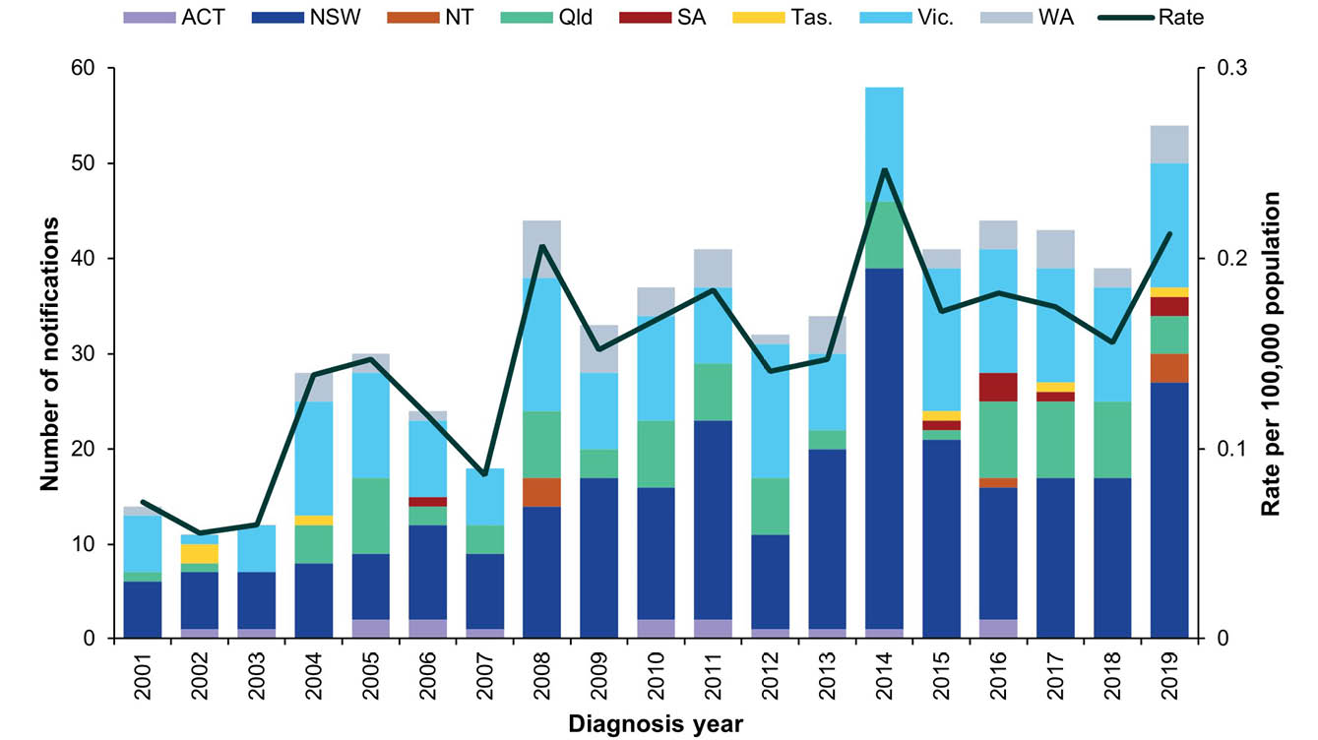

Epidemiology of HEV in Australia, 2019
Table 8: Summary of HEV notifications in Australia, 2019
Category | Value
Number of notifications | 54
Rate per 100,000 population | 0.2 cases
Jurisdiction with the highest number of notifications | New South Wales (n = 27; 50%)
Hospitalisations (% of all cases) | 36 (67%)
Cases in Aboriginal and/or Torres Strait Islandersª | 0
Foodborne outbreaks | 0
a Indigenous status was not known for three cases (6%).

Country of acquisition
- From 2004 (when travel history has been collected nationally) until 2013, almost all HEV infections were acquired overseas (Figure 11).
- While overseas travel continues to account for the majority of cases since 2013, an increasing number of Australian acquired infections have been reported (Figure 11). The extent to which this has been influenced by changes in testing practices is unclear.
Figure 11: HEV notifications in Australia by place of acquisition, 2004–2019
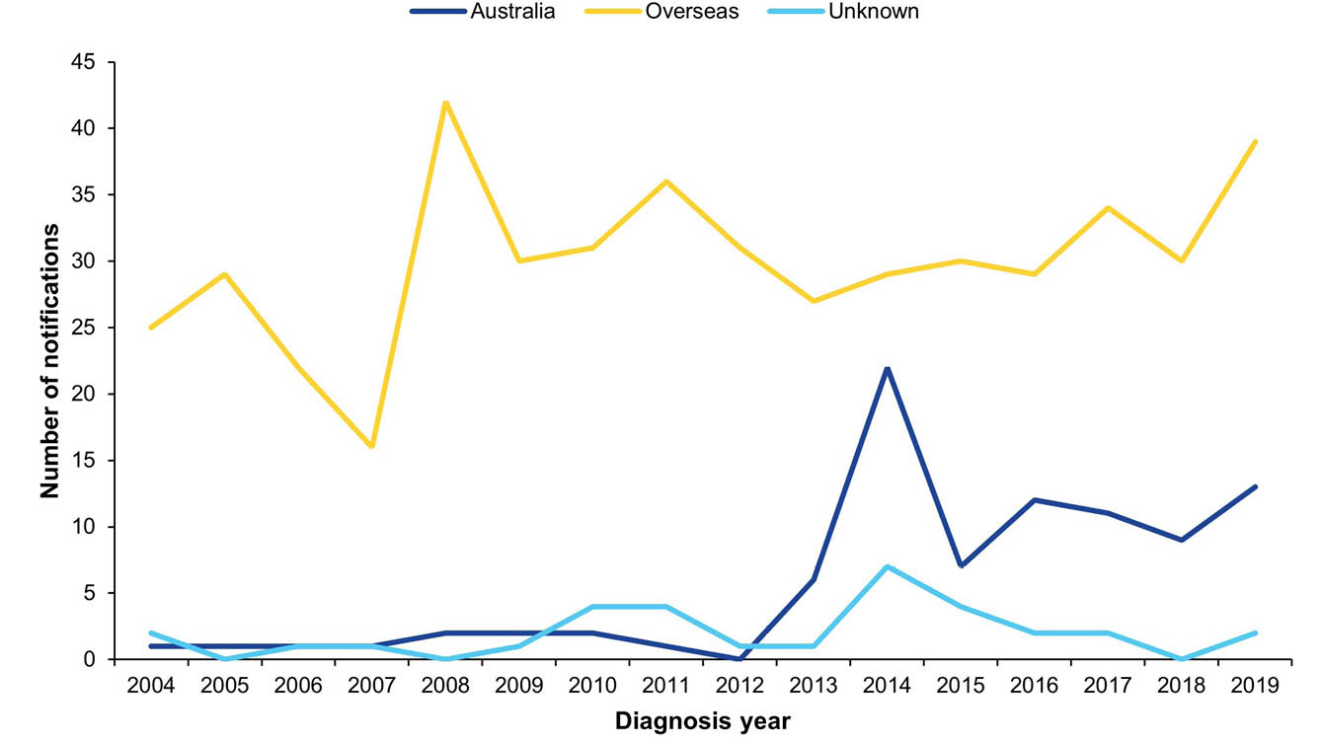

HEV cases acquired overseas (n = 39)
- As seen in previous years, HEV infection was most commonly acquired in India (n = 18). There was a large increase in notifications acquired in Pakistan (n = 12) compared to the five-year mean (n = 3) (Table 9).
- The majority of cases acquired overseas were males (n = 29; 74%), with a median age of 35 years (range 8–78 years).
Table 9: Top two countries of acquisition for overseas-acquired HEV cases in Australia, 2019 (n = 37)
Country of acquisition | Number of notifications, 2019 | Proportion of overseas acquired cases, 2019ª | Mean  2014–2018
India | 18 | 47% | 13
Pakistan | 12 | 32% | 3
a Excluding cases known to be overseas acquired without an identified country of acquisition (n = 1).

HEV cases acquired in Australia (n = 13)
- The number of HEV infections acquired in Australia in 2019 (n = 13) has remained reasonably steady since 2015.
- Cases were residents of New South Wales (n = 9), Western Australia (n = 2), the Northern Territory (n = 1) and Victoria (n = 1).
- While the source of infection was not identified for these cases, five cases with food consumption data available reportedly consumed pork products during their respective incubation periods.
- The majority of cases acquired in Australia were males (n = 8; 62%), and the median age was 58 years (range 21–72 years).

Listeriosis
Listeriosis is a rare but serious illness caused by the Listeria monocytogenes bacterium. Infection occurs following the consumption of contaminated food or, in the case of a foetus or newborn, vertically from their pregnant mother. A wide variety of foods may be contaminated with L. monocytogenes, but cases of listeriosis are predominantly associated with commercially manufactured ready to eat foods that have a long recommended refrigerated shelf-life and fresh foods that are consumed fresh or without further cooking, for example cold meats (from delicatessen or pre-packaged), cold cooked chicken, pâté, pre-packaged salads, fresh fruits such as rockmelon, chilled cooked seafood, smoked fish and soft cheeses. The elderly, pregnant women and people who are immunocompromised (either by medical condition or medications) are at an increased risk of infection.³⁰
Surveillance data includes confirmed cases only. The case definition was expanded from 1 January 2017 to include clinical and epidemiological evidence as criteria for a confirmed case (in addition to laboratory definitive evidence). The clinical and epidemiological evidence criteria for a confirmed case means that if the mother is a confirmed case by laboratory definitive evidence, then the foetus/neonate is also a confirmed case if they have the defined (foetus/neonate) clinical evidence, and vice versa. All notified cases are followed up by jurisdictional public health staff.

Overall trend
With the exception of increases due to outbreaks in 2009 and 2012–2013, the rate of listeriosis in Australia has remained steady since national notification began in 1994 (Figure 12). In 2019, listeriosis notifications were the lowest reported since 1994.

Previous outbreaks in Australia
Cases are usually sporadic, although foodborne outbreaks have been reported in Australia. Food sources of significant outbreaks identified in Australia since 2000 include:
- ready-to-eat meats (silverside, corned beef) (n = 5 cases) in South Australia in 2005;
- cooked chopped chicken (n = 3 cases) in Western Australia in 2009;
- chicken wraps (n = 36 cases) in multiple jurisdictions in 2009;
- melons (n = 9 cases) in multiple jurisdictions in 2010;
- cold meat (n = 6 cases) in Victoria in 2010;
- smoked salmon (suspected) (n = 3 cases) in multiple jurisdictions in 2012;
- soft cheese (brie/camembert) (n = 34 cases) in multiple jurisdictions in 2012–2013;³¹
- profiteroles (n = 3 cases) in New South Wales in 2013;
- pre-prepared frozen meals (n = 3 cases) in Western Australia in 2013;
- deli meats (n = 8) in multiple jurisdictions in 2016;³ and
- rockmelon (n = 24) in multiple jurisdictions in 2018.²⁴
Figure 12: Listeriosis notifications and rate per 100,000 population in Australia by jurisdiction of residence, 1994–2019
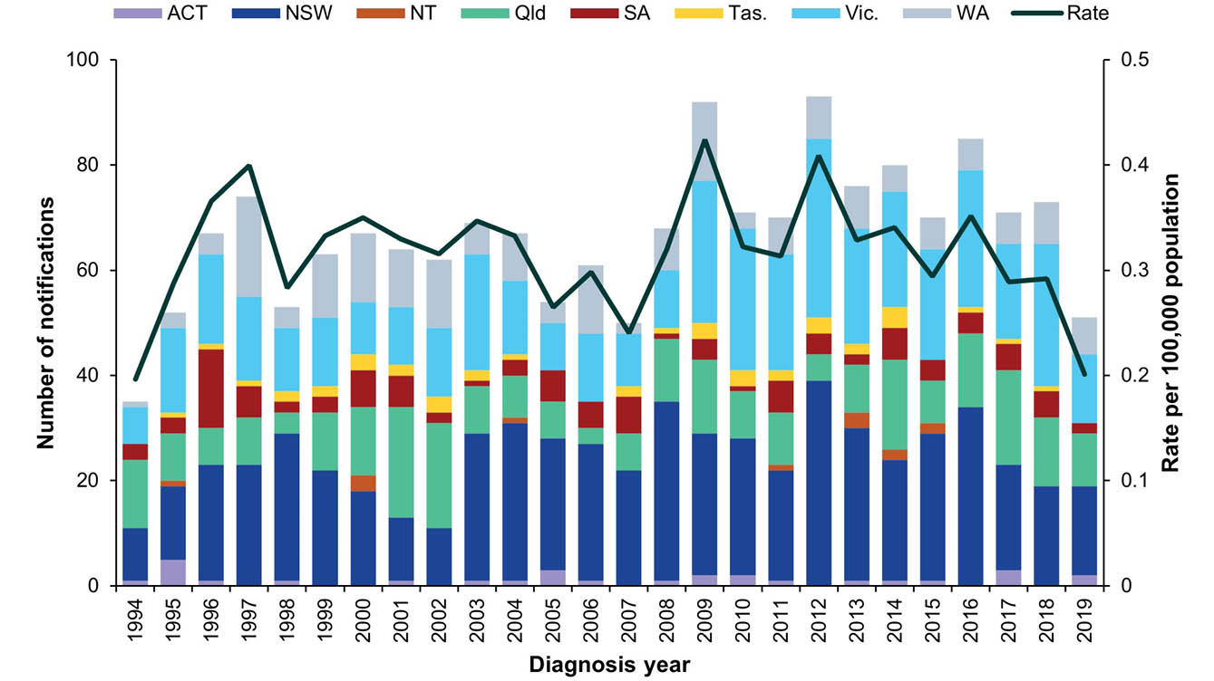

Epidemiology of listeriosis in Australia, 2019
Table 10: Summary of listeriosis notifications in Australia, 2019
Category | Value
Number of notifications | 51, comprising 40 non-perinatal cases and 11 perinatal cases
Rate per 100,000 population | 0.2 cases
Hospitalisation (% of all cases) | 51 (100%)
Cases in Aboriginal and/or Torres Strait Islanders (% of all cases)ª | 4 (8%)
Jurisdiction with the highest number of notifications | New South Wales (n = 17; 33%)
Foodborne outbreaks | 1 (n = 4 cases)
Food implicated in outbreak | Smoked salmon
a Indigenous status was not known for one case (2%).

MLST typing
Multi-locus sequence typing (MLST) is determined in silico from whole genome sequencing data. A total of 19 different MLST types were reported in 2019. The most common type identified was MLST 3, which accounted for over a quarter of all cases (Table 11).
Table 11: Listeriosis cases in Australia by multi-locus sequence typing (MLST), 2019^{a,b}
MLST | Number of cases | Proportion
1 | 5 | 11%
2 | 5 | 11%
3 | 12 | 26%
4 | 1 | 2%
5 | 1 | 2%
7 | 3 | 7%
8 | 1 | 2%
9 | 1 | 2%
54 | 1 | 2%
101 | 1 | 2%
120 | 4 | 9%
155 | 3 | 7%
220 | 1 | 2%
320 | 1 | 2%
321 | 2 | 4%
323 | 1 | 2%
480 | 1 | 2%
1525 | 1 | 2%
2078 | 1 | 2%
Total | 46 | 100%
a Excluding cases with isolates not typed (n = 1), and maternal/foetal infection counted once only (n = 4).
b Data taken from the National Enhanced Listeriosis Surveillance System (NELSS).

Perinatal cases (n = 11)
- There were 11 perinatal cases notified in 2019.
- Of these cases, seven cases were pregnant women and four were neonates (infants less than four weeks of age).
- There were four mother/neonate pairs notified (representing eight notifications) and three notifications in the mother only.
- The outcome of the seven pregnancies was predominantly neonatal survival (n = 6) and one neonatal death.
- There were no deaths reported among the pregnant women.
- Illnesses reported for the mother included bacteraemia/sepsis (n = 5), febrile gastroenteritis (n = 1), amnionitis (n = 1), non-specific ‘flu-like' symptoms (n = 1) and fever (n = 3).

Non-perinatal cases (n = 40)
- Sixty-three percent of the cases were males (n = 25).
- The majority of cases (n = 31; 78%) were aged over 65 years, with 35% (n = 14) aged over 80 years.
- Septicaemia was the most common clinical presentation (Table 12).
- Thirty-eight cases (95%) had at least one illness/condition known to increase their risk of listeriosis, with heart disease most commonly reported (Table 13).
- Two cases had no known comorbidities, and also did not report consuming any medications that would increase their susceptibility to listeriosis such as corticosteroids, cyclosporine or other immunosuppressive drugs, antidiarrheal medications, or gastric acid medications in the four weeks prior to illness.
- Ten cases died, six of whom had septicaemia. Three deaths were attributed specifically to listeriosis.
Table 12: Non-perinatal listeriosis cases by clinical presentation in Australia, 2019ª (n = 40)
Nature of the illness | Number of cases | Proportion of  all cases (%) | Deaths
Septicaemia | 23 | 58% | 6
Meningitis and septicaemia | 1 | 3% | 0
Meningitis | 0 | 0% | 0
Other^{b} | 20 | 50% | 2
Unknown | 6 | 15% | 2
Total | 40 | 100% | 10
a Data taken from NELSS.
b ‘Other’ includes: acute loss of consciousness, bacteraemia, bibasal pneumonia with hypovolaemic shock and organ failure, diabetic ketoacidosis, end stage congestive cardiac failure, and pneumonia.
Table 13: Immunocompromising conditions for non-perinatal listeriosis cases in Australia, 2019ª (n = 40)
Condition | Number of cases | Proportion of all cases (%)
Heart disease | 20 | 50%
Cancer | 16 | 40%
Diabetes | 16 | 40%
Other renal disease | 9 | 23%
Liver disease | 7 | 18%
Rheumatological condition | 7 | 18%
Chronic lung disease | 5 | 13%
Renal/kidney disease | 5 | 13%
Blood disorder | 3 | 8%
Organ transplant | 1 | 3%
No immunocompromising conditions | 2 | 5%
a Data taken from NELSS.

Salmonellosis
Salmonellosis is an infection caused by the Salmonella bacterium. It is second to campylobacteriosis as the most commonly notified enteric pathogen in Australia. Salmonella infections acquired in Australia are usually associated with consumption of contaminated food, or less commonly, after contact with infected animals or an infected person. Foods sources associated with Salmonella infection in Australia include raw and undercooked foods of animal origin, particularly eggs and poultry, and fresh produce.³² Infection can also occur following exposure to Salmonella in the environment. Many Salmonella infections are also notified in people returning from overseas.
Surveillance data includes confirmed cases only. A confirmed case requires laboratory definitive evidence of infection. Note that paratyphoid and typhoid fever infections are reportedly separately (refer to Enteric fever section). Surveillance data is monitored by jurisdictional public health staff to identify potential outbreaks. Triggers for further investigation vary within and between jurisdictions depending on background infection rates, availability and timeliness of sub-typing information, and resource capacity.

Overall trend
- Salmonellosis notification rates have increased significantly since national notification began in 1991 (Figure 13).
- A marked increase was observed across most jurisdictions from 2014, peaking in 2016. This is due, at least in part, to the increase in PCR testing as a method of laboratory diagnosis (refer to the 2016 OzFoodNet annual report).³
- A slight increase in the national notification rate was observed in 2019, following a decline in 2017 and 2018.

Previous outbreaks in Australia
Salmonellosis is the enteric pathogen most commonly identified in foodborne outbreaks in Australia. These outbreaks have been most frequently associated with the consumption of raw or minimally-cooked egg products.^{33,34} (Refer to Foodborne and probable foodborne outbreaks section.)
S. Typhimurium is the most commonly identified serotype in Salmonella outbreaks reported in Australia. The foods implicated in the largest of these outbreaks include:
- Vietnamese bánh mì rolls (n = 213 cases) in Victoria in 2003;
- dips served at a Turkish restaurant (n = 442 cases) in Victoria in 2005;
- pork or chicken and salad rolls made with raw-egg mayonnaise (n = 319 cases) in New South Wales in 2007;
- chicken (n = 391 cases) in multiple jurisdictions in 2012;
- potato salad containing raw eggs (n = 350 cases) in Queensland in 2013;
- raw-egg mayonnaise (n = 242 cases) in Victoria in 2014;
- numerous bakery items (n = 202 cases) in New South Wales in 2016; and
- eggs (n = 236 cases) in New South Wales in 2018.
Other notable foodborne Salmonella outbreaks reported in Australia include:
- S. Saintpaul associated with rockmelon (n = 38 cases) in multiple jurisdictions in 2006,³⁵ and with mung bean sprouts (n = 419 cases) in multiple jurisdictions in 2016;³
- S. Litchfield associated with papaya (n = 26 cases) in multiple jurisdictions in 2006;³⁶
- S. Anatum associated with bagged salads (n = 311 cases) in multiple jurisdictions in 2016;³ and
- S. Hvittingfoss associated with rockmelons (n = 144 cases) in multiple jurisdictions in 2016.³
Notable non-foodborne outbreaks reported in Australia include:
- S. Paratyphi B biovar Java associated with tropical fish aquariums in 2003–2004;³⁷
- S. Paratyphi B biovar Java associated with playground sand in New South Wales in 2007–2009;³⁸ and
- S. Litchfield associated with a Northern Territory car rally in 2009.³⁹
Despite the number of salmonellosis outbreaks reported, the majority of cases reported each year are considered sporadic cases.
Figure 13: Salmonellosis notifications and rate per 100,000 population in Australia by jurisdiction of residence, 1991–2019
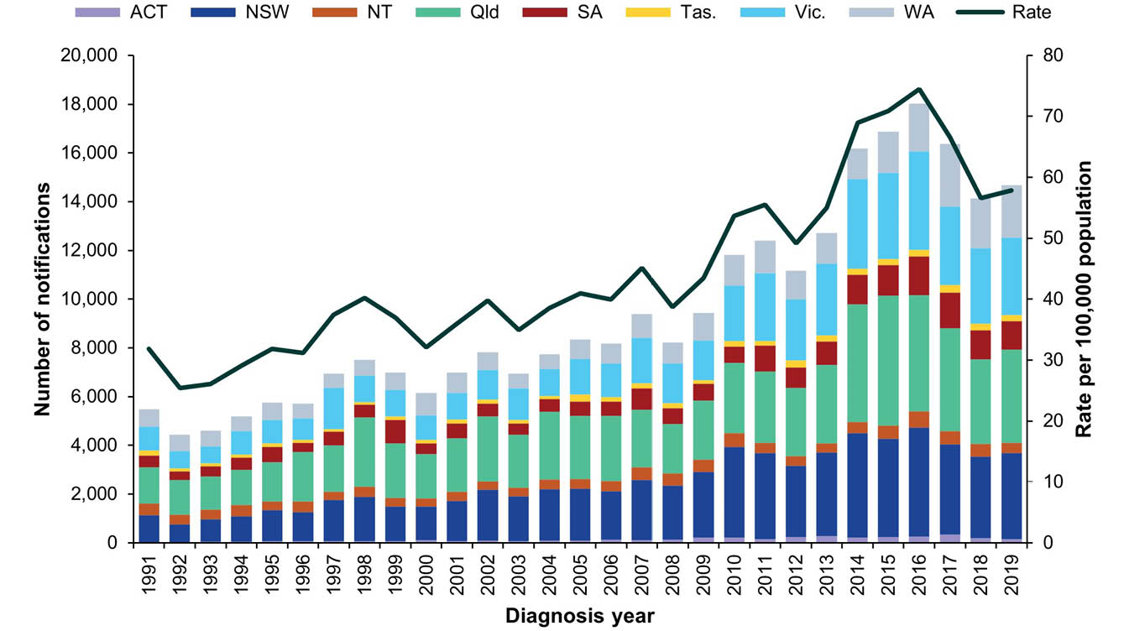
Table 14: Summary of salmonellosis notifications in Australia, 2019
Category | Value
Number of notifications | 14,676
Rate per 100,000 population | 58 cases
Jurisdiction with the highest number of notifications | Queensland (n = 3,816; 26%)
Foodborne outbreaks | 64
Foods implicated in outbreaksª | Most commonly eggs (n = 26 outbreaks)
a Refer to Foodborne and probable foodborne outbreaks section.
Table 15: Groups with the highest salmonellosis notification rate in Australia, 2019
Category | Group  most affected | Rate per 100,000 population | Number  (% of all cases)
Age group (years) | 0–4 | 221 | 3,463 (24%)
Sex | Female | 59 | 7,533 (51%)
Jurisdiction | Northern Territory | 174 | 428 (3%)

Epidemiology of salmonellosis in Australia, 2019
- Consistent with previous years, notifications were significantly higher in children aged under five years than among all other age groups. For all age groups over 15 years, slightly higher rates were reported in females compared with males (Figure 14).
- As expected, infections were more common in summer and autumn with the highest monthly count reported in January (Figure 15).
Figure 14: Salmonellosis notification rate per 100,000 population in Australia by age group and sex,ª 2019
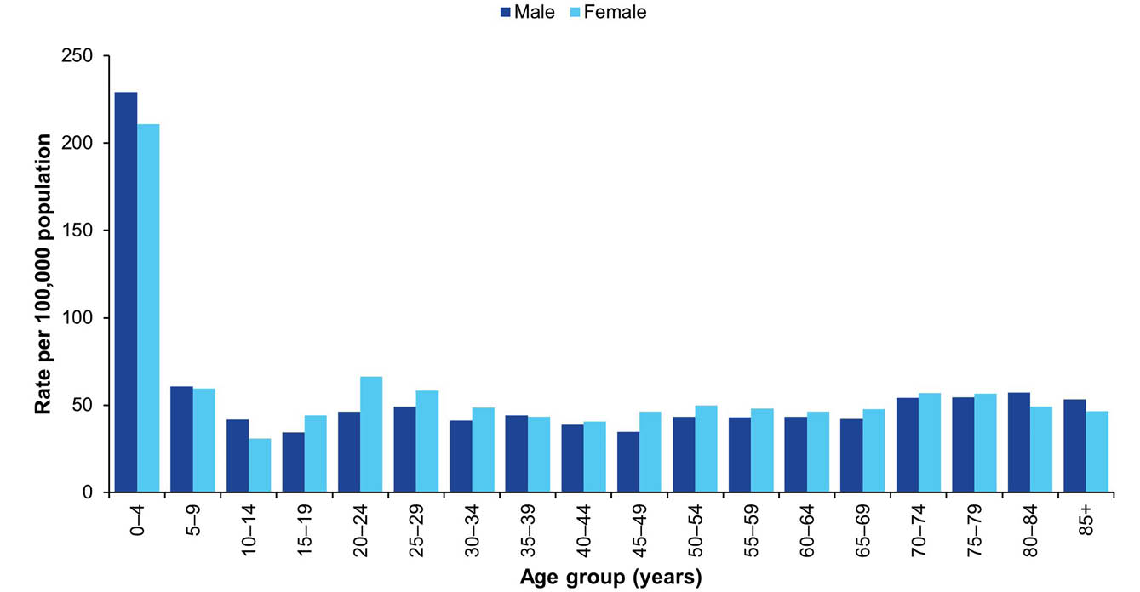
a Excluding cases with sex not defined (n = 34).
Figure 15: Salmonellosis notifications in Australia by month, and five year historical mean, 2019
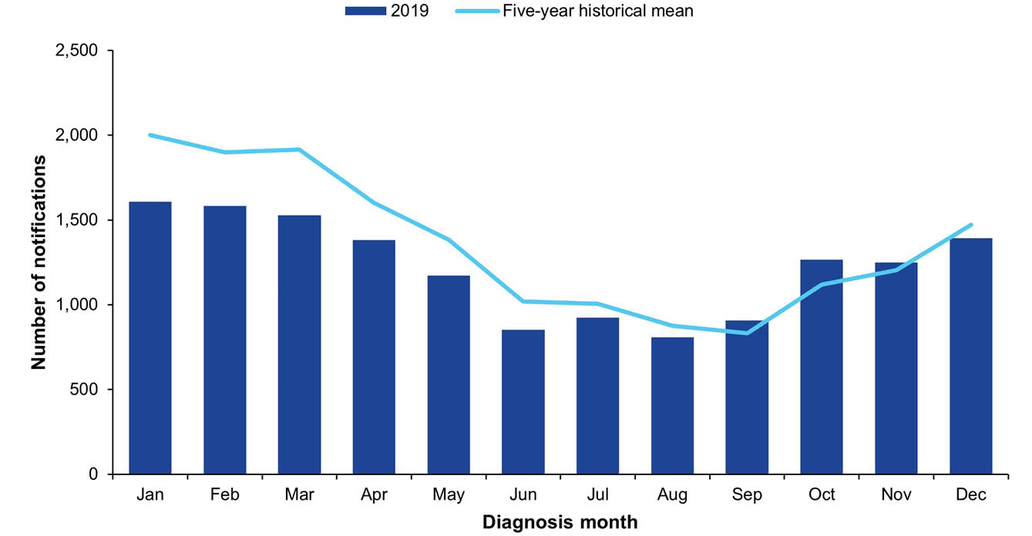

Serotyping
Serotyping information was available for 90% of Salmonella notifications in 2019 (n = 13,214/14,676), with a total of 206 different serotypes identified. The most common serotype identified in 2019 was S. Typhimurium, despite a 23% decrease in reported cases of this serotype (n = 4,891) compared to the five-year historical mean (n = 6,326): after having peaked nationally in 2014, reported cases of S. Typhimurium dropped each year during 2014–2018. The five most commonly reported serotypes in 2019 are shown in Table 16 and, when combined, account for 58% of all cases with serotyping performed.
Table 16: Top five Salmonella serotypes notified in Australia, 2019
Salmonella serotype | Number notified  in 2019 | % of all  serotypes | Mean  2014–2018
S. Typhimurium | 4,891 | 37% | 6,326
S. Enteritidis | 1,147 | 9% | 907
S. Virchow | 665 | 5% | 728
S. Saintpaul | 588 | 4% | 680
S. Weltevreden | 394 | 3% | 250

Salmonella Typhimurium
With the exception of the Northern Territory and Tasmania, S. Typhimurium was the most common serotype notified in each jurisdiction in 2019, with the highest notification rate reported in Western Australia (42 cases per 100,000 population) (Table 17). Isolates of S. Typhimurium may undergo the molecular based further typing method of multiple-locus variable number tandem repeat analysis (MLVA); however; this methodology was ceased in some jurisdictions (New South Wales and Victoria) midway through 2019 in favour of transitioning to utilisation of phylogenetic analysis of whole genome sequencing. Accordingly, MLVA data should be reviewed with caution.
In 2019, a total of 739 distinct MLVA profiles were identified with 603 of these accounting for fewer than five cases each over the year. While in Western Australia and Queensland a single MLVA profile accounted for approximately a third of cases, for the remaining jurisdictions the most common MLVA type accounted for between 12-22% of cases (Table 17). Refer to the Outbreak section for details of S. Typhimurium outbreaks.
Table 17: Salmonella Typhimurium (STm) notifications by jurisdiction and most common multiple-locus variable number tandem repeat analysis (MLVA) typeª in Australia, 2019 (n = 4,891)
Jurisdiction^{b} | Total STm 2019 |  | Number of cases with MLVA resultª | Number of MLVA types identified | Most common MLVA
Jurisdiction^{b} | Annual count | Rate per 100,000 population | Number of cases with MLVA resultª | Number of MLVA types identified | MLVA  type | Annual count | % of MLVA
ACT | 48 | 11 | 41 | 28 | 04-11-12-00-517 | 8 | 20%
NSW | 904 | 11 | 575 | 203 | 05-17-09-13-490 | 127 | 22%
NT | 37 | 15 | 11 | 8 | N/A^{c} | N/A^{c} | N/A^{c}
Qld | 743 | 15 | 713 | 244 | 03-20-11-10-523 | 256 | 34%
SA | 537 | 31 | 537 | 139 | 03-15-08-11-550 | 102 | 19%
Tas. | 46 | 8.3 | 35 | 28 | N/A^{d} | N/A^{d} | N/A^{d}
Vic. | 1,466 | 22 | 969 | 257 | 03-14-10-08-523 | 112 | 12%
WA | 1,110 | 42 | 1,069 | 199 | 03-17-09-12-523 | 361 | 34%
Total | 4,891 | 19 | 3,950 | 739 | 03-17-09-12-523 | 380 | 10%
a Excluding cases where MLVA type was not available (n = 958).
b ACT: Australian Capital Territory; NSW: New South Wales; NT: Northern Territory; Qld: Queensland; SA: South Australia; Tas.: Tasmania; Vic.: Victoria; WA: Western Australia.
c Not reported, as MLVA type was unavailable for the majority of Northern Territory cases (n = 26; 70%).
d Top seven MLVA types in 2019 for Tasmania all have two notifications each.

Salmonella Enteritidis
S. Enteritidis is a globally important Salmonella serotype that can infect the internal contents of eggs. Previously S. Enteritidis was not considered endemic in Australian egg layer flocks.⁴⁰ In 2018, S. Enteritidis was detected in Australian poultry facilities in New South Wales for the first time.⁴¹ For this reason, a travel history is sought from all notified cases, and cases who have not travelled outside Australia undergo further investigation to identify the likely source of infection.
In 2019, a total of 1,147 S. Enteritidis cases were notified. This was higher than in 2018 (n = 958) and higher than the five-year historical mean (n = 907). In accordance with previous years, the majority of cases with a known travel history reported overseas travel within their incubation period (n = 791; 77%), with approximately half reporting travel to Indonesia (n = 410; 52%). This may reflect travel practices rather than an increased risk.

S. Enteritidis acquired in Australia
S. Enteritidis infections acquired in Australia (n = 232) were more than twice the five-year historical mean (n = 106) and were most commonly reported in New South Wales (n = 141), followed by Victoria (n = 38). This increase in locally acquired infections was primarily due to a large multi-jurisdictional outbreak linked to eggs. Six additional foodborne outbreaks were identified in 2019, including three outbreaks involving passengers on cruise ships, one affecting crew on an international cargo ship, and a multi-jurisdictional outbreak associated with chicken meat. Refer to the Foodborne and probable foodborne outbreaks section for further information. One waterborne outbreak in Queensland affecting seven people was also reported in 2019. For the remaining cases, no common exposures were identified.

Shigellosis
Shigellosis is a diarrhoeal disease caused by the Shigella bacterium. In Australia, the most common mode of transmission is person-to-person spread during close contact with an infectious case. This includes transmission in poor hygiene conditions, transmission between young children, and transmission during certain types of sexual activity (such as oral-anal sex). Person-to-person transmission is common due to the low infectious dose. Outbreaks can occur in conditions of crowding and poor sanitation and hygiene. Occasionally infections may be foodborne, caused by infectious food handlers contaminating ready-to-eat food during preparation and handling. Many of the notifications reported in Australia represent infections that have been acquired during overseas travel. Populations at the highest risk of acquiring shigellosis within Australia include Aboriginal and/or Torres Strait Islander communities and MSM.^{42,43}
Surveillance data includes confirmed and probable cases as of July 2018. A confirmed case requires laboratory definitive evidence of Shigella while a probable case only requires laboratory suggestive evidence. The ipaH gene is the target of all current nucleic acid tests for Shigella. However, the ipaH gene is common to Shigella species and to enteroinvasive Escherichia coli (EIEC). When PCR testing was introduced in 2014, jurisdictions classified PCR positive cases differently. Victoria, the Northern Territory and Tasmania included cases found to be positive on PCR alone as confirmed cases in the surveillance data, whereas only cases confirmed by culture were included in the Australian Capital Territory, New South Wales, Queensland, South Australia and Western Australia during that time period. As of July 2018, the new national case definition was introduced; all jurisdictions now classify cases found to be positive on PCR alone as probable cases, and classify cases with a culture positive result as confirmed cases.

Overall trend
- Except for peaks in the number of notifications in 2005 and 2008 (observed in multiple jurisdictions), the notification rate has remained steady between 2001 (when national notification began) and 2013 (Figure 16).
- A marked increase was observed across most jurisdictions from 2014 onwards. This is due, at least in part, to the increase in PCR testing as a method of laboratory diagnosis.
- In New South Wales, outbreaks amongst MSM contributed to the increases observed in 2014 and 2016.⁴⁴
- In multiple jurisdictions, particularly the Northern Territory, South Australia, Western Australia and Queensland, a large community outbreak amongst Aboriginal and/or Torres Strait Islander people since 2017 has contributed to the increase of shigellosis (see S. flexneri 2b outbreak section below).
- The change to the national case definition in July 2018, to include PCR positive cases as probable cases in jurisdictions not previously reporting them, is likely to have contributed to the increase in rate since 2018.

Previous outbreaks in Australia
In addition to non-foodborne outbreaks amongst MSM and Aboriginal and/or Torres Strait Islander communities, nine foodborne outbreaks have been reported in Australia since 2000. The most significant foodborne outbreak was associated with the consumption of imported baby corn, with 55 cases reported in Australia in 2007.⁴⁵
Figure 16: Shigellosis notifications and rate per 100,000 population in Australia by jurisdiction of residence,ª 2001–2019
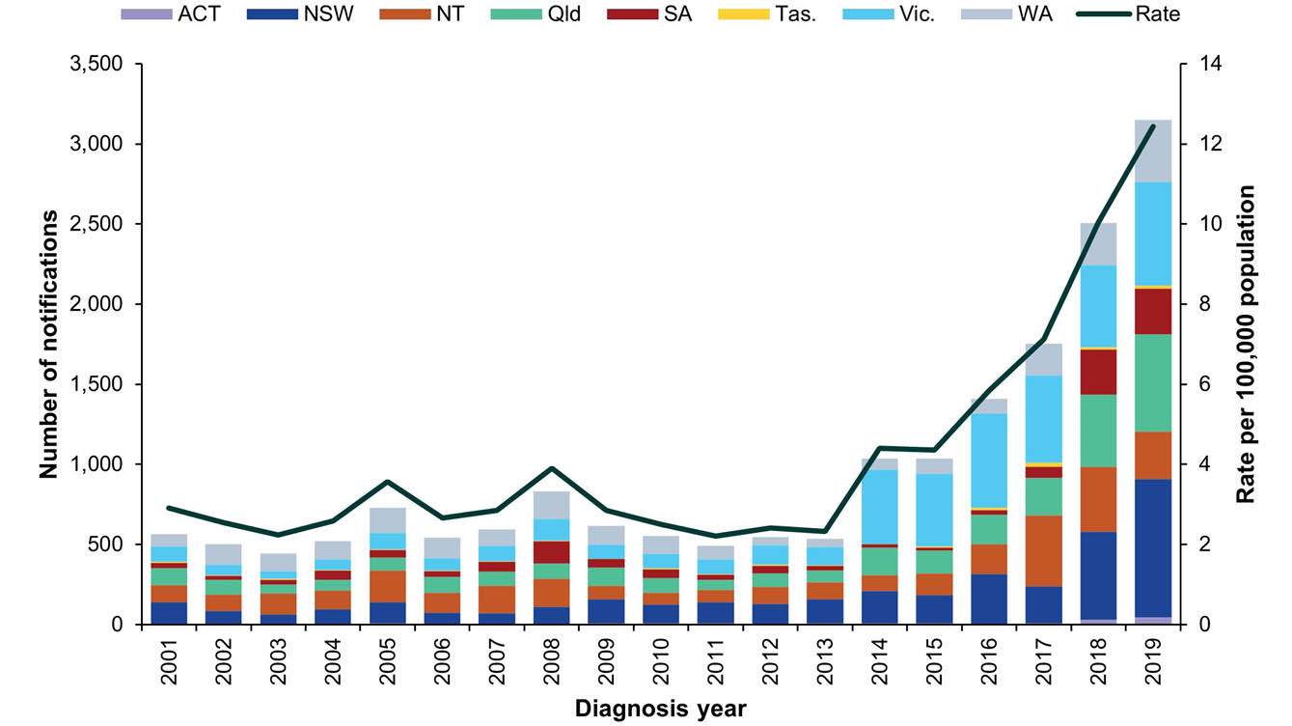
a The national shigellosis case definition changed on 1 July 2018 to include ‘probably cases’.
Table 18: Summary of shigellosis notifications in Australia, 2019
Category | Value
Number of notifications | 3,152
Rate per 100,000 population | 12 cases
Jurisdiction with the highest number of notifications | New South Wales (n = 863; 27%)
Foodborne outbreaks | 0

Epidemiology of shigellosis in Australia, 2019
- The majority of cases reported in 2019 were males (n = 1,740; 55%), compared with females (n = 1,403; 45%). The median age of cases was 33 years of age (range 0–96 years), and the most affected age group was those aged 0–4 years (n = 430; 14%).
- Probable cases accounted for 59% of cases reported during 2019 (n = 1,872).
- The most common species reported, among all shigellosis cases with typing data available, was S. sonnei (n = 681; 22%), followed by S. flexneri (n = 534; 17%). The remaining speciated isolates were S. boydii (n = 17; < 1%) and S. dysenteriae (n = 10; < 1%). Sixty-one percent of cases (n = 1,910) were not speciated.

Aboriginal and/or Torres Strait Islander people (n = 527)
- Indigenous status was available for 88% of cases (n = 2,784), with 19% identifying as Aboriginal and/or Torres Strait Islander (n = 527).
- The largest number of cases among Aboriginal and/or Torres Strait Islander people occurred in the Northern Territory (n = 250; 47%), followed by Western Australia (n = 101; 19%) and South Australia (n = 100; 19%) (Table 19).
- A higher burden of disease has been consistently observed amongst Aboriginal and/or Torres Strait Islander people between 2014 and 2019. The rate of shigellosis in Aboriginal and/or Torres Strait Islander people in 2019 (76 cases per 100,000 population), was 6.3 times higher than the overall national rate of shigellosis (12 cases per 100,000 population).
- Of the 357 (68%) shigellosis notifications among Aboriginal and/or Torres Strait Islander people that were speciated, the majority were identified as S. flexneri (n = 313; 88%), with the remainder S. sonnei (n = 42; 12%) and S. boydii (n = 2; < 1%). Where known, almost all Aboriginal and/or Torres Strait Islander S. flexneri cases were serotype 2b (n =220; 70%) or serotype 2a (n = 57; 18%) and most S. sonnei cases were biotype a (n = 34; 81%).
- Conversely, the majority of the 782 (35%) notifications from non-Indigenous people that were speciated were identified as S. sonnei (n = 558; 71%), with the remainder S. flexneri (n = 200; 26%), S. boydii (n = 15; 2%) and S. dysenteriae (n = 9; 1%). Where known, the majority of non-Indigenous S. sonnei cases were biotype g (n = 462; 83%) and the highest proportion of non-Indigenous S. flexneri cases were serotype 2a (n = 77; 39%).
Table 19: Shigellosis notifications in Aboriginal and/or Torres Strait Islander people in Australia by jurisdiction of residence,ª 2019
Jurisdiction^{b} | 2019  notifications | 2019 rate  per 100,000  people | Mean  notifications  2014–2018 | % change in notifications (2019 compared to 2014–2018)
ACT | 1 | 17 | 0 | —
NSW | 12 | 6 | 6 | 114%
NT | 250 | 313 | 220 | 14%
Qld | 61 | 29 | 59 | 4%
SA | 100 | 272 | 42 | 137%
Tas. | 0 | 0 | 0 | —
Vic. | 2 | 4 | 5 | -57%
WA | 101 | 112 | 67 | 50%
Total | 527 | 76 | 398 | 32%
a Rates are calculated using population estimates of Aboriginal and Torres Strait Islander Australians as at 30 June 2019.
b ACT: Australian Capital Territory; NSW: New South Wales; NT: Northern Territory; Qld: Queensland; SA: South Australia; Tas.: Tasmania; Vic.: Victoria; WA: Western Australia.
Figure 17: Shigellosis notifications and rates per 100,000 population in Australia by Indigenous status, 2014–2019ª
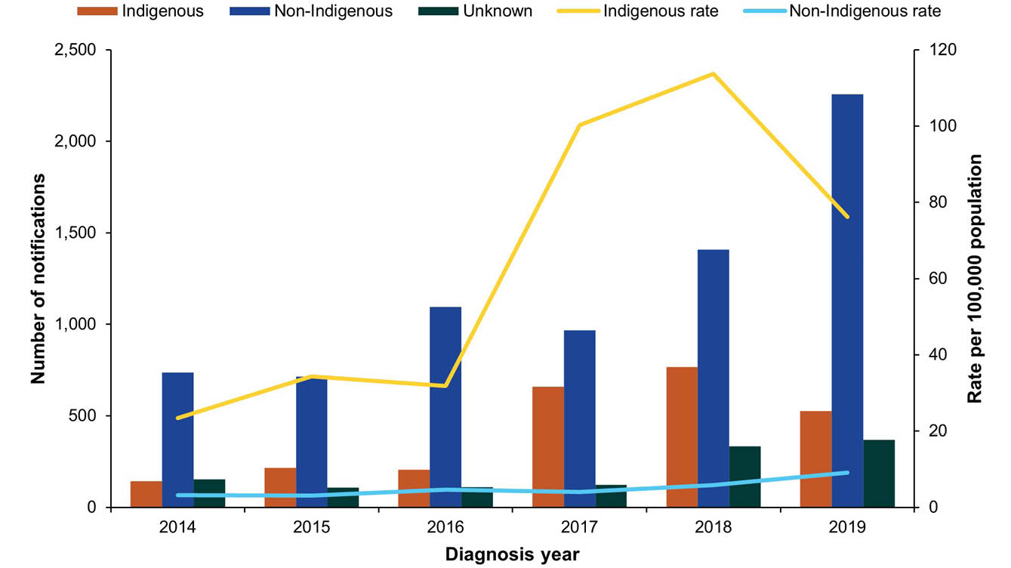
a Cases with unknown Indigenous status were included as non-Indigenous in the rate calculations.

Shigella flexneri serotype 2b outbreak amongst Aboriginal and/or Torres Strait Islander people
- The notification rate amongst Aboriginal and/or Torres Strait Islander people more than tripled in 2017 when compared with 2016 (100 cases per 100,000 Aboriginal and/or Torres Strait Islander people in 2017 compared to 32 cases per 100,000 in 2016), largely due to an outbreak of S. flexneri 2b amongst Aboriginal people. S. flexneri 2b cases were first identified in remote areas of the Northern Territory in late 2016.⁴⁶ Notifications were sporadic until an increase was observed in May 2017.
- In total, 989 S. flexneri 2b cases have been reported nationally in Aboriginal and/or Torres Strait Islander people, with a decrease observed in 2019 (n = 219) compared to 2017 (n = 338) and 2018 (n = 423).
- Cases in 2019 were across the Northern Territory (n = 102), Western Australia (n = 65), Queensland (n = 32) and South Australia (n = 20).
- An additional 11 S. flexneri 2b cases were reported in non-Indigenous residents of Western Australia, Victoria and Tasmania who reported no overseas travel during their respective incubation periods.
- Case detection is limited by the inability to identify the species of cases diagnosed solely by PCR.
- With the exception of a single probable foodborne outbreak affecting two cases in the Northern Territory in 2019, no other foodborne outbreaks were identified, suggesting person-to-person was the most likely mode of transmission.
- Children less than five years of age were most commonly affected (Figure 18). For those aged over 15 years, infections were more common in females, which may reflect child rearing practices. The outbreak continued into 2020.
Figure 18: Shigella flexneri serotype 2b notifications in Aboriginal and/or Torres Strait Islander people in Australia, by age group and sex, 2019
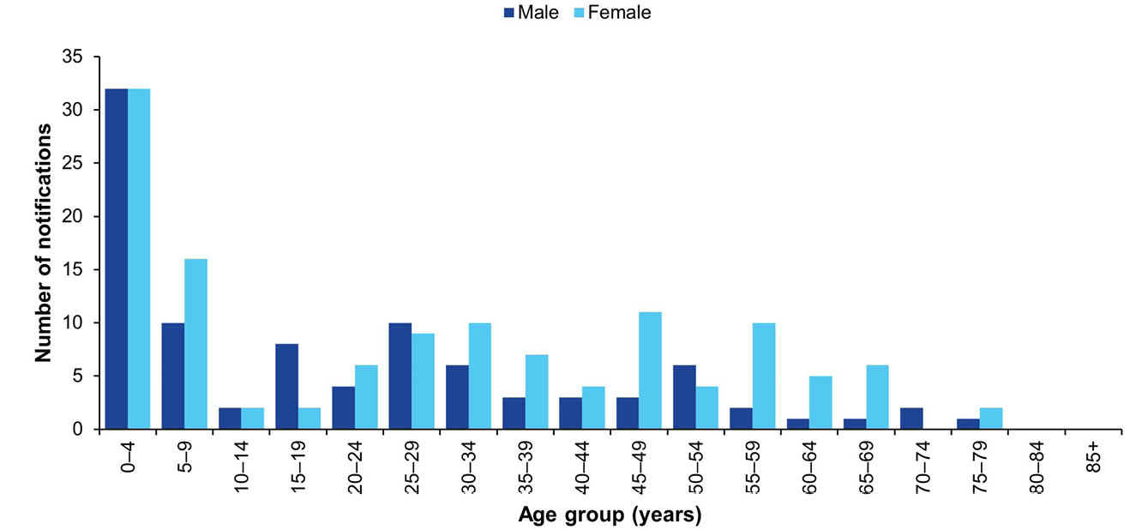

Country of acquisition
- Information on the country of acquisition was available for 62% of confirmed and probable cases (n = 1,963/3,152), for which the majority of cases (n = 1,193/1,963; 61%) were reported as acquired overseas.
- Of the infections that were acquired in Australia, males accounted for a higher proportion of cases (n = 538; 70%) than females (n = 231; 30%). This is likely to be in part associated with male-to-male sexual transmission (Figure 19).
- Consistent with previous years, overseas acquired cases (n = 1,193) were most commonly acquired in India (n = 298; 25%) and Indonesia (n = 229; 19%).
Figure 19: Shigellosis notifications (confirmed and probable) in Australia by place of acquisition and sex, 2019ª
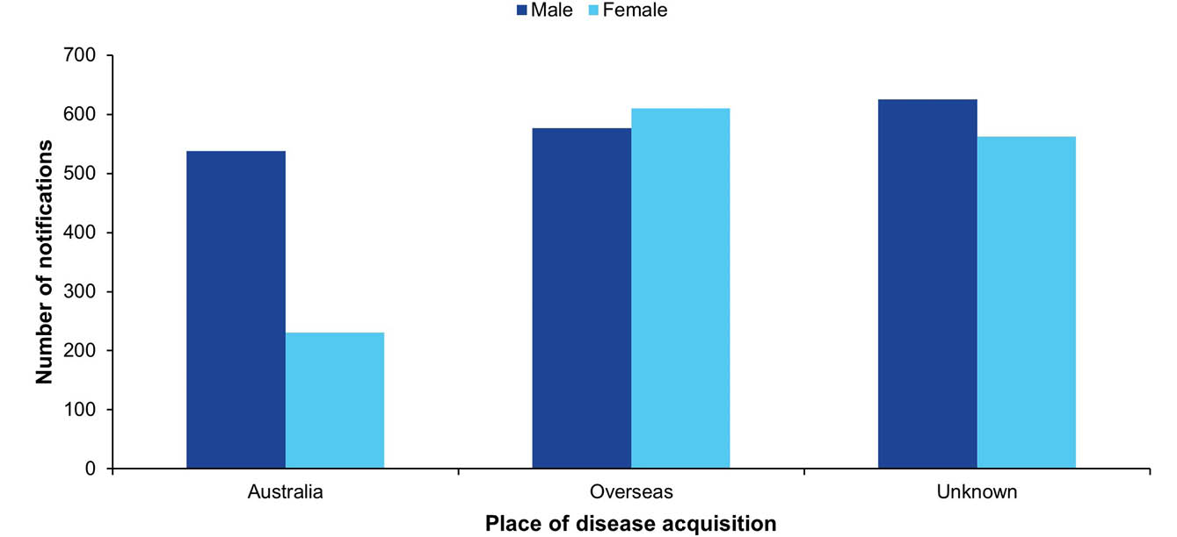
a Cases with unknown sex (n = 9) were excluded.

Shiga toxin-producing Escherichia coli infection and haemolytic uraemic syndrome
Shiga toxigenic E. coli (STEC) infection is a diarrhoeal illness caused by the strains of the Escherichia coli (E. coli) bacterium that produce shiga toxins. The principal reservoirs of STEC in Australia are the lower intestinal tract of ruminants, particularly cattle and sheep. Infections in humans can occur after consuming contaminated food including undercooked meat, particularly minced beef/burgers, unwashed salad and vegetables and unpasteurised milk or milk products, drinking or swimming in contaminated water, close contact with an infectious case or direct contact with infectious animals on farms or at petting zoos.⁴⁷
Haemolytic uraemic syndrome (HUS) is a severe and potentially fatal condition characterised by kidney failure, bleeding and anaemia that is more common in young children and the elderly. While STEC is the most common infectious agent that causes HUS, it can also be caused by other infectious agents including Shigella and Streptococcus pneumoniae. HUS can also result from non-infectious causes. Cases resulting from a STEC infection usually report a history of a diarrhoeal illness, often bloody, up to three weeks (usually within seven days) prior to the onset of HUS. Attempts are made for collection and microbiological examination of stool samples from all HUS cases. However, due to the timing since onset of diarrhoea, STEC may no longer be detectable in the stool at the time of subsequent stool testing.
Surveillance data of STEC and HUS consists of confirmed cases only. A confirmed case of STEC requires laboratory definitive evidence, and a confirmed case of HUS requires clinical evidence only. Where STEC is isolated in the context of HUS, it is notified as both STEC and HUS.
Prior to 1 July 2016, the case definition required that ‘identification of the gene associated with the production of shiga toxin or vero toxin in E. coli by nucleic acid testing on isolate or raw bloody diarrhoea’. The case definition was revised in light of the increasing uptake of CIDT to make provision for the detection of stx₁ and/or stx₂ genes in faeces without macroscopic evidence of blood or diarrhoea.

Overall trend
Notification rates of STEC have trended upwards between 2001 (when national notification began) and 2015. The peak in 2013 was related to a zoonotic outbreak in Queensland (see below) (Figure 20).
Notification rates for STEC are significantly influenced by local testing practices:
- The consistently higher rates observed in South Australia since 2001 reflect the routine testing of all bloody stool samples in addition to clinician requests.
- In June 2016, the only laboratory in South Australia conducting STEC testing began testing all faeces for STEC, instead of only bloody stool samples, resulting in an increase in notifications.
- Changes to the case definition for confirmed STEC cases in 2016 and the increasing uptake of CIDT have contributed to the increase in STEC cases nationally.
- In Western Australia, the large increase in 2019 compared to previous years is likely to be due to the introduction of PCR tests for STEC by two laboratories. One laboratory used a PCR test on faecal specimens with bloody diarrhoea, by request or upon signs of HUS, since January 2016. Another laboratory also introduced a PCR test for STEC on request in July 2016; this changed in December 2018 to include PCR testing on all stool specimens.
HUS is rare in Australia, with notification rates relatively stable since notification began in 1999 (Figure 21).

Previous outbreaks in Australia
Most STEC cases in Australia are sporadic, although outbreaks have been reported. Risk factors identified in a national case-control study in Australia between 2003 and 2007 included consuming hamburgers; eating at restaurants; occupational exposure to animals or raw red meat by case or household member; antibiotic use in the four weeks before illness; consumption of sliced chicken meat or corned beef from a delicatessen; bush camping in Australia; and eating at catered events.⁴⁷

Foodborne outbreaks
Significant foodborne outbreaks have been reported internationally, and have most commonly been associated with ground beef or sprouts. Sprouts from a farm in Germany were the implicated source of an international outbreak in 2011 that included over 3,000 STEC cases and 800 HUS cases.⁴⁸ In Australia, however, foodborne outbreaks are rare, the most notable being a large outbreak of E. coli O111 infection in 1995 associated with the consumption of contaminated mettwurst.⁴⁹ Since 2000 (when OzFoodNet commenced), the implicated foods in confirmed and probable STEC outbreaks reported in Australia include:
- potato salad consumed at a camp in rural South Australia in 2009 (n = 31, no HUS cases); and
- kangaroo meat consumed in a remote Northern Territory community in 2012 (n = 5, no HUS cases).

Non-foodborne outbreaks
Outbreaks due to contaminated tank water, person-to-person transmission and zoonotic transmission at petting zoos have been reported in Australia. The largest STEC outbreak in Australia occurred following contact with animals at a petting zoo in Queensland in 2013 (n = 57 STEC cases, no HUS cases).
Figure 20: STEC notifications and rate per 100,000 population in Australia by jurisdiction of residence,ª 2001–2019
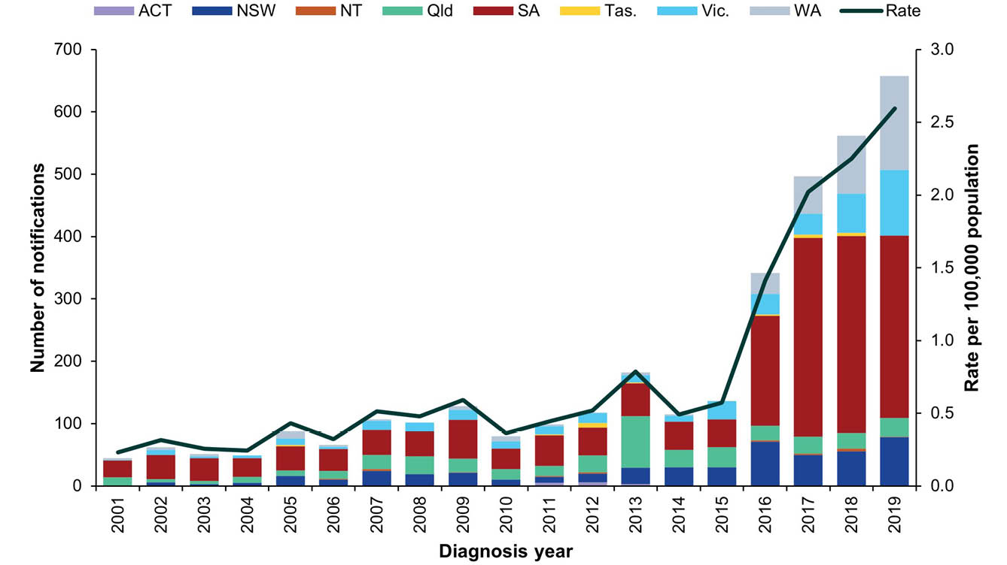
a Data includes HUS cases where a STEC organism was isolated (see footnote xxiii).
Figure 21: HUS notifications and rate per 100,000 population in Australia by jurisdiction of residence, 1999–2019
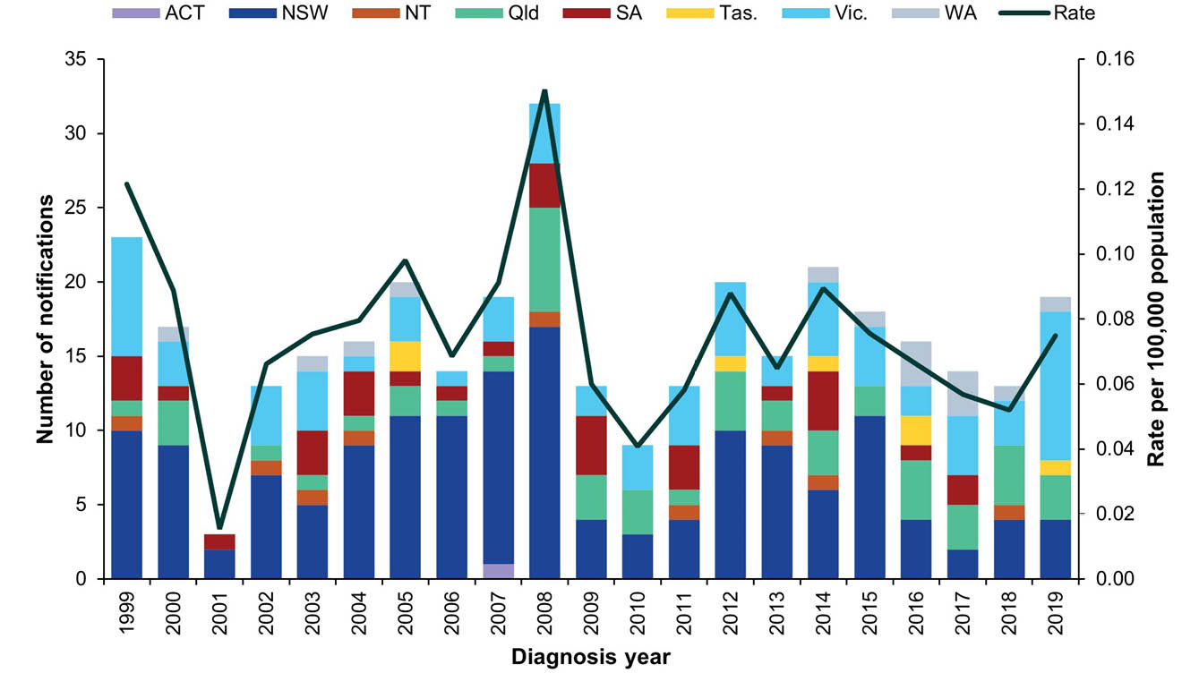

Epidemiology of STEC and HUS in Australia, 2019
Table 20: Summary of STEC and HUS notifications in Australia, 2019
Category | STEC | HUS
Number of notifications | 655 | 19
Rate per 100,000 population | 2.6 cases | 0.1 cases
Jurisdiction with highest number of notifications | South Australia (n = 293; 45%) | Victoria (n = 10; 53%)
Cases in Aboriginal and/or Torres Strait Islandersª | 35 (6%) | 0
Foodborne outbreaks | 0 | 0
a Indigenous status was unknown for 68 STEC cases and one HUS case.

STEC
- Notifications were highest in children aged 0–4 years (n = 70; 11%), followed by those aged 25–29 years (n = 57; 9%) and were more common in females (n = 376; 57%) than in males (n = 278; 42%) (Figure 22).
- Where known, the majority of cases (n = 331/518; 64%) were acquired in Australia. Of the cases known to be acquired overseas (n = 187), Indonesia was the most common country of acquisition (n = 26). Most overseas-acquired cases were without an identified country of acquisition (n = 105).
Figure 22: STEC cases in Australia by age group and sex, 2019ª
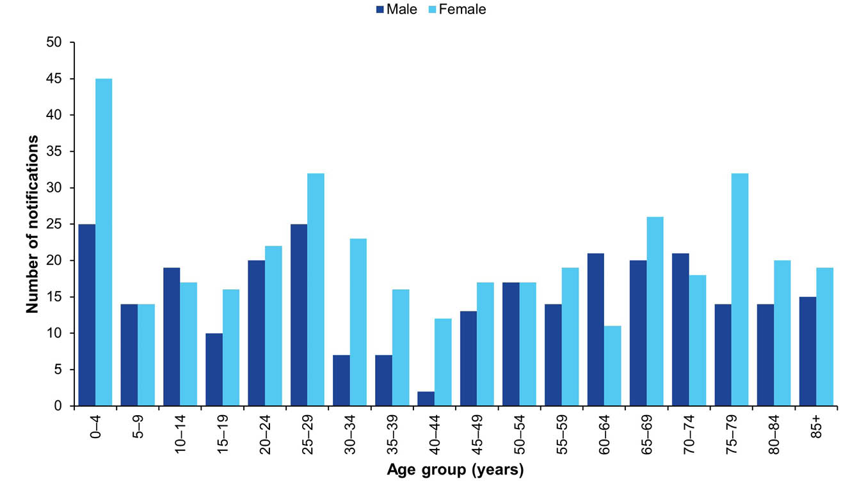
a Excluding one case with unknown sex.

HUS
- Consistent with previous years, HUS was most commonly reported in children aged less than five years (n = 8, 42%).
- Notifications were more common in females (n = 13) than in males (n = 6).
- As in recent years, STEC infection was identified in the majority of HUS cases reported in 2019 (n = 13/19; 68%).
- Of the six cases for whom STEC infection was not identified, two were caused by Streptococcus pneumoniae; two reported a history of a diarrhoeal illness; and two were diagnosed based on other clinical illness.
- Two STEC/HUS deaths occurred in 2019, one in a New South Wales resident aged in their 60s and the second in a Queensland resident aged in their 30s.

Outbreaks of gastrointestinal disease including foodborne disease outbreaks
In 2019, a total of 133 outbreaks of gastrointestinal illness caused by foodborne, animal-to-person, environmental or waterborne disease were reported by OzFoodNet sites, affecting 2,619 individuals. The majority of outbreaks (n = 121; 91%) were a result of foodborne and probable foodborne transmission of infection (Table 21).
Table 21: Gastrointestinal disease outbreaks and ill people by transmission mode in Australia, 2019
Transmission mode | Outbreaks |  |  | Ill people
Transmission mode | Number, 2019 | Proportion | Annual mean  2014–2018 | Number, 2019 | Proportion | Annual mean  2014–2018
Foodborne and probable foodborne | 121 | 91% | 161 | 2,428 | 93% | 2,400
Environmental and probable environmental | 6 | 5% | 10 | 30 | 1% | 94
Animal-to-person and probable animal-to-person | 4 | 3% | 1 | 49 | 2% | 7
Waterborne and probable waterborne | 2 | 2% | 1 | 112 | 4% | 19
Total | 133 | 100%ª | 173 | 2,619 | 100% | 2,520
a Does not equal 100% due to rounding.

Foodborne and probable foodborne outbreaks
OzFoodNet sites reported 121 outbreaks where the consumption of food was the probable or confirmed mode of transmission (hereon referred to collectively as foodborne outbreaks). Foodborne outbreaks affected a total of 2,428 people. While the total number of outbreaks reported in 2019 was lower than the five-year historical mean (n = 161 outbreaks), more people were affected (Table 21). Admission to hospital was required for at least 402 people, and four deaths were reported during the outbreaks (Table 22).
New South Wales reported the highest number of foodborne outbreaks in 2019 (Table 22). Consistent with previous years, outbreaks more commonly occurred in the warmer months of January to March (Quarter 1) (Figure 23 and Figure 24).
A summary of the foodborne outbreaks is provided in the following section. Refer to Appendix B for details on individual outbreaks.
Table 22: Foodborne outbreaks and affected people in Australia by jurisdiction, 2019
Jurisdictionª | Outbreaks |  | Ill people
Jurisdictionª | Number of outbreaks | Proportion | Total  number | Mean number ill per outbreak | Hospitalised | Fatalities
MJOI | 5 | 4% | 415 | 83 | 179 | 3
ACT | 3 | 2% | 103 | 34 | 6 | 0
NSW | 30 | 25% | 298 | 10 | 14 | 0
NT | 1 | 1% | 14 | 14 | 0 | 0
Qld | 16 | 13% | 333 | 21 | 49 | 1
SA | 10 | 8% | 239 | 24 | 67 | 0
Tas. | 4 | 3% | 63 | 16 | 0 | 0
Vic. | 26 | 21% | 491 | 19 | 34 | 0
WA | 26 | 21% | 472 | 18 | 53 | 0
Total | 121 | 100% | 2,428 | 20 | 402 | 4
a MJOI: multi-jurisdictional outbreak investigation; ACT: Australian Capital Territory; NSW: New South Wales; NT: Northern Territory; Qld: Queensland; SA: South Australia; Tas.: Tasmania; Vic.: Victoria; WA: Western Australia.
Figure 23: Foodborne outbreaks in Australia by year and quarter,ª 2014–2019
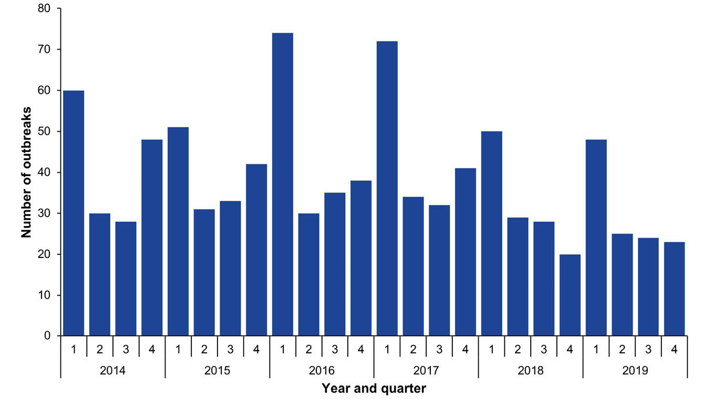
a Year and quarter of the outbreak is based on the month of onset of the first case or the month of notification of the first case or the month in which the investigation into the outbreak commenced.
Figure 24: Number of ill people in foodborne outbreaks in Australia by year and quarter,ª 2014–2019
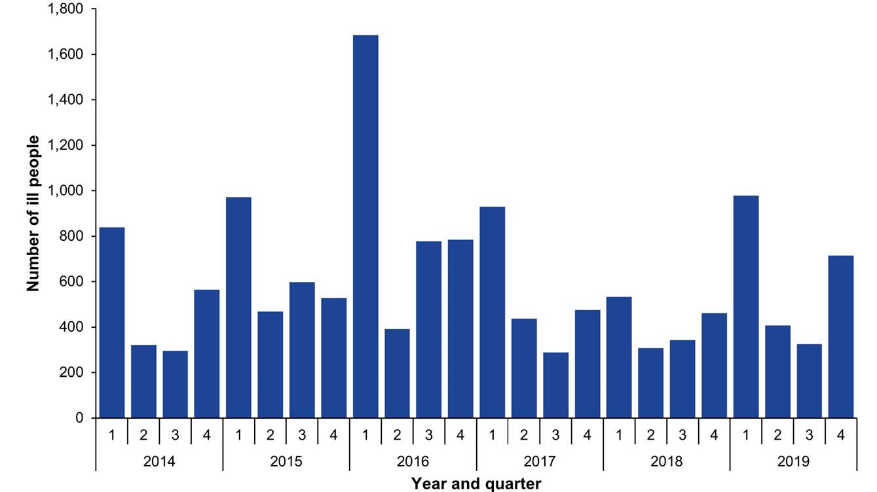
a Year and quarter of the outbreak is based on the month of onset of the first case or the month of notification of the first case or the month in which the investigation into the outbreak commenced.

Aetiologies
Consistent with previous years, Salmonella was the most commonly identified foodborne pathogen, responsible for 53% of all outbreaks (n = 64/121) and 61% of all cases of foodborne illness (n=1,480/2,428) reported during outbreaks in 2019 (Table 23). The number of Salmonella outbreaks reported in 2019 was lower than the five-year historical mean (n = 87 outbreaks). The most commonly identified serotype, accounting for 78% (50/64) of all Salmonella outbreaks reported in 2019, was S. Typhimurium, of which 36 different causative MLVA profiles were identified.
Table 23: Foodborne outbreaks, ill people and hospitalisations in Australia by aetiology, 2019
Aetiological agent | Outbreaks |  | Ill people |  | Hospitalisations
Aetiological agent | n | % of all outbreaks | n | % of  all ill | n | % of all hospitalised
Salmonella | 64 | 53% | 1,480 | 61% | 381 | 95%
Norovirus | 13 | 11% | 522 | 21% | 4 | 1%
Ciguatoxin | 9 | 7% | 35 | 1% | 1 | < 1%
Scombrotoxin | 6 | 5% | 29 | 1% | 3 | 1%
Clostridium perfringens | 5 | 4% | 63 | 3% | 1 | < 1%
Campylobacter | 1 | 1% | 5 | < 1% | 1 | < 1%
Cryptosporidium | 1 | 1% | 2 | < 1% | 0 | —
Hepatitis A | 1 | 1% | 4 | < 1% | 4 | 1%
Listeria monocytogenes | 1 | 1% | 4 | < 1% | 4 | 1%
Methemoglobinemia | 1 | 1% | 2 | < 1% | 2 | < 1%
Unknown | 19 | 16% | 282 | 12% | 1 | < 1%
Total | 121 | 100% | 2,428 | 100% | 402 | 100%

Food commodity
A food vehicle was identified in 64% of foodborne outbreaks in 2019 (n = 77/121). Outbreaks were categorised as being attributable to selected broad food categories if a single contaminated ingredient was identified, or if all of the identified ingredients belonged to a single food category. A single food commodity was identified for 43% of foodborne outbreaks (n = 52/121) in 2019. The most commonly identified commodity was eggs (n = 26; 21%), followed by seafood (n = 18; 15%) (Table 24 and Table 25).
Table 24: Foodborne outbreaks and ill people in Australia by food commodity, 2019
Category | Outbreaks |  | Ill people |  | Hospitalisations
Category | n | % of all outbreaks | n | % of  all ill | n | % of all hospitalised
Eggsª | 26 | 21% | 936 | 39% | 261 | 65%
Seafood | 18 | 15% | 83 | 3% | 59 | 15%
Meat | 5 | 4% | 57 | 2% | 6 | 1%
Dairy | 1 | 1% | 2 | < 1% | 0 | —
Produce | 1 | 1% | 45 | 2% | 0 | —
Miscellaneous | 1 | 1% | 38 | 2% | 57 | 14%
Mixed/multiple foods | 25 | 21% | 657 | 27% | 7 | 2%
Not attributed | 44 | 36% | 610 | 25% | 12 | 3%
Total | 121 | 100% | 2,428 | 100% | 402 | 100%
a Including: raw; lightly cooked; or used as a binding agent.
Table 25: Foodborne outbreaks in Australia by aetiology and food commodity, 2019
Aetiology | Dairy | Eggsª | Meat | Produce | Seafood | Miscellaneous | Mixed/ multiple foods | Not attributed
Campylobacter | 0 | 0 | 1 | 0 | 0 | 0 | 0 | 0
Ciguatoxin | 0 | 0 | 0 | 0 | 9 | 0 | 0 | 0
Clostridium perfringens | 0 | 0 | 0 | 0 | 0 | 0 | 3 | 2
Cryptosporidium | 1 | 0 | 0 | 0 | 0 | 0 | 0 | 0
Hepatitis A | 0 | 0 | 0 | 0 | 0 | 0 | 0 | 1
Listeria monocytogenes | 0 | 0 | 0 | 0 | 1 | 0 | 0 | 0
Methemoglobinemia | 0 | 0 | 0 | 0 | 1 | 0 | 0 | 0
Norovirus | 0 | 0 | 1 | 0 | 0 | 0 | 7 | 5
Salmonella | 0 | 26 | 2 | 1 | 1 | 0 | 8 | 26
Scombrotoxin | 0 | 0 | 0 | 0 | 6 | 0 | 0 | 0
Unknown | 0 | 0 | 1 | 0 | 0 | 1 | 7 | 10
Total | 1 | 26 | 5 | 1 | 18 | 1 | 25 | 44
a Including: raw; lightly cooked; or used as a binding agent.

Eggs
Outbreaks of salmonellosis associated with the consumption of raw or minimally cooked egg products are an important cause of foodborne outbreaks in Australia.^{33,34} Eggs were identified as the probable or confirmed source for 26 foodborne outbreaks reported in 2019 (21%). The number of egg outbreaks reported in 2019 was lower than the five-year historical mean (n = 45 outbreaks), but similar to the previous year (n = 28). With the exception of the Australian Capital Territory, the Northern Territory and Tasmania, egg-related outbreaks occurred throughout the country (ten in Western Australia; six in South Australia; four in Victoria; three in New South Wales; and two in Queensland). Additionally, there was one multi-jurisdictional outbreak in 2019 associated with consumption of eggs. Egg-associated outbreaks peaked in January (n = 7) (Figure 24). These outbreaks affected 936 people, of whom 261 were admitted to hospital. Egg-associated outbreaks included 24 S. Typhimurium outbreaks with 20 different MLVA profiles identified, and a single outbreak each of S. Enteritidis and S. Hessarek. The setting of preparation was most commonly a restaurant/café (n = 15; 58%), followed by primary production (n= 4; 15%) and a private residence (n = 3; 12%). The most commonly implicated foods in egg-associated outbreaks were eggs as a single food (n = 11), sauces made with raw eggs (n = 10) and desserts containing raw eggs (n = 5). See Appendix B for further details.
Figure 25: Egg outbreaks by month and jurisdiction in Australia,^{a,b} 2019
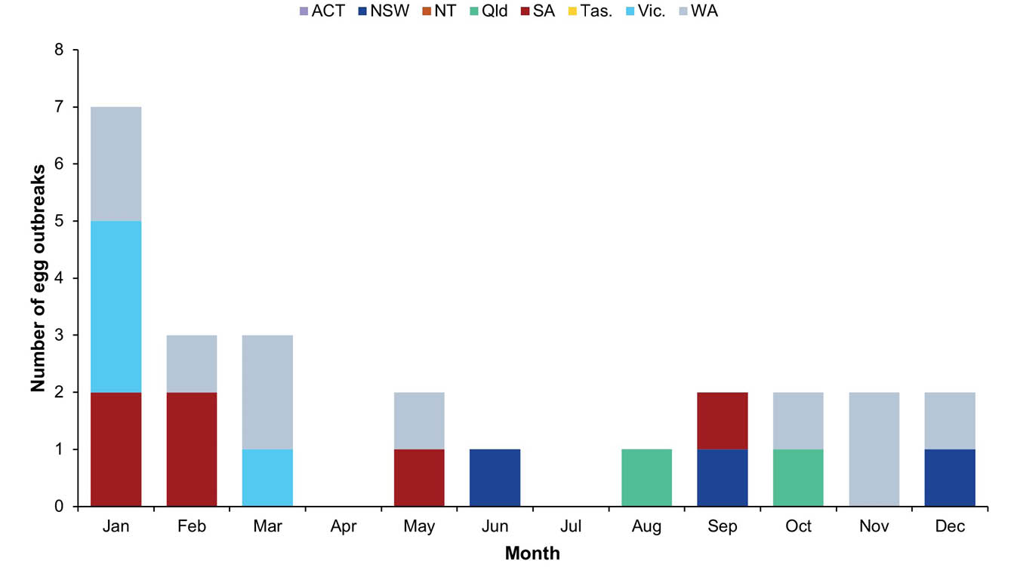
a Month of outbreak is the month of onset of the first case or month of notification of the first case or the month the investigation into the outbreak commenced.
b Excluded one multi-jurisdictional outbreak investigation.

Seafood
Seafood (comprising the three commodities of fish, molluscs and crustaceans) was implicated as the source in 18 foodborne outbreaks reported in 2019. Aetiological agents identified included ciguatoxin (n = 9), scombrotoxin (n = 6), L. monocytogenes (n = 1), S. Mississippi (n = 1) and methemoglobinemia (n = 1).
Ciguatera fish poisoning outbreaks occurred in the cooler months from June to September in 2019; these outbreaks occurred primarily in Queensland (n = 7). In seven outbreaks, the fish was purchased from a seafood retailer in Australia; one outbreak resulted from fish that had been privately purchased from a market in Fiji, brought to Australia and then cooked and consumed in Australia; and in one outbreak the fish was caught recreationally.
Scombrotoxin fish poisoning outbreaks occurred throughout the year and all were reported in New South Wales.

Settings
Restaurants/cafés were the most commonly reported food preparation setting, accounting for just under half of all foodborne outbreaks (n = 59; 49%); however, primary production had the highest total number of ill people (n = 712; 29%) and over half of the hospitalisations (n = 212; 53%) reported during outbreaks in 2019 (Table 26).
Table 26: Foodborne outbreaks in Australia by setting prepared, 2019
Setting prepared | Outbreaks |  | Ill people |  | Hospitalisations
Setting prepared | n | % of all outbreaks | n | % of all ill people | n | % of all hospitalisations
Restaurant/café | 59 | 49% | 683 | 28% | 85 | 21%
Primary production | 18 | 15% | 712 | 29% | 212 | 53%
Commercial caterer | 10 | 8% | 479 | 20% | 4 | 1%
Aged care facility | 7 | 6% | 98 | 4% | 0 | 0%
Take-away | 6 | 5% | 51 | 2% | 8 | 2%
Private residence | 5 | 4% | 37 | 2% | 6 | 1%
Bakery | 3 | 2% | 85 | 4% | 21 | 5%
Camp | 2 | 2% | 24 | 1% | 0 | 0%
Hospital | 2 | 2% | 4 | 0% | 0 | 0%
Mining camp | 2 | 2% | 51 | 2% | 9 | 2%
Commercially manufactured | 1 | 1% | 96 | 4% | 34 | 8%
Correctional facility | 1 | 1% | 4 | < 1% | 1 | < 1%
Grocery store/delicatessen | 1 | 1% | 8 | < 1% | 2 | < 1%
International cargo vessel | 1 | 1% | 19 | 1% | 0 | 0%
Military | 1 | 1% | 14 | 1% | 0 | 0%
Unknown | 2 | 2% | 63 | 3% | 20 | 5%
Total | 121 | 100% | 2,428 | 100% | 402 | 100%

Level of evidence for foodborne outbreaks
There was statistical evidence of an association between the consumption of the implicated food and illness for ten foodborne outbreaks in 2019, ascertained from six case-control studies and four point-source cohort studies. An additional two outbreaks had statistical and microbiological evidence of the aetiological agent in the epidemiologically implicated food. In addition to compelling descriptive evidence, microbiological evidence also supported the implicated food in 15 outbreaks. Compelling descriptive evidence alone supported foodborne transmission for the remaining 94 outbreaks in 2019 (Table 27).
Table 27: Evidence to support foodborne transmission for outbreaks in Australia, 2019
Aetiological agent | Evidence type(s) |  |  |  | Total
Aetiological agent | Statisticalª | Statistical and microbiological^{b} | Compelling descriptive^{c} | Microbiological and compelling descriptive | Total
Campylobacter | 1 | 0 | 0 | 0 | 1
Ciguatoxin | 0 | 0 | 8 | 1 | 9
Clostridium perfringens | 0 | 0 | 3 | 2 | 5
Cryptosporidium | 0 | 0 | 1 | 0 | 1
Hepatitis A | 0 | 0 | 1 | 0 | 1
Listeria monocytogenes | 0 | 1 | 0 | 0 | 1
Methemoglobinemia | 0 | 0 | 0 | 1 | 1
Norovirus | 5 | 0 | 8 | 0 | 13
Salmonella | 2 | 1 | 52 | 9 | 64
Scombrotoxin | 0 | 0 | 4 | 2 | 6
Unknown | 2 | 0 | 17 | 0 | 19
Total | 10 | 2 | 94 | 15 | 121
a ‘Statistical evidence’ refers to analytical epidemiological association between illness and one or more foods.
b ‘Microbiological evidence’ refers to microbiological confirmation of an aetiological agent in the suspected vehicle or food.
c ‘Compelling descriptive evidence’ refers to descriptive evidence implicating the suspected vehicle or suggesting foodborne transmission.

Point source outbreaks (within multi-jurisdictional outbreaks and large community outbreaks)
From 2018 onwards, point source outbreaks occurring within multi-jurisdictional outbreak investigations and within large community outbreaks have been reported to the OzFoodNet Outbreak Register. Point source outbreaks are smaller, contained outbreaks that have occurred as part of a larger outbreak.
There were 18 point source outbreaks reported in 2019, of which the majority were reported by New South Wales (n = 13), followed by Queensland (n = 4) and Victoria (n = 1) (Appendix C). Eight of the 13 New South Wales point source outbreaks reported in 2019 were related to an ongoing outbreak of Salmonella Typhimurium MLVA 05-17-09-13-490 which commenced in December 2018, with total case numbers reported in the OzFoodNet 2018 Annual Report.²⁴ The remaining ten point source outbreaks reported in 2019 comprised six outbreaks associated with Salmonella Enteritidis (New South Wales n = 5; Victoria n = 1) and four outbreaks associated with Salmonella Typhimurium MLVA 03-20-11-10-523 in Queensland.
Fifteen of the 18 point source outbreaks were attributed specifically to eggs, including where due to mishandling of eggs and poor food handling in a retail setting. The remaining three point source outbreaks were not able to be attributed to a specific commodity; however, given that they were each associated with larger overarching outbreak investigations, they were attributable to strains of known egg origin.
All reports of illness, hospitalisation, or death occurring within a point source outbreak are included within the totals reported for the overarching outbreak.

Multi-jurisdictional foodborne outbreak investigations in 2019
OzFoodNet undertook five multi-jurisdictional outbreak investigations (MJOI) in 2019.

S. Enteritidis
In March 2019, OzFoodNet commenced a MJOI into cases of S. Enteritidis. The outbreak was linked to an ongoing investigation of S. Enteritidis in New South Wales since July 2018, with most cases previously able to be linked to exposure in New South Wales. In March 2019, however, Victoria detected S. Enteritidis on an egg farm and identified human cases who did not report travel to New South Wales. These cases matched the New South Wales outbreak strain on phylogenetic analysis, therefore initiating a broader OzFoodNet response due to the multi-jurisdictional spread of the outbreak.
A total of 245 outbreak cases reporting onset of illness between May 2018 and July 2019 were identified, of which 234 cases met the confirmed outbreak case definition; six cases met the probable outbreak case definition; and five cases met the secondary case definition. All secondary cases were children aged under 10 years of age.
The majority of cases were residents of New South Wales (198/245; 81%), followed by Victoria (39/245; 16%), Queensland (3/245; 1%), Tasmania (3/245; 1%) and South Australia (1/245; 1%). In addition, one international contemporary case linked to the outbreak was identified through GenomeTrakr (an international network of laboratories that share whole genome sequence data for pathogen identification), with partial follow-up establishing that the case had travelled to Australia. Cases included 119 males (49%) and 126 females (51%). The median age was 27 years old (range 2 months – 90 years). At least 76 cases were hospitalised due to their illness (76/220 reported; 35%). One confirmed case died, but the primary cause of death was unable to be established. Seven restaurant clusters were identified, six in New South Wales and one in Victoria. The majority (90%) of cases who were able to be interviewed recalled consuming eggs in their incubation period, of whom 84% reported consuming eggs at home. When eggs were purchased for home consumption, many cases reported purchasing their eggs from multiple retail outlets and did not restrict purchases to a single brand. In addition, 92% of cases ate at a restaurant or had some kind of takeaway during their exposure period. A total of 62% of outbreak cases had exposure to Asian style food at a commercial food venue. This included the 26% of cases (n = 63) who were linked to the point-source restaurant clusters, of which six of the seven were either Asian restaurants or Asian bakeries. A total of 14 infected properties (13 in New South Wales and one in Victoria) were found to be linked by egg sales, farm distribution networks and equipment sharing. Each of these properties was confirmed by culture, and subsequently by whole genome sequencing, to be infected with the outbreak strain. Transmission of S. Enteritidis from property to property related to the movement of fomites, via eggs, egg packaging, people and vehicles. Control measures included prohibition orders in restaurants, egg recalls, and biosecurity directions on farms. Epidemiological data, supported by whole genome sequencing of human, food, animal and environmental isolates, confirmed commercial eggs were the source of infection, making this the first known Salmonella Enteritidis outbreak linked to Australian commercial egg farms.

S. Heidelberg
In March 2019, OzFoodNet initiated a MJOI into cases of S. Heidelberg after a reported increase across multiple states was found, on phylogenetic analysis, to be highly related. OzFoodNet sites commenced local investigations in December 2018; however, a hypothesis regarding the potential source of illness was unable to be identified. A total of 59 outbreak cases were identified across five jurisdictions, comprising 58 confirmed cases and one probable case.⁵⁰ Cases were reported in New South Wales (n = 18; 31%), Victoria (n = 14; 24%), Queensland (n = 13; 22%), Western Australia (n = 8; 14%) and South Australia (n = 6; 10%). Specimen collection dates ranged from November 2018 to May 2019, with cases peaking in December 2018. Only three cases reported interstate travel during the week before onset of illness. Among the 59 cases, 33 (56%) were male. The median age of cases was 43 years (range < 1 to 95 years). There were 16 cases hospitalised (36%) among the 45 cases who had data recorded. Thirty-nine confirmed cases of S. Heidelberg infection were interviewed across the five affected jurisdictions. Although binomial probability calculations highlighted some potential foods of interest, including cooked chicken and macadamia nuts, there was insufficient evidence to develop a strong hypothesis on any single food item.

L. monocytogenes MLST 120
In July 2019, OzFoodNet initiated a MJOI into cases of Listeria monocytogenes MLST 120 that were identified as being highly related by whole genome sequencing. The cases were also found to be highly related to one historical isolate from a smoked salmon sushi roll. In total, four confirmed cases were identified in three jurisdictions: New South Wales (n = 2), Victoria (n = 1) and Queensland (n = 1). All cases were male, and all were aged over 70 years (range 72 to 90 years). Onset dates ranged from February 2019 to July 2019. All cases were hospitalised, and two cases died. Interviews regarding food consumption in the 30 days prior to illness onset were conducted, and all four cases reported consuming smoked salmon products prior to illness onset. One case also reported consumption of cooked fresh salmon. A case-case analysis was conducted using non-outbreak cases of L. monocytogenes. The only statistically significant food item in this analysis was salmon: odds ratio (OR) = undefined; 95% confidence interval (95% CI) 7.17–undefined; p = 0.001). Where known, a single brand of salmon was not common to all cases; however, one Australian brand was common to at least two cases. Extensive product testing was conducted of Australian smoked salmon products during the investigation. The brand that was common to at least two cases had three retail smoked salmon food samples positive for L. monocytogenes; although these samples were within Australian food industry regulation limits, the food isolates were found to be highly related to the four human isolates by phylogenetic analysis.

S. Weltevreden
In October 2019, OzFoodNet initiated a MJOI into cases of S. Weltevreden linked to consumption of commercially manufactured frozen meals. Between September and December 2019, ninety-four confirmed cases and one probable case were linked to the outbreak. Outbreak cases were reported by six states and territories: South Australia (n = 30; 32%), New South Wales (n = 25; 26%), Queensland (n = 23; 24%), Western Australia (n = 13; 14%), Victoria (n = 2; 2%) and the Australian Capital Territory (n = 2; 2%). Sixty-eight percent of cases were males, and the median age of cases was 36 years (range 18–63 years). The illness was relatively severe, with 34% of cases (n = 32/95) hospitalised. Of outbreak cases interviewed, 98% (86/88) reported consumption of a frozen meal in the seven days prior to illness and all of these reported eating the same brand of frozen meal. S. Weltevreden was detected in 16 samples of unopened frozen meals of the implicated brand; however, Salmonella was not detected at the manufacturing facility or in raw ingredients. In October 2019 multiple national consumer recalls were issued by the company for implicated types of frozen meals. The source of the contamination of the frozen product could not be identified.

S. Enteritidis MLST 1972
In December 2019, OzFoodNet initiated a MJOI after five human S. Enteritidis isolates were found to be highly related to an isolate from a routine chicken meat sample collected by food safety inspectors. In total, 11 outbreak cases were identified during this investigation, with specimen collection dates ranging from September 2019 to January 2020. Six cases (55%) were residents of Queensland, with the remaining cases reported from New South Wales (n = 2), the Australian Capital Territory (n = 1), South Australia (n = 1) and Western Australia (n = 1). Among the 11 cases, seven (64%) were male. The median age of cases was 49 years (range 3 months to 90 years). Two cases were aged < 6 months. Four cases were hospitalised. None of the six cases interviewed reported overseas travel. Five cases reported eating chicken in the three days before onset of illness. There were no common chicken brands or food venues/franchises identified among these five cases. No other potential risk factors were identified from the six case interviews. The implicated broiler farm and manufacturing plant was investigated, with no Salmonella detections resulting from samples collected during on-site inspections. The investigation was unable to confirm the source of infection for the outbreak cases; however, it is very likely that poultry was the source of infection for this outbreak, considering the relatively strong contemporaneous microbiological evidence implicating chicken meat.

Animal-to-person and probable animal-to-person outbreaks
Animals were the source of four gastrointestinal outbreaks reported in 2019, comprising two outbreaks in South Australia and one each in Western Australia and Victoria (Table 21). The aetiological agent was identified as Cryptosporidium in two outbreaks that affected 14 individuals and were associated with a petting zoo and with suspected contact with cows at an excursion to a dairy farm. The remaining two outbreaks were caused by Salmonella, one due to S. subspecies III linked to a pet lizard affecting three people and the other caused by S. Typhimurium with 32 cases associated with a chick hatchery program at childcare, schools and aged care facilities. Animal-to-person outbreaks are rarely identified in Australia, with a total of six reported in the previous five years.

Waterborne and probable waterborne outbreaks
Waterborne outbreaks (including confirmed and probable outbreaks) are rare in Australia, with a total of seven reported in the previous five years. Two waterborne outbreaks were reported in 2019 (Table 21). These outbreaks were a S. Enteritidis outbreak in an Indigenous community in Queensland resulting from contaminated bore water being used in food preparation at a local store affecting seven people, and an enterotoxigenic E. coli outbreak affecting 74 guests and 31 staff at an island resort in Queensland related to a non-public water supply.

Environmental and probable environmental outbreaks
Six environmental outbreaks (including confirmed and probable outbreaks) were reported in 2019, affecting 30 people (Table 21). All were Cryptosporidium outbreaks following exposure at swimming pools. With the exception of a S. Chester outbreak linked to a mud-run event in Victoria in 2016, two norovirus outbreaks associated with a wedding function venue in Western Australia in 2018 and a S. Saintpaul outbreak in Northern Territory affecting defence personnel during remote training exercises, all environmental outbreaks reported since 2014 have been Cryptosporidium outbreaks associated with swimming pools.
Requirements for the review/follow-up of swimming pools and other swimming facilities, when a single case or cluster of cases of cryptosporidiosis is identified as possibly associated with a facility, vary by state and territory. As a result, not every instance will be reported as an outbreak and therefore may not be recorded in this report. Data on environmental and probable environmental outbreaks should be interpreted with caution.

Author details
OzFoodNet contributors to this report include (in alphabetical order): Robert Bell (Queensland), Julie Collins (New South Wales), Barry Combs (Western Australia), Shaun Coutts (Victoria), Zoe Cutcher (Victoria), Anthony Draper (Northern Territory), Emily Fearnley (South Australia), Neil Franklin (New South Wales), Keira Glasgow (New South Wales), Joy Gregory (Victoria), Michelle Harlock (Tasmania), Kirsty Hope (New South Wales), Stacey Kane (New South Wales/Central), Kim Lilly (New South Wales), Megge Miller (South Australia), Nevada Pingault (Western Australia), Tim Sloan-Gardner (Australian Capital Territory), Russell Stafford (Queensland), Ben Witham (Western Australia/Tasmania) and Rose Wright (Central).

Corresponding author
OzFoodNet Co-ordinating Epidemiologist
Health Protection Policy and Surveillance Division, Interim Australian Centre for Disease Control
Australian Government Department of Health, Disability and Ageing, GPO Box 9848, MDP 140, Canberra ACT 2601
Email: ozfoodnet@health.gov.au

Acknowledgments
We thank the many epidemiologists, Masters of Applied Epidemiology scholars, project officers, interviewers and research assistants at each of the OzFoodNet sites who contributed to this report. We acknowledge the work of various public health professionals and laboratory staff around Australia who interviewed patients, tested specimens, typed isolates and investigated outbreaks. We would particularly like to thank jurisdictional laboratories, the Australian Salmonella Reference Centre at SA Pathology, the Institute of Clinical Pathology and Medical Research, Queensland Health Forensic and Scientific Services, the Microbiological Diagnostic Unit Public Health Laboratory, the National Enteric Pathogens Surveillance Scheme, and PathWest for their help with foodborne disease surveillance.

References
- Australian National University (ANU). The annual cost of foodborne illness in Australia. Canberra: ANU, National Centre for Epidemiology and Population Health, Research School of Population Health; 15 September 2022. Available from: https://www.foodstandards.gov.au/sites/default/files/publications/Documents/ANU%20Foodborne%20Disease%20Final%20Report.pdf.
- Australian Bureau of Statistics. 3101.0 - Australian Demographic Statistics. [Internet.] Canberra: Australian Bureau of Statistics. Available from: https://www.abs.gov.au/statistics/people/population/national-state-and-territory-population.
- OzFoodNet Working Group. Monitoring the incidence and causes of diseases potentially transmitted by food in Australia: annual report of the OzFoodNet Network, 2016. Commun Dis Intell (2018). 2021;45. doi: https://doi.org./10.33321/cdi.2021.45.52.
- OzFoodNet Working Group. Monitoring the incidence and causes of disease potentially transmitted by food in Australia: annual report of the OzFoodNet network, 2017. Commun Dis Intell (2018). 2022;46. doi: https://doi.org/10.33321/cdi.2022.46.59.
- OzFoodNet Working Group. Monitoring the incidence and causes of diseases potentially transmitted by food in Australia: annual report of the OzFoodNet Network, 2013–2015. Commun Dis Intell (2018). 2021;45. doi: https://doi.org./10.33321/cdi.2021.45.21.
- Hall G, Raupach J, Yohannes K, Halliday L, Unicomb L, Kirk MD. An estimate of the under-reporting of foodborne notifiable diseases: Salmonella, Campylobacter, Shiga-toxin producing Escherichia coli (STEC). Canberra: ANU, National Centre for Epidemiology and Population Health; 2006.
- Hall G, Yohannes K, Raupach J, Becker N, Kirk M. Estimating community incidence of Salmonella, Campylobacter, and Shiga toxin-producing Escherichia coli infections, Australia. Emerg Infect Dis. 2008;14(10):1601–9. doi: https://doi.org/10.3201/eid1410.071042.
- Moffatt CRM, Glass K, Stafford R, D'Este C, Kirk MD. The campylobacteriosis conundrum – examining the incidence of infection with Campylobacter sp. in Australia, 1998–2013. Epidemiol Infect. 2017;145(4):839–47. doi: https://doi.org/10.1017/S0950268816002909.
- Stafford RJ, Schluter P, Kirk M, Wilson A, Unicomb L, Ashbolt R et al. A multi-centre prospective case-control study of campylobacter infection in persons aged 5 years and older in Australia. Epidemiol Infect. 2007;135(6):978–88. doi: https://doi.org/10.1017/S0950268806007576.
- Food Regulation. Australia’s Foodborne Illness Reduction Strategy 2018-2021+: A strategy to reduce foodborne illness in Australia, particularly related to Campylobacter and Salmonella. Canberra: Australian Government Department of Health, Food Regulation; 29 June 2018. https://foodregulation.gov.au/internet/fr/publishing.nsf/Content/51D7B1FFFCAD05C5CA2582B900051DDD/$File/FORUM-AUS-FBI-RS-2018.pdf.
- Queensland Government Department of Agriculture and Fisheries. Annual Report 2017–2018. Brisbane: Queensland Government Department of Agriculture and Fisheries; 3 October 2018. Available from: https://www.publications.qld.gov.au/dataset/annual-report-department-agriculture-fisheries/resource/9f696877-46d9-4ece-99f3-f1533f37741f.
- Curran M, Harvey B, Crerar S, Oliver G, D'Souza R, Myint H et al. Annual report of the National Notifiable Diseases Surveillance System, 1996. Commun Dis Intell. 1997;21(20):281–307.
- Forssman B, Mannes T, Musto J, Gottlieb T, Robertson G, Natoli JD et al. Vibrio cholerae O1 El Tor cluster in Sydney linked to imported whitebait. Med J Aust. 2007;187(6):345–7. doi: https://doi.org/10.5694/j.1326-5377.2007.tb01278.x.
- NNDSS Annual Report Writing Group. Australia's notifiable disease status, 2013: Annual report of the National Notifiable Diseases Surveillance System. Commun Dis Intell Q Rep. 2015;39(3):E387–478.
- Heywood AE, Zwar N, Forssman BL, Seale H, Stephens N, Musto J et al. The contribution of travellers visiting friends and relatives to notified infectious diseases in Australia: state-based enhanced surveillance. Epidemiol Infect. 2016;144(16):3554–63. doi: https://doi.org/10.1017/S0950268816001734.
- Forsyth JR, Bennett NM, Hogben S, Hutchinson EM, Rouch G, Tan A et al. The year of the Salmonella seekers—1977. Aust N Z J Public Health. 2003;27(4):385–9. doi: https://doi.org/10.1111/j.1467-842x.2003.tb00414.x.
- Scott NS, Paterson JM, Seale H, Truman G. Chronic carriage and familial transmission of typhoid in western Sydney. Commun Dis Intell Q Rep. 2014;38(1):E24–5.
- Thompson C, Dey A, Fearnley E, Polkinghorne B, Beard F. Impact of the national targeted Hepatitis A immunisation program in Australia: 2000–2014. Vaccine. 2017;35(1):170–6. doi: https://doi.org/10.1016/j.vaccine.2016.11.002.
- Andrews R, Carnie J, Tallis G (eds). Surveillance of Notifiable Infectious Diseases in Victoria 1997. Melbourne: Victorian Government Department of Human Services, Public Health and Development Division; 1997. Available from: http://www.dhs.vic.gov.au/phd/snid/downloads/snid1997_complete.pdf.
- Conaty S, Bird P, Bell G, Kraa E, Grohmann G, McAnulty JM. Hepatitis A in New South Wales, Australia from consumption of oysters: the first reported outbreak. Epidemiol Infect. 2000;124(1):121–30. doi: https://doi.org/10.1017/s0950268899003386.
- Donnan EJ, Fielding JE, Gregory JE, Lalor K, Rowe S, Goldsmith P et al. A multistate outbreak of hepatitis A associated with semidried tomatoes in Australia, 2009. Clin Infect Dis. 2012;54(6):775–81. doi: https://doi.org/10.1093/cid/cir949.
- OzFoodNet Working Group. Monitoring the incidence and causes of diseases potentially transmitted by food in Australia: annual report of the OzFoodNet Network, 2009. Commun Dis Intell Q Rep. 2010;34(4):396–426.
- Franklin N, Camphor H, Wright R, Stafford R, Glasgow K, Sheppeard V. Outbreak of hepatitis A genotype IB in Australia associated with imported frozen pomegranate arils. Epidemiol Infect. 2019;147:e74. doi: https://doi.org/10.1017/S0950268818003515.
- OzFoodNet Working Group. Monitoring the incidence and causes of disease potentially transmitted by food in Australia: annual report of the OzFoodNet network, 2018. Commun Dis Intell (2018). 2025;49. doi: https://doi.org/10.33321/cdi.2025.49.021.
- European Centre for Disease Prevention and Control (ECDC). Rapid risk assessment: Hepatitis A outbreak in the EU/EEA mostly affecting men who have sex with men – 3rd update, 28 June 2017. Stockholm: ECDC; 29 June 2017. Available from: https://www.ecdc.europa.eu/en/publications-data/rapid-risk-assessment-hepatitis-outbreak-eueea-mostly-affecting-men-who-have-sex.
- ECDC. Epidemiological update: hepatitis A outbreak in the EU/EEA mostly affecting men who have sex with men. Stockholm: ECDC; 22 December 2017. Available from: https://ecdc.europa.eu/en/news-events/epidemiological-update-hepatitis-outbreak-eueea-mostly-affecting-men-who-have-sex-men-0.
- Werber D, Michaelis K, Hausner M, Sissolak D, Wenzel J, Bitzegeio J et al. Ongoing outbreaks of hepatitis A among men who have sex with men (MSM), Berlin, November 2016 to January 2017 – linked to other German cities and European countries. Euro Surveill. 2017;22(5):30457. doi: https://doi.org/10.2807/1560-7917.ES.2017.22.5.30457.
- Yapa, CM, Furlong C, Rosewell A, Ward KA, Adamson S, Shadbolt C et al. First reported outbreak of locally acquired hepatitis E virus infection in Australia. Med J Aust. 2016;204(7):274. doi: https://doi.org/10.5694/mja15.00955.
- Chandler JD, Riddell MA, Li F, Love RJ, Anderson DA. Serological evidence for swine hepatitis E virus infection in Australian pig herds. Vet Microbiol. 1999;68(1–2):95–105. doi: https://doi.org/10.1016/s0378-1135(99)00065-6.
- Dalton CB, Merritt TD, Unicomb LE, Kirk MD, Stafford RJ, Lalor K, OzFoodNet Working Group. A national case-control study of risk factors for listeriosis in Australia. Epidemiol Infect. 2011;139(3):437–45. doi: https://doi.org/10.1017/S0950268810000944.
- OzFoodNet Working Group. Monitoring the incidence and causes of diseases potentially transmitted by food in Australia: annual report of the OzFoodNet Network, 2012. Commun Dis Intell (2018). 2018;42. pii: S2209-6051(18)00014-3.
- Ford L, Moffatt CR, Fearnley E, Miller M, Gregory J, Sloan-Gardner TS et al. The epidemiology of Salmonella enterica outbreaks in Australia, 2001–2016. Front Sustain Food Syst. 2018;2:86. doi: https://doi.org/10.3389/fsufs.2018.00086.
- Moffatt CRM, Musto J, Pingault N, Combs B, Miller M, Stafford R et al. Recovery of Salmonella enterica from Australian layer and processing environments following outbreaks linked to eggs. Foodborne Pathog Dis. 2017;14(8):478–82. doi: https://doi.org/10.1089/fpd.2016.2268.
- Moffatt CRM, Musto J, Pingault N, Miller M, Stafford R, Gregory J et al. Salmonella Typhimurium and outbreaks of egg-associated disease in Australia, 2001 to 2011. Foodborne Pathog Dis. 2016;13(7):379–85. doi: https://doi.org/10.1089/fpd.2015.2110.
- Munnoch SA, Ward K, Sheridan S, Fitzsimmons GJ, Shadbolt CT, Piispanen JP et al. A multi-state outbreak of Salmonella Saintpaul in Australia associated with cantaloupe consumption. Epidemiol Infect. 2009;137(3):367–74. doi: https://doi.org/10.1017/S0950268808000861.
- Gibbs R, Pingault N, Mazzucchelli T, O'Reilly L, MacKenzie B, Green J et al. An outbreak of Salmonella enterica serotype Litchfield infection in Australia linked to consumption of contaminated papaya. J Food Prot. 2009;72(5):1094–8. doi: https://doi.org/10.4315/0362-028x-72.5.1094.
- Musto J, Kirk M, Lightfoot D, Combs BG, Mwanri L. Multi-drug resistant Salmonella Java infections acquired from tropical fish aquariums, Australia, 2003–04. Commun Dis Intell Q Rep. 2006;30(2):222–7.
- Staff M, Musto J, Hogg G, Janssen M, Rose K. Salmonellosis outbreak traced to playground sand, Australia, 2007–2009. Emerg Infect Dis. 2012;18(7):1159–62. doi: https://doi.org/10.3201/eid1807.111443.
- Wallace P, Kirk MD, Munnoch SA, Gunn J, Stafford RJ, Kelly PM. An outbreak of Salmonella Litchfield on a car rally, Northern Territory, 2009. Commun Dis Intell Q Rep. 2010;34(2):124–6.
- Gantois I, Ducatelle R, Pasmans F, Haesebrouck F, Gast R, Humphrey TJ et al. Mechanisms of egg contamination by Salmonella Enteritidis. FEMS Microbiol Rev. 2009;33(4):718–38. doi: https://doi.org/10.1111/j.1574-6976.2008.00161.x.
- New South Wales Government Department of Primary Industries (NSW DPI). Salmonella Enteritidis. [Webpage.] Sydney: NSW DPI; 2018. [Accessed on 13 January 2023.] Available from: https://www.dpi.nsw.gov.au/animals-and-livestock/poultry-and-birds/health-disease/salmonella-enteritidis.
- Guglielmino CJD, Kakkanat A, Forde BM, Rubenach S, Merone L, Stafford R et al. Outbreak of multi-drug-resistant (MDR) Shigella flexneri in northern Australia due to an endemic regional clone acquiring an IncFII plasmid. Eur J Clin Microbiol Infect Dis. 2021;402(2):279–86. doi: https://doi.org/10.1007/s10096-020-04029-w.
- Rowe S, Radwan S, Lalor K, Valcanis M, Gregory J. An outbreak of shigellosis among men who have sex with men, Victoria, 2008. Vic Infect Dis Bull. 2010;13(4):119–24.
- New South Wales Government Department of Health (NSW Health). OzFoodNet: NSW Annual Report 2016. Sydney: NSW Health, Communicable Diseases Branch; April 2017. Available from: https://www.health.nsw.gov.au/Infectious/foodborne/Publications/NSW-ofn-annual-report-2016.pdf.
- Lewis HC, Ethelberg S, Olsen KEP, Nielsen EM, Lisby M, Madsen SB et al. Outbreaks of Shigella sonnei infections in Denmark and Australia linked to consumption of imported raw baby corn. Epidemiol Infect. 2009;137(3):326–34. doi: https://doi.org/10.1017/S0950268808001829.
- Draper A, Markey P. Shigella flexneri 2b in the Northern Territory in 2017. N T Dis Control Bull. 2017;24(4)1–6. Available from: https://digitallibrary.health.nt.gov.au/prodjspui/bitstream/10137/506/557/Vol%2024%20no%204%20December%202017.pdf.
- McPherson M, Lalor K, Combs B, Raupach J, Stafford R, Kirk MD. Serogroup-specific risk factors for Shiga toxin-producing Escherichia coli infection in Australia. Clin Infect Dis. 2009;49(2):249–56. doi: https://doi.org/10.1086/599370.
- Buchholz U, Bernard H, Werber D, Böhmer MM, Remschmidt C, Wilking H et al. German outbreak of Escherichia coli O104:H4 associated with sprouts. N Engl J Med. 2011;365(19):1763–70. doi: https://doi.org/10.1056/NEJMoa1106482.
- Paton AW, Ratcliff RM, Doyle RM, Seymour-Murray J, Davos D, Lanser JA et al. Molecular microbiological investigation of an outbreak of hemolytic-uremic syndrome caused by dry fermented sausage contaminated with Shiga-like toxin-producing Escherichia coli. J Clin Microbiol. 1996;34(7):1622–7. doi: https://doi.org/10.1128/JCM.34.7.1622-1627.1996.
- Kerr EJ, Stafford R, Rathnayake IU, Graham RMA, Fearnley E et al. Multistate outbreak of Salmonella enterica serovar Heidelberg with unidentified source, Australia, 2018–2019. Emerg Infect Dis. 2022;28(1):238–41. doi: https://doi.org/10.3201/eid2801.211462.

Appendix A
Revised OzFoodNet definitions for modes of outbreak transmission implemented in 2016
Mode | Definition
Foodborne | An incident where two or more persons experience a similar illness after consuming a common food or meal and analytical epidemiological evidence and/or microbiological evidence (including food and/or environmental) implicates the meal or food as the source of illness; or the aetiology of the outbreak can only result through foodborne transmission (for example Listeria monocytogenes, ciguatera fish poisoning).
Probable foodborne | An incident where two or more persons experience a similar illness after consuming a common food or meal and compelling descriptive epidemiological evidence implicates the meal or food as the suspected source of illness. This includes outbreaks where the mode of transmission is suspected to be from an ill food handler to food to person.
Waterborne | An incident where two or more persons experience a similar illness after the consumption of water from a common source and analytical epidemiological evidence and/or microbiological evidence implicates the drinking water supply as the source of illness. This does not include outbreaks associated with accidental consumption of water during recreational water exposures (environmental transmission).
Probable waterborne | An incident where two or more persons experience a similar illness after consumption of water from a common source and compelling descriptive epidemiological evidence implicates the drinking water supply as the source of illness. This does not include outbreaks associated with accidental consumption of water during recreational water exposures (environmental transmission).
Animal-to-person | An incident where two or more persons experience a similar illness after exposure to animals and analytical epidemiological evidence and/or microbiological evidence implicates the animal as the source of illness.
Probable animal-to-person | An incident where two or more persons experience a similar illness after exposure to animals and compelling descriptive epidemiological evidence implicates the animals as the suspected source of illness.
Environmental | An incident where two or more persons experience a similar illness following exposure to a contaminated environment and epidemiological evidence and/or microbiological evidence implicates a specific environmental source as the cause of illness. This includes recreational exposure to water.
Probable environmental | An incident where two or more persons experience a similar illness following exposure to a contaminated environment and compelling descriptive epidemiological evidence identifies a specific environmental source as the suspected cause of illness but the exact source of contamination is unknown. This includes recreational exposure to water.

Appendix B
Foodborne and probable foodborne outbreak summary for OzFoodNet sites, Australia, 2019
Jurisdictionª | Month^{b} | Setting prepared | Agent responsible^{c} | Number ill | Number hospitalised | Number of fatalities | Evidence^{d} | Epidemiological study | Responsible vehicle | Commodity | Contamination factor
MJOI | Mar | Primary production | Salmonella Enteritidis | 245 | 121 | 1 | DM | Case series | Eggs | Eggs – single food | Cross contamination from raw ingredients, Ingestion of contaminated raw products
MJOI | Mar | Unknown | Salmonella Heidelberg | 59 | 16 | Unknown | D | Case series | Unknown | Not attributed | Not applicable
MJOI | Jul | Primary production | Listeria monocytogenes, MLST 120 | 4 | 4 | 2 | AM | Case-case study | Smoked salmon | Seafood – fish | Other source of contamination
MJOI | Oct | Commercially manufactured | Salmonella Weltevreden | 96 | 34 | 0 | DM | Case series | Pre-prepared frozen meals | Mixed/ multiple | Cross contamination from raw ingredients
MJOI | Dec | Primary production | Salmonella Enteritidis | 11 | 4 | 0 | DM | Case series | Chicken | Meat – poultry | Ingestion of contaminated raw products
ACT | Jan | Restaurant/ café | Salmonella Typhimurium, MLVA 04-11-12-00-517 | 20 | 5 | 0 | DM | Case series | Multiple foods | Mixed/ multiple | Unknown
ACT | Aug | Commercial caterer | Norovirus | 77 | 0 | 0 | D | Case series | Unknown | Not attributed | Unknown
ACT | Nov | Take-away | Salmonella Wangata | 6 | 1 | 0 | D | Case series | Sushi | Mixed/ multiple | Unknown
NSW | Jan | Restaurant/ café | Scombrotoxin (histamine fish poisoning) | 2 | 2 | 0 | D | No formal study | Tuna steak | Seafood – fish | Toxic substance or part of tissue
NSW | Jan | Restaurant/ café | Campylobacter | 5 | 1 | 0 | A | Point source cohort | Chicken liver pate | Meat – poultry | Ingestion of contaminated raw products
NSW | Feb | Restaurant/ café | Salmonella Saintpaul | 11 | 0 | 0 | D | No formal study | Unknown | Not attributed | Inadequate cleaning of equipment
NSW | Feb | Restaurant/ café | Unknown | 5 | 0 | 0 | D | No formal study | Unknown | Not attributed | Unknown
NSW | Feb | Restaurant/ café | Unknown (suspected Staphylococcus aureus toxin) | 2 | 0 | 0 | D | No formal study | Ham | Meat – processed meats | Other source of contamination
NSW | Feb | Restaurant/ café | Unknown | 9 | 0 | 0 | D | No formal study | Unknown | Not attributed | Unknown
NSW | Feb | Take-away | Unknown | 13 | 1 | 0 | D | No formal study | Unknown | Not attributed | Unknown
NSW | Mar | Private residence | Scombrotoxin (histamine fish poisoning) | 2 | 0 | 0 | D | No formal study | Tuna steak | Seafood – fish | Toxic substance or part of tissue
NSW | Mar | Restaurant/ café | Salmonella Typhimurium, MLVA 03-16-10-10-523 and Salmonella subsp 1 ser 4,5:-:- | 3 | 1 | 0 | D | No formal study | Unknown | Not attributed | Unknown
NSW | Apr | Restaurant/ café | Unknown (suspected toxin) | 40 | Unknown | 0 | D | Point source cohort | Curry and rice | Mixed/ multiple | Not applicable
NSW | May | Restaurant/ café | Scombrotoxin (histamine fish poisoning) | 2 | 0 | 0 | DM | No formal study | Tuna burger patties | Seafood – fish | Toxic substance or part of tissue
NSW | May | Restaurant/ café | Norovirus | 25 | 0 | 0 | D | Point source analytical cohort | Unknown | Not attributed | Unknown
NSW | Jun | Private residence | Scombrotoxin (histamine fish poisoning) | 5 | 0 | 0 | D | No formal study | Marlin | Seafood – fish | Toxic substance or part of tissue
NSW | Jun | International cargo vessel | Salmonella Enteritidis | 19 | 0 | 0 | D | No formal study | Unknown | Not attributed | Unknown
NSW | Jun | Restaurant/ café | Unknown (suspected viral) | 4 | 0 | 0 | D | No formal study | Unknown | Not attributed | Unknown
NSW | Jun | Restaurant/ café | Salmonella Typhimurium | 3 | 0 | 0 | D | No formal study | Raw egg aioli | Eggs – sauce/ dressing | Other source of contamination
NSW | Jul | Primary production | Ciguatoxin (ciguatera fish poisoning) | 5 | 0 | 0 | D | No formal study | Red-throat emperor | Seafood – fish | Toxic substance or part of tissue
NSW | Jul | Restaurant/ café | Unknown | 15 | 0 | 0 | A | Point source cohort | Garden salad | Mixed/ multiple | Unknown
NSW | July | Unknown | Hepatitis A | 4 | 4 | Unknown | D | No formal study | Unknown (suspected imported products) | Not attributed | Unknown
NSW | Aug | Restaurant/ café | Unknown | 8 | 0 | 0 | D | No formal study | Vietnamese rolls | Mixed/ multiple | Inadequate cleaning of equipment
NSW | Sep | Private residence | Salmonella Typhimurium | 17 | Unknown | 0 | D | No formal study | Raw egg icing | Eggs – desserts | Ingestion of contaminated raw products
NSW | Sep | Take-away | Salmonella species | 4 | 0 | Unknown | D | No formal study | Unknown | Not attributed | Unknown
NSW | Sep | Restaurant/ café | Unknown | 4 | Unknown | 0 | D | No formal study | Tapas | Mixed/ multiple | Unknown
NSW | Oct | Restaurant/ café | Norovirus | 43 | 1 | Unknown | D | No formal study | Unknown | Not attributed | Person to food to person
NSW | Oct | Camp | Unknown | 17 | Unknown | 0 | D | No formal study | Unknown | Not attributed | Unknown
NSW | Nov | Restaurant/ café | Methemoglobinemia | 2 | 2 | 0 | DM | No formal study | Prawns | Seafood – crustaceans | Poisonous substance
NSW | Nov | Restaurant/ café | Salmonella Wangata | 2 | 1 | Unknown | D | No formal study | Unknown | Not attributed | Unknown
NSW | Nov | Restaurant/ café | Scombrotoxin (histamine fish poisoning) | 6 | 1 | 0 | D | No formal study | Mahi mahi | Seafood – fish | Toxic substance or part of tissue
NSW | Dec | Restaurant/ café | Salmonella Typhimurium | 9 | 0 | 0 | D | No formal study | Chocolate mousse containing raw egg | Eggs – desserts | Ingestion of contaminated raw products
NSW | Dec | Commercial caterer | Scombrotoxin (histamine fish poisoning) | 12 | 0 | Unknown | DM | No formal study | Tuna | Seafood – fish | Toxic substance or part of tissue
NT | Aug | Military | Norovirus | 14 | Unknown | 0 | D | Case series | Sandwiches | Mixed/ multiple | Food handler contamination
Qld | Jan | Restaurant/ café | Salmonella Typhimurium, MLVA 03-12-13-09-523 | 7 | 1 | 0 | D | Case series | Unknown | Not attributed | Cross contamination from raw ingredients
Qld | Mar | Restaurant/ café | Norovirus | 4 | 0 | 0 | D | Case series | Salad | Mixed/ multiple | Person to food to person
Qld | Apr | Commercial caterer | Unknown (suspected viral) | 11 | 0 | 0 | D | Case series | Food platters (fruit, sandwiches, croissants) | Mixed/ multiple | Person to food to person
Qld | Apr | Aged care | Salmonella Typhimurium, MLVA 03-13-13-09-523 | 2 | 0 | 1 | D | No formal study | Unknown | Not attributed | Unknown
Qld | Apr | Restaurant/ café | Salmonella Typhimurium, MLVA 03-20-11-10-523 | 30 | 12 | 0 | D | Case series | Unknown | Not attributed | Unknown
Qld | May | Restaurant/ café | Unknown | 3 | Unknown | 0 | D | No formal study | Arancini balls | Mixed/ multiple | Other source of contamination
Qld | Jun | Bakery | Clostridium perfringens | 3 | 0 | 0 | DM | Case series | Plain pies and potato and bacon pies | Mixed/ multiple | Other source of contamination
Qld | Jul | Primary production | Ciguatoxin (ciguatera fish poisoning) | 4 | 1 | 0 | D | Case series | Coral trout | Seafood – fish | Toxic substance or part of tissue
Qld | Jul | Primary production | Ciguatoxin (ciguatera fish poisoning) | 4 | 0 | 0 | D | Case series | Rosy jobfish or red-throat emperor | Seafood – fish | Toxic substance or part of tissue
Qld | Jul | Primary production | Ciguatoxin (ciguatera fish poisoning) | 5 | 0 | 0 | D | Case series | Red-throat emperor | Seafood – fish | Toxic substance or part of tissue
Qld | Aug | Restaurant/ café | Salmonella Typhimurium, MLVA 03-13-12-08-523 | 10 | 0 | 0 | D | Case series | Egg dishes | Eggs – single food | Ingestion of contaminated raw products
Qld | Aug | Primary production | Ciguatoxin (ciguatera fish poisoning) | 3 | 0 | 0 | D | Case series | Coral trout | Seafood – fish | Toxic substance or part of tissue
Qld | Sep | Primary production | Ciguatoxin (ciguatera fish poisoning) | 3 | 0 | 0 | D | Case series | Red-throat emperor | Seafood – fish | Toxic substance or part of tissue
Qld | Sep | Primary production | Ciguatoxin (ciguatera fish poisoning) | 4 | 0 | 0 | DM | Case series | Spanish mackerel | Seafood – fish | Toxic substance or part of tissue
Qld | Sep | Primary production | Ciguatoxin (ciguatera fish poisoning) | 2 | 0 | 0 | D | Case series | Spanish mackerel | Seafood – fish | Toxic substance or part of tissue
Qld | Oct | Primary production | Salmonella Typhimurium, MLVA 03-20-11-10-523 | 238 | 35 | 0 | DM | Case series | Eggs | Eggs – single food | Ingestion of contaminated raw products
SA | Jan | Primary production | Salmonella Hessarek^{e} | 61 | 21 | 0 | D | Case series | Eggs | Eggs – single food | Food handler contamination, Inadequate washing of food eaten uncooked
SA | Jan | Restaurant/ café | Salmonella Typhimurium, PT 9, MLVA 03-16-06-11-550 | 5 | 0 | 0 | D | Case series | Multiple foods including eggs and egg based sauces | Eggs – sauce/ dressing; Eggs – other | Cross contamination from raw ingredients, Inadequate cleaning of equipment
SA | Feb | Restaurant/ café | Salmonella Typhimurium, PT 9, MLVA 03-23-12-10-523 | 11 | 3 | 0 | D | Case series | Raw egg sauces | Eggs – sauce/ dressing | Cross contamination from raw ingredients, Inadequate cleaning of equipment
SA | Feb | Bakery | Salmonella Typhimurium, PT 9, MLVA 03-15-08-11-550 | 78 | 21 | 0 | DM | Case series | Vietnamese meat rolls containing raw egg mayonnaise | Eggs – sauce/ dressing; Eggs – other | Cross contamination from raw ingredients, Inadequate cleaning of equipment
SA | Feb | Restaurant/ café | Salmonella Typhimurium, PT 135a, MLVA 03-14-10-11-523 | 3 | 1 | 0 | D | Case series | Unknown | Not attributed | Other source of contamination
SA | Feb | Restaurant/ café | Salmonella Typhimurium, PT 12a, MLVA 04-18-11-00-490 | 12 | 1 | 0 | D | Case series | Sushi | Mixed/ multiple | Cross contamination from raw ingredients, Inadequate cleaning of equipment
SA | Mar | Restaurant/ café | Salmonella Typhimurium, PT 135, MLVA 03-12-09-11-523 | 14 | 5 | 0 | D | Case series | Mexican style meat and rice bowls and salads | Mixed/ multiple | Cross contamination from raw ingredients, Inadequate cleaning of equipment
SA | May | Restaurant/ café | Salmonella Typhimurium, PT 9, MLVA 03-24-13-10-523 | 5 | 3 | 0 | D | Case series | Eggs | Eggs – single food | Cross contamination from raw ingredients, Food handler contamination
SA | Sep | Private residence | Salmonella Typhimurium, PT 9, MLVA 03-17-08-11-550 | 5 | 5 | 0 | D | Case series | Chocolate mousse containing raw egg | Eggs – desserts | Ingestion of contaminated raw products
SA | Oct | Primary production | Salmonella Saintpaul | 45 | 7 | 0 | AM | Case control study | Papaya | Produce – fresh fruit | Inadequate washing of food eaten uncooked, Ingestion of contaminated raw products
Tas. | Mar | Commercial caterer | Unknown (suspected viral) | 30 | 0 | 0 | D | Case series | Unknown | Not attributed | Food handler contamination, Person to food to person
Tas. | Mar | Primary production | Cryptosporidium | 2 | 0 | 0 | D | Case series | Unpasteurised milk | Dairy – milk/cream | Ingestion of contaminated raw products
Tas. | Sep | Camp | Salmonella Typhimurium, MLVA 03-13-11-08-523 | 7 | 0 | 0 | D | Case series | Unknown | Not attributed | Ingestion of contaminated raw products
Tas. | Oct | Restaurant/ café | Norovirus | 24 | 0 | 0 | D | Case control study | Unknown | Not attributed | Person to food to person
Vic. | Jan | Restaurant/ café | Salmonella Typhimurium, MLVA 03-14-19-09-523 | 11 | 1 | 0 | D | Case series | Unknown | Not attributed | Unknown
Vic. | Jan | Restaurant/ café | Salmonella Typhimurium, MLVA 03-15-08-11-523 | 3 | 3 | 0 | D | Case series | Unknown | Not attributed | Unknown
Vic. | Jan | Restaurant/ café | Salmonella Typhimurium, MLVA 03-09-09-12-523 | 8 | 2 | 0 | D | Case series | Egg dishes | Eggs – single food | Ingestion of contaminated raw products
Vic. | Jan | Restaurant/ café | Salmonella Typhimurium, MLVA 03-14-10-08-523 | 16 | 1 | 0 | D | Case series | Chicken | Meat – poultry | Ingestion of contaminated raw products
Vic. | Jan | Primary production | Salmonella Mississippi | 13 | 2 | 0 | D | Case series | Oysters | Seafood –  bi-valve molluscs | Ingestion of contaminated raw products
Vic. | Jan | Restaurant/ café | Salmonella Typhimurium, MLVA 03-25-12-10-523 and MLVA 03-16-09-11-523 | 7 | 3 | 0 | D | Case series | Omelettes | Eggs – composite food | Ingestion of contaminated raw products
Vic. | Jan | Primary production | Salmonella Typhimurium, MLVA 03-25-10-12-523 | 58 | 17 | 0 | DM | Case series | Eggs | Eggs – single food | Ingestion of contaminated raw products
Vic. | Jan | Aged care | Unknown (suspected Clostridium perfringens) | 6 | 0 | 0 | D | Case series | Unknown | Not attributed | Unknown
Vic. | Jan | Commercial caterer | Clostridium perfringens | 23 | 0 | 0 | DM | Case series | Chicken and/or veggie curry and rice | Mixed/ multiple | Ingestion of contaminated raw products
Vic. | Mar | Take-away | Unknown (suspected Clostridium perfringens) | 5 | 0 | 0 | D | Case series | Chicken and/or lentil curry | Mixed/ multiple | Ingestion of contaminated raw products
Vic. | Mar | Restaurant/ café | Norovirus | 12 | 0 | 0 | D | Case series | Burgers | Mixed/ multiple | Person to food to person
Vic. | Mar | Restaurant/ café | Salmonella Typhimurium, MLVA 03-12-09-11-523 | 5 | Unknown | 0 | D | Case series | Egg dishes and raw egg aioli | Eggs – single food; Eggs – sauce/ dressing | Ingestion of contaminated raw products
Vic. | Mar | Restaurant/ café | Salmonella Typhimurium, MLVA 03-14-10-08-523 | 5 | 1 | 0 | D | Case series | Unknown | Not attributed | Unknown
Vic. | Mar | Aged care | Unknown (suspected viral) | 61 | 0 | 0 | D | Case series | Unknown | Not attributed | Person to food to person
Vic. | Apr | Take-away | Salmonella Infantis | 9 | 3 | 0 | DM | Case series | Vietnamese bánh mì rolls - chicken or pork | Mixed/ multiple | Cross contamination from raw ingredients
Vic. | Apr | Commercial caterer | Unknown (suspected bacterial) | 38 | 0 | 0 | A | Case control study | Relish | Miscellaneous – condiments | Toxic substance or part of tissue
Vic. | May | Aged care | Unknown (suspected Clostridium perfringens) | 5 | 0 | 0 | D | Case series | Unknown | Not attributed | Unknown
Vic. | May | Restaurant/ café | Norovirus | 13 | 0 | 0 | D | Case series | Unknown | Not attributed | Unknown
Vic. | Jun | Commercial caterer | Norovirus | 104 | Unknown | 0 | A | Case control study | Multiple foods | Mixed/ multiple | Unknown
Vic. | Jun | Primary production | Ciguatoxin (Ciguatera fish poisoning) | 5 | 0 | 0 | D | Case series | Salmon cod (purchased in Fiji) | Seafood – fish | Toxic substance or part of tissue
Vic. | Jun | Aged care | Clostridium perfringens | 7 | 0 | 0 | D | Case series | Unknown | Not attributed | Toxic substance or part of tissue
Vic. | Jun | Aged care | Clostridium perfringens | 11 | 0 | 0 | D | Case series | Unknown | Not attributed | Unknown
Vic. | Jul | Aged care | Unknown (suspected Clostridium perfringens) | 6 | 0 | 0 | D | Case series | Unknown | Not attributed | Unknown
Vic. | Aug | Restaurant/ café | Norovirus | 18 | 0 | 0 | A | Point source cohort | Tzatziki dip and/or lamb | Mixed/ multiple | Food handler contamination
Vic. | Aug | Restaurant/ café | Norovirus | 23 | 0 | 0 | A | Point source cohort | Capocollo | Meat – pork | Person to food to person
Vic. | Nov | Commercial caterer | Clostridium perfringens | 19 | 1 | 0 | D | Case control study | Chicken curry | Mixed/ multiple | Toxic substance or part of tissue
WA | Jan | Private residence | Salmonella Typhimurium, MLVA 03-12-14-09-523 | 8 | 1 | 0 | D | No formal study | Tiramisu containing raw egg | Eggs – desserts | Ingestion of contaminated raw products
WA | Jan | Restaurant/ café | Salmonella Typhimurium, MLVA 03-17-09-12-523 | 10 | 3 | 0 | D | Case series | Raw egg aioli and amaretto sours containing raw egg | Eggs – sauce/ dressing; Eggs – drink | Ingestion of contaminated raw products
WA | Jan | Hospital | Salmonella Typhimurium, MLVA 03-13-11-10-523 | 2 | 0 | 0 | D | Case series | Unknown | Not attributed | Unknown
WA | Jan | Restaurant/ café | Salmonella Typhimurium, MLVA 03-19-10-12-523 | 27 | 6 | 0 | D | Case series | Unknown | Not attributed | Food handler contamination, Inadequate cleaning of equipment
WA | Feb | Restaurant/ café | Salmonella Typhimurium, MLVA 03-17-09-12-523 | 5 | 0 | 0 | D | Case series | Unknown | Not attributed | Unknown
WA | Feb | Restaurant/ café | Salmonella Paratyphi B bv Java | 8 | 1 | 0 | D | Case series | Chocolate mint cheesecake | Mixed/ multiple | Unknown
WA | Feb | Restaurant/ café | Salmonella Typhimurium, MLVA 03-18-09-12-523 | 7 | 2 | 0 | D | Case series | Unknown | Not attributed | Other source of contamination
WA | Feb | Restaurant/ café | Salmonella Typhimurium, MLVA 03-12-11-10-523 | 15 | 3 | 0 | D | Case series | Doughnuts and breakfast eggs | Eggs – desserts; Eggs – single food | Cross contamination from raw ingredients, Ingestion of contaminated raw products
WA | Mar | Mining camp | Salmonella Typhimurium, MLVA 03-16/17-10-12-523 | 49 | 9 | 0 | A | Case control study | Breakfast egg dishes | Eggs – single food | Cross contamination from raw ingredients, Inadequate cleaning of equipment
WA | Mar | Hospital | Salmonella Typhimurium, MLVA 03-17-09-12-523 | 2 | Unknown | 0 | D | Case series | Unknown | Not attributed | Unknown
WA | Mar | Restaurant/ café | Salmonella Typhimurium, MLVA 03-10-16-11-496 | 9 | 0 | 0 | D | Case series | Sushi rolls containing raw egg mayonnaise | Eggs – sauce/ dressing | Ingestion of contaminated raw products
WA | Apr | Restaurant/ café | Salmonella Typhimurium, MLVA 03-17-08/09-12-523 | 44 | 5 | 0 | A | Case control study | Seafood paella | Mixed/ multiple | Cross contamination from raw ingredients
WA | Apr | Restaurant/ café | Salmonella Typhimurium, MLVA 03-10-17-11-496 | 13 | 1 | 0 | D | Case series | Unknown | Not attributed | Unknown
WA | May | Correctional facility | Salmonella Typhimurium, MLVA 03-11-15-10-523 | 4 | 1 | 0 | D | Case series | French toast | Eggs – composite food | Ingestion of contaminated raw products
WA | May | Mining camp | Salmonella Typhimurium, MLVA 03-17-09-12-523 | 2 | 0 | 0 | D | Case series | Unknown | Not attributed | Unknown
WA | Aug | Commercial caterer | Norovirus | 81 | 1 | 0 | A | Case control study | Sandwiches/ Turkish wraps | Mixed/ multiple | Person to food to person
WA | Sep | Restaurant/ café | Salmonella Typhimurium, MLVA 03-17-09-12-523 | 2 | 1 | 0 | D | Case series | Unknown | Not attributed | Cross contamination from raw ingredients
WA | Oct | Grocery store/delicatessen | Salmonella Typhimurium, MLVA 03-25-17-12-523 | 8 | 2 | 0 | D | Case series | Unknown | Not attributed | Cross contamination from raw ingredients
WA | Oct | Restaurant/ café | Salmonella Typhimurium, MLVA 03-17-09-12-523 | 37 | 9 | 0 | DM | Case series | Raw egg mayonnaise | Eggs – sauce/ dressing | Ingestion of contaminated raw products
WA | Oct | Bakery | Salmonella Typhimurium, MLVA 03-17-10-12-523 | 4 | 0 | 0 | D | Case series | Unknown | Not attributed | Cross contamination from raw ingredients
WA | Nov | Restaurant/ café | Salmonella Typhimurium, MLVA 03-10-17-11-496 | 12 | 0 | 0 | D | Case series | Raw egg aioli | Eggs – sauce/ dressing | Ingestion of contaminated raw products
WA | Nov | Restaurant/ café | Salmonella Typhimurium, MLVA 03-17-10-15-523 | 13 | 1 | 0 | D | Case series | Breakfast egg dishes | Eggs – single food | Ingestion of contaminated raw products
WA | Dec | Take-away | Salmonella Typhimurium, MLVA 03-18-08-12-523 | 14 | 3 | 0 | D | Case series | Vietnamese pork rolls containing raw egg mayonnaise | Eggs – sauce/ dressing | Ingestion of contaminated raw products
WA | Dec | Restaurant/ café | Salmonella Typhimurium, MLVA 03-18-09-12-523 | 3 | 0 | 0 | D | Case series | Unknown | Not attributed | Other source of contamination
WA | Dec | Commercial caterer | Norovirus | 84 | 2 | 0 | A | Case control study | Chicken salad | Mixed/ multiple | Unknown
WA | Dec | Restaurant/ café | Salmonella Typhimurium, MLVA 03-17-09-12-523 | 9 | 2 | 0 | D | Case series | Unknown | Not attributed | Cross contamination from raw ingredients
a MJOI: multi-jurisdictional outbreak investigation; ACT: Australian Capital Territory; NSW: New South Wales; NT: Northern Territory; Qld: Queensland; SA: South Australia; Tas.: Tasmania; Vic.: Victoria; WA: Western Australia.
b Month of outbreak is the month of onset of the first case or the month of notification of the first case or the month in which the investigation into the outbreak commenced.
c MLST: multi-locus sequence type; MLVA: multi-locus variable number tandem repeat analysis; PT: phage type.
d A: analytical epidemiological association between illness and one or more foods; D: descriptive evidence implicating the suspected vehicle or suggesting foodborne transmission; M: microbiological confirmation of aetiological agent in the suspected vehicle and cases.
e The South Australian S. Hessarek outbreak was a prolonged community-wide outbreak. At the time of closing the investigation in November 2022, a total of 94 cases had been linked to the investigation. Case numbers shown in this table were the number recorded associated in this outbreak at the time of data extraction from the outbreak register in July 2022.

Appendix C
Point source foodborne and probable foodborne outbreaks within multi-jurisdictional outbreaks and large community outbreaks, summary for OzFoodNet sites, Australia, 2019
Jurisdictionª | Month^{b} | Setting prepared | Agent responsible^{c} | Number ill^{d} | Number hospitalised^{d} | Number of fatalities^{d} | Evidence^{e} | Epidemiological study | Responsible vehicle | Commodity | Contamination factor
NSW | Jan | Restaurant/ café | Salmonella Typhimurium, MLVA 05-17-09-13-490 | 3 | 2 | 0 | D | No formal study | Eggs | Eggs – single food | Other source of contamination
NSW | Jan | Private residence | Salmonella Enteritidis | 6 | 1 | 0 | D | No formal study | Egg pancakes | Eggs – composite food | Unknown
NSW | Jan | Restaurant/ café | Salmonella Enteritidis | 14 | 4 | 0 | DM | No formal study | Eggs | Eggs – single food | Cross contamination from raw ingredients, Inadequate cleaning of equipment
NSW | Jan | Restaurant/ café | Salmonella Enteritidis | 21 | 8 | 0 | DM | Point source cohort | Fried ice cream | Eggs – desserts | Ingestion of contaminated raw products
NSW | Jan | Commercial caterer | Salmonella Typhimurium, MLVA 05-17-09-13-490 | 3 | 2 | 0 | D | No formal study | Eggs | Eggs – single food | Unknown
NSW | Jan | Restaurant/ café | Salmonella Typhimurium, MLVA 05-17-09-13-490 | 3 | 1 | 0 | D | No formal study | Unknown | Not attributed | Other source of contamination
NSW | Jan | Restaurant/ café | Salmonella Typhimurium, MLVA 05-17-09-13-490 | 2 | 1 | 0 | D | No formal study | Unknown | Not attributed | Unknown
NSW | Feb | Bakery | Salmonella Typhimurium, MLVA 05-17-09-13-490 | 43 | 6 | 0 | D | No formal study | Eggs | Eggs – single food | Cross contamination from raw ingredients, Inadequate cleaning of equipment
NSW | Feb | Take-away | Salmonella Enteritidis | 8 | 5 | 0 | D | No formal study | Eggs | Eggs – single food | Inadequate cleaning of equipment, Other source of contamination
NSW | Mar | Bakery | Salmonella Typhimurium, MLVA 05-17-09-13-490 | 6 | 1 | 0 | D | No formal study | Eggs | Eggs – single food | Inadequate cleaning of equipment
NSW | Apr | Bakery | Salmonella Typhimurium, MLVA 05-17-09-13-490 | 3 | 1 | 0 | D | No formal study | Unknown | Not attributed | Unknown
NSW | Apr | Restaurant/ café | Salmonella Typhimurium, MLVA 05-17-09-13-490 | 7 | 2 | 0 | D | No formal study | Eggs | Eggs – single food | Inadequate cleaning of equipment
NSW | May | Bakery | Salmonella Enteritidis | 3 | 0 | 0 | D | No formal study | Raw egg mayonnaise | Eggs – sauce/ dressing | Ingestion of contaminated raw products
Qld | Nov | Restaurant/ café | Salmonella Typhimurium, MLVA 03-20-11-10-523 | 5 | 1 | 0 | D | Case series | Eggs | Eggs – single food | Ingestion of contaminated raw products
Qld | Nov | Restaurant/ café | Salmonella Typhimurium, MLVA 03-20-11-10-523 | 7 | 2 | 0 | D | Case series | Eggs | Eggs – single food | Ingestion of contaminated raw products
Qld | Nov | Restaurant/ café | Salmonella Typhimurium, MLVA 03-20-11-10-523 | 4 | 0 | 0 | D | Case series | Fried ice-cream | Eggs – desserts | Ingestion of contaminated raw products
Qld | Dec | Restaurant/ café | Salmonella Typhimurium, MLVA 03-20-11-10-523 | 3 | 0 | 0 | D | Case series | Eggs | Eggs – single food | Ingestion of contaminated raw products
Vic. | Apr | Bakery | Salmonella Enteritidis | 49 | 5 | 0 | D | Case series | Cake with raw egg crème patisserie filling | Eggs – desserts | Ingestion of contaminated raw products
a NSW: New South Wales; Qld: Queensland; Vic.: Victoria.
b Month of outbreak is the month of onset of the first case or the month of notification of the first case or the month in which the investigation into the outbreak commenced.
c MLVA: multi-locus variable number tandem repeat analysis.
d Note: counts of ill persons, hospitalisations and deaths reported within point source outbreaks have already been included within the overarching larger outbreak and should not be added to the values reported in Appendix B.
e D: descriptive evidence implicating the suspected vehicle or suggesting foodborne transmission; M: microbiological confirmation of aetiological agent in the suspected vehicle and cases.

For further information see https://www.health.gov.au/our-work/nndss.
CDNA national guidelines for public health units. Listeriosis: https://www.health.gov.au/resources/publications/listeriosis-cdna-national-guidelines-for-public-health-units.
https://www.health.gov.au/resources/apps-and-tools/national-notifiable-diseases-surveillance-system-nndss-data-visualisation-tool.
Botulism case definition: https://www.health.gov.au/resources/publications/botulism-surveillance-case-definition.
Botulism became notifiable in all jurisdictions of Australia in 2001.
Campylobacteriosis case definition: https://www.health.gov.au/resources/publications/campylobacteriosis-surveillance-case-definition.
Cholera case definition: https://www.health.gov.au/resources/publications/cholera-surveillance-case-definition.
Typhoid fever case definition: https://www.health.gov.au/resources/publications/typhoid-fever-surveillance-case-definition.
Paratyphoid fever case definition: https://www.health.gov.au/resources/publications/paratyphoid-surveillance-case-definition.
CDNA national guidelines for public health units. Typhoid and paratyphoid fevers: https://www.health.gov.au/resources/publications/typhoid-and-paratyphoid-cdna-national-guidelines-for-public-health-units.
Including Aboriginal and/or Torres Strait Islander children in northern Queensland commencing in 1999 and expanding in 2005 to all Indigenous children less than two years of age in Queensland, Northern Territory, Western Australia and South Australia.
Hepatitis A case definition: https://www.health.gov.au/resources/publications/hepatitis-a-surveillance-case-definition.
Hepatitis A National Guidelines for Public Health Units: https://www.health.gov.au/resources/publications/hepatitis-a-cdna-national-guidelines-for-public-health-units.
Hepatitis E case definition: https://www.health.gov.au/resources/publications/hepatitis-e-surveillance-case-definition.
Listeriosis case definition: https://www.health.gov.au/resources/publications/listeriosis-surveillance-case-definition.
CDNA national guidelines for public health units. Listeriosis: https://www.health.gov.au/resources/publications/listeriosis-cdna-national-guidelines-for-public-health-units.
Neonatal death is defined as foetal death at greater than or equal to 20 weeks gestation.
Salmonellosis case definition: https://www.health.gov.au/resources/publications/salmonellosis-surveillance-case-definition.
Phage typing is no longer performed routinely in the majority of jurisdictions.
Shigellosis case definition: https://www.health.gov.au/resources/publications/shigellosis-surveillance-case-definition.
Shiga toxin-producing Escherichia coli (STEC) case definition: https://www.health.gov.au/resources/publications/shiga-toxin-producing-escherichia-coli-stec-infection-surveillance-case-definition.
Haemolytic uraemic syndrome (HUS) case definition: https://www.health.gov.au/resources/publications/haemolytic-uraemic-syndrome-hus-surveillance-case-definition.
Note that the usual practice in Victoria is to notify HUS cases with STEC infection as HUS only. For consistency, Victorian HUS cases diagnosed with a STEC infection have been included in the STEC data presented here.

