COVID-19 Australia: Epidemiology Report 30
Fortnightly reporting period ending 22 November 2020
COVID-19 National Incident Room Surveillance Team

Summary
Nationally, COVID-19 notifications remained at low levels this fortnight. The daily average number of cases for this reporting period was nine, which was similar to last fortnight’s average. There were 123 cases of COVID-19 and no deaths this fortnight, bringing the cumulative case count to 27,892 and 907 deaths. Hospitalisations for COVID-19 dropped further in the past two fortnights: there were just two cases admitted to FluCAN participating hospitals and there were no admissions to ICU in SPRINT-SARI sites during this four-week period. New South Wales reported the highest proportion of cases this fortnight (46%; 56/123), all of which were overseas acquired. Locally-acquired cases accounted for 15% (19/123) of all cases reported this fortnight, all of which were attributed to a cluster of cases in South Australia. At the end of this reporting period, it had been 24 days since there was a locally-acquired case of unknown source. Testing rates increased to 12.0 tests per 1,000 population per week during this reporting period, driven by a significant increasing in testing in South Australia. The overall positivity rate for the reporting period was 0.03%, will all jurisdictions reporting a positivity rate ≤ 0.10%.
Keywords: SARS-CoV-2; novel coronavirus; 2019-nCoV; coronavirus disease 2019; COVID-19; acute respiratory disease; epidemiology; Australia

Introduction
Coronavirus disease 19 (COVID-19), caused by the novel severe acute respiratory syndrome coronavirus 2 (SARS-CoV-2), was first identified in humans in Wuhan, China, in December 2019. The disease subsequently spread rapidly, leading to a global pandemic.¹ The predominant modes of transmission for COVID-19 are through direct or close contact with an infected person via respiratory droplets, or indirectly via contact with contaminated fomites.² The median incubation period of COVID-19 is 5–6 days, ranging from 1 to 14 days.^{3,4} The infectious period remains uncertain; however, it has recently been estimated to be from 48 hours before symptoms develop until two weeks after symptom onset.^{3,5} The predominant symptoms reported in COVID-19 cases are cough, sore throat, fatigue, runny nose and fever.⁶ The majority of cases recover from the disease without clinical intervention; however, approximately 20% of global cases result in more severe outcomes, such as shortness of breath and pneumonia, necessitating hospitalisation and the requirement of additional oxygen or ventilation.^{7,8} Severe or fatal outcomes are generally more common among elderly cases or those with comorbid conditions.⁸ A visual depiction of the severity spectrum of COVID-19, and of the data sources that we use in this report to measure aspects of severity, is provided in Figure 1.
The epidemiology of COVID-19 in Australia has continued to evolve since cases were first detected in the country in late January 2020. This report provides an overview of the Australian COVID-19 epidemic, and compiles data from a variety of sources to describe cases and clusters, testing patterns, disease severity, public health response measures and the international situation. The report addresses indicators listed in the Australian National Disease Surveillance Plan for COVID-19,⁴ which describes a national approach for disease surveillance for COVID-19 and its causative agent, SARS-CoV-2.

Figure 1: Severity spectrum of COVID-19 cases and data sources used to measure severity in Australia
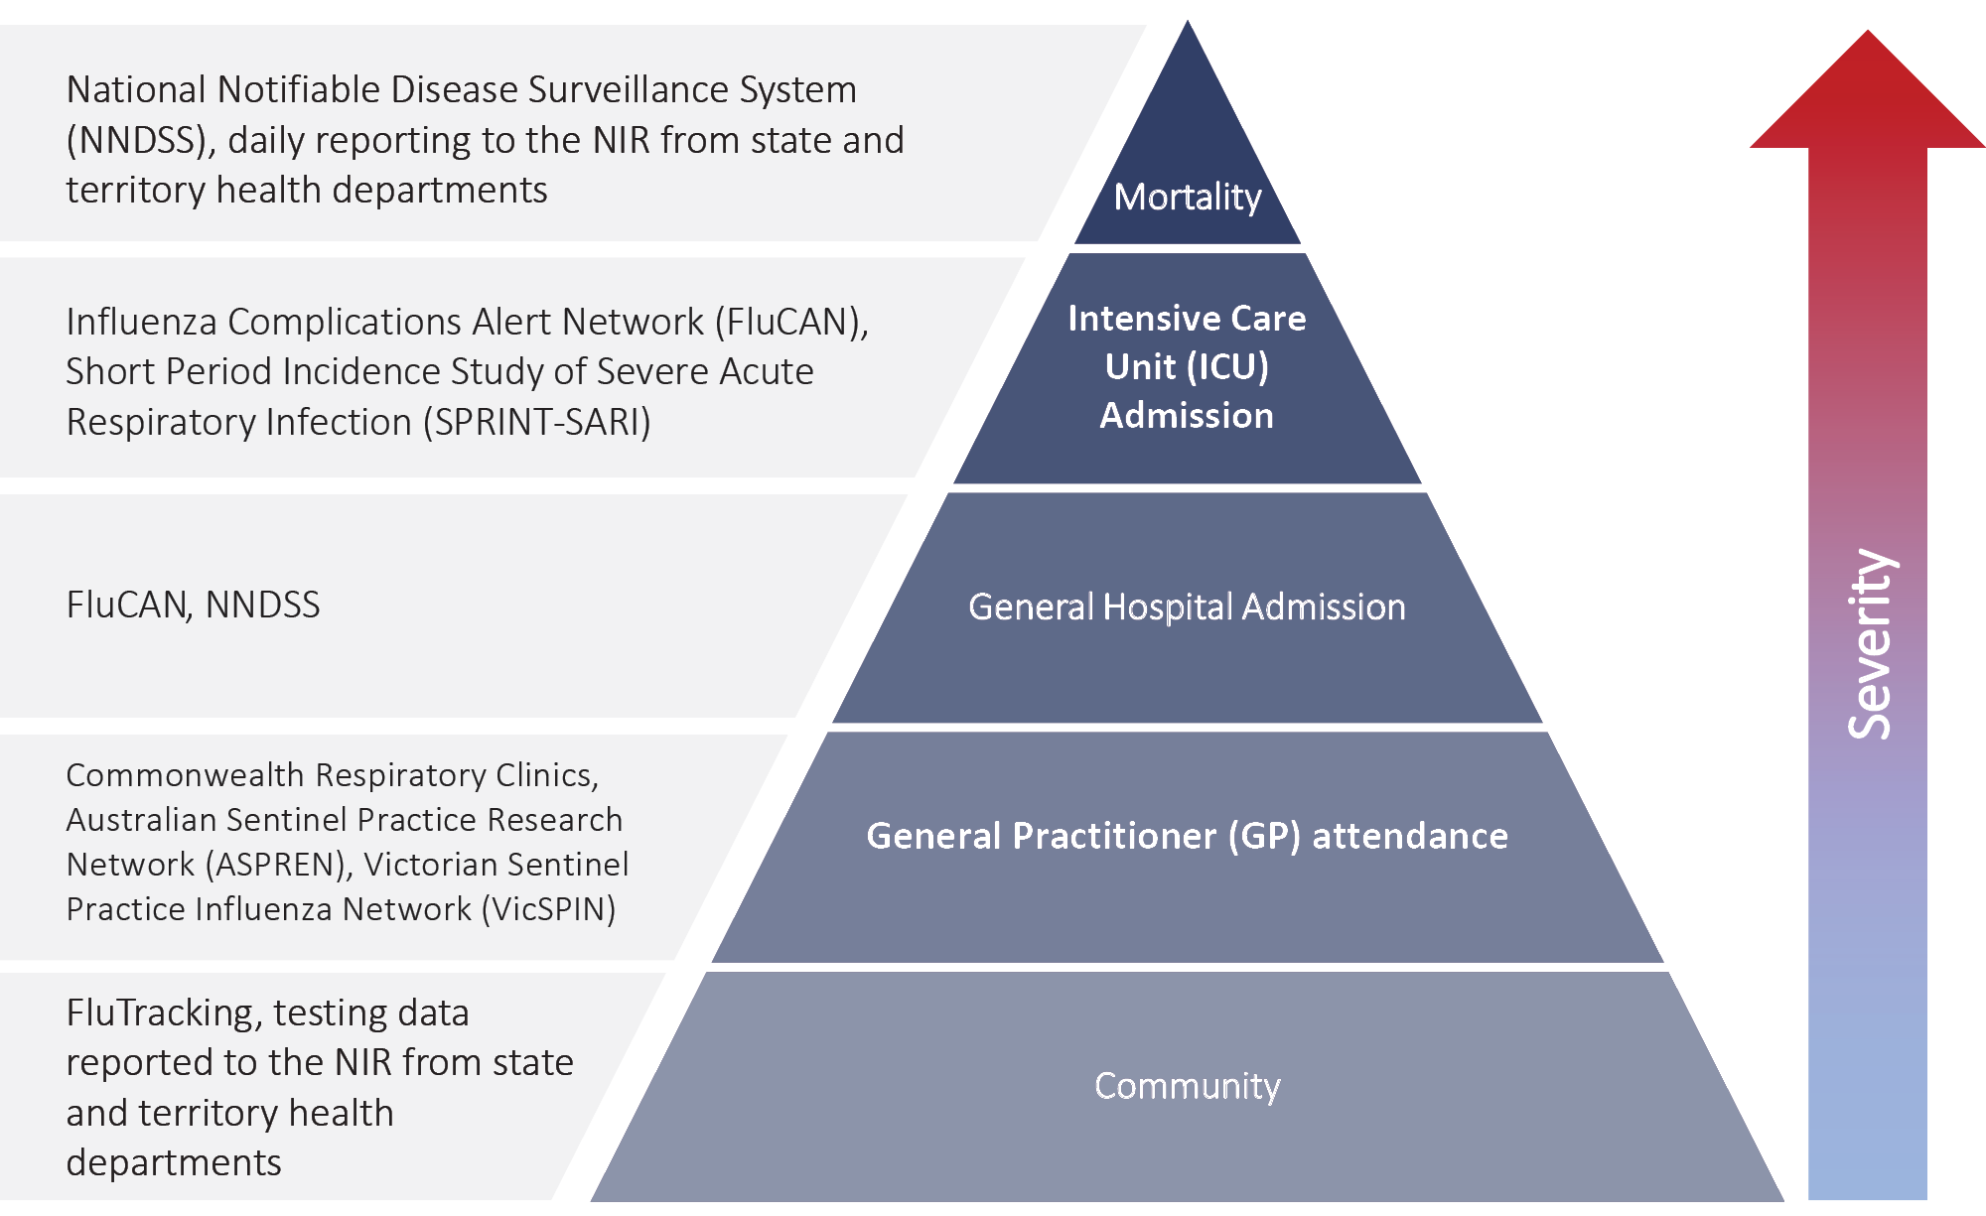

Data sources

Notifications to health departments
The majority of data presented in this report were derived from the National Notifiable Diseases Surveillance System (NNDSS). COVID-19 is a notifiable disease under public health legislation in all states and territories and is listed on the National Notifiable Diseases List under the National Health Security Act (2007). Accordingly, all jurisdictions report confirmed and probable cases of COVID-19 through the NNDSS. The national case definition for surveillance is available in the COVID-19 Series of National Guidelines.⁹ Due to the dynamic nature of the NNDSS, numbers presented in this report may be subject to revision and may vary from numbers previously reported and from case notifications released by states and territories. Case numbers for the most recent dates of illness onset may be subject to revision, due to reporting delays. Data for the current report were extracted from the NNDSS on 24 November 2020 for notifications received up to 22 November 2020. Data for COVID-19 deaths notified in this reporting period were extracted from daily notifications from state and territory health departments to the National Incident Room (NIR), received up to 22 November 2020. Air arrivals data were based on Australian Border Force data and also reported to the NIR, received up to 22 November 2020.

Acute respiratory illness
We report data from surveillance systems that monitor trends in the number of people reporting symptoms of mild respiratory illnesses in the community and in primary care settings. These systems gathered information from across Australia and include the online FluTracking syndromic surveillance system,¹⁰ the Commonwealth General Practice (GP) Respiratory Clinics, and the Australian Sentinel Practice Research Network (ASPREN) and Victorian Sentinel Practice Influenza Network (VicSPIN) GP sentinel surveillance systems. These systems capture data on any respiratory illness experienced by participants, including pathogens such as SARS-CoV-2.

Hospitalisations
To report on COVID-19 disease severity, we draw on hospitalisations and intensive care unit (ICU) admissions data provided from two sentinel surveillance systems: the Influenza Complications Alert Network (FluCAN)¹¹ and the Short Period Incidence Study of Severe Acute Respiratory Infection Study (SPRINT-SARI).¹² FluCAN is a real-time hospital sentinel surveillance system for acute respiratory disease requiring hospitalisation. Established to monitor for seasonal influenza, FluCAN has been modified to include surveillance for COVID-19. Participating sites collect detailed clinical and laboratory information from all hospitalised patients with a confirmed diagnosis of COVID-19. SPRINT-SARI is a sentinel system that collects detailed data on the characteristics and outcomes of and interventions for patients admitted to ICUs or High Dependency Units (HDUs) with COVID-19 at participating sites across Australia. Data presented from both sentinel surveillance systems may be subject to retrospective adjustments following publication. Data on severity is presented in the report each four weeks, rather than on a fortnightly basis.

Viral genomics
The Global Initiative on Sharing All Influenza Data (GISAID) is an international virus sequence database that provides open access to SARS-CoV-2 genomic data.¹³ Phylogenetic analyses are publicly available through the Nextstrain platform, which uses virus sequence data from GISAID to track the global evolution and spread of SARS-CoV-2.¹⁴

Testing data
Aggregated testing data were reported daily to the NIR by jurisdictions. Testing data by demographic breakdown were also reported on a weekly basis by jurisdictions.

Denominators
We used population data from the Australian Bureau of Statistics (ABS) Estimated Resident Population (as at 30 December 2019) to estimate rates of infection by jurisdiction, age group, sex and Indigenous status.

International
All data reported in the international section were extracted from the World Health Organization (WHO) Dashboard on 22 November 2020 unless otherwise specified.¹⁵

Activity

Acute respiratory illness

(FluTracking and Commonwealth Respiratory Clinics)
Based on self-reported FluTracking data, fever and cough in the community was three times lower than the historical average ending at 11 October (Figure 2). Runny nose and sore throat symptoms in the community decreased across this reporting period and the prevalence in the community was less than 1%.

Figure 2: Weekly trends in respiratory illness amongst FluTracking survey participants (age-standardised) compared to the average of the previous five years, Australia, 1 March – 22 November 2020ª
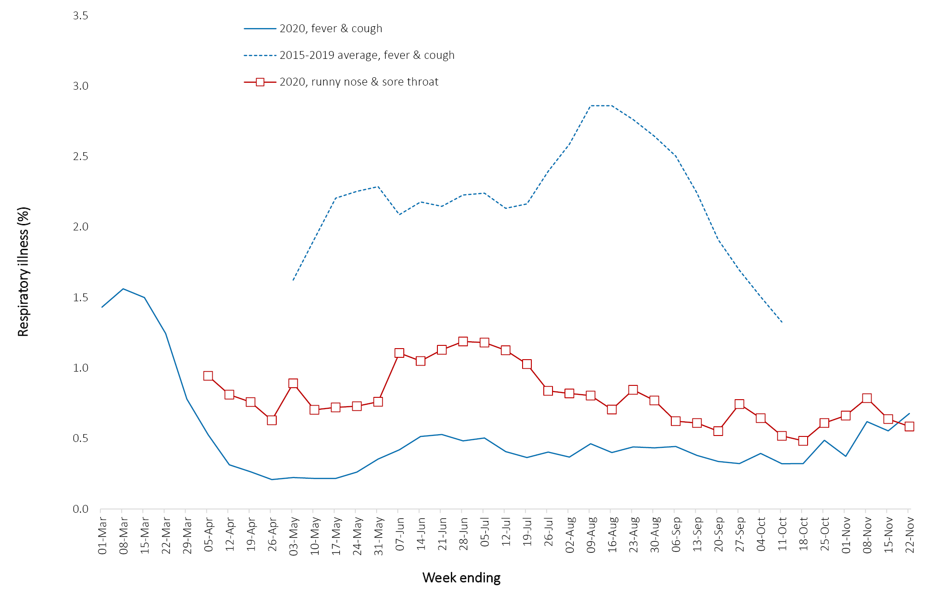
In this reporting period, acute respiratory illness was highest in those aged 0–9 and 30–39 years old, based on both self-reported FluTracking data and presentations to Commonwealth Respiratory Clinics. Females reported respiratory illness more frequently than males. Rates of fever and cough by jurisdiction ranged from 1.8/1,000 FluTracking participants in Tasmania to 6.9/1,000 participants in the Australian Capital Territory.
FluTracking data indicate that 54% of those in the community with ‘fever and cough’ and 26% of those with ‘runny nose and sore throat’ were tested for SARS-CoV-2. Testing rates varied by jurisdiction, being lowest in Western Australia and highest in Victoria and New South Wales. It is important to acknowledge that there may be legitimate reasons why people did not get tested, including barriers to accessing testing. Symptoms reported to Flutracking were not specific to COVID-19 and may also be due to chronic diseases.
During this reporting period, there were 37,005 assessments at Commonwealth Respiratory Clinics with > 95% tested for SARS-CoV-2. There were no positive SARS-CoV-2 test results in these Clinics for this reporting period.
In patients experiencing influenza-like illness in this reporting period and tested through the ASPREN and VicSPIN GP sentinel surveillance systems, the most frequent respiratory viruses detected were rhinoviruses.
The rate of self-reported fever and cough among Aboriginal and Torres Strait Islander peoples over the reporting fortnight was 2.3 times that observed in all other participants based on FluTracking data.
Rates of respiratory illness in health care worker populations were similar to those observed in the wider community, based on FluTracking data.
Based on all presentations to Commonwealth Respiratory Clinics to date, the principal symptoms reported in COVID-19 cases were cough, sore throat, tiredness, runny nose, and fever.

Transmission trends of confirmed COVID-19

(NNDSS and jurisdictional reporting to NIR)
As at 22 November 2020, there were 27,892 COVID-19 cases including 907 deaths reported nationally, with two distinct peaks in March and July (Figure 3). In this reporting period, there were 123 cases. No deaths were notified by jurisdictional health departments to the NIR in this reporting period. On average, nine cases were notified each day over this reporting period, which was similar to the previous reporting period (10 cases). The largest number of cases diagnosed this fortnight was from New South Wales (46%; 56/123), followed by South Australia (24%; 29/123), Western Australia (15%; 18/123) and Queensland (12%; 15/123). Small numbers of cases were reported in Northern Territory (4) and the Australian Capital Territory (1). No new cases were reported in Tasmania and Victoria.
Figure 3: COVID-19 notified cases by source of acquisition and diagnosis date, Australia, week ending 22 November 2020ª
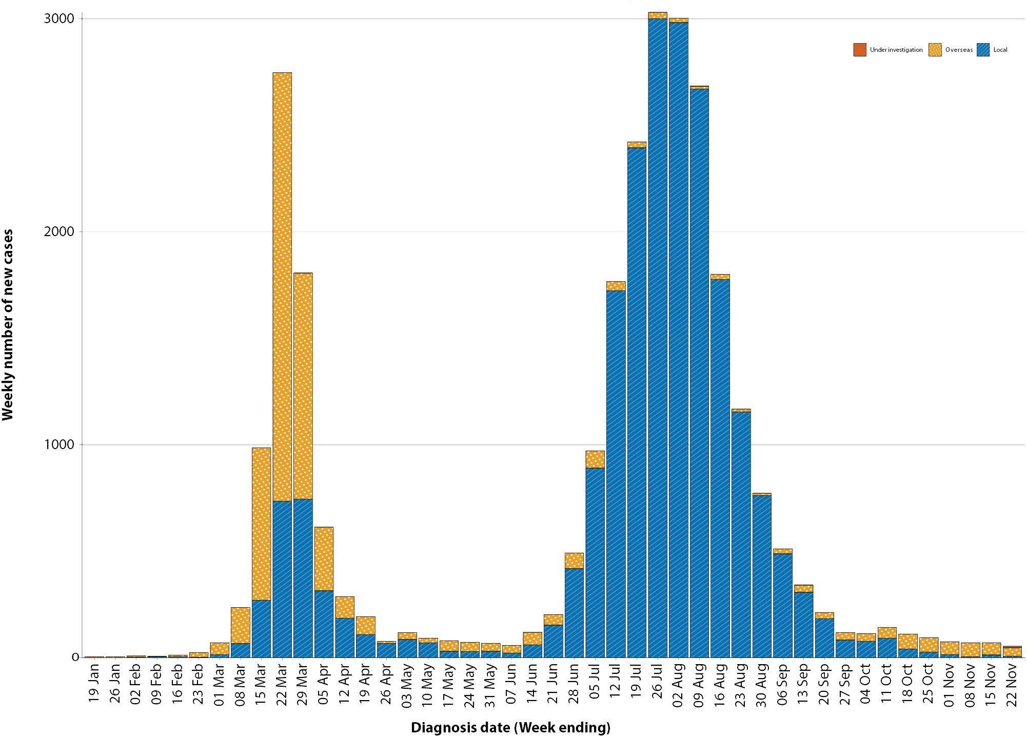
a Source: NNDSS.

Source of acquisition

(NNDSS and Australian Border Force)
In this reporting period, 79% (97/123) of cases were reported as overseas acquired. Locally-acquired cases accounted for 15% (19/123) of cases, all of which were from a known source. There were no locally-acquired cases from an unknown source in this reporting period. This is a decrease from the previous reporting period, where 5% (1/19) of all locally-acquired cases were from an unknown source. In total, 6% (7/123) of cases reported this fortnight were under investigation at the time of reporting (Table 1).
Table 1: COVID-19 notifications by jurisdiction and source of acquisition, Australia, 9–22 November 2020
Source | NSW | Vic. | Qld | WA | SA | Tas. | NT | ACT | Australia
Overseas | 56 | 0 | 14 | 12 | 10 | 0 | 4 | 1 | 97
Local — source known | 0 | 0 | 0 | 0 | 19 | 0 | 0 | 0 | 19
Local — source unknown | 0 | 0 | 0 | 0 | 0 | 0 | 0 | 0 | 0
Under investigation | 0 | 0 | 1 | 6 | 0 | 0 | 0 | 0 | 7
Total | 56 | 0 | 15 | 18 | 29 | 0 | 4 | 1 | 123

In this reporting period, the largest number of overseas-acquired cases was reported in New South Wales (58%; 56/97), followed by Queensland (14%; 14/97) and Western Australia (12%; 12/97). The higher number of overseas-acquired cases reported in New South Wales reflects the number of returned travellers managed there.
Since hotel quarantine measures were implemented on 28 March, Australia has received approximately 171,910 passengers arriving by air at the end of this reporting period. Of these, 1.3% (2212/171,910) have tested positive for COVID-19. Figure 4 shows the distribution of overseas acquired air arrival cases varies by jurisdiction, predominately reflective of those jurisdictions who manage international arrivals. The number of cases detected among international air arrivals since mid-October is similar to that observed in July (Figure 4).

Figure 4: Weekly number of overseas acquired cases (excluding cases acquired at sea) by state and the weekly percentage of arrivals testing positive (excluding crew)ª
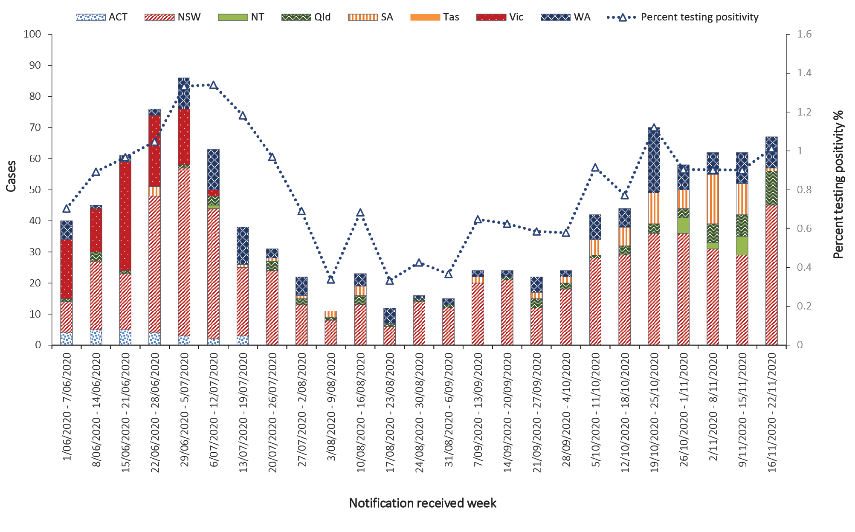
a Sources: NNDSS and Australian Border Force.
In the past fortnight, the largest number of overseas-acquired cases were from the United States of America (11%; 11/96) followed by India (9%; 9/96) and the United Kingdom (8%; 8/96). The number of cases by country is influenced by travel patterns of returning Australians as well as by the prevalence of COVID-19 in the country the person is arriving from.
South Australia had the highest proportion of locally-acquired cases with a known source of infection (100%; 19/19) and was associated with a localised cluster linked to a hotel quarantine facility.
Cumulatively, the infection rate to date for all locally-acquired cases was highest in Victoria with 293.6 infections per 100,000 population (Table 2). The rate of infection in Tasmania was 28.4 infections per 100,000 population, largely as a result of an outbreak in North West Tasmanian hospitals in April 2020, which represented half of all their cases.

Table 2: Locally-acquired COVID-19 case numbers and rates per 100,000 population by jurisdiction and reporting period, Australia, 22 November 2020
Jurisdiction | Reporting period | Reporting period | Cumulative cases
Jurisdiction | 26 October – 8 November | 9–22 November
Jurisdiction | Number of cases | Number of cases | Number of cases | Rates per 100,000 population
NSW | 13 | 0 | 1,976 | 24.4
Vic. | 5 | 0 | 19,360 | 293.6
Qld | 0 | 0 | 302 | 5.9
WA | 0 | 0 | 101 | 3.9
SA | 1 | 19 | 171 | 9.8
Tas. | 0 | 0 | 152 | 28.4
NT | 0 | 0 | 6 | 2.4
ACT | 0 | 0 | 26 | 6.1
Australia | 19 | 19 | 22,094 | 87.2
Table 3: Days since last locally-acquired COVID-19 case (source known and source unknown), by jurisdiction, reported by notification received date, 22 November 2020
Jurisdiction | Locally acquired — source unknown |  | Locally acquired — source known
Jurisdiction | Date of last case | Days since last case | Date of last case | Days since last case
NSW | 28/10/2020 | 25 | 5/11/2020 | 17
Vic. | 29/10/2020 | 24 | 29/10/2020 | 24
Qld | 26/08/2020 | 88 | 15/09/2020 | 68
WA | 12/04/2020 | 224 | 13/05/2020 | 193
SA | 15/04/2020 | 221 | 17/11/2020 | 5
Tas. | 11/08/2020 | 103 | 6/05/2020 | 200
NTª | N/A | N/A | 4/04/2020 | 232
ACT | 26/04/2020 | 210 | 12/07/2020 | 133
a The Northern Territory has not reported any locally-acquired cases with an unknown source of infection.
Nationally, it has been 24 days since there was a locally-acquired case of unknown source. There were no locally-acquired cases of unknown source since the last reporting period.

Demographic features

(NNDSS)
In this reporting period, the largest number of cases occurred in those aged 30–39 years (34 cases). For all notifications to date, the highest rate of infection was in those ≥ 90 years old with a rate of 386.8 per 100,000 population (Appendix A, Table A.1). Children aged 0–9 years had the lowest rate of infection (44.8 cases per 100,000 population), despite comparable testing rates to other age groups.
Cumulatively, the male-to-female rate ratio of cases was approximately 1:1 in most age groups. Notification rates were higher among females than among males in the 20–29 years age group and those aged ≥ 80 years old, and higher among males than among females in the 70–79 years age group (Figure 5). The largest difference in cumulative rates was in the ≥ 90 years age group, where the cumulative rate among males was 333.7 cases per 100,000 population and among females 413.3 cases per 100,000 population (Appendix A, Table A.1).
Figure 5: Cumulative COVID-19 cases, by age group and sex, Australia, 23 January – November 2020
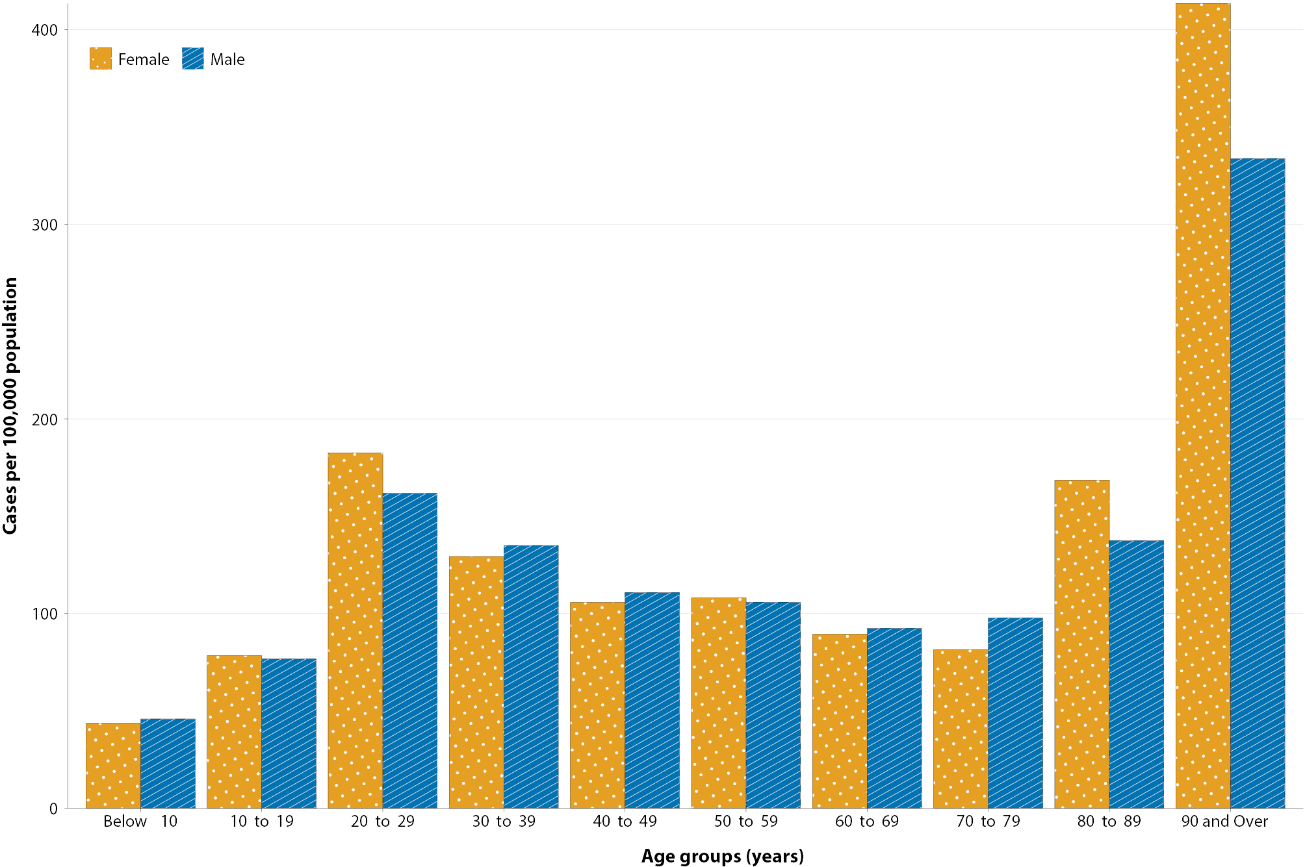
Since the beginning of the epidemic in Australia, the median age of all cases was 37 years old (interquartile range, IQR: 25–56) which has not changed since the beginning of August. Prior to 1 June 2020, COVID-19 cases were slightly older, with a median age of 46 years old (IQR: 29–62), associated with a high proportion of cases having a recent travel history or acquisition on a cruise ship. In cases reported after 1 June 2020, the median age was 34 years old (IQR: 23–53) reflecting transmission in the community and across a range of settings, especially in Victoria. The median age of cases in this reporting fortnight was 33 years old (IQR: 26–50).

Aboriginal and Torres Strait Islander persons

(NNDSS)
There have been 147 confirmed cases of COVID-19 notified in Aboriginal and Torres Strait Islander persons since the beginning of the epidemic. This represents approximately 0.5% of all confirmed cases. There were no cases among Aboriginal and Torres Strait Islander persons since early September. Table 4 compares the remoteness of cases in Aboriginal and Torres Strait Islander persons with those in the Non-Indigenous population. No new overseas-acquired cases have been reported among Aboriginal and Torres Strait Islander persons since the end of August.

Table 4: COVID-19 notifications by Aboriginal and Torres Strait Islander status by jurisdiction, source of acquisition and remoteness classification, Australia, 22 November 2020
 | Locally acquired |  |  |  | Interstate acquired | Overseas acquired | Unknownª | Total
 | Major Cities of Australia | Inner Regional Australia | Outer Regional Australia | Remote / Very Remote Australia
Aboriginal and  Torres Strait Islander^{b} | 90 | 15 | 6 | 1 | 4 | 31 | 0 | 147
Non-Indigenous | 20,451 | 915 | 223 | 20 | 151 | 5,758 | 199 | 27,745
a Includes 28 Non-Indigenous cases classified as overseas residents who were diagnosed in Australia and 171 Non-Indigenous cases with an unknown remoteness classification.
b Excludes one probable Aboriginal and Torres Strait Islander case.
Table 5: Hospital length of stay for confirmed COVID-19 cases discharged alive from sentinel sites by ICU/HDU admission status, Australia, 22 November 2020
 | Hospital length of stayª |  |  | ICU length of stay^{b}
Age group (years) | n | Median (IQR) | Mean (SD) | n | Median (IQR) | Mean (SD)
< 18 | 32 | 2.5 (1.0–6.5) | 4.9 (6.7) | 7 | 12.0 (4.0–25.0) | 17.3 (17.8)
18–39 | 68 | 4.0 (2.0–8.0) | 6.6 (7.1) | 51 | 4.0 (2.0-7.0) | 6.6 (10.0)
40–59 | 101 | 8.0 (4.0–13.0) | 11.1 (16.1) | 147 | 5.0 (3.0–12.0) | 9.2 (11.2)
60–79 | 91 | 10.0 (6.0–15.0) | 12.0 (10.6) | 182 | 8.0 (3.0–17.0) | 12.7 (13.2)
≥ 80 | 46 | 11.5 (7.0–16.0) | 12.3 (7.4) | 10 | 3.5 (3.0–8.0) | 6.5 (7.2)
a Source: FluCAN. Includes patients with a discharge outcome (n = 338).
b Source: SPRINT-SARI. Includes 78 sentinel ICU/HDUs and only those with discharge outcome (n = 396).

Figure 6: National COVID-19 notification rate per 100,000 population by age group, Aboriginal and Torres Strait Islander persons and Non-Indigenous persons, Australia, 23 January – 22 November 2020
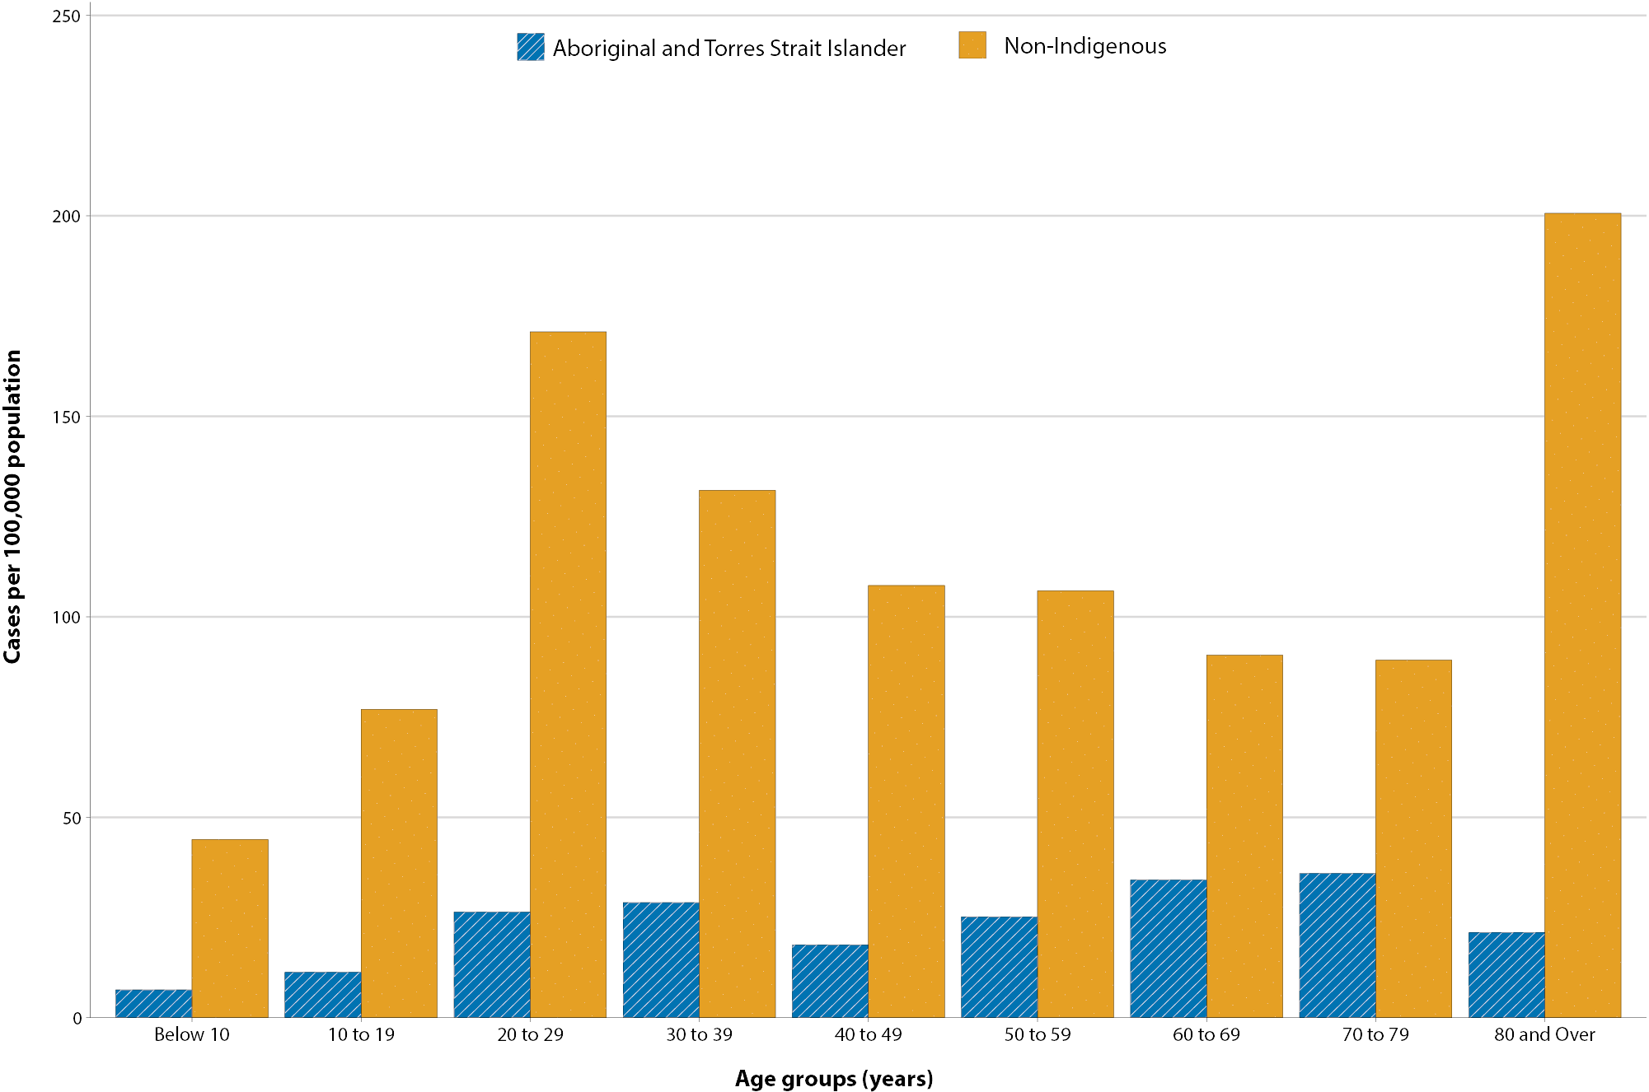
The median age of COVID-19 cases in Aboriginal and Torres Strait Islander persons was 31 years old (IQR: 21–49), which was younger than for Non-Indigenous cases where the median age was 37 years old (IQR: 25–56).
The notification rate across all age groups was higher in Non-Indigenous persons than in Aboriginal and Torres Strait Islander persons (Figure 6). The age-standardised Aboriginal and Torres Strait Islander:Non-Indigenous notification rate ratio was 0.2, indicating that the Aboriginal and Torres Strait Islander population had a lower COVID-19 case rate than the Non-Indigenous population after accounting for differences in age structure. Amongst Aboriginal and Torres Strait Islander cases, the highest notification rate was in those aged 70–79 years (36.0 cases per 100,000 population), followed by the 60–69 years age group (34.4 cases per 100,000 population). Similar to Non-Indigenous cases, children aged 0–9 years had the lowest notification rate among Aboriginal and Torres Strait Islander cases (6.9 cases per 100,000 population).

Severity

(NNDSS, FluCAN, SPRINT-SARI)
The current proportion of COVID-19 cases hospitalised based on NNDSS data remains at 13%; this figure has remained stable over the past eight weeks.^{16,17} Since 16 March 2020, FluCAN has recorded 448 COVID-19 cases hospitalised in sentinel sites,¹¹ of which 89 (20%) were subsequently admitted to an intensive care unit (ICU). There were only two hospital admissions for confirmed COVID-19 cases in participating sites since the last severity report (COVID-19 epidemiology report 28: data to 25 October).¹⁷ Since 17 February 2020, SPRINT-SARI has recorded 466 COVID-19 cases admitted to ICU in participating sites,¹² 55% of whom have been subject to mechanical ventilation for at least an hour on at least one day of their admission. There were no ICU admissions at these sites since 12 September 2020 and no ICU discharges since 14 October 2020.

Length of hospital stay
Length of hospital stay for patients with confirmed COVID-19 increases with advancing age category: those ≥ 80 years old stay slightly longer in hospital than those aged 60–79 years (Table 5). Length of stay for all cumulative hospitalised cases discharged alive (n = 338: median (IQR) = 7.0 days (3.0–13.0); mean (sd) = 10 days (11.6)) has changed little compared to the previous severity report (data to 25 October),¹⁷ with only a small number of patients with updated discharge status in the intervening four weeks (n = 38). Length of stay in ICU for survivors (n = 396) remains unchanged from the previous severity report, with a median of six days (IQR: 3–15); non-survivors stayed longer (median nine days; IQR: 5–21).

Characteristics of those with severe COVID-19 disease
The median age of cases who were hospitalised in sentinel sites (59 years; IQR: 40–75) and admitted to ICU (61 years; IQR: 50–70) was higher than for cases overall (37 years; IQR: 25–56). The ratio of males to females was similar in hospitalised cases (1.2:1) while substantially more males than females were admitted to ICU (ratio: 1.7:1); these sex ratios remain unchanged from the previous severity report. Of those hospitalised in sentinel sites (n = 448),¹¹ five (1%) identified as Aboriginal and/or Torres Strait Islander people (1 unknown and 7 missing data; > 98% completeness).
Comorbidity and other risk factor analysis can be found in the most recent previous severity report.¹⁷ We have not updated risk factor data in the present report, as hospital cohorts have remained largely unchanged in the intervening four weeks.

COVID-19 deaths
Overall, the crude case fatality rate (CFR: 3.3%, Table 6) remained stable since the last severity report (to 25 October 2020),¹⁷ with eight cases reported to NNDSS during the past four weeks as having died. These eight cases were all aged over 65 years. This is a substantial drop from the 64 updated deaths in the preceding four weeks to 25 October. The highest CFR remains in males over the age of 80 years (41.2%); the CFR among males in this age group admitted to ICU was 71%.
Table 6: Number of fatalities and CFR for all cases, hospitalised cases and cases admitted to ICU, by age group and sex, Australia, 22 November 2020
 | All casesª  n (CFR) |  |  | Hospitalisation^{b}  n (CFR) |  |  | ICU^{c}  n (CFR)
 | Male | Female | Persons | Male | Female | Persons | Male | Female | Persons
Total | 439 (3.3) | 468 (3.3) | 907 (3.3) | 26(13.0) | 19 (10.7) | 45 (11.8) | 44 (15.5) | 15 (9.0) | 60 (13.2)
< 50 | 5 (0.1) | 0 (0.0) | 5 (0.03) | 0 (0.0) | 0 (0.0) | 0 (0.0) | 2 (2.9) | 0 (0.0) | 2 (1.8)
50–64 | 19(0.8) | 10 (0.4) | 29 (0.6) | 1 (2.0) | 2 (6.1) | 3(3.6) | 9 (9.2) | 3 (5.4) | 12 (7.8)
65–79 | 118(8.9) | 62 (5.0) | 180 (7.1) | 10 (20.0) | 2.0 (6.9) | 12 (15.2) | 23 (22) | 9 (14.5) | 32 (19.3)
80+ | 297(41.2) | 396(29.8) | 693 (33.8) | 15 (46.9) | 15 (34.1) | 30 (39.5) | 10 (71.4) | 3 (60.0) | 14 (58.3)
a Source: NNDSS. (Total cases = 27, 787).
b Source: FluCAN. Includes 21 sentinel hospitals. (Total cases = 382).
c Source: SPRINT-SARI. Includes 78 sentinel ICU/HDUs and only those with discharge outcome. (Total cases = 456).

Clusters and outbreaks

(State and territory reporting)
As at 24th November there was a total of four outbreaks associated with 29 cases. These outbreaks were all in South Australia as associated with the ‘Parafield cluster’. Outbreaks were reported in the following settings: residential aged care facility (1); quarantine facility (1); extended family setting (1); and a workplace (1).
Nationally, since the beginning of the epidemic, there have been 829 outbreaks associated with 13,235 cases; 2,007 hospitalisations; and 799 deaths. Consistent with the national epidemic case trend, the first peak in outbreaks occurred in mid-March (Figure 7). This was followed by a rapid increase in outbreaks beginning in early July, corresponding with community transmission in Victoria.
Figure 7: Number of outbreaks throughout the course of the pandemic, Australia, 22 November 2020
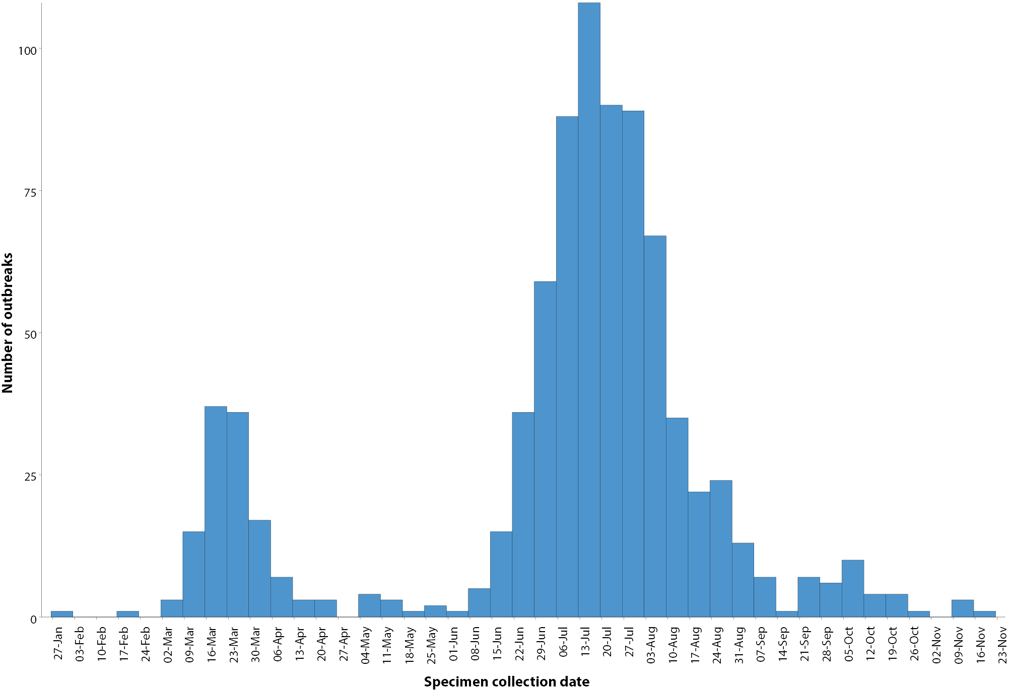
The median number of cases in each outbreak was six (range 2–331). Forty percent (326/829) of outbreaks had six to 24 cases, and almost a third (32%, 266/829) had only 3–5 cases. The largest single jurisdictional outbreak occurred in in a residential aged care facility and was associated with 331 cases (Figure 8).

Figure 8: Number of outbreaks by size, Australia, 22 November 2020
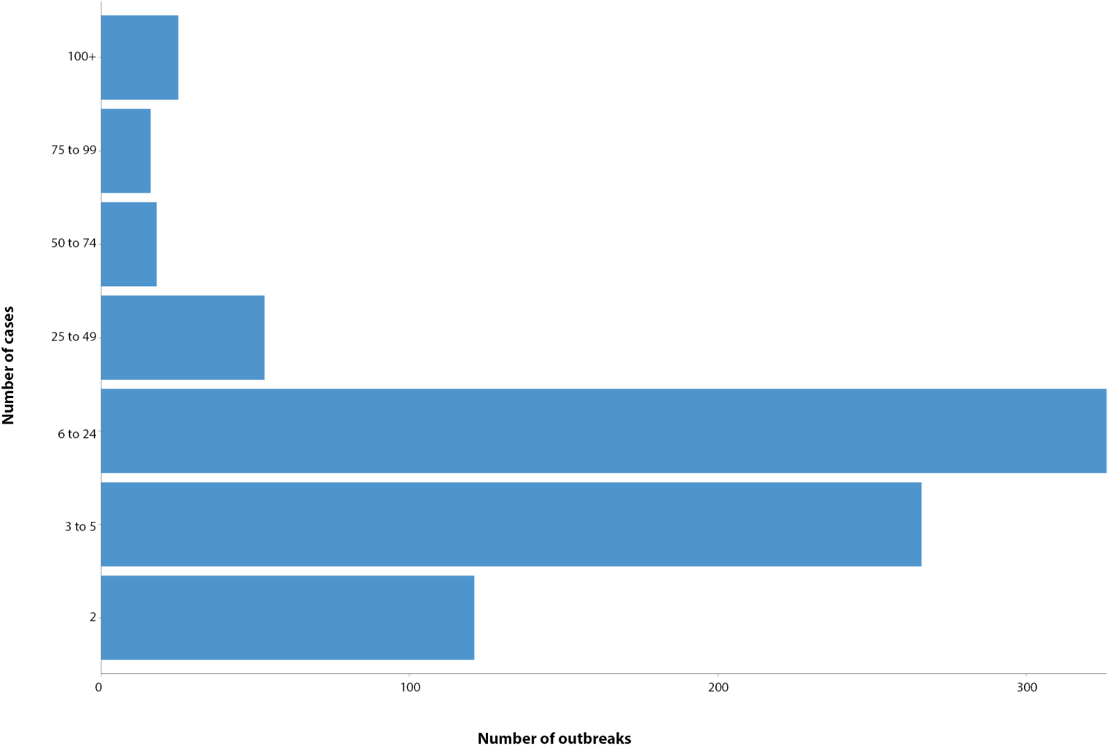
Residents of aged care facilities are at increased risk of COVID-19 infection due to the environment of communal living facilities and are more vulnerable to serious complications if they do become infected. As at 22 November 2020, there have been 4,298 cases of COVID-19 associated with 219 residential aged care facilities, with 3,609 recoveries and 685 deaths. Of these cases, 2,049 occurred in aged care residents, with the remaining 2,249 cases occurring in care staff. The Commonwealth is actively supporting services with reported incidents and outbreaks of COVID-19 providing access to personal protective equipment and additional staffing resources where required. Advice and guidelines have been provided to aged care services, including the release of an outbreak management guide.^{18,19}

Virology

(GISAID)
At the time of this report, there were 15,456 SARS-CoV-2 genome sequences available from Australian cases on the global sequence repository, GISAID.¹³ These sequences were dispersed throughout the global lineages, reflecting multiple concurrent introductions into Australia.^{1,20,21} In the last fortnight, there have been no new Australian sequences uploaded to GISAID. Recent Australian SARS-CoV-2 sequences from the last month include six from New South Wales and five from South Australia. In the past month there have been seven different sequences, reflecting the recent shift from locally-acquired to overseas-acquired cases in Australia.

Public health response measures
Since COVID-19 first emerged internationally, Australia has implemented public health measures informed by the disease’s epidemiology (Figure 9). On 8 May, the Australian Government announced a three-step framework for easing COVID-19 restrictions. Building on this framework, on 13 November the National Cabinet (except for Western Australia) agreed to a ‘Framework for National Reopening’ which aims to achieve a COVID normal Australia by Christmas 2020 wherever it is safe to do so.²² States and territories have decision-making authority in relation to public health measures and have eased restrictions at their own pace, depending on the local public health and epidemiological situation (Table 7).²³
During the current reporting period, Victoria and Queensland continued to ease COVID-19 restrictions. South Australia implemented a temporary ‘circuit breaker’ lockdown in response to a cluster of locally-acquired cases.²⁴ Although initially planned for six days, South Australia revoked stay-at-home orders after three days, following developments in information regarding the transmission of disease.²⁵

Figure 9: COVID-19 notifications in Australia by week of diagnosis and jurisdiction to 22 November 2020, with timing of key public health measures
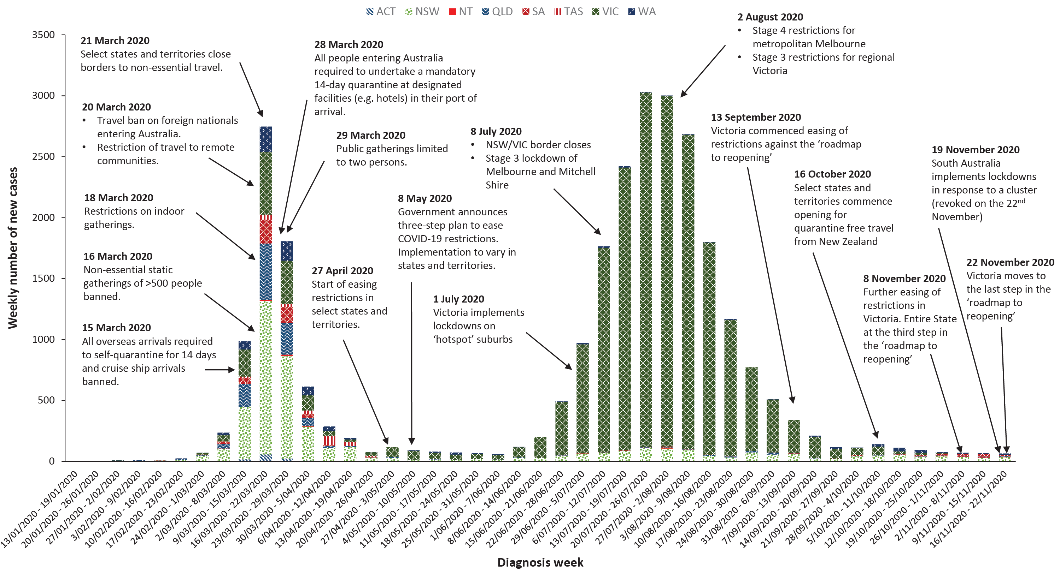

Table 7: State and territory changes to COVID-19 restrictions, Australia, 9–22 November 2020
Jurisdiction | Summary of changes to COVID-19 restrictions
New South Wales | No further easing of restrictions during this reporting period.²⁶
Victoria | From 22 November Victoria moved to the last step in their roadmap for reopening. The following restrictions were eased:²⁷  - Face masks required indoors but not outdoors when individuals can socially distance  - Phased return of workplaces  - Shops, recreational facilities, entertainment, hospitality and cultural venues open with density restrictions
Queensland | From 17 November the following restrictions were eased:²⁸  - Up to 50 permitted at private gatherings  - Density restrictions for indoor venues reduced to one person per 2m²  - Up to 200 permitted at weddings and funerals  - Seated, ticketed venues and open air stadiums permitted 100% capacity with density restrictions  - Outdoor events permitted up to 1500
Western Australia | From 14 November Western Australia amended border requirements so travellers from ‘very low risk’ jurisdictions are not required to quarantine.²⁹
South Australia | From 19 November South Australia implemented ‘circuit breaker’ lockdown measures in response to a cluster of cases:²⁴  - Remain at home restrictions in place. People permitted to leave home for emergency services work, agricultural work, to receive medical care or supplies, one person to shop at supermarkets  - Critical services to remain operational (e.g supermarkets, critical infrastructure, medical services)  - All other businesses to close  From 22 November South Australia revoked the ‘circuit breaker’ lockdown and reverted to the previous level of restrictions.²⁵
Tasmania | No further easing of restrictions during this reporting period.³⁰
Australian Capital Territory | No further easing of restrictions during this reporting period.³¹
Northern Territory | No further easing of restrictions during this reporting period.³²

Table 8: Diagnostic tests performed, by jurisdiction, Australia, 22 November 2020
Jurisdiction | Tests performed 26 October – 8 November |  |  | Tests performed 9–22 November |  |  | Cumulative tests performed to 22 November
Jurisdiction | n | Positivity (%) | Per 100,000 populationª | n | Positivity (%) | Per 100,000 populationª | n | Positivity (%) | Per 100,000 populationª
NSW | 180,561 | 0.04 | 2,233.15 | 216,291 | 0.04 | 2,675.06 | 3,383,608 | 0.13 | 41,848.00
Vic | 246,825 | < 0.01 | 3,743.24 | 198,310 | 0.00 | 3,007.48 | 3,497,612 | 0.58 | 53,043.27
Qld | 51,446 | 0.02 | 1,010.23 | 58,622 | 0.03 | 1,151.14 | 1,324,189 | 0.09 | 26,002.60
WA | 28,308 | 0.06 | 1,079.7 | 28,352 | 0.08 | 1,081.38 | 529,780 | 0.15 | 20,206.45
SA | 38,468 | 0.06 | 2,195.25 | 90,157 | 0.04 | 5,144.99 | 662,775 | 0.08 | 37,822.59
Tas | 5,675 | 0.00 | 1,061.54 | 6,044 | 0.00 | 1,130.57 | 126,336 | 0.18 | 23,631.92
NT | 4,933 | 0.12 | 2,004.45 | 6,714 | 0.10 | 2,728.13 | 67,963 | 0.07 | 27,615.67
ACT | 5,756 | 0.00 | 1,350.7 | 6,886 | 0.01 | 1,615.87 | 116,927 | 0.10 | 27,438.06
Australia | 561,972 | 0.03 | 2,216.19 | 611,376 | 0.03 | 2,411.02 | 9,709,190 | 0.29 | 38,289.14
a Population data based on Australian Bureau of Statistics (ABS) Estimated Resident Population (ERP) as at 30 December 2019.
Figure 10: SARS-CoV-2 polymerase chain reaction (PCR) testing rates per 1,000 population per week by age group, Australia, 1 May – 20 November 2020^{a,b}
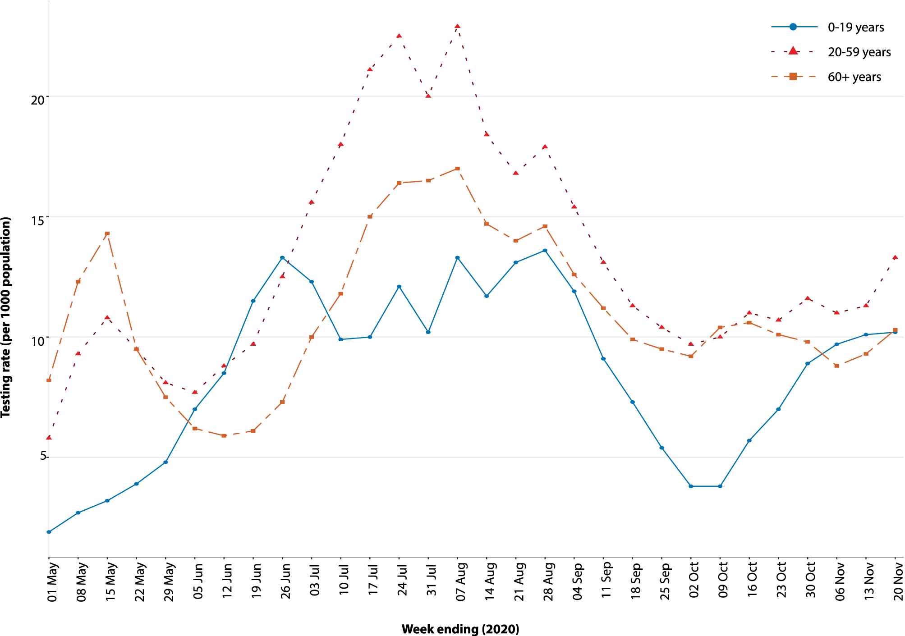
a Data provided by jurisdictions to the NIR weekly.
b The jurisdictions reporting each week (i.e. the denominator population) may vary.
Table 9: Transmission patterns for countries in Australia’s near region, WHO, 22 November 2020
Category | Country
No cases  Countries/territories/areas with no cases | American Samoa, Cook Islands, Kiribati, Federated States of Micronesia, Nauru, Niue, Palau, Pitcairn Islands, Samoa, Tokelau, Tonga, Tuvalu
Sporadic cases  Countries/territories/areas with one or more cases, imported or locally detected | Bhutan, Cambodia, Fiji, French Polynesia, Wallis and Futuna, Lao PDR, Marshall Islands, New Caledonia, Solomon Islands, Timor-Leste, Vanuatu
Clusters of cases  Countries/territories/areas experiencing cases, clustered in time, geographic location and/or by common exposures | Australia, China, Guam, Japan, Malaysia, Maldives, India, Myanmar, Nepal, New Zealand, Republic of Korea, Singapore, Sri Lanka, Thailand, Vietnam
Community transmission  Countries /territories/areas experiencing larger outbreaks of local transmission defined through an assessment of factors including, but not limited to:  large numbers of cases not linkable to transmission chains  large numbers of cases from sentinel lab surveillance or increasing positive tests through sentinel samples (routine systematic testing of respiratory samples from established laboratories)  multiple unrelated clusters in several areas of the country/territory/area. | Bangladesh, Indonesia, Papua New Guinea, Philippines

Testing

(State and territory reporting)
As at 22 November 2020, a cumulative total of 9,709,190 tests were conducted in Australia. The cumulative nationwide proportion of positive tests remained low at 0.29% (Table 8). With the exception of Victoria, the cumulative testing positivity in individual jurisdictions was < 0.2%.
During this reporting period, 611,376 tests were conducted nationally, with a positivity rate of 0.03%. This represented an 8% increase in fortnightly tests conducted compared to the last reporting period. Testing rates increased to 12.0 tests per 1,000 population per week during this reporting period, driven by a significant increase in testing in South Australia, although the nationwide rate remained nonetheless lower than the peak of 19.4 tests per 1,000 population per week in early August. Jurisdictional testing rates are driven by both current case numbers and numbers of people experiencing symptoms. All states except the Northern Territory reported a positivity rate of < 0.10% in this reporting period. The Northern Territory reported a positivity rate of 0.10%, which is a decrease from the previous reporting period (0.12%), associated with an increased number of overseas-acquired cases linked with repatriation flights. Victoria and Tasmania reported a positivity rate of 0.00% in the reporting period. The low national positivity rate, along with high rates of testing, indicates a low prevalence of COVID-19 nationally.
For the fortnight ending 20 November 2020, testing rates rose among persons aged 20–59 years and those aged 60 years and over (Figure 10). Testing rates among children and young adults aged 0–19 years have doubled since early October; however, this remains the age group with the lowest testing rates.

Countries and territories in Australia’s near region
According to WHO, as of 22 November 2020, 46 countries and territories in Australia’s near region (WHO’s South East Asia and Western Pacific regions, respectively SEARO and WPRO) reported 854,887 newly-confirmed cases and 10,857 deaths in this reporting period, bringing the cumulative cases in the two regions to 11.2 million and 175,382 cumulative deaths.¹⁵ New cases were largely concentrated in:
- India (633,726 new cases; 9,095,806 cumulative cases; 7,665 new deaths; 133,227 cumulative deaths);
- Indonesia (63,734 new cases; 493,308 cumulative cases; 1,332 new deaths; 15,774 cumulative deaths);
- Nepal (29,756 new cases; 218,639 cumulative cases; 235 new deaths; 1,305 cumulative deaths);
- Bangladesh (27,806 new cases; 445,281 cumulative cases; 314 new deaths; 6,350 cumulative deaths).
Other countries such as Fiji, the Solomon Islands, Singapore, Marshall Islands, Japan and New Zealand are detecting cases mainly among international arrivals while in quarantine, thus preventing further transmission into the community.^{33,34} (Table 9). Table 9 outlines the current Transmission Classification set by WHO for Australia’s near region. Under the WHO’s classification shown in Table 9, Australia has a transmission classification of ‘Cluster of cases’.
Of note in our region, Vanuatu recorded its first case on 10 November 2020. The case was overseas acquired and detected in quarantine through routine testing.³⁵ The Marshall Islands reported its first case on 29 October 2020; by 22 November, a total of four cases were reported. All four cases were overseas acquired and detected in routine testing of quarantined travellers.³⁶
In addition to national reporting, American Samoa reported three cases on 8 November among crew members of a cargo ship.³⁷ Samoa reported its first suspected case on 19 November 2020, however further testing is underway to confirm the diagnosis.³⁸
Nauru, Tuvalu, Tonga, Palau, Kiribati, and the Federated States of Micronesia continue to report no cases since the start of the pandemic.
Globally, over 8.7 million new cases and 135,900 deaths due to COVID-19 have been reported across the six WHO regions in the past reporting fortnight. This was the highest number of reported cases so far in a fortnightly reporting period. To date, over 57.8 million COVID-19 cases and 1.37 million deaths have been reported globally. The European Region has reported the highest number of cases and deaths, with over four million new cases in the past reporting fortnight representing 46.1% of all new cases reported worldwide. The European Region reported 66,297 deaths, representing almost half (48.8%) of the global deaths in the past fortnight. The Region of the Americas reported 3.2 million new cases and 44,006 deaths. The countries experiencing the greatest cumulative cases to date were the United States of America, India, Italy, France and Brazil.
An international summary by WHO Region can be found in the WHO Epidemiological Update dated 24 November 2020.^{39,40}

Interpretation
Since the first cases of COVID-19 were identified in Australia, all states and territories have reported cases of COVID-19, with some jurisdictions experiencing higher numbers and more substantial community-associated transmission. These differences arise from factors including differences in demographic features between jurisdictions, population size, and patterns of overseas arrivals. Nationally, there has been an overall downward trend in cases following a secondary peak in late July 2020. Australia continues to experience low levels of community transmission of COVID-19 in some jurisdictions, despite testing rates remaining stable. In this reporting period, there were no cases of COVID-19 from an unknown source.
People aged ≥ 90 years have the highest cumulative rate of infection. This trend potentially reflects the large number of outbreaks that occurred in aged care settings, which has declined in recent weeks. Other demographic trends remained consistent, with children aged 0–9 years having the lowest rate of infection, and cases in Aboriginal and Torres Strait Islander persons accounting for less than 1% of all confirmed cases and a considerably lower rate of notification than Non-Indigenous persons.
In this reporting period, no deaths were reported by any jurisdictions. Australia’s crude case fatality rate has been notably higher (3.3%) than the recent data from some other developed countries including the United States (2.1%) and France (2.2%).⁴¹ Cross-country comparison of crude case fatality rates should be done with caution as this measure will vary depending on the characteristics of the cases including their age and risk profile, a country’s adopted case and deaths definition as well as case ascertainment rates. The latter, in turn, depends on the effectiveness of a country’s public health systems, testing and data systems.
Research has found a significant correlation between the proportion of COVID-19 cases occurring in those aged 75 years and older in a country and the country-specific case fatality rate.⁴² The cumulative case fatality rate for Australia increased from August; this can be explained by a shift in the demographic make-up of the case cohort, with more older people particularly those in aged-care disproportionately affected at this time compared to earlier in the epidemic. Older people are at higher risk of severe disease and death due to COVID-19; those in aged-care are also more likely to have pre-existing comorbid conditions which can also contribute to a higher risk of death.
By contrast, in Europe and in the United States, the age-profile of recent cases (June-August, 2020) was younger than that from earlier in the pandemic (January-May, 2020);⁴³ this has, in effect, driven down the crude case-fatality rates in these regions.
Internationally, many countries are experiencing excess mortality as a result of the COVID-19 pandemic, with some regions reporting more than 40,000 deaths this fortnight. Australia has generally recorded lower than average death rates in 2020 when compared to a similar period from 2015 to 2019.⁴⁴ This may be explained by the impact of public health measures Australia implemented throughout the pandemic.
As in previous reports, the local and national epidemiology of COVID-19 continues to inform the public health response. The majority of locally-acquired cases in the last fortnight occurred in South Australia, associated with a cluster of cases from a known source. South Australia implemented a temporary ‘circuit breaker’ lockdown in this reporting period, while other jurisdictions continued to further ease restrictions.
Overseas-acquired cases in quarantine remain the greater proportion of new COVID-19 cases reported in Australia. The recent cluster in South Australia, linked to a case in hotel quarantine, highlights the importance of ongoing surveillance as Australia continues to manage overseas arrivals.
It is important to note that changes in notifications over time are strongly influenced by a range of factors other than disease incidence. These factors include changes in testing policies; screening programs, including the preferential testing of high-risk populations; and periodic awareness campaigns.

Definitions
“Cluster” in relation to COVID-19 refers to two or more cases (who do not reside in the same household) that are epidemiologically related in time, place or person where a common source (such as an event or within a community) of infection is suspected but not yet established.
“COVID-19” is the disease caused by a novel coronavirus—SARS-CoV-2—that emerged in China in late 2019. ‘CO’ stands for corona-, ‘V’ stands for virus, ‘ID’ stands for infectious disease, and ‘-19’ refers to the year that this disease was first reported.
“COVID-19 associated death” is defined for surveillance purposes as a death in a probable or confirmed COVID-19 case, unless there is a clear alternative cause of death that cannot be related to COVID-19 (e.g. trauma).³⁷ There should be no period of complete recovery from COVID-19 between illness and death. Where a Coroner’s report is available, these findings are to be observed.
“Date of illness onset” is derived from data collected by the NNDSS and represents the diagnosis date, or reported true onset of disease date. If unknown, the earliest of specimen collection date, notification date or notification receive date is used.
“Notification received date” is reported in the NNDSS and represents the date the case is first notified on the NNDSS. As notification can only occur after testing is completed and information processed, counts for a defined period will vary according to the date type used.
“Outbreak” in relation to COVID-19 refers to two or more cases (who do not reside in the same household) among a specific group of people and/or over a specific period of time where illness is associated with a common source (such as an event or within a community). Some states and territories may report a single case associated with a residential aged care facility as an outbreak.
“SARS-CoV-2” is the virus that causes the disease COVID-19. It is a betacoronavirus genetically related to the 2003 Severe acute respiratory syndrome coronavirus (SARS-CoV).
“This reporting period” refers to the period covered by this report, i.e. 9–22 November 2020.

Acknowledgements
This report represents surveillance data reported through Communicable Diseases Network Australia (CDNA) as part of the nationally-coordinated response to COVID-19. We thank public health staff from incident emergency operations centres and public health units in state and territory health departments, and the Australian Government Department of Health, along with state and territory public health laboratories. We thank those who provided data from surveillance systems, such as Commonwealth respiratory clinics, SPRINT-SARI, Flutracking, and FluCan.

Author details

Corresponding author
COVID-19 National Incident Room Surveillance Team, Australian Government Department of Health, GPO Box 9484, MDP 14, Canberra, ACT 2601. Email: epi.coronavirus@health.gov.au

References
- Rockett RJ, Arnott A, Lam C, Sadsad R, Timms V, Gray KA et al. Revealing COVID-19 transmission in Australia by SARS-CoV-2 genome sequencing and agent-based modeling. Nat Med. 2020. doi: https://doi.org/10.1038/s41591-020-1000-7.
- World Health Organization (WHO). Transmission of SARS-CoV-2: implications for infection prevention precautions. Scientific brief. [Internet.] Geneva: WHO; 9 July 2020. [Accessed on 14 October 2020.] Available from: https://www.who.int/news-room/commentaries/detail/transmission-of-sars-cov-2-implications-for-infection-prevention-precautions.
- McAloon C, Collins Á, Hunt K, Barber A, Byrne AW, Butler F et al. Incubation period of COVID-19: a rapid systematic review and meta-analysis of observational research. BMJ Open. 2020;10(8). doi: https://doi.org/10.1136/bmjopen-2020-039652.
- Australian Government Department of Health. Australian National Disease Surveillance Plan for COVID-19. [Internet.] Canberra: Australian Government Department of Health; 30 May 2020. Available from: https://www.health.gov.au/resources/publications/australian-national-disease-surveillance-plan-for-covid-19.
- Yuan Z, Xiao Y, Dai Z, Huang J, Zhang Z, Chen Y. Modelling the effects of Wuhan’s lockdown during COVID-19, China. Bull World Health Organ. 2020;98(7):484–94.
- Rothan HA, Byrareddy SN. The epidemiology and pathogenesis of coronavirus disease (COVID-19) outbreak. J Autoimmun. 2020;109. doi: https://doi.org/10.1016/j.jaut.2020.102433.
- Hu Y, Sun J, Dai Z, Deng H, Li X, Huang Q et al. Prevalence and severity of corona virus disease 2019 (COVID-19): A systematic review and meta-analysis. J Clin Virol. 2020; 127. doi: https://doi.org/10.1016/j.jcv.2020.104371.
- WHO. Report of the WHO-China Joint Mission on Coronavirus Disease 2019 (COVID-19). Geneva: WHO; 2020. [Accessed on 14 October 2020.] Available from: https://www.who.int/docs/default-source/coronaviruse/who-china-joint-mission-on-covid-19-final-report.pdf.
- Australian Government Department of Health. Coronavirus Disease 2019 (COVID-19): CDNA national guidelines for public health units. Canberra: Australian Government Department of Health; 28 October 2020. [Accessed on 9 November 2020.] Available from: https://www1.health.gov.au/internet/main/publishing.nsf/Content/7A8654A8CB144F5FCA2584F8001F91E2/$File/COVID-19-SoNG-v3.10.pdf.
- Dalton C, Durrheim D, Fejsa J, Francis L, Carlson S, d’Espaignet ET et al. Flutracking: a weekly Australian community online survey of influenza-like illness in 2006, 2007 and 2008. Commun Dis Intell Q Rep. 2009;33(3):316–22.
- Monash Health. FluCAN (Influenza surveillance): FluCAN (The Influenza Complications Alert Network) [Internet.] Melbourne: Monash Health; 2020. Available from: https://monashhealth.org/services/monash-infectious-diseases/research/influenza-research/flucan-influenza-surveillance-2/.
- Australian and New Zealand Intensive Care Society (ANZICS). SPRINT-SARI: Short period incidence study of severe acute respiratory infection. [Internet.] Camberwell: ANZICS; 2020. Available from: https://www.anzics.com.au/current-active-endorsed-research/sprint-sari/.
- Global Initiative on Sharing All Influenza Data (GISAID). [Website.] Berlin: Federal Republic of Germany, Freunde von GISAID e.V.; 2020. [Accessed on 15 October 2020.] Available from: https://www.gisaid.org/.
- Bedford T, Neher R, Hadfield J, Hodcroft E, Sibley T, Huddleston J et al. Nextstrain: Genomic epidemiology of novel coronavirus - Oceania-focused subsampling. [Internet.] Nextstrain; 2020. [Accessed on 15 October 2020.] Available from: https://nextstrain.org/ncov/oceania.
- WHO. WHO Coronavirus Disease (COVID-19) dashboard. [Internet.] Geneva: WHO; 22 November 2020. [Accessed on 23 November 2020.] Available from: https://covid19.who.int/.
- COVID-19 National Incident Room Surveillance Team. COVID-19, Australia: epidemiology report 26: fortnightly reporting period ending 27 September 2020. Commun Dis Intell (2018). 2020; 44. doi: https://doi.org/10.33321/cdi.2020.44.78.
- COVID-19 National Incident Room Surveillance Team. COVID-19, Australia: epidemiology report 28: fortnightly reporting period ending 25 October 2020. Commun Dis Intell (2018). 2020; 44. doi: https://doi.org/10.33321/cdi.2020.44.84.
- Australian Government Department of Health. Coronavirus (COVID-19) advice for the health and aged care sector. [Internet.] Canberra: Australian Government Department of Health; 2020. [Accessed 13 August 2020.] Available from: https://www.health.gov.au/news/health-alerts/novel-coronavirus-2019-ncov-health-alert/coronavirus-covid-19-advice-for-the-health-and-aged-care-sector.
- Communicable Diseases Network Australia (CDNA). Coronavirus disease 2019 (COVID-19) outbreaks in residential care facilities: CDNA national guidelines for the prevention, control and public health management of COVID-19 outbreaks in residential care facilities in Australia. Canberra: Australian Government Department of Health, CDNA; 13 March 2020. [Accessed on 13 August 2020.] Available from: https://www.health.gov.au/sites/default/files/documents/2020/03/coronavirus-covid-19-guidelines-for-outbreaks-in-residential-care-facilities.pdf.
- Seemann T, Lane CR, Sherry NL, Duchene S, Goncalves da Silva A, Caly L et al. Tracking the COVID-19 pandemic in Australia using genomics. Nat Commun. 2020;11(1):4376. doi: https://doi.org/10.1038/s41467-020-18314-x.
- Eden JS, Rockett R, Carter I, Rahman H, de Ligt J, Hadfield J et al. An emergent clade of SARS-CoV-2 linked to returned travellers from Iran. Virus Evol. 2020;6(1):veaa027. doi: https://doi.org/10.1093/ve/veaa027.
- Prime Minister of Australia. National Cabinet media statement. 13 Nov 2020. Prime Minister. [Internet.] Canberra: Australian Government Department of Prime Minister and Cabinet; 13 November 2020. [Accessed on 24 November 2020.] Available from: https://www.pm.gov.au/media/national-cabinet-2.
- Australian Government Department of Health. Framework for national reopening – October 2020. [Internet.] Canberra: Australian Government Department of Health; 23 October 2020. [Accessed on 10 November 2020.] Available from: https://www.health.gov.au/resources/publications/framework-for-national-reopening-october-2020.
- Government of South Australia. Circuit breaker restrictions in place from tonight. [Internet.] Adelaide: Government of South Australia; 18 November 2020. [Accessed on 24 November 2020.] Available from: https://www.covid-19.sa.gov.au/latest-news/circuit-breaker-restrictions-in-place-from-tonight.
- Government of South Australia. COVID-19 response. [Internet.] Adelaide: Government of South Australia; 2020. [Accessed on 24 November 2020.] Available from: https://www.covid-19.sa.gov.au/recovery.
- Government of New South Wales. What you can and can’t do under the rules. [Internet.] Sydney: Government of New South Wales; 2020. [Accessed on 10 November 2020.] Available from: https://www.nsw.gov.au/covid-19/what-you-can-and-cant-do-under-rules.
- Victoria State Government. Coronavirus. Last Step - coronavirus roadmap for reopening. Victoria moves to Last Step restrictions from 11:59pm 22 November 2020. [Internet.] Melbourne: Victoria State Government; 2020. [Accessed on 24 November 2020.] Available from: https://www.coronavirus.vic.gov.au/last-step-coronavirus-roadmap-reopening.
- Queensland Government. Roadmap to easing restrictions. [Internet.] Brisbane: Queensland Government; 2020. [Accessed on 24 November 2020.] Available from: https://www.covid19.qld.gov.au/government-actions/roadmap-to-easing-queenslands-restrictions.
- Government of Western Australia. COVID-19 coronavirus: Controlled interstate border. [Internet.] Perth: Government of Western Australia; 21 November 2020. [Accessed on 24 November 2020.] Available from: https://www.wa.gov.au/organisation/covid-communications/covid-19-coronavirus-controlled-interstate-border.
- Tasmanian Government. Coronavirus disease (COVID-19). Current restrictions. Last Updated: 18 Nov 2020 9:33am. [Internet.] Hobart: Tasmanian Government; 18 November 2020. [Accessed on 24 November 2020.] Available from: https://www.coronavirus.tas.gov.au/families-community/current-restrictions.
- Australian Capital Territory Government. Canberra’s recovery plan: easing of restrictions. [Internet.] Canberra: Australian Capital Territory Government; 2020. [Accessed on 14 October 2020.] Available from: https://www.covid19.act.gov.au/community/canberra-recovery.
- Northern Territory Government. Coronavirus (COVID-19): Roadmap to the new normal. [Internet.] Darwin: Northern Territory Government; 2020. [Accessed on 10 November 2020.] Available from: https://coronavirus.nt.gov.au/roadmap-new-normal.
- Government of Singapore, Ministry of Health. Situation Report Coronavirus Disease (COVID-19). Singapore: Government of Singapore Ministry of Health; 22 November 2020. [Accessed on 25 November 2020.] Available from: https://www.moh.gov.sg/covid-19/situation-report.
- New Zealand Government Ministry of Health: Data and statistics - current cases. Wellington: New Zealand Government Ministry of Health; 22 November 2020. [Accessed on 23 November 2020.] https://www.health.govt.nz/our-work/diseases-and-conditions/covid-19-novel-coronavirus/covid-19-data-and-statistics/covid-19-current-cases#current-situation.
- Vanuatu Government Ministry of Health. Coronavirus disease 2019 (COVID-19). Vanuatu Situation Report #29 – 15 November 2020. Port Vila: Vanuatu Government Ministry of Health; 17 November 2020. [Accessed on 25 November 2020.] Available from: https://covid19.gov.vu/images/Situation-reports/Vanuatu_COVID19_NHEOC_SitRep29_15112020.pdf.
- Republic of the Marshall Islands. [Google Drive documentation of COVID-19 case reporting.] Majuro: Government of the Republic of the Marshall Islands; 2020. [Accessed on 25 November 2020.] Available from: https://drive.google.com/file/d/1uwEbqkyn6zIJ_vw9njBP4GDWv8eOa45H/view.
- Government of Samoa. Press Release – COVID-19 cases reported in American Samoa on November 8th, 2020. [Internet.] Apia: Government of Samoa; 10 November 2020. [Accessed on 25 November 2020.] Available from: https://www.samoagovt.ws/2020/11/press-release-covid-19-cases-reported-in-american-samoa-on-november-8th-2020/.
- Government of Samoa. Media release: Update on the COVID 19 potential case in Samoa. [Internet.] Apia: Government of Samoa; 23 November 2020. [Accessed on 25 November 2020.] Available from: https://www.samoagovt.ws/2020/11/media-release-update-on-the-covid-19-potential-case-in-samoa/.
- WHO. Weekly operational update on COVID-19 - 20 November 2020. [Internet.] Geneva: WHO; 20 November 2020. [Accessed on 25 November 2020.] Available from: https://www.who.int/publications/m/item/weekly-operational-update-on-covid-19---20-november-2020.
- WHO. Weekly epidemiological update - 24 November 2020. [Internet.] Geneva: WHO; 24 November 2020. [Accessed on 25 November 2020.] Available from: https://www.who.int/publications/m/item/weekly-epidemiological-update---24-november-2020.
- Johns Hopkins University School of Medicine. Coronavirus resource center. Mortality analyses. [Internet.] Baltimore: Johns Hopkins University School of Medicine; 24 November 2020. [Accessed on 25 November 2020.] Available from: https://coronavirus.jhu.edu/data/mortality.
- Hoffman C, Wolf E. Older age groups and country-specific case fatality rates of COVID-19 in Europe, USA and Canada. Infection. 2020;1-6. doi: https:doi.org/10.1007/s1501002001538w.
- Boehmer TK, DeVies J, Caruso E, van Santen KL, Tang S, Black CL et al. Changing age distribution of the COVID-19 pandemic — United States, May–August 2020. MMWR Morb Mortal Wkly Rep. 2020;69(39):1404–9.
- Australian Bureau of Statistics. Articles. Measuring excess mortality in Australia during the COVID-19 pandemic: methodology. [Internet.] Canberra: Australian Bureau of Statistics; 25 November 2020. [Accessed on 25 November 2020.] Available from: https://www.abs.gov.au/articles/measuring-excess-mortality-australia-during-covid-19-pandemic#methodology.

Appendix A: Supplementary figures and tables
Table A.1: COVID-19 case notifications and rates per 100,000 population, by age group and sex, Australia, 22 November 2020
Age Group | This reporting period |  |  |  |  |  | Cumulative
Age Group | Cases |  |  | Rate per 100,000 population |  |  | Cases |  |  | Rate per 100,000 population
Age Group | Male | Female | People | Male | Female | People | Male | Female | People | Male | Female | People
0 to 9 | 3 | 4 | 7 | 0.2 | 0.3 | 0.2 | 751 | 677 | 1,428 | 45.9 | 43.7 | 44.8
10 to 19 | 3 | 6 | 9 | 0.2 | 0.4 | 0.3 | 1,204 | 1,165 | 2,369 | 76.7 | 78.4 | 77.5
20 to 29 | 10 | 16 | 26 | 0.5 | 0.9 | 0.7 | 3,004 | 3,289 | 6,315 | 161.7 | 182.6 | 172.6
30 to 39 | 22 | 12 | 34 | 1.2 | 0.6 | 0.9 | 2,456 | 2,400 | 4,871 | 135.0 | 129.3 | 132.6
40 to 49 | 11 | 5 | 16 | 0.7 | 0.3 | 0.5 | 1,794 | 1,751 | 3,573 | 110.8 | 105.7 | 109.1
50 to 59 | 6 | 10 | 16 | 0.4 | 0.6 | 0.5 | 1,597 | 1,699 | 3,304 | 105.9 | 108.0 | 107.3
60 to 69 | 7 | 3 | 10 | 0.6 | 0.2 | 0.4 | 1,176 | 1,201 | 2,379 | 92.5 | 89.4 | 91.0
70 to 79 | 2 | 1 | 3 | 0.2 | 0.1 | 0.2 | 851 | 752 | 1,603 | 97.8 | 81.5 | 89.5
80 to 89 | 1 | 1 | 2 | 0.3 | 0.2 | 0.2 | 491 | 777 | 1,268 | 137.4 | 168.5 | 154.9
90 and over | 0 | 0 | 0 | 0.0 | 0.0 | 0.0 | 229 | 552 | 782 | 333.7 | 413.3 | 386.8

Appendix B: Frequently asked questions
Q: Can I request access to the COVID-19 data behind your CDI fortnightly reports?
A: National notification data on COVID-19 confirmed cases is collated in the National Notifiable Disease Surveillance System (NNDSS) based on notifications made to state and territory health authorities under the provisions of their relevant public health legislation.
Normally, requests for the release of data from the NNDSS requires agreement from states and territories via the Communicable Diseases Network Australia, and, depending on the sensitivity of the data sought and proposed, ethics approval may also be required.
Due to the COVID-19 response, unfortunately, specific requests for NNDSS data have been put on hold. We are currently looking into options to be able to respond to data requests in the near future.
We will continue to publish regular summaries and analyses of the NNDSS dataset and recommend the following resources be referred to in the meantime:
- NNDSS summary tables: http://www9.health.gov.au/cda/source/cda-index.cfm
- Daily case summary of cases: https://www.health.gov.au/news/health-alerts/novel-coronavirus-2019-ncov-health-alert/coronavirus-covid-19-current-situation-and-case-numbers
- Communicable Diseases Intelligence COVID-19 epidemiology report: https://www1.health.gov.au/internet/main/publishing.nsf/Content/novel_coronavirus_2019_ncov_weekly_epidemiology_reports_australia_2020.htm
- State and territory public health websites.
Q: Can I request access to data at postcode level of confirmed cases?
A: Data at this level cannot be released without ethics approval and permission would need to be sought from all states and territories via the Communicable Diseases Network Australia. As noted above, specific requests for NNDSS data are currently on hold.
Where current or recent reported case numbers are high enough to justify it, a GIS/mapping analysis of cases will be included in the Communicable Diseases Intelligence COVID-19 epidemiology report. In order to protect privacy of confirmed cases, data in this map will be presented at SA3 level.
Q: Where can I find more detailed data on COVID-19 cases?
A: We are currently looking into ways to provide more in-depth epidemiological analyses of COVID-19 cases, with regard to transmission and severity, including hospitalisation. These analyses will continue to be built upon in future iterations of the Communicable Diseases Intelligence report.
Q: Where do I find the COVID-19 background information which was included as Appendix A in previous fortnightly epidemiology reports?
A: This information was most recently published in Epidemiology Report 24 (https://doi.org/10.33321/cdi.2020.44.75). Additional information can be found in the CDNA Series of National Guidelines (SoNG) for COVID-19. (https://www1.health.gov.au/internet/main/publishing.nsf/Content/cdna-song-novel-coronavirus.htm).

Communicable Diseases Intelligence
ISSN: 2209-6051 Online

Communicable Diseases Intelligence (CDI) is a peer-reviewed scientific journal published by the Office of Health Protection, Department of Health. The journal aims to disseminate information on the epidemiology, surveillance, prevention and control of communicable diseases of relevance to Australia.

Editor: Tanja Farmer
Deputy Editor: Simon Petrie
Design and Production: Kasra Yousefi
Editorial Advisory Board: David Durrheim, Mark Ferson, John Kaldor, Martyn Kirk and Linda Selvey

Website: http://www.health.gov.au/cdi

Contacts
Communicable Diseases Intelligence is produced by:
Health Protection Policy Branch, Office of Health Protection, Australian Government Department of Health
GPO Box 9848, (MDP 6) CANBERRA ACT 2601

Email: cdi.editor@health.gov.au

Submit an Article
You are invited to submit your next communicable disease related article to the Communicable Diseases Intelligence (CDI) for consideration. More information regarding CDI can be found at: http://health.gov.au/cdi.
Further enquiries should be directed to: cdi.editor@health.gov.au.

This journal is indexed by Index Medicus and Medline.

Creative Commons Licence - Attribution-NonCommercial-NoDerivatives CC BY-NC-ND
© 2020 Commonwealth of Australia as represented by the Department of Health
This publication is licensed under a Creative Commons Attribution-NonCommercial-NoDerivatives 4.0 International Licence from https://creativecommons.org/licenses/by-nc-nd/4.0/legalcode (Licence). You must read and understand the Licence before using any material from this publication.

Restrictions
The Licence does not cover, and there is no permission given for, use of any of the following material found in this publication (if any):
- the Commonwealth Coat of Arms (by way of information, the terms under which the Coat of Arms may be used can be found at www.itsanhonour.gov.au);
- any logos (including the Department of Health’s logo) and trademarks;
- any photographs and images;
- any signatures; and
- any material belonging to third parties.

Disclaimer
Opinions expressed in Communicable Diseases Intelligence are those of the authors and not necessarily those of the Australian Government Department of Health or the Communicable Diseases Network Australia. Data may be subject to revision.

Enquiries
Enquiries regarding any other use of this publication should be addressed to the Communication Branch, Department of Health, GPO Box 9848, Canberra ACT 2601, or via e-mail to: copyright@health.gov.au

Communicable Diseases Network Australia
Communicable Diseases Intelligence contributes to the work of the Communicable Diseases Network Australia.
http://www.health.gov.au/cdna

Open outbreaks are defined as those where a new epidemiologically-linked case was identified in the previous 14 days. Note the period of surveillance for clusters reporting differs from this reporting period.

