COVID-19 Australia: Epidemiology Report 26
Fortnightly reporting period ending 27 September 2020
COVID-19 National Incident Room Surveillance Team
Unless indicated, the source of all data, including notified cases of COVID-19 and associated deaths, is the National Notifiable Diseases Surveillance System (NNDSS) to 27 September 2020. Due to the dynamic nature of NNDSS, data in this report are subject to retrospective revision and may vary from data reported in published NNDSS reports and reports of notification data by states and territories. Case numbers for the most recent dates of illness onset may be subject to revision, due to reporting delays.
Confirmed cases in Australia | Last reporting periodª  31 August—13 September | This reporting periodª  14 —27 September | Cumulative^{b}  As at 27 September 2020
Notifications | 841 | 278 | 27,095
Deaths | 31 | 8 | 835
a Based on diagnosis date.
b Based on notification date.

Summary (14—27 September)
- The number of new cases reported nationally this fortnight was 278, a 67% decrease from the previous fortnight (841). On average, this represented 20 cases notified each day over the reporting period, a decrease from an average of 60 cases per day over the previous reporting period.
- 82% of all COVID-19 cases for the period (229/278) were reported in Victoria, with smaller numbers of cases reported from New South Wales (32), Western Australia (9), Queensland (6) and South Australia (2).
- In Victoria, 92% of cases (210/229) were locally acquired with known source, 7% (15/229) were locally acquired with unknown source, and 2% (4/229) were reported as under investigation.
- Excluding Victoria, there were 49 cases in other jurisdictions. Of these, 69% (34/49) were overseas acquired, 18% (9/49) were locally acquired, and 12% (10/49) were under investigation at this time.
- The continued decrease in new cases observed this fortnight in Victoria was the result of the public health interventions to minimise transmission.
- A total of 8 deaths were reported from cases diagnosed in this reporting period, all of whom were >75 years old, and all from Victoria.
- Although testing rates declined over the past month, they remain high at 10.4 tests per 1,000 population per week. There is variability in the testing rate by jurisdiction; the rate depends on the epidemic context.
- The overall positivity rate for the reporting period was 0.08%. Victoria reported a positivity rate of 0.18% for this reporting period, while in all other jurisdictions the positivity rate was 0.05% or lower.
Keywords: SARS-CoV-2; novel coronavirus; 2019-nCoV; coronavirus disease 2019; COVID-19; acute respiratory disease; epidemiology; Australia

Figure 1. New and cumulative COVID-19 notifications by diagnosis week ending 27 September 2020,ª Australia
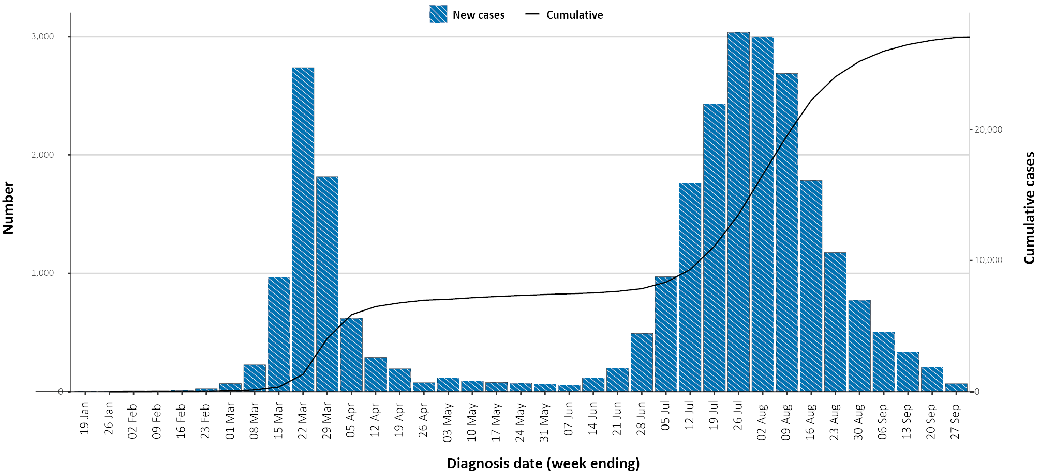
a Illnesses that began within 7 days prior to 27 September 2020 may not yet be reported and interpretation of trends during this period should be undertaken with caution.

Introduction
Coronavirus disease 19 (COVID-19), caused by the novel severe acute respiratory syndrome coronavirus 2 (SARS-CoV-2), was first identified in early January 2020. Subsequently, the disease spread rapidly, leading to a global pandemic.¹ The epidemiology of the disease in Australia has continued to evolve since the first detection of COVID-19 in Australia in late January 2020.
This report provides an overview of the COVID-19 epidemic in Australia, and compiles data from a variety of sources to describe cases and clusters, testing patterns, disease severity, public health response measures and the international situation. The report addresses indicators listed in the Australian National Disease Surveillance Plan for COVID-19,² which describes a national approach for disease surveillance for COVID-19 and its causative agent, SARS-CoV-2.

Australian cases: descriptive epidemiology

Transmission trends
Since the first case of COVID-19 was identified in Australia, all states and territories have reported cases of COVID-19, with some jurisdictions experiencing higher numbers and more community-associated transmission. These differences arise from factors including state demographics, population size, and patterns of overseas arrivals.
As at 27 September 2020, there were 27,095 COVID-19 cases including 835 deaths reported nationally, with two distinct peaks in March and July (Figure 2). During the current reporting period, there were 278 cases reported and 8 deaths. On average, 20 cases were notified each day over this reporting period, a decrease from the average of 60 cases reported per day over the previous reporting period. The majority of recently-diagnosed cases were from Victoria (82%; 229/278), followed by New South Wales (12%; 32/278). A small number of cases were reported in Western Australia (9), Queensland (6), and South Australia (2) (Figure 3). No new cases were reported in Tasmania, the Northern Territory or the Australian Capital Territory.

Figure 2. COVID-19 notifications, Victoria and all other jurisdictions, by source of acquisition and diagnosis week ending 27 September 2020
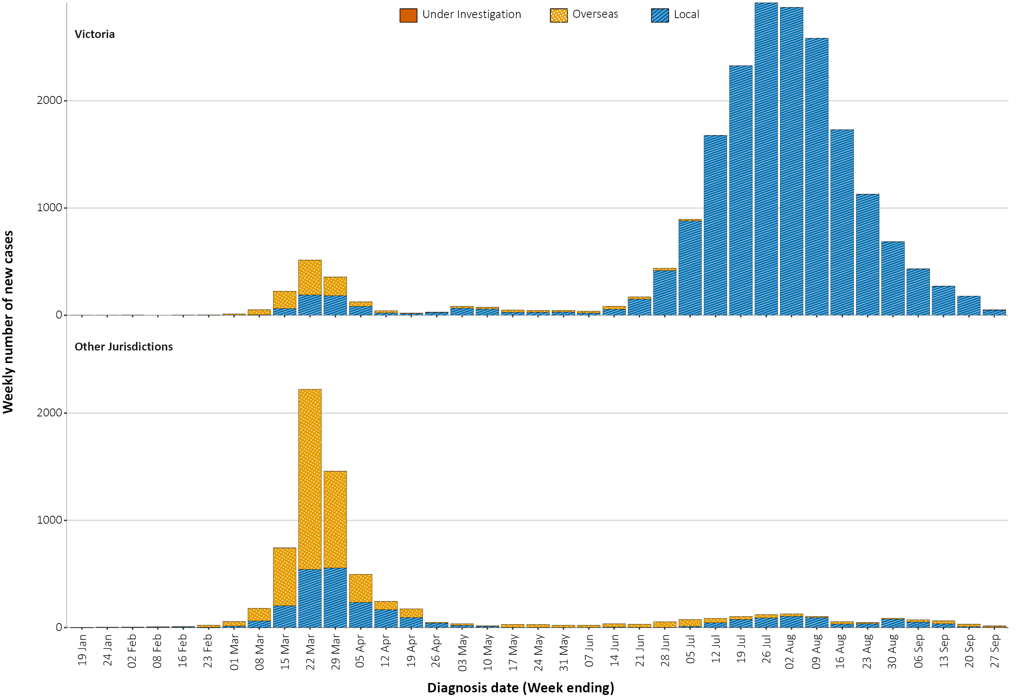

Figure 3. Heat map showing COVID-19 locally-acquired case notifications by place of residence, Australia, 14 to 27 September 2020^{a,b}
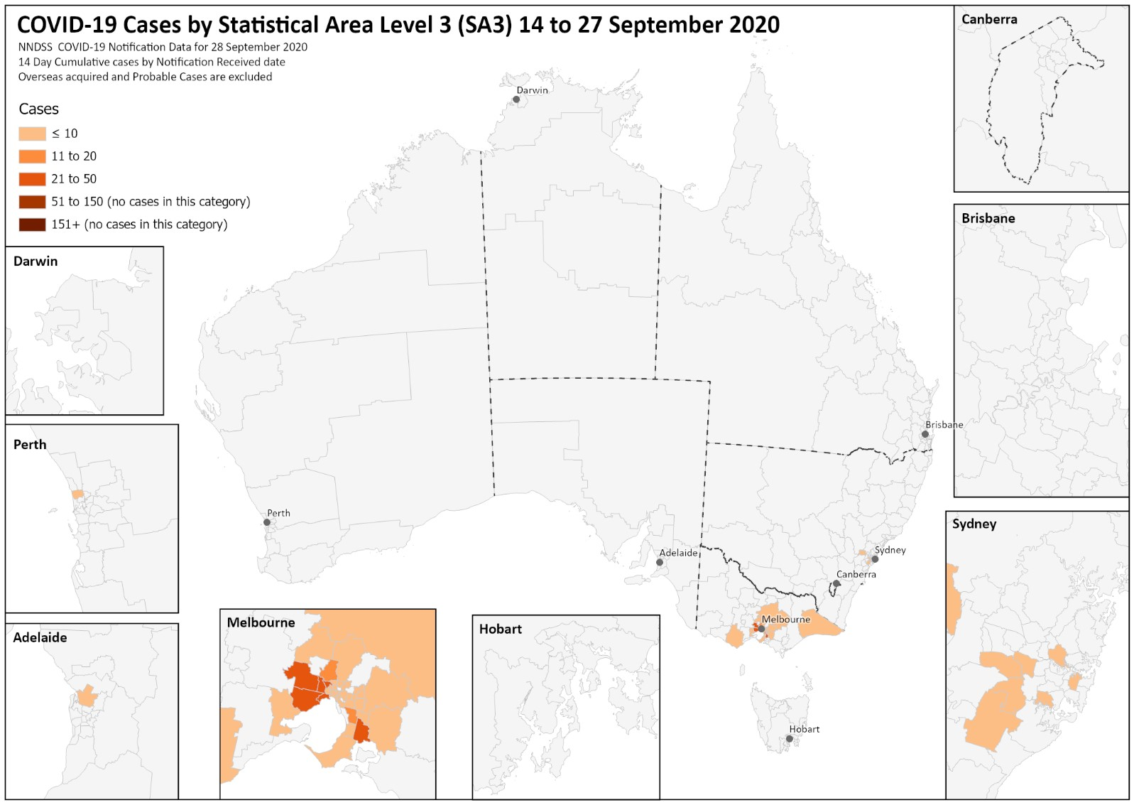
a Source: NNDSS.
b The allocation of a case to an SA3 area is based on a case’s postcode of Australian residence and does not necessarily represent the area where they acquired their infection, or were tested or managed. Cases that are overseas residents or acquired their infection overseas are not included in this mapping.

Source of acquisition
In this reporting period, 84% of all cases (234/278) were reported as locally acquired. The source of acquisition for 7% of these cases (16/234) could not be identified, which is lower than the previous reporting period (8%; 67/791). In total, 4% of cases reported this fortnight (10/278) remain under investigation and 12% (34/278) were reported as overseas acquired (Table 1).
Table 1. COVID-19 notifications by jurisdiction and source of acquisition, 14–27 September 2020
Source | NSW | Vic | Qld | WA | SA | Tas | NT | ACT | Australia
Overseas | 24 | 0 | 3 | 5 | 2 | 0 | 0 | 0 | 34
Local — source known | 6 | 210 | 1 | 1 | 0 | 0 | 0 | 0 | 218
Local — source unknown | 1 | 15 | 0 | 0 | 0 | 0 | 0 | 0 | 16
Under investigation | 1 | 4 | 2 | 3 | 0 | 0 | 0 | 0 | 10
Total | 32 | 229 | 6 | 9 | 2 | 0 | 0 | 0 | 278
In this reporting period, 82% of cases (229/278) were reported from Victoria, with 92% of these cases (210/229) reported as locally acquired with known source, 7% (15/229) as locally acquired with unknown source, and 2% (4/229) as under investigation (though likely locally acquired) (Table 1). In Victoria, the proportion of cases reported as under investigation at the end of each reporting period continues to decrease, and the proportion of cases considered to have an unknown source is also declining over time.
Excluding Victoria, for all other cases (49) in this reporting period, the majority of cases (65%; 32/49) were reported by New South Wales, and 18% (9/49) in Western Australia. Additionally, for cases outside Victoria: 16% (8/49) were reported as locally acquired with known source; 2% (1/49) as locally acquired with unknown source; 69% (34/49) as overseas acquired and 12% (6/49) as under investigation (Table 1).
Overseas-acquired cases were reported from New South Wales (24), Western Australia (5), Queensland (3) and South Australia (2). The higher number of cases reported in New South Wales reflects the number of returned travellers managed there. These proportions are similar to the previous reporting period with the majority of overseas-acquired cases undertaking quarantine in New South Wales before returning to home states or territories.
The national rate of infection in locally-acquired cases in the current reporting period was 0.9 cases per 100,000 population, which was a decrease from the rate observed in the previous reporting period (3.1 cases per 100,000 population, Table 2). In this reporting period, the rate of infection for locally-acquired cases in Victoria decreased from 10.7 per 100,000 population (previous reporting period) to 3.5 per 100,000 population.
Table 2. Locally-acquired COVID-19 case numbers and rates per 100,000 population by jurisdiction and reporting period, as at 27 September 2020
Jurisdiction | Reporting period  31 August - 13 September |  | Reporting period  14-27 September |  | Cumulative cases
Jurisdiction | Number of cases | Rate per 100,000 populationª | Number of cases | Rate per 100,000 populationª | Number of cases | Rate per 100,000 populationª
NSW | 66 | 0.8 | 8 | 0.1 | 1,902 | 23.5
Vic | 704 | 10.7 | 229 | 3.5 | 19,163 | 290.6
Qld | 20 | 0.4 | 2 | 0 | 300 | 5.9
WA | 0 | 0 | 1 | 0 | 103 | 3.9
SA | 1 | 0.1 | 0 | 0 | 151 | 8.6
Tas | 0 | 0 | 0 | 0 | 149 | 27.9
NT | 0 | 0 | 0 | 0 | 6 | 2.4
ACT | 0 | 0 | 0 | 0 | 28 | 6.6
Australia | 791 | 3.1 | 240 | 0.9 | 21,802 | 86
a Population data based on Australian Bureau of Statistics (ABS) Estimated Resident Population (ERP) as at 30 December 2019.
Cumulatively, the infection rate to date for all locally-acquired cases is highest in Victoria with 290.6 infections per 100,000 population. The rate of infection in Tasmania was 27.9 infections per 100,000 persons, largely as a result of the outbreak in North West Tasmanian hospitals in April 2020. Tasmania reported their most recent case in the fortnight ending 16 August 2020. This case was associated with interstate travel.

Demographics of cases
COVID-19 cases have affected people of all ages. In this reporting period, the largest number of cases occurred in those aged 20–29 years (64 cases), with the highest rate of infection for this period again occurring in those ≥ 90 years old (7.5 per 100,000 population). In the previous fortnight, the rate in those ≥90 years old was 21.3 cases per 100,000 population.
In this reporting period, rates were higher among females in the 10–19 years and 80–89 years age groups (Figure 4). Cumulatively, the male to female rate ratio is close to 1:1 across different age groups, except in the 20–29 years age group and those aged ≥ 80 years old where there is a higher rate among females (Figure 5). The largest difference in cumulative rates is in the ≥ 90 years age group where the cumulative rate among males is 335.2 cases per 100,000 population and among females 412.6 cases per 100,000 population (Appendix A, Table A.1).
Figure 4. New COVID-19 case notifications, cases, by age group and sex, Australia, 14 to 27 September 2020
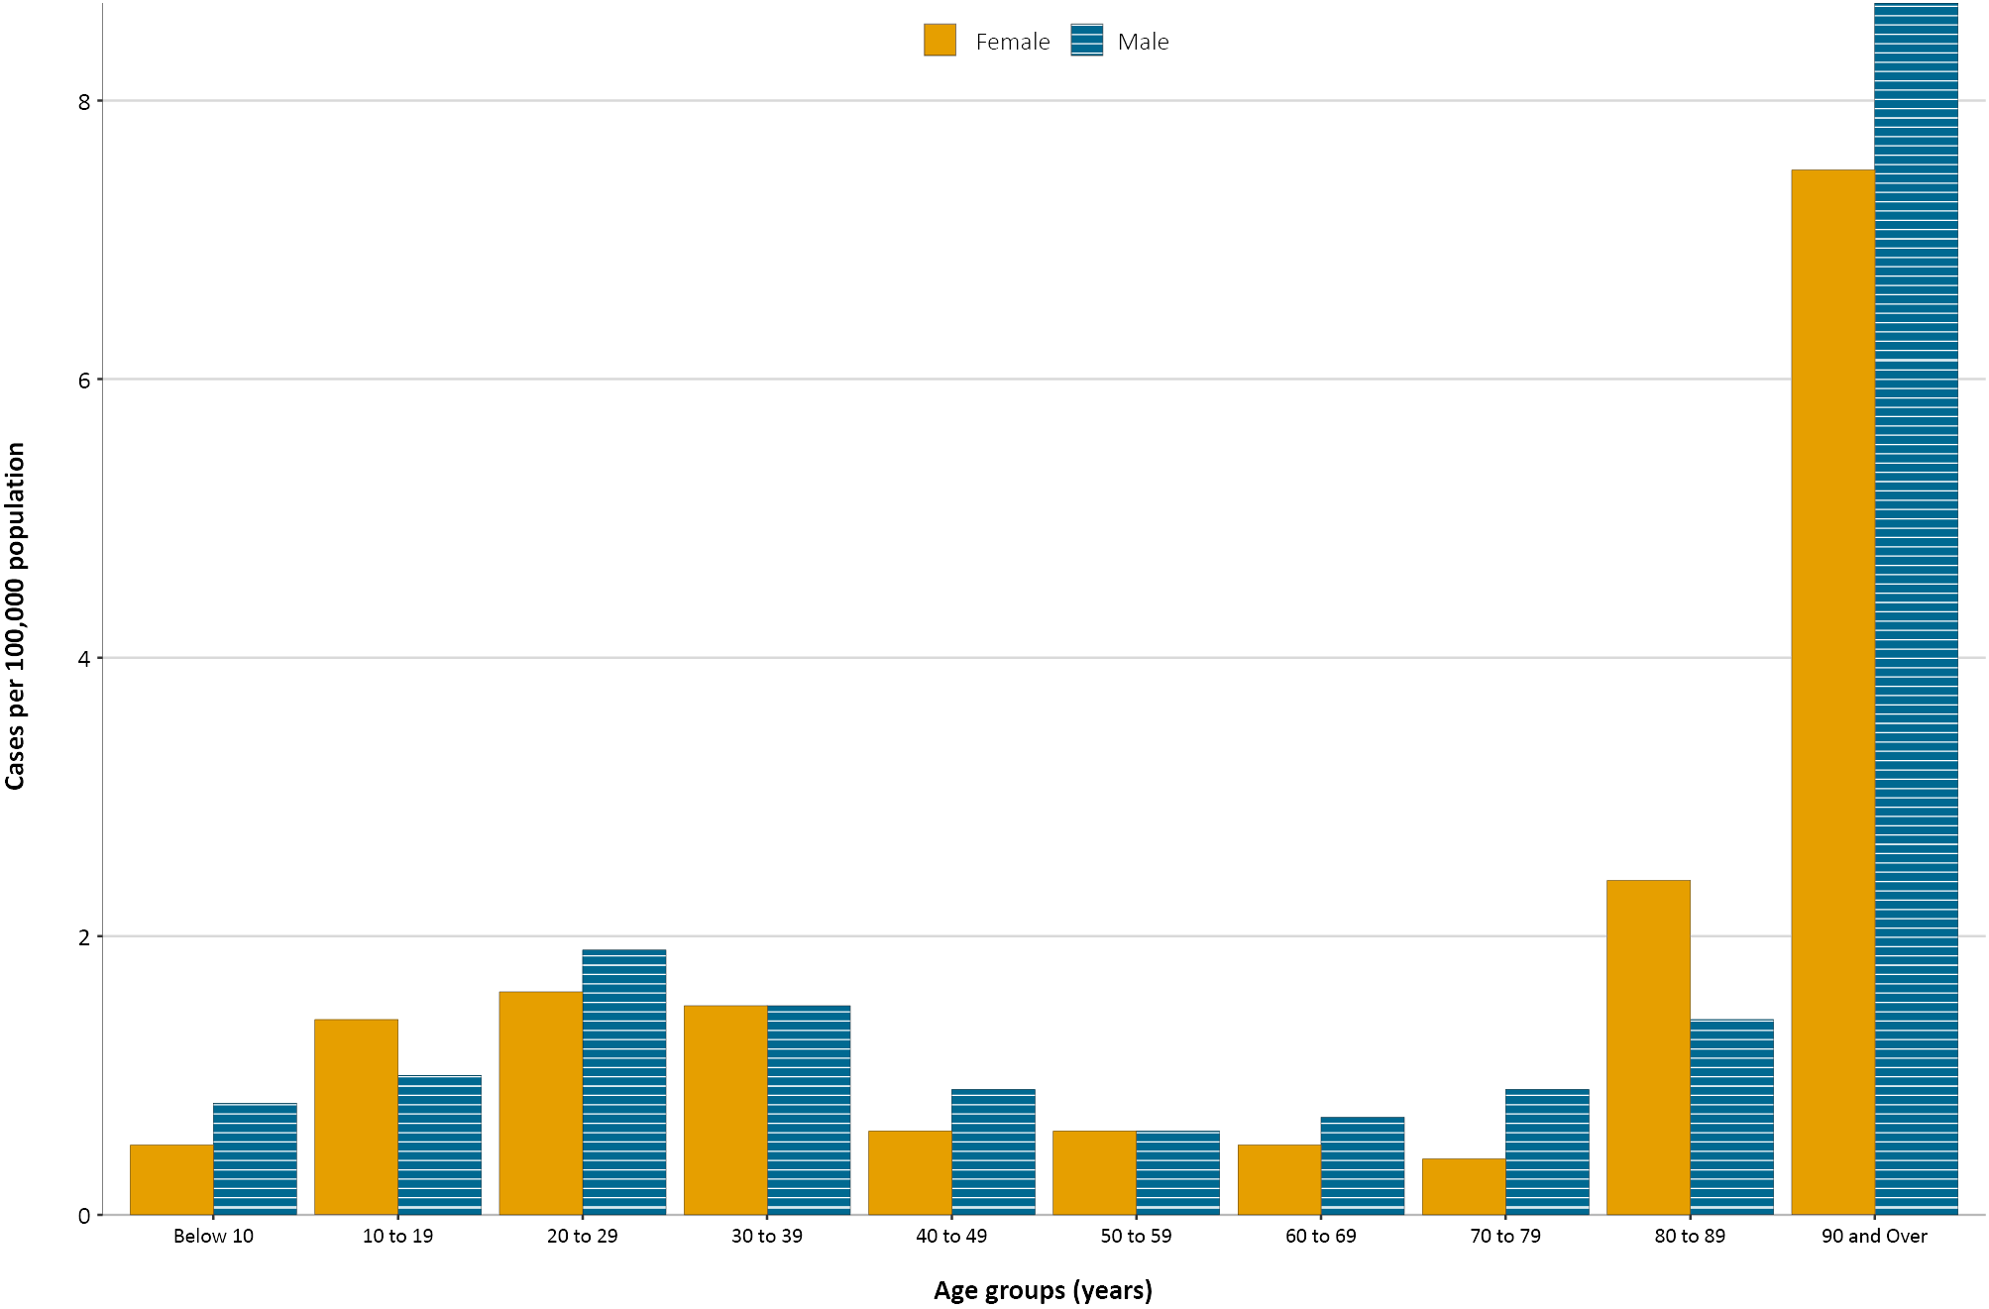

Figure 5. Cumulative COVID-19 cases, by age group and sex, Australia, 27 September 2020
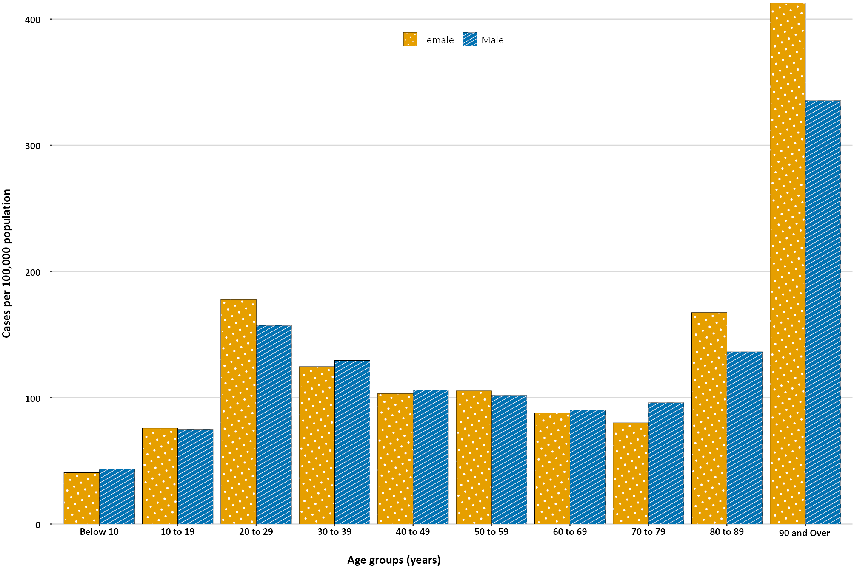
For all notifications to date, the highest rate of infection is in those ≥ 90 years old with a rate of 386.8 per 100,000 population (Appendix A, Table A.1). Children aged 0–9 years old have the lowest rate of infection (42.3 cases per 100,000 population), with testing rates comparable to other age groups.
Since the beginning of the epidemic in Australia, the cumulative median age of cases is 37 years old (interquartile range, IQR: 25–57) which has not changed since the beginning of August. Prior to 1 June 2020, the population diagnosed was slightly older, with a median age of 46 years old (IQR: 29–62), which was associated with a high proportion of cases having a recent travel history or acquisition on a cruise ship. In cases reported after 1 June 2020, the median age is 35 years (IQR: 23–54) reflecting wider transmission in the community and across a range of demographics and settings, especially in Victoria. The median age of cases in this reporting fortnight was 34 years (IQR: 22–53).

Aboriginal and Torres Strait Islander persons
There have been 148 cases of COVID-19 notified in Aboriginal and Torres Strait Islander persons since the beginning of the epidemic. This represents approximately 0.5% of all confirmed cases. Table 3 compares the remoteness of cases in Aboriginal and Torres Strait Islander persons with those in the Non-Indigenous population. While approximately 21% of all cases notified in Aboriginal and Torres Strait Islander persons (31/148) are reported as acquired overseas, no new overseas-acquired cases have been reported since the end of August. Recent cases have been reported as locally acquired, predominantly in Victoria. One case was reported as having a residential postcode in a remote/very remote area of Australia.
Table 3. COVID-19 notifications by Aboriginal and Torres Strait Islander status by jurisdiction, source of acquisition and remoteness classification, Australia, 27 September 2020
 | Locally-acquired |  |  |  | Interstate acquired | Overseas acquired | Unknownª | Total
 | Major Cities of Australia | Inner Regional Australia | Outer Regional Australia | Remote / Very Remote Australia
Aboriginal and  Torres Strait Islanderb | 90 | 15 | 6 | 1 | 4 | 31 | 1 | 148
Non-Indigenous | 20,148 | 895 | 219 | 20 | 152 | 5,262 | 251 | 26,947
a Includes 29 Non-Indigenous cases classified as overseas residents who were diagnosed in Australia, 222 Non-Indigenous cases and one Aboriginal and Torres Strait Islander case with an unknown remoteness classification.
b Excludes 1 probable Aboriginal and Torres Strait Islander case.
Figure 6. National COVID-19 notification rate per 100 000 population by age group, Aboriginal and Torres Strait Islander persons and Non-Indigenous persons, Australia, 27 September 2020
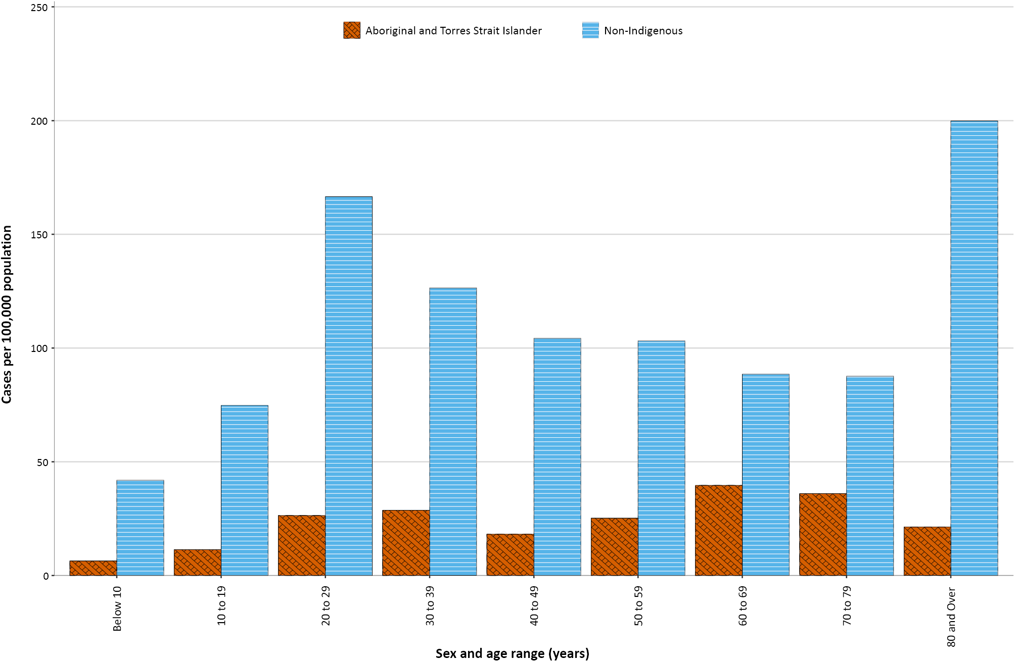
The median age of COVID-19 cases in Aboriginal and Torres Strait Islander persons was 32 years (IQR: 21–50), which was younger than for non-Indigenous cases where the median age was 37 years (IQR: 25–57).
The notification rate across all age groups was higher in Non-Indigenous persons than in Aboriginal and Torres Strait Islander persons. Amongst Aboriginal and Torres Strait Islander cases, the highest notification rate was in those aged 60–69 years (39.6 cases per 100 000 population), followed by the 70–79 years age group (36.0 cases per 100 000 population). Similar to Non-Indigenous cases, children aged 0–9 years had the lowest notification rate for Aboriginal and Torres Strait Islander cases (6.4 cases per 100 000 population).

Severity
The current estimated hospitalisation rate for confirmed COVID-19 cases to date in Australia remains at 13%. While this estimate comes with caveats around data completeness and definitional uniformity across jurisdictions, an earlier hospital-notification data linkage study for NSW cases found a similar proportion (12.4% of cases notified to 19 April hospitalised).³ Internationally, hospitalisation rates for COVID-19 positive cases are comparable to Australia with Canada reporting 12% of cases hospitalised (11,511/95,704)⁴ and the United States of America (USA) also recording 12% (cases hospitalised between 12 February – 16 March, 2020).⁵
Data from Australia’s sentinel surveillance system for severe respiratory illnesses, the Influenza Complications Alert Network (FluCAN),⁶ was analysed for this report. Since 16 March 2020, FluCAN has recorded 422 COVID-19 cases that were hospitalised, of which 87 (21%) were subsequently admitted to an intensive care unit (ICU). This is similar to the ICU admission rate amongst hospitalised patients in Canada (2,288/11,511; 20%)⁴ and the United Kingdom (3001/18,183; 17%).⁷

Length of hospital stay
Length of hospital stay for patients with confirmed COVID-19 increases with advancing age category: those ≥ 80 years old stayed the longest (Table 4). A study in the United Kingdom also found length of stay in hospital for COVID-19 patients generally increased with age.⁷ Overall, for hospitalised COVID-19 patients discharged between 16 March and 27 September 2020, the average length of hospital stay was 9.5 days (median 7 days; IQR: 3–13).
Table 4: Hospital length-of-stay for confirmed COVID-19 cases discharged alive from sentinel sites by ICU/high dependency unit (HDU) admission status, Australia, as at 27 September 2020
 | Hospital length of stayª |  |  | ICU length of stay^{b}
Age group (years) | n | Median (IQR) | Mean (SD) | n | Median (IQR) | Mean (SD)
< 18 | 31 | 2.0 (1.0–6.0) | 4.0 (4.7) | 6 | 9.0 (4.0–25.0) | 16.7 (19.3)
18–39 | 61 | 4.0 (2.0–8.0) | 6.5 (6.8) | 48 | 7.0 (5.0–11.0) | 9.4 (10.2)
40–59 | 87 | 8.0 (4.0–13.0) | 11.3 (17.2) | 145 | 12.0 (8.0–20.0) | 17.5 (16.5)
60–79 | 73 | 8.0 (5.0–15.0) | 10.9 (8.0) | 173 | 19.0 (10.0–31.0) | 23.6 (17.7)
≥ 80 | 35 | 11.0 (7.0–16.0) | 11.9 (7.0) | 7 | 13.0 (6.0–18.0) | 15.0 (10.8)
a Source: FluCAN (n = 287).
b Source: Short Period Incidence Study of Severe Acute Respiratory Infection Study (SPRINT-SARI)8 – includes 77 sentinel ICU/HDUs and only those with discharge outcome (n = 379).
Length of stay in ICU for survivors (n = 379) ranged from 0 to 79 days (median 6; IQR: 3–13) which is shorter than indicated in recent data from the United Kingdom (median 12 days; IQR 5–28).⁹ Non-survivors stayed a median of 10 days in ICU (IQR: 5–20); this is similar to that reported in the same UK study (median 9 days; IQR: 5–160).⁹ Both ICU and hospital median length of stays were increased during the two most recent reporting periods (31 August – 27 September 2020) compared to the two previous reporting periods (3–30 August 2020) (Table 5). This may reflect the higher representation of the older population in the distribution of recent cases.
Table 5: Hospital and ICU length of stay over time based on those discharged during the reporting periods specified, Australia, as at 27 September 2020ª
Length of Stay | Two previous reporting periods  3—30 August |  |  | Current two reporting periods  31 August — 27 September |  |  | Cumulative data to date  27 February – 27 September
Length of Stay | n | Median (IQR) | Mean (SD) | n | Median (IQR) | Mean (SD) | n | Median (IQR) | Mean (SD)
Hospital^{b} | 69 | 7.0(3.0–11.0) | 10.7(18.2) | 29 | 12.0(7.0–17.0) | 12.2(7.4) | 287 | 7.0(3.0–13.0) | 9.5 (11.4)
ICU^{c} | 109 | 4.0(2.0–9.0) | 7.1(78.0) | 38 | 7.0(4.0–15.0) | 11.2(11.1) | 379 | 6.0(3.0–13.0) | 10.1(12.0)
a Data over two reporting periods has been used to reduce the impact of small numbers on metric volatility.
b Source: FluCAN.
c Source: Sprint-Sari.

Characteristics of those with severe COVID-19 disease
Increased age and comorbidities are associated with higher disease severity, as indicated by hospitalisation, admission to ICU, and death. The median ages of cases who were hospitalised in sentinel sites (58 years; IQR: 39–74) and admitted to ICU (61 years; IQR: 50–70) were higher than for cases overall (37 years; IQR: 25–57). The ratio of males to females was similar in hospitalised cases (1.2:1); however, substantially more males were admitted to ICU (ratio: 1.7:1). For ICU-admitted COVID-19 patients, the male:female ratio increased with advancing age (Figure 7), while in hospitalised patients, there were more females than males admitted in the over 80 years age category.

Figure 7. Age and sex distribution for COVID-19 cases admitted to hospital (16 March – 27 September 2020)ª or admitted to ICU (27 February – 27 September 2020),^{b} Australia
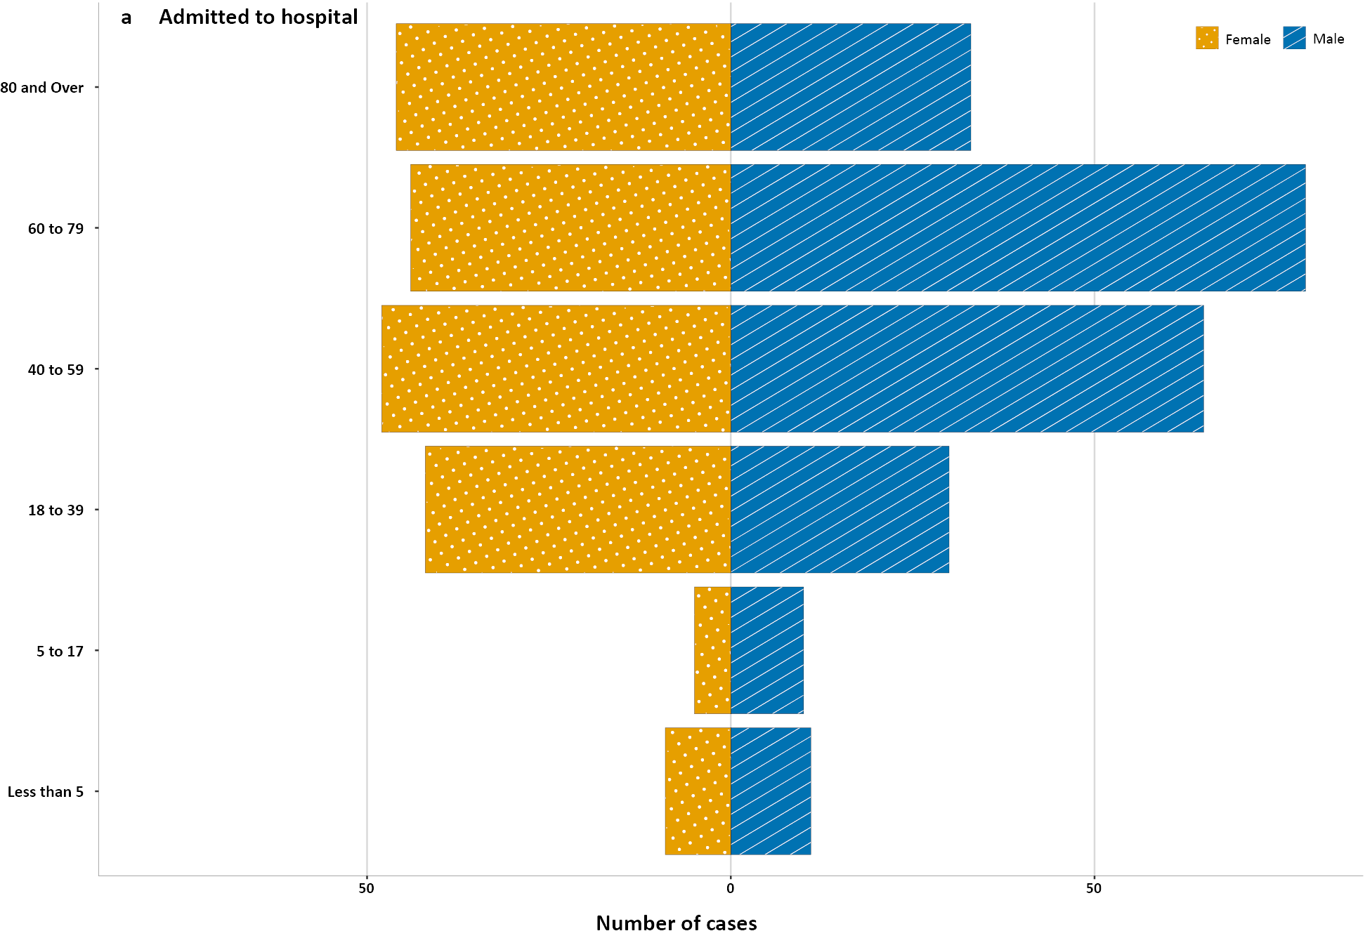
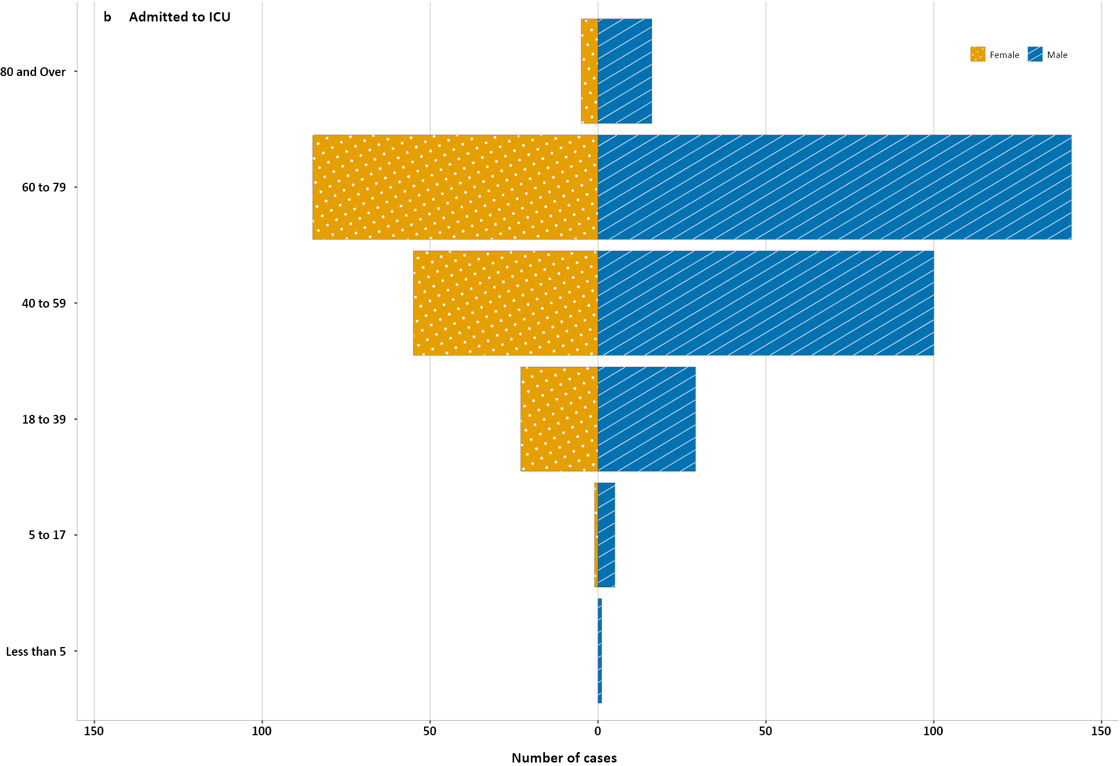
a Source: FluCAN (n = 422).
b Source: SPRINT-SARI (n = 466).
Of all those hospitalised (n = 423), fewer than ten (< 1.5%) identified as Aboriginal and/or Torres Strait Islander persons.

Underlying medical conditions and other risk factors
There is evidence that people with comorbid conditions may experience a higher risk of severe COVID-19 disease. In May 2020, the American Medical Association (AMA) released a list of comorbidities for which such evidence had emerged which included: hypertension; diabetes; cardiovascular disease; respiratory disease; and cerebrovascular disease.¹⁰ Comorbidity status was not always available: 114 cases (29%) recorded in FluCAN had missing comorbidity information. The surveillance data in this section reflects information on hospitalised patients only, meaning that it may not be generalisable to all cases.
Obesity (defined as a body mass index > 30), which was prevalent amongst those who died from COVID-19 while in ICU (29%), has also been flagged as a risk factor (supported by growing evidence) for a worse outcome from COVID-19 infection.^{11,12} In Australian hospitalised patients, the most prevalent comorbidity was cardiac disease (36%; Table 6), which is similar to its prevalence among hospitalised cases in the UK (30.9%).⁷ Diabetes was also common across both levels of hospitalisation and amongst those who died while in hospital (45%). Mortality rates by comorbidity amongst those admitted to ICU increased with rising numbers of comorbidities. The highest case fatality rate (CFR) of all comorbidities was for those with a malignancy (47%) closely followed by those with chronic renal disease (42%). A history of smoking, either as a current or past smoker, was identified where data were available in 35% (108/310) of those hospitalised and 13% (52/408) of those admitted to an ICU.

Table 6: Comorbidities for adult COVID-19 cases (> 18 years) amongst those hospitalised, those admitted to ICU and those who have died in ICU from COVID-19 and mortality rates case fatality rate, CFR by comorbidity, Australia, as at 27 September 2020.
Comorbidity | Hospitalised casesª  (n = 274)  (%) | ICU cases^{b}  (n = 423)  (%) | In-ICU deaths^{c}  (n = 55)  (%) | Case fatality amongst those admitted to ICU admitted^{b}  (n = 55)  (%)
Cardiac disease | 99 (36) | 63 (15) | 19 (34) | 19 (32)
Chronic respiratory condition^{c} | 80 (30) | 85 (20) | 15 (27) | 15 (19)
Diabetes | 93 (34) | 128 (30) | 24 (43) | 24 (20)
Obesity | 57 (23) | 109 (26) | 16 (29) | 16 (16)
Chronic renal disease | 21 (8) | 26 (6) | 10 (18) | 10 (42)
Chronic neurological condition | 78 (29) | 6 (1) | 2 (4) | 2 (33)
Malignancy | 26 (10) | 24 (6) | 11 (20) | 11 (47)
Chronic liver disease | 12 (5) | 15 (4) | 5 (9) | 5 (33)
Immunosuppression | 36 (14) | 29 (7) | 10 (19) | 10 (37)
Number of specified comorbidities^{d}
One or more | 234 (85) | 268 (63) | 46 (84) | 51 (18)
Two or more | 128 (47) | 138 (33) | 34 (62) | 39 (23)
Three or more | 49 (18) | 53 (13) | 19 (35) | 24 (28)
No comorbidities | 40 (15) | 155 (37) | 9 (16) | 9 (6)
a Source: FluCAN. Excludes those with missing data (114 (29%)) or where comorbidity is unknown (0.5–2.3%).
b Source: SPRINT-SARI. Excludes those with missing data (40 (8.7%)) on comorbidities or where comorbidity is unknown (0–2.0%).
c Includes asthma.
d Includes chronic respiratory conditions, cardiac disease (excluding hypertension), immunosuppressive condition/therapy, diabetes, obesity, liver disease, renal disease and neurological disorder.

COVID-19 deaths
Overall, the crude case fatality rate (3.1) has increased since epidemiology report 24 (to 30 August 2020) when it was 2.2% (Table 7).¹³ This is likely due to the age of those infected more recently. Of all cases, the highest proportion of deaths has occurred in males aged over 80 years. The CFR rises to 76.9% for males of the same age range admitted to ICU. The CFR is 12% amongst all cases hospitalised in FluCAN hospital sentinel sites since 16 March 2020. While there are vast differences in the course of the COVID-19 epidemics in different countries, the current Australian CFR among hospitalised cases is much lower than that of 29% (72,020/372,788; data from 21 countries) observed in European hospitalised cases.¹⁴ Overall mortality rates among those discharged from ICU with confirmed COVID-19 (CFR = 12.8%; 59/423) in Australia are also substantially lower than those reported internationally. In the UK, the non-survival rate amongst those admitted to ICU was recently reported as 39% (data to 30 August, 2020).⁹
Table 7: Number of fatalities and CFR for all cases, hospitalised cases and cases admitted to ICU, by age group and gender, Australia, at 27 September 2020
 | All casesª  n (CFR) |  |  | Hospitalisation^{b}  n (CFR) |  |  | ICU^{c}  n (CFR)
 | Male | Female | Persons | Male | Female | Persons | Male | Female | Persons
Total | 406 (3.1) | 429 (3.1) | 835 (3.1) | 22 (13.3) | 17 (10.6) | 39 (12.0) | 44 (15) | 15 (8.9) | 59 (12.8)
< 50 | 5 (0.1) | 0 (0.0) | 5 (0.03) | 0 (0.0) | 0 (0.0) | 0 (0.0) | 2 (3.0) | 0 (0.0) | 2 (1.8)
50–64 | 19 (0.9) | 9 (0.4) | 28 (0.6) | 1 (2.7) | 0 (0.0) | 0 (1.5) | 9 (9.6) | 3 (5.6) | 12 (8.1)
65–79 | 110 (8.4) | 58 (4.8) | 168 (6.7) | 6 (16.7) | 2 (7.7) | 8 (22.9) | 23 (23) | 9 (14.8) | 32 (19.9)
80 + | 272 (37.9) | 632 (27.4) | 634 (31.1) | 15 (50.0) | 14 (41.2) | 29 (45.3) | 10 (76.9) | 3 (60.0) | 13 (72.2)
a Source: NNDSS. (Total cases = 27,011).
b Source: FluCAN. Includes 21 sentinel hospitals (total cases = 325).
c Source: SPRINT-SARI. Includes 77 sentinel ICU/HDUs and only those with discharge outcome (n = 440).

Clusters and outbreaks
For the fortnight ending 27 September 2020, there were 55 open outbreaks, which were defined as those where a new epidemiologically-linked case was identified in the previous 14 days. Of these, 85% (47/55) were reported in Victoria; 7% (4/55) in New South Wales; 4% (2/55) in Queensland; 2% (1/55) in Western Australia; 2% (1/55) was a multijurisdictional outbreak. Outbreaks were reported most frequently from residential aged care settings (32) followed by hospitals (7) and workplaces (7). Outbreaks ranged in size, with the largest outbreak encompassing 260 cases in a residential aged care facility. Prominent workplace settings included hospitals, a meat rendering plant, a police branch, and a cargo ship.
Residents of aged care facilities are at increased risk of COVID-19 infection due to the environment of communal living facilities. They are also more vulnerable to serious complications if they do become infected. As at 27 September 2020, there have been 4,265 cases of COVID-19 associated with 222 residential aged care facilities, with 3,450 recoveries and 654 deaths. Of these cases, 2,049 occurred in aged care residents, with the remaining 2,216 cases occurring in care staff. The Commonwealth is actively supporting services with reported incidents and outbreaks of COVID-19, providing access to personal protective equipment and additional staffing resources where required. Advice and guidelines have been provided to aged care services, including the release of an outbreak management guide.^{15,16}

Testing
As at 27 September 2020, a total of 7,546,223 tests have been conducted in Australia. The cumulative nationwide proportion of positive tests remains low at less than 0.4% (Table 8). With the exception of Victoria, the cumulative testing positivity in individual jurisdictions is lower than 0.3%.

Table 8. Diagnostic tests performed, by jurisdiction, Australia, 27 September 2020ª
Jurisdiction | Tests performed 31 August – 13 September |  |  | Tests performed 14–27 September |  |  | Cumulative tests performed to 27 September
 | N | Positivity (%) | Per 100,000 population ^{a,b} | N | Positivity (%) | Per 100,000 population ^{a,b} | N | Positivity (%) | Per 100,000 population ^{a,b}
NSW | 279,862 | 0.05 | 3,461 | 191,554 | 0.03 | 2,369 | 2,672,392 | 0.16 | 33,052
Vic | 214,684 | 0.4 | 3,256 | 173,216 | 0.18 | 2,627 | 2,661,989 | 0.76 | 40,371
Qld | 133,974 | 0.02 | 2,631 | 75,066 | 0.01 | 1,474 | 1,097,964 | 0.11 | 21,560
WA | 46,441 | 0.01 | 1,771 | 38,793 | 0.01 | 1,480 | 461,796 | 0.1 | 17,613
SA | 39,880 | 0.01 | 2,276 | 32,888 | 0.05 | 1,877 | 410,171 | 0.16 | 23,407
Tas | 7,835 | 0 | 1,466 | 7,152 | 0 | 1,338 | 102,279 | 0.22 | 19,132
NT | 5,575 | 0 | 2,265 | 5,526 | 0 | 2,245 | 46,478 | 0.07 | 18,886
ACT | 12,247 | 0 | 2,874 | 5,938 | 0 | 1,393 | 93,154 | 0.12 | 21,859
Australia | 740,498 | 0.14 | 2,920 | 530,133 | 0.08 | 2,091 | 7,546,223 | 0.36 | 29,759
a Data in this table are based on reports of notification by states and territories.
b Population data based on Australian Bureau of Statistics (ABS) Estimated Resident Population (ERP) as at 30 December 2019.
During this reporting period 530,133 tests were conducted nationally, with a positivity rate of 0.08%. This represents a 40% decrease in testing numbers compared to the last reporting period. Jurisdictional testing rates are driven by both current case numbers and numbers of people experiencing symptoms. Testing rates have decreased to 10.4 tests per 1,000 population per week during this reporting period, from a peak of 19.4 tests per 1,000 population per week in early August. All states except Victoria reported a positivity rate of 0.05% or lower. Victoria reported a positivity rate of 0.18%, which is a decrease from the previous reporting period (0.40%). The low national positivity rate, along with high rates of testing, suggests an overall low prevalence of COVID-19 nationally.
For the fortnight ending 25 September 2020, testing rates continued to decline across all age groups (Figure 8). Testing rates were lowest in those aged 0–19 years.

Figure 8. SARS-CoV-2 (PCR) testing rates per 1,000 population per week by age group,^{a,b} Australia, 1 May to 25 September 2020
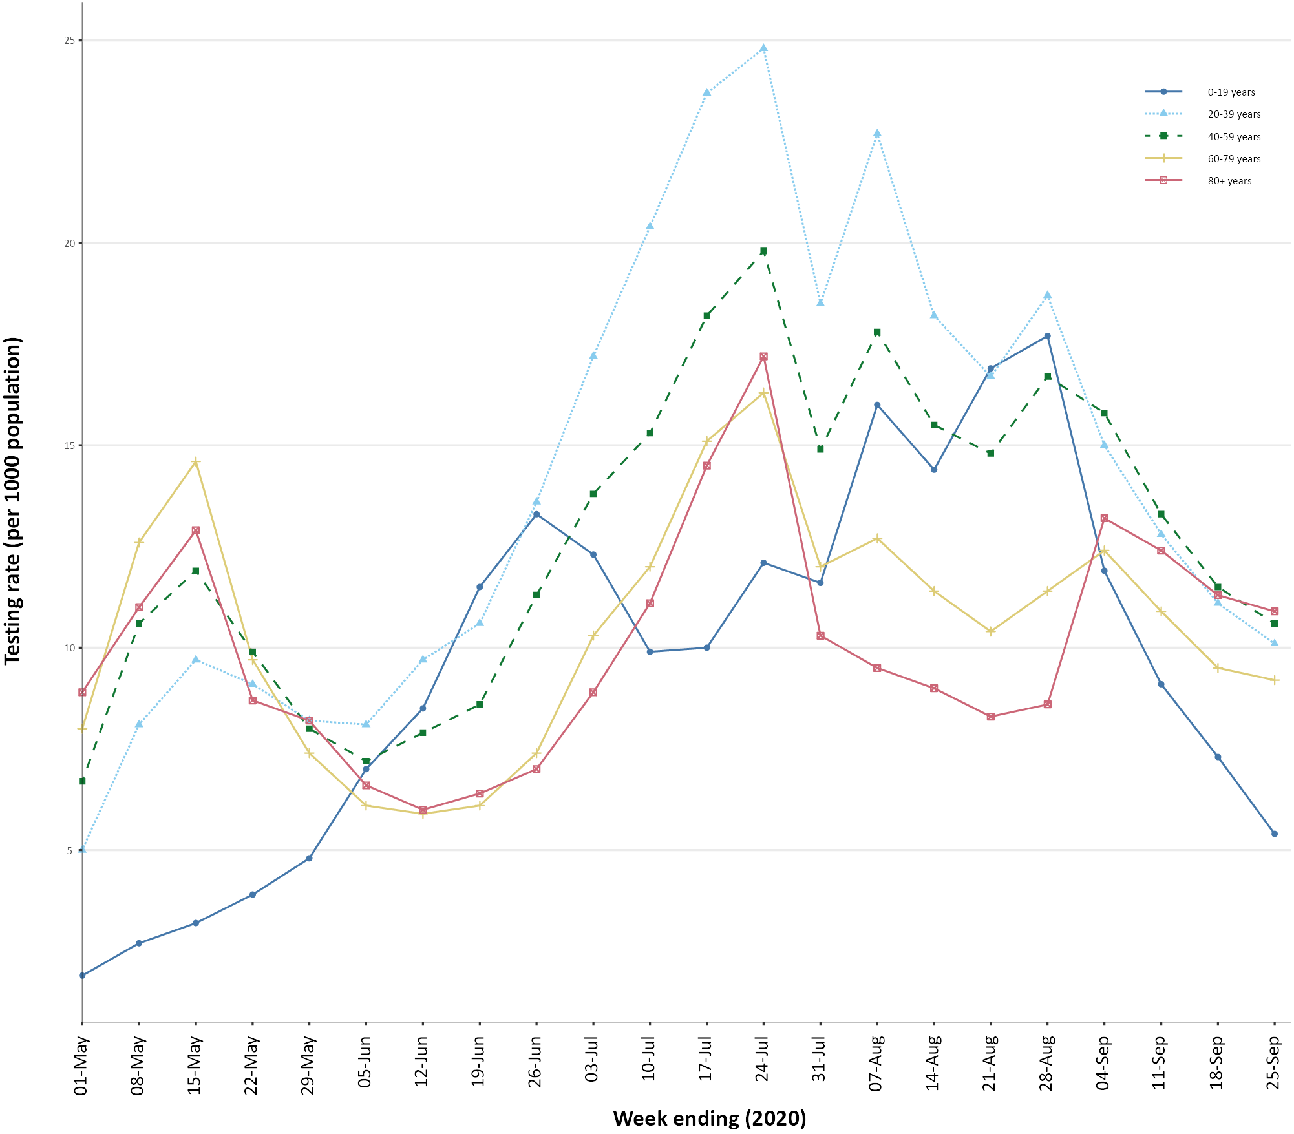
a Data provided by jurisdictions to the National Incident Room (NIR) weekly.
b The jurisdictions reporting each week (i.e. the denominator population) may vary.

Viral genomics
There are currently 7,418 SARS-CoV-2 genome sequences available from Australian cases on the global sequence repository, GISAID.¹⁷ These sequences are dispersed throughout the global lineages, reflecting multiple concurrent introductions into Australia.^{1,18,19} Recent Australian SARS-CoV-2 sequences collected during the reporting period include 58 collected from New South Wales. All of these sequences belong to the B.1.1.25 lineage, reflecting ongoing local transmission of this lineage.

Acute respiratory illness surveillance
Evidence to date suggests that COVID-19 is mild in approximately 80% of cases. The most common symptoms are consistent with an acute respiratory illness (ARI) and/or influenza-like illness (ILI). Surveillance systems and programs have been established to monitor trends in the number of people reporting symptoms of mild respiratory illnesses in the community and in primary care settings. These systems gather information from across Australia and include the online FluTracking syndromic surveillance system,²⁰ the Commonwealth general practice (GP) Respiratory Clinics, and the ASPREN and VicSPIN GP sentinel surveillance systems. These systems monitor reports of any respiratory illness experienced by participants, including but not limited to pathogens such as SARS-CoV-2. Based on self-reported FluTracking data, fever and cough in the community continues to be low nationally, five-fold lower than the historical average for this time of year (Figure 9). Runny nose and sore throat symptoms in the community have increased this reporting period.
Figure 9. Weekly trends in respiratory illness amongst FluTracking survey participants (age-standardised), weeks ending 1 March to 11 October in 2020 and previous five yearsª
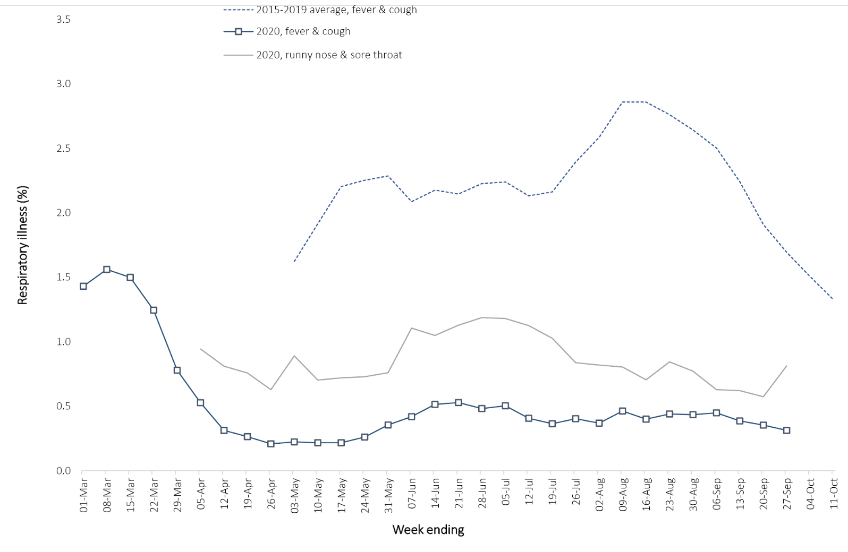
a FluTracking historically was active during the traditional Influenza season from May to October. In 2020, FluTracking commenced 10 weeks early in response to COVID-19. Data on runny nose and sore throat were only collected systematically after 29 March 2020, therefore a historical average for this symptom profile is unavailable.
Acute respiratory illness was highest in those 0–9 and 30–39 years of age, based on both self-reported FluTracking data and presentations to Commonwealth Respiratory Clinics. Females reported respiratory illness more frequently than males. Rates of fever and cough by jurisdiction were generally stable compared to the previous fortnight, ranging from 0.7/1,000 FluTracking participants in Victoria to 4.2/1,000 participants in the Northern Territory.
Based on data from FluTracking, 46% of those in the community with ‘fever and cough’ and 20% of those with ‘runny nose and sore throat’ reported being tested for SARS-CoV-2. Testing rates varied by jurisdiction, being lowest in Western Australia and the Northern Territory and highest in New South Wales and Victoria. It is important to acknowledge that there may be legitimate reasons why people do not get tested, including barriers to accessing testing. Symptoms reported to Flutracking are not specific to COVID-19 and may also be due to chronic diseases.
Testing rates in those that presented to the Commonwealth Respiratory Clinics (38,100 assessments over the reporting period) were over 95%. The positivity of SARS-CoV-2 tests conducted at Commonwealth Respiratory Clinics reduced from 0.05% in the previous reporting period to 0.01% in this reporting period.
The rate of self-reported fever and cough among Aboriginal and Torres Strait Islander peoples over the reporting fortnight was double that observed in all other participants based on FluTracking data, which is consistent with trends observed in previous weeks.
Rates of respiratory illness in health care worker populations were similar to those observed in the wider community, based on FluTracking data.
Based on all presentations to Commonwealth Respiratory Clinics to date, the principal symptoms reported in COVID-19 cases were cough (41%), sore throat (32%), tiredness (27%), runny nose (24%), and fever (19%) (Figure 10).
Figure 10. Symptom profile among people presenting to Commonwealth Respiratory Clinics for COVID-19 cases versus non-COVID-19 presentations, Australia, 27 September 2020
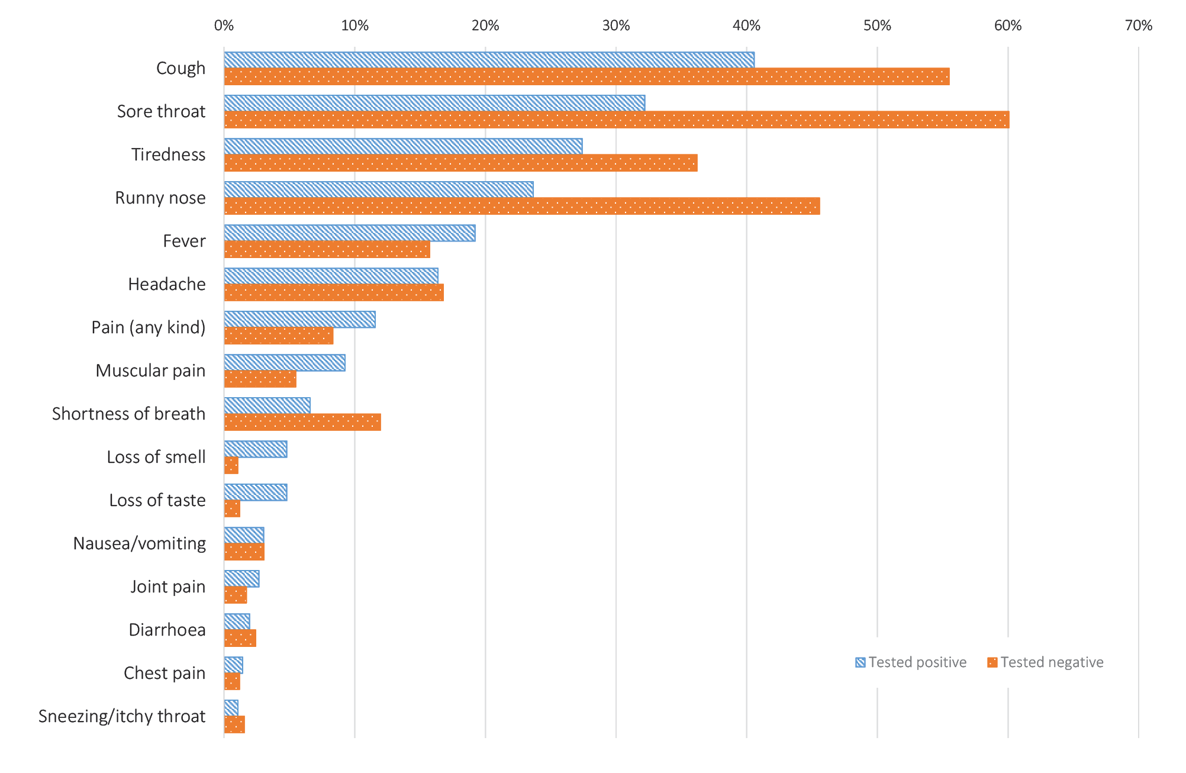

Public health response measures
Since COVID-19 first emerged internationally, Australia has implemented public health measures informed by the disease’s epidemiology (Figure 11). On 8 May, the Australian Government announced a three-step framework for easing COVID-19 restrictions. Building on this framework, on 4 September, the Australian Government announced a plan to develop a ‘Roadmap for Recovery’ to reopen by Christmas.²¹ States and territories ease restrictions at their own pace depending on the local public health and epidemiological situation (Table 9). During the current reporting period, Victoria has continued to progress through its ‘roadmap to reopening’ in response to declining case numbers.
Table 9. State and territory changes to COVID-19 restrictions, Australia, 14–27 September 2020
Jurisdiction | Summary of changes to COVID-19 restrictions
New South Wales | From 24 September the following restrictions were eased:²²  - Restrictions on school music, formals, and sport eased.  - Up to 150 permitted for weddings, up to 20 may dance.  - Up to 100 permitted in places of worship.  - Auctions and open house viewings restrictions eased.
Victoria | From 16 September, regional Victoria moved to step 3 easing of restrictions:²³  - No restrictions on reasons to leave home  - No restrictions on travel within regional Victoria  From 27 September, metropolitan Melbourne moved to step 2 easing of restrictions:²⁴  - Up to 5 people from two households permitted to gather outdoors  - Exercising and socialising permitted for two hours per day  - A planned staged return to onsite learning for schools
Queensland | From 25 September the following restrictions were eased:²⁵  - No Local Government Areas listed as Queensland COVID-19 restricted areas  - Gatherings of up to 30 permitted in private houses and public spaces
Western Australia | No further easing of restrictions during this reporting period.²⁶
South Australia | From 16 September, people entering South Australia from the Australian Capital Territory no longer required to undergo quarantine.²⁷  From 24 September, people entering South Australia from New South Wales no longer required to undergo quarantine.²⁷
Tasmania | No further easing of restrictions has occurred during this reporting period.²⁸
Australian Capital Territory | From 18 September the following restrictions were eased:²⁹  - Smaller venues and businesses to return to pre-COVID capacity (maximum of 25 persons)
Northern Territory | No further easing of restrictions has occurred during this reporting period.³⁰

Figure 11. COVID-19 notifications in Australia by week of diagnosis and jurisdiction to 27 September 2020 with timing of key public health measures
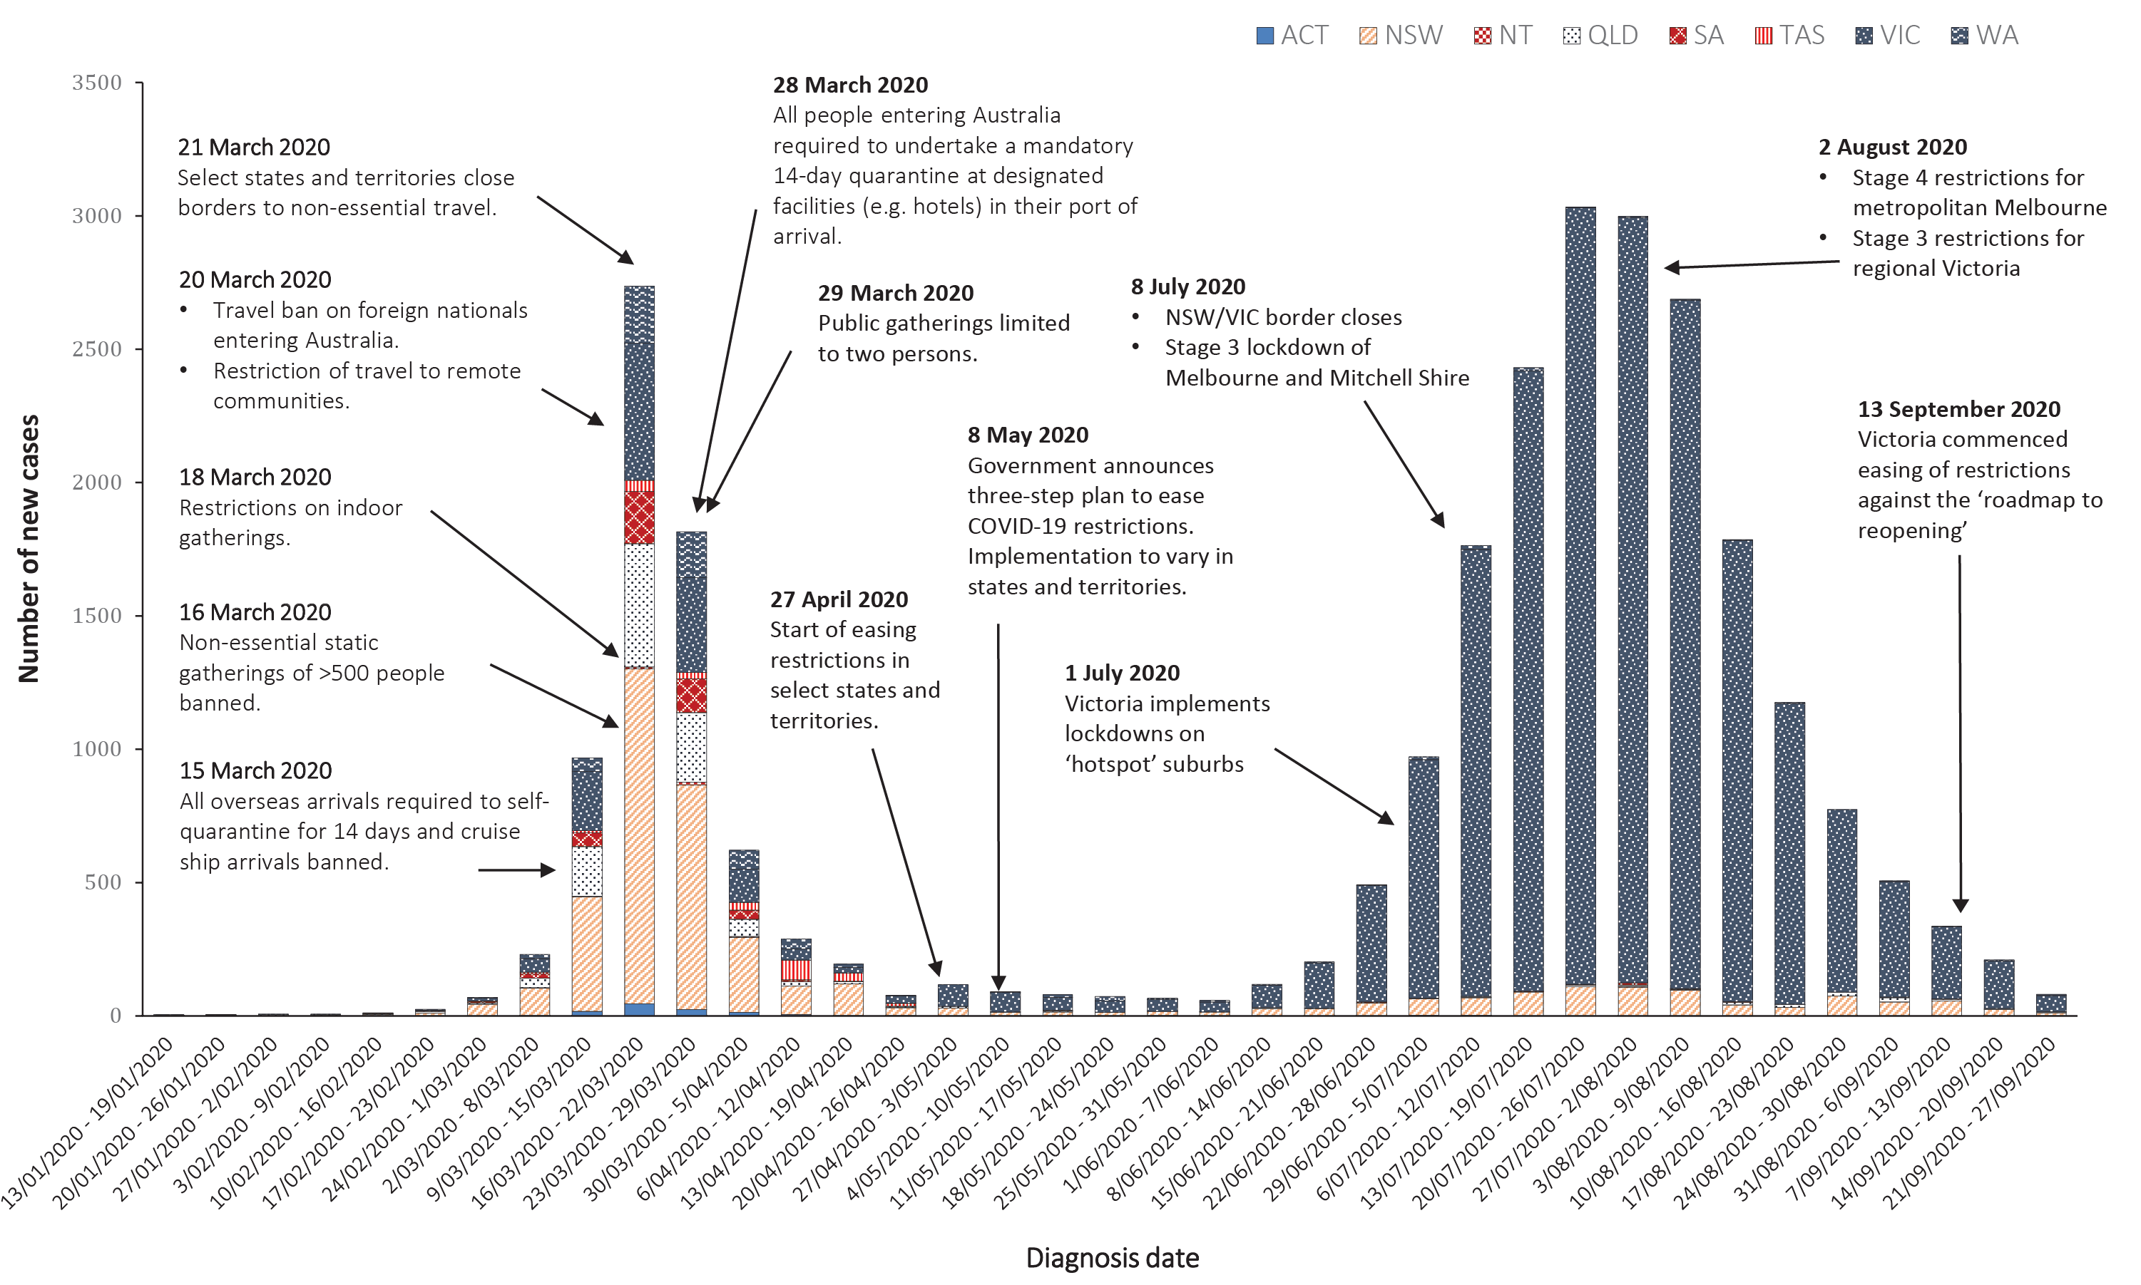

International situation
All data reported below were extracted from the World Health Organization (WHO) Dashboard on 28 September 2020 unless otherwise specified.³¹
On 27 September 2020, more than 215 countries, regions and areas had reported 32,730,204 COVID-19 cases and 991,211 deaths to the WHO, representing a 14.1% increase in global cases and an 8.1% increase in deaths in the past fortnight. Globally, the number of new cases has been relatively stable since late July, noting variability by region.
In this reporting period, regions reporting the largest proportions of global new cases were the Americas (38%, a decrease from 42%), South East Asia (33%, a decrease from 35%), and Europe (20.2%, an increase from 14.9%) indicating that Europe’s burden of global cases is proportionally increasing. Europe has experienced an increase of 16.9% in fortnightly reported cases (from 13 %) and an increase in reported deaths from 3% to 4% reflecting a resurgence in several countries.
The Americas represent approximately 50% of cumulative cases and 55% of cumulative deaths. Cases in the South East Asia Region now represent 21% of the cumulative global burden of cases and 11% of deaths. Europe’s cumulative caseload represents 17% and deaths 24% of the respective global totals. The global CFR was approximately 3% and has been decreasing as case identification improves. The global cumulative per capita rates are 426.1 cases and 12.9 deaths per 100,000 population.

Western Pacific Region
The cumulative number of cases in the Western Pacific stands at 600,891 (2% of cases globally), including 13,129 deaths (1.3% of deaths globally). In this reporting period, 54,339 new cases were reported, representing a 7% decrease in fortnightly reported cases and comprising approximately 1% of the global total number of new cases. The region reports a cumulative rate of 31.7 cases per 100,000 people (compared to 426.1 cases per 100,000 globally) and a mortality rate of 0.7 deaths per 100,000 population (compared to 12.9 deaths per 100,000 globally).
The highest numbers of overall cases in the region have been reported in the Philippines, China and Japan (Figure 12). In this reporting period, the Philippines reported 43,393 newly confirmed cases, representing 80% of new regional cases. Japan reported 6,472 newly confirmed cases representing 12% of new regional cases.

Figure 12. Number of COVID-19 cases (logarithmic scale) by selected country and days since passing 100 cases, 27 September 2020
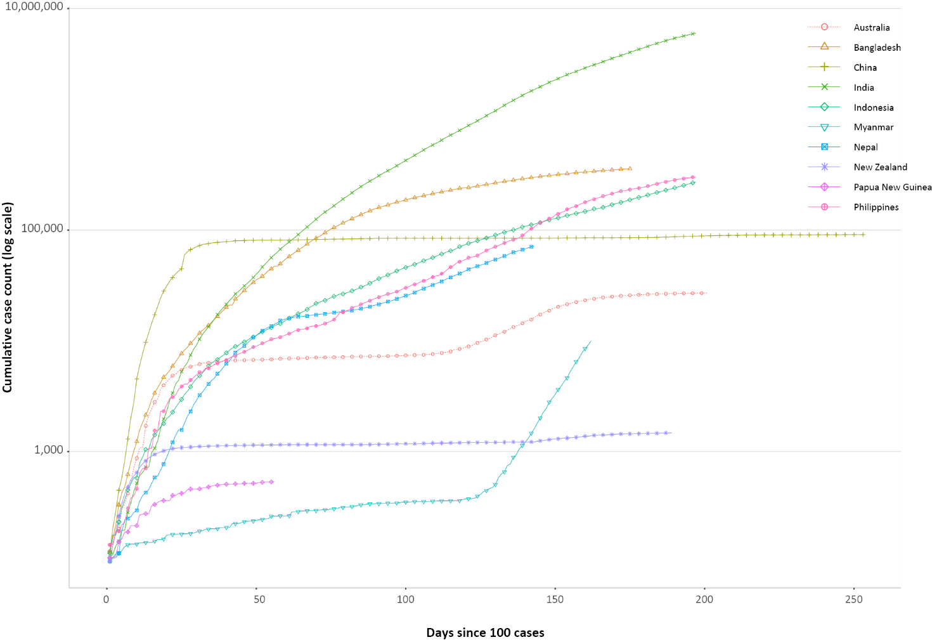
As at 27 September 2020 in New Zealand, the cluster of cases in Auckland identified in August was linked to a total of 179 cases.³² The majority of New Zealand’s 31 reported confirmed cases in the reporting period were linked to overseas travel and are being managed in isolation. A locally acquired case was suspected to have experienced an incubation period that extended longer than the standard 14 days and tested positive after leaving quarantine. This prompted the New Zealand government to reiterate that people undertaking quarantine should self-monitor for symptoms after the quarantine period and get tested.³³ Auckland remains on Alert Level 2 while the rest of New Zealand has returned to Alert Level 1.³⁴
In Papua New Guinea, there have been 532 cases and 7 deaths up until 27 September 2020. WHO reports that testing in the country remains ‘critically low’, making it difficult to understand the extent of transmission. Of provinces with sporadic cases, most report that cases have had a travel history from Port Moresby, or contact with a positive case from Port Moresby, potentially indicating wider transmission.³⁵

South East Asia Region
The South East Asia region is experiencing a large increase in new case numbers. Cumulatively the region has reported approximately 6.72 million cases and 110,711 deaths (11% of the global total), with 1.34 million new cases in this reporting period representing a 25% increase compared to the previous reporting period.
New cases in the region remain largely concentrated in India where 1.23 million new cases were reported in the past fortnight, comprising 92% of new cases reported regionally in this period (Figure 12). While the majority of new cases are occurring in India, three other countries in the region are showing signs of growing case numbers. The Republic of the Union of Myanmar continues to experience a sharp increase in case numbers with 7,195 of its cumulative case total of 9,991 reported in this past fortnight, which is an increase of 257% in cases reported from the previous reporting period. The majority of cases were locally transmitted in the Yangon region, leading the government to extend the restriction of movement in the area and other townships experiencing surges in new infections until 31 October 2020.³⁶
Nepal has experienced a sharp increase in case numbers from the previous fortnight with 18,701 new cases increasing its cumulative number of cases by 35% to 71,821 cases. Indonesia reported a fortnightly case increase of 26% in this reporting period, with 56,593 new cases increasing its cumulative case number to 271,339. Although largely concentrated in Jakarta, COVID-19 has spread to all 34 provinces. Stay-at-home restrictions and business closure measures were put in place on 14 September 2020 and will remain until further notice.³⁷
The rate of newly reported case numbers in Bangladesh has decreased in the past fortnight by 20% and deaths by 14% compared to the previous reporting fortnight, suggesting that improved case identification alongside government restrictions are beginning to flatten the country’s epidemiological curve.

Data considerations
Data were extracted from the NNDSS on 29 September 2020 for notifications received up to 27 September 2020. Due to the dynamic nature of the NNDSS, numbers presented in this report are subject to revision and may vary from numbers previously reported and from case notifications released by states and territories.

Definitions
“Cluster” in relation to COVID-19 refers to two or more cases (who do not reside in the same household) that are epidemiologically related in time, place or person where a common source (such as an event or within a community) of infection is suspected but not yet established.
“COVID-19” is the disease caused by a novel coronavirus—SARS-CoV-2—that emerged in China in late 2019. ‘CO’ stands for corona-, ‘V’ stands for virus, ‘ID’ stands for infectious disease, and ‘-19’ refers to the year that this disease was first reported.
“COVID-19 associated death” is defined for surveillance purposes as a death in a probable or confirmed COVID-19 case, unless there is a clear alternative cause of death that cannot be related to COVID-19 (e.g. trauma).³⁷ There should be no period of complete recovery from COVID-19 between illness and death. Where a Coroner’s report is available, these findings are to be observed.
“Date of illness onset” is derived from data collected by the NNDSS and represents the diagnosis date, or reported true onset of disease date. If unknown, the earliest of specimen collection date, notification date or notification receive date is used.
“Notification received date” is reported in the NNDSS and represents the date the case is first notified on the NNDSS. As notification can only occur after testing is completed and information processed, counts for a defined period will vary according to the date type used.
“Outbreak” in relation to COVID-19 refers to two or more cases (who do not reside in the same household) among a specific group of people and/or over a specific period of time where illness is associated with a common source (such as an event or within a community). Some states and territories may report a single case associated with a residential aged care facility as an outbreak.
“SARS-CoV-2” is the virus that causes the disease COVID-19. It is a betacoronavirus genetically related to the 2003 Severe acute respiratory syndrome coronavirus (SARS-CoV).
“This reporting period” refers to the period covered by this report, i.e. 14–27 September 2020.

Acknowledgements
This report represents surveillance data reported through CDNA as part of the nationally-coordinated response to COVID-19. We thank public health staff from incident emergency operations centres in state and territory health departments, and the Australian Government Department of Health, along with state and territory public health laboratories. We thank those who provided data from surveillance systems, such as Commonwealth respiratory clinics, SPRINT-SARI, Flutracking, and FluCan.

Author details

Corresponding author
COVID-19 National Incident Room Surveillance Team, Australian Government Department of Health, GPO Box 9484, MDP 14, Canberra, ACT 2601. Email: epi.coronavirus@health.gov.au

References
- Rockett RJ, Arnott A, Lam C, Sadsad R, Timms V, Gray KA et al. Revealing COVID-19 transmission in Australia by SARS-CoV-2 genome sequencing and agent-based modeling. Nat Med. 2020. doi: https://doi.org/10.1038/s41591-020-1000-7.
- Australian Government Department of Health. Australian National Disease Surveillance Plan for COVID-19. [Internet.] Canberra: Australian Government Department of Health; 30 May 2020. Available from: https://www.health.gov.au/resources/publications/australian-national-disease-surveillance-plan-for-covid-19.
- Government of New South Wales. COVID-19 weekly surveillance in NSW: epidemiological week 23, ending 6 June 2020. Sydney: Government of New South Wales; 10 June 2020. [Accessed on 31 August 2020.] Available from: https://www.health.nsw.gov.au/Infectious/covid-19/Documents/covid-19-surveillance-report-20200606.pdf.
- Statistics Canada. Table 13-10-0775-01. Detailed preliminary information on cases of COVID-19: 4 Dimensions (Aggregated data), Public Health Agency of Canada. [Internet.] Ottawa: Statistics Canada; 2020. [Accessed on 30 September 2020.] Available from: https://www150.statcan.gc.ca/t1/tbl1/en/tv.action?pid=1310077501.
- CDC COVID-19 Response Team. Severe outcomes among patients with Coronavirus Disease 2019 (COVID-19) – United States, February 12-March 16, 2020. MMWR Morb Mortal Wkly Rep. 2020;69(12):343-6.
- Monash Health. FluCAN (Influenza surveillance): FluCAN (The Influenza Complications Alert Network) [Internet.] Melbourne: Monash Health; 2020. Available from: https://monashhealth.org/services/monash-infectious-diseases/research/influenza-research/flucan-influenza-surveillance-2/.
- Docherty AB, Harrison EM, Green CA, Hardwick HE, Pius R, Norman L et al. Features of 20 133 UK patients in hospital with covid-19 using the ISARIC WHO Clinical Characterisation Protocol: prospective observational cohort study. BMJ. 2020;369:m1985. doi: http://dx.doi.org/10.1136/bmj.m1985.
- Australian and New Zealand Intensive Care Society (ANZICS). SPRINT-SARI: Short period incidence study of severe acute respiratory infection. [Internet.] Camberwell: ANZICS; 2020. Available from: https://www.anzics.com.au/current-active-endorsed-research/sprint-sari/.
- Intensive Care National Audit and Research Centre (ICNARC). ICNARC report on COVID-19 in critical care, England, Wales and Northern Ireland, 25 September 2020. London: ICNARC; 2020. [Accessed on 1 October 2020.] Available from: https://www.icnarc.org/Our-Audit/Audits/Cmp/Reports.
- Zappala C. Predicting a worse COVID-19 outcome. Chicago: American Medical Association; 8 May 2020. [Accessed on 2 September 2020.] Available from: https://ama.com.au/sites/default/files/AMA_PPE_Chris_Zappala_PREDICTING_WORSE_COVID19_OUTCOME.pdf.
- Petrakis D, Margină D, Tsarouhas K, Tekos F, Stan M, Nikitovic N et al. Obesity – a risk factor for increased COVID19 prevalence, severity and lethality (Review). Mol Med Rep. 2020;22(1):9–19.
- Dyett J. Possible link between obesity and severe COVID-19. Med J Aust. 2020. doi: https://doi.org/10.5694/mja2.50793.
- COVID-19 National Incident Room Surveillance Team. COVID-19, Australia: Epidemiology Report 24: Reporting week ending 30 August 2020. Commun Dis Intell (2018). 2020;44. doi: https://doi.org/10.33321/cdi.2020.44.75.
- European Centre for Disease Prevention and Control (ECDC). COVID-19 surveillance report: Week 38, 2020. [Internet.] Solna: ECDC; 24 September 2020. [Accessed on 1 October 2020.] Available from: https://covid19-surveillance-report.ecdc.europa.eu/.
- Australian Government Department of Health. Coronavirus (COVID-19) advice for the health and aged care sector. [Internet.] Canberra: Australian Government Department of Health; 2020. [Accessed 13 August 2020.] Available from: https://www.health.gov.au/news/health-alerts/novel-coronavirus-2019-ncov-health-alert/coronavirus-covid-19-advice-for-the-health-and-aged-care-sector.
- Communicable Diseases Network Australia (CDNA). Coronavirus disease 2019 (COVID-19) outbreaks in residential care facilities: CDNA national guidelines for the prevention, control and public health management of COVID-19 outbreaks in residential care facilities in Australia. Canberra: Australian Government Department of Health, CDNA; 13 March 2020. [Accessed on 13 August 2020.] Available from: https://www.health.gov.au/sites/default/files/documents/2020/03/coronavirus-covid-19-guidelines-for-outbreaks-in-residential-care-facilities.pdf.
- Global Initiative on Sharing All Influenza Data (GISAID). [Website.] Berlin: Federal Republic of Germany, Freunde von GISAID e.V.; 2020. [Accessed on 17 September 2020.] Available from: https://www.gisaid.org/.
- Seemann T, Lane C, Sherry N, Duchene S, Goncalves da Silva A, Caly L et al. Tracking the COVID-19 pandemic in Australia using genomics. medRxiv. 2020 doi: https://doi.org/10.1101/2020.05.12.20099929.
- Eden JS, Rockett R, Carter I, Rahman H, de Ligt J, Hadfield J et al. An emergent clade of SARS-CoV-2 linked to returned travellers from Iran. Virus Evol. 2020;6(1):veaa027. doi: https://doi.org/10.1093/ve/veaa027.
- Dalton C, Durrheim D, Fejsa J, Francis L, Carlson S, d’Espaignet ET et al.Flutracking: a weekly Australian community online survey of influenza-like illness in 2006, 2007 and 2008. Commun Dis Intell Q Rep. 2009;33(3):316–22.
- Prime Minister of Australia. Media statement: 04 Sep 2020. [Internet.] Canberra: Australian Government, Department of Prime Minister and Cabinet; 4 September 2020. [Accessed on 16 September 2020.] Available from: https://www.pm.gov.au/media/national-cabinet-040920.
- Government of New South Wales. What you can and can’t do under the rules: recent and upcoming changes. [Internet.] Sydney: Government of New South Wales; 2020. [Accessed on 1 October 2020.] Available from: https://www.nsw.gov.au/covid-19/what-you-can-and-cant-do-under-rules#recent-and-upcoming-changes.
- Victoria State Government. Third Step restrictions – Regional Victoria. [Internet.] Melbourne: Victoria State Government; 2020. [Accessed on 1 October 2020.] Available from: https://www.dhhs.vic.gov.au/third-step-restrictions-regional-victoria-covid-19.
- Victoria State Government. Second Step restrictions – Metropolitan Melbourne. [Internet.] Melbourne: Victoria State Government; 2020. [Accessed on 1 October 2020.] Available from: https://www.dhhs.vic.gov.au/second-step-restrictions-metropolitan-melbourne-covid-19.
- Queensland Government. Roadmap to easing restrictions. [Internet.] Brisbane: Queensland Government; 2020. [Accessed on 1 October 2020.] Available from: https://www.covid19.qld.gov.au/government-actions/roadmap-to-easing-queenslands-restrictions.
- Government of Western Australia. COVID-19 coronavirus: WA Roadmap. [Internet.] Perth: Government of Western Australia; 2020. [Accessed on 1 October 2020.] Available from: https://www.wa.gov.au/organisation/department-of-the-premier-and-cabinet/covid-19-coronavirus-wa-roadmap.
- Government of South Australia. COVID-19 response: COVID response updates. [Internet.] Adelaide: Government of South Australia; 2020. [Accessed on 1 October 2020.] Available from: https://www.covid-19.sa.gov.au/recovery.
- Tasmanian Government. Coronavirus disease (COVID-19): current restrictions. [Internet.] Hobart: Tasmanian Government; 2020. [Accessed on 1 October 2020.] Available from: https://www.coronavirus.tas.gov.au/families-community/current-restrictions.
- Australian Capital Territory Government. Canberra’s recovery plan: easing of restrictions. [Internet.] Canberra: Australian Capital Territory Government; 2020. [Accessed on 1 October 2020.] Available from: https://www.covid19.act.gov.au/community/canberra-recovery.
- Northern Territory Government. Roadmap to the new normal. [Internet.] Darwin: Northern Territory Government; 2020. [Accessed on 1 October 2020.] Available from: https://coronavirus.nt.gov.au/roadmap-new-normal.
- World Health Organization (WHO). WHO Coronavirus Disease (COVID-19) dashboard. [Internet.] Geneva: WHO; 27 September 2020. [Accessed on 28 September 2020.] Available from: https://covid19.who.int/.
- New Zealand Government Ministry of Health. COVID-19 – Significant clusters. [Internet.] Wellington: New Zealand Government Ministry of Health; 2020. [Accessed on 28 September 2020.] Available from: https://www.health.govt.nz/our-work/diseases-and-conditions/covid-19-novel-coronavirus/covid-19-current-situation/covid-19-current-cases/covid-19-significant-clusters.
- New Zealand Government Ministry of Health. Media release 20 September 2020. Wellington: New Zealand Government Ministry of Health; 20 September 2020. [Accessed on 28 September 2020.] Available from: https://www.health.govt.nz/news-media/media-releases/4-new-cases-covid-19-2.
- New Zealand Government. Current alert level. [Internet.] Wellington: New Zealand Government; 2020. [Accessed on 28 September 2020.] Available from: https://covid19.govt.nz/covid-19/current-alert-level/.
- Papua New Guinea National Department of Health, WHO Representative Office for Papua New Guinea. Papua New Guinea Coronavirus Disease 2019 (COVID-19) Health Situation Report #39: 21 September 2020. Port Moresby: Papua New Guinea National Department of Health; 2020. [Accessed on 28 September 2020.] Available from: https://www.who.int/docs/default-source/wpro---documents/countries/papua-new-guinea/covid-19/png-covid-19-health-situation-report-39.pdf.
- Ministry of Health and Sports (Myanmar) Department of Public Health Central Epidemiology Unit. Situation Report 172: 26 September 2020. Naypyidaw: Government of Myanmar Ministry of Health and Sports; 2020. [Accessed on 28 Sept 2020.] Available from: http://mohs.gov.mm/su/nheh5826NH.
- Kementerian Kesehatan Republik Indonesia. Infeksi Emerging. [Internet.] Jakarta: Indonesian Government Ministry of Health; 2020. [Accessed on 28 September 2020.] Available from: https://infeksiemerging.kemkes.go.id/download/Situasi_Terkini_260920.pdf.

Appendix A: Supplementary figures and tables
Table A.1. COVID-19 case notifications and rates per 100,000 population,ª by age group and sex, 27 September 2020, Australia
Age group | This reporting period  14—27 September 2020 |  |  |  |  |  | Cumulative
Age group | Cases |  |  | Rate per 100,000 population |  |  | Cases |  |  | Rate per 100,000 population
Age group | Male | Female | Total | Male | Female | Total | Male | Female | Total | Male | Female | Total
0 to 9 | 13 | 7 | 20 | 0.8 | 0.5 | 0.6 | 715 | 630 | 1,346 | 43.7 | 40.7 | 42.3
10 to 19 | 15 | 21 | 36 | 1.0 | 1.4 | 1.2 | 1,176 | 1,127 | 2,303 | 74.9 | 75.9 | 75.4
20 to 29 | 36 | 28 | 64 | 1.9 | 1.6 | 1.7 | 2,922 | 3,206 | 6,152 | 157.3 | 178.0 | 168.1
30 to 39 | 27 | 28 | 55 | 1.5 | 1.5 | 1.5 | 2,356 | 2,313 | 4,684 | 129.5 | 124.6 | 127.5
40 to 49 | 14 | 10 | 24 | 0.9 | 0.6 | 0.7 | 1,718 | 1,710 | 3,456 | 106.1 | 103.3 | 105.5
50 to 59 | 9 | 10 | 19 | 0.6 | 0.6 | 0.6 | 1,535 | 1,659 | 3,202 | 101.8 | 105.5 | 103.9
60 to 69 | 9 | 7 | 16 | 0.7 | 0.5 | 0.6 | 1,148 | 1,182 | 2,332 | 90.3 | 88.0 | 89.2
70 to 79 | 8 | 4 | 12 | 0.9 | 0.4 | 0.7 | 835 | 739 | 1,574 | 96.0 | 80.1 | 87.8
80 to 89 | 5 | 11 | 16 | 1.4 | 2.4 | 2.0 | 487 | 772 | 1,259 | 136.3 | 167.4 | 153.8
90 and Over | 6 | 10 | 16 | 8.7 | 7.5 | 7.9 | 230 | 551 | 782 | 335.2 | 412.6 | 386.8
a Cases and rates for persons include 79 cases identified as gender X or unknown gender.

Figure A.1. Variation in combinations of COVID-19 symptoms in confirmed cases as at 27 September 2020, Australiaª
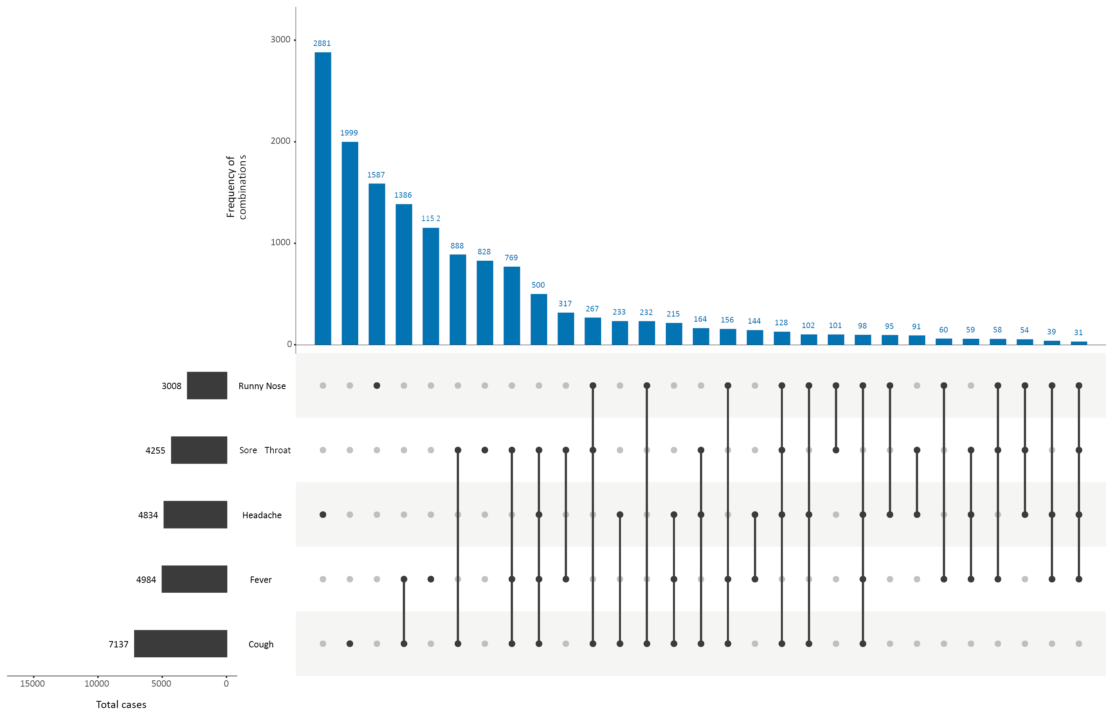
a This figure shows the variation in combinations of symptoms observed in reported cases (n = 27,095) for the five most frequently observed symptoms (cough, fever, headache, sore throat, runny nose). The horizontal bars on the left show the frequency of symptom occurrence in any combination with other symptoms. The circles and lines indicate particular combinations of symptoms observed in individual patients. The vertical blue bars indicate the frequency of occurrence of the corresponding combination of symptoms.

Appendix B: Frequently asked questions
Q: Can I request access to the COVID-19 data behind your CDI fortnightly reports?
A: National notification data on COVID-19 confirmed cases is collated in the National Notifiable Disease Surveillance System (NNDSS) based on notifications made to state and territory health authorities under the provisions of their relevant public health legislation.
Normally, requests for the release of data from the NNDSS requires agreement from states and territories via the Communicable Diseases Network Australia, and, depending on the sensitivity of the data sought and proposed, ethics approval may also be required.
Due to the COVID-19 response, unfortunately, specific requests for NNDSS data have been put on hold. We are currently looking into options to be able to respond to data requests in the near future.
We will continue to publish regular summaries and analyses of the NNDSS dataset and recommend the following resources be referred to in the meantime:
- NNDSS summary tables: http://www9.health.gov.au/cda/source/cda-index.cfm
- Daily case summary of cases: https://www.health.gov.au/news/health-alerts/novel-coronavirus-2019-ncov-health-alert/coronavirus-covid-19-current-situation-and-case-numbers
- Communicable Diseases Intelligence COVID-19 epidemiology report: https://www1.health.gov.au/internet/main/publishing.nsf/Content/novel_coronavirus_2019_ncov_weekly_epidemiology_reports_australia_2020.htm
- State and territory public health websites.
Q: Can I request access to data at post-code level of confirmed cases?
A: Data at this level cannot be released without ethics approval and permission would need to be sought from all states and territories via the Communicable Diseases Network Australia. As noted above, specific requests for NNDSS data are currently on hold.
Where current or recent reported case numbers are high enough to justify it, a GIS/mapping analysis of cases will be included in the Communicable Diseases Intelligence COVID-19 epidemiology report. In order to protect privacy of confirmed cases, data in this map will be presented at SA3 level.
Q: Where can I find more detailed data on COVID-19 cases?
A: We are currently looking into ways to provide more in-depth epidemiological analyses of COVID-19 cases, with regard to transmission and severity, including hospitalisation. These analyses will continue to be built upon in future iterations of the Communicable Diseases Intelligence report.
Q: Where do I find the COVID-19 background information which was included as Appendix A in previous fortnightly epidemiology reports?
A: This information was most recently published in Epidemiology Report 24 (https://doi.org/10.33321/cdi.2020.44.75). Additional information can be found in the CDNA Series of National Guidelines (SoNG) for COVID-19. (https://www1.health.gov.au/internet/main/publishing.nsf/Content/cdna-song-novel-coronavirus.htm).

Communicable Diseases Intelligence
ISSN: 2209-6051 Online

Communicable Diseases Intelligence (CDI) is a peer-reviewed scientific journal published by the Office of Health Protection, Department of Health. The journal aims to disseminate information on the epidemiology, surveillance, prevention and control of communicable diseases of relevance to Australia.

Editor: Tanja Farmer
Deputy Editor: Simon Petrie
Design and Production: Kasra Yousefi
Editorial Advisory Board: David Durrheim, Mark Ferson, John Kaldor, Martyn Kirk and Linda Selvey

Website: http://www.health.gov.au/cdi

Contacts
Communicable Diseases Intelligence is produced by:
Health Protection Policy Branch, Office of Health Protection, Australian Government Department of Health
GPO Box 9848, (MDP 6) CANBERRA ACT 2601

Email: cdi.editor@health.gov.au

Submit an Article
You are invited to submit your next communicable disease related article to the Communicable Diseases Intelligence (CDI) for consideration. More information regarding CDI can be found at: http://health.gov.au/cdi.
Further enquiries should be directed to: cdi.editor@health.gov.au.

This journal is indexed by Index Medicus and Medline.

Creative Commons Licence - Attribution-NonCommercial-NoDerivatives CC BY-NC-ND
© 2020 Commonwealth of Australia as represented by the Department of Health
This publication is licensed under a Creative Commons Attribution-NonCommercial-NoDerivatives 4.0 International Licence from https://creativecommons.org/licenses/by-nc-nd/4.0/legalcode (Licence). You must read and understand the Licence before using any material from this publication.

Restrictions
The Licence does not cover, and there is no permission given for, use of any of the following material found in this publication (if any):
- the Commonwealth Coat of Arms (by way of information, the terms under which the Coat of Arms may be used can be found at www.itsanhonour.gov.au);
- any logos (including the Department of Health’s logo) and trademarks;
- any photographs and images;
- any signatures; and
- any material belonging to third parties.

Disclaimer
Opinions expressed in Communicable Diseases Intelligence are those of the authors and not necessarily those of the Australian Government Department of Health or the Communicable Diseases Network Australia. Data may be subject to revision.

Enquiries
Enquiries regarding any other use of this publication should be addressed to the Communication Branch, Department of Health, GPO Box 9848, Canberra ACT 2601, or via e-mail to: copyright@health.gov.au

Communicable Diseases Network Australia
Communicable Diseases Intelligence contributes to the work of the Communicable Diseases Network Australia.
http://www.health.gov.au/cdna

This report addresses indicators listed in the CDNA National Surveillance Plan 2020.

