COVID-19 Australia: Epidemiology Report 22
Fortnightly reporting period ending 2 August 2020
COVID-19 National Incident Room Surveillance Team
Unless indicated, the source of all data, including notified cases of COVID-19 and associated deaths, is the National Notifiable Diseases Surveillance System (NNDSS) to 2 August 2020. Due to the dynamic nature of NNDSS data, data in this report are subject to retrospective revision and may vary from data reported in published NNDSS reports and reports of notification data by states and territories. Case numbers for the most recent dates of illness onset may be subject to revision, due to reporting delays.
Confirmed cases in Australia | Last reporting period  6 to 19 July | This reporting period  20 July to 2 August | Cumulative  As at 2 August 2020
Notifications | 3,462 | 6,121 | 18,367
Deaths | 52 | 71 | 240

Summary
Over the past fortnightly reporting period (20 July to 2 August):
- The number of new cases reported nationally increased from 3,462 in the previous fortnight to 6,121.
- The large increase in numbers is due to multiple epidemiologically-linked outbreaks across a range of settings and locations in Victoria (97%; 5,914 cases) with very few (207) cases reported by other jurisdictions in this reporting period.
- Of the 5,914 cases reported in Victoria, all were locally acquired. Of the remaining 207 cases nationally reported, only 23% were reported as locally acquired.
- ACT is the only jurisdiction reporting 0 cases, with its last case reported on 9 July.
- A total of 71 deaths were reported, all from Victoria.
- On average, 437 cases were reported each day over the reporting period, an increase from 247 cases per day over the previous fortnight.
- Testing rates remain high across all jurisdictions, with an overall positivity rate for the reporting period of 0.7%. Victoria reported a positivity rate of 1.7% for this reporting period. In all other jurisdictions the positivity rate was 0.07% or lower.
- Overall, syndromic surveillance of respiratory illness trends continues to show very low levels compared to previous years.
- 12% of cases have required hospitalisation or intensive care.
Keywords: SARS-CoV-2; novel coronavirus; 2019-nCoV; coronavirus disease 2019; COVID-19; acute respiratory disease; epidemiology; Australia

Figure 1: New and cumulative COVID-19 notifications by date of illness onset,ª Australia
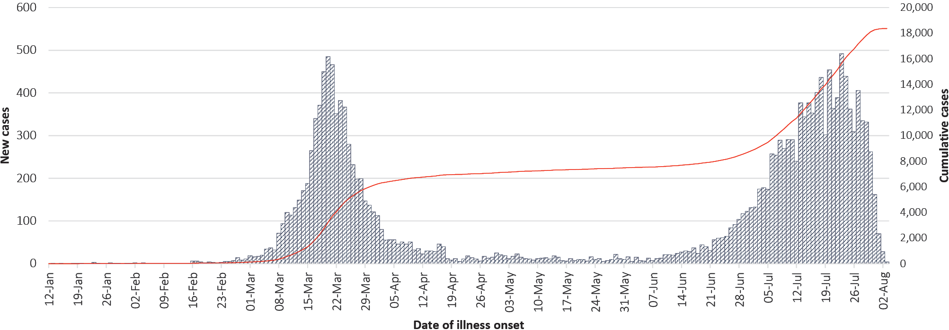
a Illnesses that began 7 days prior to 2 August may not yet be reported and interpretation of trends during this period should be undertaken with caution.

In focus: New South Wales
In New South Wales, there have been a total of 3,831 cases reported to date, with 171 cases notified in this reporting period. Most cases occurred in March, with case numbers decreasing throughout April and May. Locally-acquired cases started to increase slightly towards the end of June and this trend has continued to date (Figure 2). Of the locally-acquired cases recently diagnosed in NSW, the majority have been linked to known cases or outbreaks with a small number unable to be linked.
NSW has maintained a high rate of testing, with over 300,000 tests conducted over the reporting period, representing a testing rate of 39.5 tests per 1,000 population. Additionally, over this reporting period, NSW cases were reported more frequently in males (rate ratio 1.1:1). This trend has remained consistent over the epidemic to date (Table 1).
Cumulatively, cases in NSW were reported most frequently in people aged 20–29 years old (793 cases) (Table 1). Of the 3,831 cases reported in NSW to date, 38 cases (1%) were in those identifying as Aboriginal and Torres Strait Islander peoples.
Overall, for NSW there have been 52 deaths attributed to COVID-19, 26 males and 26 females, all over the age of 50, resulting in a crude case fatality rate of 1.36% (Table 1).
Most cases reported in NSW have been overseas acquired, although the proportion of locally-acquired cases increased markedly in July, showing a shift in source of acquisition from overseas to locally acquired (Figure 3). Importantly, the proportion of locally-acquired cases where a contact was not identified has remained low throughout the epidemic.
The age distribution of COVID-19 cases in NSW has changed over the course of the epidemic, with cases decreasing over time in those over 50 years of age and increasing over time in those less than 20 years of age (Figure 4). Prior to the start of June, the proportion of cases reported in school aged children (aged 5 to 17 years) was 2%. Since June this proportion has increased to 12%, while the proportion of cases reported in older adults (aged 65 and over) has decreased from 20% to 5% for all NSW cases. The median age of cases reported early in the epidemic was 45 years (interquartile range, IQR: 29 to 62), while in the later phase, the median age has reduced to 34 years (IQR: 23 to 48).
Figure 2: New South Wales COVID-19 notifications by notification date, cumulative and new cases
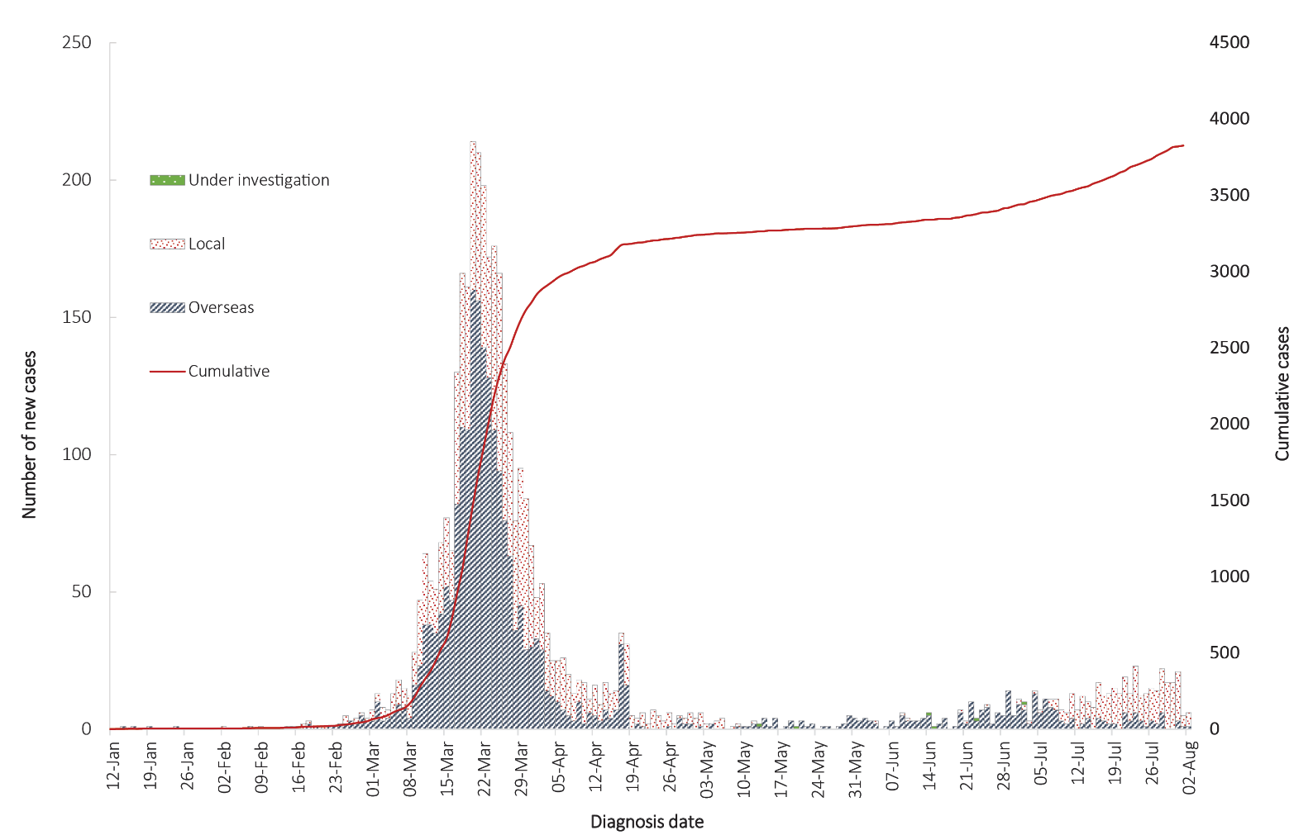
Table 1: New South Wales COVID-19 cases and deaths by age group and gender, as at 2 August 2020
Age group | Cases |  | Deaths
Age group | Male | Female | Male | Female
0 to 9 | 45 | 37 | 0 | 0
10 to 19 | 79 | 80 | 0 | 0
20 to 29 | 365 | 428 | 0 | 0
30 to 39 | 349 | 322 | 0 | 0
40 to 49 | 298 | 202 | 0 | 0
50 to 59 | 270 | 268 | 0 | 1
60 to 69 | 265 | 268 | 3 | 1
70 to 79 | 175 | 159 | 7 | 6
80 to 89 | 58 | 52 | 10 | 8
90 and over | 18 | 24 | 6 | 10
Total | 1922 | 1840 | 26 | 26

Figure 3: New South Wales COVID-19 notifications by source of infection, February–July 2020
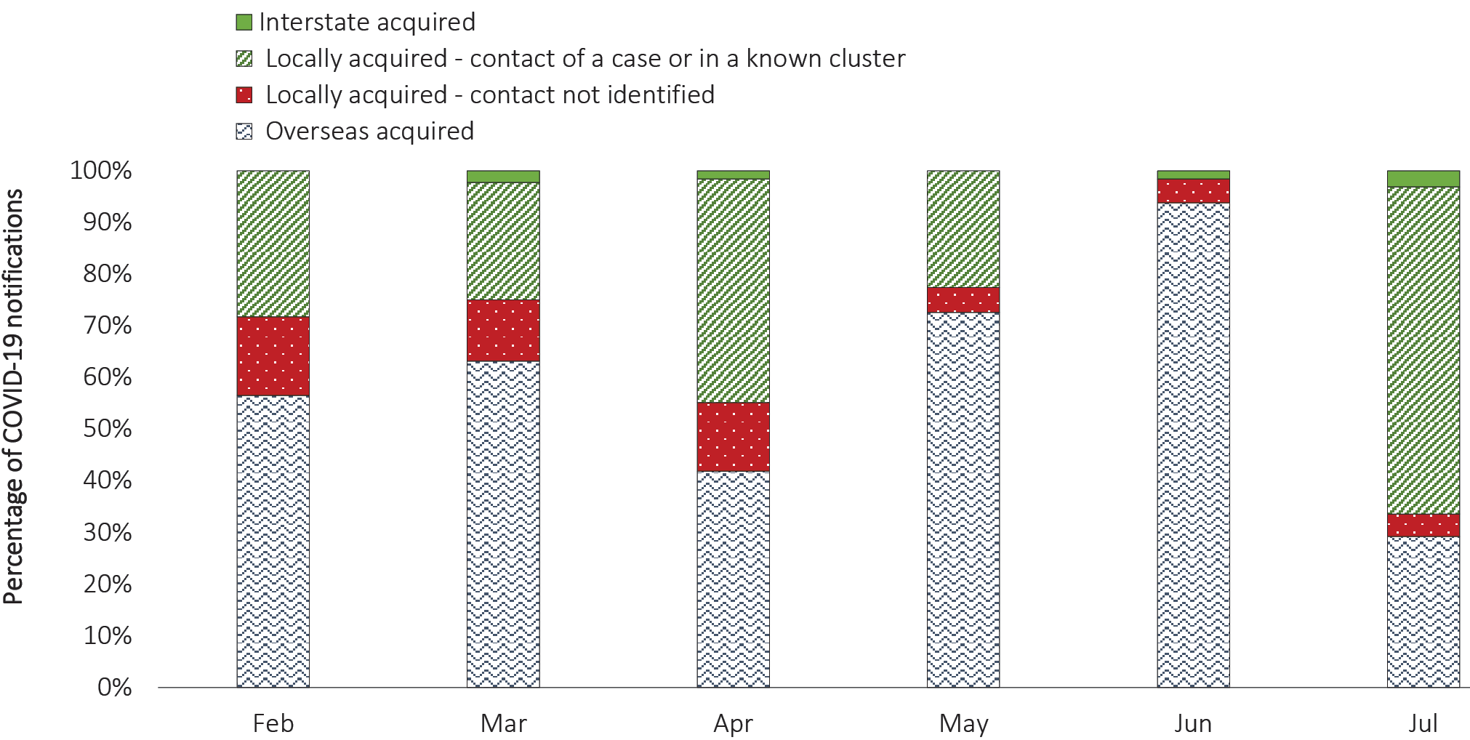
Figure 4: New South Wales COVID-19 notifications by age group, February–July 2020
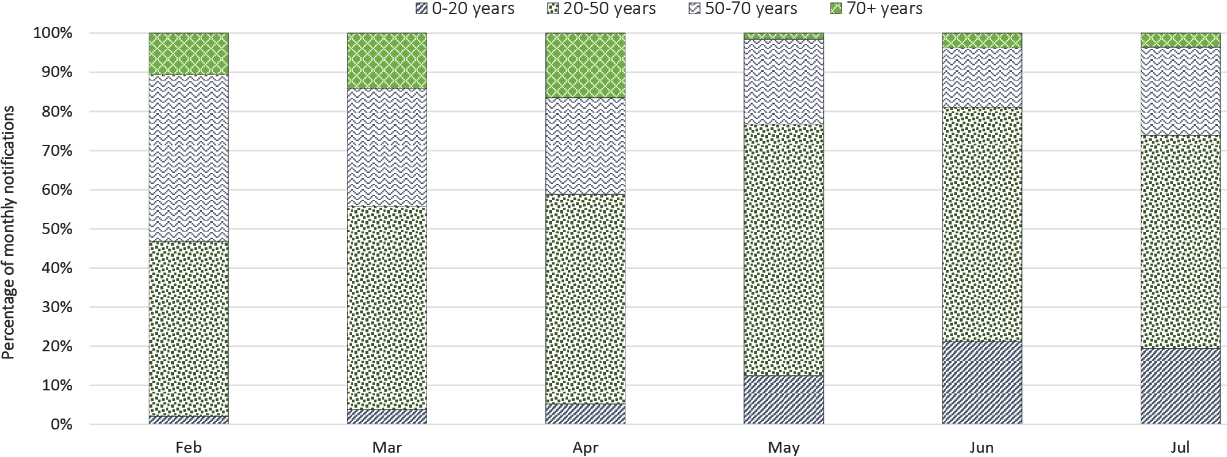

Australian cases: descriptive epidemiology

Transmission trends
Up to 2 August 2020 there were 22,358 COVID-19 cases, including 361 deaths, reported nationally. Over the latest fortnightly reporting period, there were 6,121 cases, including 71 deaths. The majority of the recently reported cases were from Victoria (97%), followed by New South Wales (2.5%). A small number of cases was also reported in Queensland, South Australia, Tasmania, Western Australia and the Northern Territory (0.5%). On average, 437 cases were reported each day over the reporting period, an increase from 247 cases per day over the previous reporting period.
Since the first case of COVID-19 was identified in Australia, all states and territories have experienced COVID-19 cases, with some jurisdictions experiencing higher numbers and more community-associated transmission. These differences arise from factors including state demographics, population size, patterns of overseas arrivals in the beginning of the pandemic, and ongoing repatriation flights which have been concentrated in Melbourne and Sydney. Cases in Victoria are currently driven by community transmission, with numerous outbreaks occurring across a range of settings and locations in Greater Melbourne.

Respiratory illness trends
The internet-based syndromic surveillance system, FluTracking,¹ monitors trends of influenza-like illness (fever and cough) and acute respiratory illness (runny nose and sore throat) in the community via self-reporting of respiratory symptoms from registered participants. Whilst this system is not specific to COVID-19, it monitors reports of respiratory symptoms and provides an indication of broader respiratory illness transmission.
Based on self-reports of fever and cough in the community, respiratory illness symptoms are currently low nationally, approximately five- to seven-fold lower than the historical average for this time of year. There was no evidence of increased community acute respiratory illness in Victoria despite the increase in COVID-19 case numbers (Figure 5).

Source of acquisition
As at 2 August 2020, Australia has recorded 18,367 cases of COVID-19 and 240 deaths: 49% of cases are reported as locally acquired; 40% are reported as overseas acquired; and 11% remain under investigation. Of all locally-acquired cases in this reporting period, the source of acquisition for 22% of cases was unable to be linked to a known case or cluster. This included 11 cases where a contact could not be identified but interstate travel had occurred.
In this reporting period, 97% of cases have been reported from Victoria (5,914). Of these cases, 43% are reported as locally acquired with known source, 12% as locally acquired with unknown source and, due to the scale of the outbreak, 45% are under investigation, though they are likely locally acquired (Table 2, Figure 6).
For all other cases (207) in this reporting period: 82% of these cases were reported from NSW; 61% of cases are reported as locally acquired with known source; 11% of cases are reported as locally acquired with unknown source; 23% of cases are reported as overseas acquired; and 5% of cases reported are under investigation (Table 2). Overseas-acquired cases in this fortnight were reported from NSW (28), WA (14) and Qld (5) and were detected in travellers in hotel quarantine from repatriation flights.

Figure 5: Weekly trends in respiratory illness amongst FluTracking survey participants (age standardised), 2020 and average of the previous five yearsª
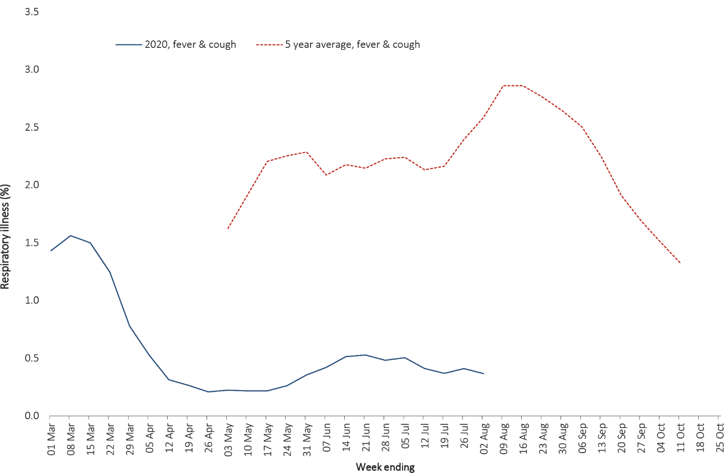

Figure 6: COVID-19 notifications Victoria, and all other jurisdictions, by source of acquisition, as at 2 August 2020
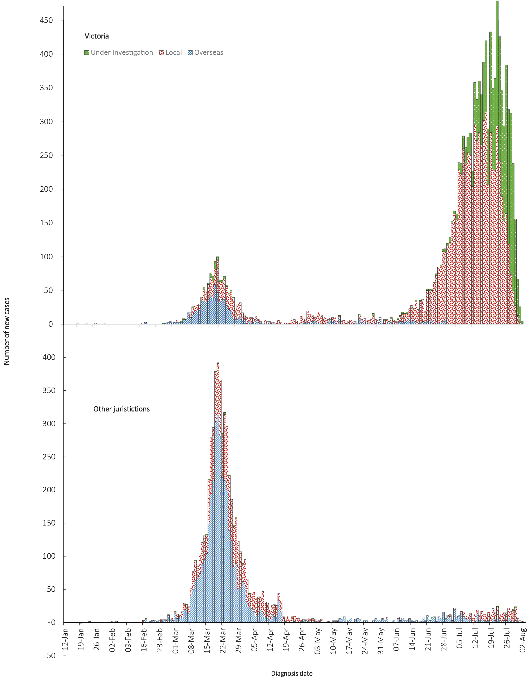
Table 2: COVID-19 notifications by jurisdiction and source of acquisition, 20 July – 2 August
Source | NSW | Vic | Qld | WA | SA | Tas | NT | ACT | Australia
Overseas | 28 | 0 | 5 | 14 | 0 | 0 | 0 | 0 | 47
Local—source known | 123 | 2,556 | 3 | 1 | 0 | 0 | 0 | 0 | 2,683
Local—source unknown | 19 | 718 | 2 | 1 | 0 | 1 | 0 | 0 | 741
Under investigation | 1 | 2,640 | 3 | 2 | 2 | 0 | 2 | 0 | 2,650
Total | 171 | 5,914 | 13 | 18 | 2 | 1 | 2 | 0 | 6,121
Table 3: Locally-acquired COVID-19 cases by jurisdiction, as at 2 August 2020
Jurisdiction | Reporting period  5–19 July |  | Reporting period  20 July–2 August |  | Cumulative cases
Jurisdiction | Number of cases | Rates per 100,000 population | Number of cases | Rates per 100,000 population | Number of cases | Rates per 100,000 population
NSW | 119 | 1.5 | 142 | 1.8 | 1,590 | 19.7
Vic | 3,234 | 49.0 | 5,914 | 89.7 | 11,052 | 167.6
Qld | 0 | 0.0 | 8 | 0.2 | 249 | 4.9
WA | 2 | 0.1 | 4 | 0.2 | 94 | 3.6
SA | 0 | 0.0 | 2 | 0.1 | 141 | 8.0
Tas | 0 | 0.0 | 1 | 0.2 | 148 | 27.7
NT | 0 | 0.0 | 2 | 0.8 | 6 | 2.4
ACT | 5 | 1.2 | 0 | 0.0 | 29 | 6.8
Australia | 3,360 | 13.2 | 6,073 | 23.9 | 13,309 | 52.0

Table 4: Diagnostic tests performed in Australia, by jurisdiction, as at 2 August 2020ª
Jurisdiction | Tests performed  6—19 July |  |  | Tests performed  20 July—2 August | Cumulative tests performed  to 2 August
Jurisdiction | N | Positivity (%) | N | Positivity (%) | N | Positivity (%) | Per 100,000 population ^{a,b}
NSW | 238,653 | 0.06 | 326,955 | 0.07 | 1,508,040 | 0.25 | 18,641
Vic | 377,015 | 0.84 | 348,526 | 1.67 | 1,653,712 | 0.70 | 25,071
Qld | 68,567 | 0.01 | 101,468 | 0.01 | 560,607 | 0.19 | 11,004
WA | 28,545 | 0.11 | 30,031 | 0.06 | 249,789 | 0.27 | 9,528
SA | 27,336 | 0.00 | 57,732 | 0.02 | 246,160 | 0.18 | 14,051
Tas | 8,023 | 0.00 | 9,026 | 0.01 | 69,983 | 0.33 | 13,094
NT | 5,159 | 0.02 | 5,304 | 0.04 | 25,211 | 0.13 | 10,251
ACT | 9,730 | 0.05 | 10,636 | 0.00 | 52,639 | 0.21 | 12,336
Australia | 763,028 | 0.44 | 889,678 | 0.68 | 4,366,141 | 0.41 | 17,216
a Data in this table are based on reports of notification by states and territories.
b Population data based on Australian Bureau of Statistics (ABS) Estimated Resident Population (ERP) as at 30 June 2019.

Figure 7: COVID-19 Laboratory (PCR) testing rates in Australia, by age group,^{a,b} 1 May to 31 July 2020
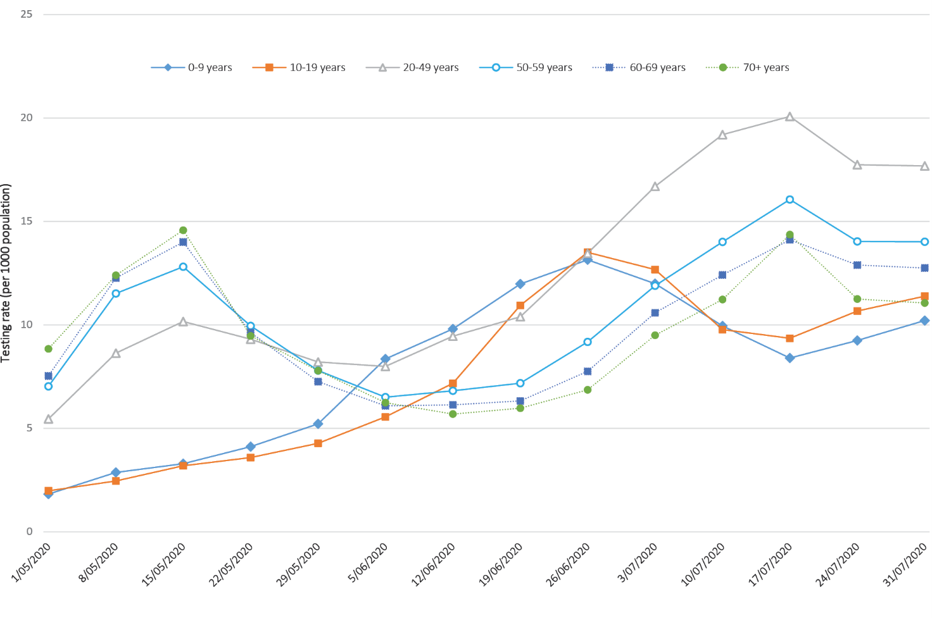
a Data provided by jurisdictions to NIR weekly.
b The jurisdictions reporting each week (i.e. the denominator population) may vary.
Figure 8: COVID-19 cases, by age group and gender, to 2 August 2020, Australia
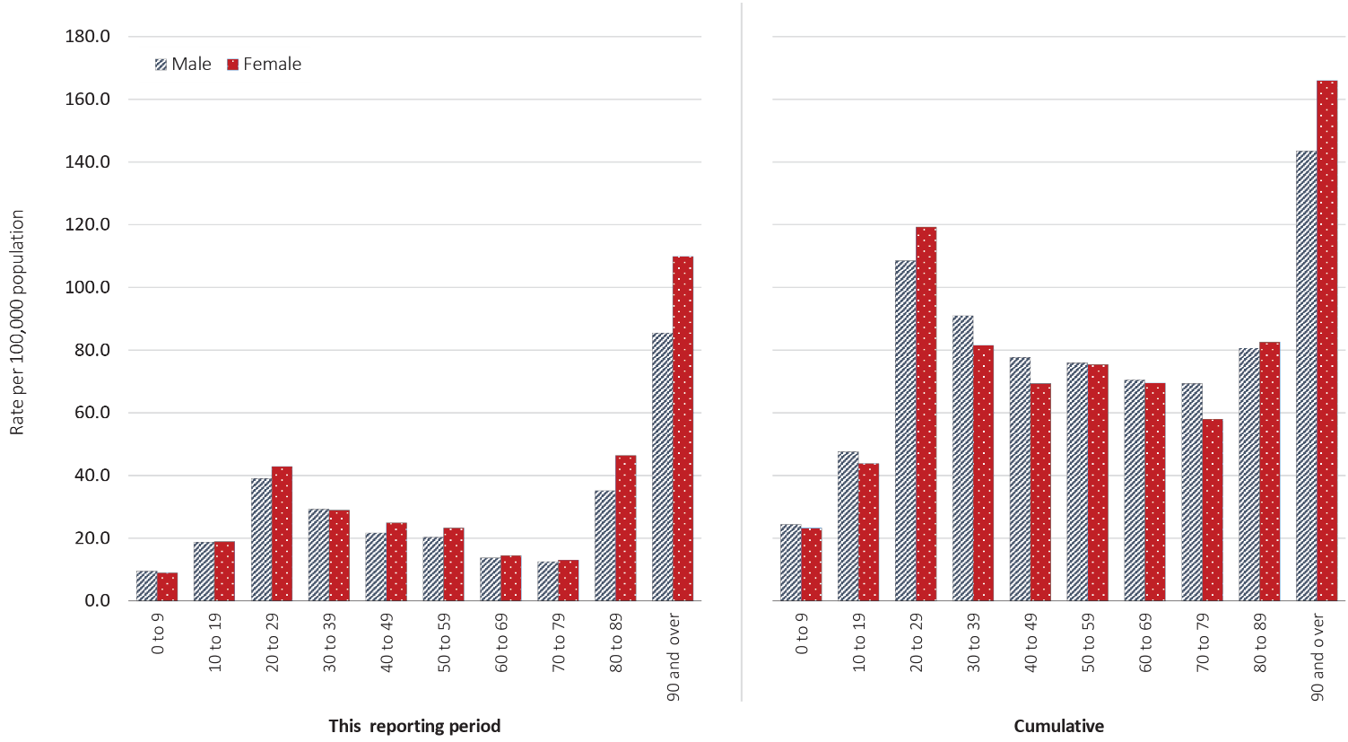
Table 5: Number and case fatality rate for all cases, hospitalised cases and cases admitted to ICU, by age group and gender, Australia
 | All casesª  n (CFR) |  |  | Hospitalisation^{b}  (non ICU)  n (CFR) |  |  | ICU^{c}  n (CFR)
 | Male | Female | Persons | Male | Female | Persons | Male | Female | Persons
All age groups | 133 (1.5) | 107 (1.2) | 240 (1.3) | 5 (5.2) | 3 (3.1) | 8 (4.2) | 27 (13) | 9 (8) | 36 (11)
Under 50 | 3 (0.05) | 0 (0) | 3 (0.02) | 0 (0.0) | 0 (0.0) | 0 (0.0) | 1 (2.0) | 0 (0.0) | 1 (1.3)
50–64 | 10 (0.6) | 4 (0.2) | 14 (0.4) | 0 (0.0) | 1 (4.3) | 1 (2.1) | 4 (6.5) | 2 (5.4) | 6 (6.1)
65–79 | 45 (4.5) | 28 (3.0) | 73 (3.8) | 2 (8.3) | 0 (0.0) | 2 (4.8) | 15 (18.3) | 5 (11.1) | 20 (15.7)
80 and over | 75 (19.4) | 75 (12.4) | 150 (15.1) | 3 (17.7) | 2 (22.2) | 5 (19.2) | 7 (58.3) | 2 (66.7) | 9 (56.3)
a Source: NNDSS (Total cases = 18,353).
b Source: FluCAN, includes 21 sentinel hospitals (Total cases = 241).
c Source: SPRINT-SARI, includes 77 sentinel ICUs and high dependency units (HDU) (n = 318).

Clusters and outbreaks
Residents of aged care facilities are at increased risk of COVID-19 infection due to the environment of communal living facilities and are more vulnerable to serious complications if they do become infected. As of 2 August 2020, there have been 1,436 cases of COVID-19 associated with 148 residential aged care facilities, with 127 recoveries and 136 deaths. Eight hundred of these cases occurred in aged care residents, with the remaining 636 cases occurring in care staff. The Commonwealth is actively supporting services with reported incidents and outbreaks of COVID-19 providing access to personal protective equipment and additional staffing resources where required. Advice and guidelines² have been provided to aged care services, including the release of an outbreak management guide.³

Testing
During this reporting period 889,678 tests were conducted nationally, with an overall positivity rate of 0.68%. All states except Victoria reported a period positivity of 0.07% or lower. Victoria reported a positivity rate of 1.67% for this period, which is an increase from the previous reporting period (0.84%).
A total of 4,366,141 tests have been conducted in Australia. High rates of testing have continued across the country, with the cumulative proportion of positive tests remaining low at less than 0.5% in most jurisdictions (Table 4). The low positivity rate indicates widespread testing in the community and supports the observation of low levels of disease in these areas. For the fortnight 18 to 31 July 2020, polymerase chain reaction (PCR) testing rates were highest in those aged 20 to 49 years (Figure 7).
Based on FluTracking data, currently 55% of those in the community with ‘fever and cough’ and 28% of those with ‘runny nose and sore throat’ reported being tested for COVID-19 during the most recent reporting fortnight. Testing and presentations to health services continue to show a gradual increase over time. In those experiencing influenza-like illness over the last fortnight, the most frequent respiratory viruses detected were rhinoviruses. It is recommended that anyone experiencing cold- or flu-like symptoms, such as a cough, fever, sore throat, shortness of breath or runny nose, even if these are mild, get tested for COVID-19 as soon as possible.

Demographics of cases
Historically, cases of COVID-19 have been reported across all age groups; however, recent reporting periods have highlighted a shift to younger populations in the cumulative totals (see Appendix B, Table B.1). Cumulatively, cases show a median age of 38 years (IQR: 25 to 57). Prior to the peak of cases in April, the population diagnosed was slightly older, with a median age of 47 years (IQR: 29 to 62) reflecting the primary source of acquisition being cruise ships. In this reporting period, the median age is 35 years (IQR: 24 to 54).
Cumulatively, people aged 90 and over have the highest rate of COVID-19 infection (158.4 cases per 100,000 population), followed by the 20–29 years age group (115.1 cases per 100,000 population) and then 30–39 years (87.0 cases per 100,000 population) (Table B.1). Children aged 0–9 years continue to have the lowest rate (24.0 cases per 100,000 population), with testing rates comparable to other age groups (Figure 8).
Across most age groups, males show a higher rate of infection than females, with the exception being in the 20–29 years age group and those aged 80 and over. The largest difference in rates between genders is observed in the 90 and over age group where females are diagnosed with COVID-19 almost 16% more per 100,000 population than are males.
In this reporting period, school-aged children account for 9.6% of all cases, which is a higher proportion than they comprise in cumulative cases (7.3%). This fortnight, 25% of cases were reported among people aged 20 to 29 years. The proportion of cases in this age group has been increasing in recent weeks, predominantly in Victoria.

Severity
International estimates of hospitalisation rate for COVID-19 vary from 10% in Canada to 29% in Europe.^{4,5} Currently, we lack reliable data to support this estimation in Australia. Of the 241 hospitalised cases captured in the sentinel surveillance system, Influenza Complications Alert Network (FluCAN), since 16 March 2020, twenty percent (49) were admitted to an intensive care unit (ICU); this is a similar proportion to ICU admission estimates in Canada (20%) and the United Kingdom (17%).^{4,6}
The case fatality rate (CFR) was highest for those COVID-19 patients aged over 80 years and admitted to ICU (CFR > 50%) (Table 5). Comparison of CFRs across levels of hospitalisation should be interpreted with caution as the sample sizes and data sources vary. Of cases hospitalised in sentinel sites, the CFR was 4.2%, which is dramatically lower than the aggregated value of 24% observed in European cases (data from 22 countries)⁵ and Canadian cases (33%).⁷ In cases with an ICU outcome (n = 247), 14% died (n = 35); this is also substantially lower than the ICU CFR reported in the United Kingdom at 52% (871/1,689).⁸ Given the large number of cases reported in the latter country, this may be influenced by the treatment options.

Hospital length of stay
In general, the length of hospital stay for patients with confirmed COVID-19 increased with advancing age category (Table 6). Of all age groups, those aged 60–79 years stayed the longest in hospital; this was the case for both general ward and ICU admissions. Overall, the median hospital length of stay in Australia was 6 days (IQR: 2–11 days) and the mean length of stay was 8.1 days (standard deviation, SD: 8.6 days). This is slightly lower than that reported in European Countries where median length of stay was 9 days and mean 13 days (data from approximately 5,100 cases),⁵ although differences in case numbers make comparison difficult. The European data also showed that length of stay increased with age, with people aged over 60 years staying for a median time of 10–11 days (mean: 13–15 days).⁵
Table 6: Hospital length of stay for confirmed COVID-19 cases discharged alive from sentinel sites by ICU/HDU admission status (median, IQR and mean, SD)
Age group (years) | General wardª |  |  | ICU/HDU^{b}
Age group (years) | n | Median (IQR) | Mean (SD) | n | Median (IQR) | Mean (SD)
Under 5 | 13 | 3.0 (1.0–7.0) | 5.3 (5.9) | 0 | 0(0) | 0(0)
5–17 | 9 | 5.0 (2.0–7.0) | 5.1 (4.1) | 3 | 5.0 (1.0–25.0) | 10.3 (12.9)
18–39 | 18 | 5.0 (2.0–10.0) | 6.7 (6.4) | 25 | 6.0 (5.0–11.0) | 11.4 (12.6)
40–59 | 38 | 5.0 (3.0–10.0) | 8.1 (10.5) | 58 | 12.5 (9.0–25.0) | 20.1 (17.6)
60–79 | 38 | 7.5 (3.0–15.0) | 10.2 (8.7) | 100 | 21.0 (11.5–34.0) | 24.6 (16.9)
80 and over | 6 | 8.0 (4.0–10.0) | 9.7 (9.1) | 3 | 15.0 (13.0–18.0) | 15.3 (2.5)
Total | 122 | 6.0 (2.0–11.0) | 8.1 (8.6) | 189 | 17.0 (8.0–29.0) | 21.1 (17.0)
a Source: FluCAN, excludes patients admitted to ICU.
b Source: Sprint-Sari.
The ICU length of stay for COVID-19 patients in Australian data for survivors had a median age of 7 days (IQR: 3–17 days); non-survivors stayed for a median of 8 days (IQR: 4–13 days). This is longer than reported in the United Kingdom, for which the median values were 4 days (IQR: 2–8 days) in survivors and 6 days (IQR: 3–9 days) in non-survivors.⁹

Characteristics of those with severe infection
Higher disease severity, as indicated by hospitalisation, admission to ICU, and death, has been associated with increased age and comorbidities.⁵ The median age for cases who have been hospitalised in sentinel sites (57 years; IQR: 38.3–71.2), admitted to ICU (62 years; IQR: 51.0-70.5) and died (82.0 years; IQR: 76.0–89.0) are higher than for cases overall (38.0 years; IQR 25.0–57.0). The ratio of males to females is similar among hospitalised cases (1.1:1); however, more males than females have been admitted to ICUs (1.8:1). The sex ratio also increases as age-group increases amongst both general hospitalised and those admitted to ICU (Figure 9). The highest number of deaths have occurred in those aged > 80 years for both males and females.

Figure 9: Age and gender distribution for COVID-19 cases by severity: hospitalised, ICU and deaths, Australia, as at 2 August 2020
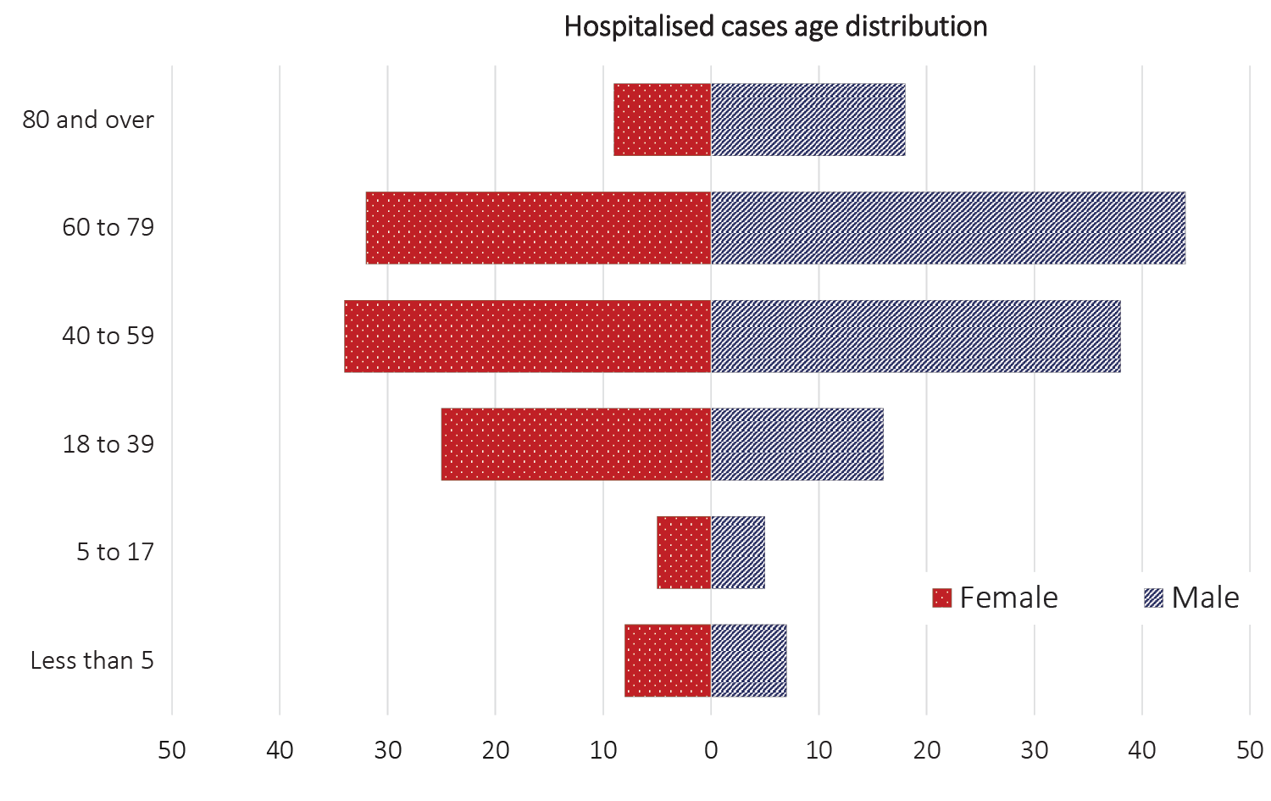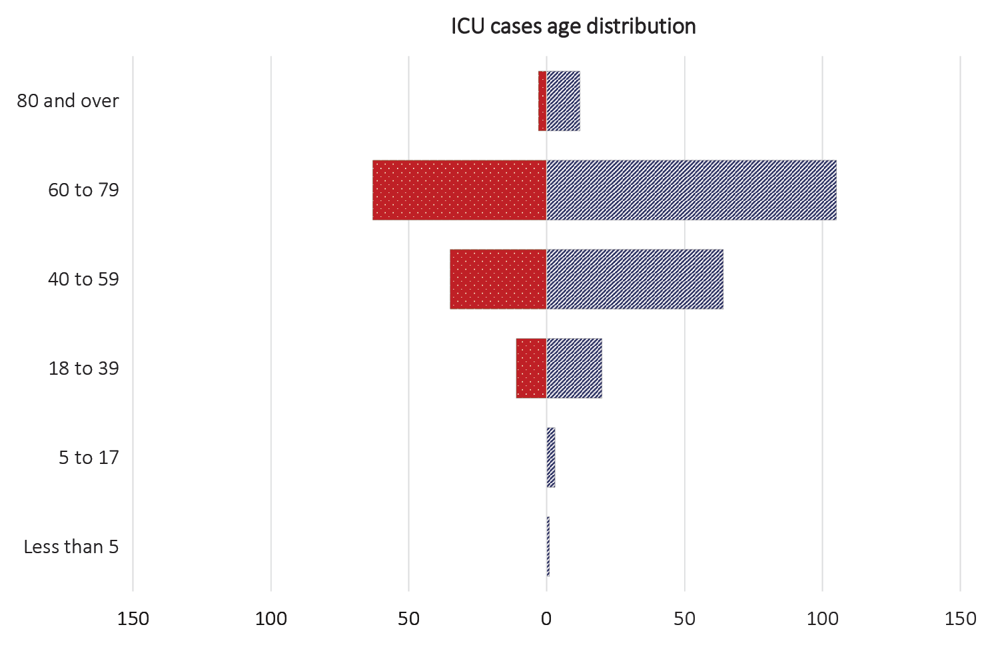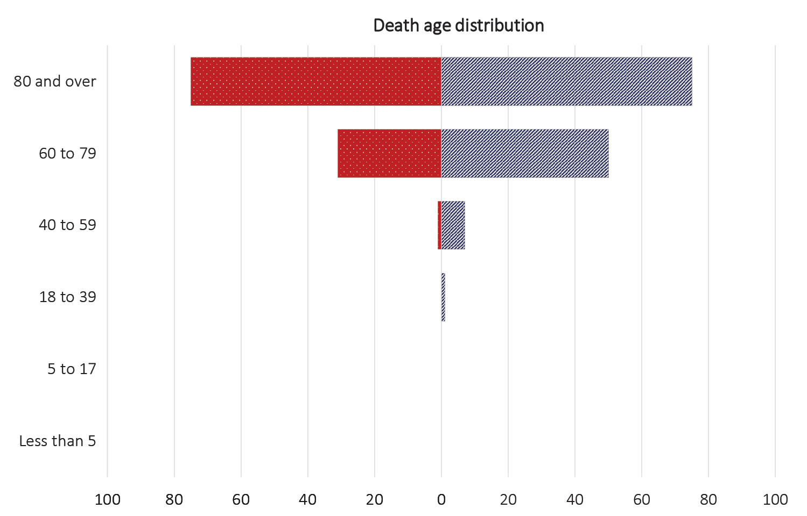
Table 7: Comorbidities amongst COVID-19 cases hospitalised, admitted to ICU and deaths (number of cases, proportion of cases), Australia, as at 2 August 2020
Comorbidity | Hospitalised casesª  (general ward)  (n = 104) Number (%) | ICU cases^{b}  (n = 300)  Number (%) | In-hospital^{b} deaths  (n = 35)  Number (%)
Cardiac disease | 27 (26) | 51 (17) | 14 (40)
Chronic respiratory condition^{c} | 34 (33) | 61 (20) | 10 (29)
Diabetes | 33 (32) | 88 (29) | 13 (37)
Obesity | 18 (17) | 75 (25) | 8 (23)
Chronic renal disease | 6 (6) | 17 (6) | 6 (17)
Chronic neurological condition | 20 (19) | 4 (1) | 0
Malignancy | 11 (11) | 17 (6) | 6 (17)
Chronic liver disease | 3 (3) | 9 (3) | 3 (9)
Immunosuppression | 19 (18) | 20 (7) | 6 (17)
Number of specified comorbidities^{d}
One or more | 85 (82) | 189 (63) | 28 (80)
Two or more | 44 (42) | 99 (33) | 20 (57)
Three or more | 17 (16) | 39 (13) | 12 (34)
No comorbidities | 19 (18) | 111 (37) | 7 (20)
a Source: FluCAN; excludes those with missing data on comorbidities or where comorbidity is unknown.
b Source: SPRINT-SARI; excludes those with missing data on comorbidities or where comorbidity is unknown.
c Includes asthma.
d Includes chronic respiratory conditions, cardiac disease (excluding hypertension), immunosuppressive condition/therapy, diabetes, obesity, liver disease, renal disease and neurological disorder.

Comorbidities
Comorbidities were common in those COVID-19 cases admitted to Australian sentinel hospitals (general ward or ICU), with 78% recording at least one of the specified comorbidities; only 9% recorded no comorbidity. The proportion of hospitalised cases with no known comorbidity recorded in U.S hospital surveillance system COVID-NET was also reportedly 9%.¹⁰ By contrast, in the UK, 22.5% of 20,133 hospitalised COVID-19 cases had no recorded comorbidities.^{6,9} This UK study reports similar prevalence estimates for key comorbidities amongst hospitalised COVID-19 patients as found in Australian data. In sentinel Australian sites, chronic cardiac disease occurred in 29% of hospitalised cases (30.9% in the UK), diabetes in 32% (20.7% UK) and chronic respiratory disease (including asthma) in 31% of hospitalised cases (32% UK study).
Compared to ward-admitted patients, we observed higher prevalence rates amongst those admitted to ICU for almost all specified comorbidities (Table 7). A history of smoking (current or past smoker) was identified in 31% of those hospitalised (52/166) and 14% those admitted to ICU (41/292).

Symptom profile
The symptoms reported by COVID-19 cases in Australia are consistent with a mild respiratory infection in the majority of cases. The principal symptoms reported in cases (Figure B.1) were cough (42%), fever (30%), sore throat (27%) and headache (20%). Other symptoms reported include malaise, lethargy or fatigue (20%) and loss of taste or smell (10%). These are currently not standard fields in NNDSS, and are likely to under-represent those presenting with these symptoms. A small number of cases reported more severe symptoms, with pneumonia and/or acute respiratory disease (ARD) reported in 2% of cases and in 15% of deaths.
In more severe cases cough, fever and shortness of breath were the most common symptoms reported, as well as an increasing proportion reporting malaise/lethargy/fatigue or acute respiratory syndrome/pneumonia with increasing severity. The proportion reporting a loss or taste or smell dropped with increasing severity. The completeness of the symptom field in the NNDSS was 99%, with 73% of records indicating known symptoms.
The symptom profile of Australian cases is broadly similar to the symptoms reported by COVID-19 cases internationally. Among EU/EEA countries and the UK, a dry or productive cough and fever/chills were the most commonly reported symptoms.⁵ Differences in reported symptoms will be influenced by differences in surveillance strategies and symptom reporting across countries.

Aboriginal and Torres Strait Islander persons
There have been 107 cases of COVID-19 notified in Aboriginal and Torres Strait Islander persons. This represents approximately 0.6% of all confirmed cases. Table 8 compares the remoteness of cases in Aboriginal and Torres Strait Islander persons with those in the non-Indigenous population. Approximately 28% (30) of all cases notified in Aboriginal and Torres Strait Islander persons are reported as being acquired overseas with almost half of these (13 cases) associated with cruise ships.
By gender, there is a higher proportion of cases in Aboriginal and Torres Strait Islander females (56%, 60 cases) than in non-Indigenous females (49%, 9,026 cases). The differences observed in gender for Aboriginal and Torres Strait Islander people likely reflect the small number of cases rather than any specific transmission pattern.
The median age of COVID-19 cases in Aboriginal and Torres Strait Islander persons is 34 years (IQR: 22.5–52.0), which is younger than for non-Indigenous cases where the median age is 38 years (IQR: 25.0–57.0). Overall, Aboriginal and Torres Strait Islander males are reporting a slightly higher proportion of cases in the 20–29 year age group (28%) compared to non-Indigenous cases (22%) and Aboriginal and Torres Strait Islander females are reporting a higher proportion of cases in the 10–19 year and 50–59 year age groups (13% and 18% respectively) than is seen among non-Indigenous cases (7% and 13% respectively) (Figure 10).

Figure 10: National COVID-19 notifications by age group and sex, Aboriginal and Torres Strait Islander persons and non-Indigenous Australiansª
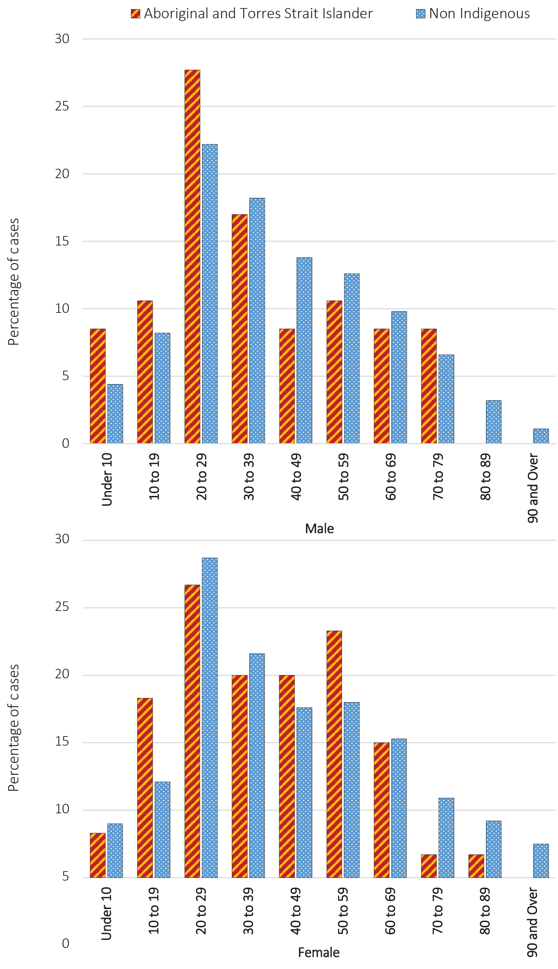
a ‘Non-Indigenous’ includes one person identified as gender X, and 88 non-Indigenous Australians with unknown gender.
For NNDSS, completeness of reporting in the Aboriginal and Torres Strait Islander field remains steady at 88%.
Table 8: COVID-19 notifications by Aboriginal and Torres Strait Islander status by jurisdiction, source of acquisition and remoteness classification as at 2 August 2020ª
 | Locally acquired^{b} |  |  |  | Overseas acquired | Unknown | Total
 | Major Cities of Australia | Inner Regional Australia | Outer Regional Australia | Remote / Very Remote Australia | Overseas acquired | Unknown | Total
Aboriginal and Torres Strait Islander | 55 | 11 | 7 | 3 | 30 | 1 | 107
Non-Indigenous | 12,140 | 568 | 218 | 21 | 5,027 | 257 | 18,231
a Excludes 1 probable Aboriginal and Torres Strait Islander case.
b Excludes 28 cases classified as overseas residents who were diagnosed in Australia.

Public health response measures
Since COVID-19 first emerged internationally, Australia has implemented public health measures informed by the disease’s epidemiology (Figure 11). Key aspects of Australia’s evolving public health response are summarised in previous reports. On Friday 8 May, the Australian Government announced a three-step framework for easing COVID-19 restrictions, with states and territories easing restrictions at their own pace depending on the current public health situation and local epidemiology.

Figure 11: COVID-19 notifications in Australia by date of illness onset to 2 August 2020ª with timing of key public health measures
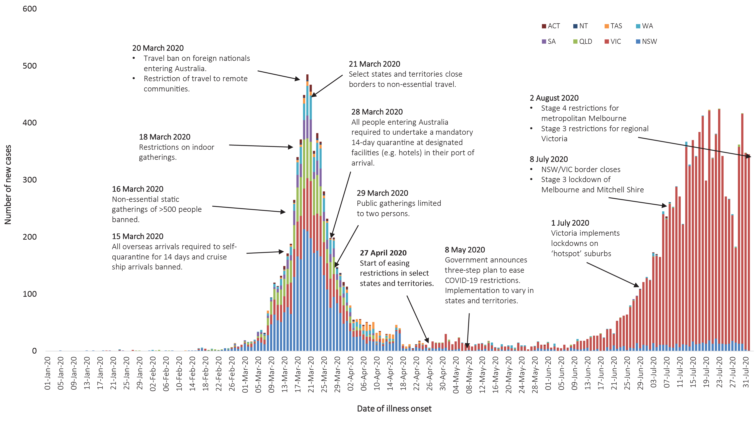

During the current reporting period, due to the evolving epidemiological and public health situation, several states and territories have re-implemented previously eased restrictions and/or implemented new restrictions (see Table 9). In Victoria, residents in metropolitan Melbourne have been placed under stage 4 restrictions, and residents in regional Victoria have been placed under stage 3 restrictions. Residents in Victoria are required to wear facemasks when leaving their home, and residents in New South Wales are strongly encouraged to wear facemasks in indoor settings with a high risk of transmission. Queensland, South Australia and Tasmania have adjusted domestic border restrictions. New South Wales and South Australia have also adjusted some restrictions on public gatherings.

Table 9: State and territory changes to COVID-19 restrictions, from 20 July to 2 August 2020
Jurisdiction | Summary of changes to COVID-19 restrictions
New South Wales | From 31 July, the following restrictions on gatherings and movement were implemented:¹¹  - Gyms required to have a COVID-19 Safety Hygiene Marshal present at all times and registered as COVID Safe  - Up to 20 people permitted in households or outdoor public gatherings  - Funerals permitted up to 100 mourners and weddings permitted up to 150 attendees subject to the 4 square metre rule  From 2 August, it was recommended that facemasks be used in indoor settings with high risk of transmission (e.g. places of worship, supermarkets).¹²
Victoria | From 2 August, the following restrictions were implemented:¹³  - Stage 4 restrictions in place for metropolitan Melbourne  - Curfew from 8 pm to 5 am  - Only permitted to leave house for work, essential health, care or safety reasons, and to shop for essential goods and services  - Only permitted to travel within 5 km of home residence  - Stage 3 restrictions in place for regional Victoria  - Only permitted to leave home to shop for essential goods, provide care, seek medical treatment, exercise, work or study (if this can’t be done at home)  - All Victorians required to wear a facemask when leaving home
Queensland | From 24 July, the following restrictions were implemented:  - All patrons in food and drink venues must be seated when eating and drinking  - COVID SAFE Event Plans required for events with more than 500 people  From 31 July, travellers from other States and Territories are not required to quarantine if they pass through a hotspot, provided they adhere to restrictions.¹⁴
Western Australia | No further easing of restrictions has occurred during this reporting period.¹⁵
South Australia | From 29 July, the following restrictions were implemented:¹⁶  - South Australians no longer able to return from Victoria, unless essential traveller  - A cap of 100 people for funerals and weddings  - A cap of 50 for gatherings in private homes  - Cross border communities must reside within 40 km of border (previously 50 km)
Tasmania | From 31 July, the following amendments to border restrictions were implemented:¹⁷  - Essential travellers from affected regions (currently Victoria) required to undertake a COVID-19 test and screening on arrival  - Individuals entering mandatory government-designated accommodation required to pay a fee
Australian Capital Territory | No changes during this reporting period.¹⁸
Northern Territory | No changes during this reporting period.¹⁹

International situation
On 2 August 2020, more than 216 countries, regions and areas had reported 17,660,523 COVID-19 cases and 680,894 deaths to WHO.²⁰ All data reported below are drawn from the WHO Dashboard extracted on 5 August unless otherwise specified. The Americas and Europe continue to be the epicentres of the pandemic with the former representing approximately 54% of cumulative cases and 53% of cumulative deaths, and the latter representing 19% of cases and 32% of deaths. The global case fatality rate (CFR) is approximately 3.9% and is decreasing as case identification improves. The global cumulative per capita rates are 226.5 cases and 8.8 deaths per 100,000 population.
- By country, the largest numbers of cases are from: the United States of America (4,456,389); Brazil (2,610,102); and India (1,695,988).
- By country, the largest numbers of deaths are from: the United States of America (151,265); Brazil (91,263); and the United Kingdom (46,119).
In the previous fortnight the largest number of cases were reported by the Americas (57%) and the South East Asian (21%) regions, led predominantly by the countries highlighted above.

Western Pacific Region
To date, the Western Pacific Region is the least affected region on the globe, reporting the lowest number of COVID-19 cases and deaths. The cumulative number of cases in this region stands at approximately 313,000, with approximately 56,000 new cases reported in the previous fortnight (22% increase). This represents 1.6% of the global total number of new cases reported in the period. Cumulatively, the Western Pacific region accounts for 1.8% of all cases globally and 1.2% of all deaths. This region has so far reported a cumulative rate of 16.5 cases per 100,000 people and a mortality rate of 0.4 deaths per 100,000 population, which is low when compared to the global rates.
The highest numbers of cases in the region have been observed in the Philippines, China and Singapore. Their epidemic trajectories are shown in Figure 12. However, in the past fortnight the greatest numbers of new cases have been observed in the Philippines (54%) and Japan (21%). There were three countries/territories that did not report any new cases in the previous fortnight (Brunei Darussalam, New Caledonia and French Polynesia).

Figure 12: Number of COVID-19 cases (logarithmic scale) by selected country and days since passing 100 cases, up to 2 August 2020
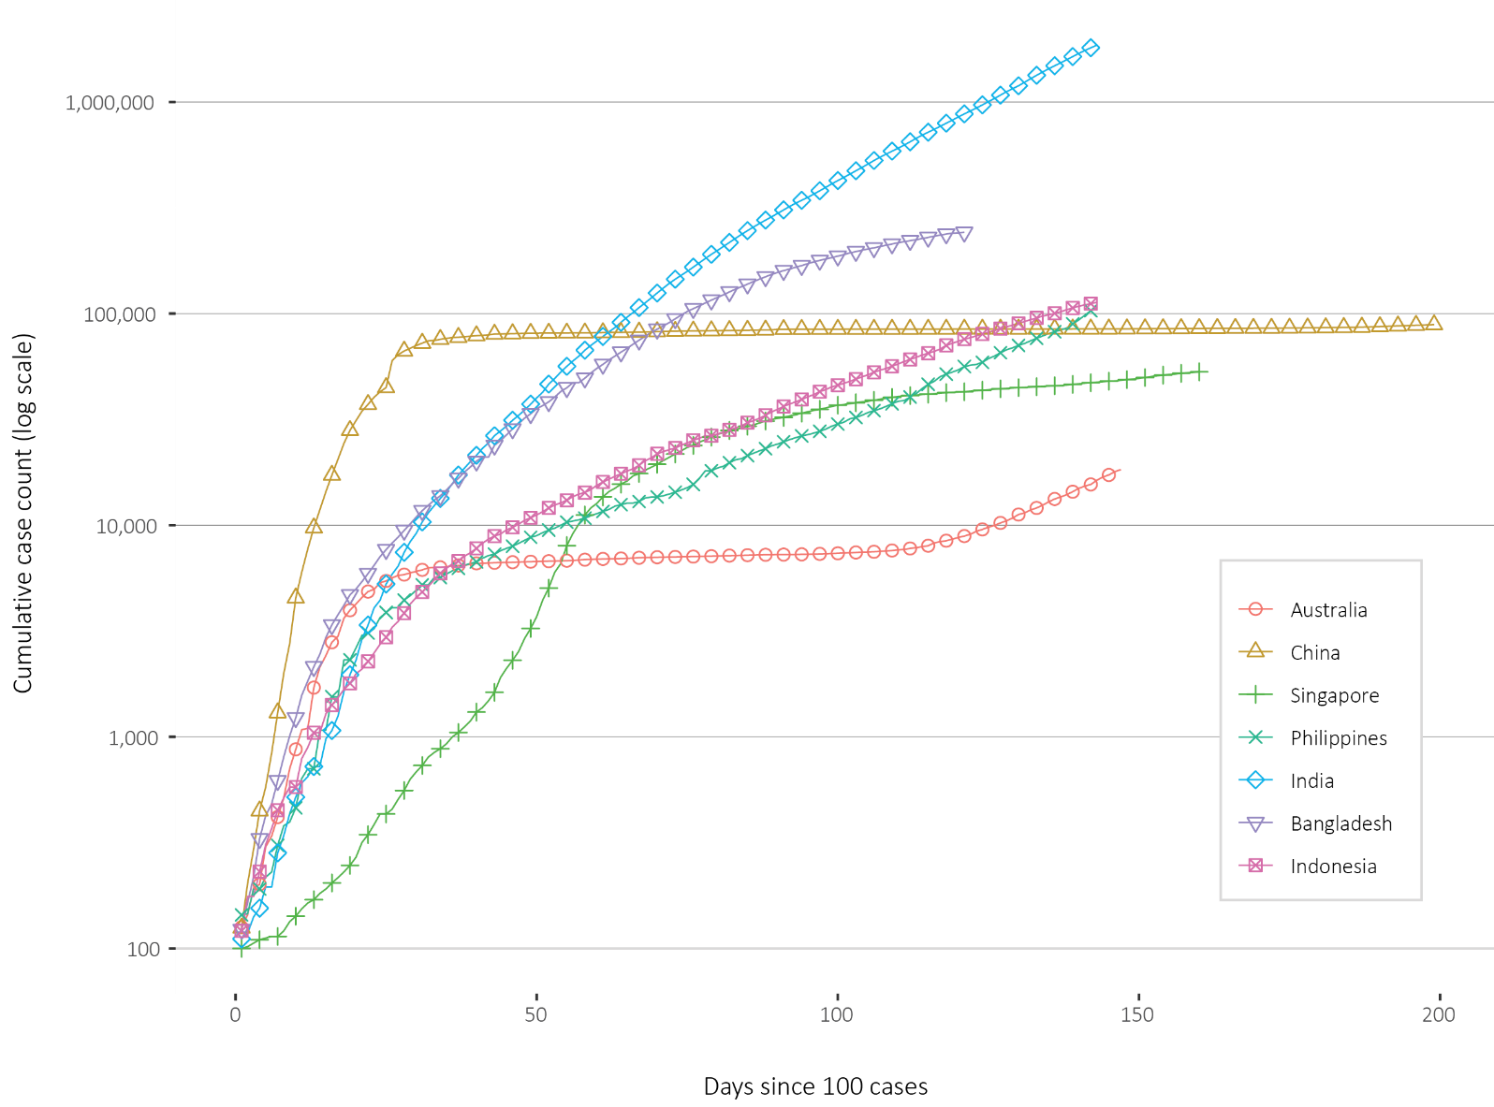
In the past fortnight Papua New Guinea has reported a large growth in case numbers, growing by 730% over the fortnight with a cumulative total of 110 cases.²¹ The new cases have predominantly been identified in Port Moresby, with the exception of two cases in Lae, and the national pandemic response controller indicates that community transmission is occurring. Port Moresby has been placed into a 14-day lockdown and community-based testing has commenced. An Australian Medical Assistance Team has been enacted to assist the COVID-19 response in the country. Vietnam has reported community transmission of a more infectious strain of the virus, with 144 new cases since 25 July, predominantly in the Da Nang area.²² Three deaths have also been reported, the country’s first. These occurred in older people with comorbidities.

South East Asia Region
In this fortnight, the South East Asia region has seen a large growth in new case numbers. Cumulatively the region has reported approximately 2.07 million cases and 44,900 deaths, with approximately 724,000 cases reported in the last fortnight (a 54% increase). Cumulatively, the region accounts for 11.9% of global cumulative cases and 6.7% of global cumulative deaths. Regionally, the per capita burden of disease is relatively low, compared to the global rates, at 103.8 cases and 2.2 deaths per 100,000 population, though the case rate has increased sharply in this reporting period.
The majority of the cases in the region have been observed almost exclusively in India, Bangladesh and Indonesia, which also comprise the greatest proportion of new cases in the previous fortnight, at 91%, 5% and 4% respectively. Their epidemic trajectories are shown in Figure 11. The remaining countries combined have reported only 3,418 cases. India reported the greatest rise in case count, increasing by 63% over the reporting period. The Maldives is the most affected country in the region per capita, reporting 701.1 cases per 100,000 people. Only Timor-Leste did not report a case in the previous fortnight.

Data considerations
Data were extracted from the NNDSS on 5 August 2020 for notifications received up to 2 August. Due to the dynamic nature of the NNDSS, numbers presented in this report are subject to revision and may vary from numbers previously reported and from case notifications released by states and territories.
Data were extracted from the FluCAN and SPRINT-SARI (Short Period Incidence Study of Severe Acute Respiratory Infection) databases on 8 August for data up to 7 August 2020.
FluCAN is a sentinel passive surveillance system which captures COVID-19 cases confirmed by nucleic acid testing admitted to participating hospitals.²³ Case fatality is based on currently available data at the time of reporting and is likely to underestimate the true mortality.
SPRINT SARI is a hospital-based surveillance database that enables real time tracking and reporting of the sickest patients with COVID-19 in Australian hospitals and Intensive Care Units.²⁴

Definitions
‘Date of illness onset’ is derived from data collected by the NNDSS and represents the diagnosis date, or reported true onset of disease date. If unknown, the earliest of specimen collection date, notification date or notification receive date is used.
‘Notification received date’ is reported in the NNDSS and represents the date the case is first notified on the NNDSS. As notification can only occur after testing is completed and information processed, counts for a defined period will vary according to the date type used.
‘Cluster’ in relation to COVID-19 refers to two or more cases (who do not reside in the same household) that are epidemiologically related in time, place or person where a common source (such as an event or within a community) of infection is suspected but not yet established.
‘Outbreak’ in relation to COVID-19 refers to two or more cases (who do not reside in the same household) among a specific group of people and/or over a specific period of time where illness is associated with a common source (such as an event or within a community). Some states and territories may report a single case associated with a residential aged care facility as an outbreak.

Acknowledgements
This report represents surveillance data reported through CDNA as part of the nationally-coordinated response to COVID-19. We thank public health staff from incident emergency operations centres in state and territory health departments, and the Australian Government Department of Health, along with state and territory public health laboratories.

Author details

Corresponding author
COVID-19 National Incident Room Surveillance Team, Australian Government Department of Health, GPO Box 9484, MDP 14, Canberra, ACT 2601. Email: epi.coronavirus@health.gov.au

References
- Dalton C, Durrheim D, Fejsa J, Francis L, Carlson S, d’Espaignet ET et al.Flutracking: a weekly Australian community online survey of influenza-like illness in 2006, 2007 and 2008. Commun Dis Intell Q Rep. 2009;33(3):316-22.
- Australian Government Department of Health. Coronavirus (COVID-19) advice for the health and aged care sector. [Internet.] Canberra: Australian Government Department of Health; 2020. [Accessed 13 August 2020.] Available from: https://www.health.gov.au/news/health-alerts/novel-coronavirus-2019-ncov-health-alert/coronavirus-covid-19-advice-for-the-health-and-aged-care-sector.
- Communicable Diseases Network Australia (CDNA). Coronavirus disease 2019 (COVID-19) outbreaks in residential care facilities: CDNA national guidelines for the prevention, control and public health management of COVID-19 outbreaks in residential care facilities in Australia. Canberra: Australian Government Department of Health, CDNA; 13 March 2020. [Accessed on 13 August 2020.] Available from: https://www.health.gov.au/sites/default/files/documents/2020/03/coronavirus-covid-19-guidelines-for-outbreaks-in-residential-care-facilities.pdf.
- Public Health Agency of Canada (PHAC). Coronavirus disease 2019 (COVID-19). Epidemiology update. Updated: June 22, 2020, 7 pm EDT. [Internet.] Ottawa: Government of Canada, PHAC; 2020. [Accessed on 30 July 2020.] Available from: https://health-infobase.canada.ca/covid-19/epidemiological-summary-covid-19-cases.html.
- European Centre for Disease Prevention and Control (ECDC). Weekly COVID-19 country overview: Week 30, 2020. [Internet.] Solna: ECDC; 31 July 2020. [Accessed on 4 August 2020.] Available from: https://www.ecdc.europa.eu/en/covid-19/country-overviews.
- Docherty AB, Harrison EM, Green CA, Hardwick HE, Pius R, Norman L et al. Features of 20 133 UK patients in hospital with covid-19 using the ISARIC WHO Clinical Characterisation Protocol: prospective observational cohort study. BMJ. 2020;369:m1985. doi: http://dx.doi.org/10.1136/bmj.m1985.
- Statistics Canada. Table 13-10-0775-01. Detailed preliminary information on cases of COVID-19: 6 Dimensions (Aggregated data), Public Health Agency of Canada. [Internet.] Ottawa: Statistics Canada; 2020. [Accessed on 10 July 2020.] Available from: https://www150.statcan.gc.ca/t1/tbl1/en/tv.action?pid=1310077401.
- Intensive Care National Audit and Research Centre (ICNARC). ICNARC report on COVID-19 in critical care 24 July 2020. London: ICNARC; 2020. [Accessed on 4 August 2020.] Available from: https://www.icnarc.org/Our-Audit/Audits/Cmp/Reports.
- ICNARC. Table Appendix 2020-07-31.xlsx. [Downloadable resource.] London: ICNARC; 2020. [Accessed on 4 August 2020.] Available from: https://www.icnarc.org/DataServices/Attachments/Download/c31dd38d-d77b-ea11-9124-00505601089b.
- Centers for Disease Control and Prevention (CDC). COVID-Net: a weekly summary of U.S. COVID-19 hospitalization data. COVID-19 laboratory-confirmed hospitalizations: preliminary data as of May 23, 2020. [Internet.] Atlanta: United States Government Department of Health and Human Services, CDC; 2020. [Accessed on 3 June 2020.] Available from: https://gis.cdc.gov/grasp/COVIDNet/COVID19_5.html.
- Government of New South Wales. What you can and can’t do under the rules: outdoor public gatherings. [Internet.] Sydney: Government of New South Wales; 2020. [Accessed on 4 August 2020.] Available from: https://www.nsw.gov.au/covid-19/what-you-can-and-cant-do-under-rules#outdoor-public-gatherings.
- Government of New South Wales. Health advice update on masks. [Internet.] Sydney: Government of New South Wales; 2 August 2020. [Accessed on 4 August 2020.] Available from: https://www.nsw.gov.au/media-releases/health-advice-update-on-masks.
- Department of Health and Human Services (DHHS). Stage 4 restrictions. [Internet.] Melbourne: Victoria State Government, DHHS; 2020. [Accessed on 4 August 2020.] Available from: https://www.nsw.gov.au/media-releases/health-advice-update-on-masks.
- Queensland Government. Border restrictions. [Internet.] Brisbane: Queensland Government; 2020. [Accessed on 4 August 2020.] Available from: https://www.qld.gov.au/health/conditions/health-alerts/coronavirus-covid-19/current-status/public-health-directions/border-restrictions.
- Government of Western Australia. COVID-19 coronavirus: WA Roadmap. [Internet.] Perth: Government of Western Australia; 2020. [Accessed on 4 August 2020.] Available from: https://www.wa.gov.au/organisation/department-of-the-premier-and-cabinet/covid-19-coronavirus-wa-roadmap.
- Government of South Australia. Recovery from COVID-19. [Internet.] Adelaide: Government of South Australia; 2020. [Accessed on 4 August 2020.] Available from: https://www.covid-19.sa.gov.au/recovery.
- Tasmanian Government. Roadmap to recovery. [Internet.] Hobart: Tasmanian Government; 2020. [Accessed on 4 August 2020.] Available from: https://coronavirus.tas.gov.au/families-community/roadmap-to-recovery.
- Australian Capital Territory Government. Canberra’s recovery plan: easing of restrictions. [Internet.] Canberra: Australian Capital Territory Government; 2020. [Accessed on 4 August 2020.] Available from: https://www.covid19.act.gov.au/community/canberra-recovery.
- Northern Territory Government. Roadmap to the new normal: other information. [Internet.] Darwin: Northern Territory Government; 2020. [Accessed on 4 August 2020.] Available from: https://coronavirus.nt.gov.au/roadmap-new-normal#section2.
- World Health Organization (WHO). Coronavirus disease 2019 (COVID-19) situation report – 195. [Internet.] Geneva: WHO; 2020. [Accessed on 5 August 2020.] Available from: https://www.who.int/docs/default-source/coronaviruse/situation-reports/20200802-covid-19-sitrep-195.pdf.
- Papua New Guinea National Department of Health, World Health Organization (WHO) Representative Office for Papua New Guinea. Papua New Guinea Coronavirus Disease 2019 (COVID-19) Health Situation Report #32: 02 August 2020. Port Moresby: Papua New Guinea National Department of Health; 2020. [Accessed on 5 August 2020.] Available from: https://www.who.int/docs/default-source/wpro---documents/countries/papua-new-guinea/covid-19/png-covid-19-health-situation-report-32.pdf.
- Government of Vietnam Ministry of Health. Tightening the entire system, putting forces in Da Nang, 2 Aug 2020. Viet Nam Ministry of Health Press Release. [Internet.] Hanoi: Government of Vietnam Ministry of Health; 2020. [Accessed on 5 August 2020.] Available from: https://ncov.moh.gov.vn/web/guest/-/siet-chat-toan-bo-he-thong-don-luc-dap-dich-o-a-nang.
- Monash Health. FluCAN (Influenza surveillance): FluCAN (The Influenza Complications Alert Network) [Internet.] Melbourne: Monash Health; 2020. Available from: https://monashhealth.org/services/monash-infectious-diseases/research/influenza-research/flucan-influenza-surveillance-2/.
- Australian and New Zealand Intensive Care Society (ANZICS). SPRINT-SARI: Short period incidence study of severe acute respiratory infection. [Internet.] Camberwell: ANZICS; 19 March 2020. [Accessed on 9 July 2020.] Available from: https://www.anzics.com.au/current-active-endorsed-research/sprint-sari/.
- WHO. Report of the WHO-China joint mission on coronavirus disease 2019 (COVID-19). [Internet.] Geneva: WHO; 2020. [Accessed 1 Mar 2020.] Available from: https://www.who.int/docs/default-source/coronaviruse/who-china-joint-mission-on-covid-19-final-report.pdf.
- Harding H, Broom A, Broom J. Aerosol-generating procedures and infective risk to healthcare workers from SARS-CoV-2: the limits of the evidence. J Hosp Infect. 2020;105(4):717–25.
- Morawska L, Milton DK. It is time to address airborne transmission of COVID-19. Clin Infect Dis. 2020;ciaa939. doi: https://doi.org/10.1093/cid/ciaa939.
- WHO. Transmission of SARS-CoV-2: implications for infection prevention precautions. [Internet.] Geneva: WHO; 9 July 2020. [Accessed on 28 July 2020.] Available from: https://www.who.int/news-room/commentaries/detail/transmission-of-sars-cov-2-implications-for-infection-prevention-precautions.
- Pulinx B, Kieffer D, Michiels I, Petermans S, Strybol D, Delvaux S et al. Vertical transmission of SARS-CoV-2 infection and preterm birth. Eur J Clin Microbiol Infect Dis. 2020. doi: https://doi.org/10.1007/s10096-020-03964-y.
- ECDC. Rapid risk assessment: Paediatric inflammatory multisystem syndrome and SARS-CoV-2 infection in children – 15 May 2020. Solna: ECDC; 2020. [Accessed on 19 May 2020.] Available from: https://www.ecdc.europa.eu/sites/default/files/documents/covid-19-risk-assessment-paediatric-inflammatory-multisystem-syndrome-15-May-2020.pdf.
- WHO. Coronavirus disease 2019 (COVID-19) situation report – 29. [Internet.] Geneva: WHO; 2020. [Accessed 22 Feb 2020.] Available from: https://www.who.int/docs/default-source/coronaviruse/situation-reports/20200218-sitrep-29-covid-19.pdf.
- Pung R, Chiew CJ, Young BE, Chin S, Chen M, Clapham HE. Investigation of three clusters of COVID-19 in Singapore: implications for surveillance and response measures. Lancet. 2020;395(10229):1039–46.
- Park M, Cook AR, Lim JT, Sun Y, Dickens BL. A systematic review of COVID-19 epidemiology based on current evidence. J Clin Med. 2020;9(4):967.
- WHO. Coronavirus disease 2019 (COVID-19) situation report – 73. [Internet.] Geneva: WHO; 2020. [Accessed on 4 August 2020.] Available from: https://www.who.int/docs/default-source/coronaviruse/situation-reports/20200402-sitrep-73-Covid-19.pdf.
- WHO. Criteria for releasing COVID-19 patients from isolation: scientific brief. [Internet.] Geneva: WHO; 17 June 2020. [Accessed on 4 August 2020.] Available from: https://www.who.int/news-room/commentaries/detail/criteria-for-releasing-covid-19-patients-from-isolation.
- Wölfel R, Corman VM, Guggemos W, Seilmaier M, Zange S, Müller MA et al. Virological assessment of hospitalized patients with COVID-2019. Nature. 2020. doi: https://doi.org/10.1038/s41586-020-2196-x.
- He X, Lau EHY, Wu P, Deng X, Wang J, Hao X. Temporal dynamics in viral shedding and transmissibility of COVID-19. Nat Med. 2020;26(5):672-675.
- WHO Regional Office for the Eastern Mediterranean. Transmission of COVID-19 by asymptomatic cases. [Internet.] Geneva: WHO; 11 June 2020. [Accessed on 4 August 2020.] Available from: http://www.emro.who.int/health-topics/corona-virus/transmission-of-covid-19-by-asymptomatic-cases.html.
- Lennon NJ, Bhattacharyya RP, Mina MJ, Rehm HL, Hung DT, Smole S et al. Comparison of viral levels in individuals with or without symptoms at time of COVID-19 testing among 32,480 residents and staff of nursing homes and assisted living facilities in Massachusetts. medRxiv. 2020. doi: https://doi.org/10.1101/2020.07.20.20157792.
- Cheng HY, Jian SW, Liu DP, Ng TC, Huang WT, Lin HH. Contact tracing assessment of COVID-19 transmission dynamics in Taiwan and risk at different exposure periods before and after symptom onset. JAMA Intern Med. 2020. doi: https://doi.org/10.1001/jamainternmed.2020.2020.
- Chandrashekar A, Liu J, Martinot AJ, McMahan K, Mercado NB, Peter L et al. Deng W, Bao L, Liu J, Xiao C, Liu J, Xue J et al. SARS-CoV-2 infection protects against rechallenge in rhesus macaques. Science. 2020;eabc4776. doi: https://doi.org/10.1126/science.abc4776.
- Deng W, Bao L, Liu J, Xiao C, Liu J, Xue J et al. Primary exposure to SARS-CoV-2 protects against reinfection in rhesus macaques. Science. 2020;eabc5343. doi: https://doi.org/10.1126/science.abc5343.
- Seow J, Graham C, Merrick B, Acors S, Steel KJA, Hemmings O et al. Longitudinal evaluation and decline of antibody responses in SARS-CoV-2 infection. medRxiv. 2020. doi: https://doi.org/10.1101/2020.07.09.20148429.
- Korea Centers for Disease Control and Prevention (KCDC). Division of risk assessment and international cooperation. Findings from investigation and analysis of re-positive cases. [Internet.] Cheongju: Government of South Korea, KCDC; 2020. [Accessed on 24 May 2020.] Available from: https://www.cdc.go.kr/board/board.es?mid=a30402000000&bid=0030&act=view&list_no=367267&nPage=1.
- Rockett RJ, Arnott A, Lam C, Sadsad R, Timms V, Gray KA et al. Revealing COVID-19 transmission in Australia by SARS-CoV-2 genome sequencing and agent-based modeling. Nat Med. 2020. doi: https://doi.org/10.1038/s41591-020-1000-7.
- Seemann T, Lane C, Sherry N, Duchene S, Goncalves da Silva A, Caly L et al. Tracking the COVID-19 pandemic in Australia using genomics. medRxiv. 2020 doi: https://doi.org/10.1101/2020.05.12.20099929.
- Eden JS, Rockett R, Carter I, Rahman H, de Ligt J, Hadfield J et al. An emergent clade of SARS-CoV-2 linked to returned travellers from Iran. Virus Evol. 2020;6(1):veaa027. doi: https://doi.org/10.1093/ve/veaa027.
- Sun P, Qie S, Liu Z, Ren J, Li K, Xi JJ. Clinical characteristics of hospitalized patients with SARS-CoV-2 infection: A single arm meta-analysis. J Med Virol. 2020;92(6):612–7. doi: https://doi.org/10.1002/jmv.25735.
- Li B, Bai W, Hashikawa T. The neuroinvasive potential of SARS-CoV-2 may be at least partially responsible for the respiratory failure of COVID-19 patients. J Med Virol. 2020. doi: https://doi.org/10.1002/jmv.25728.
- Mao L, Jin H, Wang M, Hu Y, Chen S, He Q et al. Neurological manifestations of hospitalized patients with coronavirus disease 2019 in Wuhan, China. JAMA Neurol. 2020;e201127. doi: https://doi.org/10.1001/jamaneurol.2020.1127.
- Drew DA, Nguyen LH, Steves CJ, Menni C, Freydin M, Varsavsky T et al. Rapid implementation of mobile technology for real-time epidemiology of COVID-19. Science. 2020;368(6497):1362–7. doi: https://doi.org/10.1126/science.abc0473.
- Ellul MA, Benjamin L, Singh B,Lant S, Michael BD, Easton A et al. Neurological associations of COVID-19. Lancet Neurol. 2020. doi: https://doi.org/10.1016/S1474-4422(20)30221-0.
- Venkatakrishnan AJ, Puranik A, Anand A, Zemmour D, Yao X, Wu X et al. Knowledge synthesis of 100 million biomedical documents augments the deep expression profiling of coronavirus receptors. Elife. 2020;9:e58040. doi: https://doi.org/10.7554/eLife.58040.
- Brann DH, Tsukahara T, Weinreb C, Lipovsek M, Van den Berge K, Gong B et al. Non-neural expression of SARS-CoV-2 entry genes in the olfactory epithelium suggests mechanisms underlying anosmia in COVID-19 patients. Sci Adv. 2020;6(31):eabc5801. doi: https://doi.org/10.1126/sciadv.abc5801.
- Inciardi RM, Lupi L, Zaccone G, Italia L, Raffo M, Tomasoni D et al. Cardiac involvement in a patient with coronavirus disease 2019 (COVID-19). JAMA Cardiol. 2020. doi: https://doi.org/10.1001/jamacardio.2020.1096.
- Guo T, Fan Y, Chen M, Wu X, Zhang L, He T et al. Cardiovascular implications of fatal outcomes of patients with coronavirus disease 2019 (COVID-19). JAMA Cardiol. 2020. doi: https://doi.org/10.1001/jamacardio.2020.1017.
- Madjid M, Safavi-Naeini P, Solomon SD, Vardeny O. Potential effects of coronaviruses on the cardiovascular system: a review. JAMA Cardiol. 2020. doi: https://doi.org/10.1001/jamacardio.2020.1286.
- Riphagen S, Gomez X, Gonzalez-Martinez C, Wilkinson N, Theocharis P. Hyperinflammatory shock in children during COVID-19 pandemic. Lancet. 2020. doi: https://doi.org/10.1016/S0140-6736(20)31094-1.
- Morand A, Urbina D, Fabre A. COVID-19 and Kawasaki like disease: the known-known, the unknown-known and the unknown-unknown. Preprints. 2020;2020050160. doi: https://doi.org/10.20944/preprints202005.0160.v1.
- WHO. Clinical management of severe acute respiratory infection when novel coronavirus (nCoV) infection is suspected. [Internet.] Geneva: WHO; 2020. [Accessed 23 Feb 2020.] Available from: https://www.who.int/publications-detail/clinical-management-of-severe-acute-respiratory-infection-when-novel-coronavirus-(ncov)-infection-is-suspected.
- Harrison C. Coronavirus puts drug re-purposing on the fast track. Nat Biotechnol. 2020. doi: https://doi.org/10.1038/d41587-020-00003-1.
- Wang M, Cao R, Zhang L, Yang X, Liu J, Xu M et al. Remdesivir and chloroquine effectively inhibit the recently emerged novel coronavirus (2019-nCoV) in vitro. Cell Research. 2020;30;269–71.
- Tang W, Cao Z, Han M, Wang Z, Chen W, Sun W et al. Hydroxychloroquine in patients with mainly mild to moderate coronavirus disease 2019: open label, randomised controlled trial. BMJ. 2020. doi: https://doi.org/10.1136/bmj.m1849.
- Cao B, Wang Y, Wen D, Liu W, Wang J, Fan G et al. A trial of lopinavir–ritonavir in adults hospitalized with severe Covid-19. N Engl J Med. 2020;382:1787–99.
- WHO. “Solidarity” clinical trial for COVID-19 treatments. [Internet.] Geneva: WHO; 2020. [Accessed on 4 August 2020.] Available from: https://www.who.int/emergencies/diseases/novel-coronavirus-2019/global-research-on-novel-coronavirus-2019-ncov/solidarity-clinical-trial-for-covid-19-treatments.
- National Institute of Allergy and Infectious Diseases (NIAID). NIH Clinical Trial Shows Remdesivir Accelerates Recovery from Advanced COVID-19. [Internet.] Bethesda: Government of the United States of America, National Institutes of Heath, NIAID; 2020. [Accessed on 19 May 2020.] Available from: https://www.niaid.nih.gov/news-events/nih-clinical-trial-shows-remdesivir-accelerates-recovery-advanced-covid-19.
- Wang Y, Zhang D, Du G, Du R, Zhao J, Jin Y et al. Remdesivir in adults with severe COVID-19: a randomised, double-blind, placebo-controlled, multicentre trial. Lancet. 2020;395(10236);1569–78.
- Therapeutic Goods Administration (TGA). Australia’s first COVID treatment approved. [Internet.] Canberra: Australian Government Department of Health, TGA; 10 July 2020. [Accessed on 4 August 2020.] https://www.tga.gov.au/media-release/australias-first-covid-treatment-approved.
- WHO. Draft landscape of COVID-19 candidate vaccines. [Internet.] Geneva: WHO; 2020. [Accessed on 4 August 2020.] Available from: https://www.who.int/publications/m/item/draft-landscape-of-covid-19-candidate-vaccines.
- University of Oxford. Low-cost dexamethasone reduces death by up to one third in hospitalised patients with severe respiratory complications of COVID-19. [News release.] Oxford: University of Oxford; 16 June 2020. [Accessed on 24 June 2020.] Available from: https://www.recoverytrial.net/files/recovery_dexamethasone_statement_160620_final.pdf.

Appendix A: Background
Last updated 4 August 2020
Epidemiological parameters of SARS-CoV-2 infection and COVID-19 disease are under investigation and are likely to change as more information becomes available. The information provided in this Appendix comes from peer-reviewed and official sources. Pre-prints that have not been peer reviewed have been referenced and are identified in the text.

Modes of transmission
Human-to-human transmission of SARS-CoV-2 is primarily via droplets and fomites from an infected person to a close contact.²⁵
Airborne transmission may occur through medical aerosol generating procedures, and although there are limited studies in the literature to evaluate the risk of specific procedures, it is prudent for health care workers to continue to undertake appropriate precautions.²⁶ The potential for transmission by aerosols in other settings is the subject of discussion.²⁷
SARS-CoV-2 may cause intestinal infection and viral shedding in faeces has been reported, but there are no reports of faecal-oral transmission.²⁸
There is limited information about the potential for vertical transmission; however, SARS-CoV-2 RNA has been detected in placental tissue and amniotic fluid associated with a stillbirth in Belgium,²⁹ suggesting it may be possible under some circumstances.
Several studies suggest that children do not play a key role in transmission and are unlikely to be the primary source of infections.³⁰ Studies from the EU have suggested that child-to-adult transmission is uncommon.^{31,32}

Incubation period
A systematic review of published and preprint studies has estimated the median incubation period of COVID-19 as between 5 and 6 days (ranging from 1 to 14 days).^{33,34}

Infectious period
The infectious period is not well described due to a lack of studies using virus isolation to assess the presence of viable SARS-CoV-2 over time following infection.³⁵
Viral RNA has been identified in respiratory tract specimens 1–2 days prior to symptom onset, and has been observed after symptom cessation.³⁶ A retrospective analysis of 77 pairs of primary and secondary cases suggested that infectiousness may commence from 2.3 days before symptom onset, peaking at 0.7 days before symptom onset. It also suggested 44% of secondary cases may have been infected before the primary case was symptomatic.³⁷
Cases can be infectious while not displaying symptoms, although it is not clear whether these individuals are pre-symptomatic or truly asymptomatic. Current World Health Organization (WHO) advice is that asymptomatic individuals are less infectious than people who display symptoms.³⁸ However, a cross-sectional study in Massachusetts USA of residents and staff in aged care settings demonstrated that viral shedding was similar between people who were symptomatic and not symptomatic at the time of sampling.³⁹ This study has not yet been peer reviewed.
Viral RNA levels peak in the first week of illness, suggesting transmission is most likely to occur early with infectivity gradually decreasing over time.³⁶ In a Taiwanese study examining over 2,500 close contacts of 100 patients with COVID-19, all 22 secondary cases had their first exposure to the index case within six days of symptom onset. No infections were documented in the 850 contacts whose exposure was after six days.⁴⁰

Immunology
No correlates of immunity have been established but two challenge trials of rhesus macaques suggest that individuals with neutralising antibody titres between 8 and 200 were protected from clinical signs of disease (but not viral shedding) when exposed to SARS-CoV-2 at 28 and 35 days after initial challenge.^{41,42} Cell-mediated immunity has also been demonstrated in recovered people, but the importance of cell-mediated and humoral immunity in clinical recovery and protection against infection and disease requires further study.
In a study of nine cases in Germany, around 50% of the patients seroconverted occurred seven days after symptom onset, and all patients had seroconverted by 14 days. Infectious virus was not able to be isolated from naso/oropharyngeal and sputum samples after the first 8 days of illness.³⁶
The duration of humoral antibody response is not well characterised. A cohort study of 96 SARS-CoV-2 infected people in the United Kingdom demonstrated that serum neutralising antibody responses waned after 40 days post infection, and individuals who had experienced milder symptoms had no neutralisation response at around 60 days post infection.⁴³ This study has not been peer reviewed.
The potential for reinfection or recrudescence of infection is also unclear. However, analysis from the Korea Centres for Disease Control and Prevention, of 108 cases who tested positive after previously being cleared from isolation, found live virus was unable to be cultured from any cases selected for testing.⁴⁴

Viral genomics
Since December 2019, the virus has diversified into multiple lineages as it has spread globally, with some degree of geographical clustering. There are currently 2,728 SARS-CoV-2 genome sequences available from Australian cases on the global sequence repository, GISAID. These sequences are dispersed throughout the global lineages, reflecting multiple concurrent introductions into Australia.^{45–47} Recent Australian SARS-CoV-2 sequences from the last month include 31 collected from NSW and 7 from South Australia. Most of these sequences belong to the B.1.1.25 lineage, reflecting ongoing local transmission of this lineage. Genomic epidemiology continues to be used to support epidemiological investigations, particularly for confirming presumed transmission pathways. It has proven particularly useful for linking those cases classified as ‘locally-acquired – contact not identified’ to known genomic clusters, highlighting the utility of virus sequencing to informing the public health response.^{45,46}

Clinical features
COVID-19 presents as mild illness in the majority of cases, with cough and fever the most commonly reported symptoms (see Appendix B). Severe or fatal outcomes are more likely to occur in the elderly or those with comorbid conditions.^{25,48}
Some COVID-19 patients show neurological signs such as headache, nausea and vomiting. There is evidence that SARS-CoV-2 viruses are not always confined to the respiratory tract and may invade the central nervous system causing neurological signs and symptoms. As such, it is possible that invasion of the central nervous system is partially responsible for the acute respiratory failure of COVID-19 patients.⁴⁹
Impairment or loss of the sense of smell (hyposmia/anosmia) or taste (hypoguesia/aguesia) is commonly associated with COVID-19.^{50–52} This is supported by research finding a biological mechanism for the SARS-CoV-2 virus to cause olfactory dysfunction.^{53,54} Case reports have also linked SARS-CoV-2 infection with less common neurological syndromes including encephalopathy, encephalitis, Guillian-Barré syndrome and acute cerebrovascular disease.⁵²
Several studies have also identified linked cardiovascular diseases to COVID-19.^{55–57} Vascular inflammation has been observed in a number of cases and may be a potential mechanism for myocardial injury which can result in cardiac dysfunction and arrhythmias.
COVID-19 disease in children is more likely to be mild and self-limiting, compared to adults. Internationally, children make up a small proportion of confirmed COVID-19 cases, with those shown to be infected either presenting with milder symptoms than adults or remaining asymptomatic. However, the greater likelihood of mild clinical presentation in children may result in lower testing and case detection in this cohort. Studies have also shown that hospital admission is inversely related to age. From European reporting, death associated with COVID-19 has been rare among those aged less than 15 years, with 4 deaths reported from 44,695 cases, as at 13 May 2020.³⁰
There have been reports of a rare clinical presentation of paediatric inflammatory multisystem syndrome resembling Kawasaki disease temporally associated with SARS-CoV-2 infection in children. However, evidence of the association between COVID-19 and the development of a Kawasaki-like disease is currently inconclusive and further investigation is needed due to variability in clinical presentations in reported paediatric cases.^{58,59}

Treatment
Current clinical management of COVID-19 cases focuses on early recognition, isolation, appropriate infection control measures and provision of supportive care.⁶⁰ Whilst there is no specific antiviral treatment currently recommended for patients with suspected or confirmed SARS-CoV-2 infection, multiple clinical trials are underway to evaluate a number of therapeutic agents, including remdesivir, lopinavir/ritonavir, and chloroquine or hydroxychloroquine.^{61,62}
An open-label randomised controlled trial did not find a significant impact of hydroxychloroquine treatment on disease progression for hospitalised patients with mild to moderate COVID-19, with those receiving treatment also reporting a higher number of adverse events.⁶³ Similarly, an open-label randomised controlled trial of lopinavir/ritonavir among hospitalised patients found no benefit for time to clinical improvement.⁶⁴ WHO announced the interruption of clinical trials of hydroxychloroquine and lopinavir/ritonavir under the ‘Solidarity Trial’ on 4 July 2020.⁶⁵
Results for remdesivir treatment have been mixed, with one randomised double-blind placebo-controlled trial finding patients recovered 31% faster and a lower mortality rate (8.0% compared with 11.6% among placebo patients),⁶⁶ while another found no effect.⁶⁷ The Therapeutic Goods Administration has granted provisional approval for use of remdesivir in hospitalised adults and adolescents with severe COVID-19 symptoms.⁶⁸
As at 27 July 2020, the WHO reports that at least 25 candidate vaccines are in clinical trials and 139 are in preclinical evaluation.⁶⁹
Research from the UK has found dexamethasone could significantly reduce death in critically ill patients.⁷⁰ Yet to be published, the preliminary findings announcing by Oxford University reported a 30% reduction in deaths for patients with severe respiratory symptoms. Reduced mortality was observed in ventilated cases and cases requiring oxygen support. No benefit was observed for mild to moderate cases. There are no barriers to the use of dexamethasone in Australian patients who are critically ill, such as cases who require ventilation or oxygen support.⁷⁰

Appendix B: Supplementary figures and tables
Table B.1: COVID-19 case notifications and rates per 100,000 population, by age group and gender, 2 August 2020, Australiaª
Age Group | This reporting period 20 July—2 August 2020 |  |  |  |  |  | Cumulative
Age Group | Cases |  |  | Rate per 100,000 population |  |  | Cases |  |  | Rate per 100,000 population
Age Group | Male | Female | Total | Male | Female | Total | Male | Female | Total | Male | Female | Total
0—10 | 156 | 139 | 301 | 9.5 | 9.0 | 9.4 | 399 | 359 | 764 | 24.4 | 23.2 | 24.0
10—20 | 295 | 281 | 587 | 18.8 | 18.9 | 19.2 | 748 | 652 | 1,413 | 47.6 | 43.8 | 46.2
20—30 | 729 | 774 | 1,529 | 39.1 | 42.9 | 41.7 | 2,023 | 2,153 | 4,223 | 108.6 | 119.3 | 115.1
30—40 | 532 | 536 | 1,082 | 29.3 | 28.9 | 29.5 | 1,655 | 1,511 | 3,194 | 91.0 | 81.5 | 87.0
40—50 | 351 | 413 | 774 | 21.7 | 24.9 | 23.6 | 1,258 | 1,150 | 2,447 | 77.7 | 69.4 | 74.7
50—60 | 306 | 367 | 682 | 20.3 | 23.3 | 22.1 | 1,145 | 1,186 | 2,348 | 76.0 | 75.4 | 76.2
60—70 | 176 | 195 | 375 | 13.8 | 14.5 | 14.4 | 895 | 933 | 1,833 | 70.4 | 69.5 | 70.1
70—80 | 109 | 121 | 231 | 12.5 | 13.1 | 12.9 | 604 | 535 | 1,140 | 69.4 | 58.0 | 63.6
80—90 | 126 | 214 | 341 | 35.2 | 46.4 | 41.7 | 288 | 381 | 670 | 80.6 | 82.6 | 81.9
a Cases and rates for persons include 5 cases with unknown gender.
Figure B.1: Variation in combinations of COVID-19 symptoms in confirmed cases as at 2 August 2020, Australiaª
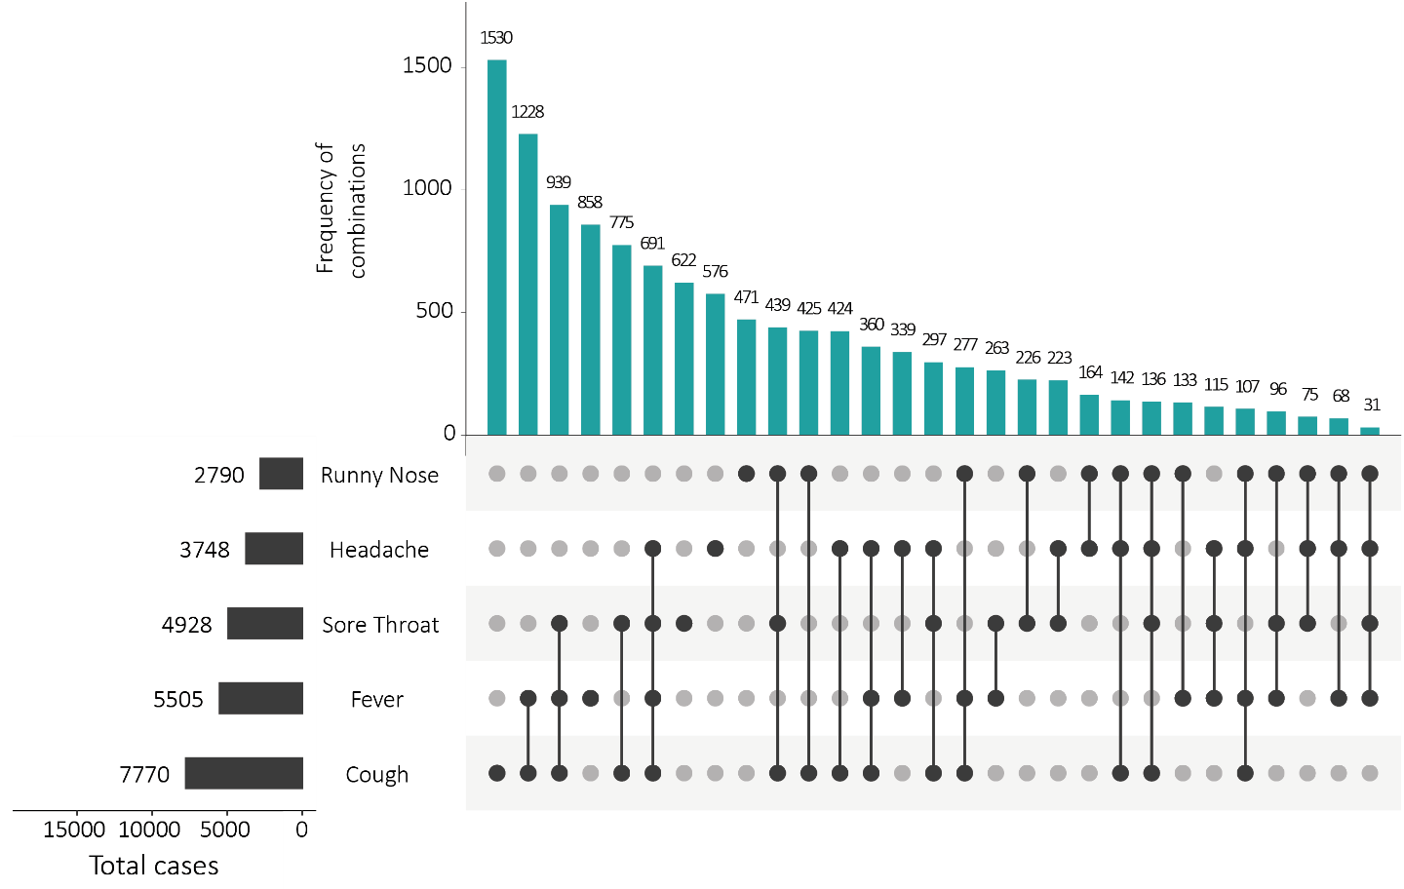
a This figure shows the variation in combinations of symptoms observed in reported cases (n = 12,636) for the five most frequently observed symptoms (cough, fever, headache, sore throat, runny nose). The horizontal bars on the left show the frequency of symptom occurrence in any combination with other symptoms. The circles and lines indicate particular combinations of symptoms observed in individual patients. The vertical green bars indicate the frequency of occurrence of the corresponding combination of symptoms.

Appendix C: Frequently asked questions
Q: Can I request access to the COVID-19 data behind your CDI fortnightly reports?
A: National notification data on COVID-19 confirmed cases is collated in the National Notifiable Disease Surveillance System (NNDSS) based on notifications made to state and territory health authorities under the provisions of their relevant public health legislation.
Normally, requests for the release of data from the NNDSS requires agreement from states and territories via the Communicable Diseases Network Australia, and, depending on the sensitivity of the data sought and proposed, ethics approval may also be required.
Due to the COVID-19 response, unfortunately, specific requests for NNDSS data have been put on hold. We are currently looking into options to be able to respond to data requests in the near future.
We will continue to publish regular summaries and analyses of the NNDSS dataset and recommend the following resources be referred to in the meantime:
- NNDSS summary tables: http://www9.health.gov.au/cda/source/cda-index.cfm
- Daily case summary of cases: https://www.health.gov.au/news/health-alerts/novel-coronavirus-2019-ncov-health-alert/coronavirus-covid-19-current-situation-and-case-numbers
- Communicable Diseases Intelligence COVID-19 epidemiology report: https://www1.health.gov.au/internet/main/publishing.nsf/Content/novel_coronavirus_2019_ncov_weekly_epidemiology_reports_australia_2020.htm
- State and territory public health websites.
Q: Why have the reports changed from weekly to fortnightly?
A: The change to fortnightly reporting is to allow more time for an in-depth analysis of the NNDSS data, therefore enhancing the contents of the report.
Q: Can I request access to data at post-code level of confirmed cases?
A: Data at this level cannot be released without ethics approval and permission would need to be sought from all states and territories via the Communicable Diseases Network Australia. As noted above, specific requests for NNDSS data are currently on hold.
Where current or recent reported case numbers are high enough to justify it, a GIS/mapping analysis of cases will be included in the Communicable Diseases Intelligence COVID-19 epidemiology report. In order to protect privacy of confirmed cases, data in this map will be presented at SA3 level.
Q: Where can I find more detailed data on COVID-19 cases?
A: We are currently looking into ways to provide more in-depth epidemiological analyses of COVID-19 cases, with regard to transmission and severity, including hospitalisation. These analyses will continue to be built upon in future iterations of the Communicable Diseases Intelligence report.

Communicable Diseases Intelligence
ISSN: 2209-6051 Online

Communicable Diseases Intelligence (CDI) is a peer-reviewed scientific journal published by the Office of Health Protection, Department of Health. The journal aims to disseminate information on the epidemiology, surveillance, prevention and control of communicable diseases of relevance to Australia.

Editor: Tanja Farmer
Deputy Editor: Simon Petrie
Design and Production: Kasra Yousefi
Editorial Advisory Board: David Durrheim, Mark Ferson, John Kaldor, Martyn Kirk and Linda Selvey

Website: http://www.health.gov.au/cdi

Contacts
Communicable Diseases Intelligence is produced by:
Health Protection Policy Branch, Office of Health Protection, Australian Government Department of Health
GPO Box 9848, (MDP 6) CANBERRA ACT 2601

Email: cdi.editor@health.gov.au

Submit an Article
You are invited to submit your next communicable disease related article to the Communicable Diseases Intelligence (CDI) for consideration. More information regarding CDI can be found at: http://health.gov.au/cdi.
Further enquiries should be directed to: cdi.editor@health.gov.au.

This journal is indexed by Index Medicus and Medline.

Creative Commons Licence - Attribution-NonCommercial-NoDerivatives CC BY-NC-ND
© 2020 Commonwealth of Australia as represented by the Department of Health
This publication is licensed under a Creative Commons Attribution-NonCommercial-NoDerivatives 4.0 International Licence from https://creativecommons.org/licenses/by-nc-nd/4.0/legalcode (Licence). You must read and understand the Licence before using any material from this publication.

Restrictions
The Licence does not cover, and there is no permission given for, use of any of the following material found in this publication (if any):
- the Commonwealth Coat of Arms (by way of information, the terms under which the Coat of Arms may be used can be found at www.itsanhonour.gov.au);
- any logos (including the Department of Health’s logo) and trademarks;
- any photographs and images;
- any signatures; and
- any material belonging to third parties.

Disclaimer
Opinions expressed in Communicable Diseases Intelligence are those of the authors and not necessarily those of the Australian Government Department of Health or the Communicable Diseases Network Australia. Data may be subject to revision.

Enquiries
Enquiries regarding any other use of this publication should be addressed to the Communication Branch, Department of Health, GPO Box 9848, Canberra ACT 2601, or via e-mail to: copyright@health.gov.au

Communicable Diseases Network Australia
Communicable Diseases Intelligence contributes to the work of the Communicable Diseases Network Australia.
http://www.health.gov.au/cdna

This report addresses indicators listed in the CDNA National Surveillance Plan 2020.

