COVID-19, Australia: Epidemiology Report 20
Fortnightly reporting period ending 5 July 2020
COVID-19 National Incident Room Surveillance Team
Erratum: An error occurred in the caption for Figure 7 (Number of COVID-19 cases (logarithmic scale) by selected country and days since passing 100 cases, up to 5 July 2020) as originally published, which inadvertently listed the wrong date. This has now been amended.
Notified cases of COVID-19 and associated deaths reported to the National Notifiable Diseases Surveillance System (NNDSS) to 5 July 2020
Confirmed cases in Australia notified up to 5 July 2020 |  | 22 June to 5 July
Notificationsª | 8,566 | 897
Deaths | 106 | 4
a On 3 July, 189 historic cases reported in crew members on board a ship were classified as Australian cases and included in Australian totals.

Summary
Over the past fortnightly reporting period (22 June to 5 July):
- The national incidence of COVID-19 remained low, with very few cases reported by most jurisdictions in this reporting period.
- The majority of the current cases reported over this fortnight are from Victoria, with an increasing number and proportion of cases reported as being locally acquired.
- Total case numbers have increased with an average of 54 cases reported on any one day, more than twice the average number reported in the previous reporting period.
- The number and proportion of deaths associated with COVID-19 remains low and it appears that vulnerable populations have not been disproportionately affected by COVID-19 overall.
- Testing rates continue to be high across all jurisdictions, with the nationwide positivity rate remaining very low at less than 0.3%.
In this reporting period, the number of cases reported nationally has increased from 214 (8 June to 21 June) to 897 (22 June to 5 July). Of the cases notified in this reporting period, 87% (781 cases) were notified from Victoria and 89% of these cases were acquired locally. Of the remaining 116 cases reported from other jurisdictions only 6% were locally acquired. The increase in Victoria is attributable to multiple epidemiologically linked outbreaks across a range of settings and locations.
A small proportion of cases have experienced severe disease, requiring hospitalisation or intensive care, with some fatalities. The crude case fatality rate amongst Australian cases is 1.2%. People who are older and have one or more comorbidities are more likely to experience severe disease.
Keywords: SARS-CoV-2; novel coronavirus; 2019-nCoV; coronavirus disease 2019; COVID-19; acute respiratory disease; epidemiology; Australia
New and cumulative COVID-19 notifications by date of illness onset, Australiaª
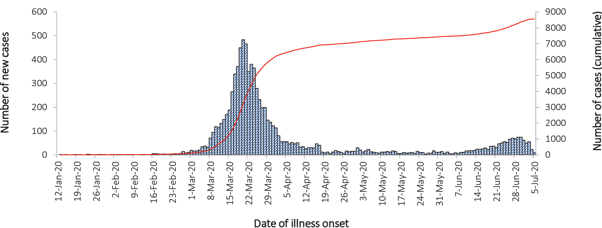
a Source: NNDSS

In focus: Victoria
During this reporting period, Victoria has experienced a resurgence in cases with 781 cases reported (Table 1). Of those cases, 89.0% were reported as locally acquired, 5.9% were under investigation, and 5.1% were reported as overseas acquired (Figure 1). Cases were limited in their geographic spread to the Greater Melbourne Area (Figure 2). These data suggest an increase in community transmission when compared to the previous reporting periods.
Table 1: COVID-19 notifications by jurisdiction and source of acquisition, 22 June to 5 Julyª
Source | NSW | Vic | Qld | WA | SA | Tas | NT | ACT | Australia
Overseas | 98 | 40 | 0 | 7 | 3 | 0 | 0 | 0 | 148
Local | 0 | 470 | 2 | 0 | 0 | 0 | 1 | 0 | 473
Local unknown | 1 | 225 | 0 | 0 | 0 | 0 | 0 | 0 | 226
Under investigation | 4 | 46 | 0 | 0 | 0 | 0 | 0 | 0 | 50
Total | 103 | 781 | 2 | 7 | 3 | 0 | 1 | 0 | 897
a Source NNDSS

Figure 1: Victorian daily COVID-19 cases by acquisition, 1 June to 5 July 2020ª
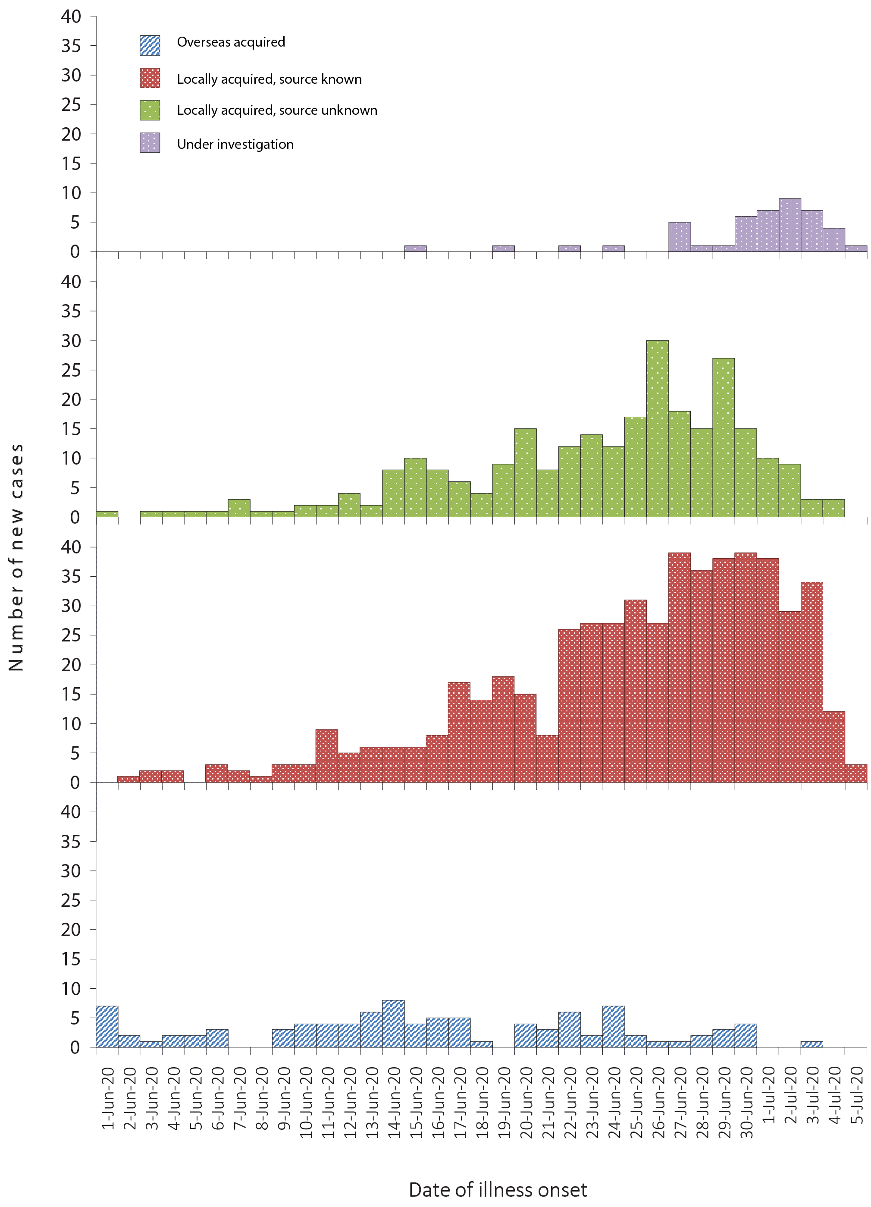
a Source: NNDSS.
Figure 2: COVID-19 cases in Greater Melbourne by Statistical Area Level 3 (SA3), 8 June to 5 July
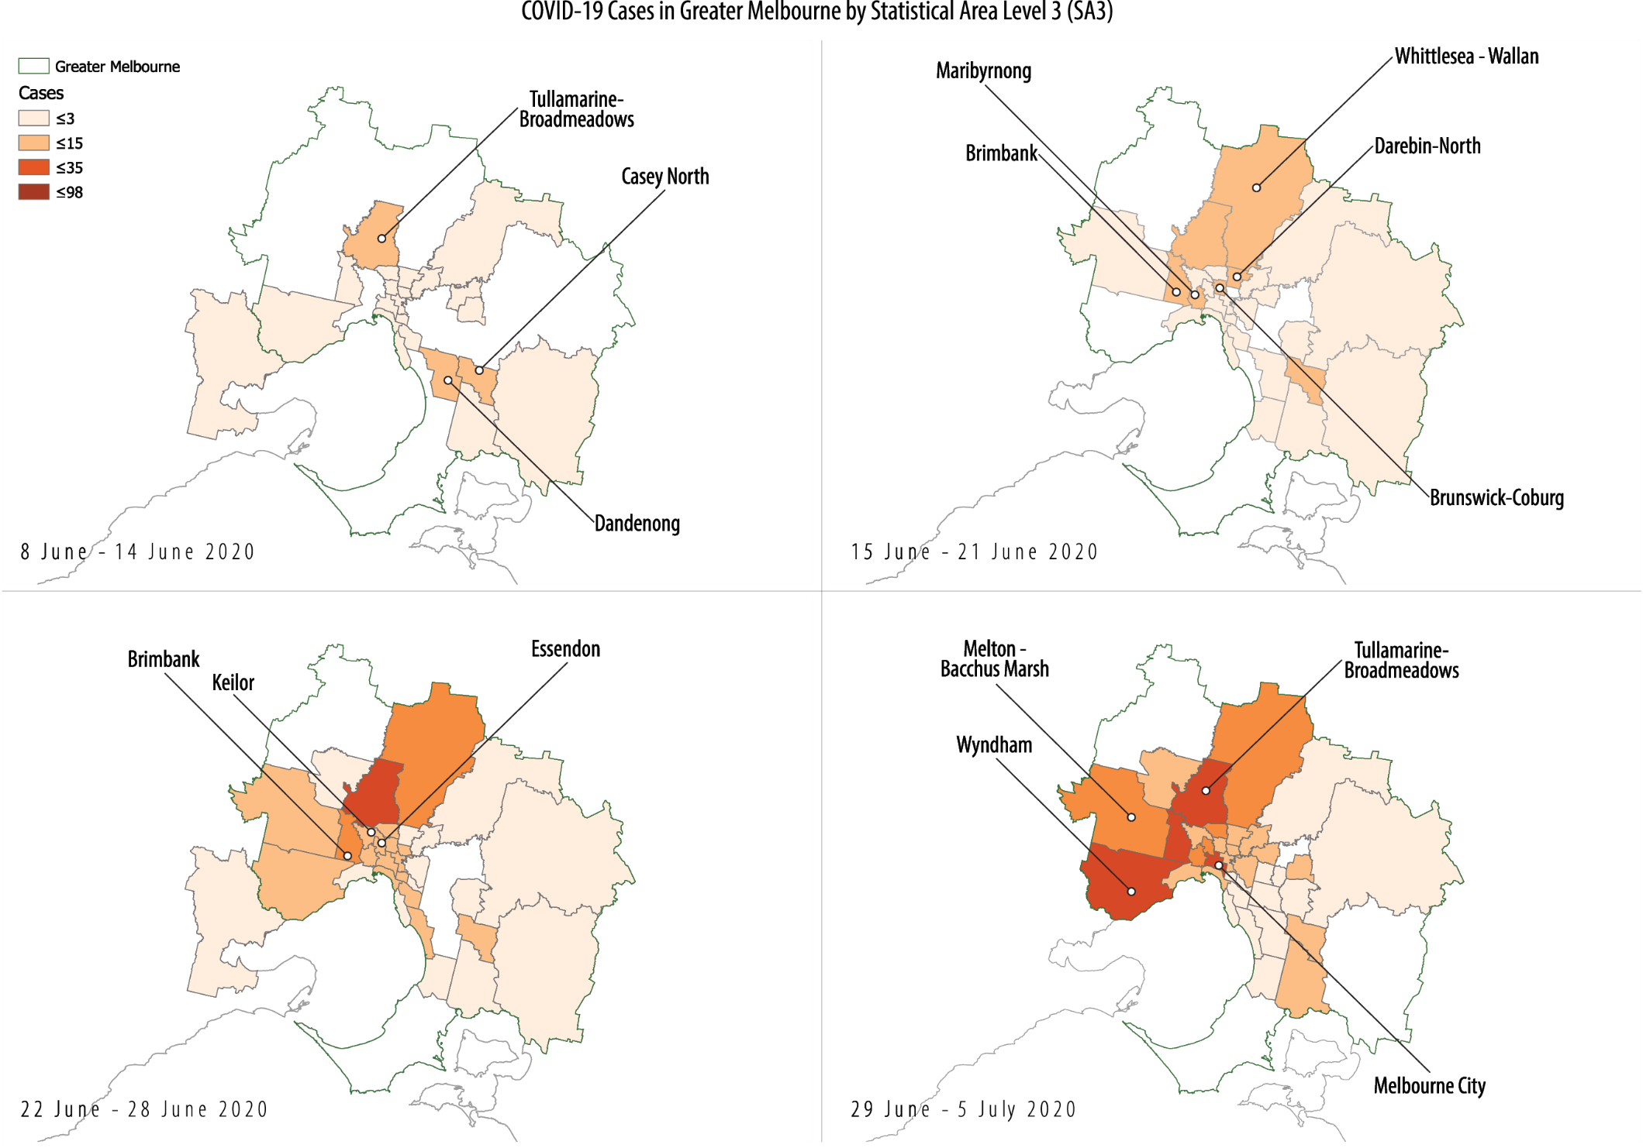
Cases continue to be notified in parts of Melbourne, with the Victorian Local Government Areas (LGAs) of Hume, Casey, Brimbank, Moreland, Cardinia and Darebin named as current outbreaks of concern. The Australian Health Protection Principal Committee (AHPPC) has recognised the importance of measures taken by the Victorian Government which seek to reduce further spread and the development of new outbreaks, and has stopped travel to and from these areas until control of community transmission has been confirmed.¹
In response, the Victorian Government has re-introduced restrictions for household and outdoor gatherings. Cases in Victoria have been driven by multiple epidemiologically linked outbreaks across a range of settings. These include between and within households, hotels providing quarantine services, retail businesses, distribution centres, schools, childcare centres, healthcare practices and public housing towers.
Cases of COVID-19 reported by Victoria over the past 28 days (2 reporting periods) have spanned across all age groups. There has been a slight increase in median age for Victorian cases for the current reporting period [37 (interquartile range, IQR: 25 to 55 years] compared to median for the previous reporting period [34 (IQR: 23 to 53 years)]. There have been proportionally more cases reported in the 10–20 year age group in the current reporting period when compared to the previous. This reflects the increase in cases in school aged children (aged 5 to 17) which comprise approximately 20% of the cases in Victoria this reporting period. The median age in this group is 12 (IQR: 9 to 15 years).
There have been a total of over 928,171 tests conducted in Victoria. The total tests per 100,000 population for Victoria are more than 14,000, which is the highest testing rate in the country and is higher than the national rate of over 10,656 tests per 100,000 population. For this reporting period, testing in Victoria returned a positivity rate of 0.26% which was double that of NSW (0.12%) for the same period.

Testing
At the conclusion of the reporting period, a total of 2,713,435 tests had been conducted in Australia. High rates of testing continued across the country with the cumulative proportion of positive tests remaining low at less than 0.5% in each jurisdiction (Table 2). Between 22 June and 5 July, 672,111 tests were conducted nationally, with an overall positivity rate of less than 0.2%.

Table 2: Diagnostic tests performed as at 5 July 2020, Australia, by jurisdictionª
Jurisdiction | Tests performed  7 – 21 June |  | Tests performed  22 June – 5 July |  |  | Cumulative tests performed to 5 July
Jurisdiction | n | positivity (%) | n | positivity (%) | n |  | positivity (%) | per 100,000  population^{a,b}
NSW | 160,654 | 0.02 | 216,615 | 0.12 | 942,432 |  | 0.36 | 11,650
Vic | 120,845 | 0.12 | 267,370 | 0.26 | 928,171 |  | 0.27 | 14,072
Qld | 55,266 | 0.01 | 115,884 | 0.00 | 390,572 |  | 0.27 | 7,667
WA | 45,758 | 0.01 | 29,948 | 0.04 | 191,213 |  | 0.32 | 7,294
SA | 22,541 | 0.00 | 23,802 | 0.01 | 161,092 |  | 0.27 | 9,195
Tas | 11,301 | 0.00 | 8,909 | 0.00 | 52,934 |  | 0.43 | 9,904
NT | 2,079 | 0.00 | 3,215 | 0.03 | 14,748 |  | 0.20 | 5,997
ACT | 5,418 | 0.00 | 6,368 | 0.00 | 32,273 |  | 0.33 | 7,563
Australia | 423,862 | 0.05 | 672,111 | 0.15 | 2,713,435 |  | 0.31 | 10,697
a Data in this table are based on reports of notification by states and territories.
b Population data based on Australian Bureau of Statistics (ABS) Estimated Resident Population (ERP) as at 30 June 2019.

Australian cases: descriptive epidemiology

National trends
Since the first case of COVID-19 was identified in Australia, all states and territories have experienced COVID-19 cases, with some jurisdictions experiencing higher numbers and more community-associated transmission. These differences arise from factors including state demographics, population size, patterns of overseas arrivals in the beginning of the pandemic, and ongoing repatriation flights being concentrated in Melbourne and Sydney.
Figure 3 shows case notifications from 12 January 2020 for New South Wales, Victoria and Queensland. It can be seen that as the pandemic progressed more cases were reported as overseas acquired in these jurisdictions. This reporting period shows that most cases are currently being reported as locally acquired and Victoria has reported outbreaks due to community transmission.

Figure 3: COVID-19 case notifications 12 January – 5 July 2020,a for New South Wales, Victoria and Queensland
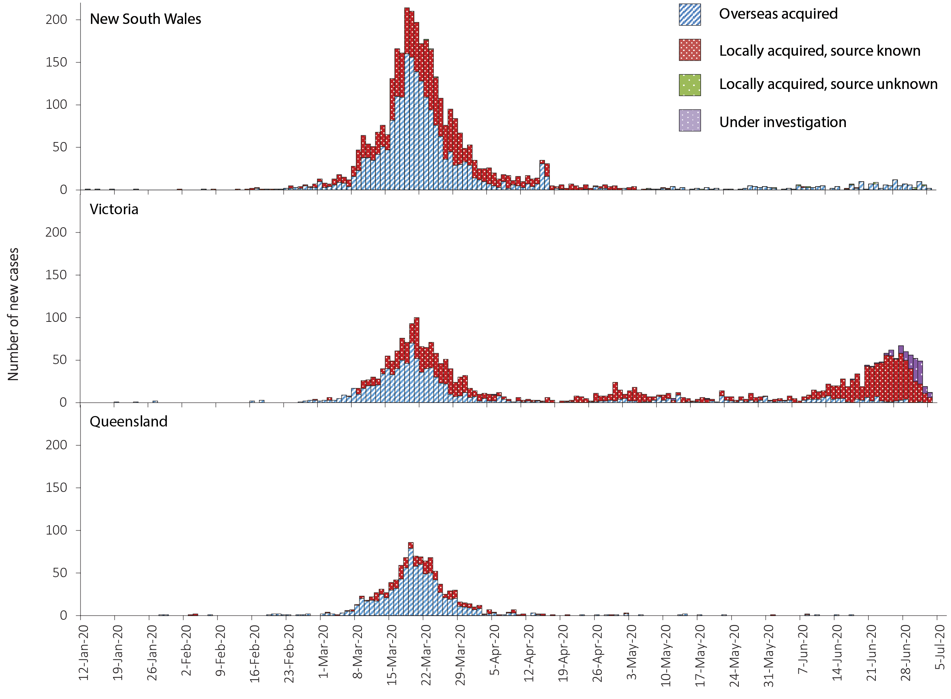
a Source: NNDSS.
In this reporting period, the national rate of infection was 3.5 per 100,000 population (Table 3). However, Victoria’s rate of infection for this period was 11.9 per 100,000 population, more than three times the national average. The Victorian rate during this period is similar to the state’s rate during the fortnight 16 to 29 March, which was the initial height of the epidemic (11.3), but much lower than was New South Wales during the same period (22.9). Nationally, the current Victorian rate is the highest rate of COVID-19 per capita since mid-April.
Table 3: COVID-19 fortnightly notifications, cumulative total cases and rates per 100,000,ª Australia
Jurisdiction | New cases^{b} |  |  | Total cases
Jurisdiction | 8 – 21 June | 22 June – 5 July | Rates per 100,000 population  22 June – 5 July | Number of cases | Rates per 100,000 population
NSW | 42 | 103 | 1.24 | 3,444 | 42.6
Vic | 163 | 781 | 11.9 | 2,633 | 39.9
Qld | 4 | 2 | 0.04 | 1,068 | 21.0
WA | 6 | 7 | 0.27 | 612 | 23.3
SA | 0 | 3 | 0.17 | 443 | 25.3
Tas | 0 | 0 | 0 | 228 | 42.7
NT | 0 | 1 | 0.41 | 30 | 12.2
ACT | 0 | 0 | 0 | 108 | 25.3
Australia | 215 | 897 | 3.55 | 8,566 | 33.8
a Source: NNDSS.
b New cases notified to NNDSS within each fortnightly period.

Source of acquisition
As at 5 July 2020, Australia has recorded 8,566 cases of COVID-19. Of these 41% are reported as locally acquired, and 58% are reported as overseas acquired (Figure 4). For this reporting period, 78% of cases were locally acquired, 16% were overseas acquired, and 6% were under investigation at time of reporting.

Figure 4: Number of new case notifications in Australia, by source of acquisitionª
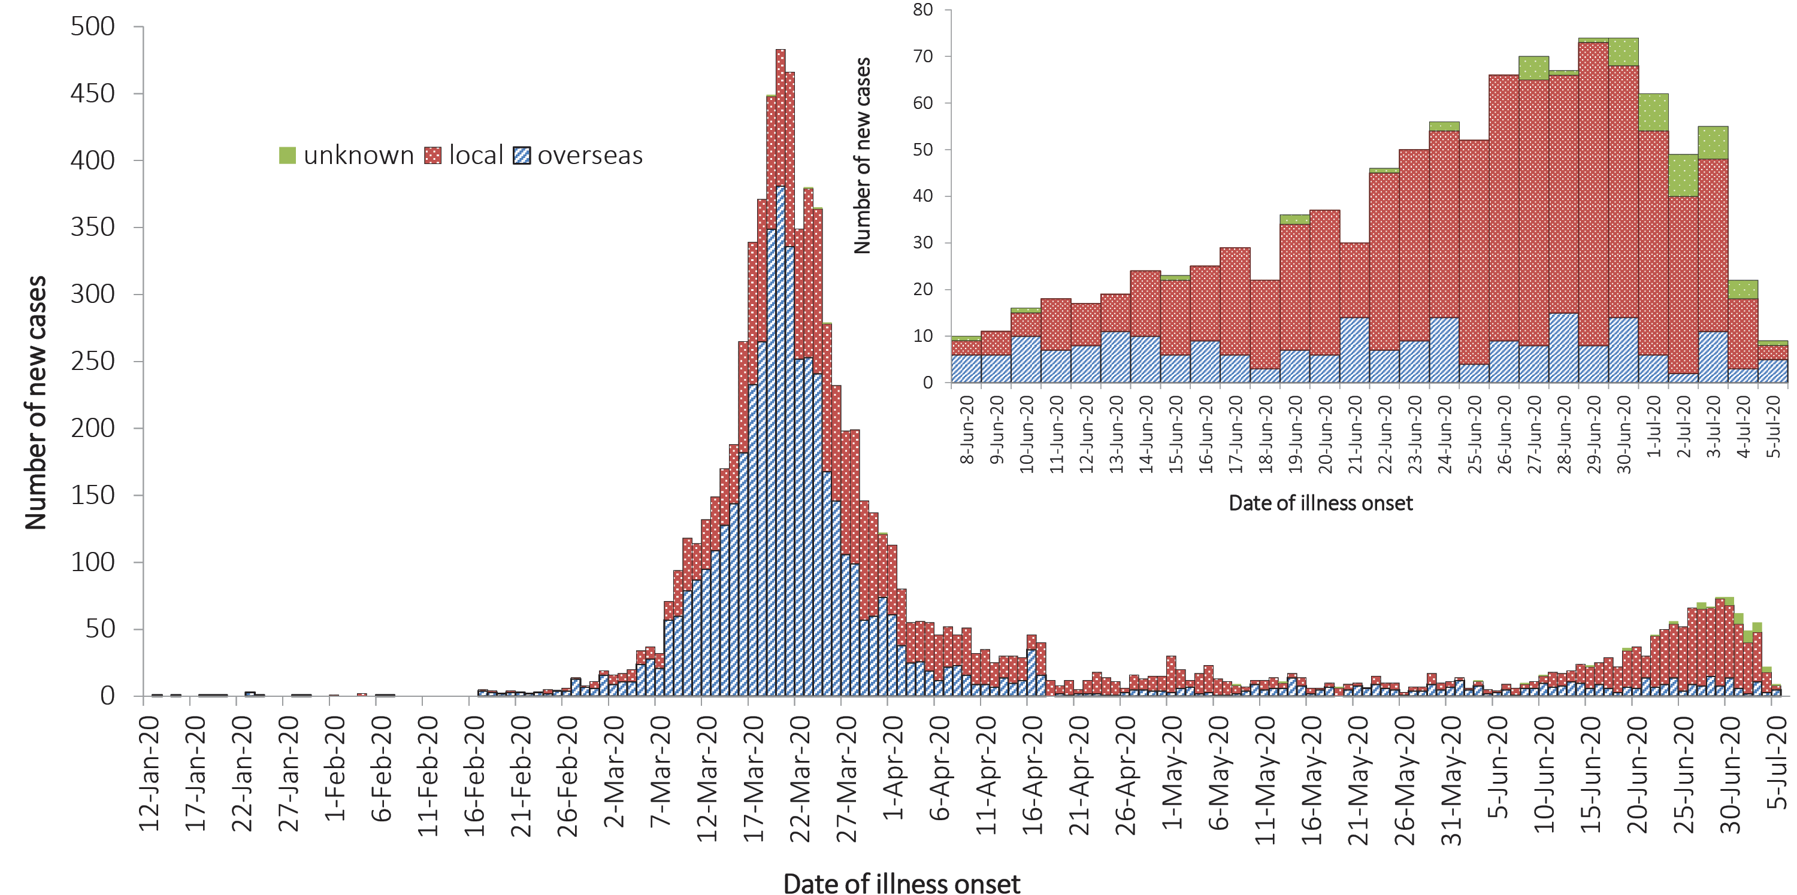
a Source: NNDSS.

During this reporting period the number and proportion of locally-acquired cases continued to increase, largely due to outbreaks in Victoria. Of all locally-acquired cases, the source of acquisition for 68% of cases was found to be a contact of a case or in a known cluster, 32% were unable to be linked to another case and less than 1% were unable to be linked to any case or cluster but had travelled interstate during their exposure period.
The majority of overseas-acquired cases during this reporting period were related to cruise-ship travel, travel in the European region and repatriation flights. Overseas-acquired cases were predominantly reported from NSW and WA and were detected in travellers in hotel quarantine from repatriation flights.

Demographics of cases
Historically, cases of COVID-19 have been reported across all age groups, with a mean age of 44.5 years and a median age of 44 years (IQR: 28 to 61) (see Appendix B, Figure B.1 and Table B.1). In the first two months of the epidemic the population diagnosed was slightly older, with a median age of 45 (IQR: 31 to 57) reflecting the source of acquisition being primarily cruise ships.
In this reporting period, the median age for all cases is 31 (IQR: 19 to 46). This reflects the increasing number of young people affected through community transmission (Figure 5 and Appendix B, Table B.2). The rate of cases in males aged 80 and above was at least twice that of females in the same age group. Additionally, within the past fortnight the rate in the male 20–29 years age group was higher than that of females, which is the opposite of the long term trend (Figure 5).
Figure 5. COVID-19 cases, by age group and sex, Australia (22 June – 5 July 2020)ª
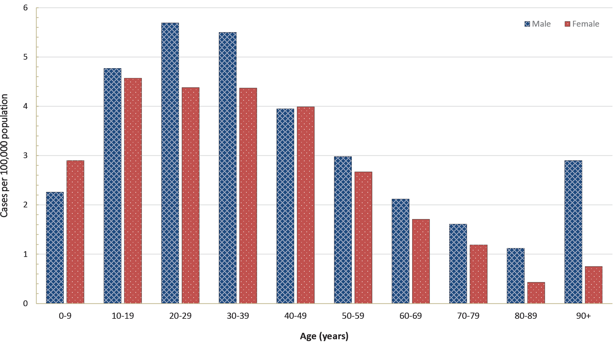
a Source: NNDSS.
People aged 20–29 years now have the highest rate of COVID-19 infection (with 49.3 cases per 100,000 population), followed closely by the age groups of 60–69 years (with 47.3 cases per 100,000 population) and then 70–79 years (with 44.2 cases per 100,000 population). People aged 0–9 years have the lowest rate, with 6.9 cases per 100,000 population. In most age groups males show a higher rate of infection than females, with exceptions seen in the 0–9 years and 20–29 years age groups. The largest difference in rates is observed in the older age groups where 50% more males than females are diagnosed with COVID-19.
Children aged less than 18 years currently account for 5.4% of all cases, which has increased from 3.5% observed in the first two months of the outbreak. In this reporting period, approximately 22.3% of cases are under 18 years old. A similar trend is seen within school children in this group. School-aged children between 5 and 17 years comprise 3.9% of all cases. However, in this reporting period there are 161 cases in this age group, 18% of all cases reported. Of these cases, 91% were reported from Victoria as locally acquired.

Aboriginal and Torres Strait Islander persons
Sixty-nine cases (0.8%) have been reported in Aboriginal and Torres Strait Islander persons since the start of the epidemic in Australia. Of these cases, 43% (30/69) acquired their infection overseas. Of locally-acquired cases, the majority (74%) were reported in areas classified ‘Major cities of Australia’ based on the case’s usual place of residence (Table 4). No cases among Aboriginal and Torres Strait Islander persons have been notified from remote or very remote areas of Australia.
Table 4: COVID-19 cases, notified among Aboriginal and Torres Strait Islander persons, and among all Australian cases, as at 5 July 2020 by remoteness classification and source of acquisitionª
 | Locally-acquired^{b} |  |  |  | Overseas-acquired | Not specified^{c} | Total
 | Major cities of Australia | Inner regional Australia | Outer regional Australia | Remote/very remote Australia | Overseas-acquired | Not specified^{c} | Total
Aboriginal and Torres Strait Islander cases | 29 | 4 | 6 | 0 | 30 | 0 | 69
All Australian cases^{c} | 3,127 | 193 | 188 | 20 | 4,963 | 75 | 8,570
a Source: NNDSS.
b ‘Locally-acquired’ comprises all cases without an overseas place of acquisition.
c Total Australian cases classified as not specified includes 48 cases with missing remoteness information, and 27 cases classified overseas residents.
The median age of COVID-19 cases among Aboriginal and Torres Strait Islander persons is 33 years (IQR: 23–52 years), which is lower than the median age of non-Indigenous COVID-19 cases which is 44 (IQR: 28–61 years).
Of the cases notified amongst Aboriginal and Torres Strait Islander persons, 12% were admitted to hospital, which is similar to the proportion of all cases hospitalised (14%). Of cases in Aboriginal and Torres Strait Islander persons, no cases were reported as being admitted to an intensive care unit (ICU) or requiring ventilation and no fatalities have been reported.
Across all Australian cases, completeness of the Indigenous status field was approximately 91%.

Severity
Of total cases notified in Australia, approximately 14% (n = 1,200) were admitted to hospital. Of hospitalised cases, 19% (n = 225) were admitted to ICU (Table 5) and 85 (7% of hospitalisations) of those were ventilated. Canada has reported a similar severity profile, with 15% of cases hospitalised, of which 20% were admitted to the ICU and 4% required mechanical ventilation.² Higher rates have been observed across the EU/EEA with 31% of reported cases requiring hospitalisation (data from 24 countries) and 14% of reported/hospitalised cases (data from 17 countries) admitted to the ICU and/or requiring respiratory support.³ Proportions vary considerably between countries and are affected by each country’s underlying health and testing strategies, with some European countries only testing hospitalised individuals for COVID-19. There are also variations in the way different countries classify and report hospitalisations. The European region also reported a decrease in both the hospitalisation and severe hospitalisation rate with increasing age beyond 80 years, which is not seen in the Australian data. This was hypothesised to reflect clinical decisions about the use of hospital resources for people in this age group and was observed in the data from many countries.³
Table 5: Number and case fatality rate (CFR) for all cases, hospitalised cases and cases admitted to ICU, by age group and gender, Australiaª
 | All cases |  |  | Hospitalisation |  |  | ICU
 | Male | Female | Persons | Male | Female | Persons | Male | Female | Persons
Number
Total | 4,379 | 4,114 | 8,566 | 645 | 555 | 1,200 | 147 | 78 | 225
Case fatality rate (%)
Under 50 | 0.0 | 0.0 | 0.0 | 0.5 | 0.0 | 0.3 | 0.0 | 0.0 | 0.0
50–64 | 0.4 | 0.3 | 0.4 | 2.5 | 1.8 | 2.2 | 10.3 | 3.9 | 7.7
65–79 | 3.4 | 2.4 | 3.0 | 9.9 | 8.8 | 9.5 | 17.9 | 13.3 | 16.5
80 and over | 21.9 | 22.8 | 22.3 | 33.3 | 33.3 | 33.3 | 70.0 | 28.6 | 52.9
All age groups | 1.4 | 1.1 | 1.2 | 7.8 | 6.3 | 7.1 | 15.7 | 9.0 | 13.3
a Source: NNDSS.
Among Australian cases, the case fatality rate (CFR) for males aged 65–79 years is higher than for females of the same age (Table 5). However, this is reversed in the population aged 80 years and over. The ratio of males to females is similar among hospitalised cases (1.2:1); however, more males than females have been admitted to the ICU (1.9:1). Overall, fatality rates by age group are similar to those observed in China and Italy as of 17 March 2020,^{4,5} but lower than those observed for the European region when aggregated.³
The CFR for males aged 80 years and over admitted to ICU is high at 70.0% (7 deaths from 10 cases in ICU). These results are similar to the CFR for Canadian males meeting the same criteria (65%; 79 deaths from 113 cases in ICU).⁶ The CFR of Australian hospitalised cases was 7.1%, which dramatically lower than the aggregated value of 24% observed in European cases (data from 22 countries)³ and Canadian cases (33%).⁶ Australian results are based on small numbers of cases and therefore may not be directly comparable to results from other countries.

Hospital length of stay
Information on hospitalised cases in Australia is available through the Influenza Complications Alert Network (FluCAN).⁷ In general, the length of hospital stay increased with advancing age category (Table 6). On average, patients aged 60 or more stayed the longest in hospital and those aged under 18 stayed the least time. Eight of the 119 FluCAN admissions examined died. These people had a median length of stay of 11 days (IQR: 7–15 days). These times were much lower than those who were discharged from the ICU who stayed a median time of 18 days (IQR: 8–24 days).
Table 6: Hospital length-of-stay for confirmed COVID-19 cases discharged from sentinel sites by ICU/high dependency unit (HDU) admission status (n = 119), median, IQR and mean, standard deviation (SD)^{a,b}
Age group (years) | n | General ward  median (IQR) | ICU/HDU  median (IQR)^{c} | Total  median (IQR) | Total  mean (SD)
<18 | 16 | 5 (0.5–8.5) | 0 | 5 (0.5–8.5) | 5.9 (5.7)
18–59 | 58 | 6 (3–11) | 13 (8–25) | 7.5 (4–13) | 10 (9.8)
60+ | 45 | 9 (3–15) | 21 (5–24) | 9 (4–17) | 11.2 (9.0)
Total | 119 | 6 (3–13) | 18 (8–24) | 7 (3–13) | 9.9 (9.1)
a Source: FluCAN.
b Deceased persons excluded.
c Of those admitted to ICU/HDU within 24 hours of hospital admission.
This is similar to the length of stay observed in European countries with the median length of stay of 9 days and a mean of 12 days (data from approximately 4,600 cases).³ The European data also showed the length of stay also increased with age, with people aged 60 years or over staying for a median time of 10 days and a mean of 13–14 days.³

Characteristics of those with severe COVID-19 disease
Higher disease severity, as indicated by hospitalisation, admission to intensive care unit (ICU), and death, has been associated with increased age and comorbidities.⁸ The median ages of cases who have been hospitalised (61 years; IQR 42.5–72), admitted to ICU (65 years; IQR 54–73) and died (80 years; IQR 74–86) are higher than for cases overall (44 years; IQR 28–61).

Underlying medical conditions and other risk factors
Comorbidity information on cases hospitalised in Australia is available through FluCAN,⁷ the Australian and New Zealand Intensive Care Society-supported real-time hospital-based surveillance system (SPRINT-SARI),⁹ and the NNDSS. FluCAN found a greater prevalence of comorbid conditions in a sample of hospitalised COVID-19 patients aged 18 years and over (n = 67) compared to the NNDSS (n = 6,781). This difference may be attributed to more severe disease as a result of comorbidities resulting in hospitalisation, a much smaller sample size from the FluCAN data and/or a more comprehensive review of patient medical records assessed as part of FluCAN.⁸
Amongst hospitalised cases drawn from FluCAN data where comorbidity data was recorded, the most common comorbidities were chronic respiratory condition (37%), diabetes (34%), obesity (30%), cardiac disease (27%) and immunosuppression (26%) (Table 7). Only 10% of patients reported no comorbidities. A history of smoking (current or past smoker) was identified in 36% of FluCAN and 14% of SPRINT-SARI cases.
Table 7: COVID-19 comorbidities for all cases, hospitalised cases, cases admitted to ICU and deaths (number of cases, proportion of cases), Australiaª
Comorbidity | All cases  NNDSS  (n = 6,781) | Hospitalised cases (general ward)  FluCAN (n=67) | ICU cases  SPRINT SARI (n = 209) | Deaths  NNDSS  (n=87)
Common comorbidities
Cardiac diseaseb | 516 (8%) | 18 (27%) | 42 (20%) | 31 (36%)
Chronic respiratory conditionc | 683 (10%) | 24 (37%) | 36 (17%) | 23 (26%)
Diabetes | 472 (7%) | 22 (34%) | 60 (29%) | 23 (26%)
Obesity | 227 (3%) | 17 (30%) | – | 7 (8%)
Chronic renal disease | 69 (1%) | 2 (3.2%) | 14 (6.7%) | 5 (6%)
Chronic neurological condition | 106 (2%) | 9 (14%) | 1 (0.5%) | 15 (17%)
Malignancy | – | 9 (13%) | 12 (5.7%) | –
Chronic liver disease | 45 (1%) | 2 (3.2%) | 4 (1.9%) | 2 (2%)
Immunosuppression | 177 (3%) | 16 (26%) | 13 (6.2%) | 16 (18%)
Number of specified comorbidities^{d}
One or more | 1,776 (26%) | 60 (90%) | 131 (63%) | 66 (76%)
Two or more | 393 (6%) | 34 (51%) | 78 (37%) | 37 (43%)
Three or more | 100 (1%) | 14 (21%) | 33 (16%) | 14 (16%)
No comorbidities | 3,774 (56%) | 7 (10%) | 80 (38%) | 21 (24%)
a Source: NNDSS, FluCAN and SPRINT-SARI. Excludes those with missing data on comorbidities or where comorbidity is unknown.
b Excluding hypertension.
c Including asthma.
d Includes asthma, chronic respiratory conditions (excluding asthma), cardiac disease (excluding hypertension), immunosuppressive condition/therapy, diabetes, obesity, liver disease, renal disease and neurological disorder.
Australian data on hospitalised comorbidities are different to results reported internationally. The United States CDC publish comorbidity data for a small proportion of cases where a complete chart review is available (COVID-NET).¹⁰ In the CDC data, the most common comorbidities found for hospitalised adults with at least one reported comorbidity were hypertension (55%), obesity (50%), metabolic disease (42%) and cardiovascular disease (32%). Amongst all cases included in the CDC report, only 9% reported no known comorbidity. These are higher proportions of comorbidity than the figures reported from FluCAN.
Within the European region, analysis of comorbidities of hospitalised patients has shown 36% had no reported comorbidity. The most common comorbidities for hospitalised cases with at least one reported comorbidity were cardiac disorder (excluding hypertension) (16%), diabetes (12%) and chronic lung disease (8%).³ These findings are slightly above the level of comorbidity seen for hospitalised cases in Australia based on NNDSS figures.

Symptom profile
The symptoms reported by COVID-19 cases in Australia are consistent with a mild respiratory infection in the majority of cases. The most common symptoms reported (see Appendix B, Figure B.1) were cough (67%), fever (47%), headache (42%) and sore throat (40%). Other symptoms reported include fatigue (31%), chills or rigors (14%) and loss of taste or smell (12%), noting that these are currently not standard fields in NNDSS, and are likely to under-represent those presenting with these symptoms. A small number of cases reported more severe symptoms, with pneumonia and/or acute respiratory disease (ARD) reported in 3% of cases with symptoms.
Adults and children reported similar symptoms, with cough and fever the most commonly-reported symptoms across all age groups. Shortness of breath increased with age, with those aged 80 and over much more likely than the other groups to report it (31%).
The symptom profile of Australian cases is broadly similar to the symptoms reported by COVID-19 cases internationally. Among EU/EEA countries and the UK, fever/chills and dry or productive cough were the most commonly reported symptoms.¹¹ Cough, headaches and fever and chills were the most commonly reported symptoms among cases in Canada.¹² Differences in reported symptoms will be influenced by differences in surveillance strategies and symptom reporting across countries.

Cluster and outbreak investigations
Cluster
The term ‘cluster’ in relation to COVID-19 refers to two or more cases (who do not reside in the same household) that are epidemiologically related in time, place or person where a common source (such as an event or within a community) of infection is suspected but not yet established.
Outbreak
The term ‘outbreak’ in relation to COVID-19 refers to two or more cases (who do not reside in the same household) among a specific group of people and/or over a specific period of time where illness is associated with a common source (such as an event or within a community). Some states and territories may report a single case associated with a residential aged care facility as an outbreak.
In the week ending 5 July 2020, 35 open clusters and outbreaks of COVID-19 were reported, all in Victoria. This is an increase of twenty-five outbreaks compared to the preceding reporting period ending 21 June 2020. Open clusters and outbreaks are defined as those where a new case was identified in the last 14 days as at the end of the reporting period. Of the 35 open clusters and outbreaks, 13 were family-based outbreaks, six were associated with schools, five were associated with workplaces, four were associated with health care facilities, two were associated with childcare centres, one was associated with a residential aged care facility, one was associated with an event, and the remaining three outbreaks were associated with various other settings. The number of open clusters and outbreaks may be revised as a result of ongoing investigations in states and territories.
Residents of aged care facilities are at increased risk of COVID-19 infection due to the environment of communal living facilities and are more vulnerable to serious complications if they do become infected. As of 5 July 2020, there have been 139 cases of COVID-19 associated with 37 residential aged care facilities, with 107 recoveries and 31 deaths. Seventy-one of these cases occurred in aged care residents, with the remaining 68 cases occurring in care staff. In addition, there have been 44 cases associated with 32 in-home Commonwealth funded aged care services providing support to older Australians who live at home, with 39 recoveries and 3 deaths. Thirty-three of these cases occurred in care recipients, with the remaining 11 cases occurring in care staff. The Commonwealth is actively supporting services with reported incidents and outbreaks of COVID-19 providing access to personal protective equipment and additional staffing resources where required. Advice and guidelines have been provided to aged care services,¹³ including the release of an outbreak management guide.¹⁴

Public health response measures
Since COVID-19 first emerged internationally, Australia has implemented public health measures informed by the disease’s epidemiology (Figure 6). Key aspects of Australia’s evolving public health response are summarised in previous reports. On Friday 8 May, the Australian Government announced a three-step framework for easing COVID-19 restrictions, with states and territories easing restrictions at their own pace depending on the current public health situation and local epidemiology. A summary of the restrictions that have been eased is listed at Table 8.
Table 8: State and territory actions for easing COVID-19 restrictions, from 22 June to 5 July 2020
Jurisdiction | Summary of restrictions which have been eased
New South Wales | From 1 July the following restrictions were eased:^{15,16}  - Gatherings in households remain at up to 20  - Number of people allowed inside indoor venues determined by 4 metre square rule, with no upper limit  - Community sport to recommence  - Stadiums permitted up to 25% capacity up to 10,000 people  NSW has announced that from 7 July residents from Greater Melbourne will not be allowed to enter NSW, and from 8 July the border with Victoria will close.
Victoria | From 22 June Victoria re-implemented the following restrictions:¹⁷  - Number permitted to gather in a household reduced to 5 people  - Number permitted to gather outdoors reduced to 10 people  - Restrictions on restaurants, cafes and community services will remain at up to 20 patrons  From 1 July targeted suburbs in Melbourne were subject to a lockdown.
Queensland | From 3 July the following restrictions were eased:¹⁸  - Gatherings of up to 100 permitted in households, and at weddings and funerals  - Public gatherings subject to 4 metre square density rule, except for venues of less than 200 square metres which are permitted up to 50 persons (2 metre square rule)  - Concerts and stadiums permitted up to 50% capacity (max 25,000)  - Industries including sport, beauty and food courts to reopen with industry plan
Western Australia | No further easing of restrictions has occurred during this reporting period.¹⁹
South Australia | From 29 June the following restrictions were eased:^{20,21}  - Density requirements within venues eased to one person per two square metres  - Most businesses permitted to reopen including food courts, all hospitality, nightclubs, casinos, spas and amusement parks
Tasmania | From 26 June the following restrictions were eased:²²  - Gatherings in households remain at up to 20  - Gatherings in businesses up to 250 for indoors and 500 outdoors, following 2 metre square rule  - Most businesses permitted to reopen including food courts, night clubs, stadiums, casinos, strip clubs, spas and amusement parks  - Full contact sport permitted
Australian Capital Territory | No further easing of restrictions has occurred during this reporting period.²³
Northern Territory | No further easing of restrictions has occurred during this reporting period.²⁴

Figure 6: COVID-19 notifications in Australia by date of illness onset, to 6 July 2020ª with timing of key public health measures
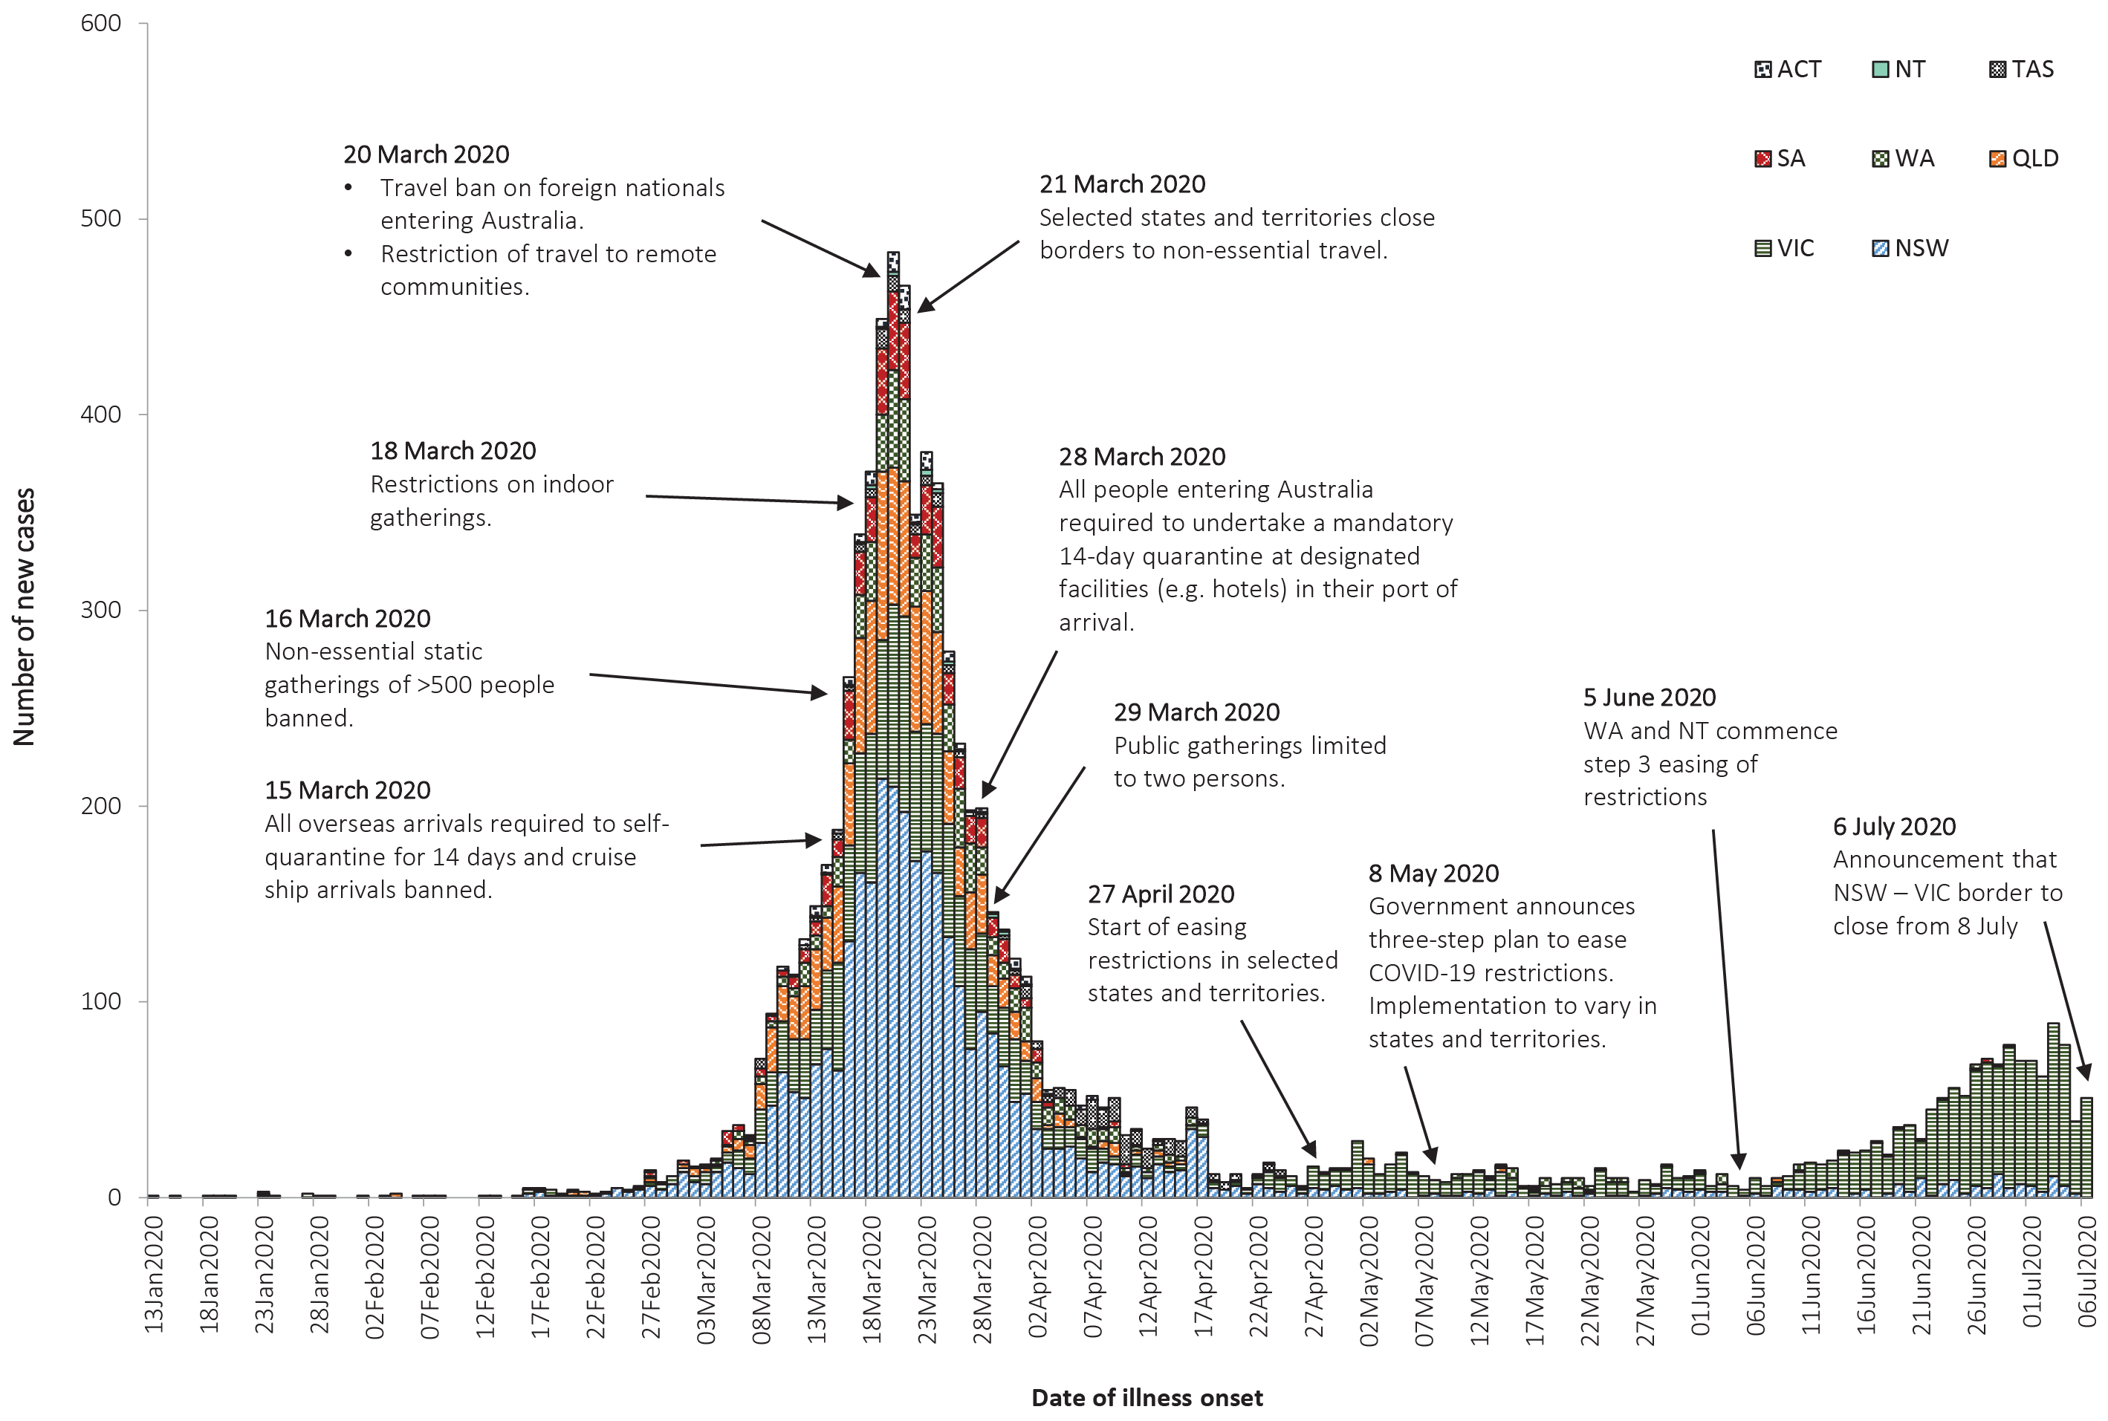
a Source: NNDSS. Due to reporting delays, interpret the latest days’ new cases with caution.

During this reporting period, there has been a significant increase in the number of reported cases in Victoria. As a result, from 1 July Victoria implemented targeted lockdowns in suburbs with high case numbers. Residents in selected postcodes in Melbourne are now only permitted to leave their homes for essential reasons (school, work, exercise, shopping for food and supplies, or care and caregiving). In addition, on 6 July it was announced that from 7 July residents from the Greater Melbourne area will not be permitted to enter New South Wales, and from 8 July the border between Victoria and New South Wales will close. While other states and territories have continued to ease restrictions, most states and territories have announced that people travelling from Victoria will be subject to a 14-day quarantine after domestic border restrictions are eased.

International situation
On 5 July 2020, more than 216 countries, regions and areas had reported 11,125,245 COVID-19 cases and 528,204 deaths to the World Health Organization (WHO).^{25,26} All data is drawn from WHO unless otherwise specified. The Americas and Europe continue to be the epicentres of the pandemic with the former representing approximately 51% of cumulative cases and 50% of cumulative deaths, and the latter representing 25% of cases and 38% of deaths. The global case fatality rate (CFR) is approximately 4.7%. The global cumulative rates are 144.8 cases and 6.9 deaths per 100,000 population.
- By country, the largest numbers of cases are from: the United States of America (2,776,000); Brazil (1,539,000); and the Russian Federation (681,000).
- By country, the largest numbers of deaths are from: the United States of America (129,200); Brazil (63,200); and the United Kingdom (44,200).
In the previous fortnight, the largest numbers of cases have been reported by the Americas (59%) and the South East Asian (14%) regions, led predominantly by the United States of America, Brazil and India. The Russian Federation, South Africa and Mexico are also seeing strong growth in new cases, with each accounting for over 3% of the total cases reported globally in the previous fortnight.

Western Pacific Region
To date, the Western Pacific Region is the least affected in the globe, reporting the lowest number of COVID-19 cases and deaths. The cumulative number of cases in the region stands at approximately 224,000, with approximately 19,000 new cases reported in the previous fortnight (9.3% increase). This represents 0.8% of the global total number of new cases reported in the period. Cumulatively, the Western Pacific region accounts for 2.0% of all cases globally and 1.4% of all deaths. This region has so far reported a cumulative rate of 11.8 cases per 100,000 people and a mortality rate of 0.4 deaths per 100,000 population, which is low when compared to the global rates.
The majority of the cases in the region are observed in China, Singapore and the Philippines so far. However, in the past fortnight the greatest numbers of new cases have been observed in the Philippines (65%), Singapore (15%) and Japan (9%). Their epidemic trajectories are shown in Figure 7. There were four countries/territories that did not report any new cases in the previous fortnight (Brunei Darussalam, Fiji, Lao People’s Democratic Republic and New Caledonia).
In the past month, several countries in the region who have passed their initial peak are now attributing a large proportion of their new cases to clusters. According to Chinese media reports,²⁷ an outbreak in a Beijing food market had resulted in 334 cases (since the initial case was reported on 11 June 2020), which is approximately half of the cases reported to WHO during the same period. In Singapore, following an outbreak in migrant workers living in dormitories, there continues to be a high proportion of new cases in this population group.²⁸ In Japan,²⁹ the Republic of Korea³⁰ and Australia, there has been a recent increase in the daily number of new cases which have involved a number of clusters.

South East Asia Region
In this fortnight the South East Asia region has seen a large growth in new case numbers. Cumulatively the region reports 919,000 cases and 24,400 deaths, with approximately 338,000 cases reported in the last fortnight (58% increase). Cumulatively, the region accounts for 8.2% of cumulative cases and 4.6% of cumulative deaths. Regionally the burden of disease is relatively low, compared to the global rates, at 46.0 cases and 1.2 deaths per 100,000 population.
The majority of the cases in the region are observed in India, Bangladesh and Indonesia, which also comprise the greatest proportion of new cases in the previous fortnight, at 78%, 15% and 5% respectively. Their epidemic trajectories are shown in Figure 7. Nepal reported the greatest rise in case count, increasing by 80% over the reporting period. The Maldives is the most affected country in the region per capita, reporting 450 cases per 100,000 people. Only Timor-Leste did not report a case in the previous fortnight.

Figure 7: Number of COVID-19 cases (logarithmic scale) by selected country and days since passing 100 cases, up to 5 July 2020
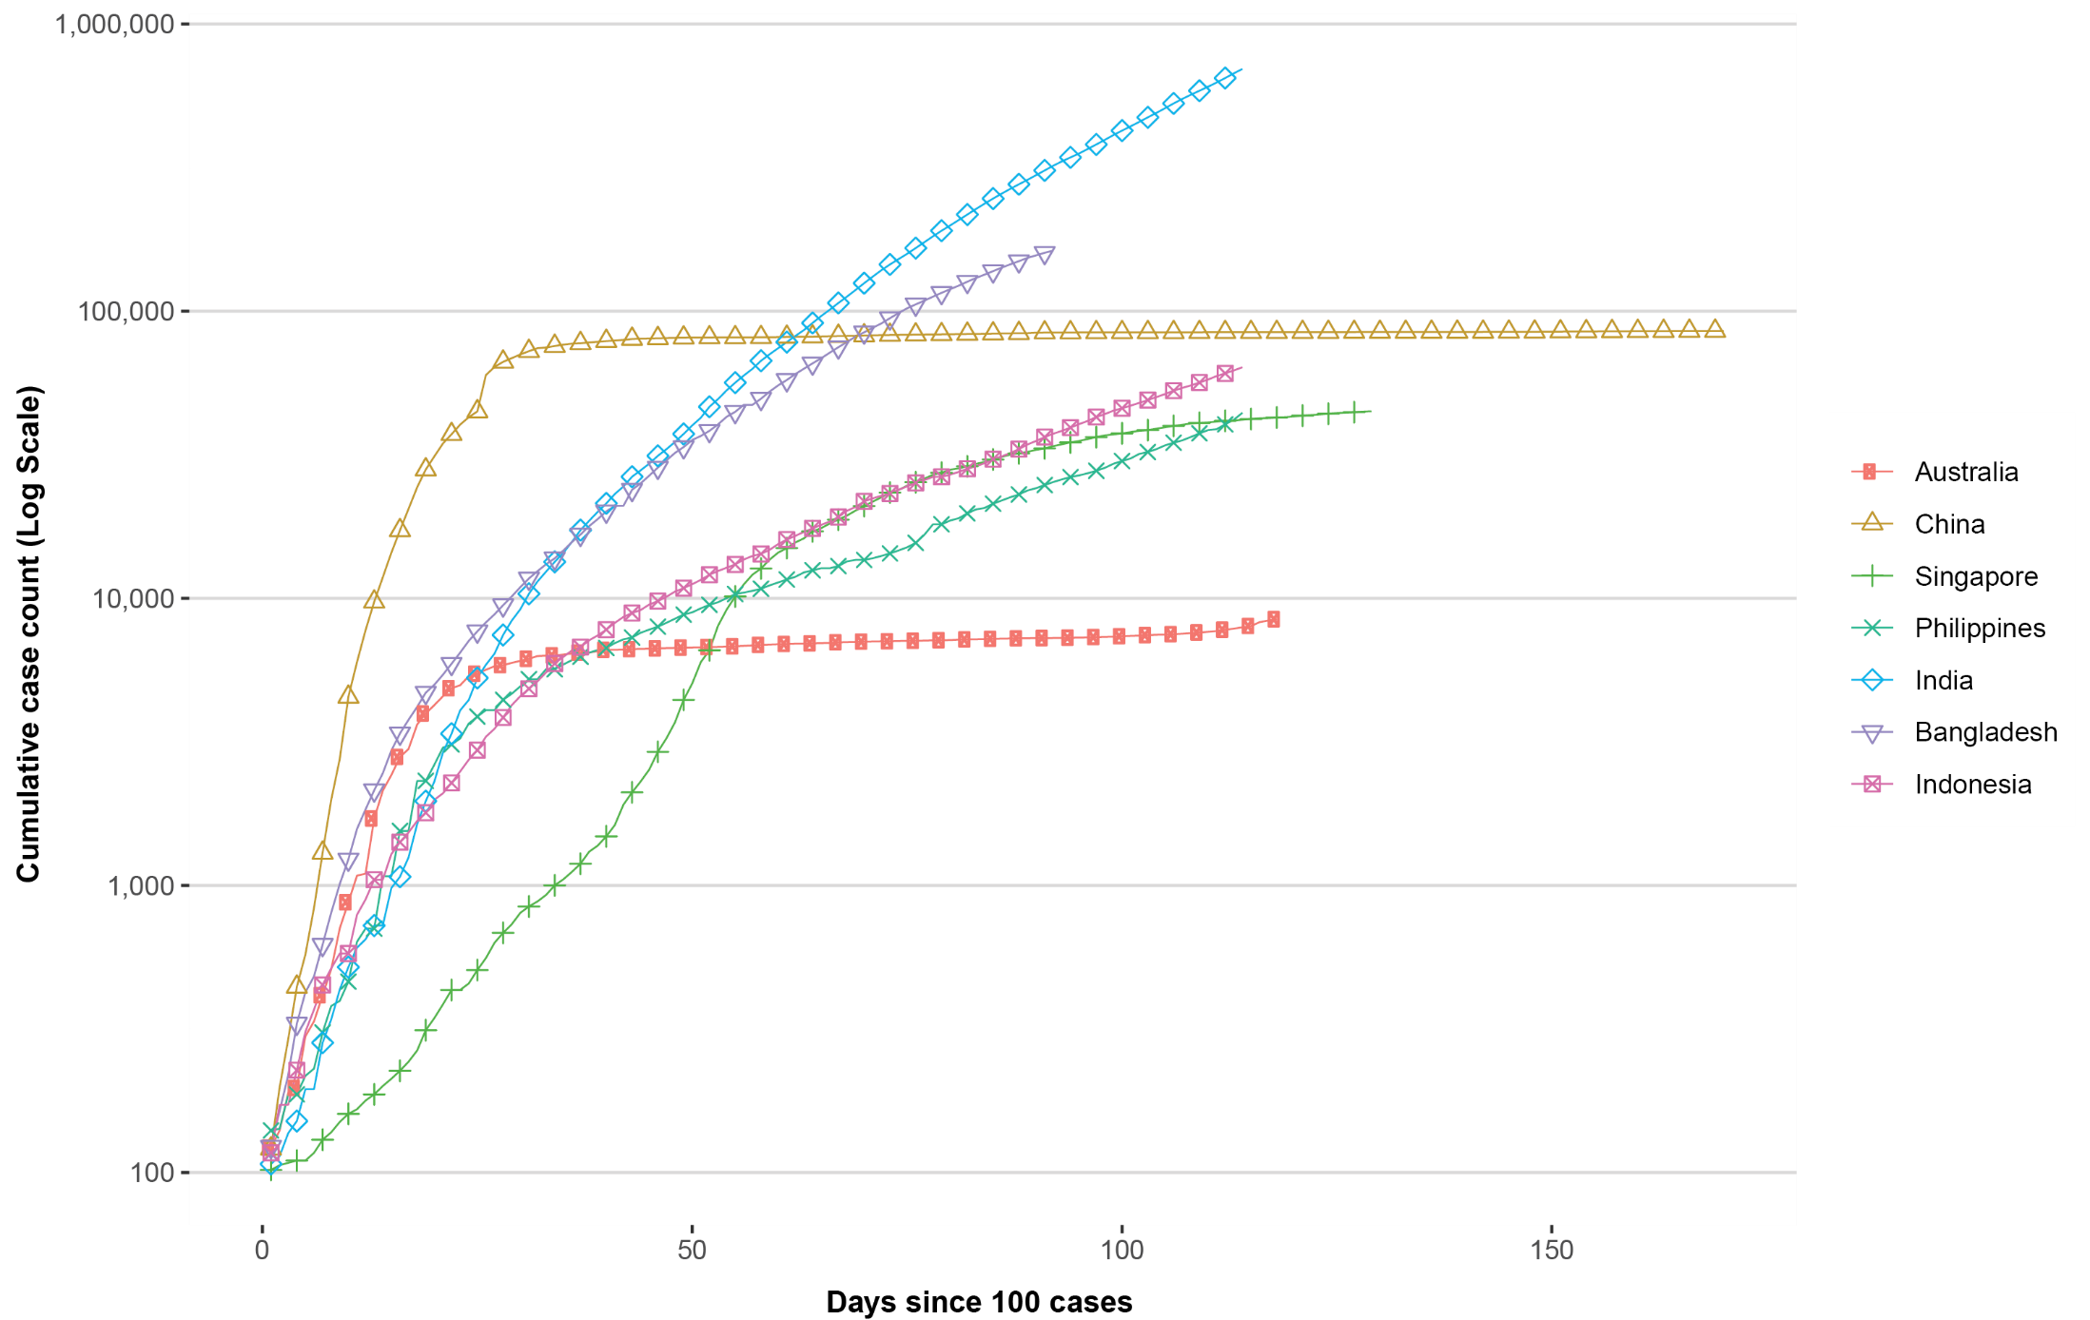

Testing rates in the three highest-caseload countries in the region have improved over time. India has completed nearly 10 million tests, and has increased its testing to approximately 223,000 samples per day over the past week.³¹ Cumulatively the positivity rate in India is approximately 7%, however in the last week, on average, the positivity was approximately 10% suggesting that the epidemic has not yet been controlled. Cumulatively Bangladesh has conducted approximately 750,000 tests, with 118,000 tests in the last week; the current positivity rate is 22%.³²

Data considerations
Data were extracted from the NNDSS on 7 July 2020 for notifications received up to 5 July 2020. Due to the dynamic nature of the NNDSS, numbers presented in this report are subject to revision and may vary from numbers previously reported and from case notifications released by states and territories.

Definitions
‘Date of illness onset’ is derived from data collected by the NNDSS and represents the diagnosis date, or reported true onset of disease date. If unknown, the earliest of specimen collection date, notification date or notification receive date is used.
‘Notification received date’ is reported in the NNDSS and represents the date the case is first notified on the NNDSS. As notification can only occur after testing is completed and information processed, counts for a defined period will vary according to the date type used.

Acknowledgements
This report represents surveillance data reported through CDNA as part of the nationally-coordinated response to COVID-19. We thank public health staff from incident emergency operations centres in state and territory health departments, and the Australian Government Department of Health, along with state and territory public health laboratories.

Author details

Corresponding author
COVID-19 National Incident Room Surveillance Team, Australian Government Department of Health, GPO Box 9484, MDP 14, Canberra, ACT 2601. Email: epi.coronavirus@health.gov.au

References
- Australian Government Department of Health. Australian Health Protection Principal Committee (AHPPC) statement on recent outbreaks of COVID-19 in Victoria. [Internet.] Canberra: Australian Government Department of Health; 21 June 2020. [Accessed on 24 June 2020.] Available from: https://www.health.gov.au/news/australian-health-protection-principal-committee-ahppc-statement-on-recent-outbreaks-of-covid-19-in-victoria.
- Public Health Agency of Canada (PHAC). Coronavirus disease 2019 (COVID-19). Epidemiology update. Updated: July 8, 2020, 7 pm EDT. [Internet.] Ottawa: Government of Canada, PHAC; 2020. [Accessed on 9 July 2020.] Available from: https://health-infobase.canada.ca/covid-19/epidemiological-summary-covid-19-cases.html.
- European Centre for Disease Prevention and Control (ECDC). COVID-19 surveillance report: Week 26, 2020. [Internet.] Solna: ECDC; 4 July 2020. [Accessed on 9 July 2020.] Available from: https://covid19-surveillance-report.ecdc.europa.eu/.
- Zheng Z, Peng F, Xu B, Zhao J, Liu H, Peng J et al. Risk factors of critical & mortal COVID-19 cases: a systematic literature review and meta-analysis. J Infect. 2020. doi: https://doi.org/10.1016/j.jinf.2020.04.021.
- Onder G, Rezza G, Brusaferro S. Case-fatality rate and characteristics of patients dying in relation to COVID-19 in Italy. JAMA. 2020;323(18):1775-1776. doi: https://doi.org/10.1001/jama.2020.4683.
- Statistics Canada. Table 13-10-0775-01. Detailed preliminary information on cases of COVID-19: 6 Dimensions (Aggregated data), Public Health Agency of Canada. [Internet.] Ottawa: Statistics Canada; 2020. [Accessed on 10 July 2020.] Available from: https://www150.statcan.gc.ca/t1/tbl1/en/tv.action?pid=1310077401.
- Monash Health. FluCAN (Influenza surveillance): FluCAN (The Influenza Complications Alert Network) [Internet.] Melbourne: Monash Health; 2020. Available from: https://monashhealth.org/services/monash-infectious-diseases/research/influenza-research/flucan-influenza-surveillance-2/.
- COVID-19 National Incident Room Surveillance Team. COVID-19, Australia: Epidemiology Report 16: Reporting week ending 23:59 AEST 17 May 2020. Commun Dis Intell (2018). 2020;44. doi: https://doi.org/10.33321/cdi.2020.44.45.
- Australian and New Zealand Intensive Care Society (ANZICS). SPRINT-SARI: Short period incidence study of severe acute respiratory infection. [Internet.] Camberwell: ANZICS; 19 March 2020. [Accessed on 9 July 2020.] Available from: https://www.anzics.com.au/current-active-endorsed-research/sprint-sari/.
- Centers for Disease Control and Prevention (CDC). COVID-Net: a weekly summary of U.S. COVID-19 hospitalization data. COVID-19 laboratory-confirmed hospitalizations: preliminary data as of May 23, 2020. [Internet.] Atlanta: United States Government Department of Health and Human Services, CDC; 2020. [Accessed on 3 June 2020.] Available from: https://gis.cdc.gov/grasp/COVIDNet/COVID19_5.html.
- ECDC. COVID-19 surveillance report: Week 2020-19. 6: Other epidemiological characteristics. [Internet.] Solna: ECDC; 14 May 2020. [Accessed on 19 May 2020.] Available from: https://covid19-surveillance-report.ecdc.europa.eu/#6_other_epidemiological_characteristics.
- Government of Canada. Epidemiological summary of COVID-19 cases in Canada: last data update May 19, 2020, 11:00 ET. [Internet.] Ottawa: Government of Canada; 2020. [Accessed on 19 May 2020.] Available from: https://health-infobase.canada.ca/covid-19/epidemiological-summary-covid-19-cases.html.
- Australian Government Department of Health. Coronavirus (COVID-19) advice for the health and aged care sector. [Internet.] Canberra: Australian Government Department of Health; 2020. [Accessed 3 June 2020.] Available from: https://www.health.gov.au/news/health-alerts/novel-coronavirus-2019-ncov-health-alert/coronavirus-covid-19-advice-for-the-health-and-aged-care-sector.
- Communicable Diseases Network Australia (CDNA). Coronavirus disease 2019 (COVID-19) outbreaks in residential care facilities: CDNA national guidelines for the prevention, control and public health management of COVID-19 outbreaks in residential care facilities in Australia. Canberra: Australian Government Department of Health, CDNA; 13 March 2020. [Accessed on 3 June 2020.] Available from: https://www.health.gov.au/sites/default/files/documents/2020/03/coronavirus-covid-19-guidelines-for-outbreaks-in-residential-care-facilities.pdf.
- Government of New South Wales. What you can and can’t do under the rules: visiting family and friends at home. [Internet.] Sydney: Government of New South Wales; 2020. [Accessed on 7 July 2020.] Available from: https://www.nsw.gov.au/covid-19/what-you-can-and-cant-do-under-rules#visiting-family-and-friends-at-home.
- Government of New South Wales: NSW Health. Stay COVID-19 safe as restrictions eased. [Internet.] Sydney: Government of New South Wales, Minister for Health; 1 July 2020. [Accessed on 7 July 2020.] Available from: https://www.nsw.gov.au/covid-19/latest-news-and-updates.
- Department of Health and Human Services (DHHS). Victoria’s restriction levels. [Internet.] Melbourne: Victoria State Government, DHHS; 2020. [Accessed on 7 July 2020.] Available from: https://www.dhhs.vic.gov.au/victorias-restriction-levels-covid-19.
- Queensland Government. Roadmap to easing restrictions. [Internet.] Brisbane: Queensland Government; 2020. [Accessed on 7 July 2020.] Available from: https://www.covid19.qld.gov.au/government-actions/roadmap-to-easing-queenslands-restrictions.
- Government of Western Australia. COVID-19 coronavirus: WA Roadmap. Phase 4. [Internet.] Perth: Government of Western Australia; 2020. [Accessed on 23 June 2020.] Available from: https://www.wa.gov.au/organisation/department-of-the-premier-and-cabinet/covid-19-coronavirus-wa-roadmap#phase4.
- Government of South Australia. Recovery from COVID-19. [Internet.] Adelaide: Government of South Australia; 2020. [Accessed on 22 June 2020.] Available from: https://www.covid-19.sa.gov.au/recovery.
- Government of South Australia. South Australian roadmap for easing COVID-19 restrictions. Adelaide: Government of South Australia; 2020. [Accessed on 22 June 2020.] Available from: https://www.covid-19.sa.gov.au/__data/assets/pdf_file/0012/195879/200059.4-COVID-19-RoadMap-19June-V7.pdf.
- Tasmanian Government. Roadmap to recovery. [Internet.] Hobart: Tasmanian Government; 2020. [Accessed on 7 July 2020.] Available from: https://coronavirus.tas.gov.au/families-community/roadmap-to-recovery.
- Australian Capital Territory Government. Canberra’s recovery plan: COVID-19 easing of restrictions roadmap as at 12 June 2020. Canberra: Australian Capital Territory Government; 2020. [Accessed on 7 July 2020.] https://www.covid19.act.gov.au/__data/assets/pdf_file/0009/1558701/COVID-19-Easing-of-Restrictions-Roadmap-Release-2.0-12-June-2020.pdf.
- Northern Territory Government. Roadmap to the new normal. Stage 3 – Friday 5 June (current). [Internet.] Darwin: Northern Territory Government; 2020. [Accessed on 22 June 2020.] Available from: https://coronavirus.nt.gov.au/roadmap-new-normal#/stage_3_friday_5_june_current.
- World Health Organization (WHO). Coronavirus disease 2019 (COVID-19) situation report – 167. [Internet.] Geneva: WHO; 2020. [Accessed on 6 July 2020.] Available from: https://www.who.int/docs/default-source/coronaviruse/situation-reports/20200705-covid-19-sitrep-167.pdf.
- WHO. WHO Coronavirus Disease (COVID-19) dashboard. [Internet.] Geneva: WHO; 5 July 2020. [Accessed on 6 July 2020.] Available from: https://covid19.who.int/.
- Liu C, Zhao Y. Beijing reports single-digit cases for 8 consecutive days, eyes zero this week. [Internet.] Beijing: Global Times; 6 July 2020. [Accessed on 6 July 2020.] Available from: https://www.globaltimes.cn/content/1193614.shtml.
- Singapore Government Ministry of Health. 5 July 2020 Daily Report on COVID-19. Singapore Government Ministry of Health; 2020. [Accessed on 6 July 2020.] Available from: https://www.moh.gov.sg/docs/librariesprovider5/local-situation-report/situation-report---5-jul-2020.pdf.
- Kim CR. Office cluster pushes Tokyo coronavirus cases to one-and-half-month high, governor says. [Internet.] London: Reuters; 24 June 2020. [Accessed on 6 July 2020.] Available from: https://www.reuters.com/article/us-health-coronavirus-japan/office-cluster-pushes-tokyo-coronavirus-cases-to-one-and-half-month-high-governor-says-idUSKBN23V0I9.
- Ministry of Health and Welfare. Situation report 4 July 2020. Sejong: Republic of Korea, Ministry of Health and Welfare; 2020. [Accessed on 6 July 2020.] Available from: http://ncov.mohw.go.kr/upload/viewer/skin/doc.html?fn=1593762642540_20200703165042.pdf&rs=/upload/viewer/result/202007/.
- Roser M, Ritchie H, Ortiz-Ospina E, Hasell J. Statistics and research: Coronavirus pandemic (COVID-19). [Website.] Oxford: Our World in Data; 2020. [Accessed on 7 July 2020.] https://ourworldindata.org/coronavirus.
- WHO. COVID-19: 29 June 2020. Morbidity and Mortality Weekly Update (MMWU) #18. Bangladesh: WHO; 2020. [Accessed on 7 July 2020.] Available from: https://www.who.int/docs/default-source/searo/bangladesh/covid-19-who-bangladesh-situation-reports/who-covid-19-update-18-20200629.pdf.
- WHO. Report of the WHO-China joint mission on coronavirus disease 2019 (COVID-19). [Internet.] Geneva: WHO; 2020. [Accessed 1 Mar 2020.] Available from: https://www.who.int/docs/default-source/coronaviruse/who-china-joint-mission-on-covid-19-final-report.pdf.
- Wölfel R, Corman VM, Guggemos W, Seilmaier M, Zange S, Müller MA et al. Virological assessment of hospitalized patients with COVID-2019. Nature. 2020. doi: https://doi.org/10.1038/s41586-020-2196-x.
- Cheng HY, Jian SW, Liu DP, Ng TC, Huang WT, Lin HH. Contact tracing assessment of COVID-19 transmission dynamics in Taiwan and risk at different exposure periods before and after symptom onset. JAMA Intern Med. 2020. doi: https://doi.org/10.1001/jamainternmed.2020.2020.
- Korea Centers for Disease Control and Prevention (KCDC). Division of risk assessment and international cooperation. Findings from investigation and analysis of re-positive cases. [Internet.] Cheongju: Government of South Korea, KCDC; 2020. [Accessed on 24 May 2020.] Available from: https://www.cdc.go.kr/board/board.es?mid=a30402000000&bid=0030&act=view&list_no=367267&nPage=1.
- Zhu Y, Bloxham CJ, Hulme KD, Sinclair JE, Tong ZW, Steele LE et al. Children are unlikely to have been the primary source of household SARS-CoV-2 infections. medRxiv. 2020. doi: https://doi.org/10.1101/2020.03.26.20044826.
- Gudbjartsson DF, Helgason A, Jonsson H, Magnusson OT, Melsted P, Norddahl GL et al. Spread of SARS-CoV-2 in the Icelandic population. N Engl J Med. 2020. doi: https://doi.org/10.1056/NEJMoa2006100.
- ECDC. Rapid risk assessment: Paediatric inflammatory multisystem syndrome and SARS-CoV-2 infection in children – 15 May 2020. Solna: ECDC; 2020. [Accessed on 19 May 2020.] Available from: https://www.ecdc.europa.eu/sites/default/files/documents/covid-19-risk-assessment-paediatric-inflammatory-multisystem-syndrome-15-May-2020.pdf.
- WHO. Coronavirus disease 2019 (COVID-19) situation report – 29. [Internet.] Geneva: WHO; 2020. [Accessed 22 Feb 2020.] Available from: https://www.who.int/docs/default-source/coronaviruse/situation-reports/20200218-sitrep-29-covid-19.pdf.
- 41 Pung R, Chiew CJ, Young BE, Chin S, Chen M, Clapham HE. Investigation of three clusters of COVID-19 in Singapore: implications for surveillance and response measures. Lancet. 2020;395(10229):1039–46.
- Rockett RJ, Arnott A, Lam C, Sadsad R, Timms V, Gray KA et al. Revealing COVID-19 transmission by SARS-CoV-2 genome sequencing and agent based modelling. bioRxiv. doi: https://doi.org/10.1101/2020.04.19.048751.
- Nextstrain team. Genomic epidemiology of novel coronavirus – Oceania-focused subsampling. [Internet.] [Accessed on 5 May 2020.] Available online: https://nextstrain.org/ncov/oceania?c=division&f_country=Australia&l=radial.
- Seemann T, Lane C, Sherry N, Duchene S, Goncalves da Silva A, Caly L et al. Tracking the COVID-19 pandemic in Australia using genomics. medRxiv. 2020 doi: https://doi.org/10.1101/2020.05.12.20099929.
- Sun P, Qiu S, Liu Z, Ren J, Xi JJ. Clinical characteristics of 50466 patients with 2019-nCoV infection. medRxiv. 2020. doi: https://doi.org/10.1101/2020.02.18.20024539.
- Li B, Bai W, Hashikawa T. The neuroinvasive potential of SARS-CoV-2 may be at least partially responsible for the respiratory failure of COVID-19 patients. J Med Virol. 2020. doi: https://doi.org/10.1002/jmv.25728.
- Mao L, Jin H, Wang M, Hu Y, Chen S, He Q et al. Neurological manifestations of hospitalized patients with coronavirus disease 2019 in Wuhan, China. JAMA Neurol. 2020;e201127. doi: https://doi.org/10.1001/jamaneurol.2020.1127.
- Drew DA, Nguyen LH, Steves CJ, Wolf J, Spector TC, Chan AT. Rapid implementation of mobile technology for real-time epidemiology of COVID-19. medRxiv. 2020. doi: https://doi.org/10.1101/2020.04.02.20051334.
- Venkatakrishnan AJ, Puranik A, Anand A, Zemmour D, Yao X, Wu X et al. Knowledge synthesis from 100 million biomedical documents augments the deep expression profiling of coronavirus receptors. bioRxiv. 2020. doi: https://doi.org/10.1101/2020.03.24.005702.
- Brann DH, Tsukahara T, Weinreb C, Logan DW, Datta SR. Non-neural expression of SARS-CoV-2 entry genes in the olfactory epithelium suggests mechanisms underlying anosmia in COVID-19 patients. bioRxiv. 2020. doi: https://doi.org/10.1101/2020.03.25.009084.
- Inciardi RM, Lupi L, Zaccone G, Italia L, Raffo M, Tomasoni D et al. Cardiac involvement in a patient with coronavirus disease 2019 (COVID-19). JAMA Cardiol. 2020. doi: https://doi.org/10.1001/jamacardio.2020.1096.
- Guo T, Fan Y, Chen M, Wu X, Zhang L, He T et al. Cardiovascular implications of fatal outcomes of patients with coronavirus disease 2019 (COVID-19). JAMA Cardiol. 2020. doi: https://doi.org/10.1001/jamacardio.2020.1017.
- Madjid M, Safavi-Naeini P, Solomon SD, Vardeny O. Potential effects of coronaviruses on the cardiovascular system: a review. JAMA Cardiol. 2020. doi: https://doi.org/10.1001/jamacardio.2020.1286.
- Riphagen S, Gomez X, Gonzalez-Martinez C, Wilkinson N, Theocharis P. Hyperinflammatory shock in children during COVID-19 pandemic. Lancet. 2020. doi: https://doi.org/10.1016/S0140-6736(20)31094-1.
- Morand A, Urbina D, Fabre A. COVID-19 and Kawasaki like disease: the known-known, the unknown-known and the unknown-unknown. Preprints. 2020;2020050160. doi: https://doi.org/10.20944/preprints202005.0160.v1.
- WHO. Clinical management of severe acute respiratory infection when novel coronavirus (nCoV) infection is suspected. [Internet.] Geneva: WHO; 2020. [Accessed 23 Feb 2020.] Available from: https://www.who.int/publications-detail/clinical-management-of-severe-acute-respiratory-infection-when-novel-coronavirus-(ncov)-infection-is-suspected.
- Harrison C. Coronavirus puts drug re-purposing on the fast track. Nat Biotechnol. 2020. doi: https://doi.org/10.1038/d41587-020-00003-1.
- Wang M, Cao R, Zhang L, Yang X, Liu J, Xu M et al. Remdesivir and chloroquine effectively inhibit the recently emerged novel coronavirus (2019-nCoV) in vitro. Cell Research. 2020;30;269–71.
- Tang W, Cao Z, Han M, Wang Z, Chen W, Sun W et al. Hydroxychloroquine in patients with mainly mild to moderate coronavirus disease 2019: open label, randomised controlled trial. BMJ. 2020. doi: https://doi.org/10.1136/bmj.m1849.
- Cao B, Wang Y, Wen D, Liu W, Wang J, Fan G et al. A trial of lopinavir–ritonavir in adults hospitalized with severe Covid-19. N Engl J Med. 2020;382:1787–99.
- National Institute of Allergy and Infectious Diseases (NIAID). NIH Clinical Trial Shows Remdesivir Accelerates Recovery from Advanced COVID-19. [Internet.] Bethesda: Government of the United States of America, National Institutes of Heath, NIAID; 2020. [Accessed on 19 May 2020.] Available from: https://www.niaid.nih.gov/news-events/nih-clinical-trial-shows-remdesivir-accelerates-recovery-advanced-covid-19.
- Wang Y, Zhang D, Du G, Du R, Zhao J, Jin Y et al. Remdesivir in adults with severe COVID-19: a randomised, double-blind, placebo-controlled, multicentre trial. Lancet. 2020;395(10236);1569–78.
- University of Oxford. Low-cost dexamethasone reduces death by up to one third in hospitalised patients with severe respiratory complications of COVID-19. [News release.] Oxford: University of Oxford; 16 June 2020. [Accessed on 24 June 2020.] Available from: https://www.recoverytrial.net/files/recovery_dexamethasone_statement_160620_final.pdf.

Appendix A: Frequently asked questions
Q: Can I request access to the COVID-19 data behind your CDI fortnightly reports?
A: National notification data on COVID-19 confirmed cases is collated in the National Notifiable Disease Surveillance System (NNDSS) based on notifications made to state and territory health authorities under the provisions of their relevant public health legislation.
Normally, requests for the release of data from the NNDSS requires agreement from states and territories via the Communicable Diseases Network Australia, and, depending on the sensitivity of the data sought and proposed, ethics approval may also be required.
Due to the COVID-19 response, unfortunately, specific requests for NNDSS data have been put on hold. We are currently looking into options to be able to respond to data requests in the near future.
We will continue to publish regular summaries and analyses of the NNDSS dataset and recommend the following resources be referred to in the meantime:
- NNDSS summary tables: http://www9.health.gov.au/cda/source/cda-index.cfm
- Daily case summary of cases: https://www.health.gov.au/news/health-alerts/novel-coronavirus-2019-ncov-health-alert/coronavirus-covid-19-current-situation-and-case-numbers
- Communicable Diseases Intelligence COVID-19 epidemiology report: https://www1.health.gov.au/internet/main/publishing.nsf/Content/novel_coronavirus_2019_ncov_weekly_epidemiology_reports_australia_2020.htm
- State and territory public health websites.
Q: Why have the reports changed from weekly to fortnightly?
A: With the number of new cases in Australia slowing, this report has moved from a weekly to a fortnightly reporting schedule. The change to fortnightly reporting is to allow more time for an in-depth analysis of the NNDSS data, therefore enhancing the contents of the report.
Q: Can I request access to data at post-code level of confirmed cases?
A: Data at this level cannot be released without ethics approval and permission would need to be sought from all states and territories via the Communicable Diseases Network Australia. As noted above, specific requests for NNDSS data are currently on hold.
Where current or recent reported case numbers are high enough to justify it, a GIS/mapping analysis of cases will be included in the Communicable Diseases Intelligence COVID-19 epidemiology report. In order to protect privacy of confirmed cases, data in this map will be presented at SA3 level.
Q: Where can I find more detailed data on COVID-19 cases?
A: We are currently looking into ways to provide more in-depth epidemiological analyses of COVID-19 cases, with regard to transmission and severity, including hospitalisation. These analyses will continue to be built upon in future iterations of the Communicable Diseases Intelligence report.

Appendix B: Supplementary figures and tables
Figure B.1: Number of cases, by age group and sex, as at 5 July 2020, Australiaª
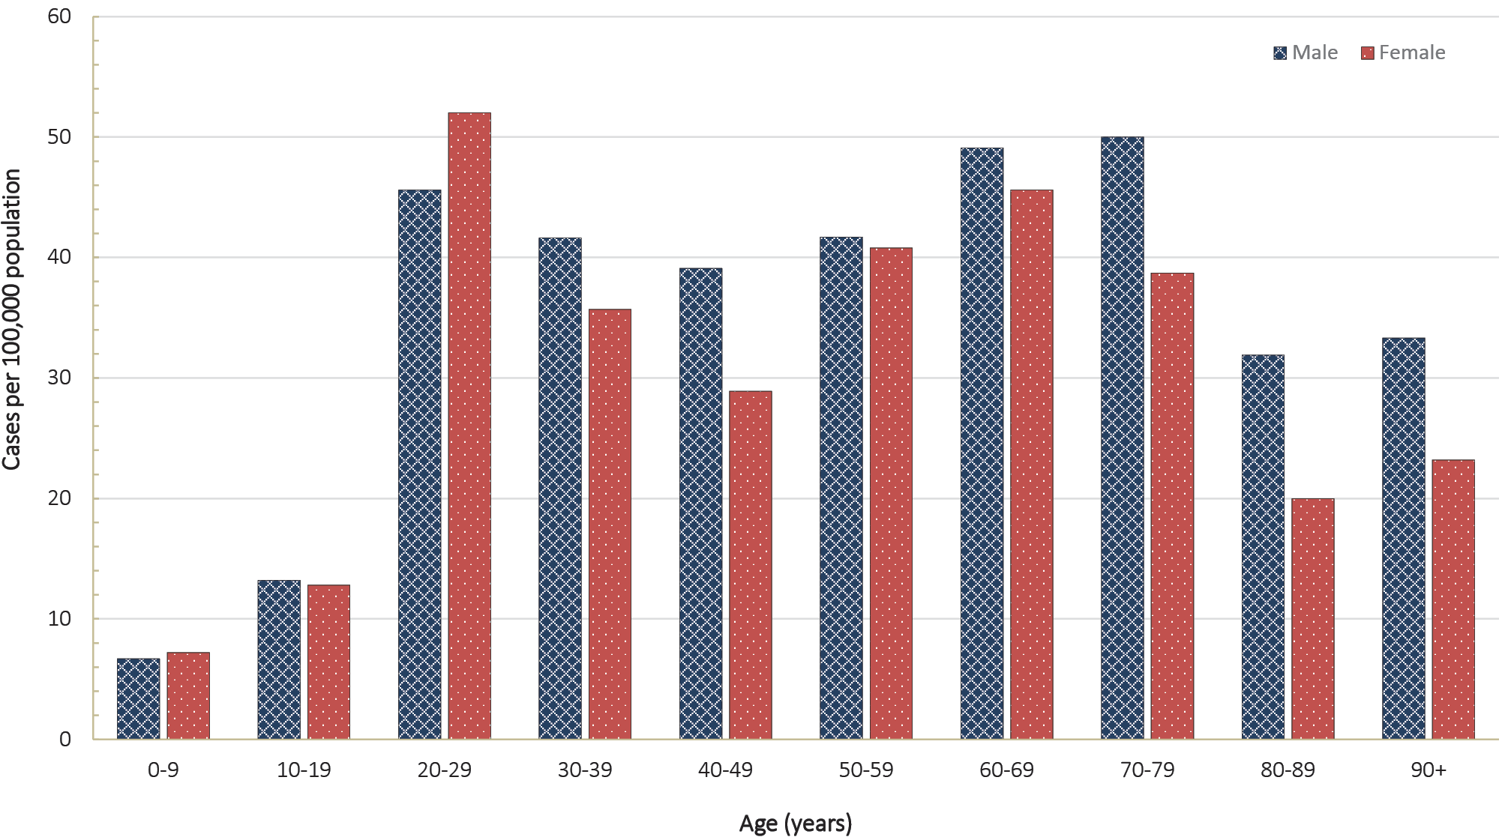
a Source: NNDSS.
Table B.1: Cumulative COVID-19 case notifications and rates per 100,000 population, by age group and gender, 5 July 2020, Australia ^{a,b}
Cases |  |  |  | Rate (per 100,000 population)
Age group | Male  (n = 4,379) | Female  (n = 4,114) | Persons  (n = 8,565) | Male | Female | Persons
0–9 | 109 | 112 | 221 | 6.7 | 7.2 | 6.9
10–19 | 208 | 190 | 400 | 13.2 | 12.8 | 13.1
20–29 | 850 | 938 | 1,808 | 45.6 | 52 | 49.3
30–39 | 756 | 663 | 1,433 | 41.6 | 35.7 | 39
40–49 | 632 | 478 | 1,138 | 39.1 | 28.9 | 34.8
50–59 | 628 | 641 | 1,276 | 41.7 | 40.8 | 41.4
60–69 | 624 | 612 | 1,237 | 49.1 | 45.6 | 47.3
70–79 | 435 | 357 | 792 | 50 | 38.7 | 44.2
80–89 | 114 | 92 | 206 | 31.9 | 20 | 25.2
90 and over | 23 | 31 | 54 | 33.3 | 23.2 | 26.6
a Source: NNDSS.
b Cases and rates for persons include 72 cases with unknown gender.
Table B.2: COVID-19 case notifications and rates per 100,000 population, by age group and gender, 22 June to 5 July 2020, Australia^{a,b}
Age group | Cases |  |  | Rate (per 100,000 population)
Age group | Male  (n = 474) | Female  (n = 418) | Persons  (n = 897) | Male | Female | Persons
0–9 | 37 | 45 | 82 | 2.3 | 2.9 | 2.6
10–19 | 75 | 68 | 145 | 4.8 | 4.6 | 4.7
20–29 | 106 | 79 | 186 | 5.7 | 4.4 | 5.1
30–39 | 100 | 81 | 182 | 5.5 | 4.4 | 5.0
40–49 | 64 | 66 | 130 | 4.0 | 4.0 | 4.0
50–59 | 45 | 42 | 87 | 3.0 | 2.7 | 2.8
60–69 | 27 | 23 | 50 | 2.1 | 1.7 | 1.9
70–79 | 14 | 11 | 25 | 1.6 | 1.2 | 1.4
80–89 | 4 | 2 | 6 | 1.1 | 0.4 | 0.7
90 and over | 2 | 1 | 3 | 2.9 | 0.8 | 1.5
a Source: NNDSS.
b Cases and rates for persons include 5 cases with unknown gender.

Figure B.2: Variation in combinations of COVID-19 symptoms in confirmed cases as at 5 July 2020, Australiaª
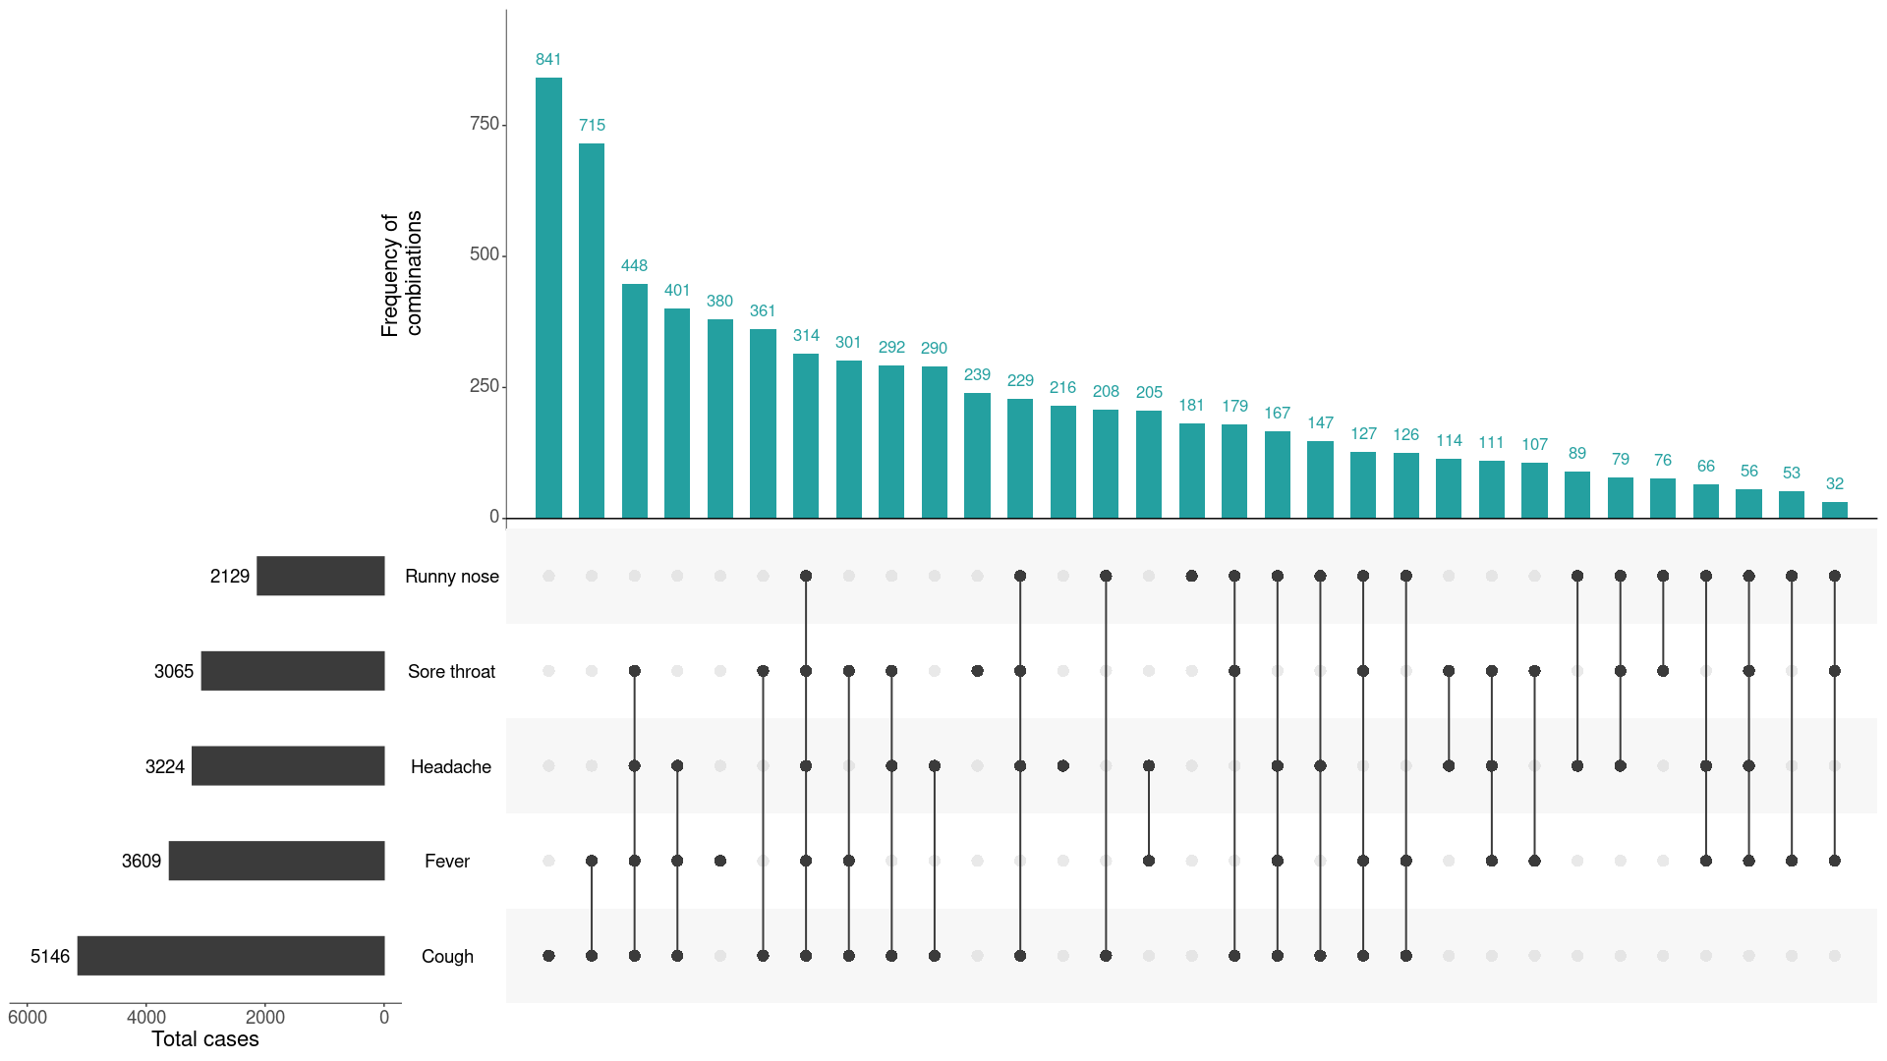
a This figure shows the variation in combinations of symptoms observed in reported cases (n = 7,678) for the five most frequently observed symptoms (cough, fever, headache, sore throat, runny nose). The horizontal bars on the left show the frequency of symptom occurrence in any combination with other symptoms. The circles and lines indicate particular combinations of symptoms observed in individual patients. The vertical green bars indicate the frequency of occurrence of the corresponding combination of symptoms.

Appendix C: Background
The current estimates on epidemiological parameters including severity, transmissibility and incubation period are uncertain. Estimates are likely to change as more information becomes available.

Transmission
Human-to-human transmission of SARS-CoV-2 is via droplets and fomites from an infected person to a close contact.³³ Several studies have detected that viral RNA levels peak in the first week of illness, suggesting transmission is most likely to occur early in the illness with infectivity gradually decreasing over time.³⁴ In a Taiwanese study examining over 2,500 close contacts of 100 patients with COVID-19, all 22 secondary cases had their first exposure to the index case within six days of symptom onset. No infections were documented in the 850 contacts whose exposure was after six days.³⁵
Viral RNA has been identified in respiratory track specimens 1–2 days prior to symptom onset, and has been observed after symptom cessation.³⁴ In 50% of the patients, seroconversion occurred after seven days with a range of up to 14 days; this seroconversion was not followed by a rapid decline in viral load.³⁴ However, the detection of viral RNA does not always correlate with transmission risk. A study of nine patients with mild COVID-19 infection found infectious virus was not able to be isolated from naso/oropharyngeal and sputum samples after the first 8 days of illness, despite continued high viral RNA levels.³⁴ Recent analysis from the Korea Centres for Disease Control and Prevention of cases who tested positive after previously being cleared from isolation found live virus was unable to be cultured from any cases selected for testing (n = 108).³⁶
Several studies suggests that children do not play a key role in transmission and are unlikely to be the primary source of infections.³⁷ Studies out of the EU have suggested that child to adult transmission is uncommon.^{38,39}
Current evidence does not support airborne or faecal-oral spread as major factors in transmission.³³

Incubation period
Estimates of median incubation period, based on seven published studies, are 5 to 6 days (ranging from 1 to 14 days). Patients with long incubation periods do occasionally occur; however, they are likely to be ‘outliers’ who should be studied further but who are unlikely to represent a change in epidemiology of the virus.^{40,41}

Molecular epidemiology
Since December 2019, the virus has diversified into multiple lineages as it has spread globally, with some degree of geographical clustering. The whole genome sequences currently available from Australian cases are dispersed across these lineages, reflecting multiple concurrent introductions into Australia.^{42–44} Multiple genomic clusters, closely related sequences reflecting local transmission chains, have also been identified in Australia.^{42,43} Genomic epidemiology has successfully been used to link many cases that were epidemiologically classified as ‘locally-acquired – contact not identified’ to known genomic clusters, highlighting the utility of virus sequencing to informing the public health response.^{42,43}

Clinical features
COVID-19 presents as mild illness in the majority of cases, with cough and fever being the most commonly reported symptoms. Severe or fatal outcomes are more likely to occur in the elderly or those with comorbid conditions.^{33,45}
Some COVID-19 patients show neurological signs such as headache, nausea and vomiting. There is evidence that SARS-CoV-2 viruses are not always confined to the respiratory tract and may invade the central nervous system inducing neurological symptoms. As such, it is possible that invasion of the central nervous system is partially responsible for the acute respiratory failure of COVID-19 patients.⁴⁶
There is some evidence to suggest that impairment or loss of the sense of smell (hyposmia/anosmia) or taste (hypoguesia/aguesia) is associated with COVID-19.^{47,48} This is supported by research finding a biological mechanism for the SARS-CoV-2 virus to cause olfactory dysfunction.^{49,50}
Several studies have identified cardiovascular implications resulting from COVID-19.^{51–53} Vascular inflammation has been observed in a number of cases and may be a potential mechanism for myocardial injury which can result in cardiac dysfunction and arrhythmias.
COVID-19 disease in children is more likely to be mild and self-limiting, compared to adults. Internationally, children make up a small proportion of confirmed COVID-19 cases, with those shown to be infected either presenting with milder symptoms than adults or remaining asymptomatic, a similar pattern has been observed with SARS and MERS. However, the greater likelihood of mild clinical presentation in children may result in lower testing and case detection in this cohort. Studies have also shown that hospital admission is inversely related to age. From European reporting, death associated with COVID-19 has been rare among those aged less than 15 years, with 4 deaths reported from 44,695 cases, as at 13 May 2020.³⁹
There have been reports of a rare clinical presentation of paediatric inflammatory multisystem syndrome resembling Kawasaki disease temporally associated with SARS-CoV-2 infection in children. However, evidence of the association between COVID-19 and the development of a Kawasaki like disease is currently inconclusive and further investigation is needed due to variability in clinical presentations in reported paediatric cases.^{54,55}

Treatment
Current clinical management of COVID-19 cases focuses on early recognition, isolation, appropriate infection control measures and provision of supportive care.⁵⁶ Whilst there is no specific antiviral treatment currently recommended for patients with suspected or confirmed SARS-CoV-2 infection, multiple clinical trials are underway to evaluate a number of therapeutic agents, including remdesivir, lopinavir/ritonavir, and chloroquine or hydroxychloroquine.^{57,58}
An open-label randomised controlled trial did not find a significant impact of hydroxychloroquine treatment on disease progression for hospitalised patients with mild to moderate COVID-19, with those receiving treatment also reporting a higher number of adverse events.⁵⁹ Similarly, an open-label randomised controlled trial of lopinavir/ritonavir among hospitalised patients found no benefit for time to clinical improvement.⁶⁰
Results for remdesivir treatment have been mixed, with one randomised double-blind placebo-controlled trial finding patients recovered 31% faster and there was a lower mortality rate (8.0% compared with 11.6% among placebo patients),⁶¹ while another found no effect.⁶² Taiwan Food and Drug Administration (TFDA) has recently approved remdesivir for the treatment of patients with severe SARS-CoV-2 infection based on preliminary evidence on its safety and effectiveness. Further trials are required to assess the effectiveness of these treatments on COVID-19. Multiple COVID-19 vaccines have commenced clinical trials.
Research from the UK has found dexamethasone could significantly reduce death in critically ill patients.⁶³ Yet to be published, the preliminary findings announcing by Oxford University reported a 30% reduction in deaths for patients with severe respiratory symptoms. Reduced mortality was observed in ventilated cases and cases requiring oxygen support. No benefit was observed for mild to moderate cases.
Communicable Diseases Intelligence
ISSN: 2209-6051 Online

Communicable Diseases Intelligence (CDI) is a peer-reviewed scientific journal published by the Office of Health Protection, Department of Health. The journal aims to disseminate information on the epidemiology, surveillance, prevention and control of communicable diseases of relevance to Australia.

Editor: Tanja Farmer
Deputy Editor: Simon Petrie
Design and Production: Kasra Yousefi
Editorial Advisory Board: David Durrheim, Mark Ferson, John Kaldor, Martyn Kirk and Linda Selvey

Website: http://www.health.gov.au/cdi

Contacts
Communicable Diseases Intelligence is produced by:
Health Protection Policy Branch, Office of Health Protection, Australian Government Department of Health
GPO Box 9848, (MDP 6) CANBERRA ACT 2601

Email: cdi.editor@health.gov.au

Submit an Article
You are invited to submit your next communicable disease related article to the Communicable Diseases Intelligence (CDI) for consideration. More information regarding CDI can be found at: http://health.gov.au/cdi.
Further enquiries should be directed to: cdi.editor@health.gov.au.

This journal is indexed by Index Medicus and Medline.

Creative Commons Licence - Attribution-NonCommercial-NoDerivatives CC BY-NC-ND
© 2020 Commonwealth of Australia as represented by the Department of Health
This publication is licensed under a Creative Commons Attribution-NonCommercial-NoDerivatives 4.0 International Licence from https://creativecommons.org/licenses/by-nc-nd/4.0/legalcode (Licence). You must read and understand the Licence before using any material from this publication.

Restrictions
The Licence does not cover, and there is no permission given for, use of any of the following material found in this publication (if any):
- the Commonwealth Coat of Arms (by way of information, the terms under which the Coat of Arms may be used can be found at www.itsanhonour.gov.au);
- any logos (including the Department of Health’s logo) and trademarks;
- any photographs and images;
- any signatures; and
- any material belonging to third parties.

Disclaimer
Opinions expressed in Communicable Diseases Intelligence are those of the authors and not necessarily those of the Australian Government Department of Health or the Communicable Diseases Network Australia. Data may be subject to revision.

Enquiries
Enquiries regarding any other use of this publication should be addressed to the Communication Branch, Department of Health, GPO Box 9848, Canberra ACT 2601, or via e-mail to: copyright@health.gov.au

Communicable Diseases Network Australia
Communicable Diseases Intelligence contributes to the work of the Communicable Diseases Network Australia.
http://www.health.gov.au/cdna

This report addresses indicators listed in the CDNA National Surveillance Plan 2020

