COVID-19, Australia: Epidemiology Report 5:
Reporting week ending 19:00 AEDT 29 February 2020
COVID-19 National Incident Room Surveillance Team

Summary
This is the fifth epidemiological report for coronavirus disease 2019 (COVID-19), reported in Australia as at 19:00 Australian Eastern Daylight Time [AEDT] 29 February 2020. It includes data on COVID-19 cases diagnosed in Australia, the international situation and a review of current evidence.
Keywords: SARS-CoV-2; novel coronavirus; 2019-nCoV; coronavirus disease 2019; COVID-19; acute respiratory disease; case definition; epidemiology; Australia
The following epidemiological data are subject to change both domestically and internationally due to the rapidly evolving situation. Australian cases are still under active investigation. While every effort has been made to standardise the investigation of cases nationally, there may be some differences between jurisdictions.
In Australia:
- 25 COVID-19 cases were notified up until 19:00 AEDT 29 February 2020;
- The first 15 cases are all considered to have had a direct or indirect link to Wuhan, Hubei Province, China;
- Nine cases were among the ‘Diamond Princess’ cruise ship passengers repatriated from Japan to the Northern Territory on 20 February 2020;
- The most recent case in Queensland had travelled from Iran;
- There were zero deaths at time of reporting;
- On 27 February 2020, the Australian Health Protection Principal Committee (AHPPC) recommended that the current travel restrictions for mainland China remain in place for a further seven days; and
- On 29 February 2020, travel restrictions were announced for travellers from Iran.

Internationally:
- 85,403 infections have been confirmed globally, with 2,924 deaths;
- The majority of confirmed infections (93%; n = 79,251) and deaths (97%; n = 2,835) have been reported in mainland China;
- On 26 February 2020, the number of cases reported in a 24 hour period from outside mainland China exceeded the number of cases from mainland China for the first time;
- All passengers from the ‘Diamond Princess’ cruise ship have now disembarked and remaining staff will complete 14 days quarantine in Japan;
- Eighty-nine deaths were reported outside mainland China – 34 in Iran (Islamic Republic of), 21 in Italy, 17 in Republic of Korea, six associated with the ‘Diamond Princess’, five in Japan, two each in Hong Kong and France and one each in the Philippines and Taiwan; and
- Republic of Korea, Italy and Iran are now reporting high levels of transmission.

Domestic cases
There were 25 confirmed cases reported in Australia as at 19:00 AEDT 29 February 2020 (Table 1). Nine (36.0%) of the 25 confirmed cases were among the ‘Diamond Princess’ cruise ship passengers repatriated from Japan (n=164) to the Northern Territory on 20 February 2020. The remaining cases were reported in New South Wales (n = 4), Victoria (n = 4), Queensland (n = 6) and South Australia (n = 2). The first 15 cases all had direct or indirect links to Wuhan. The most recent case in Queensland had returned from Iran and was the first Australian case not linked to the outbreaks in Wuhan or on the ‘Diamond Princess’.¹
Table 1: Cumulative notified cases of confirmed COVID-19 by jurisdiction, Australia, 2020 (n = 25)
Jurisdiction | This week  (to 19:00 AEDT 29 Feb)  No. of cases | Last week  (to 19:00 AEDT 22 Feb)  No. of cases | Total cases  (to 19:00 AEDT 29 Feb 2020)  No. of cases
NSW | 0 | 0 | 4
Vic | 0 | 0 | 4
Qld | 1 | 0 | 6
WA | 0 | 0 | 0
SA | 0 | 0 | 2
Tas | 0 | 0 | 0
NT | 0 | 0 | 0
ACT | 0 | 0 | 0
Repatriation (Diamond Princess) | 2 | 7 | 9
Total cases | 3 | 7 | 25
The first case in Australia reported onset of symptoms on 13 January 2020 (Figure 1). The median age of all 25 reported Australian cases was 53 years (range 8–79 years) with a male-to-female ratio of 1:1.3. The following analysis involves 23 out of 25 cases who had detailed data available at the time of reporting. Sixteen cases (69.6%) reported fever, 12 cases (52.2%) reported cough, and nine (39.1%) had a sore throat. Two cases (8.7%) were reported to have pneumonia and five (21.7%) reported diarrhoea. Four cases had no symptoms recorded. Seven cases were reported as having no comorbidities and one case was reported as having diabetes. The first 15 cases have been reported to have recovered, and no deaths were recorded at time of reporting.

Figure 1: Confirmed cases of COVID-19 infection by date of illness onset, Australia 2020 (n = 22)ª
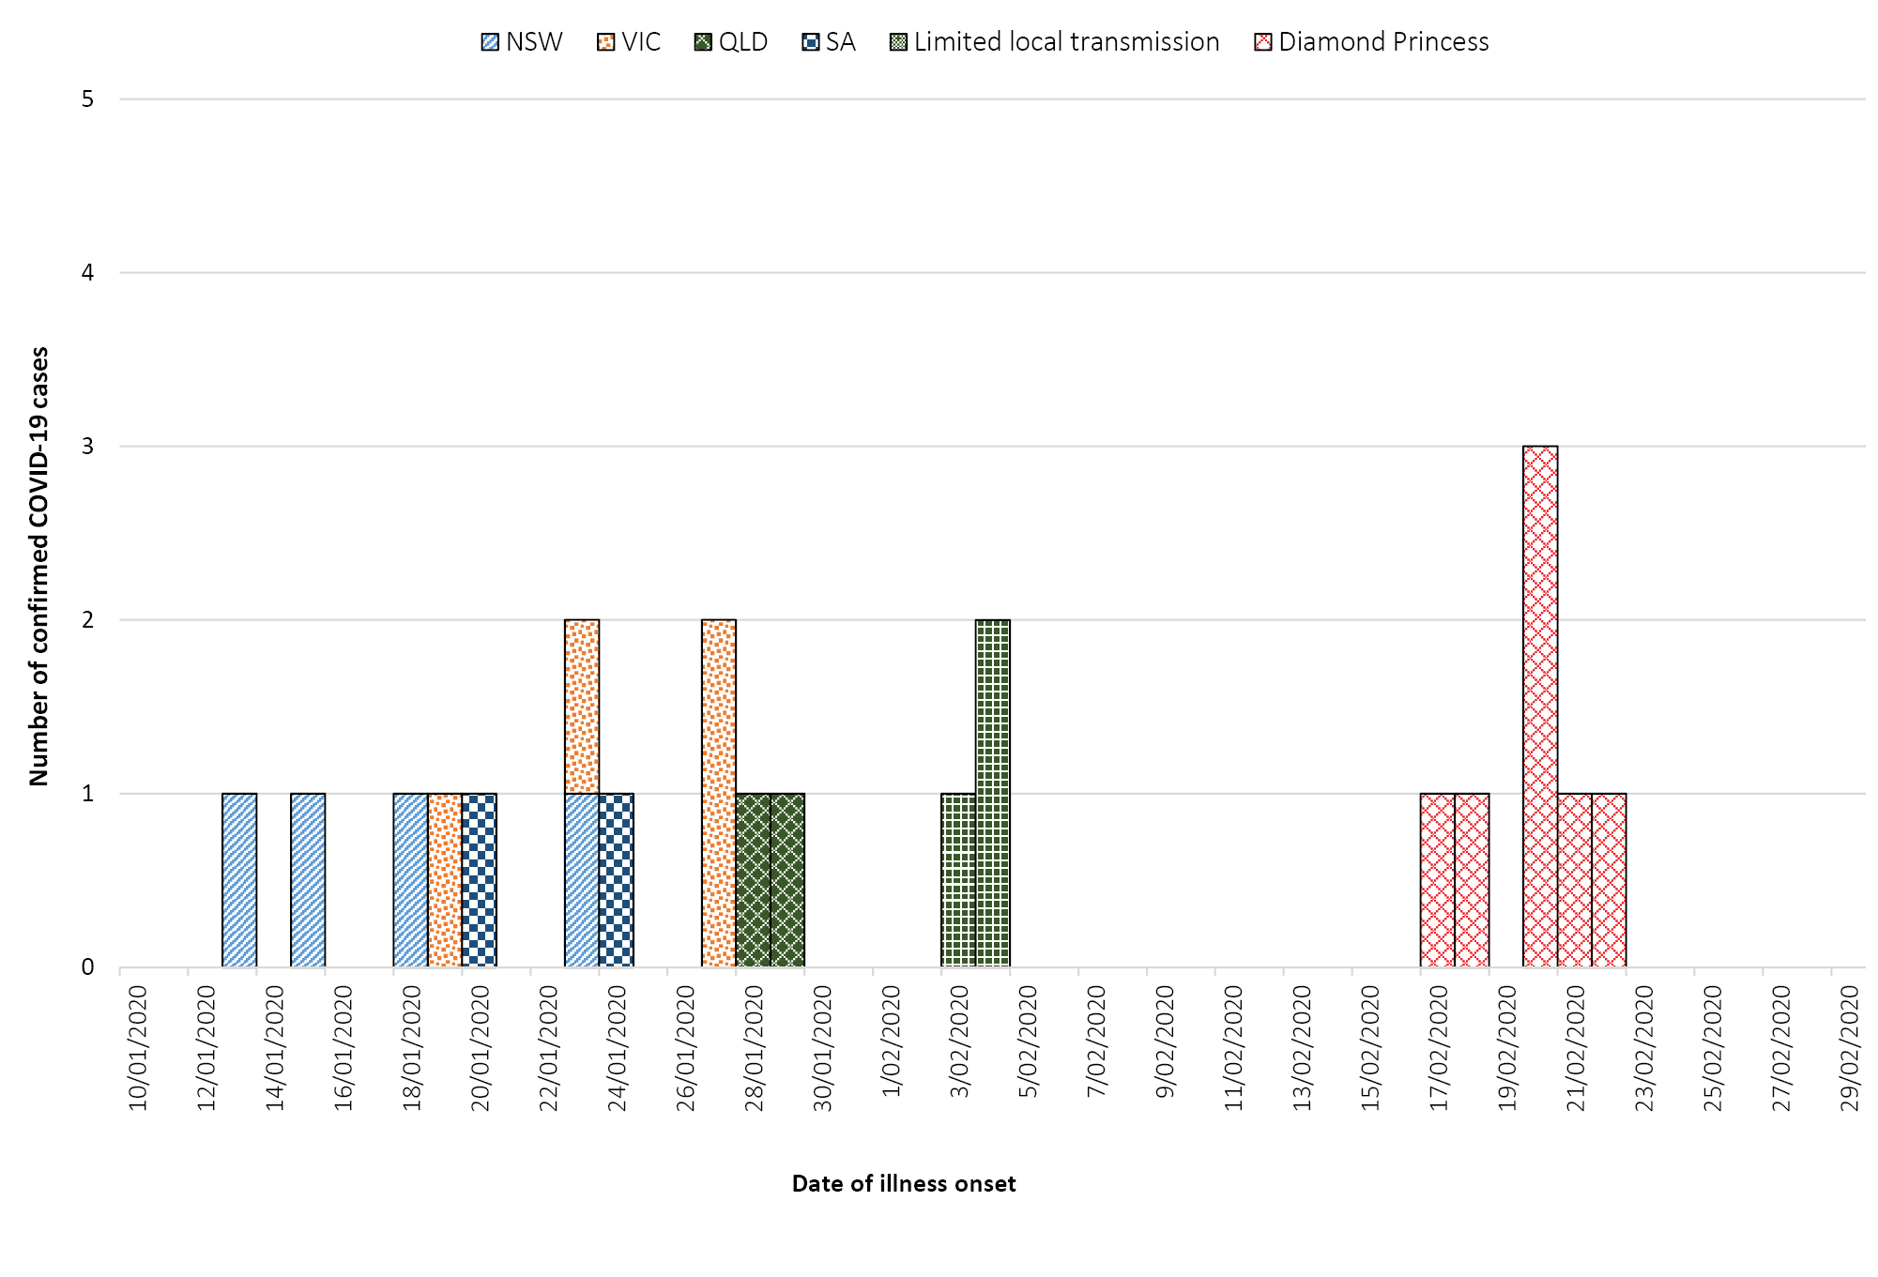
a Date of symptom onset not available for three cases.
Twenty cases had recorded onset of symptoms prior to laboratory testing. The median time between onset of symptoms and testing in these cases was 2 days (range 0–10 days). From these cases, those associated with the ‘Diamond Princess’ (n = 6) had a median time between onset of symptoms and testing of 2 days (range 0–5 days), whilst the remaining cases (n=14) had a median time of 2.5 days (range 0–10 days) between onset of symptoms and testing. The slightly shorter time from symptom onset to testing in the ‘Diamond Princess’ cohort may be because they were under active surveillance for COVID-19. Two cases were tested prior to recorded onset of symptoms and one case did not have a date of symptom onset or any symptoms recorded.
No cases have been detected among Australians who have returned from mainland China since 1 February 2020 or among students from mainland China.² Evidence of limited secondary transmission of COVID-19 in Australia is thought to have occurred for three cases who were part of a five-person cluster identified in Queensland. There is currently no evidence of community transmission within Australia.

International cases
As at 19:00 AEDT 29 February 2020, the number of confirmed COVID-19 cases reported to the World Health Organization (WHO) was 85,403 globally (Table 2). Whilst mainland China reported 92.8% of cases (n = 79,251), this is a decrease from 98.1% on 22 February 2020 as the proportion of new cases reported from outside of mainland China increased over the last week. On 26 February 2020, the number of new cases outside of mainland China exceeded the number reported from mainland China for the first time and this trend has continued to date (Figure 2). Fifty-six countries and Special Administrative Regions outside of mainland China have reported a total of 5,447 confirmed COVID-19 cases. There were an additional 705 confirmed cases on the cruise ship ‘Diamond Princess’. Republic of Korea reported 51.2% of all cases outside of mainland China (n = 3,150), Italy reported 14.4% (n = 888), Iran (Islamic Republic of) 6.3% (n = 388) and Japan 3.7% (n = 230).³

Table 2: Cumulative confirmed cases of COVID-19 globally, 2019–2020
Country / Special Administrative Region | This reporting week  (to 19:00 AEDT 29 Feb 2020) | Last reporting week (to 19:00 AEDT 22 Feb 2020) | Total cases (from Dec 2019)ª | Total deaths (from Dec 2019)ª
Mainland China (total) | 2,963 | 9,796 | 79,251 | 2,835
(Hubei Province | 2,883 | 9,048 | 66,337 | 2,727)
Republic of Korea | 2,804 | 318 | 3,150 | 17
Italy | 879 | 6 | 888 | 21
Diamond Princess cruise ship | 71 | 416 | 705 | 6
Iran (Islamic Republic of) | 370 | 18 | 388 | 34
Japan | 125 | 64 | 230 | 5
Singapore | 12 | 19 | 98 | 0
Hong Kong | 26 | 12 | 94 | 2
United States of America | 27 | 20 | 62 | 0
France | 45 | 1 | 57 | 2
Germany | 41 | 0 | 57 | 0
Kuwait | 45 | 0 | 45 | 0
Thailand | 7 | 1 | 42 | 0
Taiwan | 13 | 8 | 39 | 1
Bahrain | 38 | 0 | 38 | 0
Spain | 30 | 0 | 32 | 0
Australia | 3 | 6 | 24^{b} | 0
Malaysia | 2 | 1 | 24 | 0
United Kingdom | 11 | 0 | 20 | 0
United Arab Emirates | 8 | 3 | 19 | 0
Vietnam | 0 | 0 | 16 | 0
Canada | 6 | 1 | 14 | 0
Sweden | 11 | 0 | 12 | 0
Macau | 0 | 0 | 10 | 0
Switzerland | 10 | 0 | 10 | 0
Iraq | 8 | 0 | 8 | 0
Norway | 6 | 0 | 6 | 0
Oman | 6 | 0 | 6 | 0
Austria | 5 | 0 | 5 | 0
Croatia | 5 | 0 | 5 | 0
Israel | 4 | 1 | 5 | 0
Greece | 3 | 0 | 3 | 0
India | 0 | 0 | 3 | 0
Philippines | 0 | 0 | 3 | 1
Romania | 3 | 0 | 3 | 0
Denmark | 2 | 0 | 2 | 0
Finland | 1 | 0 | 2 | 0
Georgia | 2 | 0 | 2 | 0
Lebanon | 1 | 1 | 2 | 0
Mexico | 2 | 0 | 2 | 0
Netherlands | 2 | 0 | 2 | 0
Pakistan | 2 | 0 | 2 | 0
Russian Federation | 0 | 0 | 2 | 0
Afghanistan | 1 | 0 | 1 | 0
Algeria | 1 | 0 | 1 | 0
Belarus | 1 | 0 | 1 | 0
Belgium | 0 | 0 | 1 | 0
Brazil | 1 | 0 | 1 | 0
Cambodia | 0 | 0 | 1 | 0
Egypt | 0 | 0 | 1 | 0
Estonia | 1 | 0 | 1 | 0
Lithuania | 1 | 0 | 1 | 0
Nepal | 0 | 0 | 1 | 0
New Zealand | 1 | 0 | 1 | 0
Nigeria | 1 | 0 | 1 | 0
North Macedonia | 1 | 0 | 1 | 0
San Marino | 1 | 0 | 1 | 0
Sri Lanka | 0 | 0 | 1 | 0
Total | 7,609 | 10,692 | 85,403 | 2,924
a Data taken from WHO Situation Reports.
b This is different to the case numbers reported in previous sections of this report (i.e. Table 1), which may be due to the internal cut-off times used by WHO for reporting.

Twenty-five new countries or Member States (Afghanistan, Algeria, Austria, Bahrain, Belarus, Brazil, Croatia, Denmark, Estonia, Georgia, Greece, Iraq, Kuwait, Lithuania, Mexico, Netherlands, New Zealand, Nigeria, Norway, North Macedonia, Oman, Pakistan, Romania, San Marino, Switzerland) reported cases of COVID-19 in the past seven days. Eastern Mediterranean and European regions had the greatest growth in number of new countries reporting cases. The first African and South American countries reported cases over the last seven days. Two new countries (Croatia and San Marino) have reported possible or confirmed limited local transmission since the last report on 22 February 2020. Reports suggest sustained local transmission is evident in Republic of Korea, Italy and Iran. Vietnam, Philippines, Cambodia, Russia, Belgium, India, Nepal, Sri Lanka, and Egypt have not reported any new cases for at least 14 days.³
Globally, 2,924 deaths have been reported, with 93.3% (n = 2,727) reported from Hubei Province, China. Eighty-nine deaths were reported outside mainland China: 34 in Iran, 21 in Italy, 17 in Republic of Korea, six from the ‘Diamond Princess’, five in Japan, two each in Hong Kong and France and one each in the Philippines and Taiwan.³

Background
On 31 December 2019, the World Health Organization (WHO) were notified about a large number of cases of pneumonia of unknown origin in Wuhan City, Hubei Province, China. Chinese authorities isolated and identified a novel coronavirus on 7 January 2020.⁴ WHO declared the outbreak of COVID-19 a Public Health Emergency of International Concern (PHEIC) on 30 January 2020.⁵ From 1 February 2020, Australia denied entry to anyone who had left or transited through mainland China, with the exception of Australian citizens, permanent residents and their immediate family and air crew who have been using appropriate personal protective equipment.⁶ The Australian Health Protection Principal Committee (AHPPC) have reviewed these restrictions weekly, and on 27 February 2020, they released a statement recommending current travel restrictions remain in place for a further seven days.² AHPPC acknowledged that while there has been a decrease in number of cases being reported in mainland China (outside of Hubei Province), there is an increasing risk of sustained transmission being established in several other countries.² On the same day, the Australian Prime Minister announced the activation of the Australian Health Sector Emergency Response Plan for Novel Coronavirus (COVID-19).⁷ On the 29 February 2020, the Minister for Health announced travel restrictions for travellers coming from Iran. From 1 March 2020 those who are neither Australian citizens nor permanent residents will be prevented from coming to Australia until 14 days after leaving Iran. Australian citizens, permanent residents and their immediate family will be required to self-isolate on return from Iran.⁸

Figure 2. Cases of COVID-19 reported to WHO and number of countries and SARs reporting outside mainland China from 21 January to 29 February 2020¹⁵
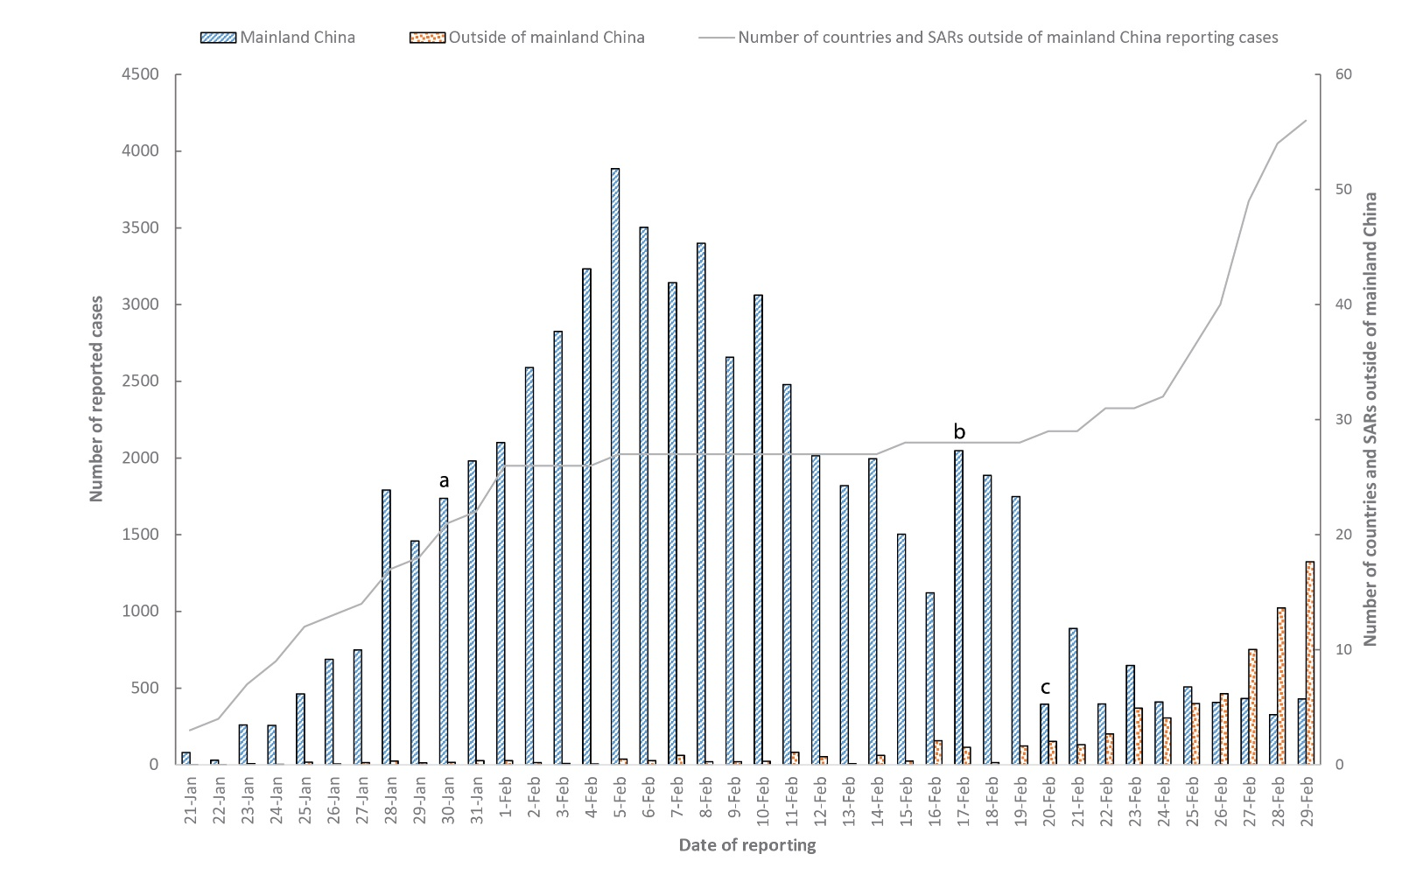
a WHO declares the outbreak of COVID-19 a Public Health Emergency of International Concern
b WHO start reporting both laboratory confirmed and clinically diagnosed cases from Hubei Province
c Hubei Province cease reporting clinically diagnosed cases
The current estimates on epidemiological parameters including severity, transmissibility and incubation period are uncertain. Estimates are likely to change as more information becomes available.

Severity
Ongoing evidence from China supports previous research that COVID-19 presents as mild illness in the majority of cases with fever and cough the most commonly reported symptoms. Severe or fatal outcomes tend to occur in the elderly or those with comorbid conditions.¹⁶ Reports from cases in Republic of Korea suggest that their experience is similar.⁹ Examination of cases in China found the median time from onset to resolution of symptoms was two weeks for those with mild disease and three to six weeks for severe or critical disease. Severe disease tended to develop one week after onset of symptoms and in fatal cases, time from onset of symptoms to death was two to eight weeks.¹⁶
Calculated case fatality rates (CFR) have varied depending on location across China and in countries outside China. Ji et al found a significant correlation between mortality rate and population case load in China. They discussed that the high and rapid escalation of disease may have quickly overwhelmed health services and been a contributing factor to Hubei’s high case fatality rate (CFR).¹⁷ In the wealthy and developed province of Zhejiang, the zero fatality rate despite the large number of cases might be due to well-resourced and accessible healthcare facilities.¹⁷ These findings suggest that delaying the onset of the outbreak and slowing the escalation of cases may allow health authorities in countries not yet reporting sustained community transmission to better prepare for and adapt to manage increasing numbers of cases. However, resource–limited regions might be overwhelmed earlier and at a lower number of cases.
A small case series from China has described four cases who tested positive for SARS-CoV-2 five to 13 days after meeting the criteria for hospital discharge. The criteria for hospital discharge included: normal temperature for at least 3 days; resolved respiratory symptoms; substantially improved acute exudative lesions on chest computed tomography (CT scan); and reverse transcription polymerase chain reaction (RT-PCR) negative on at least two consecutive specimens separated by at least one day. Three repeat RT-PCR tests were performed in the next four to five days for each patient, all of whom remained asymptomatic, and all returned positive.¹⁸ The Australian Series of National Guidelines for COVID-19 acknowledges that a small proportion of people may have an illness that has completely resolved but their respiratory specimens remain persistently PCR positive. The guideline recommends that a decision to release these patients from isolation should be made on a case-by-case basis and that a follow up should take place seven days after release from isolation for clinical review to ensure full symptom resolution.¹⁹

Transmission
Human-to-human transmission of SARS-CoV-2 is via droplets and fomites from an infected person to a close contact.¹⁶ Reports from China, Republic of Korea and Australia of clusters within family and close social groups support this.^{16,20} Current evidence does not support airborne or faecal-oral spread as major factors in transmission.¹⁶

Incubation period
No new research has been published on the incubation period for COVID-19. Please refer to COVID-19, Australia: Epidemiology Report 4.²¹

Recommendations for control
The Report of the WHO-China Joint Mission on Coronavirus Disease 2019 (COVID-19) made the following major recommendations for countries with imported cases and/or outbreaks of COVID-19:¹⁶
- Immediately activate the highest level of national Response Management protocols to ensure the all-of-government and all-of-society approach needed to contain COVID-19 with non-pharmaceutical public health measures;
- Prioritise active, exhaustive case finding and immediate testing and isolation, painstaking contact tracing and rigorous quarantine of close contacts;
- Fully educate the general public on the seriousness of COVID-19 and their role in preventing its spread;
- Immediately expand surveillance to detect COVID-19 transmission chains, by testing all patients with atypical pneumonias, conducting screening in some patients with upper respiratory illnesses and/or recent COVID-19 exposure, and adding testing for the COVID-19 virus to existing surveillance systems (e.g. systems for influenza-like-illness); and
- Conduct multi-sector scenario planning and simulations for the deployment of even more stringent measures to interrupt transmission chains as needed (e.g. the suspension of large-scale gatherings and the closure of schools and workplaces).

Treatment
Current clinical management of COVID-19 cases focuses on early recognition, isolation, appropriate infection control measures and provision of supportive care.²² Whilst there is no specific antiviral treatment currently recommended for patients with suspected or confirmed SARS-CoV-2 infection, there are multiple clinical trials underway in China and the US have begun a clinical trial evaluating Remdesivir, an antiviral developed for the treatment of Ebola virus disease.²³

Testing
The North West London National Health Service (NHS) Trust has implemented a pilot program of home testing of potential cases. Those identified as potential cases by general practitioners, emergency departments or via the NHS hotline are referred to the program. Cases are triaged over the phone before a trained healthcare professional in personal protective equipment goes to the person’s house to collect the specimen and provide education on self-isolation, advice on what to do if they deteriorate and an emergency contact number. The potential case is then contacted with the results and if the result is positive they are admitted to hospital.²⁴ The aim of the program is to reduce the risk of ambulance services and emergency waiting rooms being overwhelmed with potential cases and reduce the risk of disease transmission to potentially vulnerable populations within healthcare settings whilst still allowing for early identification and isolation of cases.

Virology
Several countries have isolated and sequenced the genome for SARS-CoV-2 from cases with COVID-19. Analysis of the genetic diversity of these samples found few mutations, suggesting that following initial animal-to-human transmission from a single source, spread has resulted from human-to-human transmission over a limited period of time. Based on modelling, researchers estimate that initial human infection was in November to early December 2019. Groups of sequences with the same mutations are being identified, confirming human-to-human transmission and linking cases across countries.²⁵ Ongoing surveillance of sequences and shared mutations will assist with understanding of the global spread of the virus.

Methods
Data for this report were current as at 19:00 hours AEDT, 29 February 2020.
This report outlines what is known epidemiologically on COVID-19 in Australia and from publicly available data from WHO Situation Reports, other countries’ official updates and the scientific literature. Data on domestic cases in this report were collected from the National Notifiable Diseases Surveillance System (NNDSS) and state and territory health department media releases. The Communicable Diseases Network Australia (CDNA) developed the case definition for suspected and confirmed cases, which was modified at different time points in the epidemic (Table 3). Based on this guidance, state and territory health department investigators conducted interviews of suspected cases to collect core and enhanced data for inclusion in the NNDSS. Data was analysed using Stata to describe the epidemiology of COVID-19 in Australia and the progress of the epidemic.
Table 3: Australian COVID-19 case definition as of 29 February 2020¹⁹
Version | Date of development | Suspect Case | Confirmed Case
1.13 | 28 February 2020 | If the patient satisfies epidemiological and clinical criteria, they are classified as a suspect case.  Epidemiological criteria  - Travel to (including transit through) mainland China in the 14 days before the onset of illness.  OR  - Close or casual contact in 14 days before illness onset with a confirmed case of COVID-19.  Clinical criteria  - Fever  OR  - Acute respiratory infection (e.g. shortness of breath or cough) with or without fever. | A person who tests positive to a validated specific SARS-CoV-2 nucleic acid test or has the virus identified by electron microscopy or viral culture.
Data for the international cases of COVID-19 by country were compiled from the latest WHO Situation Report. Case definitions may vary by country making comparisons difficult. Rapid reviews of the current state of knowledge on COVID-19 were conducted from the literature using PubMed.

Acknowledgements
This report represents surveillance data reported through CDNA as part of the nationally-coordinated response to COVID-19. We thank public health staff from incident emergency operations centres in state and territory health departments, and the Australian Government Department of Health; along with state and territory public health laboratories.

Author details

Corresponding author
Olivia Williams
NIR Surveillance Team, Communicable Disease Epidemiology and Surveillance Section, Health Protection Policy Branch, Australian Government Department of Health, GPO Box 9484, MDP 14, Canberra, ACT 2601.
Email: epi.coronavirus@health.gov.au

References
- Queensland Health. Novel coronavirus alert. [Internet.] Brisbane: Queensland Health; 2020. [Accessed on 1 March 2020.] Available from: https://www.health.qld.gov.au/news-events/health-alerts/novel-coronavirus .
- Australian Government Department of Health. Australian Health Protection Principal Committee (AHPPC) statement on coronavirus (COVID-19). [Internet.] Canberra: Australian Government Department of Health; 2020. [Accessed on 28 February 2020.] Available from: https://www.health.gov.au/news/australian-health-protection-principal-committee-ahppc-statement-on-coronavirus-covid-19-0 .
- World Health Organization (WHO). Coronavirus disease 2019 (COVID-19) situation report – 40: 29 February 2020. Geneva: WHO; 2020. [Accessed on 1 March 2020.] Available from: https://www.who.int/docs/default-source/coronaviruse/situation-reports/20200229-sitrep-40-covid-19.pdf .
- WHO. Novel coronavirus (2019-nCoV) situation report – 1: 21 January 2020. Geneva: WHO; 2020. [Accessed on 22 January 2020.] Available from: https://www.who.int/docs/default-source/coronaviruse/situation-reports/20200121-sitrep-1-2019-ncov.pdf .
- WHO. Statement on the second meeting of the International Health Regulations (2005) Emergency Committee regarding the outbreak of novel coronavirus (2019-nCoV). [Internet.] Geneva: WHO; 2020. [Accessed on 31 January 2020.] Available from: https://www.who.int/news-room/detail/30-01-2020-statement-on-the-second-meeting-of-the-international-health-regulations-(2005)-emergency-committee-regarding-the-outbreak-of-novel-coronavirus-(2019-ncov).
- Australian Government Department of Health. Australian Health Protection Principal Committee (AHPPC) novel coronavirus statement on 1 February 2020. [Internet.] Canberra: Australian Government Department of Health; 2020. [Accessed on 7 February 2020.] Available from: https://www.health.gov.au/news/australian-health-protection-principal-committee-ahppc-novel-coronavirus-statement-on-1-february-2020 .
- Australian Government Department of Health. Australian Health Sector Emergency Response Plan for novel coronavirus (COVID-19). [Internet.] Canberra: Australian Government Department of Health; 2020. [Accessed on 1 March 2020.] Available from: https://www.health.gov.au/sites/default/files/documents/2020/02/australian-health-sector-emergency-response-plan-for-novel-coronavirus-covid-19_1.pdf .
- Australian Government Department of Health. Press conference about coronavirus (COVID-19) with the Chief Medical Officer. [Internet.] Canberra: Australian Government Department of Health; 2020. [Accessed on 1 March 2020.] Available from: https://www.health.gov.au/ministers/the-hon-greg-hunt-mp/media/press-conference-about-coronavirus-covid-19-with-the-chief-medical-officer .
- Korea Centers for Disease Control & Prevention (KCDC). The updates of COVID-19 in Republic of Korea as of 26 February, 2020. [Internet.] Osong, Republic of Korea: KCDC; 2020. [Accessed on 1 March 2020.] Available from: https://www.cdc.go.kr/board/board.es?mid=a30402000000&bid=0030&act=view&list_no=366352 .
- KCDC. The updates of COVID-19 in Korea as of 29 Feb. 2020. [Internet.] Osong, Republic of Korea: KCDC; 2020. [Accessed on 1 March 2020.] Available from: https://www.cdc.go.kr/board/board.es?mid=a30402000000&bid=0030&act=view&list_no=366406 .
- Cable News Network (CNN). How novel coronavirus spread through the Shincheonji religious group in South Korea. [Internet.] Atlanta: CNN; 2020. [Accessed on 1 March 2020.] Available from: https://edition.cnn.com/2020/02/26/asia/shincheonji-south-korea-hnk-intl/index.html.
- KCDC. The updates of COVID-19 in Republic of Korea. [Internet.] Osong, Republic of Korea: KCDC; 2020. [Accessed on 1 March 2020.] Available from: https://www.cdc.go.kr/board/board.es?mid=a30402000000&bid=0030&act=view&list_no=366363 .
- KCDC. Press release – 219 additional cases are confirmed. [Internet.] Osong, Republic of Korea: KCDC; 2020. [Accessed on 3 March 2020.] Available from: https://www.cdc.go.kr/board/board.es?mid=a30402000000&bid=0030&act=view&list_no=366407 .
- KCDC. The updates of COVID-19 in Republic of Korea as of 24 February, 2020. [Internet.] Osong, Republic of Korea: KCDC; 2020. [Accessed on 1 March 2020.] Available from: https://www.cdc.go.kr/board/board.es?mid=a30402000000&bid=0030&act=view&list_no=366328 .
- WHO. Coronavirus disease 2019 (COVID-19) situation reports. [Internet.] Geneva: WHO; 2020. [Accessed on 3 March 2020.] Available from: https://www.who.int/emergencies/diseases/novel-coronavirus-2019/situation-reports/ .
- WHO. Report of the WHO-China joint mission on coronavirus disease 2019 (COVID-19). [Internet.] Geneva: WHO; 2020. [Accessed on 1 March 2020.] Available from: https://www.who.int/docs/default-source/coronaviruse/who-china-joint-mission-on-covid-19-final-report.pdf .
- Ji Y, Ma Z, Peppelenbosch MP, Pan Q. Potential association between COVID-19 mortality and healthcare resource availability. Lancet Glob Health. 2020. doi: https://doi.org/10.1016/S2214-109X(20)30068-1 .
- Lan L, Xu D, Ye G, Xia C, Wang S, Li Y, et al. Positive RT-PCR test results in patients recovered from COVID-19. JAMA. 2020. doi: https://doi.org/10.1001/jama.2020.2783 .
- Australian Government Department of Health. Novel coronavirus 2019 (2019-nCoV) - CDNA national guidelines for public health units. [Internet.] Canberra: Australia Government Department of Health; 2020. [Accessed on 28 February 2020.] Available from: https://www1.health.gov.au/internet/main/publishing.nsf/Content/cdna-song-novel-coronavirus.htm .
- Queensland Health. Queensland coronavirus update. [Internet.] Brisbane: Queensland Health; 2020. [Accessed on 1 March 2020.] Available from: https://www.health.qld.gov.au/news-events/doh-media-releases/releases/queensland-coronavirus-update5 .
- COVID-19 National Incident Room Surveillance Team. COVID-19, Australia: Epidemiology Report 4. Reporting week ending 19:00 AEDT 22 February 2020. Commun Dis Intell (2018). 2020;44. doi: https://doi.org/10.33321/cdi.2020.44.17 .
- WHO. Clinical management of severe acute respiratory infection when novel coronavirus (nCoV) infection is suspected. [Internet.] Geneva: WHO; 2020. [Accessed on 23 February 2020.] Available from: https://www.who.int/publications-detail/clinical-management-of-severe-acute-respiratory-infection-when-novel-coronavirus-(ncov)-infection-is-suspected .
- Chinese Clinical Trial Registry. Trial search. [Internet.] Sichuan: Chinese Clinical Trial Registry; 2020. [Accessed on 1 March 2020.] Available from: http://www.chictr.org.cn/searchprojen.aspx .
- Mahase E. Coronavirus: home testing pilot launched in London to cut hospital visits and ambulance use. BMJ;368:m621. 2020. doi: http://doi.org/10.1136/bmj.m621 .
- Bedford T, Neher R, Hadfield J, Hodcroft E, Ilcisin M, Müller N. Genomic analysis of nCOV spread. Situation report 2020-01-30. [Internet.] 2020. Available from: https://nextstrain.org/narratives/ncov/sit-rep/2020-01-30.
Communicable Diseases Intelligence
ISSN: 2209-6051 Online

Communicable Diseases Intelligence (CDI) is a peer-reviewed scientific journal published by the Office of Health Protection, Department of Health. The journal aims to disseminate information on the epidemiology, surveillance, prevention and control of communicable diseases of relevance to Australia.

Editor: Cindy Toms
Deputy Editor: Simon Petrie
Design and Production: Kasra Yousefi
Editorial Advisory Board: David Durrheim, Mark Ferson, John Kaldor, Martyn Kirk and Linda Selvey

Website: http://www.health.gov.au/cdi

Contacts
Communicable Diseases Intelligence is produced by:
Health Protection Policy Branch, Office of Health Protection, Australian Government Department of Health
GPO Box 9848, (MDP 6) CANBERRA ACT 2601

Email: cdi.editor@health.gov.au

Submit an Article
You are invited to submit your next communicable disease related article to the Communicable Diseases Intelligence (CDI) for consideration. More information regarding CDI can be found at: http://health.gov.au/cdi.
Further enquiries should be directed to: cdi.editor@health.gov.au.

This journal is indexed by Index Medicus and Medline.

Creative Commons Licence - Attribution-NonCommercial-NoDerivatives CC BY-NC-ND
© 2019 Commonwealth of Australia as represented by the Department of Health
This publication is licensed under a Creative Commons Attribution-NonCommercial-NoDerivatives 4.0 International Licence from https://creativecommons.org/licenses/by-nc-nd/4.0/legalcode (Licence). You must read and understand the Licence before using any material from this publication.

Restrictions
The Licence does not cover, and there is no permission given for, use of any of the following material found in this publication (if any):
- the Commonwealth Coat of Arms (by way of information, the terms under which the Coat of Arms may be used can be found at www.itsanhonour.gov.au);
- any logos (including the Department of Health’s logo) and trademarks;
- any photographs and images;
- any signatures; and
- any material belonging to third parties.

Disclaimer
Opinions expressed in Communicable Diseases Intelligence are those of the authors and not necessarily those of the Australian Government Department of Health or the Communicable Diseases Network Australia. Data may be subject to revision.

Enquiries
Enquiries regarding any other use of this publication should be addressed to the Communication Branch, Department of Health, GPO Box 9848, Canberra ACT 2601, or via e-mail to: copyright@health.gov.au

Communicable Diseases Network Australia
Communicable Diseases Intelligence contributes to the work of the Communicable Diseases Network Australia.
http://www.health.gov.au/cdna

