2025 • Volume 49 • https://doi.org/10.33321/cdi.2025.49.015 • Electronic publication date: 25/03/2025

A cluster of Brucella melitensis in Melbourne, Australia 2023: clinical and public health actions
Manogna Metlapalli, Fiona Clarke, Anna B Pierce, Norelle L Sherry, Jake A Lacey, Edura Jalil, Aswan Tai, Christian McGrath, Tony Korman, James H McMahon, Rhonda L Stuart

Abstract
Brucellosis is a rare zoonotic infection most commonly seen in parts of the Northern Hemisphere. Infections in Australia are uncommon and occur predominantly in Queensland and New South Wales due to exposure to Brucella suis through wild pig hunting activities. We describe a clustering of two cases of brucellosis in Victoria confirmed by genomic analysis but with no identified exposure. We detail the medical management, laboratory confirmation, and the public health investigation. While the source of the outbreak remains unclear, the two cases demonstrate a detailed and coordinated public health response to a rare infection with a unique geographical and temporal relationship.
Keywords: Brucellosis; Brucella melitensis; Victoria; Australia

Introduction
Brucellosis is a zoonotic infection with a global incidence of approximately 2.1 million cases per year.¹ There are twelve identified species of Brucella, with four known to cause human infection: Brucella suis, B. melitensis, B. abortus, and B. canis.²
Human infection is most commonly acquired through handling of infected livestock; consumption of unpasteurised milk and food products; contaminated water; and wild pig hunting. Human to human transmission appears to be infrequent, with two case reports of breast milk and sexual intercourse as possible means of transmission.^{3,4} Strict biosafety protocols with clinical specimens on suspicion of the diagnosis of brucellosis mitigates the risk of aerosol transmission in the laboratory setting.⁵
High risk areas for infection are Africa, Central and South America, the Mediterranean and the Middle East.¹ In Australia, the average annual incidence rate was 20 cases per year between 2008 to 2023.⁶ Infections predominantly occur with the Brucella suis species in the northern half of Australia associated with wild pig hunting in that region.
Within Victoria (holding an approximate population of 6 million people as of June 2022),⁷ there have been seven notified cases of brucellosis between 2017 and 2023: six confirmed cases and one probable.⁶ Prior to our described cluster, all infections were acquired overseas, with the last locally acquired case in 2003 which was associated with consuming unpasteurised cheese.
In Victoria, brucellosis is a notifiable condition under the Public Health and Wellbeing Act 2008, requiring notification from both medical practitioners and laboratories.⁸ The primary objective for public health action is to prevent further spread by identifying potential local sources of infection.
We describe a sporadic geographic and temporal clustering of two cases of likely locally acquired brucellosis in Victoria in 2023 and the subsequent public health response and investigation.

Methods

Case summary
Case 1 was a 45-year-old immunocompetent man who presented with a three-day history of fevers, rigors and left lower quadrant abdominal pain. He had a history of diverticulitis with abdominal imaging showing diverticulosis. He was admitted and treated with ceftriaxone and metronidazole for three days with resolution of symptoms. He also had a history of coryzal symptoms beginning three days prior to admission and rhinovirus/enterovirus ribonucleic acid (RNA) as detected by polymerase chain reaction (PCR) on a nasopharyngeal swab. He was discharged home without any further antibiotics. The day after discharge, he was recalled for a positive blood culture. At that point, he did not have abdominal pain but had subjective fevers, generalised headache, blurred vision, lower back pain and right shoulder pain. Cerebrospinal fluid obtained by lumbar puncture and magnetic resonance imaging (MRI) of the brain and spine were normal.
On the same day that Case 1 presented, a 27-year-old immunocompetent female (Case 2) presented with a two-week history of coryzal symptoms and a 10-day history of fevers, rigors, drenching sweats and right lower quadrant abdominal pain. At the onset of coryzal symptoms she tested positive for influenza via her local doctor and was treated with 75 mg oseltamivir twice daily for five days. On admission she was treated with intravenous ceftriaxone and metronidazole for three days for a presumed intra-abdominal bacterial infection. Computed tomography (CT) scan of the abdomen and stool cultures were normal and the patient went home but was recalled two days later for a positive blood culture. On readmission her fevers had resolved but sweating and abdominal pain persisted. She had developed a frontal, band-like headache without other signs of meningitis. Lumbar puncture was not performed. Abdominal ultrasound and CT brain were unremarkable. Blood cultures from both cases were positive for growth of a short gram-negative coccobacillus which was later confirmed as B. melitensis.

Laboratory diagnosis
Blood cultures were collected from cases and incubated as per standard laboratory methods. When Gram stains revealed short coccobacilli, raising suspicion of Brucella, the blood cultures were referred to the Microbiological Diagnostic Unit (MDU) Public Health Laboratory at the University of Melbourne for further testing. Samples underwent the FilmArray BioFire Biothreat PCR panel under physical containment level 3 (PC3) conditions, followed by rapid genomic sequencing (Oxford Nanopore and Illumina)., Antibiotic susceptibility testing was performed by E-tests in PC3 conditions, and interpreted according to Clinical and Laboratory Standards Institute (CLSI) M45 breakpoints.⁹
Genome data underwent standard quality control checks, and species was determined to be B. melitensis by k-mer identification. The sequence type (ST) was identified using the PubMLST scheme (also consistent with B. melitensis).¹⁰ The case genomes were compared to an ST8 B. melitensis reference strain ATCC 23457 and 177 publicly-available ST8 B. melitensis reference genomes, with a maximum-likelihood phylogeny constructed using 2,495 parsimonious single nucleotide polymorphisms (SNPs) in IQTree2 using the GTR+F+G4 model and 1000 rapid bootstraps.

Public health response
Case 1 was notified to the South East Public Health Unit (SEPHU) 16 days after symptom onset. A case interview was conducted using a standardised case investigation form to assess the likely acquisition source of this infection. Investigation initially focused on his possible workplace exposure; however, reactivation of latent infection acquired years ago in Chile was also considered possible.
Case 2 was notified to SEPHU one day after Case 1 and the same standardised case investigation form was administered. Given the proximity in time and location of the two cases, a Problem Assessment Group (PAG) was formed on day 18 to discuss the likelihood of a common source of exposure for both cases. This was chaired by SEPHU and was attended by representatives from the Victorian Department of Health and Agriculture Victoria (AgVIC).
At this meeting, based on the information available and the low likelihood of reactivation of disease in either case, it was deemed necessary to investigate a possible local common source and the decision was made to declare an outbreak. An Incident Management Team (IMT) was formed, which was led by SEPHU with the first meeting convened, 19 days after the onset of Case 1.
A health alert was issued to infectious disease specialists, informing them of the outbreak and advising testing for those who may have clinically compatible symptoms. An alert was also issued to laboratories via the Public Health Laboratory Network (PHLN) to inform them of the cases and to take the necessary precautions when handling specimens.
An outbreak case was defined as a person notified with B. melitensis in Victoria after 7 August 2023 who may have acquired their infection locally in Victoria.
Public health investigation included detailed food interviews and environmental testing of soil and wastewater. The detailed food interviews with both cases were conducted using the OzFoodNet questionnaire over several days, relating to food consumed eight weeks prior to symptom onset.
The timeline of case events and the public health response is detailed in Figure 1.
Figure 1: Timeline of case events and public health responseª
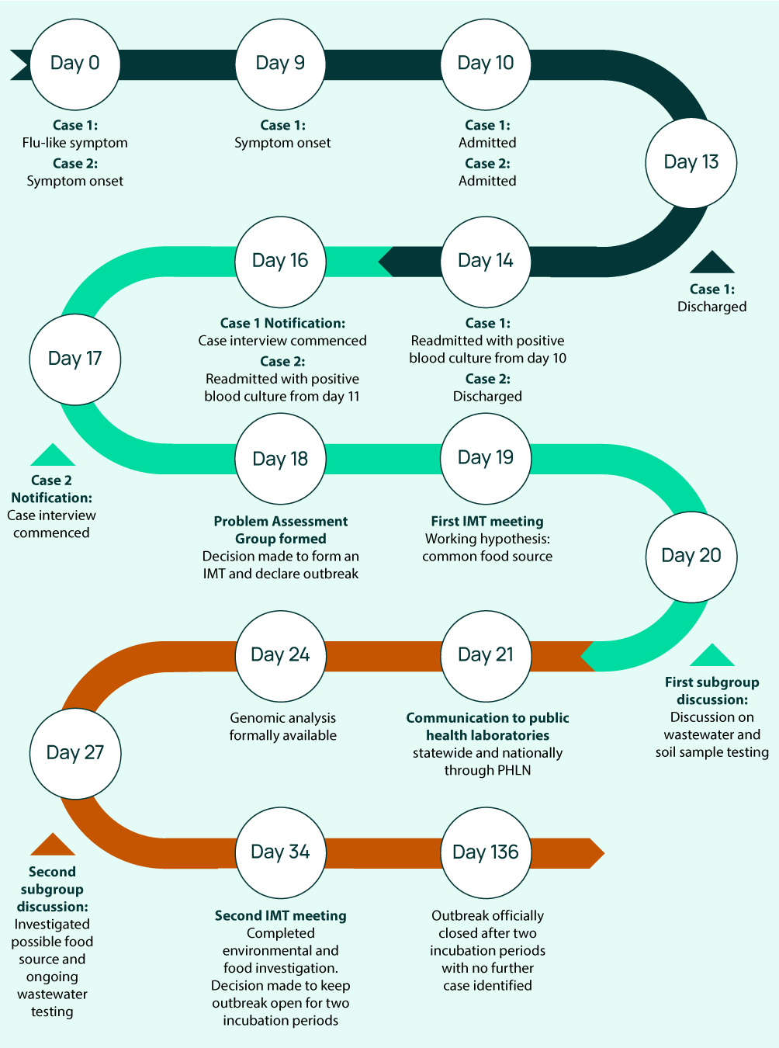
a IMT: incident management team; PHLN: public health laboratory network.

Results

Epidemiological
Case 1 was born in Chile and at the age of five, 40 years before presentation, drank unpasteurised milk from cows at a farm in Chile. He did not report consumption of unpasteurised products in the interval immediately prior to onset of symptoms, and did not have direct contact with farm animals. As part of his job, he was required to assess flooded farm areas in North and South-East Victoria three months prior to presentation. This involved smelling flood-affected soil on farms with cattle, sheep, and horses and crawling in small spaces under houses in close proximity to soil. He did not report any recent interstate travel; his most recent overseas travel was to Indonesia in 2019.
Case 2 was born in India and only migrated to Australia 15 months prior to onset of symptoms. In India, she lived in a village where she had contact with farm animals and drank unpasteurised buffalo milk. In Australia, she had not visited any farms nor had any contact with farm animals. She had not travelled interstate or overseas since arrival to Australia. She was vegetarian and did not report consuming unpasteurised products. She was an avid gardener and recently received a new batch of soil.
The cases lived approximately six kilometres apart from each other in the south-eastern suburbs of metropolitan Melbourne.

Laboratory results
Following characterisation by rapid genomic sequencing, the multilocus sequence type (ST) was determined to be ST 8, consistent with the East Mediterranean lineage (Eastern Mediterranean, Middle East, East and South East Asia distribution) and distinct from the American lineage of B. melitensis. The phylogenetic analysis and pairwise comparisons demonstrated that these two isolates were very closely related (< 10 SNPs difference) and were more closely related to each other than to any other sequence from publicly available sequences worldwide (Figure 2). Thus, the conclusion was that these two isolates likely came from the same or a similar source, and generated the hypothesis that a common food source was most likely.
E-test antibiotic susceptibility testing demonstrated susceptibility to doxycycline (minimum inhibitory concentration [MIC]: 0.125 mg/L), gentamicin (MIC: 0.5 mg/L), tetracyclines (MIC: 0.25 mg/L), and cotrimoxazole (MIC: 1.0 mg/L).
Figure 2: Maximum-likelihood phylogeny of two Victorian Brucella melitensis casesª
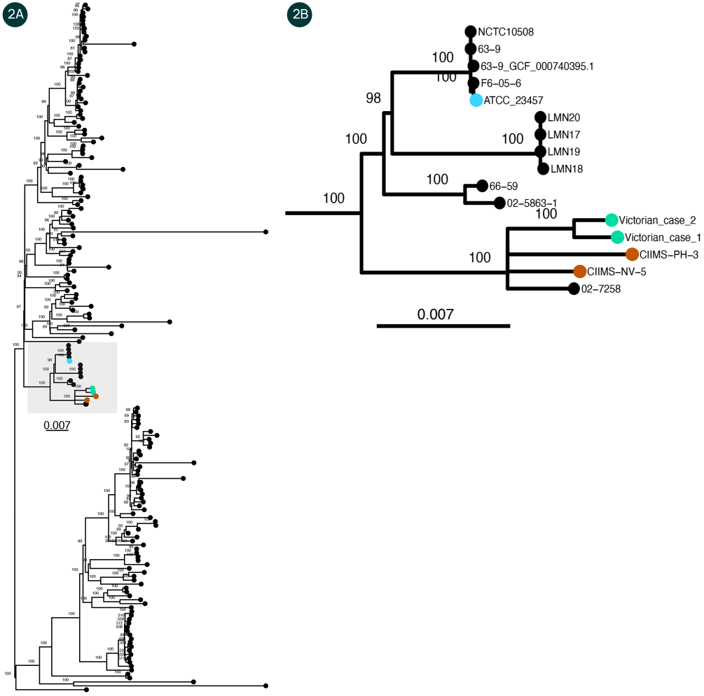
a The Victorian cases are shown in green. Figure 2A shows their maximum-likelihood phylogeny alongside 177 publicly available reference genomes of ST8 B. melitensis obtained from Refseq. This phylogeny was constructed using 2,495 parsimonious SNPs based on the mapping of isolate reads to reference strain ATCC 23457 (blue) and was constructed in IQtree2 using the GTR+F+G4 model and 1000 rapid bootstraps. Figure 2B shows the highlighted clade of the most-related genomes to the Victorian cases, including two cases from India (orange).

Findings from public health response
Given that dairy products (particularly unpasteurised milk products) are known to cause infection, and that Case 2 did not consume meat, food interviews focused primarily on consumption of such products. The only common food source identified was the consumption of feta cheese. Feta cheese was consumed by both cases at different food venues or was purchased from large commercial retailers. The Food Safety Unit at the Victorian Department of Health and relevant local councils contacted the identified food venues and confirmed that there was no common supplier and only feta cheese purchased by large commercial suppliers was utilised. No food samples were tested, as large commercial suppliers and retailers do not use unpasteurised milk in their produce.
B. melitensis infection is a notifiable disease of livestock in Victoria.¹¹ In addition, Australia is considered, internationally, to be free of B. melitensis infection in livestock and surveillance has never detected the condition in sheep or goats.¹⁴ Therefore, livestock was not thought to be the likely source of infection in this outbreak, either through direct or indirect contact.
The environmental sampling was conducted due to Case 2’s extensive gardening activities, coupled with her recent acquisition of a new batch of soil. The council facilitated the soil sampling process, and the samples were subsequently sent to the MDU for testing which returned negative.
Further active case finding was difficult, as the presenting symptoms are very non-specific. The cases were not known to each other, had no contact prior to hospitalisation, and were located in separate wards throughout their admission. Wastewater testing was also conducted for surveillance, although this was considered experimental.

Discussion
This case demonstrates a co-ordinated and co-operative public health investigation in response to an unprecedented infection.

Treatment
Both cases were treated empirically with intravenous ceftriaxone 2 g daily and oral doxycycline 100 mg twice daily (bd), based on the Gram stain results. Once brucellosis had been confirmed, ceftriaxone was ceased, and daily intravenous 5 mg/kg gentamicin commenced. Gentamicin was ceased in Case 1 at day four of treatment due to symptoms of vestibular toxicity. Case 2 completed seven days of gentamicin and both patients completed six weeks of doxycycline.
Case 1 had minimal symptoms at the onset of treatment and was symptom-free on completion of treatment. Case 2’s headache persisted for approximately two months, but all other symptoms markedly improved within twelve hours of commencing gentamicin and doxycycline.
Both cases had successful outcomes due to recognition and treatment of the infection. Current local recommendations for the treatment of brucellosis includes oral doxycycline 100 mg bd for six weeks with intravenous gentamicin 5 mg/kg daily for the first seven days.¹³ Tetracyclines appear to be the most active drugs and recommendations are for use in combination with streptomycin, gentamicin or rifampicin to prevent relapse.¹⁴ However, it has been reported that aminoglycosides may be more effective due to the effect of rifampicin inducing doxycycline thereby lowering serum doxycycline levels.¹⁵
More recent literature, published post-treatment of these cases, includes a systematic review and meta-analysis analysing the efficacy of a triple drug regimen over the current double drug regime.¹⁶ The study reviewed eleven randomised controlled trials and four cohort studies on the use of doxycycline, rifampicin and gentamicin versus doxycycline, rifampicin, and streptomycin versus doxycycline, rifampicin and quinolones versus dual antibiotics of doxycycline and rifampicin. An analysis of the therapeutic failure rate, relapse rate, and rate of adverse effects demonstrated that a triple antibiotic regime had better efficacy compared to dual antibiotics and there was no increase in the rate of adverse effects.¹⁶ Treatment, however, was successful in both our cases with the aforementioned two-drug regimen.

Public health response
The public health response was swift and detailed. Communication was considered key to this response, with early notification to the public health unit and ongoing discussion as new information arose. This can be credited to a close working relationship between the public health unit, the treating infectious diseases team and microbiology laboratory with doctors working within both units, access to shared systems, and close relationships with the public health reference laboratory. The early genomic analysis was critical in understanding the close genomic relationship between the two isolates, in generating the hypothesis of a common food source, and detailed case interviews were used to direct further investigations as detailed above. Another key element of the public health response was communication of the case details to public health units across Australia through the Communicable Diseases Network Australia and the PHLN, which would have allowed rapid identification of an outbreak should there have been other cases identified. Whilst no cause was identified, we still consider this case an example of successful public health strategy and response to unexpected infection.
Despite extensive investigations, the source of this outbreak was not identified; to date, no further cases of B. melitensis have been identified in Victoria. The outbreak was officially closed following the completion of two incubation periods.
Laboratory contamination was considered as a possible explanation. However, given that both isolates grew from blood cultures taken at independent locations and time points, and blood cultures were processed at different times, laboratory contamination is not plausible.

Conclusion
We describe a cluster of highly related cases of brucellosis in Victoria which are likely to be locally acquired, but without an identified source. Clinical cases of brucellosis require prompt identification of the organism, and prompt treatment for cases, to prevent adverse clinical outcomes. The close temporal clustering of these cases led to an outbreak declaration, and formation of an incident management team, within three days of notification of the first case to the relevant regional public health unit; these actions mandated a coordinated clinical, laboratory and public health response. While Australia remains free from B. melitensis infection in livestock, notification of human infection with this potentially hazardous pathogen, from an unknown but assumed local source, has implications for multiple sectors of the community, including the food and livestock industries as well as for diagnostic microbiology services and clinical services.

Acknowledgments
The authors gratefully acknowledge the assistance and advice of Dr Sally Salmon (Deputy Chief Veterinary Officer, Biosecurity and Agriculture Services, Agriculture Victoria).

Conflict of interest
None.

Consent
The authors certify that they have obtained informed written consent from both patients.

Author details
Manogna Metlapalli^{1,}
Fiona Clarke^{1,iii}
Anna B Pierce^{1, 2,3, 4}
Norelle L Sherry^{5, 6}
Jake A Lacey⁵
Edura Jalil²
Aswan Tai²
Christian McGrath⁷
Tony Korman^{1,8}
James H McMahon^{1,3,4,}
Rhonda L Stuart^{1,2,3,iv}
- Department of Infectious Diseases, Monash Health, Clayton, Australia
South East Public Health Unit, Monash Health, Clayton, Australia
Faculty of Medicine, Nursing and Health Science, Monash University
Department of Infectious Diseases, The Alfred Hospital, Australia
Microbiological Diagnostic Unit, Department of Microbiology and Immunology, University of Melbourne at the Peter Doherty Institute for Infection and Immunity, Melbourne, Australia
Department of Infectious Diseases & Immunology, Austin Health, Heidelberg, Victoria, Australia
Community and Public Health Division, Department of Health Victoria, Australia
Department of Microbiology Monash Health, Clayton, Australia

Corresponding author
Dr Manogna Metlapalli
Address: Monash Medical Centre, 246 Clayton Road, Clayton, Vic 3186
Telephone: +61 3 9594 6666
Email: manognaa.01@gmail.com

References
- Laine CG, Johnson VE, Scott HM, Arenas-Gamboa AM. Global estimate of human brucellosis incidence. Emerg Infect Dis. 2023;29(9):1789–97. doi: https://doi.org/10.3201/eid2909.230052.
- Carroll KC, Pfaller MA, Landry ML, McAdam AJ, Patel R, Richter SS et al, eds. Manual of Clinical Microbiology (twelfth edition). Washington DC: ASM Press; 2019.
- Mesner O, Riesenberg K, Biliar N, Borstein E, Bouhnik L, Peled N et al. The many faces of human-to-human transmission of brucellosis: congenital infection and outbreak of nosocomial disease related to an unrecognized clinical case. Clin Infect Dis. 2007;45(12):e135–40. doi: https://doi.org/10.1086/523726.
- Ruben B, Band JD, Wong P, Colville J. Person-to-person transmission of Brucella melitensis. Lancet. 1991;337(8732):14–5. doi: https://doi.org/10.1016/0140-6736(91)93332-4.
- Public Health Laboratory Network (PHLN). Brucellosis (Brucella sp.) Laboratory case definition. Canberra: Australian Government Department of Health and Aged Care, PHLN; 25 October 2006. Available from: https://www.health.gov.au/sites/default/files/documents/2022/06/brucellosis-laboratory-case-definition_0.pdf.
- Australian Department of Health and Aged Care, National Notifiable Disease Surveillance System (NNDSS). National Communicable Disease Surveillance Dashboard. [Webpage.] Canberra: Australian Department of Health and Aged Care, NNDSS; 2023. Available from: https://nindss.health.gov.au/pbi-dashboard/.
- Australian Government Centre for Population. National, state and territory population, March 2022. [Webpage.] Canberra: Australian Government Centre for Population; 26 September 2022. Available from: https://population.gov.au/data-and-forecasts/key-data-releases/national-state-and-territory-population-march-2022.
- State Government of Victoria. Public Health and Wellbeing Act 2008. [Legislation.] Melbourne: State Government of Victoria; 2022. Available from: https://www.legislation.vic.gov.au/in-force/acts/public-health-and-wellbeing-act-2008/065.
- Clinical and Laboratory Standards Institute (CLSI). Methods for antimicrobial dilution and disk susceptibility testing of infrequently isolated or fastidious bacteria (third edition). CLSI guideline M45. Wayne: CLSI; August 2016.
- Whatmore AM, Koylass MS, Muchowski J, Edwards-Smallbone J, Gopaul KK, Perrett LL. Extended multilocus sequence analysis to describe the global population structure of the genus Brucella: phylogeography and relationship to biovars. Front Microbiol. 2016;7:2049. doi: https://doi.org/10.3389/fmicb.2016.02049.
- Australian Government Department of Agriculture, Fisheries and Forestry. National list of notifiable animal diseases. [Webpage.] Canberra: Australian Government Department of Agriculture, Fisheries and Forestry; 1 May 2024. Available from: https://www.agriculture.gov.au/biosecurity-trade/pests-diseases-weeds/animal/notifiable.
- Geering WA, Forman AJ, Nunn MJ. Exotic diseases of animals: a field guide for Australian veterinarians. Canberra: Australian Government Publishing Service; 1995.
- Therapeutic Guidelines (eTG). Brucellosis. [Webpage.] West Melbourne: Therapeutic Guidelines Limited; April 2019. Available from: https://tgldcdp.tg.org.au/viewTopic?etgAccess=true&guidelinePage=Antibiotic&topicfile=brucellosis&guidelinename=Antibiotic&sectionId=toc_d1e47#toc_d1e47.
- Solera J, Espinosa A, Martínez-Alfaro E, Sánchez L, Geijo P, Navarro E et al. Treatment of human brucellosis with doxycycline and gentamicin. Antimicrob Agents Chemother. 1997;41(1):80–4. doi: https://doi.org/10.1128/AAC.41.1.80.
- Colmenero JD, Fernández-Gallardo LC, Agúndez JA, Sedeño J, Benítez J, Valverde E. Possible implications of doxycycline-rifampin interaction for treatment of brucellosis. Antimicrob Agents Chemother. 1994;38(12):2798–802. doi: https://doi.org/10.1128/AAC.38.12.2798.
- Huang S, Wang H, Li F, Du L, Fan W, Zhao M et al. Better efficacy of triple antibiotics therapy for human brucellosis: a systematic review and meta-analysis. PLoS Negl Trop Dis. 2023;17(9):e0011590. doi: https://doi.org/10.1371/journal.pntd.0011590.

© 2025 Commonwealth of Australia as represented by the Department of Health and Aged Care
ISSN: 2209-6051 Online
This journal is indexed by Index Medicus and Medline.
Creative Commons Licence
This publication is licensed under a Creative Commons Attribution-NonCommercial-NoDerivatives 4.0 International Licence (CC BY-NC-ND) available from https://creativecommons.org/licenses/by-nc-nd/4.0/legalcode (Licence). You must read and understand the Licence before using any material from this publication.
Restrictions
The Licence does not cover, and there is no permission given for, use of any of the following material found in this publication (if any):
- the Commonwealth Coat of Arms (by way of information, the terms under which the Coat of Arms may be used can be found on the Department of Prime Minister and Cabinet website;
- any logos (including the Department of Health and Aged Care’s logo) and trademarks;
- any photographs and images;
- any signatures; and
- any material belonging to third parties.
Disclaimer
Opinions expressed in Communicable Diseases Intelligence are those of the authors and not necessarily those of the Department of Health and Aged Care or the Communicable Diseases Network Australia. Data may be subject to revision.
Enquiries
Enquiries regarding any other use of this publication should be addressed to the CDI Editor at: cdi.editor@health.gov.au.
Communicable Diseases Network Australia
Communicable Diseases Intelligence contributes to the work of the Communicable Diseases Network Australia.

About Communicable Diseases Intelligence
Communicable Diseases Intelligence (CDI) is a peer-reviewed scientific journal published by the Health Security & Emergency Management Division, Department of Health and Aged Care. The journal aims to disseminate information on the epidemiology, surveillance, prevention and control of communicable diseases of relevance to Australia.
Editor: Christina Bareja • Deputy Editor: Simon Petrie • Design and Production: Lisa Thompson
Editorial Advisory Board: David Durrheim, Mark Ferson, Clare Huppatz, John Kaldor, Martyn Kirk and Meru Sheel
Submit an Article
Submit your next communicable disease related article to CDI for consideration. Information for authors and details on how to submit your publication is available on our website, or by email at cdi.editor@health.gov.au.
Contact us
Communicable Diseases Intelligence (CDI)
Health Security & Emergency Management Division
Department of Health and Aged Care
GPO Box 9848, CANBERRA ACT 2601
Website: www.health.gov.au/cdi
Email: cdi.editor@health.gov.au

https://nanoporetech.com/.
https://www.illumina.com/.
Joint first authors.
Joint senior authors.

