2025 • Volume 49 • https://doi.org/10.33321/cdi.2025.49.006 • Electronic publication date: 22/01/2025

Australian Trachoma Surveillance Report update: 2014–2022
Alison Jaworski, Carleigh Cowling, Gordana C Popovic, Absar Noorul, Sergio Sandler, Susana Vaz Nery, John Kaldor

Abstract
Australia is the only high-income country where trachoma has been endemic, defined as an overall trachoma prevalence in Aboriginal and Torres Strait Islander children aged 5–9 years of 5% or more. The Australian Government funds the National Trachoma Surveillance and Reporting Unit to collate and analyse trachoma prevalence data and control strategies annually. This report presents data submitted from 2014 to 2022. In 2022, there were 87 remote communities considered at-risk of endemic trachoma, a decline of 51% since 2014 when 177 communities were considered at-risk. World Health Organization grading criteria are used to diagnose trachoma in at-risk populations. Overall prevalence, which includes estimates from all communities ever considered at-risk, fell below 5% endemicity thresholds for the first time in 2022 in Western Australia (2.9%), the Northern Territory (2.1%), New South Wales (0.5%), and in Queensland and South Australia (0.0% each). New cases of trachomatous trichiasis—a severe consequence of trachoma that causes blindness—were detected in eight out of 10,806 persons, aged 15 years and over, screened in 2022. Jurisdictional trichiasis prevalence was 0.2% in Western Australia, 0.1% in South Australia and 0.0% in the Northern Territory. Australia must maintain overall trachoma and trichiasis prevalence below endemicity levels for a further two years before applying for World Health Organization validation of elimination of trachoma as a public health problem.
Keywords: SAFE control strategy; surveillance; elimination

Introduction
Trachoma is the leading cause of preventable infectious blindness globally.¹ Infection with the bacterium Chlamydia trachomatis, namely serotypes A–C, is characterised by the presence of multiple follicles or white spots (trachomatous inflammation – follicular) and/or by inflammatory thickening of the upper tarsal conjunctiva or upper inner eyelid (trachomatous inflammation – intense).^{2–4} Repeated episodes of infection can lead to scarring and distortion of the eyelid, causing the upper eyelashes to turn inward (trachomatous trichiasis), eventually damaging the cornea and resulting in vision loss and blindness.^{5,6}
Trachoma is a disease of poverty and is linked to poor living conditions, including overcrowding and inadequate water and sanitation facilities to prevent C. trachomatis transmission.^{7,8} Transmission occurs person-to-person via infected hands, eyes and fomites (e.g. clothing and bedding), and by eye-seeking flies.⁹ Children under ten years of age generally have the highest prevalence of trachoma and are believed to be the main reservoirs of infection.¹⁰ Trachoma in Australia has primarily been found in remote Aboriginal communities in the Northern Territory, South Australia and Western Australia.¹¹ In 2008, trachoma was also detected in New South Wales and Queensland communities where it was previously thought to have been eliminated as a public health problem.¹² Cases of trachomatous trichiasis (hereafter trichiasis) have been recorded in all states and territories.^{11,12}
Australia is a part of the World Health Organization (WHO) Alliance for the Global Elimination of Trachoma initiative, which has set a new global target for the elimination of trachoma as a public health problem by 2030.¹³ To meet elimination thresholds, Australia is required to maintain for a period of at least two years in each formerly endemic jurisdiction (state/territory) a prevalence of trachoma, defined as the prevalence of trachomatous inflammation – follicular, of less than 5% in children.¹⁴ Australia is also required to demonstrate a prevalence of trichiasis ‘unknown to the health system’ (i.e. new cases) of less than 0.2% in persons aged 15 years or older, as well as evidence of the health system’s ability to manage incident trichiasis cases.¹⁵
Australia initiated the National Trachoma Management Program in 2006 and has adopted the WHO’s package of interventions for trachoma control known as the SAFE strategy,¹⁶ comprising: surgery to correct trichiasis; antibiotic treatment for C. trachomatis to reduce the reservoir of infection; facial cleanliness and environmental improvements to reduce chlamydia transmission.¹⁷⁻²⁰ States and territories with areas historically at risk of trachoma receive funding from the Australian Government to deliver control programs. Programs must be conducted in accordance with the WHO SAFE strategy and the Communicable Diseases Network Australia (CDNA) national guidelines for the public health management of trachoma in Australia.²¹
The Australian Government funds the National Trachoma Surveillance and Reporting Unit (NTSRU) to provide a national mechanism for monitoring and evaluating trachoma control. The NTSRU is responsible for data collection, analysis and annual reporting of surveillance and clinical management activities. This paper presents data submitted by state/territory health departments and other parties involved in trachoma control activities across the period 2014 to 2022. Due to an update to the CDNA guidelines in 2014 regarding trachoma screening intervals (details in methods), this report presents trachoma surveillance data only for the period 2014–2022 to ensure comparability in data collection methods over time.

Ethics statement
The collection, analysis, and reporting of Australia’s jurisdictional trachoma surveillance data is approved by the University of New South Wales (UNSW) Sydney Human Research Ethics Committee (Committee B), number: HC200882.

Methods

Trachoma screening coverage
A community is defined as a specific geographic location where people reside and there is at least one school. Communities are classified by jurisdictional health departments as ‘at risk’ of trachoma if, at least once within the past five years, prevalence of trachomatous inflammation – follicular and/or trachomatous inflammation – intense is 5% or more in children aged 5-9 years screened.²¹ An update to the CDNA guidelines published in 2014 provided the option of not screening all at-risk communities every year, allowing jurisdictions the opportunity to concentrate efforts on control activities in high prevalence communities, or alternatively to make more efficient use of resources in communities with low levels of trachoma that would otherwise benefit little from annual screening.
Whilst WHO guidance for trachoma control focuses on children aged 1–9 years,²² the target group for surveillance activities in Australia since 2006 has been children aged 5–9 years.²¹ This narrower age group was chosen because of ready accessibility through schools and greater feasibility of eye examination. Previous research has demonstrated that trachoma prevalence in 1–4 year-olds in Australia is no higher than in those aged 5–9 years.²³ Children aged 0–4 years or 10–14 years, however, may be examined opportunistically during regular screening activities.
Screening coverage is defined as the proportion of resident children aged 5–9 years who were screened. Estimated resident populations in each community are derived by health programs using Australian Bureau of Statistics census data, enrolment lists from schools and health clinics, supplemented by local advice on movement into and out of communities. CDNA guidelines set a screening coverage target at a minimum of 85% of resident children aged 5–9 years.²¹

Trachoma prevalence
In the Northern Territory, South Australia, and Western Australia, diagnosis of active trachoma is by visual inspection by trained personnel, and defined as the presence of five or more follicles ≥ 0.5 mm in diameter (trachomatous inflammation – follicular) and/or inflammatory thickening of the upper tarsal conjunctiva obscuring more than half of the normal deep vessels (trachomatous inflammation – intense) in accordance with WHO simplified grading criteria.⁴ In Queensland, screening for trachoma includes a detailed ophthalmological examination as well as polymerase chain reaction (PCR) testing of eye swabs for C. trachomatis.
Two prevalence figures are presented in this report. Observed prevalence is calculated using only the data from at-risk communities requiring and receiving screening during the relevant calendar year. Additionally, overall prevalence is calculated by combining observed prevalence from at-risk communities screened during the calendar year, estimated prevalence from communities that were not screened that year but still considered at-risk, and the most recent observed prevalence rates carried forward from formerly at-risk communities now judged by jurisdictions to have eliminated trachoma. Over time, some smaller communities have been amalgamated into larger units for reporting purposes by some jurisdictions to protect confidentiality. In calculations of overall prevalence, community-specific data for these communities are used (or carried forward) until the year of amalgamation.

Facial cleanliness
During screening, children are also examined for clean faces, as ocular and nasal secretions have been linked to C. trachomatis transmission and auto-reinfection.¹⁶ Facial cleanliness is defined as the absence of nasal and ocular discharge, and no dirt, dust and crusting on cheeks and forehead. CDNA guidelines also set a target of at least 85% of children in a community at any one time to have a clean face.²¹

Treatment distribution and coverage
Trachoma is usually treated by a single dose of the antibiotic azithromycin. In Australia, alongside treatment of active cases and household contacts, community-wide treatment is recommended in endemic communities where there is no obvious case clustering. Community-wide treatment strategies vary between jurisdictions, with the Northern Territory typically offering treatment to all persons > 3 kg living in households with children under 15 years, whilst South Australia and Western Australia supply treatment to all children aged six months to 14 years.

Trachoma-related trichiasis
Trachomatous trichiasis is defined as where at least one eyelash from the upper eyelid touches the eyeball, or where there is evidence of recent removal of in-turned eyelashes from the upper eyelid.⁴ In November 2018, the fourth global scientific meeting on trachoma amended the definition of trachomatous trichiasis to exclude trichiasis affecting only the lower eyelid, due to the potential for misclassification.²⁴ As such, trichiasis data is not compared over time in this report. Trichiasis screening methods also vary by jurisdiction, and include visiting regional optometrist service assessments, screening undertaken during annual influenza vaccination programs, and opportunistic screening during the annual health assessment for Aboriginal and Torres Strait Islander people (also called the 715 health check) where available.

Results

Trachoma screening coverage
The total number of communities at-risk of trachoma nationally declined 51% from 177 communities in 2014 to 87 in 2022 (Figure 1). The number of communities at risk of trachoma has fallen in all states and territories during this period, with the largest proportional decline seen in Western Australia at 54% (68 at-risk communities in 2014 to 31 in 2022). In 2022, only the Northern Territory, South Australia and Western Australia continued to identify communities at-risk of trachoma. No communities have been identified as at-risk in New South Wales since 2015; whilst for the first time since 2016 no communities were considered at-risk of trachoma in Queensland in 2022. Of the 87 communities considered at-risk of trachoma in 2022, 79 (91%) were determined to require and received screening, whilst eight (9%) did not require screening.
Figure 1: Number of communities designated at-risk for trachoma by jurisdiction, Australia, 2014 – 2022
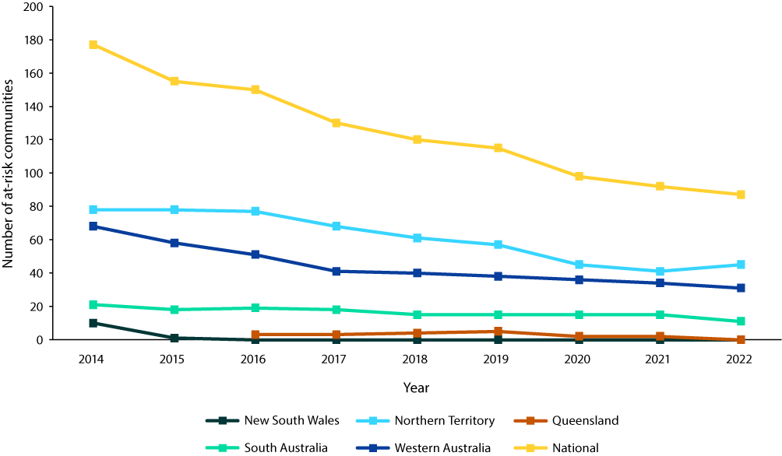

Trachoma prevalence
In 2014, there were 125 at-risk communities in four jurisdictions (New South Wales, the Northern Territory, South Australia and Western Australia) screened for trachoma (Table 1). By 2022, there were 79 at-risk communities in three jurisdictions (the Northern Territory, South Australia and Western Australia) that were screened for trachoma, a decrease of 37%. Additionally, the number of children screened declined by 65% between 2014 and 2022.
Table 1: Trachoma screening coverage and prevalence by jurisdiction,ª Australia, 2014 and 2022
 | NSW |  | NT |  | SA |  | WA |  | Total
 | 2014 | 2022 | 2014 | 2022 | 2014 | 2022 | 2014 | 2022 | 2014 | 2022
Communities screened for trachoma^{b} (n) | 10 | − | 44 | 41 | 13 | 11 | 58 | 27 | 125 | 79
Aboriginal and/or Torres Strait Islander children aged 5-9 years (n) | 396 | − | 1,937 | 1,007 | 783 | 250 | 1,724 | 386 | 4,840 | 1,643
Children screened for trachoma (n) | 249 | − | 1,789 | 918 | 681 | 215 | 1,565 | 358 | 4,284 | 1,491
Trachoma screening coverage (%) | 63 | − | 92 | 91 | 87 | 86 | 91 | 93 | 89 | 91
Children with active trachoma (n) | 0 | − | 99 | 50 | 27 | 0 | 32 | 37 | 158 | 87
Observed trachoma prevalence (%) | 0.0 | − | 5.5 | 5.4 | 4.0 | 0.0 | 2.0 | 10.3 | 3.7 | 5.8
Overall trachoma prevalence (%) | 0.5 | 0.5 | 5.8 | 2.1 | 2.8 | 0.0 | 3.6 | 2.9 | 4.3 | 2.0
a NSW: New South Wales; NT: Northern Territory; SA: South Australia; WA: Western Australia
b Screening in Queensland was undertaken between 2016 and 2021.
There were 158 cases of active trachoma (trachomatous inflammation – follicular and/or intense) reported in children aged 5–9 years in 2014. In 2022, cases of active trachoma declined by 45% to 87 cases detected. Trachoma cases in 2022 were reported either in the Northern Territory or Western Australia.
In 2022, among at-risk communities screened, 39% (31/79) of the communities recorded observed active trachoma levels of 5% or more, with 13% (10/79) of communities recording hyper-endemic prevalence levels at or above 20% (Figure 2). The proportion of screened communities with hyper-endemic trachoma has tended to remain stable since 2014 at around 11–13%, apart from 2019 when 22% of screened communities recorded hyper-endemic trachoma. In contrast, the proportion of screened communities recording no trachoma has steadily increased over the past three years, largely reversing declines seen from 2014 to 2018.
Overall prevalence of trachoma in children aged 5-9 years, which includes prevalence in currently and formerly at risk communities, sat under 5% at the national level in 2014 (Figure 3). However, it was not until 2022 that the overall prevalence declined for the first time below 5% in each jurisdiction. Overall prevalence was 2.9% in Western Australia, 2.1% in the Northern Territory, 0.5% in New South Wales, and 0.0% in Queensland and South Australia in 2022. Between 2014 and 2022, the largest decreases in overall prevalence were seen in the Northern Territory with a 3.7 percentage point decline and in South Australia with a 2.8 percentage point decline. Overall prevalence has tended to remain very low in New South Wales and Queensland, which were declared non-endemic for trachoma in 2017 and 2022 respectively.
Figure 2: Proportion of at-risk communities according to the level of observed trachoma prevalence in Aboriginal and/or Torres Strait Islander children aged 5–9 years, Australia, 2014–2022
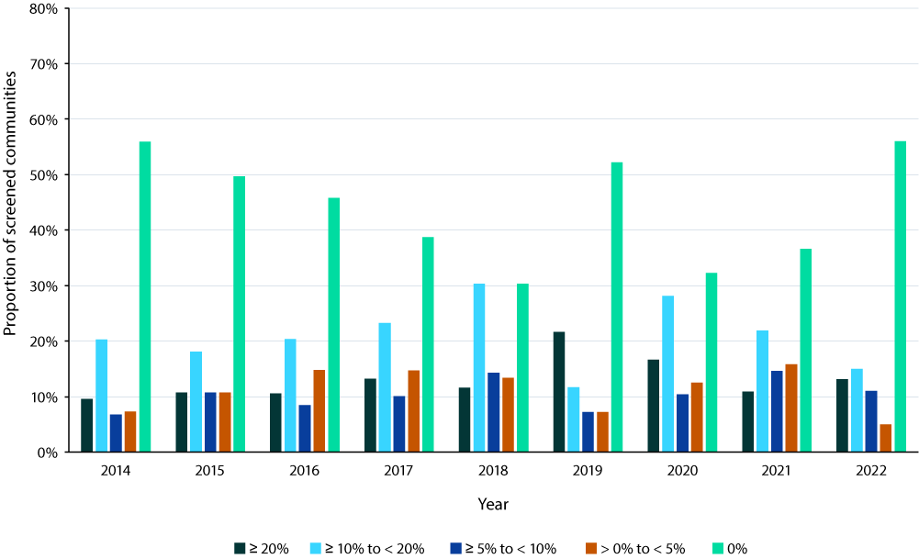
Figure 3: Overall trachoma prevalence in Aboriginal and/or Torres Strait Islander children aged 5–9 years by jurisdiction,ª Australia 2014–2022
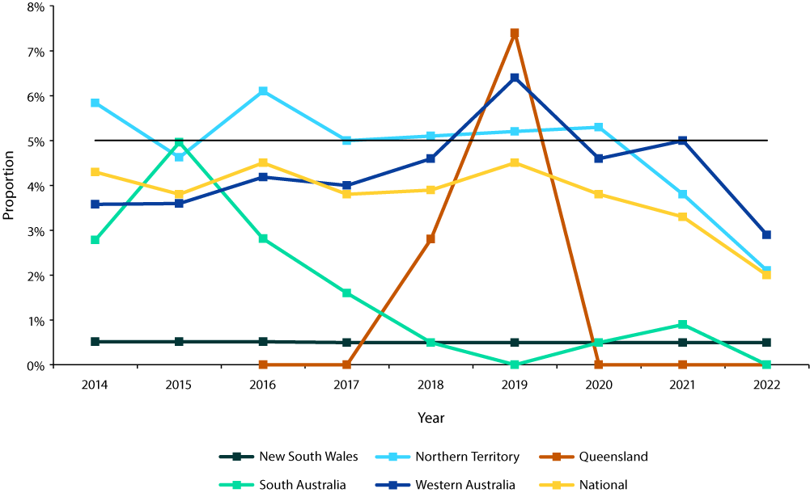
a The horizontal black line shows the 5% trachoma prevalence threshold required to be maintained in each formerly endemic jurisdiction for at least two successive years, as one of the criteria set by WHO for validation of elimination of trachoma as a public health problem.

Facial cleanliness
Since 2014, clean face prevalence has tended to fluctuate around or below the target of 85% of children screened across all states/territories. In Queensland and Western Australia, data indicates a decline in clean face prevalence over time, although for Western Australia it should be noted that the reduction in number of at-risk communities will alter the number of children screened for clean faces (Figure 4).
Figure 4: Proportion of screened Aboriginal and/or Torres Strait Islander children aged 5–9 years who had a clean face by jurisdiction, Australia, 2014–2022ª
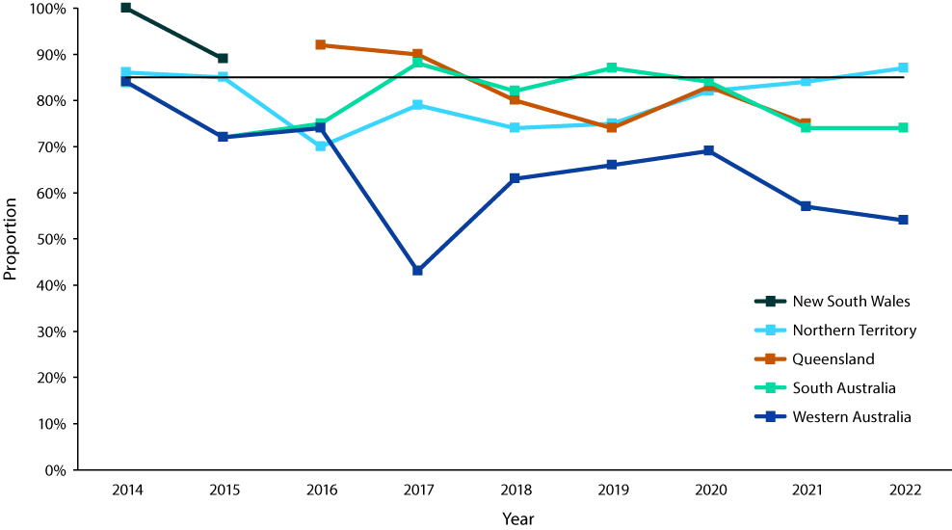

Treatment distribution and coverage
Between 2014 and 2022, the number of communities requiring treatment for trachoma declined by almost half (47%) from 66 to 35 communities (Table 2). This was led by the large decline in communities requiring treatment in the Northern Territory; however, this jurisdiction still accounted for the majority (63%) of all azithromycin doses in 2022. This continues a pattern recorded in previous years, although the gap in dosage numbers has markedly narrowed since 2018, when dosage numbers in the Northern Territory were over six times higher than any other state or territory (Figure 5).
In total, screening programs identified 90 cases of active trachoma in children under 15 years in 2022, all of whom received treatment with azithromycin according to CDNA guidelines. Doses administered were 92% lower in 2022 than in 2014.
Table 2: Azithromycin treatment for trachoma by jurisdiction,ª Australia, 2014 and 2022
 | NT |  | SA |  | WA |  | Total
 | 2014 | 2022 | 2014 | 2022 | 2014 | 2022 | 2014 | 2022
Communities receiving treatment (n) | 43 | 20 | 3 | − | 20 | 15 | 66 | 35
Household-based treatment | 17 | 19 | 3 | − | 17 | 14 | 37 | 33
Community-wide treatment | 26 | 1 | 0 | − | 3 | 1 | 29 | 2
Children requiring treatment for active trachoma (n) | 146 | 50 | 29 | − | 53 | 40 | 228 | 90
Children who received treatment for active trachoma (n) | 134 | 50 | 29 | − | 46 | 40 | 209 | 90
Estimated community contacts requiring treatment^{b} (n) | 8,654 | 508 | 175 | − | 1,780 | 275 | 10,609 | 783
Community contacts who received treatment (n) | 7,671 | 474 | 171 | − | 1,752 | 264 | 9,594 | 738
Estimated overall treatment coverage (%) | 89 | 94 | 98 | − | 98 | 97 | 90 | 95
a NT: Northern Territory; SA: South Australia; WA: Western Australia.
b As per CDNA guidelines.
Figure 5: Number of doses of azithromycin administered for the treatment of trachoma by jurisdiction, Australia, 2014–2022
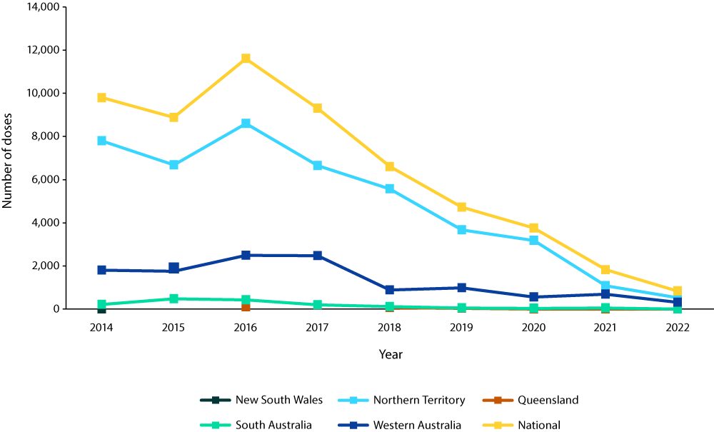

Trachoma-related trichiasis
Prevalence of trichiasis in all states/territories has generally remained low. Overall, 10,806 persons aged 15 years and over in at-risk and previously at-risk communities were screened in 2022, with eight new cases of trichiasis reported, a prevalence of 0.07% (Figure 6). Jurisdictional prevalence amongst populations screened in 2022 was 0% in the Northern Territory, 0.1% in South Australia and 0.2% in Western Australia. Surgery to correct trichiasis was undertaken for four persons nationally in 2022.
Figure 6: Prevalence of trichiasis in Aboriginal and/or Torres Strait Islander persons aged 15+ years screened and surgery casesª by jurisdiction, Australia,
2014–2022
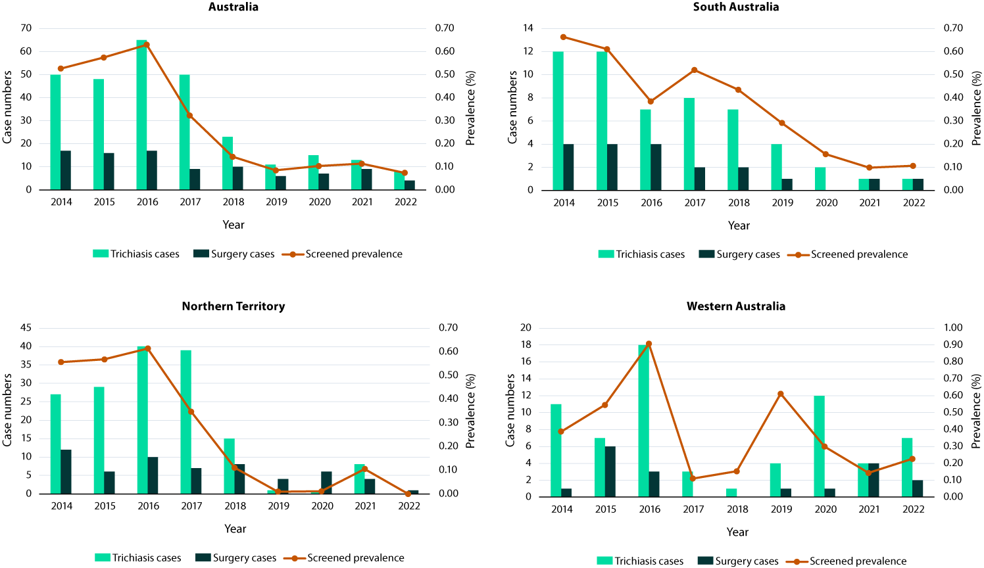
a Surgery cases may include trichiasis cases identified in previous years.

Discussion
Between 2014 and 2022, overall trachoma prevalence declined across Australia. Overall prevalence fell below the 5% elimination threshold at the state/territory level for the first time in 2022. The large drop in number of azithromycin doses distributed between 2014 and 2022 may reflect the declining number of trachoma cases detected as well as the shift in treatment mode away from community-wide distribution to treatment of active cases and household contacts, which was the method chosen in the vast majority (94%) of communities requiring treatment in 2022.
The proportion of trichiasis ‘unknown to the health system’ in screened persons aged 15 years old or older in 2022 was also at elimination targets. Unlike trachoma, trichiasis cases are also detected in non-remote locations, likely due to population movement over time.^{12,25} It is important to note that trichiasis prevalence estimates calculated from jurisdictional screening activities alone are likely to be an overestimation, as this does not capture the full range of ophthalmological services (such as 715 health checks in other states or services within the private health system) provided for trichiasis screening among lower risk populations nation-wide.
Australia must maintain overall trachoma and trichiasis prevalence below elimination targets for two years before an application can be made to the WHO for validation of elimination as a public health problem. Evidence indicates that maintaining appropriate antibiotic treatment regimes, and enhancing community partnerships to shape the design and to increase acceptance of health programs, have been important to reducing trachoma in Australia to date.^{17,20} However, there remain a number of remote communities, particularly in the Northern Territory and Western Australia, with persistent endemic levels of active (observed) trachoma. Whilst treatment coverage was high in 2022, there are anecdotal reports that community-wide treatment is increasingly less acceptable. In this context, sustaining low trachoma prevalence is unlikely to succeed without fully addressing underlying environmental determinants—particularly housing conditions and home health hardware—that influence disease transmission/reinfection and the performance of hygiene activities. However, improving environmental conditions has often proved challenging, with little change in rates of acceptable housing in remote communities in the past decade.²⁶ Improving and maintaining adequate housing supply requires not only increased investment (including in higher quality health hardware),²⁷ but also community-based support to report and facilitate maintenance issues²⁸ and the inclusion of Aboriginal and Torres Strait Islander expertise in the design of housing infrastructure programs.²⁹ Opportunities for sharing cross-jurisdictional and sector learnings need to be fostered³⁰ to enhance the transfer of innovative solutions across settings and to promote the inclusion of health outcomes in housing projects.
The WHO validation dossier requires the submission of a suitable post elimination plan for continued surveillance, treatment, health promotion and environmental health improvement.¹⁴ Developing this plan requires addressing several challenges. The appropriateness of integrating trachoma surveillance into routine health services or school programs, as has been done elsewhere,³³ will need to be investigated for a remote Australian context. Utilisation of laboratory detection methods may be considered given the low specificity of clinical diagnostic indictors using the WHO simplified grading system in low-prevalence settings.^{34,35} There is currently no nationally unified system to track and monitor persons with trichiasis, and approaches to trichiasis surveillance that concentrate on current trachoma endemic areas will need to be broadened to ensure all at-risk persons can be identified and managed appropriately. Solutions to these issues will need to be developed in partnership with Aboriginal and Torres Strait Islander people and organisations to ensure relevance and accountability to communities.

Conclusion
As Australia moves closer to validation of elimination of trachoma as a public health problem, attention needs to turn to the restructuring of post-elimination surveillance for early identification of potential recrudescence, ongoing prevention and control of known environmental risk factors, and monitoring of cases requiring surgical interventions. Community and cross-sectoral collaboration will be essential to maintaining elimination status.

Acknowledgments
The authors would like to thank all jurisdictions that contribute to the Australian Trachoma Surveillance Reports, including the Northern Territory Department of Health Central Australia Public Health Unit, Katherine West Health Board, Queensland Health Communicable Diseases Branch, South Australia Health Eyre and Far North Local Health Network, Aboriginal Health Council of South Australia, Nganampa Health Council, Western Australia Country Health Service Population Health Units, Aboriginal Health Council of Western Australia, and Western New South Wales Local Health District Population Health Unit.

Funding statement
Australia’s trachoma surveillance program and the National Trachoma Surveillance and Reporting Unit are funded by the Commonwealth Department of Health and Aged Care (HEALTH/20-21/PH20/19651).

Author details
Alison Jaworski,¹
Carleigh Cowling,¹
Gordana C Popovic,²
Absar Noorul,¹
Sergio Sandler,¹
Susana Vaz Nery,¹
John Kaldor¹
- The Kirby Institute, UNSW Sydney, Australia
- Stats Central, Mark Wainwright Analytical Centre, UNSW Sydney, Australia

Corresponding author
National Trachoma Surveillance and Reporting Unit
(secretariat to the National Trachoma Surveillance and Control Reference Group).
email: NTSRU_SMB@kirby.unsw.edu.au

References
- WHO Alliance for the Global Elimination of Trachoma. Progress report on elimination of trachoma, 2022. Wkly Epidemiol Rec. 2023;98(28):297–314. Available from: https://iris.who.int/handle/10665/371094.
- Elwell C, Mirrashidi K, Engel J. Chlamydia cell biology and pathogenesis. Nat Rev Microbiol. 2016;14(6):385–400. doi: https://doi.org/10.1038/nrmicro.2016.30.
- Taylor HR, Johnson SL, Schachter J, Caldwell HD, Prendergast RA. Pathogenesis of trachoma: the stimulus for inflammation. J Immunol. 1987;138(9):3023–7. doi: https://doi.org/10.4049/jimmunol.138.9.3023.
- Solomon AW, Kello AB, Bangert M, West SK, Taylor HR, Tekeraoi R et al. The simplified trachoma grading system, amended. Bull World Health Organ. 2020;98(10):698–705. doi: https://doi.org/10.2471/BLT.19.248708.
- Merbs S, Resnikoff S, Kello AB, Mariotti S, Greene G, West SK. Trichiasis surgery for trachoma, Second Edition. Geneva: World Health Organization (WHO); 9 July 2015. Available from: https://www.who.int/publications/i/item/9789241549011.
- West SK, Muñoz B, Mkocha H, Hsieh YH, Lynch MC. Progression of active trachoma to scarring in a cohort of Tanzanian children. Ophthalmic Epidemiol. 2001;8(2–3):137–44. doi: https://doi.org/10.1076/opep.8.2.137.4158.
- Habtamu E, Wondie T, Aweke S, Tadesse Z, Zerihun M, Zewdie Z et al. Trachoma and relative poverty: a case-control study. PLoS Negl Trop Dis. 2015;9(11):e0004228. doi: https://doi.org/10.1371/journal.pntd.0004228.
- Stocks ME, Ogden S, Haddad D, Addiss DG, McGuire C, Freeman MC. Effect of water, sanitation, and hygiene on the prevention of trachoma: a systematic review and meta-analysis. PLoS Med. 2014;11(2):e1001605. doi: https://doi.org/10.1371/journal.pmed.1001605.
- Last A, Versteeg B, Shafi Abdurahman O, Robinson A, Dumessa G, Abraham Aga M et al. Detecting extra-ocular Chlamydia trachomatis in a trachoma-endemic community in Ethiopia: identifying potential routes of transmission. PLoS Negl Trop Dis. 2020;14(3):e0008120. doi: https://doi.org/10.1371/journal.pntd.0008120.
- Solomon AW, Holland MJ, Burton MJ, West SK, Alexander ND, Aguirre A et al. Strategies for control of trachoma: observational study with quantitative PCR. Lancet. 2003;362(9379):198–204. doi: https://doi.org/10.1016/S0140-6736(03)13909-8.
- Cowling CS, Liu BC, Snelling TL, Ward JS, Kaldor JM, Wilson DP. Australian trachoma surveillance annual report, 2013. Commun Dis Intell Q Rep. 2016;40(2):E255–66.
- Taylor HR, Fox SS, Xie J, Dunn RA, Arnold ALMR, Keeffe JE. The prevalence of trachoma in Australia: the National Indigenous Eye Health Survey. Med J Aust. 2010;192(5):248–53. doi: https://doi.org/10.5694/j.1326-5377.2010.tb03501.x.
- WHO Alliance for the Global Elimination of Trachoma. Progress report, 2019. Wkly Epidemiol Rec. 2020;95(30):349–60. Available from: https://iris.who.int/handle/10665/333443.
- WHO. Validation of elimination of trachoma as a public health problem. Geneva: WHO; 4 June 2016. Available from: https://www.who.int/publications/i/item/who-htm-ntd-2016.8.
- WHO. Ending the neglect to attain the Sustainable Development Goals: a road map for neglected tropical diseases 2021–2030. Geneva: WHO; 28 January 2021. Available from: https://www.who.int/publications/i/item/9789240010352.
- Kuper H, Solomon AW, Buchan J, Zondervan M, Foster A, Mabey D. A critical review of the SAFE strategy for the prevention of blinding trachoma. Lancet Infect Dis. 2003;3(6):372–81. doi: https://doi.org/10.1016/s1473-3099(03)00659-5.
- Liu B, Cowling C, Hayen A, Watt G, Mak DB, Lambert S et al. Relationship between community drug administration strategy and changes in trachoma prevalence, 2007 to 2013. PLoS Negl Trop Dis. 2016;10(7):e0004810. doi: https://doi.org/10.1371/journal.pntd.0004810.
- Warren JM, Birrell AL. Trachoma in remote Indigenous Australia: a review and public health perspective. Aust N Z J Public Health. 2016;40(Suppl 1):S48–52.
doi: https://doi.org/10.1111/1753-6405.12396.
- Ewald DP, Hall GV, Franks CC. An evaluation of a SAFE-style trachoma control program in Central Australia. Med J Aust. 2003;178(2):65–8. doi: https://doi.org/10.5694/j.1326-5377.2003.tb05065.x.
- Wright HR, Keeffe JE, Taylor HR. Barriers to the implementation of the SAFE strategy to combat hyperendemic trachoma in Australia. Ophthalmic Epidemiol. 2010;17(6):349–59. doi: https://doi.org/10.3109/09286586.2010.528135.
- Communicable Diseases Network Australia (CDNA). CDNA national guidelines for the public health management of trachoma. Canberra: Australian Government Department of Health and Aged Care, CDNA; 31 January 2014. Available from: https://www.health.gov.au/sites/default/files/documents/2020/02/trachoma-cdna-national-guidelines-for-public-health-units.pdf.
- WHO. Trachoma control: a guide for programme managers. Geneva: WHO; 20 July 2006. Available from: https://www.who.int/publications/i/item/9241546905.
- The National Trachoma Surveillance and Reporting Unit. Australian Trachoma Surveillance Report 2021. Sydney: University of New South Wales, The Kirby Institute, WHO Collaborating Centre in Neglected Tropical Diseases; 2022. Available from: https://www.kirby.unsw.edu.au/sites/default/files/documents/TRACHOMA_2021.pdf.
- WHO. Report of the 4th global scientific meeting on trachoma: Geneva, 27–29 November 2018. Geneva: WHO; 4 June 2019.
Available from: https://www.who.int/publications/i/item/who-htm-ntd-pct-2019.03.
- Dirani M, Keel S, Foreman J, van Wijngaarden P, Taylor HR. Prevalence of trachomatous trichiasis in Australia: the National Eye Health Survey. Clin Exp Ophthalmol. 2018;46(1):13–7. doi: https://doi.org/10.1111/ceo.13003.
- Australian Bureau of Statistics (ABS). Housing statistics for Aboriginal and Torres Strait Islander peoples. [Internet.] Canberra: ABS; 16 September 2021. [Accessed on 22 August 2023.] Available from: https://www.abs.gov.au/statistics/people/aboriginal-and-torres-strait-islander-peoples/housing-statistics-aboriginal-and-torres-strait-islander-peoples/latest-release.
- Standen JC, Morgan GG, Sowerbutts T, Blazek K, Gugusheff J, Puntsag O et al. Prioritising housing maintenance to improve health in Indigenous communities in NSW over 20 years. Int J Environ Res Public Health. 2020;17(16):5946. doi: https://doi.org/10.3390/ijerph17165946.
- Wyber R, Kelly A, Lee AM, Mungatopi V, Kerrigan V, Babui S et al. Formative evaluation of a community-based approach to reduce the incidence of Strep A infections and acute rheumatic fever. Aust N Z J Public Health. 2021;45(5):449–54. doi: https://doi.org/10.1111/1753-6405.13127.
- Johnston L, Doyle J, Morgan B, Atkinson-Briggs S, Firebrace B, Marika M et al. A review of programs that targeted environmental determinants of Aboriginal and Torres Strait Islander health. Int J Environ Res Public Health. 2013;10(8):3518–42. doi: https://doi.org/10.3390/ijerph10083518.
- Lea T, Grealy L, Moskos M, Brambilla A, King S, Habibis D et al. Final Report No. 368: Sustainable Indigenous housing in regional and remote Australia. Melbourne: Australian Housing and Urban Research Institute Limited; 4 November 2021. doi: https://doi.org/10.18408/ahuri7323701.
- WHO. Informal consultation on end-game challenges for trachoma elimination, Task Force for Global Health, Decatur, United States of America, 7–9 December 2021. Geneva: WHO; 18 October 2022. Available from: https://www.who.int/publications/i/item/9789240048089.
- Quesada-Cubo V, Damián-González DC, Prado-Velasco FG, Fernández-Santos NA, Sánchez-Tejeda G, Correa-Morales F et al. The elimination of trachoma as a public health problem in Mexico: from national health priority to national success story. PLoS Negl Trop Dis. 2022;16(8):e0010660. doi: https://doi.org/10.1371/journal.pntd.0010660.
- Hammou J, Mohammadi F, Raisi AA, Harbi SA. Sustaining trachoma elimination: lessons from North Africa and the Middle East. Community Eye Health. 2019;32(105):23.
- Senyonjo LG, Debrah O, Martin DL, Asante-Poku A, Migchelsen SJ, Gwyn S et al. Serological and PCR-based markers of ocular Chlamydia trachomatis transmission in northern Ghana after elimination of trachoma as a public health problem. PLoS Negl Trop Dis. 2018;12(12):e0007027. doi: https://doi.org/10.1371/journal.pntd.0007027.
- Lynch KD, Brian G, Ahwang T, Morotti W, Wharton G, Newie T et al. Assessing the prevalence of trachoma: lessons from community screening with laboratory testing in Australia’s Torres Strait Islands. Ophthalmic Epidemiol. 2022;30(6):663–670. doi: https://doi.org/10.1080/09286586.2022.2136389.
- Aboe A, Joof BM, Kanyi SK, Hydara A, Downs P, Bush S et al. The Gambia has eliminated trachoma as a public health problem: challenges and successes. PLoS Negl Trop Dis. 2022;16(3):e0010282. doi: https://doi.org/10.1371/journal.pntd.0010282.

© 2025 Commonwealth of Australia as represented by the Department of Health and Aged Care
ISSN: 2209-6051 Online
This journal is indexed by Index Medicus and Medline.
Creative Commons Licence
This publication is licensed under a Creative Commons Attribution-NonCommercial-NoDerivatives 4.0 International Licence (CC BY-NC-ND) available from https://creativecommons.org/licenses/by-nc-nd/4.0/legalcode (Licence). You must read and understand the Licence before using any material from this publication.
Restrictions
The Licence does not cover, and there is no permission given for, use of any of the following material found in this publication (if any):
- the Commonwealth Coat of Arms (by way of information, the terms under which the Coat of Arms may be used can be found on the Department of Prime Minister and Cabinet website;
- any logos (including the Department of Health and Aged Care’s logo) and trademarks;
- any photographs and images;
- any signatures; and
- any material belonging to third parties.
Disclaimer
Opinions expressed in Communicable Diseases Intelligence are those of the authors and not necessarily those of the Department of Health and Aged Care or the Communicable Diseases Network Australia. Data may be subject to revision.
Enquiries
Enquiries regarding any other use of this publication should be addressed to the CDI Editor at: cdi.editor@health.gov.au.
Communicable Diseases Network Australia
Communicable Diseases Intelligence contributes to the work of the Communicable Diseases Network Australia.

About Communicable Diseases Intelligence
Communicable Diseases Intelligence (CDI) is a peer-reviewed scientific journal published by the Health Security & Emergency Management Division, Department of Health and Aged Care. The journal aims to disseminate information on the epidemiology, surveillance, prevention and control of communicable diseases of relevance to Australia.
Editor: Christina Bareja • Deputy Editor: Simon Petrie • Design and Production: Lisa Thompson
Editorial Advisory Board: David Durrheim, Mark Ferson, Clare Huppatz, John Kaldor, Martyn Kirk and Meru Sheel
Submit an Article
Submit your next communicable disease related article to CDI for consideration. Information for authors and details on how to submit your publication is available on our website, or by email at cdi.editor@health.gov.au.
Contact us
Communicable Diseases Intelligence (CDI)
Health Security & Emergency Management Division
Department of Health and Aged Care
GPO Box 9848, CANBERRA ACT 2601
Website: www.health.gov.au/cdi
Email: cdi.editor@health.gov.au

