Surveillance of adverse events following immunisation in Australia: annual report, 2018
Aditi Dey, Han Wang, Helen Quinn, Alexis Pillsbury, Catherine Glover, Megan Hickie, Nicholas Wood, Frank Beard and Kristine Macartney

Abstract
This report summarises Australian spontaneous surveillance data for adverse events following immunisation (AEFI) for 2018 reported to the Therapeutic Goods Administration and describes reporting trends over the 19-year period 1 January 2000 to 31 December 2018. There were 4221 AEFI records for vaccines administered in 2018, an annual AEFI reporting rate of 16.9 per 100,000 population. There was a 2.9% increase in the overall AEFI reporting rate in 2018 compared to 2017. This slight increase in reported adverse events in 2018 was likely due to new additions to the National Immunisation Program schedule, namely meningococcal ACWY vaccination for children aged 12 months, enhanced immunogenicity trivalent influenza vaccines for adults aged ≥65 years, and state- and territory-funded seasonal influenza vaccination programs for children aged 6 months to <5 years. AEFI reporting rates for most individual vaccines in 2018 were similar to 2017. The most commonly reported adverse events were injection site reaction (34%), pyrexia (15%), rash (15%), vomiting (8%), headache (6%) and pain (6%). Two deaths were reported to the TGA but no clear causal relationship with vaccination was found.
Keywords: AEFI, adverse events, vaccines, surveillance, immunisation, vaccine

Introduction
This report summarises national spontaneous surveillance data for adverse events following immunisation (AEFI) reported to the Therapeutic Goods Administration (TGA). The report focuses on AEFI reported for vaccines administered during 2018 and on trends in AEFI reporting over the 19-year period 1 January 2000 – 31 December 2018.
An adverse event following immunisation is defined as any untoward medical occurrence which follows immunisation and which does not necessarily have a causal relationship with the usage of the vaccine.¹ The adverse event may be any unfavourable or unintended sign, abnormal laboratory finding, symptom or disease.¹ Thus, AEFI may be caused by a vaccine(s) or may be coincidental. Adverse events may also include conditions that occur following the incorrect handling and/or administration of a vaccine(s). The post-marketing surveillance of AEFI is particularly important to detect signals of rare, late onset or unexpected events, which are difficult to detect in pre-registration vaccine trials.
Reports summarising national AEFI surveillance data have been published regularly since 2003.^{2–15} Trends in reported AEFI are influenced by changes to vaccine funding and availability through the National Immunisation Program (NIP), and the impact of these changes on the interpretation of trend data has been described in previous reports published since 2003.^{2–15} Changes to the NIP since 2005 are summarised in Table 1. Recent changes that impact on AEFI surveillance data presented in this 2018 report are:

October 2018
- Multicomponent recombinant meningococcal B vaccine funded by SA for children 6 weeks to 12 months of age, with catch-up for children from 12 months to <4 years of age
July 2018
- Meningococcal ACWY conjugate vaccine funded for all children at 12 months of age, replacing combined Hib and meningococcal C-containing vaccine
- Hib dose moved to 18 months and given as monovalent Hib vaccine
- Schedule for routine childhood vaccination with 13vPCV changed from 2, 4 and 6 months of age to 2, 4 and 12 months of age
April 2018
- Enhanced trivalent influenza vaccines (high-dose and adjuvanted) funded nationally for all adults aged ≥65 years
- Annual seasonal influenza vaccination funded by ACT, NSW, Qld, SA, TAS and Vic for all children aged 6 months to <5 years
- Meningococcal A, C, Y, W-135 conjugate vaccine funded by SA for Aboriginal and Torres Strait Islander children and adolescents aged 12 months to 19 years living in the Eyre and Far North, and Flinders and Upper North regions
February 2018
- Meningococcal A, C, Y, W-135 conjugate vaccine funded by ACT for grade 10 students and persons aged 16–19 years who no longer attend school
- A 2-dose schedule of 9vHPV funded for adolescents aged 12–14 years, delivered through a school-based program; 4vHPV ceased to be used in the program
January 2018
- Meningococcal A, C, Y, W-135 conjugate vaccine funded by WA for children aged 12 months to <5 years
- Meningococcal ACWY school-based vaccination program funded for all NSW secondary school students in Years 10 and 11, as well as adolescents aged 15 to 19 years who have not received the vaccine at school.
To assist readers, at the end of this report there is a glossary of the abbreviations of the vaccines referred to in this report.

Table 1: Changes in immunisation policy and the National Immunisation Program (2005–2018)^{2,4,5,7,10,12,14,15,36,37,40}
Year | Change
2018 | October 2018  - Multicomponent recombinant meningococcal B vaccine funded by SA for children 6 weeks to 12 months of age, with catch-up for children from 12 months to <4 years of age  July 2018  - Meningococcal ACWY conjugate vaccine funded for all children at 12 months of age, replacing combined Hib and meningococcal C-containing vaccine  - Hib dose moved to 18 months and given as monovalent Hib vaccine.  - Schedule for routine childhood vaccination with 13vPCV changed from 2, 4 and 6 months of age to 2, 4 and 12 months of age.  April 2018  - Enhanced trivalent influenza vaccines (high-dose and adjuvanted) funded nationally for all adults aged ≥65 years.  - Annual seasonal influenza vaccination funded by ACT, NSW, Qld, SA, TAS and Vic for all children aged 6 months to <5 years  - Meningococcal A, C, Y, W-135 conjugate vaccine funded by SA for Aboriginal and Torres Strait Islander children and adolescents aged 12 months to 19 years living in the Eyre and Far North, and Flinders and Upper North regions  February 2018  - Meningococcal A, C, Y, W-135 conjugate vaccine funded by ACT for grade 10 students and persons aged 16–19 years who no longer attend school  - A 2-dose schedule of 9vHPV funded for adolescents aged 12–14 years, delivered through a school-based program; 4vHPV ceased to be used in the program.  January 2018  - Meningococcal A, C, Y, W-135 conjugate vaccine funded by WA for children aged 12 months to <5 years  - Meningococcal ACWY school-based vaccination program funded for all NSW secondary school students in Years 10 and 11, as well as adolescents aged 15 to 19 years who have not received the vaccine at school.
2017 | From January to December 2017, meningococcal ACWY conjugate vaccine funded in Western Australia, Victoria and Tasmania for grade 10–12 students; New South Wales for grade 11–12; Queensland grade 10 students and persons aged 15–19 years who no longer attend school. The Northern Territory introduced the vaccine for at-risk people aged 1–19 years living in specified remote regions and all children aged 12 months. For more details see the meningococcal vaccination history table at http://ncirs.org.au/sites/default/files/2019-04/Meningococcal-history-April-2019.pdf  From April 2017, meningococcal B vaccine study commenced in South Australia for grade 10–12 students at participating schools.
2016 | From November 2016, zoster vaccine (Zostavax®) provided free for people aged 70 years under the National Immunisation Program (NIP) with a five year catch-up program for people aged 71–79 years.  From March 2016, free booster dose of the diphtheria, tetanus, and acellular pertussis-containing vaccine (DTPa) at 18 months of age.
2015 | From March 2015, seasonal influenza vaccine funded for Aboriginal and Torres Strait Islander children aged 6 months to less than 5 years.  From March to June 2015, the dTpa vaccine for women during the third trimester of pregnancy was funded by New South Wales, South Australia, Western Australia, the Australian Capital Territory, Victoria and Tasmania. The Northern Territory had funded it since September 2013 and Queensland since July 2014.  In March 2015, a booster dose of DTPa vaccine recommended at 18 months of age (funded in March 2016).  In April 2015, new immunisation requirements for family assistance payments were announced by the federal government (the ‘No Jab, No Pay’ policy), to come into effect on 1 January 2016. Only parents of children (aged less than 20 years) who are ‘fully immunised’ or on a recognised catch-up schedule remain eligible to receive the Child Care Benefit, Child Care Rebate, and/or the Family Tax Benefit Part A end-of-year supplement.
2014 | 4vHPV vaccine catch-up program for males aged 14–15 years ceased in December 2014.  In July 2014, dTpa vaccine was funded by Queensland for women during the third trimester of pregnancy.
2013 | From 1 February 2013, 4vHPV vaccine was extended to males aged 12–13 years, delivered through a school-based program, with a catch-up program for males aged 14–15 years in 2013 and 2014.  From July 2013, the second dose of MMR vaccine, previously given at 4 years, was brought forward to 18 months of age and delivered as MMRV vaccine.  From July 2013, combined Haemophilus influenzae type b (Hib) and meningococcal serogroup C (MenC) vaccine, Menitorix®, was funded for infants aged 12 months. This combination vaccine replaced the single dose of monovalent meningococcal C conjugate vaccine (MenCCV) and booster dose of monovalent Hib vaccine previously scheduled at 12 months of age.  At the end of December 2013, the secondary school Year 7 hepatitis B vaccine catch-up program ceased, as all younger age cohorts were eligible for infant immunisation under the NIP (commenced 2000).  In September 2013, dTpa vaccine funded by NT for women during the third trimester of pregnancy and for parents of infants aged <7 months under cocoon strategy
2012 | From 1 October 2012, a fourth dose of Prevenar 13®, (13vPCV, a 13-valent pneumococcal conjugate vaccine) was listed on the National Immunisation Program (NIP) for Indigenous children, aged 12–18 months, residing in Queensland, South Australia, Western Australia and the Northern Territory. This replaced the booster dose of Pneumovax®23, (23vPPV, a 23-valent pneumococcal polysaccharide vaccine) administered between 18 and 24 months of age for Indigenous children from these jurisdictions.
2011 | From 1 July 2011, Prevenar 13® replaced Prevenar® on the NIP for children at 2, 4 and 6 months of age in all states and territories except the Northern Territory which adopted 13vPCV from 1 October 2011.  1 October 2011 to 30 September 2012: all children aged between 12 - 35 months who had completed a primary pneumococcal vaccination course with 7vPCV were eligible to receive a free supplementary dose of Prevenar 13®.  On 25 March 2011, TGA issued a recall of Batch N3336 of the 23 valent pneumococcal polysaccharide vaccine 23vPPV, Pneumovax®23. April 2011: health professionals were advised not to administer a second or subsequent dose of Pneumovax®23 vaccine. December 2011: Revised recommendations regarding which patients should be re-vaccinated under the NIP were provided.
2010 | Annual vaccination with seasonal trivalent influenza vaccine (TIV, containing 3 influenza strains: A/H1N1, A/H3N2 and B) was funded under the NIP for people aged ≥6 months with medical risk factors (previously subsidised through the Pharmaceutical Benefits Scheme) and all Indigenous people aged ≥15 years (previously all Indigenous adults ≥50 years and 15–49 years with medical risk factors).  On 23 April 2010, the use of the 2010 seasonal TIV in children <5 years of age was suspended by Australia’s Chief Medical Officer due to an increased number of reports of fever and febrile convulsions post vaccination. A subsequent investigation identified that Fluvax® and Fluvax® junior® (CSL Biotherapies), but neither of the other two available brands registered for use in young children, were associated with an unacceptably high risk of febrile convulsions. The recommendation to resume the use of seasonal influenza vaccine in children aged 6 months to 5 years, using brands other than Fluvax® and Fluvax® junior®, was made in August 2010.
2009 | By late 2009, all states and territories were using the single hexavalent DTPa-IPV-Hib-HepB (Infanrix hexa®) vaccine for all children at 2, 4 and 6 months of age, due to an international shortage of Haemophilus influenzae type b (Hib) (PedvaxHib® [monovalent] and Comvax® [Hib-HepB]) vaccines.  Pandemic H1N1 2009 influenza vaccine (Panvax®) was rolled out across Australia from 30 September 2009 for people aged ≥10 years. From December 2009, the pandemic vaccine was made available to children aged 6 months to 10 years.
2008 | Western Australia commenced a seasonal influenza vaccination program for all children aged 6 months to <5 years (born after 1 April 2003).  In March 2008, Queensland, South Australia and Victoria changed from using two combination vaccines (quadrivalent DTPa-IPV and Hib-HepB) to the single hexavalent DTPa-IPV-HepB-Hib vaccine.
2007 | From April 2007, funded immunisation against human papillomavirus for all Australian girls aged 12–13 years delivered through a school-based program from April 2007, with a temporary catch-up program through schools or primary care providers for females aged 13–26 years until December 2009.  From July 2007, universal funded immunisation against rotavirus at 2 and 4 months of age (Rotarix®) or at 2, 4 and 6 months of age (Rotateq®).
2005 | From January 2005, universal funded infant 7-valent pneumococcal conjugate vaccine (7vPCV) program replaced the previous targeted childhood program, with a catch-up program for children aged <2 years.  Universal 23-valent pneumococcal polysaccharide vaccine (23vPPV) for adults aged ≥65 years replaced previous subsidy through the Pharmaceutical Benefits Scheme.  From November 2005, universal funded immunisation against varicella at 18 months of age with a school-based catch-up program for children at 10–13 years of age not previously vaccinated and without a history of varicella infection (no funded catch-up for children 2–10 years of age).  IPV was funded to replace OPV, in combination vaccines.

Methods
AEFI are notified to the TGA by state and territory health departments, health professionals, vaccine companies and members of the public.¹⁶ All reported AEFI are assessed using internationally consistent criteria¹⁷ and entered into the Australian Adverse Events Management System (AEMS) database. Where there is insufficient information to determine causality for select serious adverse events the TGA will attempt to contact the reporter on up to three occasions to elicit further information. Data mining and signal detection activities are also conducted by the TGA.

AEFI data
De-identified information on all AEFI reported to the TGA from 1 January 2000 to 31 December 2018 and stored in the AEMS database were released to the National Centre for Immunisation Research and Surveillance (NCIRS) in July 2019. Readers are referred to previous AEFI surveillance reports for a description of the surveillance system.^{3,6}
Records^{i} contained in the AEMS database were eligible for inclusion in the analysis if a vaccine was recorded as ‘suspected’^{ii} of causal involvement in the reported adverse event and either
- The vaccination occurred between 1 January 2000 and 31 December 2018, or
- For records where the vaccination date was not recorded, the date of onset of symptoms or signs occurred between 1 January 2000 and 31 December 2018.

i The term ‘AEFI record’ is used throughout this report because a single AEFI notification/report to the TGA can generate more than one record in the AEMS database. This may occur if there is a time sequence of separate adverse events in a single patient, such as local and systemic adverse events.
ii Vaccines are classified as ‘suspected’ if the notification/report contains sufficient information to be valid and a causal relationship between reported adverse events and the vaccine is deemed at least possible.

Study definitions of AEFI outcomes
Australian sponsors are required to apply seriousness coding to vaccine AEFI reports to ensure legislated requirements are met. Reports are coded as ‘serious’ or ‘non-serious’ based on criteria similar to those used by the World Health Organization¹⁷ and the US Vaccine Adverse Events Reporting System.¹⁸ An adverse event report is defined as ‘serious’ if it meets one or more of the following criteria: (1) results in death; (2) is life-threatening; (3) requires inpatient hospitalisation or prolongation of existing hospitalisation; (4) results in persistent or significant disability/incapacity; (5) is a congenital anomaly/birth defect; or (6) is a medically important event or reaction. Typically, each AEFI record lists several reaction terms that are symptoms, signs and/or diagnoses that have been coded by TGA staff from the reporter’s description into standardised terms using the Medical Dictionary for Regulatory Activities (MedDRA).^{19,20}
A limitation of our report was interpretation of the ‘serious’ code for reported adverse events which, while included for completeness, is primarily used as a guide for sponsor reporting. As it is not necessarily applied based on review of detailed and verified clinical data, and may not capture all medically important events, reporting rates of serious adverse events are unlikely to be robust.
In reports published previously, in order to analyse the data, MedDRA coding terms were grouped to create a set of reaction categories that were broadly analogous to the adverse events listed in previous editions of the Australian Immunisation Handbook.^{16,21} However, the methodological framework of reporting of adverse events was revised in 2014 and an amended format for AEFI analyses using MedDRA preferred terms (PTs) was adopted.²² Since 2014, MedDRA PTs have been used for analysis in our reports. Grouping of adverse events using PTs is more comparable with data from other countries and internationally accepted.^{23–25} In conjunction with the currently used national vaccine-specific reporting form,²⁶ the use of PTs allows better reflection of post-marketing surveillance data on vaccines in Australia.

Data analysis
All data analyses were performed using SAS software version 9.4.²⁷ Average annual population-based AEFI reporting rates were calculated for each state and territory and by age group, using 2018 population estimates obtained from the Australian Bureau of Statistics.²⁸ All rates are presented as average annual rates per 100,000 population. AEFI reporting rates per 100,000 administered doses were estimated where information was available on the number of doses administered. ﻿The number of administered doses of each of the vaccines given was obtained from the Australian Immunisation Register (AIR), a national population-based register.²⁹ From 30 September 2016, the Australian Childhood Immunisation Register (ACIR) became a whole-of-life register (AIR), with the ability to record all vaccinations for people of all ages given by a registered vaccination provider.³⁰ As part of the transition to a whole-of-life register, from late 2018, all vaccinations given through school-based programs should be recorded on the AIR.

Notes on interpretation
Caution is required when interpreting the data presented in this report. Due to reporting delays and late onset of some AEFI, the data are considered preliminary, particularly for the fourth quarter of 2018. Data published in previous reports may differ from those presented in this report for the same period because this report has been updated to include delayed notifications to the TGA that were not included in previous publications. Data can also differ because records may be updated and recoded when follow-up information is received or when vaccine-specific analyses are conducted.
The information collated in the AEMS database is intended primarily for signal detection and hypothesis generation. While AEFI reporting rates can be estimated using appropriate denominators, they cannot be interpreted as incidence rates due to under-reporting and biased reporting of suspected events, and the variable quality and completeness of information provided in individual notifications.^{3–14,31}
It is important to note that this report is based on vaccine information and MedDRA PTs collated in the AEMS database and not on comprehensive clinical notes or case reviews. The reported symptoms, signs and diagnoses in each AEFI record in the AEMS database are temporally associated with vaccination but are not necessarily causally associated with a vaccine or vaccines.
For children aged 7 years to <17 years, AEFI reporting rates for HPV, dTpa booster and meningococcal ACWY vaccines should be interpreted with caution due to possible under-reporting/transitioning issues of school-based vaccinations to the AIR.

Comparison with online Database of Adverse Events Notifications (DAEN)
In August 2012, the TGA made available to the public on its website a searchable database, the Database of Adverse Event Notifications (DAEN), that contains reports of adverse event reports for medicines and vaccines.³² The data in this report have not been downloaded from DAEN. This report uses data sent to NCIRS by the TGA and includes more detailed information than provided by DAEN. The numbers published in this report may be different from the numbers in DAEN, due to different dates of data extraction and amendment to reports where further information has become available. In addition, this report provides several features that are not available from DAEN, including long-term trends and population and dose-based reporting rates, described in the context of changes in vaccine policy and utilisation, and in reporting practices.

Results
The AEMS database included a total of 4221 records where the date of vaccination (or onset of adverse event, if vaccination date was not reported) was between 1 January and 31 December 2018. Of these, 56.4% (2380) were in females, 41.8% (1763) in males and 1.8% (78) missing data on sex. Also, 1.5 % (62) were reported in Aboriginal and Torres Strait Islander people.
In 2018, approximately 69.3% (n = 2926) of AEFI were reported to the TGA via states and territories, while the rest were reported directly to the TGA by nurses (8.2%; n = 346), medical practitioners (7.4%; n = 312), patients/consumers (7.3%; n = 307), vaccine companies (4.4%; n = 186), hospitals (1.6%; n = 68), pharmacists (1.3%; n = 53) and other healthcare professionals (0.5%, n=23).

Reporting trends
The overall AEFI reporting rate for 2018 was 16.9 per 100,000 population compared with 16.4 per 100,000 in 2017. The highest rate over the 2000–2018 period was observed in 2010 (17.4 per 100,000), predominantly due to reported AEFI in children following vaccination with the pandemic and 2010 seasonal trivalent influenza vaccines.¹²
Most reported events in 2018 (from all reporter types) were recorded as non-serious, similar to previous years (Figure 1).^{10,11} Figures 2, 3 and 4 demonstrate marked variations in reporting levels in all age groups associated with changes to the NIP. The increase in reports in 2018 was predominantly associated with NIP funding for meningococcal ACWY conjugate vaccine for all children at 12 months of age; the enhanced immunogenicity trivalent influenza vaccines (high-dose and adjuvanted) for all adults aged ≥65 years; and state- and territory-funded annual seasonal influenza vaccination for all children aged 6 months to <5 years (Figures 3 & 4).

Figure 1: Adverse events following immunisation, AEMS database, 2000 to 2018, by year and quarter of vaccinationª
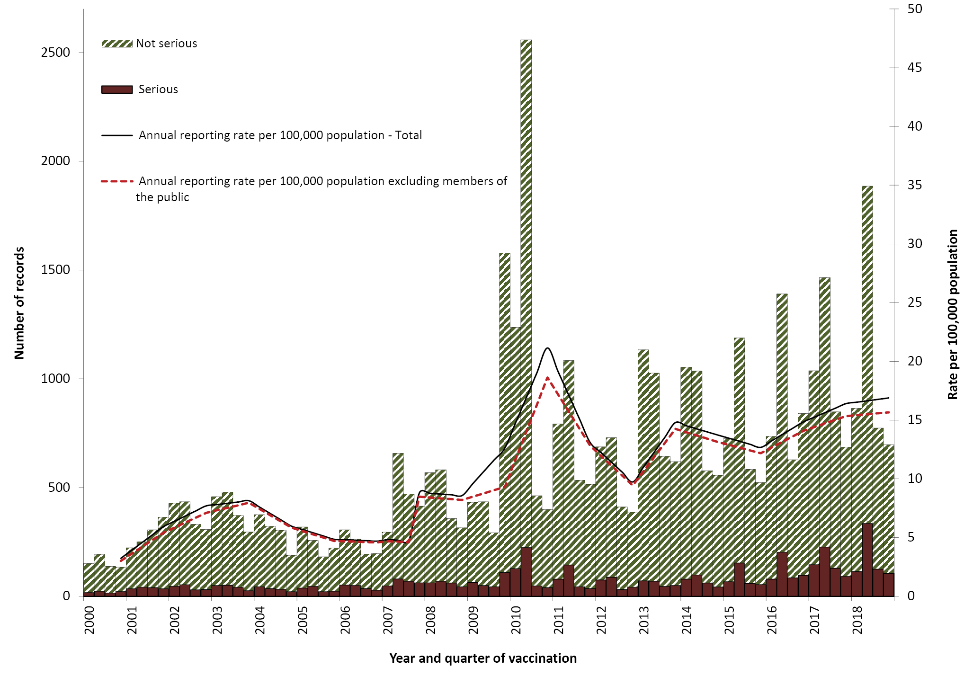
a For reports where the date of vaccination was not recorded, the date of onset or date event was reported to TGA was used as a proxy for vaccination date.

Figure 2: Adverse events following immunisation for children aged <1 year, AEMS database, 2000 to 2018, by year and quarter of vaccination^{a,b}
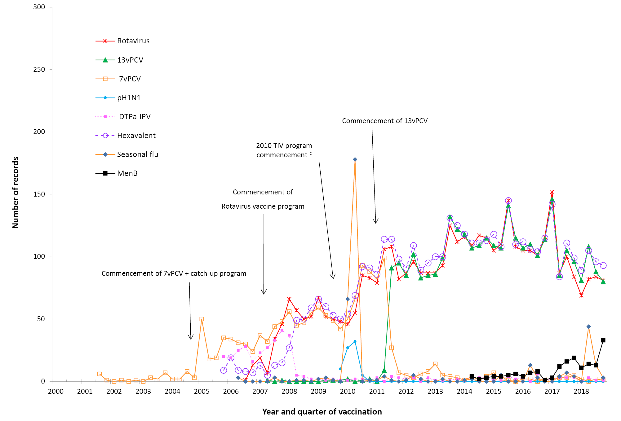
a For reports where the date of vaccination was not recorded, the date of onset or date event was reported to TGA was used as a proxy for vaccination date.
b DTPa-IPV and DTPa-IPV-HepB-Hib (hexavalent) vaccines were introduced into the NIP schedule in November 2005; rotavirus (Rotateq® and Rotarix®) vaccines on 1 July 2007; pH1N1 influenza vaccine for children 6 months to 10 years on December 2009; seasonal trivalent influenza vaccine in 2010 which was an extension of existing adult and Indigenous programs to at risk populations; and the 13-valent pneumococcal conjugate vaccine (13vPCV) on 1 July 2011. In July 2018, the schedule for routine childhood vaccination with 13vPCV changed from 2, 4 and 6 months of age to 2, 4 and 12 months of age. Also, MenB vaccine is recommended for use in those with increased risk of invasive meningococcal disease and is not currently funded under the NIP. In October 2018, a multicomponent recombinant meningococcal B vaccine was funded by SA for children 6 weeks to 12 months of age, with catch-up for children from 12 months to <4 years of age.
c Safety signal for fever and febrile convulsion found to be due to Seqirus (formerly bioCSL) Fluvax® 2010 TIV in children.

Figure 3: Adverse events following immunisation for children aged 1 to <7 years in frequently reported vaccines, AEMS database, 2000 to 2018, by year and quarter of vaccination^{a,b}
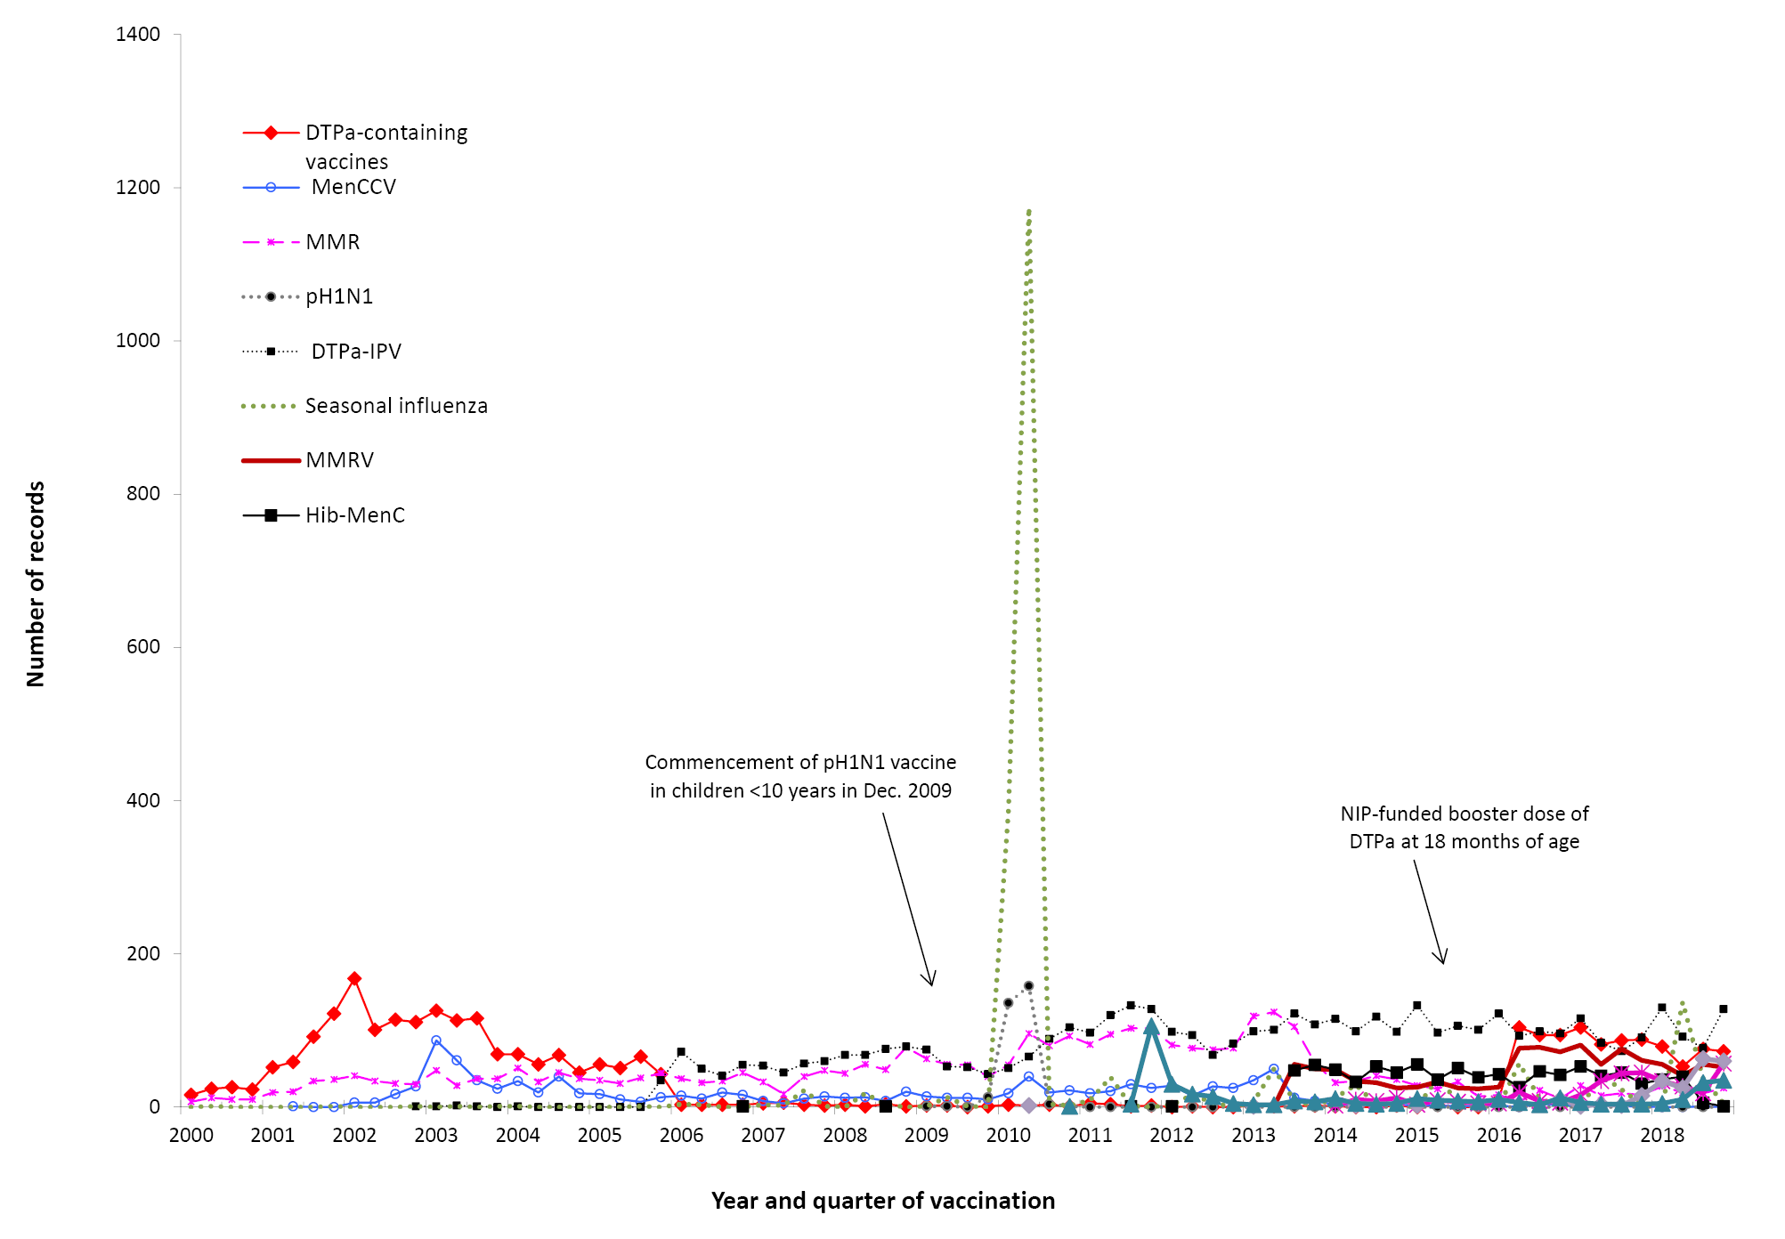
a For reports where the date of vaccination was not recorded, the date of onset or date event was reported to TGA was used as a proxy for vaccination date.
b DTPa-IPV vaccine was introduced into the NIP schedule in November 2005 replacing DTPa and OPV vaccines; seasonal trivalent influenza vaccine in 2010 which was an extension of existing adult and Indigenous programs to at risk populations; MMRV and Hib–MenC vaccines on July 2013, and HPV vaccine program extended to boys in February 2013. MenB vaccine is recommended for use in those with increased risk of invasive meningococcal disease and is not currently funded under the NIP. In April 2016, NIP-funded booster dose of DTPa vaccine was introduced at 18 months of age. In October 2018, a multicomponent recombinant meningococcal B vaccine was funded by SA for children 6 weeks to 12 months of age, with catch-up for children from 12 months to <4 years of age. In July 2018, a meningococcal ACWY conjugate vaccine funded for all children at 12 months of age, replacing combined Hib and meningococcal C-containing vaccine. The Hib dose was moved to 18 months and given as a monovalent Hib vaccine.

Figure 4. Adverse events following immunisation for people aged ≥7 years in frequently reported vaccines, AEMS database, 2000–2018, by year and quarter of vaccination.^{a,b}
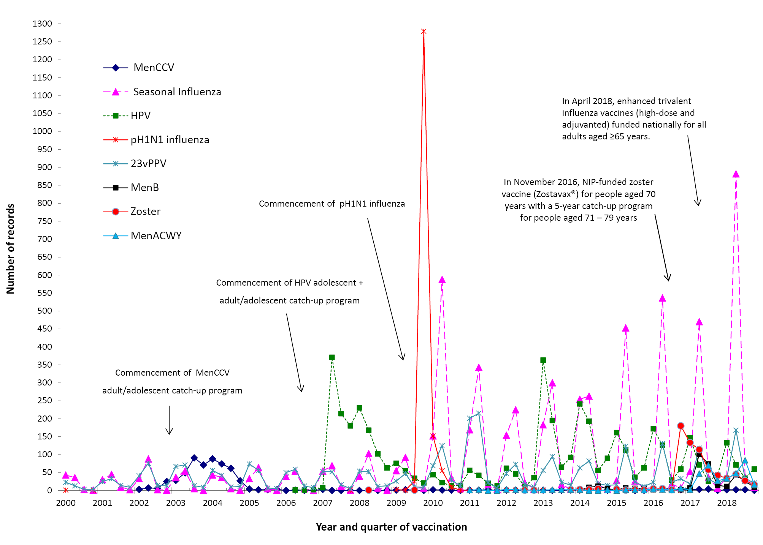
a For reports where the date of vaccination was not recorded, the date of onset or date event was reported to TGA was used as a proxy for vaccination date.
b MenCCV was introduced into the NIP schedule on 1 January 2003; pH1N1 influenza vaccine for children 6 months to 10 years on December 2009; pH1N1 vaccination for those ≥10 years commenced on 30 September 2009; seasonal trivalent influenza vaccine in 2010 which was an extension of existing adult and Indigenous programs to at risk populations; and HPV vaccine program extended to boys in February 2013. MenB vaccine is recommended for use in those with increased risk of invasive meningococcal disease and is not currently funded under the NIP.
In November 2016, zoster vaccine (Zostavax®) was NIP-funded for people aged 70 years with a 5-year catch-up program for people aged 71–79 years.
In April 2018, enhanced trivalent influenza vaccines (high-dose and adjuvanted) funded nationally for all adults aged ≥65 years.

Figure 5: Reporting rates of adverse events following immunisation per 100,000 population, AEMS database, 2000 to 2018, by age group and year of vaccinationª
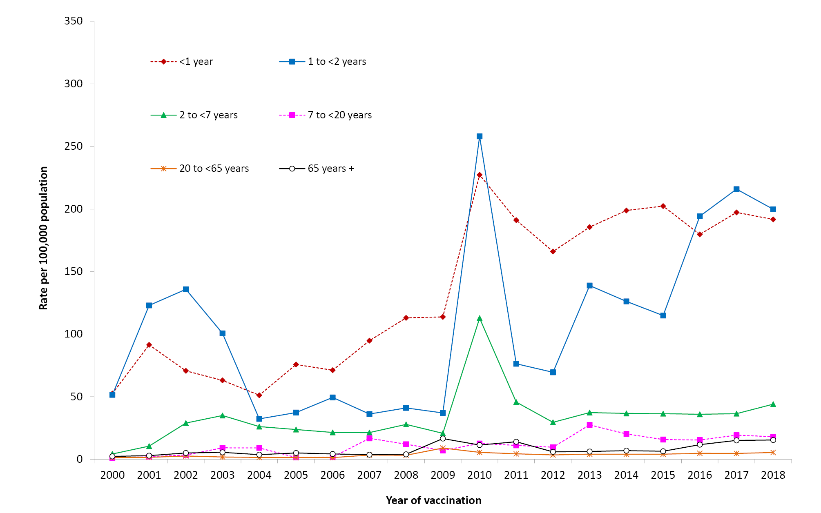
a For reports where the date of vaccination was not recorded, the date of onset or date event was reported to TGA was used as a proxy for vaccination date.

Figure 6: Selected frequently reported adverse events following immunisation, AEMS database, 2000 to 2018, by year and quarter of vaccinationª
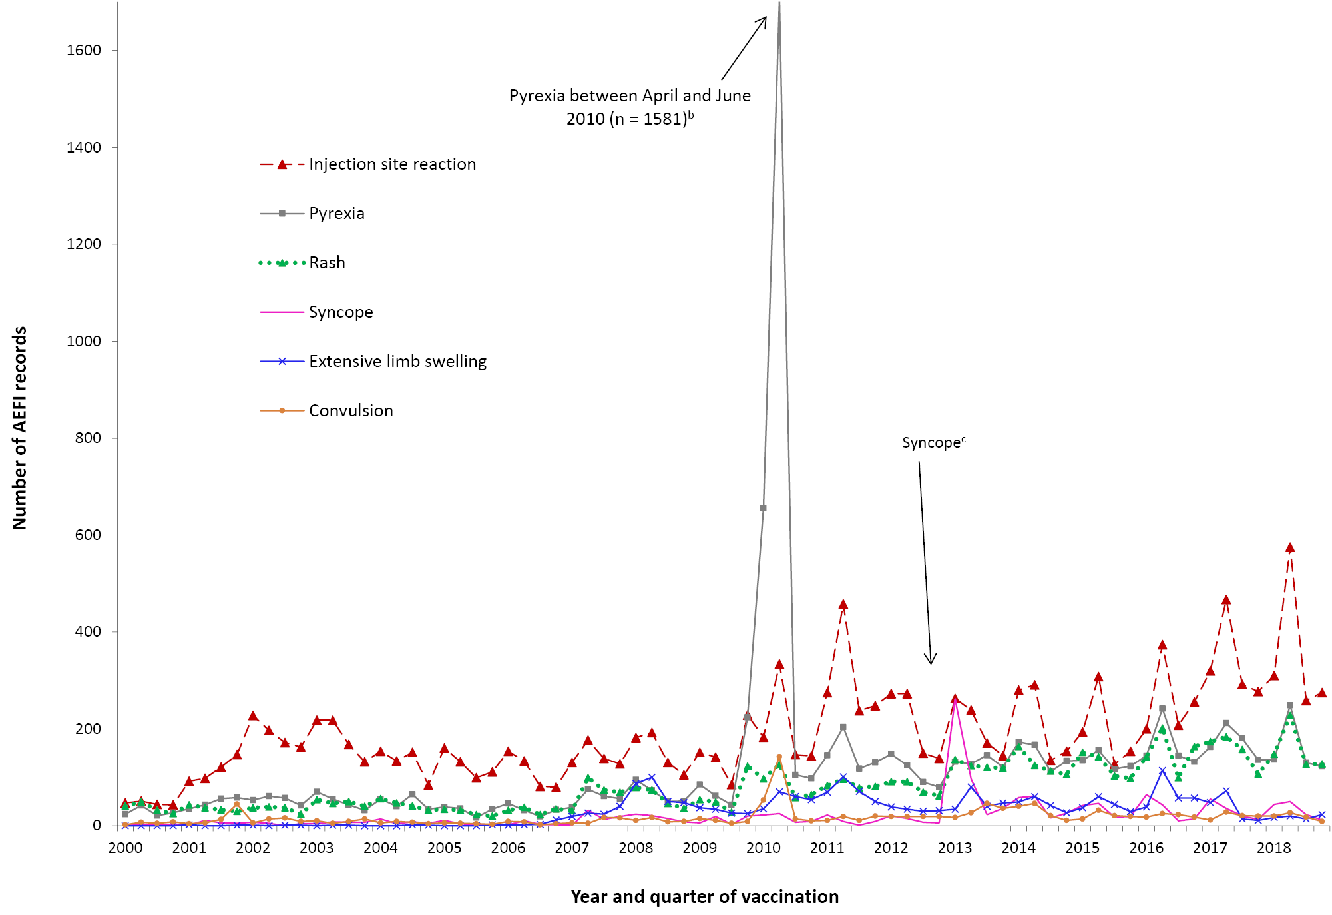
a For reports where the date of vaccination was not recorded, the date of onset or date event was reported to TGA was used as a proxy for vaccination date.
b Associated with administration of Seqirus (formerly bioCSL) Fluvax® 2010 TIV and associated stimulated reporting.
c The peak in syncope coincided with the enhanced HPV surveillance program in which there was stimulated reporting of syncope for the first 6 months of 2013.
A seasonal pattern of AEFI reporting was apparent in 2018 as in previous years, with the highest number of AEFI notifications for vaccinations administered in the first half of the year (Figure 1). This corresponds to the months when influenza vaccine is given and older Australians may be more likely to be given 23vPPV in conjunction with the influenza vaccine (April to June). Considerably more AEFI reports following influenza vaccination were received in each year from 2010 onwards than in previous (pre-pandemic) years (Figure 4).

Age distribution
The highest age-specific AEFI reporting rate per 100,000 population occurred in children aged 1 to <2 years, the age group scheduled to receive meningococcal ACWY vaccination at 12 months of age and the booster dose of DTPa at 18 months of age, and to be affected by the change in schedule for 13vPCV from 2, 4 and 6 months of age to 2, 4 and 12 months of age (Figure 5). Compared to 2017, AEFI reporting rates in 2018 remained relatively stable across most age groups; however, there were slight increases observed in children aged 2 to <7 years and in adults aged 20 to <65 years and 65 years and older (Figure 5).
There were overlapping confidence intervals for reporting rates per 100,000 doses for most individual vaccines in 2018 compared to 2017, noting the new additions to the NIP schedule, namely: meningococcal ACWY vaccination for children aged 12 months; enhanced trivalent influenza vaccines (high-dose and adjuvanted) for adults aged ≥65 years; changes in 13vPCV schedule and in state/territory-based seasonal influenza vaccination programs for children 6 months to <5 years (Table 2).
For children <7 years of age, AEFI reporting rates for varicella and MenC vaccines should be interpreted with caution since monovalent versions of these vaccines were replaced by combination vaccines in July 2013 and hence very few doses of monovalent vaccine were recorded in 2018.
Table 2: Vaccine types listed as ‘suspected’ in records of adverse events following immunisation by age groups (<7, 7–17, 18–64 and ≥65 years), AEMS database, 2018
Vaccinesª | AEFI records^{b}  (n) | Vaccine  Doses^{c}  2018 | Reporting rate^{d}  per 100,000 doses (95% CI)
Vaccinesª | AEFI records^{b}  (n) | Vaccine  Doses^{c}  2018 | 2018 | 2017
<7 years |  |  | Rate (95% Confidence Interval)
DTPa-containing vaccines | 1,127 | 1,451,925 | 77.6 (73.2 – 82.3) | 79.5 (75.0 – 84.2)
• Hexavalent (DTPa-IPV-HepB-Hib)  • DTPa-IPV  • DTPa | 411 | 850,171 | 48.3 (43.8 – 53.2) | 50.6 (45.9 – 55.6)
• Hexavalent (DTPa-IPV-HepB-Hib)  • DTPa-IPV  • DTPa | 284 | 300,527 | 94.5 (83.8 – 106.1) | 117.2 (105.5 – 129.9)
• Hexavalent (DTPa-IPV-HepB-Hib)  • DTPa-IPV  • DTPa | 432 | 301,227 | 143.4 (130.2 – 157.6) | 122.9 (110.7 – 136.0)
Pneumococcal conjugate -13vPCV | 439 | 821,374 | 53.4 (48.6 – 58.7) | 50.5 (45.9 – 55.4)
Rotavirus vaccine | 319 | 547,545 | 58.3 (52.0 – 65.0) | 60.0 (54.3 – 66.1)
Seasonal influenza | 240 | 694,620 | 34.6 (30.3 – 39.2) | 59.3 (47.0 – 73.8)
Measles-mumps-rubella | 228 | 309,005 | 73.8 (64.5 – 84.0) | 70.4 (61.5 – 80.2)
Meningococcal ACWY | 211 | 310,909 | 67.9 (59.0 – 77.7) | –
Meningococcal B | 207 | 199,745 | 103.6 (90.0 – 118.7) | 120.3 (103.5 – 139.1)
Measles-mumps-rubella-varicella | 206 | 302,682 | 68.1 (59.1 – 78.0) | 87.7 (77.5 – 98.9)
Hib-MenC | 91 | 155,851 | 58.4 (47.0 – 71.7) | 54.6 (46.7 – 63.5)
Varicella | 20 | 16,036 | 124.7 (76.2 – 192.6) | 173.0 (109.7 – 259.6)
Haemophilus influenzae type b | 13 | 16,191 | 80.3 (42.8– 137.3) | 36.7 (7.6– 107.2)
Hepatitis B | 10 | 31,066 | 32.2 (15.4 – 59.2) | 25.8 (11.1 – 50.9)
Meningococcal C conjugate | 2 | 5,126 | 39.0 (4.7– 140.9) | 161.7 (86.1– 276.5)
7–17 years
HPV | 288 | 500,522 | 57.5 (51.1 – 64.6) | –
dTpa | 219 | 161,438 | 135.7 (118.3 – 154.8) | –
Meningococcal ACWY | 147 | 232,731 | 63.2 (53.4 – 74.2) | –
Seasonal influenza | 93 | 381,689 | 24.4 (19.7 – 29.8) | –
Meningococcal B | 72 | 54,968 | 131.0 (102.5 – 164.9) | –
Measles-mumps-rubella | 11 | 25,975 | 42.3 (21.1 – 75.8) | –
23vPPV | 11 | 2,192 | 501.8 (250.8 – 896.1) | –
Varicella | 8 | 16,411 | 48.7 (21.1 – 75.8) | –
dTpa-IPV | 7 | 4,817 | 145.3 (58.4 – 299.2) | –
Hepatitis B | 5 | 32,089 | 15.6 (5.1 – 36.4) | –
Meningococcal C conjugate | 4 | 10,294 | 38.9 (10.6 – 99.5) | –
Measles-mumps-rubella-varicella | 2 | 7,467 | 26.8 (3.2 – 96.7) | –
18–64 years
Seasonal influenza | 534 | 1,875,459 | 28.5 (26.1 – 31.0) | –
dTpa | 120 | 454,466 | 26.4 (21.9 – 31.6) | –
23vPPV | 47 | 41,593 | 113.0 (83.0 – 150.2) | –
MMR | 44 | 81,888 | 53.7 (39.0 – 72.1) | –
Hepatitis B | 35 | 136,170 | 25.7 (17.9 – 35.7) | –
Meningococcal ACWY | 34 | 71,705 | 47.4 (32.8 – 66.3) | –
Hepatitis A | 22 | 126,839 | 17.3 (10.9 – 26.3) | –
Meningococcal B | 18 | 22,959 | 78.4 (46.5 – 123.9) | –
Varicella | 13 | 26,403 | 49.2 (26.2 – 84.2) | –
Hepatitis A-typhoid | 11 | 139,311 | 7.9 (3.9 – 14.1) | –
Hepatitis A-hepatitis B | 9 | 70,969 | 12.7 (5.8 – 24.1) | –
Q fever | 5 | n/a | – | –
≥65 years
Seasonal influenza | 338 | 2,058,186 | 16.4 (14.7 – 18.3) | –
23vPPV | 198 | 266,339 | 74.3 (64.3 – 85.4) | –
Zoster | 112 | 227,092 | 49.3 (40.6 – 59.3) | –
dTpa | 18 | 79,994 | 22.5 (13.3 – 35.6) | –
a Records where at least one of the vaccines shown in the table was suspected of causal involvement in the reported adverse event.
b Number of AEFI records in which the vaccine was coded as ‘suspected’ of causal involvement in the reported adverse event and the vaccination was administered between 1 January and 31 December 2018. More than one vaccine may be coded as ‘suspected’ if several were administered at the same time.
c Number of vaccine doses recorded on the AIR and administered between 1 January and 31 December 2018.
d The estimated reporting rate per 100,000 vaccine doses recorded.
n/a Not applicable

Table 3: Adverse events following immunisation (AEFI) records, AEMS database, January to December 2018, by jurisdiction
State or territory | AEFI records |  |  | Annual reporting rate per 100,000 populationª
State or territory | n | (%) | ‘Serious’^{b} | Aged  <7 years | Overall Rate | (95% Confidence Interval)
Australian Capital Territory | 116 | (2.7) | 5.2 | 80.1 | 27.6 | (22.8–33.1)
New South Wales | 831 | (19.7) | 2.4 | 46.1 | 10.4 | (9.7–11.1)
Northern Territory | 74 | (1.8) | 3.2 | 145.3 | 29.9 | (23.5–37.6)
Queensland | 763 | (18.1) | 1.9 | 71.2 | 15.2 | (14.2–16.3)
South Australia | 320 | (7.6) | 2.2 | 98.8 | 18.4 | (16.5–20.6)
Tasmania | 178 | (4.2) | 8.1 | 128.5 | 33.7 | (28.9–39.0)
Victoria | 1,569 | (37.2) | 3.2 | 149.6 | 24.3 | (23.1–25.5)
Western Australia | 342 | (8.1) | 2.3 | 62.8 | 13.2 | (11.8–14.7)
Other^{c} | 28 | (0.7) | na | na | na | –
Total | 4,221 | (100.0) | 2.7 | 86.4 | 16.9 | (16.4–17.4)
a Average annual rates per 100,000 population calculated using mid-2018 population estimates (Australian Bureau of Statistics).
b AEFI records defined as ‘serious’ (i.e. recovery with sequelae, hospitalisation, life-threatening or death).
c Records where the jurisdiction in which the adverse event occurred was not reported or was unclear.

Table 4: Vaccine types listed as ‘suspected’ in records of adverse events following immunisation (AEFI), AEMS database, 2018
Suspected vaccine typeª | AEFI records |  | One suspected vaccine only^{b} |  | ‘Serious’^{c} |  | Age group^{d}  <7 years |  | Age group^{d}  ≥7 years
Suspected vaccine typeª | n | (%) | n | (%)^{e} | n | (%)^{e} | n | (%)^{e} | n | (%)^{e}
Influenza | 1,261 | (29.9) | 1,065 | (91.7) | 234 | (20.2) | 240 | (20.7) | 965 | (83.1)
13vPCV | 450 | (10.7) | 33 | (7.3) | 97 | (21.6) | 439 | (97.6) | 8 | (1.8)
DTPa-IPV | 446 | (10.6) | 395 | (88.6) | 45 | (10.1) | 432 | (96.9) | 12 | (2.7)
DTPa-IPV-HepB-Hib | 426 | (10.1) | 58 | (13.6) | 90 | (21.1) | 411 | (96.5) | 9 | (2.1)
Men ACWY | 396 | (9.4) | 231 | (58.3) | 51 | (12.9) | 211 | (53.3) | 182 | (46.0)
dTpa | 357 | (8.5) | 132 | (37.0) | 27 | (7.6) | 0 | (0.0) | 357 | (100.0)
Rotavirus | 324 | (7.7) | 46 | (14.2) | 74 | (22.8) | 319 | (98.5) | 2 | (0.6)
HPV | 307 | (7.3) | 116 | (37.8) | 15 | (4.9) | 0 | (0.0) | 298 | (97.1)
Meningococcal B | 301 | (7.1) | 217 | (72.1) | 35 | (11.6) | 207 | (68.8) | 89 | (29.6)
MMR | 301 | (7.1) | 87 | (28.9) | 45 | (15.0) | 228 | (75.7) | 56 | (18.6)
DTPa | 284 | (6.7) | 93 | (32.7) | 29 | (10.2) | 284 | (100.0) | 0 | (0.0)
23vPPV | 270 | (6.4) | 168 | (62.7) | 31 | (11.5) | 12 | (3.8) | 256 | (96.2)
MMRV | 211 | (5.0) | 29 | (13.7) | 23 | (10.9) | 206 | (97.6) | 3 | (1.4)
Zoster | 135 | (3.2) | 126 | (93.3) | 23 | (17.0) | 0 | (0.0) | 122 | (90.4)
Hib-MenC | 92 | (2.2) | 5 | (5.4) | 16 | (17.4) | 91 | (98.9) | 0 | (0.0)
Hepatitis B | 58 | (1.4) | 38 | (65.5) | 7 | (12.1) | 10 | (17.2) | 40 | (69.0)
Hepatitis A | 49 | (1.2) | 10 | (20.4) | 8 | (16.3) | 20 | (40.8) | 29 | (59.2)
Varicella | 41 | (1.0) | 18 | (43.9) | 5 | (12.2) | 20 | (48.8) | 21 | (51.2)
Typhoid | 30 | (0.7) | 5 | (16.7) | 3 | (10.0) | 6 | (20.0) | 24 | (80.0)
BCG | 23 | (0.5) | 20 | (87.0) | 4 | (17.4) | 18 | (78.3) | 0 | (0.0)
Hepatitis A-Typhoid | 21 | (0.5) | 11 | (52.4) | 3 | (14.3) | 0 | (0.0) | 19 | (90.5)
dT | 20 | (0.5) | 13 | (65.0) | 1 | (5.0) | 0 | (0.0) | 20 | (100.0)
Rabies | 19 | (0.5) | 13 | (68.4) | 4 | (21.1) | 0 | (0.0) | 19 | (100.0)
Hepatitis A + B | 14 | (0.3) | 38 | (271.4) | 2 | (14.3) | 0 | (0.0) | 13 | (92.9)
Hib | 13 | (0.3) | 0 | (0.0) | 1 | (7.7) | 13 | (100.0) | 0 | (0.0)
IPV | 9 | (0.2) | 3 | (33.3) | 0 | (0.0) | 2 | (22.2) | 6 | (66.7)
MenCCV | 8 | (0.2) | 3 | (37.5) | 3 | (37.5) | 2 | (25.0) | 6 | (75.0)
Yellow fever | 7 | (0.2) | 3 | (42.9) | 2 | (28.6) | 0 | (0.0) | 6 | (85.7)
Q fever | 7 | (0.2) | 7 | (100.0) | 2 | (28.6) | 0 | (0.0) | 6 | (85.7)
Japanese encephalitis | 5 | (0.1) | 2 | (40.0) | 0 | (0.0) | 2 | (40.0) | 6 | (120.0)
Tetanus | 1 | (0.0) | 1 | (100.0) | 0 | (0.0) | 0 | (0.0) | 1 | (100.0)
a See appendix for abbreviations of vaccine names.
b AEFI records where only one vaccine was suspected of causal involvement in a reported adverse event.
c ‘Serious’ is defined in the Methods section.
d Includes only AEFI records where an age or date of birth has been reported.
e Percentages are calculated for the number of AEFI records where the vaccine was suspected of causal involvement in the event.

Table 5: Selected reported adverse eventsª classified by MedDRA Preferred Terms in records of adverse events following immunisation (AEFI), AEMS database, 2018^{b}
MedDRA Preferred Terms (adverse events) | AEFI records | Only adverse event reported^{c} |  | ‘Serious’^{d} |  | Age group^{e} |  | Age group^{e}
 |  |  |  |  |  | <7 years |  | ≥7 years
MedDRA Preferred Terms (adverse events) | N | n | (%)^{f} | n | (%)^{f} | n | (%)^{f} | n | (%)^{f}
Injection site reaction^{g} | 1,419 | 829 | (58.4) | 108 | (7.6) | 706 | (49.8) | 689 | (48.6)
Pyrexia | 639 | 37 | (5.8) | 104 | (16.3) | 372 | (58.2) | 256 | (40.1)
Rash^{h} | 631 | 278 | (44.1) | 52 | (8.2) | 395 | (62.6) | 228 | (36.1)
Vomiting | 324 | 45 | (13.9) | 61 | (18.8) | 189 | (58.3) | 125 | (38.6)
Headache | 274 | 9 | (3.3) | 44 | (16.1) | 18 | (6.6) | 223 | (81.4)
Pain | 240 | 47 | (19.6) | 22 | (9.2) | 32 | (13.3) | 199 | (82.9)
Nausea | 225 | 3 | (1.3) | 41 | (18.2) | 15 | (6.7) | 203 | (90.2)
Urticaria | 196 | 112 | (57.1) | 24 | (12.2) | 115 | (58.7) | 76 | (38.8)
Dizziness | 184 | 12 | (6.5) | 20 | (10.9) | 8 | (4.3) | 170 | (92.4)
Malaise | 171 | 12 | (7.0) | 26 | (15.2) | 18 | (10.5) | 149 | (87.1)
Diarrhoea | 164 | 15 | (9.1) | 28 | (17.1) | 102 | (62.2) | 55 | (33.5)
Myalgia | 133 | 7 | (5.3) | 21 | (15.8) | 5 | (3.8) | 123 | (92.5)
Lethargy | 131 | 1 | (0.8) | 27 | (20.6) | 47 | (35.9) | 77 | (58.8)
Syncope | 129 | 55 | (42.6) | 15 | (11.6) | 20 | (15.5) | 106 | (82.2)
Irritability | 108 | 5 | (4.6) | 11 | (10.2) | 101 | (93.5) | 3 | (2.8)
Angioedema | 98 | 11 | (11.2) | 24 | (24.5) | 31 | (31.6) | 67 | (68.4)
Pallor | 92 | 6 | (6.5) | 14 | (15.2) | 53 | (57.6) | 37 | (40.2)
Pruritus | 82 | 7 | (8.5) | 10 | (12.2) | 19 | (23.2) | 62 | (75.6)
Paraesthesia | 79 | 8 | (10.1) | 17 | (21.5) | 3 | (3.8) | 74 | (93.7)
Erythema | 78 | 12 | (15.4) | 11 | (14.1) | 39 | (50.0) | 38 | (48.7)
Extensive limb swelling | 74 | 52 | (70.3) | 27 | (36.5) | 54 | (73.0) | 19 | (25.7)
Fatigue | 74 | 0 | (0.0) | 10 | (13.5) | 10 | (13.5) | 62 | (83.8)
Convulsions^{i} | 74 | 42 | (56.8) | 38 | (51.4) | 58 | (78.4) | 14 | (18.9)
Abdominal pain | 71 | 1 | (1.4) | 13 | (18.3) | 26 | (36.6) | 43 | (60.6)
Decreased appetite | 70 | 0 | (0.0) | 12 | (17.1) | 53 | (75.7) | 16 | (22.9)
Chills | 68 | 2 | (2.9) | 14 | (20.6) | 8 | (11.8) | 58 | (85.3)
Cough | 67 | 3 | (4.5) | 14 | (20.9) | 29 | (43.3) | 37 | (55.2)
Hypotonic-hyporesponsive episode | 60 | 42 | (70.0) | 29 | (48.3) | 59 | (98.3) | 0 | (0.0)
Injected limb mobility decreased | 58 | 5 | (8.6) | 3 | (5.2) | 8 | (13.8) | 49 | (84.5)
Flushing | 56 | 0 | (0.0) | 5 | (8.9) | 6 | (10.7) | 48 | 85.7
Dyspnoea | 53 | 2 | (3.8) | 11 | (20.8) | 8 | (15.1) | 44 | (83.0)
Arthralgia | 51 | 4 | (7.8) | 13 | (25.5) | 2 | (3.9) | 47 | (92.2)
Somnolence | 48 | 3 | (6.3) | 8 | (16.7) | 29 | (60.4) | 19 | (39.6)
Presyncope | 45 | 29 | (64.4) | 5 | (11.1) | 19 | (42.2) | 25 | (55.6)
Anaphylactic reaction | 40 | 29 | (72.5) | 22 | (55.0) | 7 | (17.5) | 26 | (65.0)
Throat irritation | 36 | 2 | (5.6) | 7 | (19.4) | 3 | (8.3) | 32 | (88.9)
Hyperhidrosis | 32 | 1 | (3.1) | 6 | (18.8) | 5 | (15.6) | 26 | (81.3)
Hypoaesthesia | 32 | 3 | (9.4) | 8 | (25.0) | 1 | (3.1) | 30 | (93.8)
Asthenia | 32 | 0 | (0.0) | 4 | (12.5) | 2 | (6.3) | 30 | (93.8)
Rhinorrhoea | 31 | 0 | (0.0) | 4 | (12.9) | 17 | (54.8) | 13 | (41.9)
Oropharyngeal pain | 26 | 0 | (0.0) | 5 | (19.2) | 1 | (3.8) | 25 | (96.2)
Apnoea | 26 | 10 | (38.5) | 11 | (42.3) | 23 | (88.5) | 0 | (0.0)
Chest discomfort | 25 | 0 | (0.0) | 4 | (16.0) | 1 | (4.0) | 24 | (96.0)
Tachycardia | 23 | 1 | (4.3) | 11 | (47.8) | 7 | (30.4) | 16 | (69.6)
Cold Sweat | 22 | 0 | (0.0) | 1 | (4.5) | 2 | (9.1) | 20 | 90.9
Chest Pain | 18 | 1 | (5.6) | 7 | (38.9) | 1 | (5.6) | 17 | 94.4
Haematochezia | 16 | 7 | (43.8) | 2 | (12.5) | 16 | (100.0) | 0 | (0.0)
Hypotonia | 16 | 0 | (0.0) | 8 | (50.0) | 15 | (93.8) | 1 | (6.3)
Guillain-Barre syndrome | 14 | 11 | (78.6) | 14 | (100.0) | 4 | (28.6) | 10 | (71.4)
Hypotension | 12 | 1 | (8.3) | 5 | (41.7) | 1 | (8.3) | 11 | (91.7)
Blister | 11 | 1 | (9.1) | 3 | (27.3) | 6 | (54.5) | 5 | (45.5)
Tremor | 10 | 1 | (10.0) | 3 | (30.0) | 1 | (10.0) | 8 | (80.0)
Lymphadenitis | 9 | 4 | (44.4) | 2 | (22.2) | 1 | (11.1) | 8 | (88.9)
Intussusception | 8 | 7 | (87.5) | 5 | (62.5) | 8 | (100.0) | 0 | (0.0)
Hypersensitivity | 8 | 1 | (12.5) | 2 | (25.0) | 1 | (12.5) | 7 | (87.5)
a A complete list of adverse events as classified by individual Preferred Terms is available on request.
b Selected reported adverse events reported during January to December 2018. Note: for injection site reaction, rash and convulsions, PTs were grouped as described below.
c AEFI records where only one adverse event was reported.
d ‘Serious’ outcomes are defined in the Methods section.
e Includes only AEFI records where an age or date of birth has been reported
f Percentages relate to the number of AEFI records in which the specific adverse event was listed
g Injection site reaction includes the following MedDRA PTs: injection site reaction, injection site swelling, injection site pain, injection site mass, injection site erythema, injection site cellulitis, injection site rash, injection site induration, injection site abscess, injection site pruritus, injection site nodule, injected limb mobility decreased, injection site urticaria, injection site inflammation, injection site bruising, injection site infection, and injection site warmth.
h Rash includes the following MedDRA PTs: rash, rash generalised, rash erythematous, rash pruritic, rash maculo-papular, rash macular, rash vesicular, rash papular, rash morbilliform, and rash pustular.
i Convulsion includes the following MedDRA PTs: febrile convulsion, convulsion, grand mal convulsion, and partial seizures.

Geographical distribution
Population-based AEFI reporting patterns varied between states and territories during 2018 (Table 3).

Vaccines
The vaccine most frequently reported as associated with AEFI was seasonal influenza vaccine (1,261 records; 29.9% of 2018 records) followed by 13vPCV (n = 450, 10.7%), DTPa-IPV (n = 446; n = 10.6%) hexavalent DTPa-IPV-HepB-Hib (n = 426; 10.1%), meningococcal ACWY (n = 396; 9.4%), dTpa (n = 357; n = 8.5%) rotavirus (n = 324; 7.7%), HPV (n = 307; 7.3%), meningococcal B (n = 301; 7.1%), and MMR (n = 301; 7.1%) (Table 4).
Of the 1,261 adverse events following seasonal influenza vaccination, 338 (26.8%) were reported in adults aged ≥65 years, with most of these following enhanced immunogenicity influenza vaccines, Fluad® (128) and Fluzone® High Dose (195).
There were 396 reported adverse events following meningococcal ACWY vaccination with 53.3% of these (211) in children < 7 years of age (Table 4).

Adverse events
The most frequently reported adverse events in 2018 were injection site reactions (ISRs) (n = 1,419; 33.6% of total), pyrexia (n = 639; 15.1%), rash (n = 631; 14.9%), vomiting (n = 324; 7.7%), headache (n = 274; 6.5%) and pain (n = 240; 5.7%) (Table 5, Figure 6). Adverse events of particular interest included convulsions (n = 74; 1.8%), hypotonic-hyporesponsive episode (n = 60; 1.4%), anaphylaxis (n = 40; 0.9%), Guillain-Barré Syndrome (GBS) (n = 14; 0.3%) and intussusception (n = 8; 0.2%) (Table 5).
Of the 14 GBS cases, 6 were in adults aged ≥65 years and 5 of these cases had received an enhanced immunogenicity influenza vaccine.
The number of reports of particular adverse events has changed over time (Figure 6) and these relate to changes in the vaccination schedule (Table 1).

Serious adverse events
There were variations in the proportions with outcomes defined as serious (Table 4), although these remained generally low as in previous years. The majority of reported adverse events in 2018 were defined as non-serious (n = 3,538, 84%). Sixteen percent of reported adverse events in 2018 were coded as serious, noting that not all reports included detailed or clinically verified data.
Two deaths were reported to the TGA, but no clear causal relationship with vaccination was found.
- A 22-month-old female died in late March 2018, approximately 5 months after receiving a dose of DTPa-containing vaccine and the MMRV vaccine in early November 2017. The child had a >3 month history of a refractory seizure disorder, likely mitochondrial based on genetic testing.
- A 77-year-old male died in late June 2018, a month after receiving an enhanced immunogenicity seasonal trivalent influenza vaccine. He was diagnosed with sporadic Creutzfeldt-Jakob Disease–Heidenhain variant.
Two miscarriages (spontaneous abortion) were reported in this period, noting that spontaneous abortions are known to occur in 11–22% of all pregnancies.^{33,34}
- A 27-year-old female who was known to be pregnant was vaccinated with hepatitis B vaccine for occupational purposes, following advice from her physician on the risks and benefits of vaccination. She was previously unvaccinated. She presented to the emergency department 2 days after vaccination with vaginal bleeding and abdominal cramping. Ultrasound showed a pregnancy with an absent yolk sac and she had a miscarriage at the hospital.
- A female patient was vaccinated with a dose of Japanese encephalitis vaccine. Following vaccination, testing confirmed pregnancy. The patient subsequently suffered a miscarriage. The patient had a history of two previous miscarriages. The report did not include information such as the age of the patient, past medical history, medications, date of vaccination, date of miscarriage, or any other clinical detail but stated that the miscarriage was not thought to be related to the vaccine.
In summary, all deaths following immunisation reported to the TGA were reviewed by the TGA and where relevant, other relevant authorities, based on the information received from reporters. The TGA encourages all reporters to provide sufficient information to allow the TGA to assess any causal relationship between the administration of a vaccine and the adverse event reported. Both deaths were assessed as being most likely due to concomitant disease that was pre-existing at the time of vaccination and both miscarriages were assessed as being unlikely to have been caused by vaccination.

Discussion
This report uses similar methodology to the previous five annual reports.^{2,15,35–37} The use of MedDRA preferred terms for analysis allows for clearer reporting of adverse events, but needs to be taken into account when comparing the data in this report with data from annual reports prior to 2013.
In 2018, there was a 2.9% increase in the AEFI reporting rate compared to the previous year, though reporting rates were not significantly different (with overlapping confidence intervals) in the majority of jurisdictions in 2018 compared with 2017.³⁷
This increase was mainly attributable to NIP funding for the meningococcal ACWY conjugate vaccine for all children at 12 months of age; the enhanced trivalent influenza vaccines (high-dose and adjuvanted) for all adults aged ≥65 years; and also state- and territory-funded annual seasonal influenza vaccination for all children aged 6 months to <5 years.
There is usually an increase in reporting of adverse events when a new program or scheduled dose is rolled out, as immunisation providers are more likely to report milder, less serious AEFI for vaccines they are not as familiar with, or that are being given to a new population group. The variation in reporting of injection site reactions is related to changes in the immunisation schedule for vaccines that are known to have higher rates of ISR, including DTPa-containing vaccines, 23vPPV and HPV vaccine.^{3–14,38,39} Increases in reported AEFI were largely associated with time periods when new vaccines were added to the NIP, or eligibility extended, including: 7vPCV (2005) and HPV (2007); the extension of seasonal influenza vaccine on the NIP to include persons <65 years at high risk of influenza in 2010; 13vPCV replacing 7vPCV in July 2011; the extension of HPV to males in 2013; seasonal influenza vaccine funded for Aboriginal and Torres Strait Islander children aged 6 months to <5 years in 2015; booster dose of DTPa for children at 18 months of age in 2016; zoster vaccine funded for adults aged 70 years with a five year catch-up program for people aged 71–79 years from November 2016; and in 2018, NIP funding for the meningococcal ACWY conjugate vaccine for all children at 12 months of age; the enhanced trivalent influenza vaccines (high-dose and adjuvanted) for all adults aged ≥65 years; and also state- and territory-funded annual seasonal influenza vaccination for all children aged 6 months to <5 years.
A reduction and stabilisation of reporting rates over time often occurs thereafter.^{2,4,5,7,10,12–15,35–37,40} During this second year of implementation of the zoster vaccination program, there were 135 AEFI reports in adults who received the zoster vaccine, although the majority (83%) were not serious.
Overall, injection site reaction, pyrexia, rash, vomiting, headache and pain were the most commonly reported adverse events to the TGA in 2018. AEFI reporting rates for most individual vaccines in 2018 were similar to those for 2017. These findings are similar to nationally-representative vaccine safety data from AusVaxSafety,⁴¹ which actively monitors the safety of vaccines (e.g. pertussis, zoster, influenza, HPV) in vaccinated people from more than 300 sentinel surveillance sites nationwide. From 1 February 2018, AusVaxSafety monitored the safety of a new HPV vaccine, Gardasil®9, in 11- to 14-year old adolescents. During the reporting period 1 February 2018 to 31 December 2018, AusVaxSafety received data from 15,959 adolescents aged 11–14 years; 7.9% of those receiving only HPV vaccine, and 9.6% of those receiving HPV and dTpa vaccines, reported an adverse event, demonstrating event rates that were consistent with what are expected according to the existing data. Injection site reactions were the most commonly reported events. Zoster vaccine was monitored by AusVaxSafety through to November 2018. Approximately 17,500 AusVaxSafety participants received zoster vaccine from 1 January 2018; of these participants, approximately 8.0% reported an adverse event, typically an injection site reaction. No safety signals were observed for pertussis, zoster, influenza and HPV vaccines in 2018 in AusVaxSafety.⁴¹
Overall for data from the AEMS, the majority of AEFI reports detailed non-serious events and no new safety concerns arose during this period (2018). More than half (56.4%) of reported events were in females and 1.5% were reported in Aboriginal and Torres Strait Islander people. Two deaths were reported during 2018, which were assessed as being most likely due to concomitant disease that was pre-existing at the time of vaccination.

Conclusion
The number of reported AEFI increased slightly in 2018 compared to 2017, though the majority were non-serious transient events. The data reported here are consistent with an overall high level of safety for vaccines used in Australia when administered according to the clinical recommendations contained within the Australian Immunisation Handbook.¹⁶

Acknowledgments
We thank Alexandra Hendry, NCIRS, for providing vaccine dose data from the Australian Immunisation Register.
The National Centre for Immunisation Research and Surveillance is supported by the Australian Government Department of Health, New South Wales Health and The Children’s Hospital at Westmead, Australia.

Author details
Aditi Dey¹
Han Wang¹
Helen Quinn¹
Alexis Pillsbury¹
Catherine Glover¹
Megan Hickie²
Nicholas Wood¹
Frank Beard¹
Kristine Macartney¹
- National Centre for Immunisation Research and Surveillance, The University of Sydney and The Children’s Hospital at Westmead, Sydney, Australia
- Pharmacovigilance and Special Access Branch, Therapeutic Goods Administration, Department of Health, Canberra, Australia

Corresponding author
Dr Aditi Dey
National Centre for Immunisation Research and Surveillance, Locked Bag 4001, Westmead NSW 2145
Phone: (02) 9845 1416
Fax: (02) 9845 1418
Email: aditi.dey@health.nsw.gov.au

References
- Council for International Organizations of Medical Sciences (CIOMS) c/o World Health Organization. Definition and Application of Terms for Vaccine Pharmacovigilance: Report of CIOMS/WHO Working Group on Vaccine Pharmacovigilance. Geneva: World Health Organization; 2012. Available from: https://www.who.int/vaccine_safety/initiative/tools/CIOMS_report_WG_vaccine.pdf
- Dey A, Wang H, Quinn H, Hill R, Macartney K. Surveillance of adverse events following immunisation in Australia annual report, 2014. Commun Dis Intell Q Rep. 2016;40(3):E377–90.
- Lawrence G, Boyd I, McIntyre P, Isaacs D. Surveillance of adverse events following immunisation: Australia 2002 to 2003. Commun Dis Intell Q Rep. 2004;28(3):324–38.
- Lawrence G, Boyd I, McIntyre P, Isaacs D. Annual report: surveillance of adverse events following immunisation in Australia, 2005. Commun Dis Intell Q Rep. 2006;30(3):319–33.
- Lawrence G, Gold MS, Hill R, Deeks S, Glasswell A, McIntyre PB. Annual report: surveillance of adverse events following immunisation in Australia, 2007. Commun Dis Intell Q Rep. 2008;32(4):371–87.
- Lawrence G, Menzies R, Burgess M, McIntyre P, Wood N, Boyd I et al. Surveillance of adverse events following immunisation: Australia, 2000–2002. Commun Dis Intell Q Rep. 2003;27(3):307–23.
- Lawrence GL, Aratchige PE, Boyd I, McIntyre PB, Gold MS. Annual report on surveillance of adverse events following immunisation in Australia, 2006. Commun Dis Intell Q Rep. 2007;31(3):269–82.
- Lawrence GL, Boyd I, McIntyre PB, Isaacs D. Annual report: surveillance of adverse events following immunisation in Australia, 2004 Commun Dis Intell Q Rep. 2005;29(3):248–62.
- Mahajan D, Cook J, Dey A, Macartney K, Menzies R. Supplementary report: surveillance of adverse events following immunisation among children aged less than seven years in Australia, 1 January to 30 June 2012. Commun Dis Intell Q Rep. 2013;37(2):E130–4.
- Mahajan D, Cook J, Dey A, Macartney K, Menzies RI. Annual report: surveillance of adverse events following immunisation in Australia, 2011. Commun Dis Intell Q Rep. 2012;36(4):E315–32.
- Mahajan D, Cook J, McIntyre P, Macartney K, Menzies R. Supplementary report: surveillance of adverse events following immunisation among children aged less than seven years in Australia, 1 January to 30 June 2011. Commun Dis Intell Q Rep. 2012;36(1):114–9.
- Mahajan D, Cook J, McIntyre PB, Macartney K, Menzies RI. Annual report: surveillance of adverse events following immunisation in Australia, 2010. Commun Dis Intell Q Rep. 2011;35(4):263–80.
- Mahajan D, Roomiani I, Gold MS, Lawrence GL, McIntyre PB, Menzies RI. Annual report: surveillance of adverse events following immunisation in Australia, 2009. Commun Dis Intell Q Rep. 2010;34(3):259–76.
- Menzies R, Mahajan D, Gold MS, Roomiani I, McIntyre P, Lawrence G. Annual report: surveillance of adverse events following immunisation in Australia, 2008. Commun Dis Intell Q Rep. 2009;33(4):365–81.
- Mahajan D, Dey A, Cook J, Harvey B, Menzies R, Macartney K. Surveillance of adverse events following immunisation in Australia annual report, 2013. Commun Dis Intell Q Rep. 2015;39(3):E369–86.
- Australian Technical Advisory Group on Immunisation (ATAGI). Australian Immunisation Handbook. [Internet.] Canberra: Australian Government Department of Health; 2018. [Accessed on 17 January 2019.] Available from: https://www.health.gov.au/resources/publications/the-australian-immunisation-handbook
- Uppsala Monitoring Centre. [Internet.] WHO Collaborating Centre for International Drug Monitoring. [Accessed on 9 July 2014.] Available from: http://www.who-umc.org/
- Zhou W, Pool V, Iskander JK, English-Bullard R, Ball R, Wise RP et al. Surveillance for safety after immunization: Vaccine Adverse Event Reporting System (VAERS)--United States, 1991-2001. [erratum appears in MMWR Morb Mortal Wkly Rep. 2003;52(06):113]. MMWR Surveill Summ. 2003;52(1):1–24.
- Brown EG. Using MedDRA: implications for risk management. Drug Saf. 2004;27(8):591–602.
- Brown EG, Wood L, Wood S. The medical dictionary for regulatory activities (MedDRA). Drug Saf. 1999;20(2):109–17.
- National Health and Medical Research Council. The Australian Immunisation Handbook. 8th edn. Canberra: Australian Government Department of Health and Ageing; 2003.
- Mahajan D, Dey A, Hill R, Harvey B, Menzies R, McIntyre P et al. Methodological framework for reporting of adverse events following immunisation (AEFI). [Conference presentation.] In: PHAA National Immunisation Conference, 17–19 June 2014; Melbourne, Australia.
- Leroy Z, Broder K, Menschik D, Shimabukuro T, Martin D. Febrile seizures after 2010-2011 influenza vaccine in young children, United States: a vaccine safety signal from the vaccine adverse event reporting system. Vaccine. 2012;30(11):2020–3.
- Moro PL, Broder K, Zheteyeva Y, Revzina N, Tepper N, Kissin D et al. Adverse events following administration to pregnant women of influenza A (H1N1) 2009 monovalent vaccine reported to the Vaccine Adverse Event Reporting System. Am J Obstet Gynecol. 2011;205(5):473.e1–9.
- Zheteyeva Y, Moro PL, Yue X, Broder K. Safety of meningococcal polysaccharide-protein conjugate vaccine in pregnancy: a review of the Vaccine Adverse Event Reporting System. Am J Obstet Gynecol. 2013;208(6):478.e1–6.
- Australian Government Department of Health, Therapeutic Goods Administration. National Adverse Events Following Immunisation (AEFI) reporting form. [Internet.] Canberra: Australian Government Department of Health. [Accessed on 26 March 2013.] Available from: https://www.tga.gov.au/form/national-adverse-events-following-immunisation-aefi-reporting-form
- SAS Institute Inc. The SAS system for Windows [computer program]. Version 9.4. Cary, N.C. 2012.
- Australian Bureau of Statistics. Australian Demographic Statistics, Jun 2015. [Internet.] Available from: https://www.abs.gov.au/AUSSTATS/abs@.nsf/allprimarymainfeatures/6CBA90A25BAC951DCA257F7F001CC559?opendocument
- Australian Government Department of Human Services. Australian Immunisation Register. [Internet.] Canberra: Australian Government Department of Human Services. [Accessed on 21 October 2016.] Available from: https://www.humanservices.gov.au/individuals/services/medicare/australian-immunisation-register
- Australian Government Department of Health. UPDATE: Expansion of Australia’s Immunisation Registers. [Accessed on 21 October 2016.] Available from: https://sydneynorthhealthnetwork.org.au/wp-content/uploads/2015/12/Factsheet-Immunisation-Registers-Expansion-23102015.pdf
- Varricchio F, Iskander J, DeStefano F, Ball R, Pless R, Braun MM et al. Understanding vaccine safety information from the Vaccine Adverse Event Reporting System. Pediatr Infect Dis J. 2004;23(4):287–94.
- Australian Government Department of Health, Therapeutic Goods Administration. Database of Adverse Event Notifications. [Internet.] Canberra: Australian Government Department of Health. [Accessed on 26 March 2013.] Available from: http://www.tga.gov.au/safety/daen.htm
- Rouse CE, Eckert LO, Babarinsa I, Fay E, Gupta M, Harrison MS et al. Spontaneous abortion and ectopic pregnancy: Case definition & guidelines for data collection, analysis, and presentation of maternal immunization safety data. Vaccine. 2017;35(48A):6563–74.
- Ammon Avalos L, Galindo C, Li DK. A systematic review to calculate background miscarriage rates using life table analysis. Birth Defects Res A Clin Mol Teratol. 2012;94(6):417–23.
- Dey A, Wang H, Quinn H, Cook J, Macartney K. Surveillance of adverse events following immunisation in Australia annual report, 2015. Commun Dis Intell Q Rep. 2017;41(3):E264–278.
- Dey A, Wang H, Quinn H, Cook J, Macartney K. Surveillance of adverse events following immunisation in Australia annual report, 2016. Commun Dis Intell (2018). 2018;42. pii: S2209-6051(18)00011-8
- Dey A, Wang H, Quinn H, Hiam R, Wood N, Beard F et al. Surveillance of adverse events following immunisation in Australia annual report, 2017. Commun Dis Intell (2018). 2019;43. https://doi.org/10.33321/cdi.2019.43.29.
- Simon LS. Pharmacovigilance: towards a better understanding of the benefit to risk ratio. Ann Rheum Dis. 2002;61(Suppl II):ii88–9.
- Reisinger KS, Block SL, Lazcano-Ponce E, Samakoses R, Esser MT, Erick J et al. Safety and persistent immunogenicity of a quadrivalent human papillomavirus types 6, 11, 16, 18 L1 virus-like particle vaccine in preadolescents and adolescents: a randomized controlled trial. Pediatr Infect Dis J. 2007;26(3):201–9.
- Mahajan D, Dey A, Cook J, Harvey B, Menzies RI, Macartney KM. Surveillance of adverse events following immunisation in Australia, 2012. Commun Dis Intell Q Rep. 2014;38(3):E232–46.
- National Centre for Immunisation Research and Surveillance. AusVaxSafety. [Internet.] Sydney: National Centre for Immunisation Research and Surveillance; 2019. [Accessed on 1 November 2019.] Available from: http://www.ausvaxsafety.org.au/

Appendix
Abbreviations of vaccine types
BCG | Bacille Calmette-Guérin (i.e. tuberculosis)
DTPa | diphtheria-tetanus-pertussis (acellular) – paediatric formulation
dTpa | diphtheria-tetanus-pertussis (acellular) – adolescent and adult formulation
DTPa-IPV | combined diphtheria-tetanus-pertussis (acellular) and inactivated poliovirus (quadrivalent)
DTPa-IPV-HepB-Hib | combined diphtheria-tetanus-pertussis (acellular), inactivated poliovirus, hepatitis B and Haemophilus influenzae type b vaccine (hexavalent)
HepB | hepatitis B
Hib | Haemophilus influenzae type b
Hib-HepB | combined Haemophilus influenzae type b and hepatitis B
Hib-MenC | combined Haemophilus influenzae type b and meningococcal C conjugate vaccine
HPV | human papillomavirus
MenACWY | quadrivalent meningococcal (serogroups A, C, W-135, Y) conjugate vaccine
MenB | meningococcal B vaccine
MenCCV | meningococcal C conjugate vaccine
MMR | measles-mumps-rubella
MMRV | measles-mumps-rubella-varicella
pH1N1 | pandemic H1N1 influenza 2009
7vPCV | 7-valent pneumococcal conjugate vaccine
13vPCV | 13-valent pneumococcal conjugate vaccine
23vPPV | 23-valent pneumococcal polysaccharide vaccine

Communicable Diseases Intelligence
ISSN: 2209-6051 Online

Communicable Diseases Intelligence (CDI) is a peer-reviewed scientific journal published by the Office of Health Protection, Department of Health. The journal aims to disseminate information on the epidemiology, surveillance, prevention and control of communicable diseases of relevance to Australia.

Editor: Cindy Toms
Deputy Editor: Simon Petrie
Design and Production: Kasra Yousefi
Editorial Advisory Board: David Durrheim, Mark Ferson, John Kaldor, Martyn Kirk and Linda Selvey

Website: http://www.health.gov.au/cdi

Contacts
Communicable Diseases Intelligence is produced by:
Health Protection Policy Branch, Office of Health Protection, Australian Government Department of Health
GPO Box 9848, (MDP 6) CANBERRA ACT 2601

Email: cdi.editor@health.gov.au

Submit an Article
You are invited to submit your next communicable disease related article to the Communicable Diseases Intelligence (CDI) for consideration. More information regarding CDI can be found at: http://health.gov.au/cdi.
Further enquiries should be directed to: cdi.editor@health.gov.au.

This journal is indexed by Index Medicus and Medline.

Creative Commons Licence - Attribution-NonCommercial-NoDerivatives CC BY-NC-ND
© 2019 Commonwealth of Australia as represented by the Department of Health
This publication is licensed under a Creative Commons Attribution-NonCommercial-NoDerivatives 4.0 International Licence from https://creativecommons.org/licenses/by-nc-nd/4.0/legalcode (Licence). You must read and understand the Licence before using any material from this publication.

Restrictions
The Licence does not cover, and there is no permission given for, use of any of the following material found in this publication (if any):
- the Commonwealth Coat of Arms (by way of information, the terms under which the Coat of Arms may be used can be found at www.itsanhonour.gov.au);
- any logos (including the Department of Health’s logo) and trademarks;
- any photographs and images;
- any signatures; and
- any material belonging to third parties.

Disclaimer
Opinions expressed in Communicable Diseases Intelligence are those of the authors and not necessarily those of the Australian Government Department of Health or the Communicable Diseases Network Australia. Data may be subject to revision.

Enquiries
Enquiries regarding any other use of this publication should be addressed to the Communication Branch, Department of Health, GPO Box 9848, Canberra ACT 2601, or via e-mail to: copyright@health.gov.au

Communicable Diseases Network Australia
Communicable Diseases Intelligence contributes to the work of the Communicable Diseases Network Australia.
http://www.health.gov.au/cdna

