2024 • Volume 48 • https://doi.org/10.33321/cdi.2024.48.9 • Electronic publication date: 10/04/2024

COVID-19 Australia: Epidemiology Report 83 Reporting period ending 14 January 2024
Viral Respiratory Diseases Epidemiology and Surveillance Section

Summary
Four-week reporting period (18 December 2023 – 14 January 2024)
Case definitions for confirmed and probable cases are in accordance with the coronavirus disease 2019 (COVID-19) CDNA National Guidelines for Public Health Units.
Trends – Nationally, case notifications have slowly increased from early October 2023, and appeared to have stabilised in recent weeks. In the four-week period 18 December 2023 – 14 January 2024, there were 31,626 confirmed and 10,207 probable cases of COVID-19, a total of 41,833 COVID-19 cases reported in Australia to the National Notifiable Diseases Surveillance System (NNDSS). In the most recent reporting fortnight, a total of 21,386 confirmed and probable cases were notified (an average of 1,528 cases per day), compared to 20,447 in the previous fortnight (an average of 1,461 cases per day), representing a 4.6% fortnight-on-fortnight increase.
Age group – Since the start of the sixth Omicron wave in mid-August 2023, the notification rates among most age groups have stabilised, except among adults aged 70 years and over where rates have slowly increased. In the Omicron wave to date, the highest notification rate was observed among adults aged 20–29 years, whilst the lowest rate was among older adults aged 70–79 years.
Aboriginal and Torres Strait Islander people – In the reporting period 18 December 2023 – 14 January 2024, there were 1,140 new cases notified in Aboriginal and Torres Strait Islander people, accounting for 2.7% of all notified cases (1,140/41,833) during this time. In the Omicron wave to date (15 December 2021 – 14 January 2024), notifications among Aboriginal and Torres Strait Islander people have comprised 3.7% of all cases (425,980/11,527,427).
Severity – Since the emergence of the Omicron variant, there has been a consistent decrease in the incidence of severe illness, with a smaller severe-illness peak observed with each subsequent Omicron wave. Decreasing incidence may be due to high COVID-19 vaccination coverage, hybrid immunity and access to oral antiviral treatments. Since the start of the sixth Omicron wave, the weekly number of cases with severe illness reached an apparent peak in mid-November 2023. The crude case fatality rate from the start of the Omicron wave to date was 0.19%, which was lower than the crude rate during the Delta wave (0.71%).
Virology – For samples collected in the four-week period 18 December 2023 – 14 January 2024, all sequences uploaded to AusTrakka were assigned as Omicron strains or as recombinants consisting of Omicron lineages. There were 693 sequences uploaded to AusTrakka during 18 December 2023 – 14 January 2024, a 40% decrease in the number of uploaded sequences compared to the previous reporting period. In this reporting period, most of the sequences analysed (61.9%) were BA.2 sub-sub lineages; 38.1% were recombinant or recombinant sub-lineages.
Acute respiratory illness – Based on self-reported FluTracking data, over the current four-week period, the weekly average proportions of both ‘fever and cough’ (1.4%) and ‘runny nose and sore throat’ symptoms (1.0%) were either slightly above or similar to proportions observed during the same period in 2023.
International situation – According to the World Health Organization (WHO), as of 7 January 2024, over 774 million COVID-19 cases and over 7 million deaths have been reported globally since the start of the pandemic, with a global case fatality rate (CFR) of approximately 0.91%.
Keywords: SARS-CoV-2; novel coronavirus; coronavirus disease 2019; COVID-19; acute respiratory disease; epidemiology; Australia
This reporting period covers the four-week period 18 December 2023 – 14 January 2024. Within this period, data for each fortnight is compared. The previous reporting period was the preceding four weeks (20 November – 17 December 2023).¹ The focus of this report is on the epidemiological situation in Australia since the beginning of the Omicron wave. For the purposes of this report, 15 December 2021 is used as a proxy for the beginning of this wave. This date was chosen as, from this date onward, most sequenced strains from cases were Omicron. Readers are encouraged to consult prior reports in this series for information on the epidemiology of coronavirus disease 2019 (COVID-19) in Australia.
Methods of data analysis in these reports have changed over the course of this reporting series to date. Please refer to the Technical Supplement for details of such changes, and for definitions of terminology.²
From Report #72 onward, and unless specified otherwise, all data from the National Notifiable Diseases Surveillance System (NNDSS) have been extracted using ‘diagnosis date’ rather than ‘notification received date’ (see the Technical Supplement for definitions). Due to COVID-19 reporting changes in several states and territories, the use of ‘diagnosis date’ now provides a more consistent and accurate method for describing transmission trends in Australia.
The case data provided includes both confirmed cases and probable cases reported to the NNDSS, as defined in accordance with the COVID-19 Communicable Diseases Network Australia (CDNA) National Guidelines for Public Health Units.³ For the purposes of this report, only probable cases from 5 January 2022 were included. Six jurisdictions have ceased collecting and reporting data on probable COVID-19 cases: Victoria ceased collection on 1 July 2023; Queensland on 1 September 2023; New South Wales on 1 October 2023; Western Australia on 9 October 2023; the Northern Territory on 21 October 2023; and the Australian Capital Territory on 22 December 2023. Rapid antigen tests administered in healthcare or aged care settings continue to be reported to the NNDSS by some jurisdictions.
From Report #71 onward, population data for Aboriginal and Torres Strait Islander people was updated (from 2016) and is now based on the Australian Bureau of Statistics (ABS) Estimated Resident Population (ERP) as at 2021. There has been an increase of 185,600 Aboriginal and Torres Strait Islander people (23.2%) since the previous ERP (June 2016). Therefore, notification rate comparisons with reports prior to #71 should be undertaken with caution.
Due to the dynamic nature of data in the NNDSS, numbers may be subject to revision and may vary from numbers previously reported and from case notifications released by states and territories.

Background and data sources
See the Technical Supplement for general information on COVID-19 including modes of transmission, common symptoms, and severity.²

Activity

COVID-19 trends
(NNDSS)
Since the beginning of the pandemic to 14 January 2024, jurisdictions in Australia reported 11,770,874 COVID-19 cases to the NNDSS. Nationally, case notifications increased slowly from early October 2023, and appear to have stabilised in recent weeks (Figure 1).
Figure 1: Confirmed and probable COVID-19 cases notified to the NNDSS by date of onset, Australia, 27 February 2023 – 14 January 2024^{a,b}
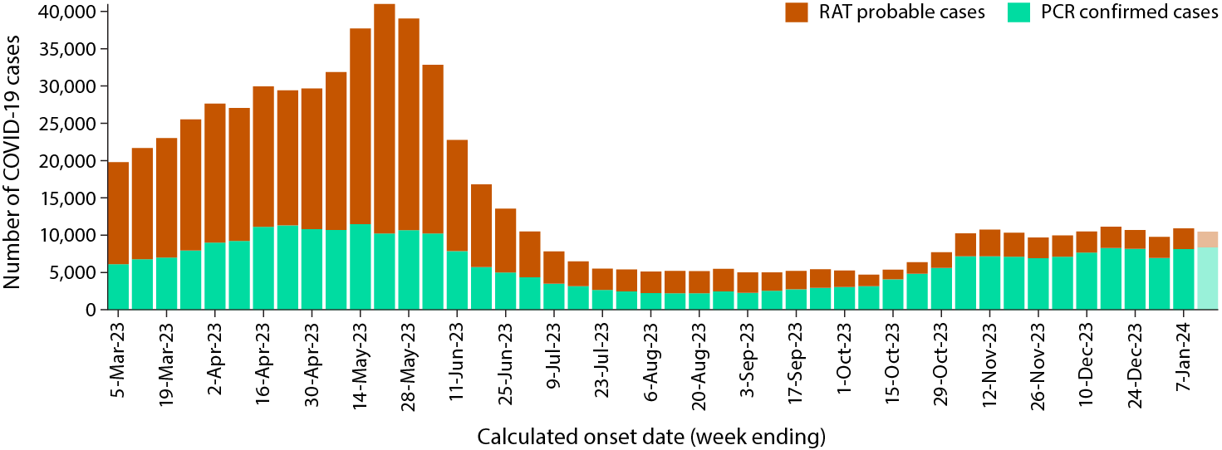
a Source: NNDSS, extracted on 18 January 2024 for cases with an illness onset from 27 February 2023 to 14 January 2024.
b Since 1 July 2023, several jurisdictions have progressively ceased collecting and reporting data on probable COVID-19 cases.
In the four-week period 18 December 2023 – 14 January 2024, there were 31,626 confirmed and 10,207 probable cases of COVID-19 reported in Australia to the NNDSS (Table 1). In the most recent reporting fortnight, a total of 21,386 confirmed and probable cases were notified (an average of 1,528 cases per day), compared to 20,447 in the previous fortnight (an average of 1,461 cases per day), representing a 4.6% fortnight-on-fortnight increase.
Table 1: Confirmed and probable COVID-19 cases notified to the NNDSS by jurisdiction and date of illness onset, Australia, 15 December 2021 – 14 January 2024^{a,b,c}
Jurisdiction | Reporting period |  |  |  |  |  | Omicron wave to date
Jurisdiction | 18 – 31 December 2023 |  |  | 1 – 14 January 2024 |  |  | 15 December 2021 – 14 January 2024
Jurisdiction | Confirmed | Probable | Total | Confirmed | Probable | Total | Confirmed | Probable | Total
ACT^{d} | 155 (56.6%) | 119 (43.4%) | 274 | 252 (100.0%) | 0  (0.0%) | 252 | 134,311 (53.8%) | 115,267 (46.2%) | 249,578
NSW^{d} | 5,691 (88.8%) | 717 (11.2%) | 6,408 | 7,303 (91.1%) | 710  (8.9%) | 8,013 | 2,192,461 (56.5%) | 1,685,885 (43.5%) | 3,878,346
NT^{d} | 156 (99.4%) | 1  (0.6%) | 157 | 159 (100.0%) | 0  (0.0%) | 159 | 26,219 (23.7%) | 84,179 (76.3%) | 110,398
Qld^{d} | 3,580 (90.4%) | 381  (9.6%) | 3,961 | 3,573 (93.4%) | 252 (6.6%) | 3,825 | 719,917 (40.9%) | 1,041,558 (59.1%) | 1,761,475
SA | 1,406 (36.7%) | 2,422 (63.3%) | 3,828 | 1,043 (29.0%) | 2,550 (71.0%) | 3,593 | 539,391 (55.8%) | 426,600 (44.2%) | 965,991
Tas. | 302 (15.3%) | 1,666 (84.7%) | 1,968 | 290 (17.7%) | 1,351 (82.3%) | 1,641 | 68,857 (21.7%) | 248,486 (78.3%) | 317,343
Vic.^{d} | 2,906 (99.3%) | 21  (0.7%) | 2,927 | 2,979 (99.4%) | 17  (0.6%) | 2,996 | 1,122,047 (39.2%) | 1,737,757 (60.8%) | 2,859,804
WA^{d} | 924 (100.0%) | 0  (0.0%) | 924 | 907 (100.0%) | 0  (0.0%) | 907 | 509,655 (36.8%) | 874,837 (63.2%) | 1,384,492
Australia | 15,120 (73.9%) | 5,327 (26.1%) | 20,447 | 16,506 (77.2%) | 4,880 (22.8%) | 21,386 | 5,312,858 (46.1%) | 6,214,569 (53.9%) | 11,527,427
a Source: NNDSS, extracted on 18 January 2024 for cases with an illness onset from 15 December 2021 to 14 January 2024.
b ACT: Australian Capital Territory; NSW: New South Wales; NT: Northern Territory; Qld: Queensland; SA: South Australia; Tas.: Tasmania; Vic.: Victoria; WA: Western Australia.
c Since 1 July 2023, cases are classified based on jurisdiction of residence. This does not necessarily reflect the place where the disease was acquired or where the case presented. Please note prior to this, cases were classified based on the jurisdiction in which they tested positive.
d Six jurisdictions have ceased collecting and reporting data on probable COVID-19 cases: Victoria ceased collection on 1 July 2023; Queensland on 1 September 2023; New South Wales on 1 October 2023; Western Australia on 9 October 2023; the Northern Territory on 21 October 2023; and the Australian Capital Territory on 22 December 2023. Rapid antigen tests (probable COVID-19 cases) administered in healthcare or aged care settings continue to be reported to the NNDSS by some of these jurisdictions.
As the pandemic has progressed, the proportion of cases reported through traditional surveillance has decreased and there are many different sub-lineages of virus circulating simultaneously. Additionally, increases in other measures of disease activity, such as the numbers of people admitted to hospital, to intensive care units (ICU), or having died, often lag weeks behind increases in infections in the community. This has made defining the start of a new wave more complex, with the determination often now only possible several weeks after the wave has commenced.
Since the emergence of the Omicron variant in Australia, there have been six distinct waves of transmission, defined either by the predominant Omicron subvariant circulating, or a combination of existing and newly emerging Omicron subvariants. The first wave, of the BA.1 subvariant, occurred from mid-December 2021 to February 2022, with a peak in cases observed in early January 2022. From March 2022, the BA.2 subvariant was the predominant strain; in this second Omicron wave, there was a primary peak in early April and a secondary peak in late May 2022. In early July 2022, BA.5 (including sub-lineages) became the predominant subvariant detected in Australia, driving a third wave of transmission which peaked in the week ending 24 July 2022. A fourth wave of transmission commenced in late October 2022, driven by a combination of existing and newly emerging Omicron subvariants. This wave peaked during the week ending 11 December 2022. A fifth Omicron wave of transmission, similarly driven by a combination of existing and newly emerging recombinant Omicron subvariants, commenced in early March 2023 and led to a peak in case notifications in the week ending 21 May 2023 (Figure 1). The most recent sixth wave of transmission, also driven by a combination of existing and newly emerging recombinant Omicron subvariants (XBB*), commenced in late August 2023, signalled by an increasing trend in several surveillance indicators (Figures 1, 3 and 5). Holiday-related population mixing, particularly across the four-week period 18 December 2023 – 14 January 2024, the newly emerging Omicron BA.2.86.1.1 (JN.1) sub-lineage and waning of hybrid immunity may explain the prolonged sixth Omicron wave.
Due to a reduction in case ascertainment in all jurisdictions, including changes in testing and reporting requirements, reported case numbers underestimate disease incidence in the community.

Demographic features
(NNDSS)
Following the start of the sixth Omicron wave in mid-August 2023, notification rates among most age groups have remained relatively low and stable, except among adults aged 70 years and over where rates have slowly increased and remain the highest notification rates among all age groups (Figure 2). This is likely a reflection of the higher case ascertainment due to targeted testing in populations at risk of severe disease. In the current reporting period, 18 December 2023 – 14 January 2024, the highest notification rate was observed among adults aged 70 years and over (Figure 2). In the Omicron wave to date the highest notification rate was observed among adults aged 20–29 years, whilst the lowest rate was among older adults aged 70–79 years (Appendix A, Table A.1).
Figure 2: Confirmed and probable COVID-19 crude notification rates for ten-year age groups by date of onset, Australia, 27 February 2023 – 14 January 2024^{a,b}
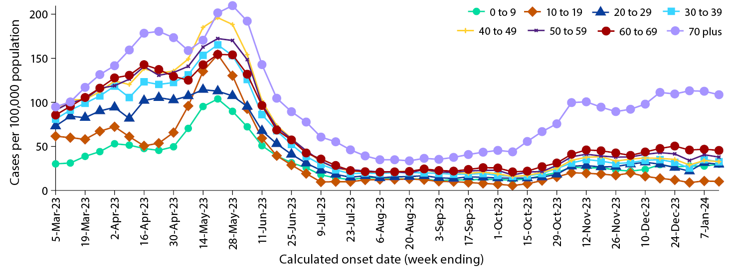
a Source: NNDSS, extracted on 18 January 2024 for cases with an illness onset from 27 February 2023 to 14 January 2024.
b Population data based on Australian Bureau of Statistics (ABS) Estimated Resident Population (ERP) as at June 2022.

Aboriginal and Torres Strait Islander persons
(NNDSS)
Overall, since the start of the pandemic, Aboriginal and Torres Strait Islander status is unknown for approximately 13.4% of COVID-19 notifications in NNDSS. Therefore, the number of cases classified as Aboriginal and Torres Strait Islander people is likely an under-representation. During the reporting period, there were 1,140 new cases notified among Aboriginal and Torres Strait Islander people (Table 2). In the Omicron wave to date (15 December 2021 – 14 January 2024), notifications among Aboriginal and Torres Strait Islander people comprised 3.7% (425,980/11,527,427) of all cases.
Of the COVID-19 cases notified among Aboriginal and Torres Strait Islander people from 15 December 2021 to date, and where location of residence was known, 54.6% (232,604/425,980) lived in a regional or remote area (Table 3).
Nationally, there have been 442 COVID-19 related deaths among Aboriginal and Torres Strait Islander people notified to the NNDSS from the start of the pandemic to 14 January 2024. This comprises 144 (32.6%) from New South Wales; 131 (29.6%) from Queensland; 61 (13.8%) from Western Australia; 58 (13.1%) from the Northern Territory; 25 (5.7%) from South Australia; 19 (4.3%) from Victoria; and two (0.5%) each from the Australian Capital Territory and Tasmania. Nationally, there have been 780 COVID-19 associated intensive care admissions among Aboriginal and Torres Strait Islander people notified to the NNDSS from the start of the pandemic to 14 January 2024. In the Omicron wave to date, the rate of severe illness increased with higher age, with the highest rate observed among those aged 70 years and over (Table 4). It should be noted that ICU status in NNDSS is likely incomplete.
Table 2: Confirmed and probable COVID-19 cases among Aboriginal and Torres Strait Islander people notified to the NNDSS by jurisdiction and date of onset, Australia, 1 January 2020 – 14 January 2024^{a,b,c}
Jurisdiction^{b,c} | Reporting period 18 December 2023 – 14 January 2024 | Omicron wave to date 15 December 2021 – 14 January 2024 | Delta wave  16 June – 14 December 2021 | Pandemic to date 1 January 2020 – 14 January 2024
ACT^{d} | 1 | 4,318 | 240 | 4,562
NSW^{d} | 281 | 140,028 | 7,715 | 147,814
NT^{d} | 129 | 27,158 | 94 | 27,253
Qld^{d} | 375 | 114,040 | 19 | 114,082
SA | 74 | 24,329 | 4 | 24,338
Tas. | 149 | 17,841 | 1 | 17,854
Vic.^{d} | 27 | 36,485 | 1,939 | 38,520
WA^{d} | 104 | 61,781 | – | 61,783
Australia | 1,140 | 425,980 | 10,012 | 436,206
a Source: NNDSS, extracted on 18 January 2024 for cases with an illness onset from 1 January 2020 to 14 January 2024.
b ACT: Australian Capital Territory; NSW: New South Wales; NT: Northern Territory; Qld: Queensland; SA: South Australia; Tas: Tasmania; Vic: Victoria; WA: Western Australia.
c Since 1 July 2023, cases are classified based on jurisdiction of residence. This does not necessarily reflect the place where the disease was acquired or where the case presented. Please note that, prior to this, cases were classified based on the jurisdiction in which they tested positive.
d Six jurisdictions have ceased collecting and reporting data on probable COVID-19 cases: Victoria ceased collection on 1 July 2023; Queensland on 1 September 2023; New South Wales on 1 October 2023; Western Australia on 9 October 2023; the Northern Territory on 21 October 2023; and the Australian Capital Territory on 22 December 2023. Rapid antigen tests (probable COVID-19 cases) administered in healthcare or aged care settings continue to be reported to the NNDSS by some of these jurisdictions.
Table 3: Confirmed and probable cases of COVID-19 among Aboriginal and Torres Strait Islander people notified to the NNDSS by area of remoteness, Australia, 15 December 2021 – 14 January 2024ª
Jurisdiction^{b,c} | Major city | Inner regional | Outer regional | Remote^{d}
ACT^{e} | 4,269 | 35 | 12 | 1
NSW^{e} | 75,127 | 45,285 | 15,636 | 3,179
NT^{e} | 74 | 21 | 8,506 | 17,625
Qld^{e} | 44,489 | 26,220 | 31,544 | 11,628
SA | 13,219 | 2,610 | 5,075 | 3,270
Tas. | 206 | 10,938 | 6,240 | 309
Vic.^{e} | 20,804 | 11,752 | 3,869 | 19
WA^{e} | 32,285 | 4,467 | 7,727 | 16,636
Australia | 190,473 | 101,328 | 78,609 | 52,667
a Source: NNDSS, extracted on 18 January 2024 for cases with an illness onset from 15 December 2021 to 14 January 2024. Excludes cases with an overseas place of residence, and where place of residence is unknown.
b ACT: Australian Capital Territory; NSW: New South Wales; NT: Northern Territory; Qld: Queensland; SA: South Australia; Tas.: Tasmania; Vic.: Victoria; WA: Western Australia.
c Since 1 July 2023, cases are classified based on jurisdiction of residence. This does not necessarily reflect the place where the disease was acquired or where the case presented. Please note that, prior to this, cases were classified based on the jurisdiction in which they tested positive.
d ‘Remote’ here also includes areas classified as ‘very remote’.
e Six jurisdictions have ceased collecting and reporting data on probable COVID-19 cases: Victoria ceased collection on 1 July 2023; Queensland on 1 September 2023; New South Wales on 1 October 2023; Western Australia on 9 October 2023; the Northern Territory on 21 October 2023; and the Australian Capital Territory on 22 December 2023. Rapid antigen tests (probable COVID-19 cases) administered in healthcare or aged care settings continue to be reported to the NNDSS by some of these jurisdictions.
Table 4: Crude notification rate of COVID-19 cases admitted to intensive care or died among Aboriginal and Torres Strait Islander people notified to the NNDSS by ten-year age groups, Australia, 1 January 2020 to 14 January 2024ª
Age group (years) | Sixth Omicron wave to date 14 August 2023 – 14 January 2024 | Fifth Omicron wave  1 March – 13 August 2023 | Fourth Omicron wave  24 October 2022 – 28 February 2023 | Omicron wave to date  15 December 2021 – 14 January 2024 | Pandemic  to date  1 January 2020 – 14 January 2024
0–9 | 1.4 | 0.9 | 5.1 | 23.3 | 24.2
10–19 | 0.5 | 3.4 | 1.9 | 21.3 | 26.1
20–29 | 1.8 | 3.0 | 3.0 | 45.4 | 54.4
30–39 | < 0.1 | 3.2 | 11.3 | 53.2 | 68.5
40–49 | 6.1 | 7.1 | 10.1 | 107.9 | 130.1
50–59 | 12.5 | 29.6 | 30.8 | 217.6 | 252.9
60–69 | 23.5 | 54.2 | 41.6 | 383.1 | 419.3
70 + | 32.8 | 128.0 | 170.7 | 870.0 | 929.1
All | 4.8 | 12.2 | 14.8 | 102.6 | 116.6
a Rate per 100,000 population for the given time period. Aboriginal and Torres Strait Islander population data is based on the Australian Bureau of Statistics (ABS) Estimated Resident Population (ERP) as at 2021.

Severity
(NNDSS, FluCAN, SPRINT-SARI)
To provide a more accurate assessment of severity (defined as those admitted to ICU and/or died), cases with an illness onset in the last two weeks of the reporting period have been excluded from the analyses, given the delay between illness onset and development of severe illness.
Since the emergence of the Omicron variant, the number of cases with severe illness peaked in mid-January 2022, at over 1,270 severe cases per week (data not shown). Since this time there has been a consistent decrease in the incidence of severe illness, with a smaller peak observed with each subsequent Omicron wave. This is likely due to a combination of factors such as high COVID-19 vaccination coverage, hybrid immunity and access to oral antiviral treatments. Since the start of the sixth Omicron wave, the incidence of severe illness gradually increased and reached an apparent peak at approximately 190 severe cases in the week ending 12 November 2023 (Figure 3). Since mid-November 2023, there has been an overall decreasing trend in the number of cases developing severe illness; however, week-on-week increases have been observed.
Figure 3: Confirmed and probable COVID-19 cases, intensive care admissions and deaths notified to the NNDSS by date of onset, Australia, 27 February 2023 – 14 January 2024^{a,b}
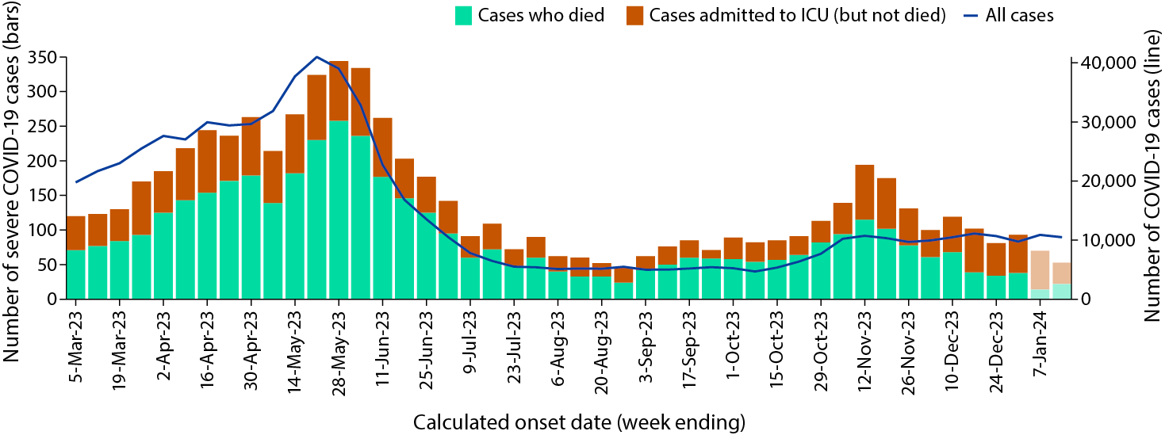
a Source: NNDSS, extracted on 18 January 2024 for cases with an illness onset from 27 February 2023 to 14 January 2024.
b Shaded bars at the right represent the most recent two reporting weeks and should be interpreted with caution, as cases with an illness onset in these weeks may not have yet developed severe disease.
Similar to previous transmission waves, rates of severe illness during the Omicron waves remain highest in older age groups, particularly those aged 70 years and older (Figure 4). The rate of severe illness in this age group has increased gradually since the start of the sixth Omicron wave and subsequently reached an apparent peak in mid-November 2023 at just above 4 cases per 100,000 population. In comparison, rates of severe illness in younger age groups have remained relatively low and stable throughout earlier Omicron waves, not surpassing 1.3 cases per 100,000 population per week since the start of the fifth Omicron wave (Figure 4).
Figure 4: Crude notification rates of COVID-19 cases admitted to intensive care or died for ten-year age groups by date of onset, Australia, 27 February 2023 to 31 December 2023^{a,b}
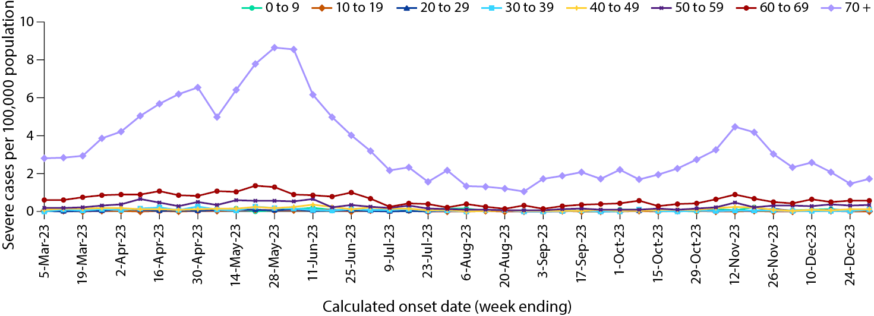
a Source: NNDSS, extracted on 18 January 2024 for cases with an illness onset from 27 February 2023 to 31 December 2023; cases with an illness onset in the last two weeks (1–14 January 2024) were excluded to account for the delay between onset and development of severe illness.
b Population data based on Australian Bureau of Statistics (ABS) Estimated Resident Population (ERP) as at June 2022.

Hospitalisation and ICU admissions
Influenza Complications Alert Network—FluCAN
Between 15 December 2021 and 14 January 2024, there were 19,803 hospital admissions with confirmed COVID-19 reported at Influenza Complications Alert Network (FluCAN) sentinel sites, including 5.7% (1,122/19,803) admitted directly to ICU. Since the start of the fifth Omicron wave, there were 5,014 hospital admissions with confirmed COVID-19 reported at FluCAN sentinel sites, including 5.9% (296/5,014) admitted directly to ICU (Figure 5). During the latest four-week reporting period (18 December 2023 – 14 January 2024), there were 364 hospital admissions with COVID-19 reported at FluCAN sentinel sites, with 3.8% (14/364) admitted directly to ICU. The proportion of COVID-19 ICU admissions in the year to date (1 January to 14 January 2024) was 4.0% (5/126), slightly lower than the proportion for the same period in 2023 (5.9%).
Figure 5: Weekly trends for patients admitted with confirmed COVID-19 to FluCAN sentinel hospitals, Australia, 27 February 2023 – 14 January 2024ª
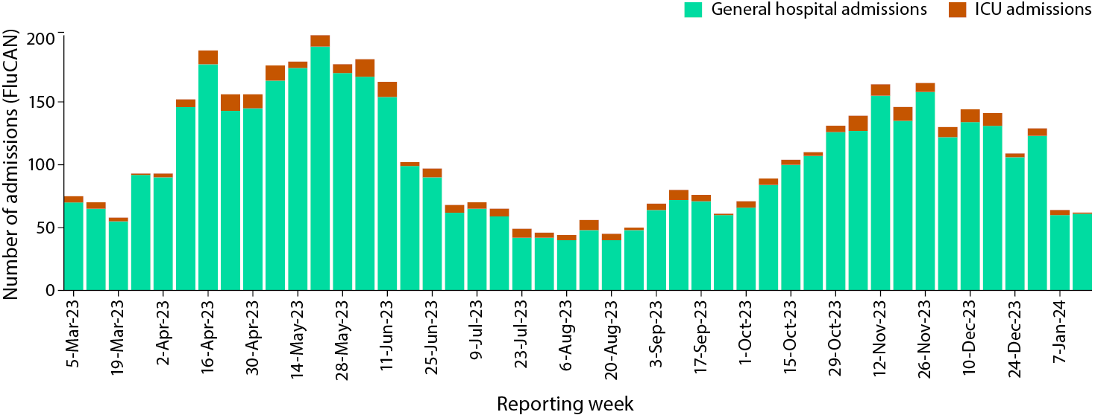
a Source: FluCAN.⁴

Short Period Incidence Study of Severe Acute Respiratory Infection—SPRINT-SARI
Between 15 December 2021 and 14 January 2024, there were 6,772 COVID-19 cases admitted to ICUs participating in the sentinel surveillance system, Short Period Incidence Study of Severe Acute Respiratory Infection (SPRINT-SARI)⁵ (Table 5). Most patients (62.1%; 4,205/6,772) were discharged home. Thirteen percent (864/6,772) died in ICU and 5.2% (351/6,772) died within the general hospital ward, with an overall in-hospital mortality rate of 17.9% (1,215/6,772).
Since the start of the Omicron wave (15 December 2021) to 14 January 2024, for patients admitted to SPRINT-SARI sentinel sites with COVID-19 (n = 6,772), the median duration of mechanical ventilation was 4.1 days (interquartile range [IQR]: 1.6–9.1 days); the median length of stay in ICU was 3.4 days (IQR: 1.7–7.2 days); and the median length of stay in hospital was 11.0 days (IQR: 6.0–20.0 days).
In the four-week reporting period (18 December 2023 – 14 January 2024), there were 69 adult patients with COVID-19 (36 males, 33 females; median age: 67 years; IQR: 61.0–76.0 years) admitted to ICU reported at contributing SPRINT-SARI sentinel sites (Table 5). During the four-week reporting period (18 December 2023 – 14 January 2024), for adult patients admitted to contributing SPRINT-SARI sentinel sites with COVID-19 (n = 69), the median duration of mechanical ventilation was 2.3 days (IQR: 1.4–4.9 days); the median length of stay in ICU was 3.4 days (IQR: 1.8–5.0 days); and the median length of stay in hospital was 6.7 days (IQR: 3.8–8.9 days).
Table 5: Patient outcomes for adult COVID-19 cases (aged greater than or equal to 18 years), Australia, 15 December 2021 – 14 January 2024ª
Outcomes | Reporting period  18 December 2023 – 14 January 2024  (n = 69) | Omicron wave to date  15 December 2021 – 14 January 2024 (n = 6,772)
Patient status
Ongoing care in ICU | 26 (37.7%) | 43 (0.6%)
Ongoing care in hospital ward^{b} | 15 (21.7%) | 37 (0.5%)
Transfer to other hospital/facility | 1 (1.4%) | 501 (7.4%)
Transfer to rehabilitation | 0 (0%) | 663 (9.8%)
Discharged home | 18 (26.1%) | 4,205 (62.1%)
Mortality – ICU | 7 (10.1%) | 864 (12.8%)
Mortality – hospital ward | 1 (1.4%) | 351 (5.2%)
Unknown | 0 (0%) | 78 (1.2%)
Missing^{c} | 1 (1.4%) | 30 (0.4%)
a Source: SPRINT-SARI.⁵
b Patients who were admitted in ICU/hospital wards with no discharge information for less than 90 days were assumed to have ongoing care in the hospital.
c Patients who were admitted to ICU/hospital wards for more than 90 days with no discharge information were treated as ‘missing data’.

Risk factors for severe disease
Comorbidity data extracted from SPRINT-SARI reflect the sickest patients with COVID-19 who are managed in ICU; data are therefore not generalisable to all cases. Figure 6 shows the most prevalent comorbidities among adult patients admitted to ICU with COVID-19 during the four-week period 18 December 2023 – 14 January 2024, where comorbidity information was available. Of those adult patients admitted to ICU during the four-week reporting period, for whom comorbidity data was known, 39.1% (27/69) had three or more comorbidities (data not shown).
Figure 6: Prevalence of comorbidities for COVID-19 cases among admitted adult ICU patients (aged greater than or equal to 18 years), Australia, 18 December 2023 – 14 January 2024^{a,b}
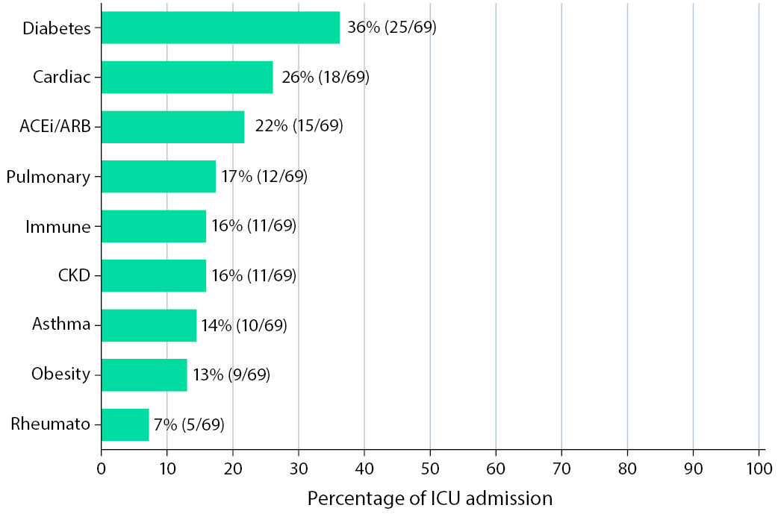
a Source: SPRINT-SARI. Only includes adult cases (≥ 18 years old) and excludes those with missing data on comorbidities or where comorbidity is unknown.
b Abbreviated comorbidities defined as: Cardiac: chronic cardiac disease; ACEi/ARB: past use of ACE inhibitor or A2 Blocker; CKD: chronic kidney disease; Immune: chronic immunosuppression; Pulmonary: chronic pulmonary disease (not including asthma); and Rheumato: rheumatologic disorder.

Paediatric Inflammatory Multisystem Syndrome – Temporally Associated with SARS-CoV-2
Paediatric Active Enhanced Disease Surveillance
Since the start of the pandemic to 14 January 2024, there have been 187 cases of paediatric inflammatory multisystem syndrome – temporally associated with SARS-CoV-2 (PIMS-TS) reported to the Paediatric Active Enhanced Disease Surveillance network (PAEDS), including 21 PIMS-TS cases reported in 2023. There were no new PIMS-TS cases during the current reporting period (Figure 7). The majority of PIMS-TS cases to date have occurred in those aged 5 to < 12 years (53%; 99/187), followed by those aged 6 months to < 5 years (27%; 51/187). To date, there have been no PIMS-TS associated deaths.
Figure 7: PIMS-TS cases reported to PAEDS, by admission month and level of care required, Australia, 1 June 2021 – 14 January 2024ª
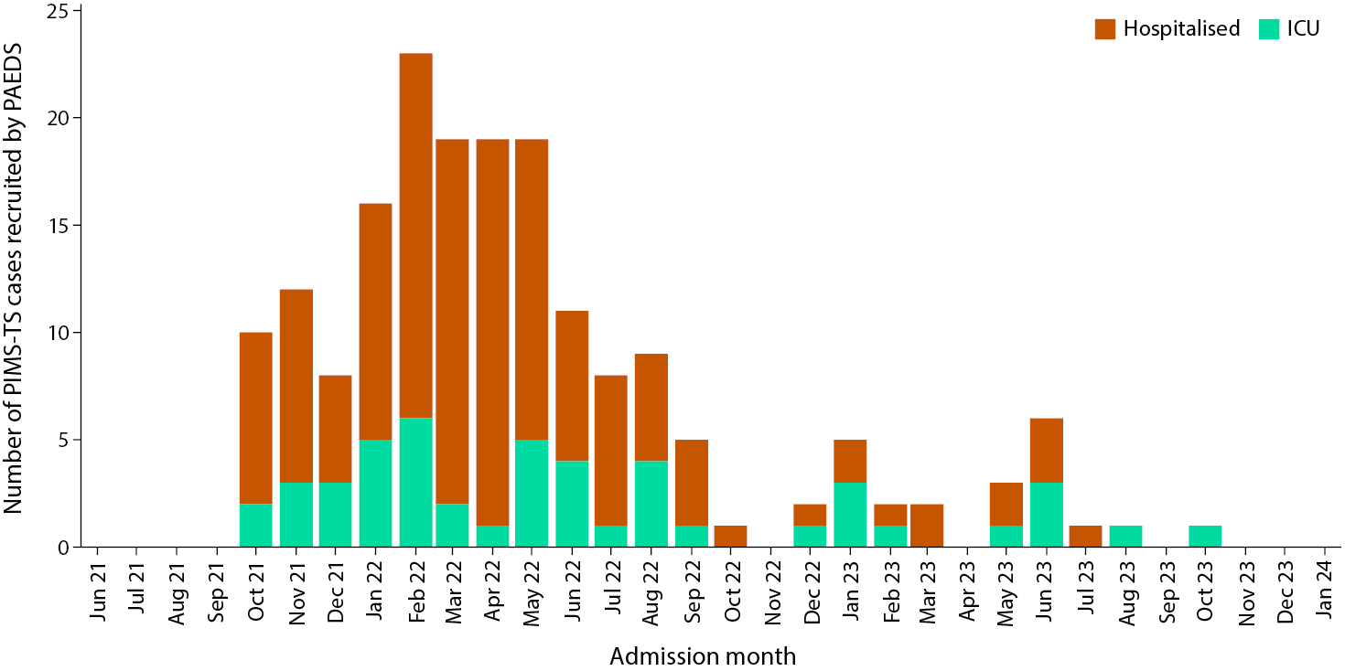
a Source: PAEDS.

COVID-19 deaths
Since the beginning of the pandemic to 14 January 2024, there have been 24,357 COVID-19 related deaths reported to the NNDSS, with 1,338 COVID-19 related deaths notified in the sixth Omicron wave to date (Table 6). The crude case fatality rate from the start of the overall Omicron wave to date is 0.19%, which is lower than the crude case fatality rate for the Delta wave (0.71%) (Table 7).
Table 6: COVID-19 related deaths in cases notified to NNDSS, by jurisdiction and date of death, Australia, 1 January 2020 – 14 January 2024^{a,b,c}
Jurisdiction^{c} | Sixth Omicron wave to date 14 August 2023 – 14 January 2024 | Fifth Omicron wave  1 March – 13 August 2023 | Fourth Omicron wave  24 October 2022 – 28 February 2023 | Omicron wave to date  15 December 2021 – 14 January 2024 | Pandemic to date 1 January 2020 – 14 January 2024
ACT^{d} | 18 (1.3%) | 46 (1.5%) | 38 (1.0%) | 278 (1.3%) | 293 (1.2%)
NSW^{d} | 279 (20.9%) | 1,078 (34.1%) | 1,065 (29.0%) | 7,224 (32.7%) | 7,925 (32.5%)
NT^{d} | 8 (0.6%) | 14 (0.4%) | 18 (0.5%) | 118 (0.5%) | 119 (0.5%)
Qld^{d} | 167 (12.5%) | 521 (16.5%) | 510 (13.9%) | 3,508 (15.9%) | 3,515 (14.4%)
SA | 31 (2.3%) | 247 (7.8%) | 323 (8.8%) | 1,709 (7.7%) | 1,714 (7.0%)
Tas. | 35 (2.6%) | 54 (1.7%) | 63 (1.7%) | 326 (1.5%) | 339 (1.4%)
Vic.^{d} | 723 (54.0%) | 973 (30.8%) | 1,355 (36.9%) | 7,560 (34.2%) | 9,082 (37.3%)
WA^{d} | 77 (5.8%) | 230 (7.3%) | 300 (8.2%) | 1,361 (6.2%) | 1,370 (5.6%)
Australia | 1,338 (100.0%) | 3,163 (100.0%) | 3,672 (100.0%) | 22,084 (100.0%) | 24,357 (100.0%)
a Source: NNDSS, extracted on 18 January 2024 for deaths with an illness onset date to 14 January 2024.
b Deaths are categorised into time periods using date of death. Deaths with a missing date of death are classified using date of illness onset.
c ACT: Australian Capital Territory; NSW: New South Wales; NT: Northern Territory; Qld: Queensland; SA: South Australia; Tas.: Tasmania; Vic.: Victoria; WA: Western Australia.
d Six jurisdictions have ceased collecting and reporting data on probable COVID-19 cases: Victoria ceased collection on 1 July 2023; Queensland on 1 September 2023; New South Wales on 1 October 2023; Western Australia on 9 October 2023; the Northern Territory on 21 October 2023; and the Australian Capital Territory on 22 December 2023. Rapid antigen tests (probable COVID-19 cases) administered in healthcare or aged care settings continue to be reported to the NNDSS by some of these jurisdictions.
Table 7: COVID-19 associated case fatality rates among cases notified to NNDSS, by age group and date of onset, 1 January 2020 to 31 December 2023^{a,b,c}
Age group (years) | Omicron wave to date 15 December 2021 – 31 December 2023 | Delta wave  16 June – 14 December 2021 | Pandemic to date 1 January 2020 – 31 December 2023
0–9 | < 0.05% | < 0.05% | < 0.05%
10–19 | < 0.05% | < 0.05% | < 0.05%
20–29 | < 0.05% | < 0.05% | < 0.05%
30–39 | < 0.05% | 0.06% | < 0.05%
40–49 | < 0.05% | 0.18% | < 0.05%
50–59 | < 0.05% | 0.65% | 0.06%
60–69 | 0.18% | 1.97% | 0.20%
70+ | 2.06% | 10.91% | 2.24%
Australia | 0.19% | 0.71% | 0.21%
a Source: NNDSS, extracted on 18 January 2024 for deaths with an illness onset date to 31 December 2023.
b To account for the lag between illness onset and the development of severe illness, cases with an onset date in the last two weeks have been excluded from calculations of the case fatality rate.
c Crude case fatality rates which reflect number of deaths as a proportion of reported COVID-19 cases during specific periods. Note, the current crude case fatality rates are likely overestimated due to changes in case ascertainment and increased underreporting of non-severe cases.

Genomic surveillance and virology
(Communicable Disease Genomics Network, AusTrakka and jurisdictional sequencing laboratories)

Variants of concern (VOC)
AusTrakka⁶ is actively monitoring and reporting on one lineage and its associated sub- and sub-sub-lineages, currently designated as a variant of concern (VOC) by international organisations, including the World Health Organization (WHO): Omicron (B.1.1.529). The Omicron variant displays a characteristic set of mutations which differentiate the lineage from previously circulating VOCs. Further information on variants and their mutations is available in the Technical Supplement.²
There have been five major sub-lineages defined under B.1.1.529: BA.1, BA.2, BA.3, BA.4 and BA.5, and a large number of sub-lineages, including recombinants, under these; all are designated Omicron. Unlike previous periods in Australia’s COVID-19 waves, where one or two dominant lineages were the main driver of disease, there is currently significant diversity in the range of sub-sub-lineages circulating within Australia. During this reporting period, more than 200 unique lineages have been identified, and it is likely that there are more that are not being characterised through whole genome sequencing. This diversity of circulating lineages has sometimes been referred to as a ‘variant soup’. Many of these circulating lineages will die out without causing a significant disease burden, but others appear to have stronger growth potential.

Variants of interest and variants under monitoring
The Communicable Diseases Genomics Network (CDGN) VOC working group tracks notable SARS-CoV-2 variants, including:
- variants of interest (VOI): XBB.1.5, XBB.1.16, EG.5, BA.2.86, JN.1; and
- the following variants under monitoring (VUM) and their descendent lineages: BA.2.75 and BA.2.75.2 (including CH*), and recombinants XBB* (in particular XBB.1.9.1* and XBB.1.9.2*), and XBF*.
This report uses the VOI classification for lineages with possible evidence for epidemiological, pathological or immunological features of concern. This is consistent with CDGN usage and with the WHO use of the term.^{7,8} VUMs are other lineages with early observations of potential significance, but little to no evidence of current concern. In this report, details are included of Omicron subvariants under monitoring as designated by the WHO.

AusTrakka SARS-CoV-2 genomic epidemiology
From 18 December 2023 to 14 January 2024, there were 693 sequences uploaded to AusTrakka. This represents a 40% decrease in the number of sequences compared to the previous reporting period. This decrease is possibly the result of the impact that the end of year and holiday period had on testing and reporting numbers; the total number of sequences will be monitored for any genuine trends in subsequent reports. All sequences uploaded during this reporting period have been assigned to sub-lineages within B.1.1.529 (Omicron) or to recombinants consisting of one or more Omicron sub-lineages.
Of the 693 sequences uploaded to AusTrakka between 18 December 2023 and 14 January 2024:
- 38.1% (264/693) were recombinant or recombinant sub-lineages; and
- 61.9% (429/693) were BA.2 sub-sub-lineages.
No BA.1, BA.3, BA.4 or BA.5 Omicron sub-lineages were identified.
From 1 July 2023, jurisdictional sequencing strategies for SARS-CoV-2 have changed. Some jurisdictions have ceased SARS-CoV-2 sequencing, while other jurisdictions have reduced the number of SARS-CoV-2 cases being sequenced. For jurisdictions which are continuing SARS-CoV-2 genomic surveillance, SARS-CoV-2 cases which are likely to be prioritised for sequencing include ICU or hospitalised cases, high-risk cases, or cases of clinical significance. As a result, these changes are likely to affect the representativeness of the distribution of sequenced SARS-CoV-2 sub-lineages across Australia.
Case numbers and sequencing proportion are primarily based on polymerase chain reaction (PCR) results only, as RATs do not allow for sequencing. Since late 2022, the rates of PCR for testing and subsequent referrals of positive PCR samples to sequencing laboratories have decreased significantly, resulting in changes to sequencing strategies across the country.
The Australian SARS-CoV-2 genome sequences in AusTrakka identified as VOC, VOI or VUM are highlighted in Table 8. The VOI and VUM where the proportion has increased compared to the previous reporting period are highlighted in orange, those that have remained stable are highlighted in blue, while those where proportions have decreased are highlighted in green.
In the reporting period to 14 January 2024, recombinant sublineages were no longer the predominant lineage being identified in AusTrakka, currently representing 38.1% of all sequences this reporting period. Instead, the BA.2 sub-lineages made up 61.8% of all samples. This has been driven by the increasing proportion of the VOI BA.2.86, and more specifically JN.1 sequences. JN.1 sequences made up more than 50% of all sequences seen in this reporting period, compared to 16.3% in the previous reporting period (Table 8). This is in line with international reports of increasing rates of JN.1. In contrast, all other lineages have declined. This includes the VOI EG.5 (XBB.1.9.2.5), which dropped from 54.3% of all samples uploaded last reporting period to 27% for this report. The other VOI XBB sublineages, XBB.1.16 and XBB.1.5, continued to decline and now make up fewer than 5% of sequences during this reporting period combined (Table 8). Both the recently designated WHO VUM DV.7 (CH.1.1.1, a sub-lineage of the previously dominant BA.2.75 sub-lineage) and the VUM XBB.2.3 were only identified in one sequence each in AusTrakka this reporting period.
Figure 8: Omicron sub-lineage in Australia since 1 January 2023 by sample collection date, showing (A) proportions and (B) count per week^{a,b,c}
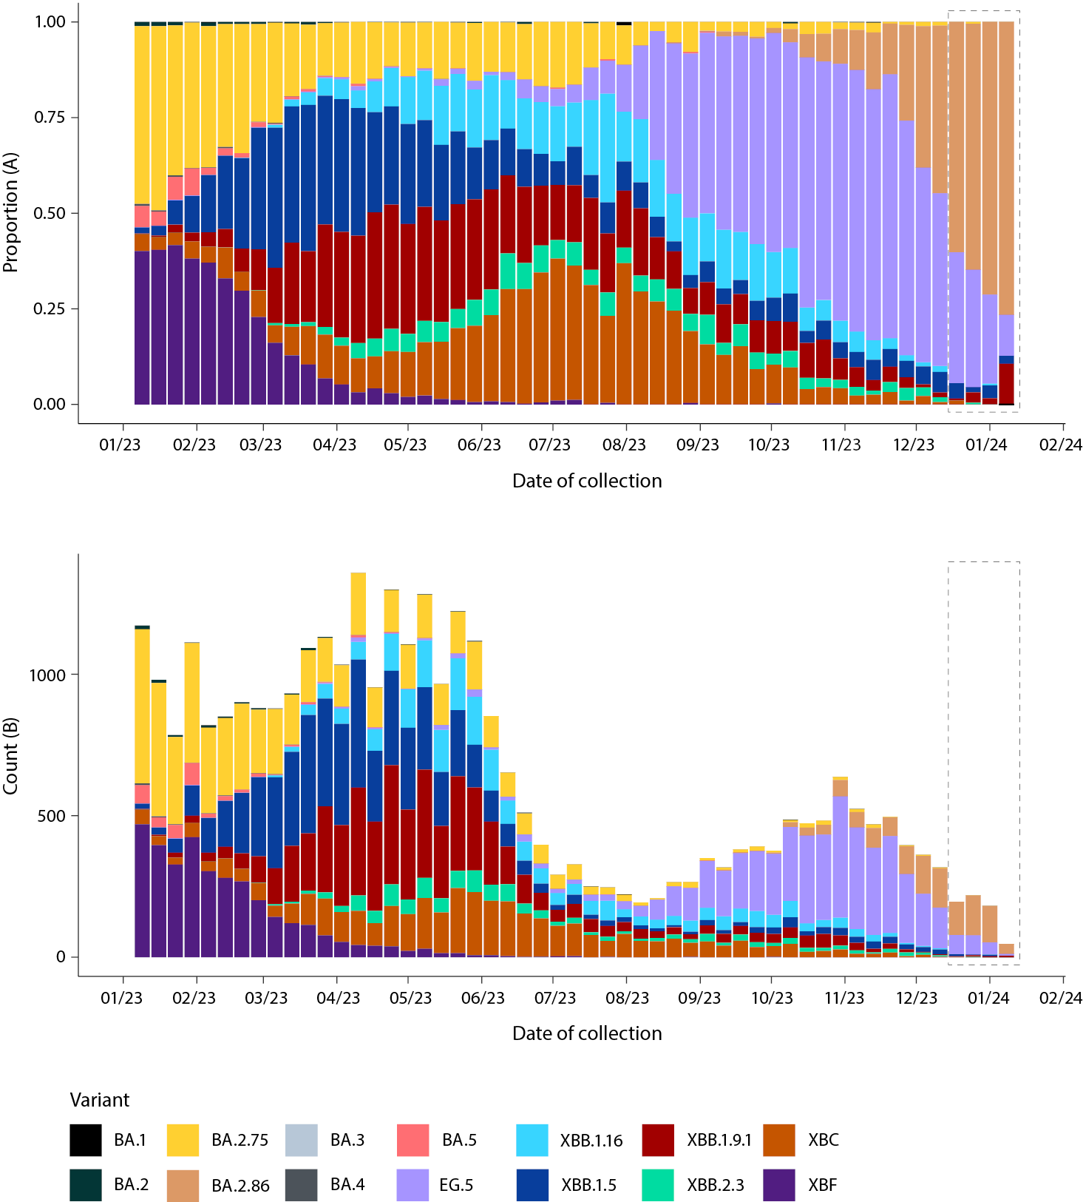
a Sequences in AusTrakka aggregated by epidemiological week.
b The dashed box indicates the distribution of sequences collected within the reporting period.
c Proportions in Figure 8A may not be representative when sequence numbers are small; refer to Figure 8B. Data for earlier epidemiological weeks may change between reporting periods as sequences with older collection dates are uploaded. These numbers are not equivalent to number of cases, as there are many cases which may not be sequenced. Non-VOI and non-VUM Omicron sub-lineages have been collapsed into parent lineages BA.1, BA.2, BA.3, BA.4 and BA.5.
Table 8: Australian SARS-CoV-2 genome sequences in AusTrakka, identified as variants of concern, variants of interest or variants under monitoring and proportion of positive cases sequenced for the current and previous reporting periods, and since 23 January 2020^{a,b,c}
Variant category | Measure | Reporting period 18 December 2023 – 14 January 2024 | Previous reporting period  20 November 2023 – 17 December 2023 | Total sequences to date  23 January 2020 – 14 January 2024
Variants of concern (VOC) | BA.1 | 0 (0%) | 0 (0%) | 26,272 (15.7%)
Variants of concern (VOC) | BA.2 (excluding BA.2.75) | 428 (61.8%) | 276 (24.0%) | 42,000 (25.2%)
Variants of concern (VOC) | BA.2.75 | 1 (0.14%) | 8 (0.69%) | 14,502 (8.7%)
Variants of concern (VOC) | BA.3 | 0 (0%) | 0 (0%) | 3 (< 0.01%)
Variants of concern (VOC) | BA.4 | 0 (0%) | 0 (0%) | 5,052 (3.0%)
Variants of concern (VOC) | BA.5 | 0 (0%) | 0 (0%) | 43,203 (25.9%)
Variants of concern (VOC) | Total recombinants | 264 (38.1%) | 865 (75.2%) | 35,775 (21.4%)
Variants of concern (VOC) | Total VOC | 693 (100%) | 1,150^{d} (100%) | 166,870 (100%)
Variants of interest (VOI) | XBB.1.5 + sub-lineages | 18 (2.6%) | 54 (4.7%) | 5,804 (3.5%)
Variants of interest (VOI) | XBB.1.16 | 11 (1.6%) | 36 (3.1%) | 4,574 (2.7%)
Variants of interest (VOI) | EG.5 (XBB.1.9.2.5) | 187 (27.0%) | 625 (54.3%) | 4,634 (2.8%)
Variants of interest (VOI) | JN.1 (BA.2.86.1.1) | 353 (50.9%) | 188 (16.3%) | 741 (0.44%)
Variants of interest (VOI) | BA.2.86 + sub-lineages | 428 (61.8%) | 276 (24.0%) | 1,148 (0.69%)
Variants under monitoring (VUM) | XBB + all sub-lineages | 236 (34.0%) | 807 (70.2%) | 24,217 (14.5%)
Variants under monitoring (VUM) | XBB.1.9.1, XBB.1.9.2 + sub-lineages | 204 (29.4%) | 674 (58.6%) | 10,035 (6.0%)
Variants under monitoring (VUM) | XBB.2.3 | 1 (0.14%) | 29 (0.8%) | 1,413 (0.85%)
Variants under monitoring (VUM) | XBF | 0 (0%) | 0 (0%) | 6,437 (3.9%)
Variants under monitoring (VUM) | XBC | 11 (1.6%) | 39 (3.4%) | 4,550 (2.7%)
Variants under monitoring (VUM) | DV.7 (CH.1.1.1) | 1 (0.14%) | 8 (0.69%) | 121 (0.07%)
Omicron BA.2 | BA.2.75 + sub-lineages | 1 (0.14%) | 8 (0.69%) | 14,579 (8.7%)
Omicron BA.2 | CH.1.1 + sub-lineages (BA.2.75.1.1) | 1 (0.14%) | 8 (0.69%) | 4,467 (2.7%)
a All lineages have been designated as variants of concern (VOC), variants of interest (VUI) or variants under monitoring (VUM) in Australia, by the CDGN VOC working group.
b Sequencing of samples from cases identified in the reporting period may be in process at the time of reporting. Remaining unsequenced samples may be due to jurisdictional sequencing strategy, or where samples have been deemed unsuitable for sequencing (typically because viral loads were too low for sequencing to be successful).
c Proportional changes compared to the previous 28-day period are highlighted by the following colours: green boxes indicate a decrease; orange boxes indicate an increase and blue boxes indicate no change/stable.
d Includes one sample that was not able to be typed beyond base Omicron lineage B.1.1.529.

Acute respiratory illness
(FluTracking, ASPREN)
Based on self-reported FluTracking data,⁹ there has been an overall increase in the incidence of ‘fever and cough’ symptoms since mid-October 2023 at 1.2%. The average proportion in the current four-week reporting period (18 December 2023 – 14 January 2024) remains similar to the proportion observed during the same period in 2022/2023, at 1.4% (Figure 9).
Week-on-week increases were observed in the incidence of ‘runny nose and sore throat’ symptoms between late November and December 2023, followed by a substantial decrease in recent weeks. In the current four-week reporting period, the average proportion of ‘runny nose and sore throat’ symptoms remains slightly above the proportion observed during the same period in 2022/2023, at 1.0% (Figure 10).
Figure 9: Weekly trends in fever and cough amongst FluTracking survey participants (age-standardised) compared to the average of 2017–2019 & 2022–2023, Australia, 1 January 2020 – 14 January 2024ª
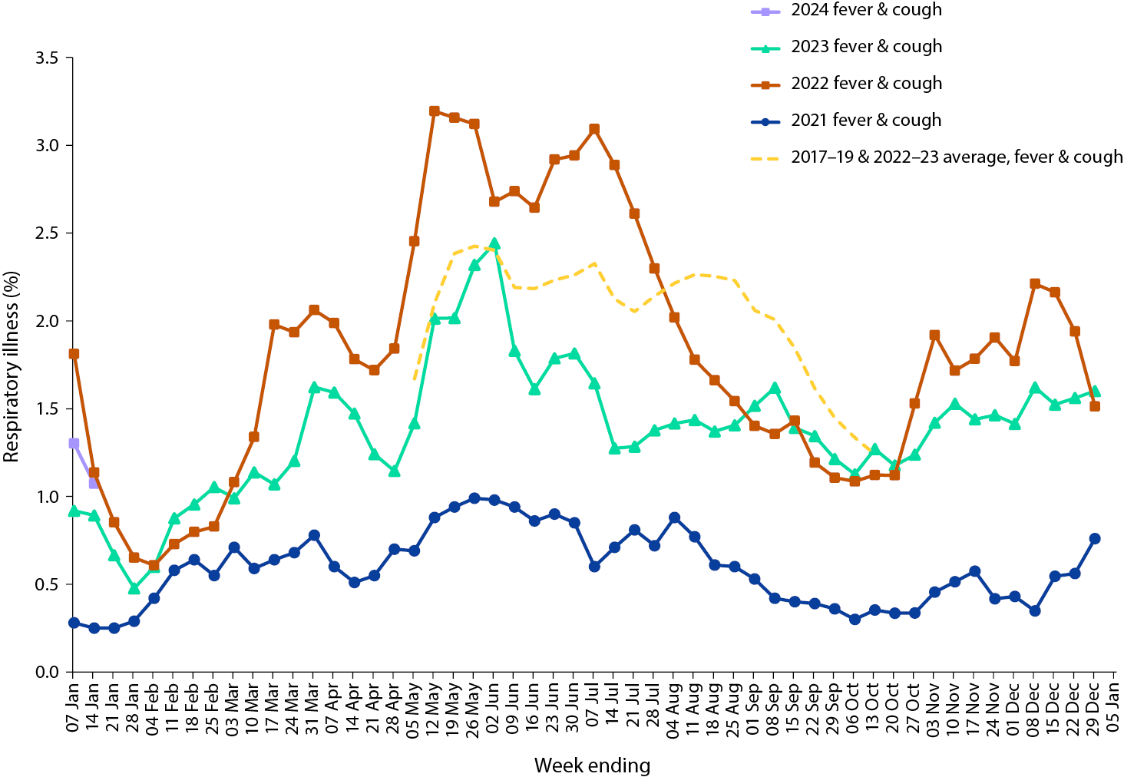
a In years prior to 2020, FluTracking was activated during the main Influenza season from May to October. A historical average beyond the week ending 13 October is therefore not available.
Figure 10: Weekly trends in runny nose and sore throat symptoms amongst FluTracking survey participants (age-standardised), Australia, 1 January 2021 – 14 January 2024ª
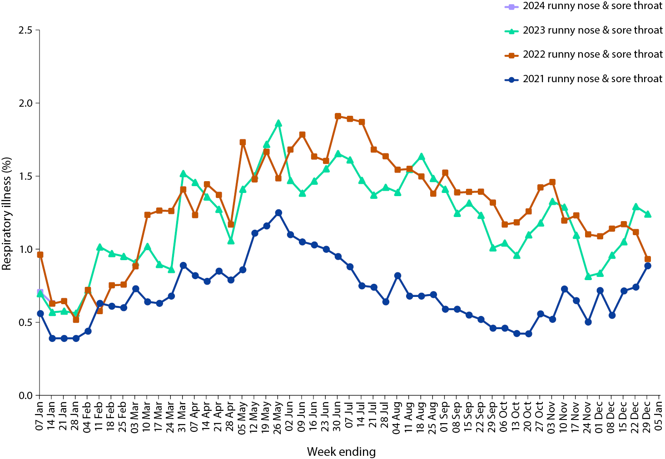
a Data on runny nose and sore throat were only collected systematically after 29 March 2020, therefore a historical average for this symptom profile is unavailable.
Over the reporting period, FluTracking data indicated that 10.2% of participants with ‘fever and cough’ were tested for SARS-CoV-2 with a PCR test and 84.6% were tested using a RAT (noting that in some instances RATs will be followed up by a PCR test for the same case). Of those with ‘runny nose and sore throat’, 4.2% were tested for SARS-CoV-2 using a PCR test and 60.9% were tested using a RAT. In the current reporting period, the percent positivity for ‘fever and cough’ symptoms decreased for PCR (24.4%) and increased for RAT (58.5%) compared to the previous reporting period. For ‘runny nose and sore throat’ symptoms, the percent positivity increased for both PCR (12.0%) and RAT (15.2%). Note that participants with one set of symptoms are not excluded from having the other. It is important to acknowledge that there may be legitimate reasons why people did not get tested, including barriers to accessing testing. Symptoms reported to FluTracking are not specific to COVID-19 and may also be due to infections with other respiratory pathogens and to chronic diseases, such as asthma.
In the current reporting period, of those presenting to sentinel ASPREN sites with influenza-like illness who were tested for respiratory viruses, 57.1% (24/42) tested positive for a respiratory virus. Among those positive, the most common viruses detected were rhinovirus (29.2%; 7/24) followed by metapnuemovirus (25.0%; 6/24), parainfluenza (12.5%; 3/24), and SARS-CoV-2 (12.5%; 3/24).

COVID-19 trends by WHO region
As of 7 January 2024, over 774 million COVID-19 cases and over 7 million deaths have been reported globally since the start of the pandemic, with a global case fatality rate (CFR) of approximately 0.91%.¹⁰ Current trends in reported COVID-19 cases are an underestimate of the true number of global infections due to the reduction in testing and reporting in many countries. For more information, please refer to the WHO monthly COVID-19 epidemiological update.¹¹

Acknowledgments
We thank public health staff from incident emergency operations centres and public health units in state and territory health departments, and the Australian Government Department of Health and Aged Care, along with state and territory public health laboratories. We thank those who have provided data from surveillance systems, such as ASPREN, FluTracking, FluCAN, PAEDS, SPRINT-SARI, the Communicable Disease Genomics Network, AusTrakka and jurisdictional sequencing laboratories.

Author details
Corresponding author
Viral Respiratory Diseases Epidemiology and Surveillance Section
Interim Australian Centre for Disease Control, Australian Government Department of Health and Aged Care
GPO Box 9484, MDP 14
Canberra, ACT 2601
Email: respiratory.surveillance@health.gov.au

References
- COVID-19 National Incident Room Surveillance Team. COVID-19 Australia: Epidemiology Report 82: Reporting period ending 17 December 2023. Commun Dis Intell (2018). 2024;48. doi: https://doi.org/10.33321/cdi.2024.48.5.
- COVID-19 National Incident Room Surveillance Team. Technical supplement. COVID-19 Australia: Epidemiology reporting. Commun Dis Intell (2018). 2021;45. doi: https://doi.org/10.33321/cdi.2021.45.2.
- Australian Government Department of Health and Aged Care. Coronavirus (COVID-19) – CDNA National Guidelines for Public Health Units. [Internet.] Canberra: Australian Government Department of Health and Aged Care; 14 October 2022. [Accessed on 9 November 2022.] Available from: https://www.health.gov.au/resources/publications/coronavirus-covid-19-cdna-national-guidelines-for-public-health-units.
- FluCAN (The Influenza Complications Alert Network). FluCAN (Influenza surveillance). [Webpage.] Melbourne: Monash Health, FluCAN. [Accessed on 30 June 2023.] Available from: https://monashhealth.org/services/monash-infectious-diseases/research/influenza-research/flucan-influenza-surveillance-2/.
- Australian and New Zealand Intensive Care Research Centre (ANZIC-RC). SPRINT-SARI: Short period incidence study of severe acute respiratory infection. [Internet.] Melbourne: Monash University, ANZIC-RC; 2020. Available from: https://www.monash.edu/medicine/sphpm/anzicrc/research/sprint-sari.
- Communicable Diseases Genomics Network (CDGN). AusTrakka. [Website.] Melbourne: CDGN; 2020. Available from: https://www.cdgn.org.au/austrakka.
- World Health Organization (WHO). Updated working definitions and primary actions for SARS-CoV-2 variants. Geneva: WHO; 15 March 2023. [Accessed on 11 October 2023.] Available from: https://www.who.int/publications/m/item/updated-working-definitions-and-primary-actions-for--sars-cov-2-variants.
- WHO. Tracking SARS-CoV-2 variants. [Webpage.] Geneva: WHO; 17 August 2023. [Accessed on 23 August 2023.] Available from: https://www.who.int/activities/tracking-SARS-CoV-2-variants.
- Dalton C, Durrheim D, Fejsa J, Francis L, Carlson S, d’Espaignet ET et al. Flutracking: a weekly Australian community online survey of influenza-like illness in 2006, 2007 and 2008. Commun Dis Intell Q Rep. 2009;33(3):316–22.
- WHO. COVID-19 epidemiological update – 19 January 2024. [Internet.] Geneva: WHO; 19 January 2024. [Accessed on 9 January 2024.] Available from: https://www.who.int/publications/m/item/covid-19-epidemiological-update---19-january-2024.
- WHO. Coronavirus disease (COVID-19) Weekly Epidemiological Updates and Monthly Operational Updates. [Webpage.] Geneva: WHO; 2024. Available from: https://www.who.int/emergencies/diseases/novel-coronavirus-2019/situation-reports.

Appendix A: Supplementary figures and tables
Table A.1: COVID-19 cases and rates per 100,000 population, by age group, sex, and date of onset, Australia, 15 December 2021 – 14 January 2024^{a,b,c,d}
Age group (years) | Four-week reporting period |  |  |  |  |  | Omicron wave to date
Age group (years) | 18 December 2023 – 14 January 2024 |  |  |  |  |  | 15 December 2021 – 14 January 2024
Age group (years) | Cases |  |  | Rate per 100,000 population |  |  | Cases |  |  | Rate per 100,000 population
Age group (years) | Male | Female | People^{d} | Male | Female | People^{d} | Male | Female | People^{d} | Male | Female | People^{d}
0–9 | 1,890 | 1,602 | 3,494 | 117.7 | 105.7 | 111.9 | 530,394 | 503,264 | 1,154,400 | 33,044.3 | 33,196.1 | 36,986.5
10–19 | 598 | 728 | 1,331 | 36.6 | 47.3 | 42.0 | 663,390 | 704,842 | 1,504,736 | 40,645.2 | 45,797.7 | 47,450.4
20–29 | 1,365 | 2,389 | 3,764 | 77.5 | 141.6 | 109.1 | 804,339 | 986,954 | 1,916,995 | 45,667.5 | 58,488.6 | 55,585.6
30–39 | 1,787 | 2,948 | 4,752 | 95.0 | 153.7 | 125.1 | 830,638 | 1,041,183 | 2,018,817 | 44,147.5 | 54,292.6 | 53,137.5
40–49 | 1,710 | 2,643 | 4,355 | 104.1 | 157.2 | 131.0 | 689,966 | 877,837 | 1,689,422 | 41,999.1 | 52,220.7 | 50,827.7
50–59 | 1,966 | 2,938 | 4,911 | 125.4 | 181.5 | 154.1 | 561,575 | 699,904 | 1,349,420 | 35,820.5 | 43,229.3 | 42,344.1
60–69 | 2,303 | 2,963 | 5,272 | 170.2 | 205.5 | 188.6 | 410,180 | 476,596 | 940,369 | 30,317.3 | 33,058.7 | 33,649.2
70–79 | 2,928 | 3,002 | 5,935 | 301.7 | 286.5 | 294.1 | 266,839 | 272,508 | 564,145 | 27,498.2 | 26,009.2 | 27,953.9
80–89 | 2,559 | 3,031 | 5,600 | 635.9 | 608.5 | 621.8 | 124,678 | 141,816 | 275,999 | 30,980.1 | 28,471.0 | 30,647.7
90 + | 850 | 1,521 | 2,378 | 1,120.8 | 1,095.0 | 1,107.4 | 33,123 | 61,563 | 97,413 | 43,677.1 | 44,319.3 | 45,362.4
a Source: NNDSS, extracted on 18 January 2024 for case notifications to 14 January 2024.
b Population data based on Australian Bureau of Statistics (ABS) Estimated Resident Population (ERP) as at June 2022.
c Excludes cases where age was unknown.
d Total cases includes those where sex was unknown and those classified as X, i.e., persons who reported their sex as another term, other than male or female.

About Communicable Diseases Intelligence
Communicable Diseases Intelligence (CDI) is a peer-reviewed scientific journal published by the Health Protection Policy & Surveillance Division, Department of Health and Aged Care. The journal aims to disseminate information on the epidemiology, surveillance, prevention and control of communicable diseases of relevance to Australia.
© 2024 Commonwealth of Australia as represented by the Department of Health and Aged Care
ISSN: 2209-6051 Online
This journal is indexed by Index Medicus and Medline.
This publication is licensed under a Creative Commons Attribution-NonCommercial-NoDerivatives 4.0 International Licence (CC BY-NC-ND) available from https://creativecommons.org/licenses/by-nc-nd/4.0/legalcode (Licence). You must read and understand the Licence before using any material from this publication.
Restrictions
The Licence does not cover, and there is no permission given for, use of any of the following material found in this publication (if any):
- the Commonwealth Coat of Arms (by way of information, the terms under which the Coat of Arms may be used can be found at www.pmc.gov.au/resources/commonwealth-coat-arms-information-and-guidelines);
- any logos (including the Department of Health and Aged Care’s logo) and trademarks;
- any photographs and images;
- any signatures; and
- any material belonging to third parties.
Disclaimer
Opinions expressed in Communicable Diseases Intelligence are those of the authors and not necessarily those of the Australian Government Department of Health and Aged Care or the Communicable Diseases Network Australia. Data may be subject to revision.
Enquiries
Enquiries regarding any other use of this publication should be addressed to the CDI Editor at: cdi.editor@health.gov.au
Communicable Diseases Network Australia
Communicable Diseases Intelligence contributes to the work of the Communicable Diseases Network Australia. www.health.gov.au/cdna
Editor: Christina Bareja • Deputy Editor: Simon Petrie • Design and Production: Lisa Thompson
Editorial Advisory Board: David Durrheim, Mark Ferson, Clare Huppatz, John Kaldor, Martyn Kirk, Meru Sheel and Stephanie Williams
Contacts
CDI is produced by:
Health Protection Policy & Surveillance Division, Australian Government Department of Health and Aged Care,
GPO Box 9848, (MDP 6) CANBERRA ACT 2601
Website: www.health.gov.au/cdi
Email: cdi.editor@health.gov.au
Submit an Article
You are invited to submit your next communicable disease related article to the Communicable Diseases Intelligence (CDI) for consideration. More information regarding CDI can be found at: www.health.gov.au/cdi.
Further enquiries should be directed to: cdi.editor@health.gov.au

